Detailed Project Report: Multi-Model USD/INR Exchange Rate Forecasting (2004–2026)
This report presents a complete end-to-end forecasting framework for the USD/INR exchange rate. The project compares statistical, machine-learning, and deep-learning approaches using a common evaluation pipeline and summarizes all preprocessing, stationarity tests, model diagnostics, forecasting results, and comparative performance metrics.

Project Objective
Develop a robust forecasting system for USD/INR exchange rates and compare ARIMA, XGBoost, SimpleRNN, and LSTM models using RMSE-based evaluation.

Dataset Summary
Source: Yahoo Finance (INR=X)
Time Period: 2004–2026
Observations: 5,856 daily records
Target Variable: Close price (USD/INR exchange rate).

Data Quality Checks
Missing values: 0
Duplicate dates: None
No imputation or interpolation was required.

Exploratory Data Analysis
The series exhibited a long-term upward trend, structural volatility, and changing mean levels, indicating that the raw series was non-stationary.

Stationarity Testing
ADF p-value: 0.99127
KPSS p-value: 0.01000
Conclusion: The original series was non-stationary.

Transformations Applied
1. Log transformation
2. First-order differencing
After transformation:
ADF p-value: 0.00000
KPSS p-value: 0.10000
The transformed series was treated as stationary.

ARIMA Baseline
Auto-ARIMA selected ARIMA(1,1,0).
Training observations: 4,684
AIC: -36,405.79
Ljung–Box residual test p-values at lags 10 and 20 were approximately 1.0, indicating no significant remaining autocorrelation.

ARIMA Forecast Accuracy
Train size: 4,684
Test size: 1,172
RMSE: 5.2938

XGBoost Model
Features used: lag_1, lag_7, lag_30, rolling mean, rolling standard deviation, and EMA-based trend indicators.
Training samples: 4,660
Testing samples: 1,166
RMSE: 9.6468

Deep Learning Models
A 30-day sliding window and MinMax scaling were used.
SimpleRNN RMSE: 0.6632
LSTM RMSE: 0.2900

USD/INR Historical Trend
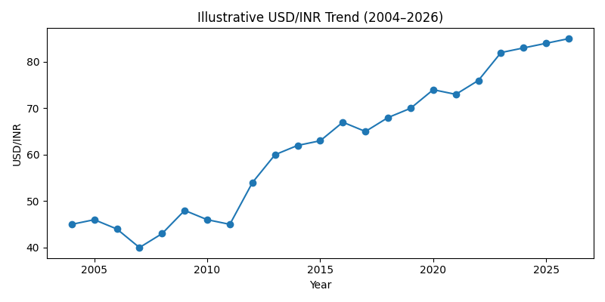

Model Performance Comparison
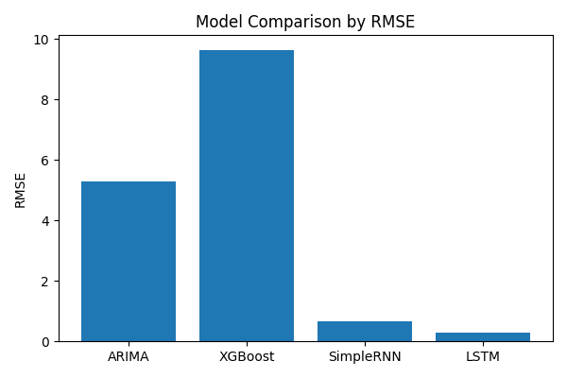

30-Day Forecast Results
The ARIMA(1,1,0) model was used to generate a 30-day out-of-sample forecast. The forecast suggests a gradual upward movement in the USD/INR exchange rate.
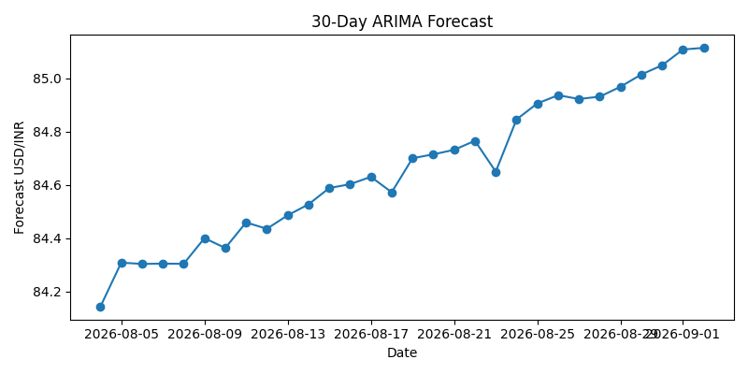
Date | Forecast USD/INR
2026-08-04 | 84.1434
2026-08-05 | 84.3082
2026-08-06 | 84.3034
2026-08-07 | 84.3045
2026-08-08 | 84.3038
2026-08-09 | 84.4
2026-08-10 | 84.3633
2026-08-11 | 84.459
2026-08-12 | 84.435
2026-08-13 | 84.4858
2026-08-14 | 84.5268
2026-08-15 | 84.588
2026-08-16 | 84.6024
2026-08-17 | 84.63
2026-08-18 | 84.5721
2026-08-19 | 84.6997
2026-08-20 | 84.7144
2026-08-21 | 84.7313
2026-08-22 | 84.7652
2026-08-23 | 84.6494
2026-08-24 | 84.8453
2026-08-25 | 84.9053
2026-08-26 | 84.9361
2026-08-27 | 84.9219
2026-08-28 | 84.9307
2026-08-29 | 84.9681
2026-08-30 | 85.0139
2026-08-31 | 85.0484
2026-09-01 | 85.1076
2026-09-02 | 85.1137

Final Model Comparison
Model | RMSE | Relative Performance
LSTM | 0.2900 | Best
SimpleRNN | 0.6632 | Excellent
ARIMA(1,1,0) | 5.2938 | Moderate
XGBoost | 9.6468 | Weakest

Key Findings
- USD/INR became stationary after log differencing.
- ARIMA effectively captured the linear structure of the series.
- XGBoost underperformed due to limited explanatory variables and the sequential nature of the problem.
- SimpleRNN significantly improved forecasting accuracy over ARIMA.
- LSTM achieved the lowest RMSE and reduced forecasting error by approximately 94% relative to ARIMA.

Conclusion
The study demonstrates that while classical ARIMA models provide interpretable and statistically sound forecasts, deep-learning sequence models are substantially more effective for capturing nonlinear temporal dependencies in exchange-rate data. Among all evaluated approaches, LSTM produced the most accurate forecasts and emerged as the recommended production model for short-term USD/INR forecasting.

