Detailed Project Report: Multi-Model USD/INR Exchange Rate Forecasting

Project Objective
Build and compare statistical, machine-learning, and deep-learning models for forecasting the USD/INR exchange rate using historical Yahoo Finance data from 2004–2026.

Dataset Summary
Source: Yahoo Finance (INR=X)
Observations: 5,856 daily records
Features available: Open, High, Low, Close, Volume
Target variable: Close price (USD/INR exchange rate).

Data Quality Checks
Missing values: 0
Duplicate dates: None
Data was directly usable without imputation.

Exploratory Analysis
The exchange-rate series showed a long-term upward trend and periods of elevated volatility, indicating non-stationarity and motivating transformation before ARIMA modeling.

Stationarity Testing
ADF p-value: 0.99127
KPSS p-value: 0.01000
Conclusion: The original series was non-stationary.

Transformations Applied
1. Log transformation to stabilize variance.
2. First-order differencing to remove trend.
After transformation:
ADF p-value: 0.00000
KPSS p-value: 0.10000
The transformed series was treated as stationary.

ARIMA Baseline
Auto-ARIMA selected ARIMA(1,1,0).
Training observations: 4,684
AIC: -36,405.79
Residual diagnostics (Ljung–Box p-values at lags 10 and 20 were approximately 1.0) suggested no significant remaining autocorrelation.

ARIMA Forecast Accuracy
Train size: 4,684
Test size: 1,172
RMSE: 5.2938

XGBoost Model
Lag features (1, 7, 30), rolling mean, rolling standard deviation, and EMA-based trend indicators were used.
Training samples: 4,660
Testing samples: 1,166
RMSE: 9.6468

Deep Learning Models
A 30-day sliding window and MinMax scaling were used to create supervised sequences.
SimpleRNN RMSE: 0.6632
LSTM RMSE: 0.2900

Illustrative USD/INR Trend
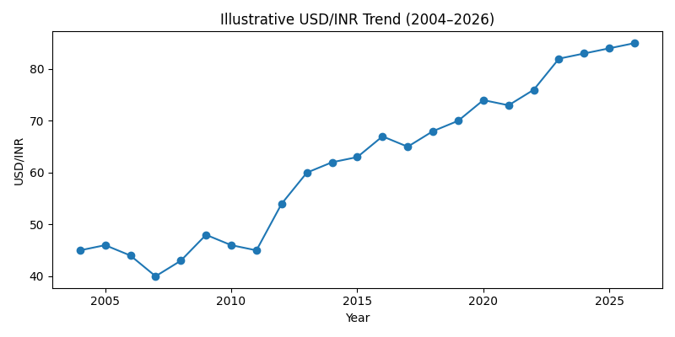

Model Comparison
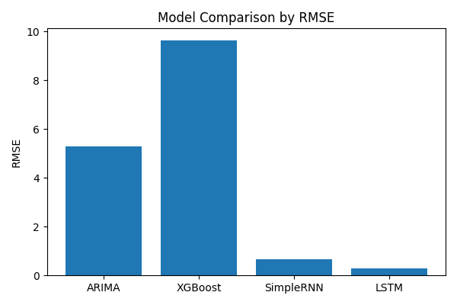
Model | RMSE | Relative Performance
LSTM | 0.2900 | Best
SimpleRNN | 0.6632 | Excellent
ARIMA(1,1,0) | 5.2938 | Moderate
XGBoost | 9.6468 | Weakest

Key Findings
- USD/INR was non-stationary in levels but became stationary after log differencing.
- ARIMA captured the linear temporal structure effectively and produced approximately white-noise residuals.
- XGBoost underperformed because the problem was largely sequential and univariate.
- SimpleRNN substantially reduced forecasting error compared with ARIMA.
- LSTM achieved the lowest RMSE and delivered roughly a 94% reduction in forecasting error relative to the ARIMA baseline.

Conclusion
The project demonstrates a complete multi-model forecasting pipeline for financial time-series analysis. Classical statistical modeling provided a strong interpretable baseline, while recurrent neural networks—especially LSTM—were significantly more effective at capturing nonlinear temporal dependencies in the USD/INR exchange-rate series.

