**Front-end:  
1.desktop view from 1024 to 1400 :**=>logo is over lapping on about us menu & tender box in nav bar **=>Done**=>banner & nav bar should fit to screen size **=>Done**  
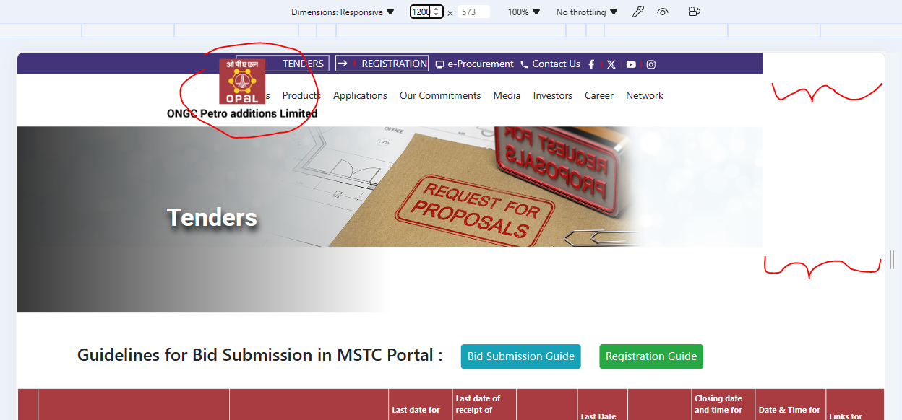

**2.Tender notice form**:  
=>Add validation for all mandatory fields **=>Done**=>add validations for invalid email id & invalid contact number**=>pending**=>add download file button & captcha field (refer below SS)**=>done**=>remove “sess” from Remark text**=>pending**

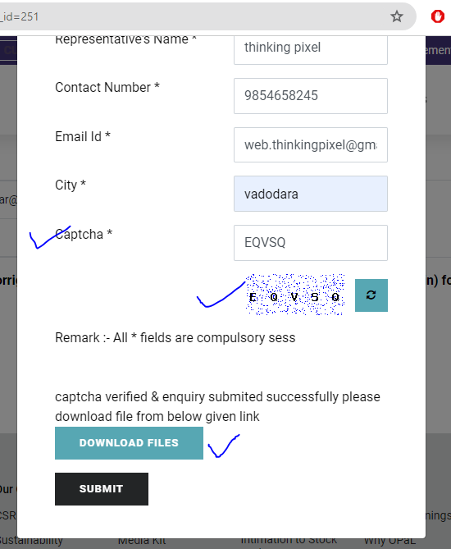  
  
  
**3.Tender details page:**=> set the content horizontally  
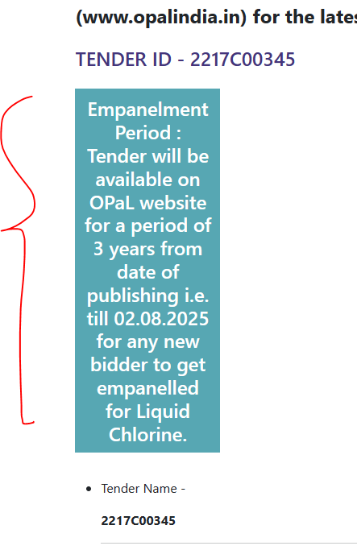  
 **Admin panel:  
1.admin:** set logo properly when we maximize screen  
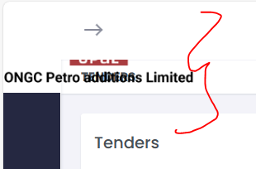  
  
**2.Admin>tender form:  
=>** add validation for all mandatory fields  
=>when we upload tender file & click on upload button, it shows two remove buttons  
=> after adding new tender, when we click on download tender button on front-end, tender details page not showing instead displaying blank page  
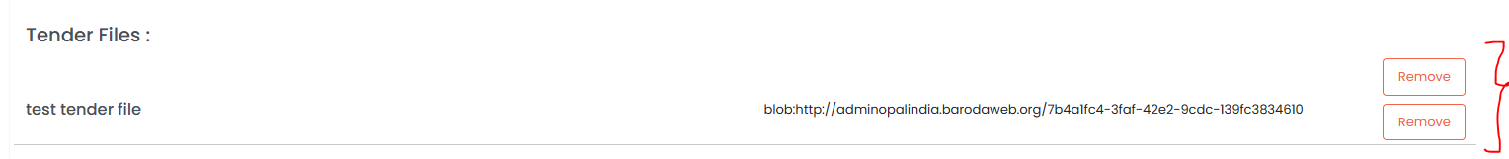  
**3. For front-end & admin panel:**   
=>when we add new tender, it’s entry should be shown on first page but it is showing on last page  
=>taking more time to load data

**4.Admin>tender enquiries**

=>not able to load data, page keeps on loading  
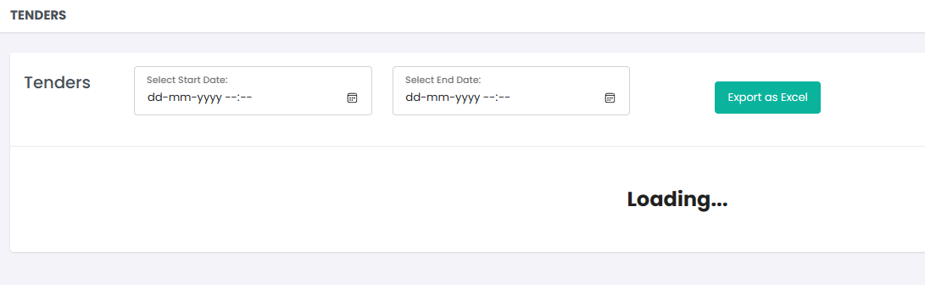  
 **5.Change page heading on top right corner for both forms:**  
=>Tender master>tenders  
=>Tender master>Tender Inquiries  
