**Logging**

Log files are not only useful from a developer’s perspective, but also when delicate, high-stake data is processed. Excel allows you to keep logs in form of text files, containing information such as date, time and other details

The following process outlines how to create log files within Excel:

1. Start VBA development environment (alt + F11)
2. Navigate to Insert and choose Module
3. Copy the following code:

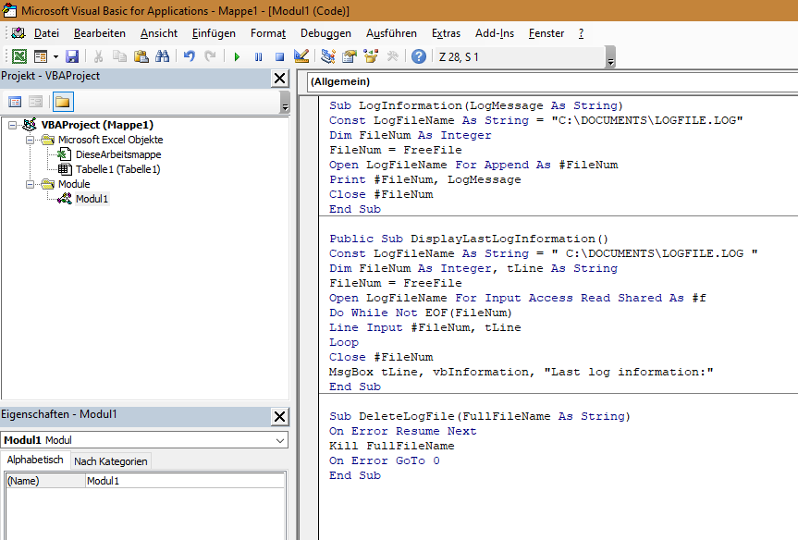

1. Copy the following code in your current workbook module:

*Private Sub Workbook_Open()*

*LogInformation ThisWorkbook.Name & " opened by " & _*

*Application.UserName & " " & Format(Now, "yyyy-mm-dd hh:mm")*

*End Sub*