Base Invaders – Game Play

**Backstory:**

In a distant time in a place far far away, a competition rages amongst the space pilots.

The name of this competition: BaseInvaders  
The pilots’ play for points, eternal glory and best of all real world prizes.   
You own one of the ships, but you are not one of the pilots. You have something better up your sleeve.   
You have outfitted your ship with a computer which will execute any program you upload.   
It is now your job to write this program that will steer your ship to victory

**The Game**:

The rules of the game are simple:  
There are preplaced markers in space.   
If your ship gets in range of one of the markers (codenamed MINE), The MINE is yours until another ship gets in range.   
If more than one ship is in range, nobody owns the MINE until only one ship is in range again.   
Every predetermined period, a point is added for each mine a ship owns.   
  
After a predetermined time, the game ends and the ship with the most points wins.   
In order to achieve victory, your ship has been outfitted with a set of gadgets.

Your ship has a thruster. This thruster can be pointed in any direction, and can be fed any amount of fuel up to a maximum. The laws of physics do apply so any object in motion will remain in motion. There is also a slight amount of kinetic friction. A pilot’s manual on steering has been attached to this document.

Your ship is also equipped with brakes.   
Your ship has two sensors:   
One sensor will scan the immediate area around the ship and return the coordinates of all the objects in range.  
The other sensor will return all the objects in range of any position in the world. This sensor needs to be charged to use and therefore has a lengthy cool down.   
Your ship has also been equipped with a bomb factory and the ability to place bombs. Due to the weight of bombs, your ship can only be manufacturing/carrying one bomb at a time.

You can place a bomb anywhere in a range. The bomb will explode after a certain time, and push away any ships in the area including yours. The closer the ship is to the center of the explosion, the more it will be pushed away.   
  
With these tools, you have everything you need to achieve victory.   
Good Luck.

**Game Commands:**

Below are the possible commands that you can send to the server. All commands should be followed by a newline. Note that the first line sent to the server constitutes your login. There is no command name, simply send ‘USER_NAME PASSWORD’, followed by a newline. Only one simultaneous connection is allowed per user name. If you’d like to test multiple versions of your bot in parallel, be sure to use separate logins.

1. STATUS

*Returns* – X Y DX DY [MINES] NUM_MINES (OWNER X Y)* [PLAYERS] NUM_PLAYERS (X Y DX DY)* [BOMBS] NUM_BOMBS (X Y)*

The STATUS command provides information concerning all activity within your current viewing radius. That includes your own coordinates and velocity (x, y, dx, dy), all visible gold mines, all visible players (including their instantaneous velocities), and all live bombs. You do NOT know how much time is remaining on a given bomb’s fuse.

1. ACCELERATE RADIANS(0 - 2pi) ACCEL(0 - 1)

*Returns* – ACCELERATE_OUT

The ACCELERATE command is your primary means of movement. Note that this command does not allow you to set your actual acceleration to a value between 0 and 1, it merely allows you to set your thruster somewhere between minimum (0) and maximum (1) output. For example, if you send the command ‘ACCELERATE 3.14 1’, then your thruster will be set to full at an angle of 180° (relative to the map, not your ship; your ship does not really have its own orientation, and your thrusters can simply be pointed instantaneously in any direction), and you will accelerate to peak velocity as quickly as possible.

1. BRAKE

*Returns* – BRAKE_OUT

This command will bring your ship to a halt as quickly as possible. Note that this command is not strictly necessary. By accelerating at an angle offset pi radians from your current trajectory, you can accomplish the same thing.

1. BOMB X Y or BOMB X Y T

*Returns* – BOMB_OUT

Place a bomb at the specified position, which must be within your viewing radius. You may only place one bomb per second. T is an optional parameter specifying the timer for the bomb in frames.

1. SCAN X Y

*Returns* – Same return as STATUS, but centered on arbitrary coordinates instead of your ship’s.   
Can only use once every 5 seconds.

This is the same as the STATUS command, except you can read status for any (x,y) coordinate in the entire map. Though throttled, you can use this command to scope out areas of the map to use in path planning.

1. SCOREBOARD

*Returns* - (PLAYER SCORE MINES_OWNED)*

As the name implies, this command retrieves the scores of all players currently in the field. Note that it does not tell you the rate at which scores are changing, though it should be possible for you to determine this yourself.

1. CONFIGURATIONS  
     
   *Returns* - CONFIGURATIONS_OUT   
   MAPWIDTH * MAPHEIGHT * CAPTURERADIUS * VISIONRADIUS *  
   FRICTION * BRAKEFRICTION * BOMBPLACERADIUS *   
   BOMBEFFECTRADIUS * BOMBDELAY * BOMBPOWER * SCANRADIUS *   
   SCANDELAY *  
     
   Note that * is a numerical value for each field and that the fields and values are separated only by a single space each. This command provides all of the pertinent game configuration parameters to your bot, as these may not be the same as are set during bot development.

Base Invaders – Local Testing

**Obtaining the server jar:**

You need three files to run the server, which live in <http://codebb.cloudapp.net/BaseInvaders.jar> . You will need the server jar file (BaseInvaders.jar), the settings file (settings.cfg), and the relevant image (spaceships.png). This jar file must be run with Java version 1.8.

**Java on your laptop:**

<https://java.com/en/download/>

**Running the Server:**

Create a directory containing both the server jar and configuration file. Run the following command from that directory to bring up the server:

java -jar BaseInvaders.jar

At this point, the server is running. There are 10 user name / password pairs that are valid to connect to your local server. They are the letters a through j. For example, passing a username of ‘a’ and a password of ‘a’ at startup will allow a connection. Same with ‘g’ and ‘g’, etc. By default, the server will bind to localhost and listen on port 17429. Any of these parameters can be changed by editing the settings.cfg file.

Your server is now ready for testing. The UI should launch so that you can verify it is up. To prove you can connect, you can run, for example:

telnet localhost 17429

a a

STATUS

That should output a status message for the ship with user name ‘a’. For example, something like this:

STATUS_OUT 512.0 512.0 0.0 0.0 MINES 3 -- 542.0150474167419 404.67105520638904 -- 473.2410246299456 423.9064931687125 -- 611.0567644236098 594.879095429467 PLAYERS 9 512.0 512.0 0.0 0.0 512.0 512.0 0.0 0.0 512.0 512.0 0.0 0.0 512.0 512.0 0.0 0.0 512.0 512.0 0.0 0.0 512.0 512.0 0.0 0.0 512.0 512.0 0.0 0.0 512.0 512.0 0.0 0.0 512.0 512.0 0.0 0.0 BOMBS 0

**Note on Dev Ports:**

The server is configured to run on port 17429 by default, as discussed above. If you are bringing up your local instance on your computer, be aware that another program may be running on the same port. In that case, your sever will fail to bind to the port that is already in use and exit immediately. We encourage you to change your port number in the config file.

That’s it! Happy testing!

Base Invaders – Basic Physics for Pilots

**Kinematics**  
The game you have before you relies upon very basic kinematics dictating how your ship moves through space. In a single direction, motion can be described with two equations: $$x(t)=x_{0}+v(t)∙t+\frac{1}{2}a(t)∙t^{2} \\ v(t)=v_{0}+a(t)∙t$$  
where $x$ is your position, $v$ your velocity and $a$ is your acceleration. For a computerized, discreet system like the one in this game, we can rewrite these as such: $$x_{t}=x_{t-1}+v_{t-1}∙∆t+\frac{1}{2}a_{t-1}∙{∆t}^{2} \\ v_{t}=v_{t-1}+a_{t-1}∙∆t.$$

These equations relate your position and velocity at the start of the round, ${(x}_{t-1}, v_{t-1}),$ to what they will be at the end of the round. A common optimization is to offset the velocity a half step from the position. So first we compute $v_{t+1/2}:$

$$v_{t+1/2}=v_{t}+a_{t}∙\frac{∆t}{2}$$

Then we compute $x_{t+1}:$

$$x_{t+1}=x_{t}+v_{t}∙∆t+\frac{1}{2}a_{t}∙{∆t}^{2} \\ =x_{t}+\left(v_{t+\frac{1}{2}}-a_{t}∙\frac{∆t}{2}\right)∙∆t+\frac{1}{2}a_{t}∙{∆t}^{2} \\ =x_{t}+ v_{t+1/2}∙∆t$$

Then we add another half time step to the velocity: $$v_{t+1}=v_{t+1/2}+a_{t}∙\frac{∆t}{2}=v_{t}+a_{t}∙∆t$$

If we further simplify the equations with $∆t=1$, this leaves: $$x_{t}=x_{t-1}+v_{t-\frac{1}{2}}$$

$$v_{t}=v_{t-1}+a_{t-1} \\ The game is in two dimensions of course, so these need to expand to: \\ x_{t}=x_{t-1}+{vx}_{t-\frac{1}{2}}$$

$$y_{t}=y_{t-1}+{vy}_{t-\frac{1}{2}}$$

$${vx}_{t}=μ({vx}_{t-1}+{ax}_{t-1}) \\ {vy}_{t}={μ(vy}_{t-1}+{ay}_{t-1})$$ where $ax=a∙\cos\left(θ\right)$ and $ay=a∙\sin\left(θ\right)$, and $μ$ is the friction of space, typically .99.

One final note about acceleration: the BRAKE command sets the velocity equations to: $${vx}_{t}=ϑ∙{vx}_{t-1} \\ {vy}_{t}=ϑ∙{vy}_{t-1}$$

where $ϑ$ is the brake friction, default set to .987.

**What’s your vector, Johnny?**

As a player, you get to know your position, $x,y$, your velocity $vx, vy$, and you get to set your acceleration, $a,θ$. An essential skill for any pilot is to know how to adjust their heading. Suppose you are in this situation:

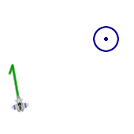You want to adjust your velocity (in green) to point at the nearby mine. Your position is the point $(1,1)$, your velocity is vector $〈-.520, 2.954〉$, and the mine’s position is point $(10, 9)$.   
  
First thing you want to do is determine the direction you wish to face. Directions are vectors and a vector can be derived from the subtraction of two points:

$$\vec{D}=p_{mine}-p_{player}=〈10-1, 9-1〉=〈9,8〉$$

Furthermore, we can normalize this by taking the magnitude and dividing it, so it is of length 1:

$$\vec{d}={\vec{D}}/{\left|D\right|}=\frac{〈9,8〉}{\sqrt{9^{2}+8^{2}}}≈〈.747, .664〉≈ 〈\cos\left(41.63°\right), sin⁡(41.63°)〉$$

Now we want our velocity to point in this direction. First, let’s normalize it to get our angle (where in I cheat because I chose the angle first):

$$\vec{v}={\vec{V}}/{\left|V\right|}=\frac{〈-.520, 2.954〉}{3}=〈\cos\left(100°\right), sin⁡(100°)〉$$

Now we want our new vector to be the same as the direction to the mine. This can be stated as: $$\vec{V}+\vec{A}=n∙\vec{d}, \vec{A}= 〈A_{x},A_{y}〉$$

where $n$ is the new magnitude of our velocity, and can be anything. Letting $n=3$:

$$3〈\cos\left(100°\right),\sin\left(100°\right)〉+〈A_{x},A_{y}〉=3〈\cos\left(41.63°\right),\sin\left(41.63°\right)〉 \\ →A_{x}=3\cos\left(100°\right)-3\cos\left(41.63°\right)=2.76194 \\ →A_{y}=3\sin\left(100°\right)-3\sin\left(41.63°\right)=-.962423$$

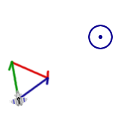So that our desired acceleration is: $$\vec{A}= 〈A_{x},A_{y}〉=〈2.76194,-.962423〉≈2.923*〈\cos\left(-19.211°\right),\sin\left(-19.211°\right)〉$$

This is seen in the new picture to the right; our current velocity in green, the velocity we want to go in blue, and the acceleration in red.

However, as you may have noticed, the acceleration has a magnitude of 2.923 (by design). So in this game, you cannot do this one time step. We will leave it to you to figure out where to go from here, but all the basic mathematics you will need is above.

Base Invaders – UI Contest

UIs are about giving out information in an easily digestible manner that is both aesthetically pleasing and serves a purpose, like a massive hot pink banner that grabs your attention!

With that in mind, part of this competition will be about feeding up SOMETHING to a user in a potentially interactive manner. That something could be an overhead view of the current state of the game.

You could improve upon the UI for the standalone mode:  
  
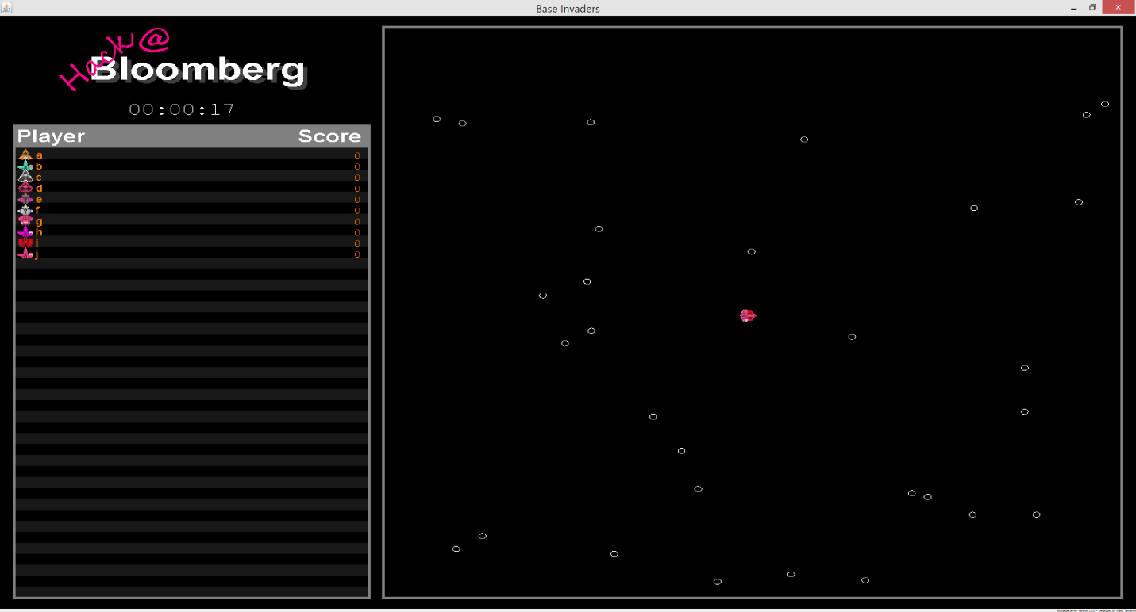  
Maybe you’re a fan of the web version: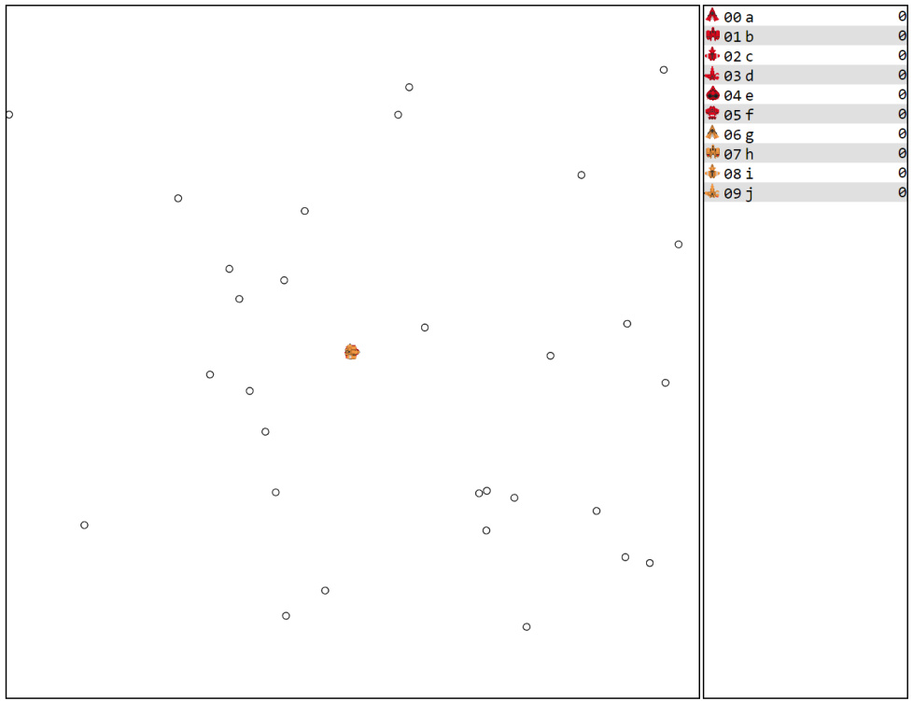

Remember, the prizes for this UI portion are identical to those for the algorithmic portion. Don’t be afraid to get creative and think of something completely new…  
  
  
  
  
  
  
  
  
Instead of a birds-eye view of the game, you might want to make your ship interactive and playable like an old-school classic Descent game.

**BUT WAIT! THERE IS SO MUCH MORE!!!**

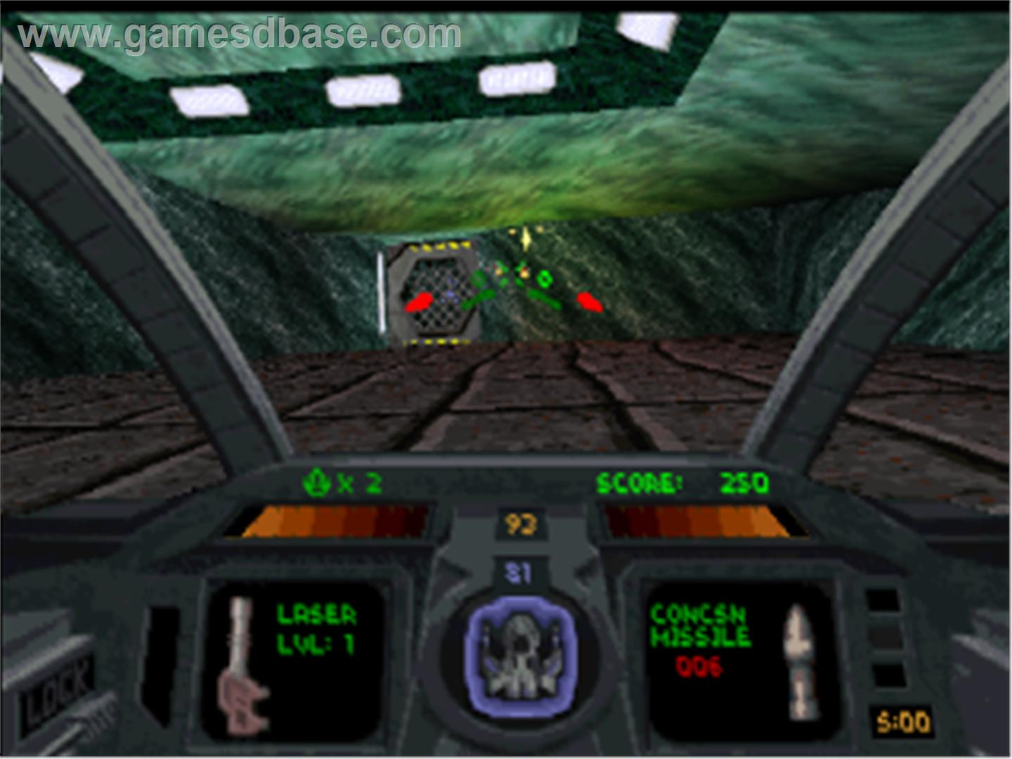

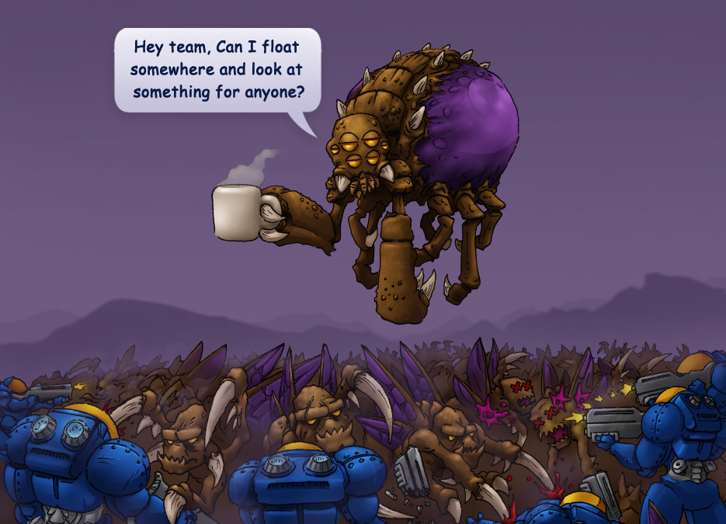Maybe you’re more a fan of exploring the map so that the rest of your imaginary ships will know where all the mines are, just like an overlord in StarCraft. You could click all around a game board to reveal what is actually there while doing almost nothing!

What it is and what it becomes is up to you. This is a choose-your-own-adventure book where you get to be the narrator and the protagonist.