

TABLE OF CONTENTS

1. Review the data from earlier days. 2

1.1 Review the MQC data from earlier days. 2

1.2. Review the PQC data from earlier days. 3

1.3. Review the all Product Codes data from earlier days. 3

2. Functions on the Model Data dashboard. 4

3. See product code information on just one line. 6

3.1. See product code information on just one line in MQC. 6

3.2. See product code information on just one line in PQC. 7

4. Change the software's automatic update schedule. 8

software instruction manual for diagramming MES data

# 1. Review the data from earlier days.

## 1.1 Review the MQC data from earlier days.

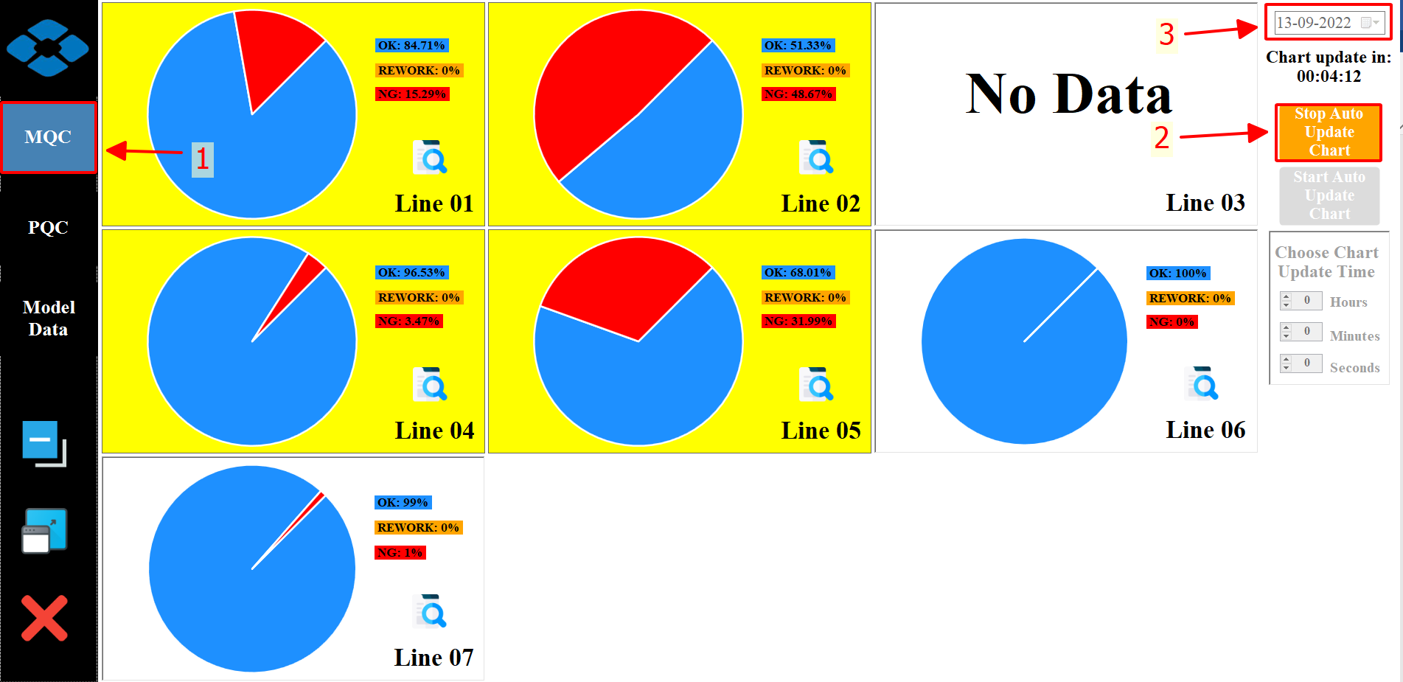

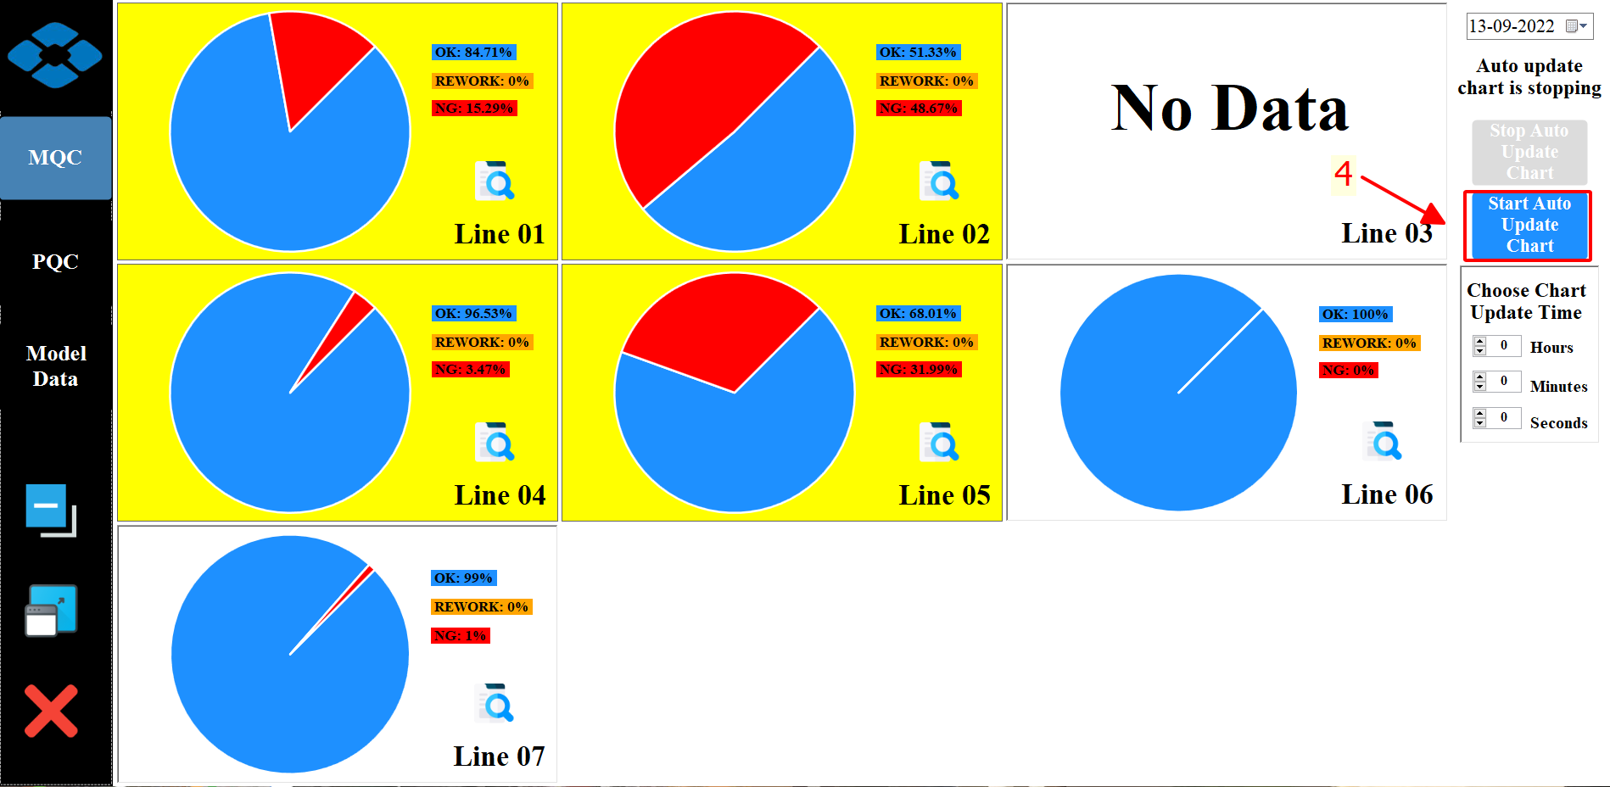

**Step 1:** The control bar's MQC button should be clicked to view the MQC 7-line data for today.

**Step 2**: Stop updating software diagrams automatically.

**Step 3**: Choose the day on which you want to examine the MQC data and wait for the software to load.

**Step 4**: Complete the MQC data review.

## 1.2. Review the PQC data from earlier days.

**Step 1:** The control bar's PQC button should be clicked to view the PQC 7-line data for today.

**Step 2, Step 3, Step 4:** Steps are same as **Review the MQC data from earlier days.**

## 1.3. Review the all Product Codes data from earlier days.

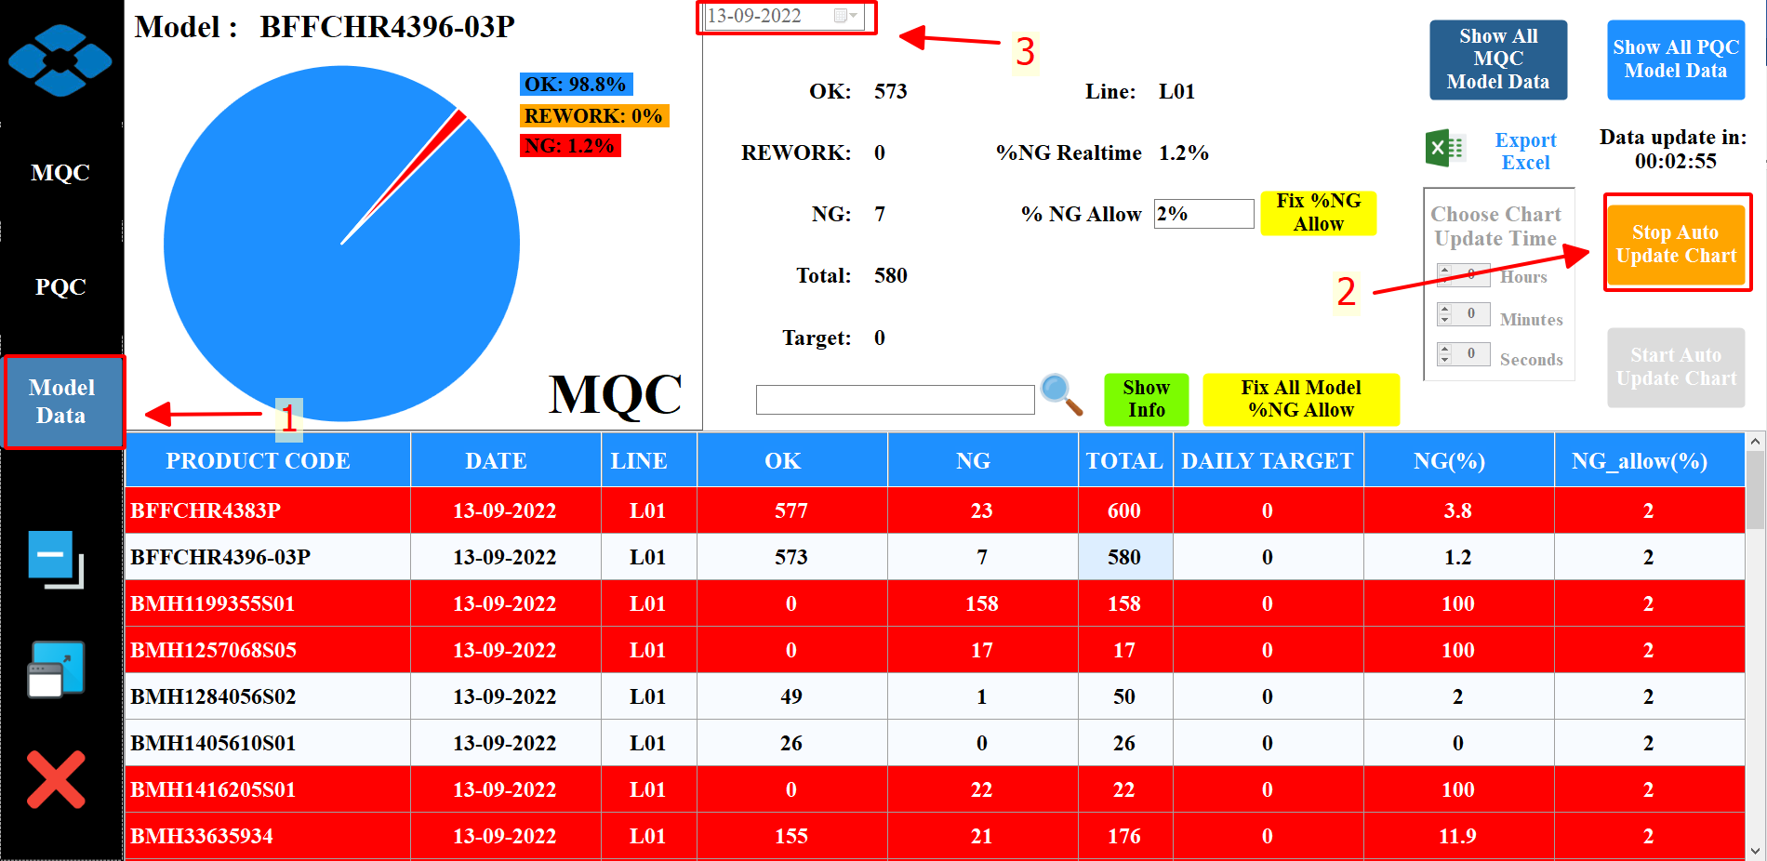

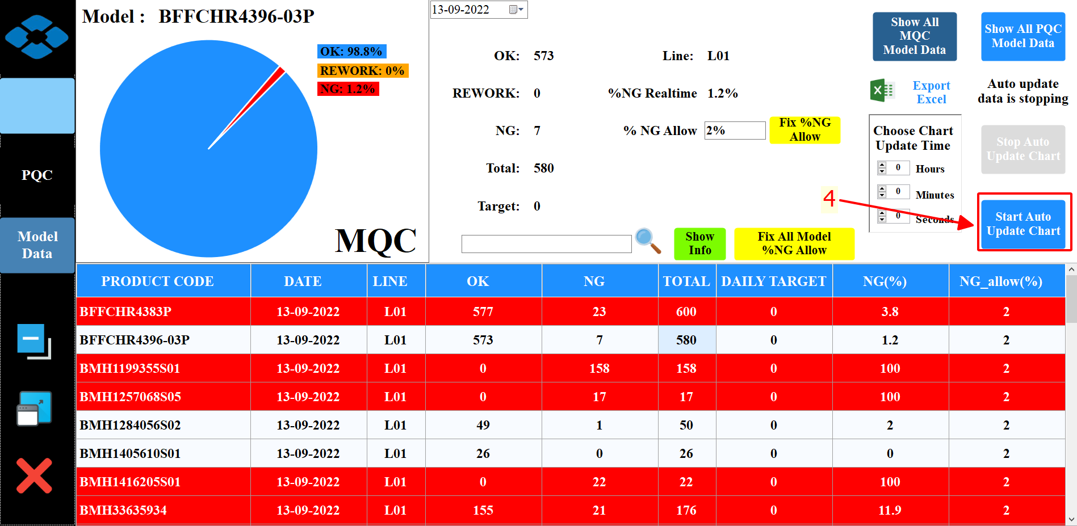

**Step 1:** The control bar's Model Data button should be clicked to view information for all Product Codes on seven lines.

**Step 2**: Stop updating software diagrams automatically.

**Step 3**: Choose the day on which you want to examine the MQC data and wait for the software to load.

**Step 4**: Complete the Product Code data review.

# 2. Functions on the Model Data dashboard.

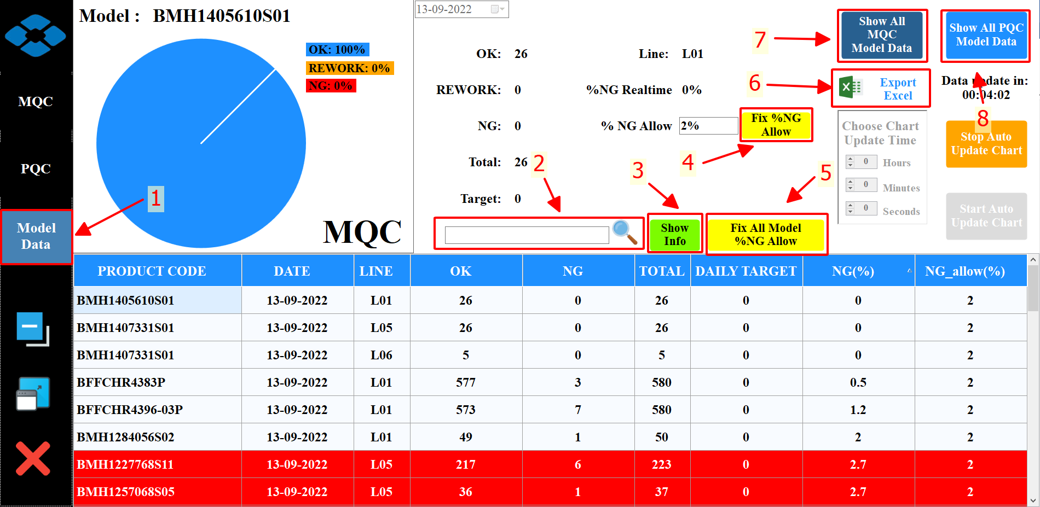

**1:** The control bar's Model Data button should be clicked to view information for all Product Codes on seven lines.

**2:** Search Product Code here.

**3:** View thorough details for 1 product code.

Example: After pressing the show info button for product code BFFCHR4383P of MQC.

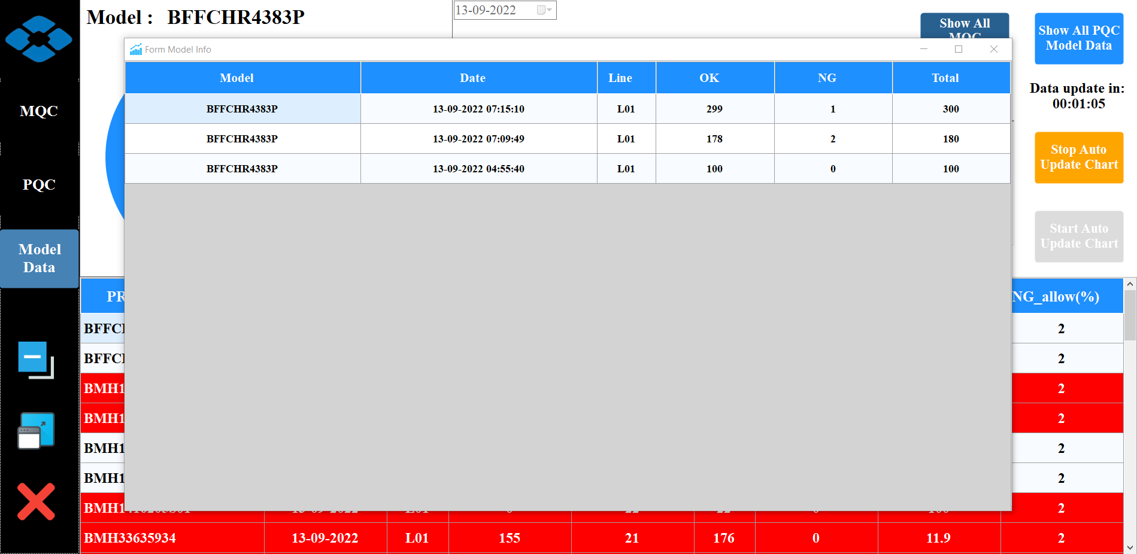

**4, 5:** Fix NG rate allow

**6:** Export an Excel document with the current day's MQC and PQC data.

**7:** Show all MQC Product Code data.

**8:** Show all PQC Product Code data.

# 3. See product code information on just one line.

## 3.1. See product code information on just one line in MQC.

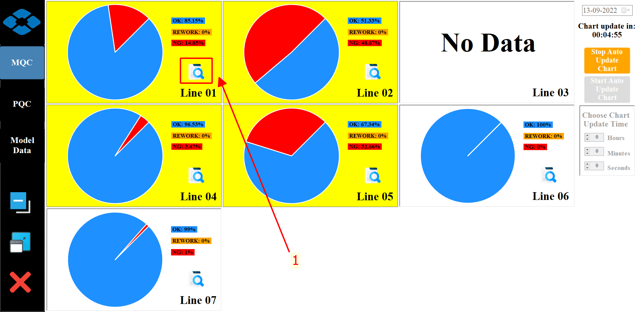

**Step 1:** Press this button.

Example: The program only shows details about all Product Codes of MQC on Line 1 after pressing the button.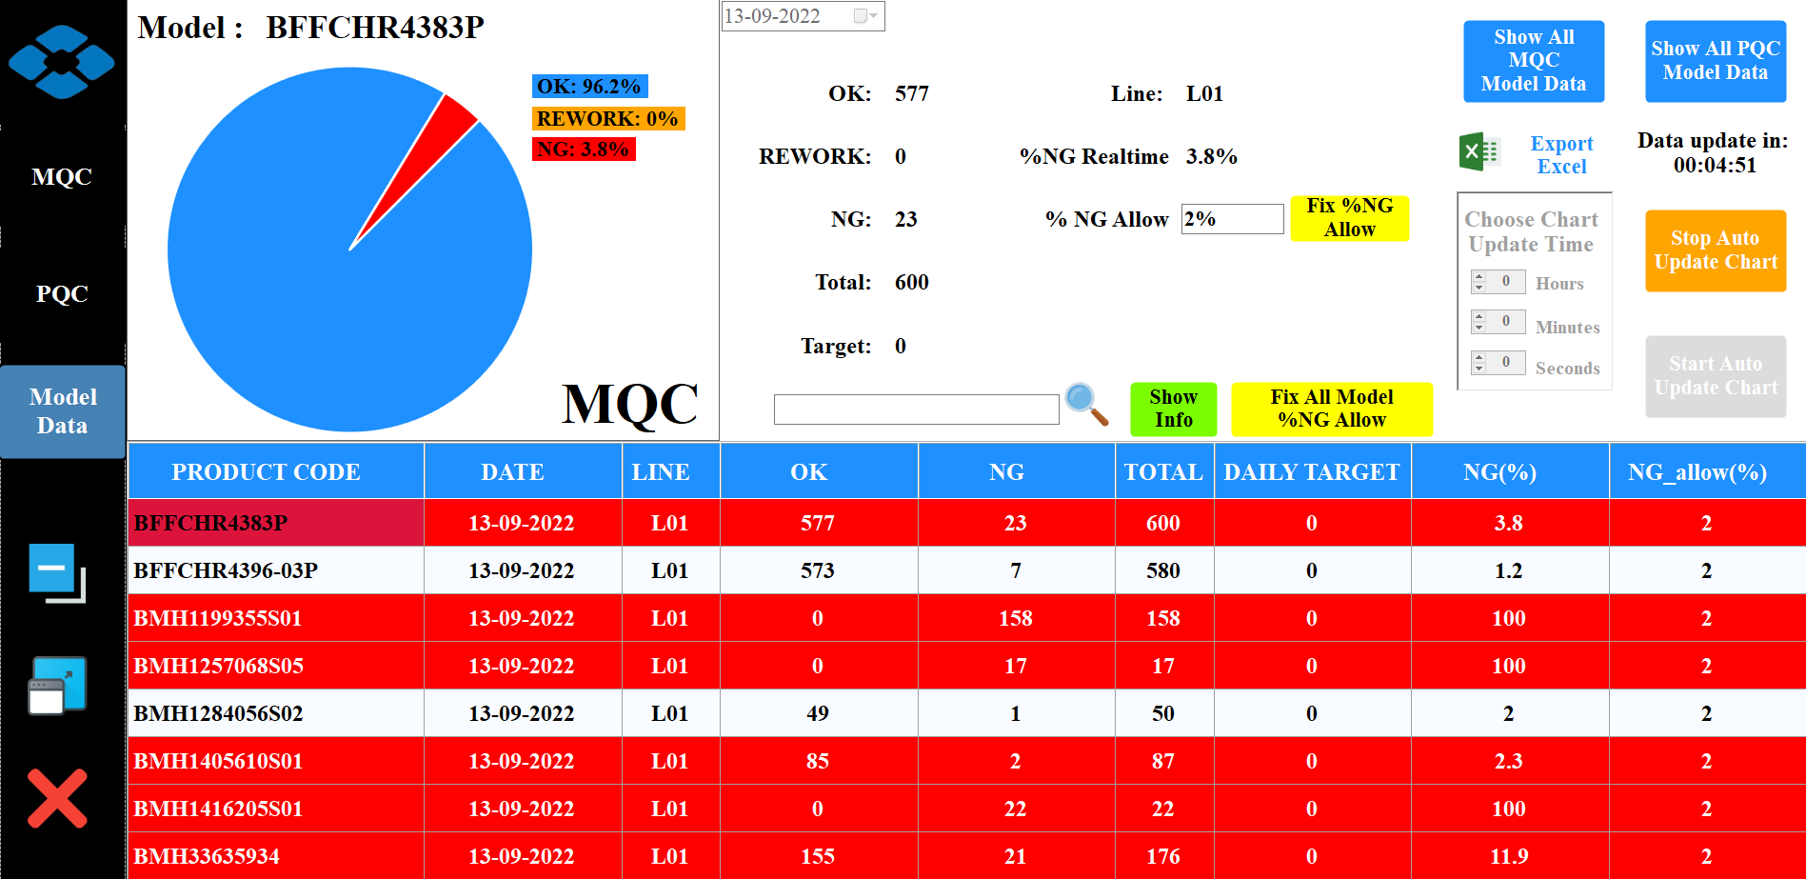

## 3.2. See product code information on just one line in PQC.

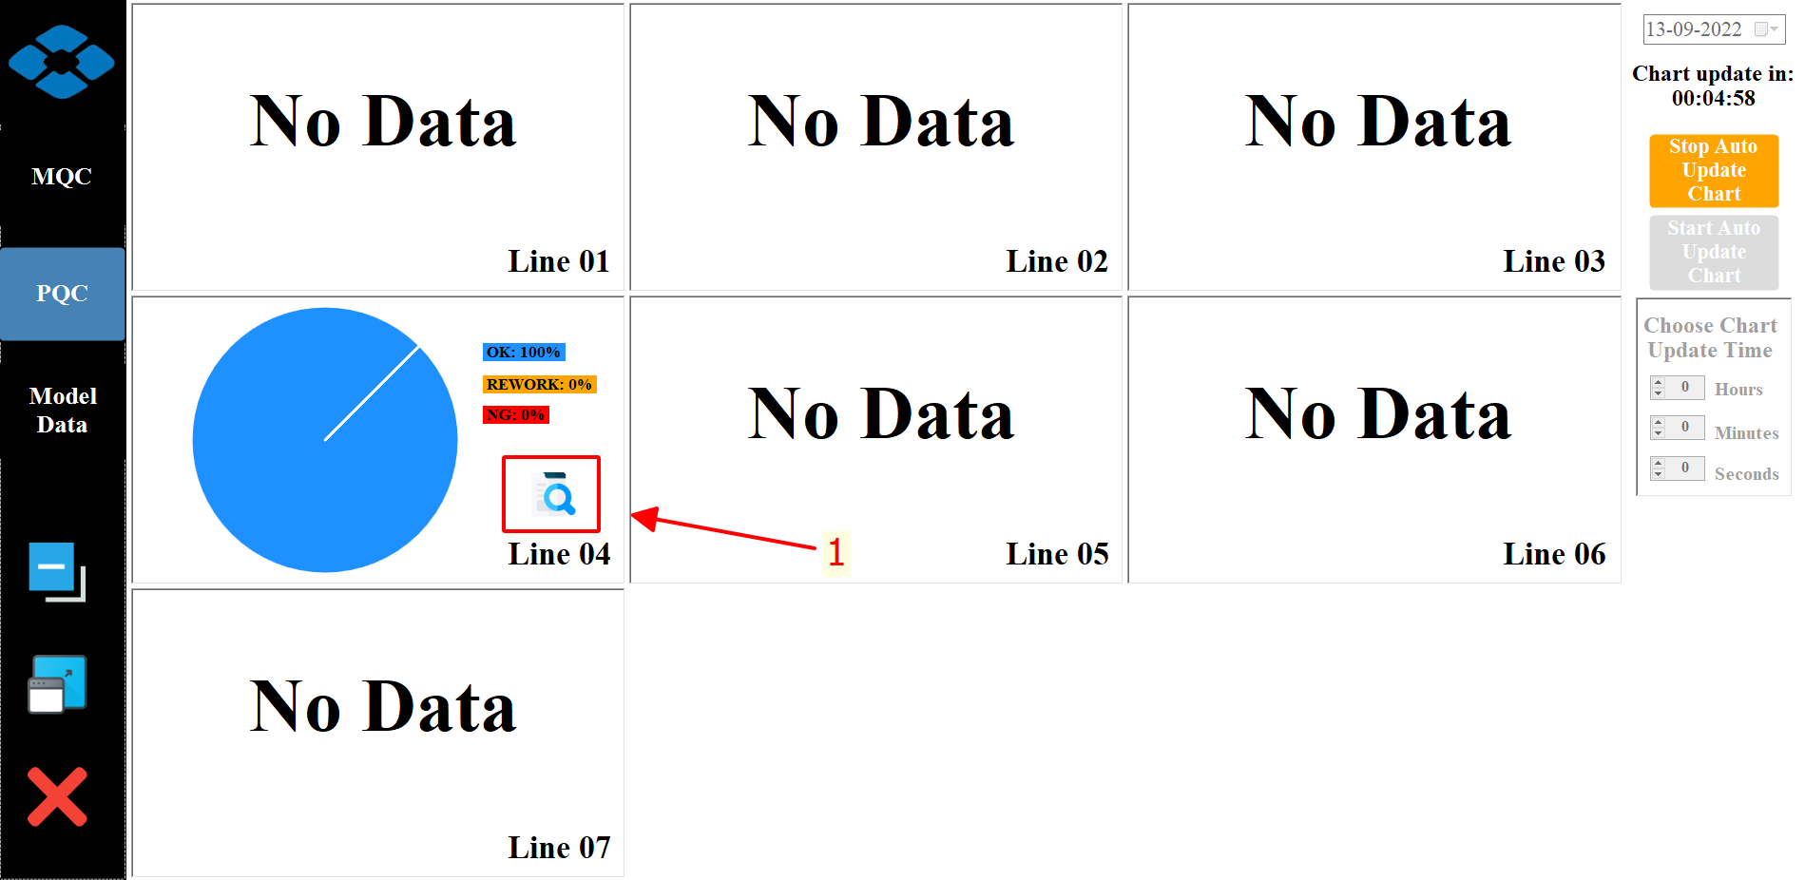

**Step 1:** Press this button.

Example: The program only shows details about all Product Codes of PQC on Line 4 after pressing the button.

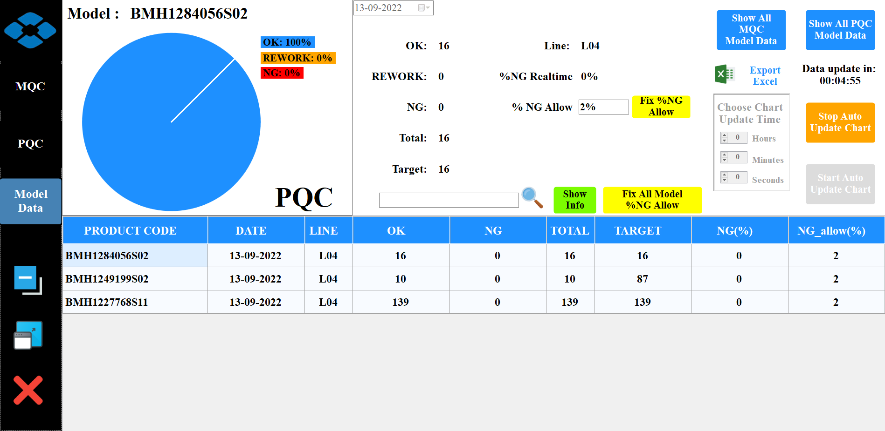

# 4. Change the software's automatic update schedule.

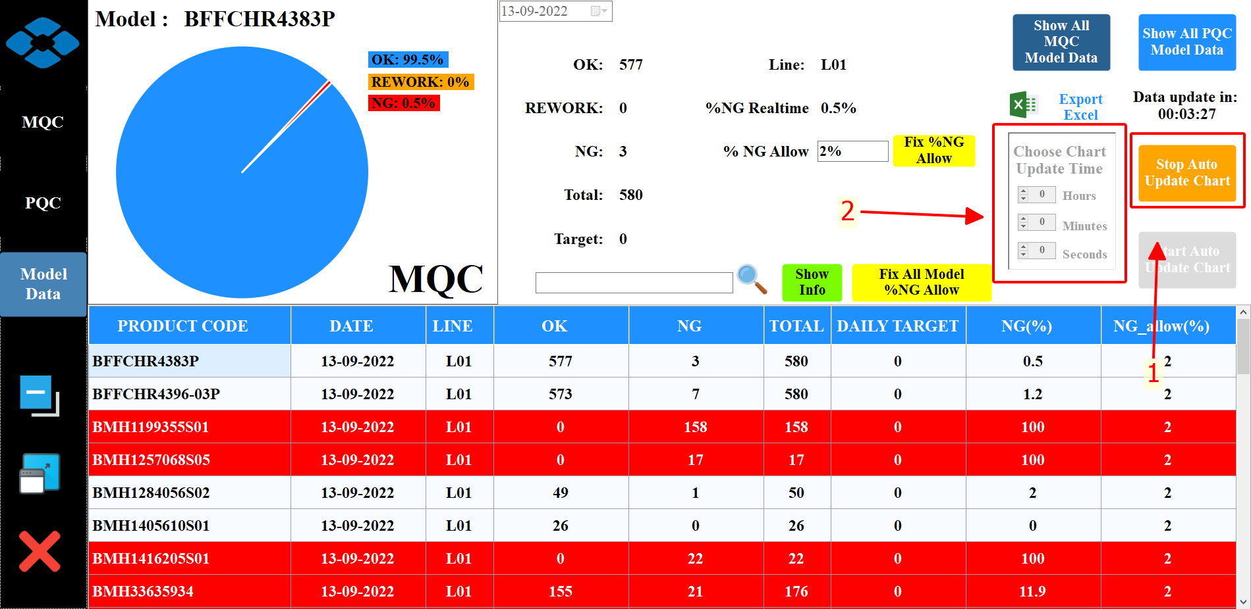

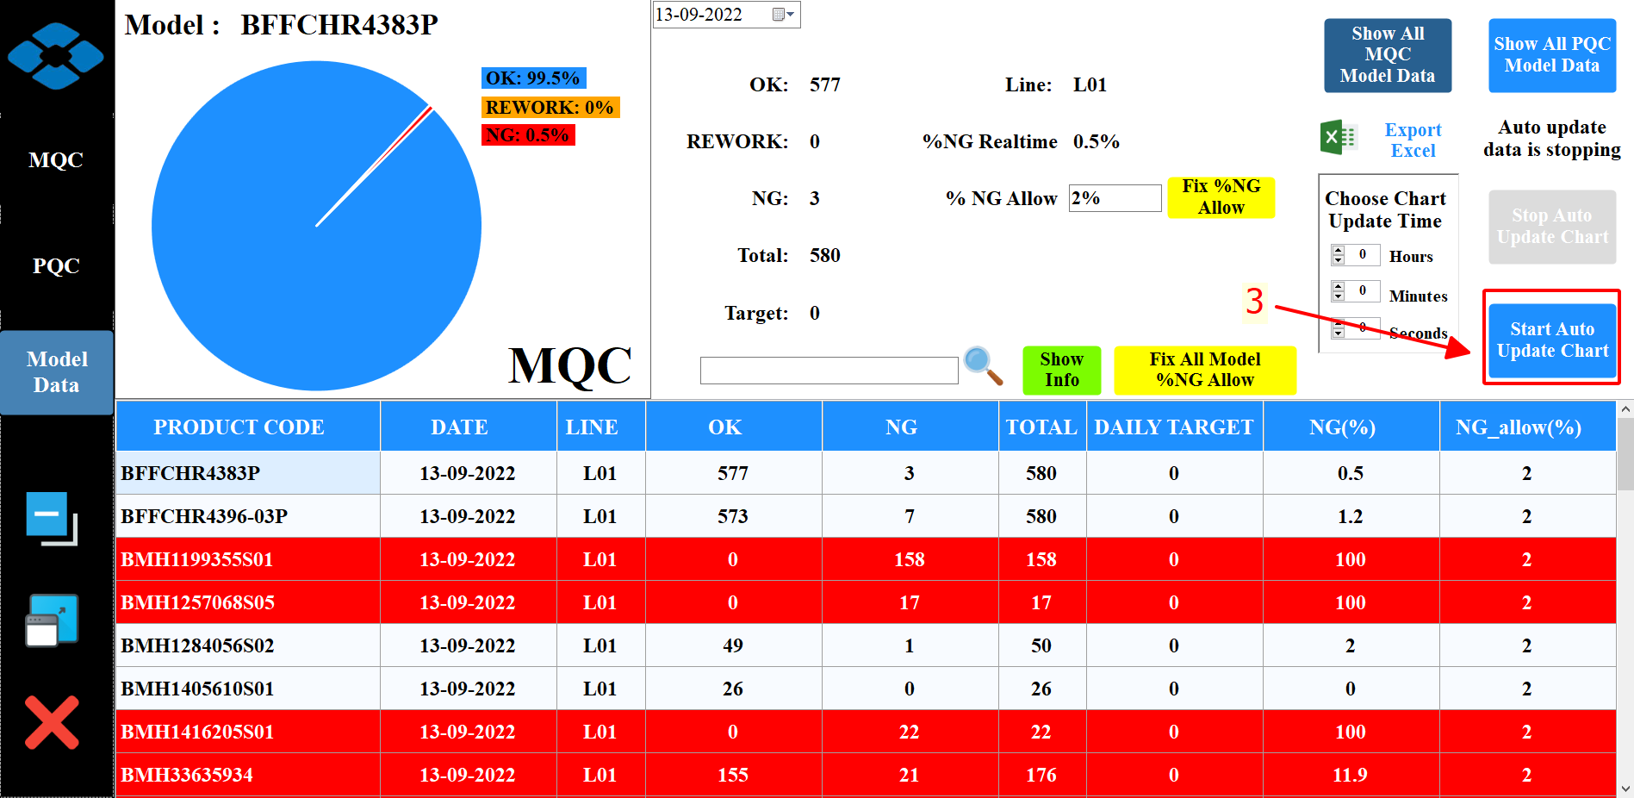

**Step 1:** Stop updating software diagrams automatically.

**Step 2**: Choose update time.

**Step 3**: Complete change the software's automatic update schedule.