**PRACTICAL WORK n°1: HAZARD MODELLING**

**Context:**

* CAT models have three main modules : hazard, vulnerability and financial. Here, we will focus only on the Hazard module.
* The insurance company studied here has a high exposure in Mexico. The characteristics of the insurance portoflio company are dummy data.
* The cyclonic activity in the North Atlantic and East Pacific basins may be very intense.
* IBTrACS is a free database gathering data on tropical systems in the whole world.

In this practical work, we want to have a better knowledge of the hurricane risk in Mexico by analysing the IBTrACS database and using a parametric model.

**« IBTrACS » database:**

IBTrACS (International Best Track Archive for Climate Stewardship) is a database containing main characteristics of tropical systems in the whole world since 1850. IBTrACS gathers information provided by several meteorological agencies specialized in the monitoring of tropical systems (NHC for the Atlantic basin for example). You can find some useful informaton on the NOAA website: <https://www.ncdc.noaa.gov/ibtracs/>

***1. GETTING FAMILIAR WITH THE IBTRACS DATABASE***

We use in this exercise the version « hotel1 » of the IBTrACS database contained in the following CSV file : « 1-TP_HAZARD/INPUTS/ibtracs.ALL.list.hotel1.csv ».

* 1. **– Load the IBTRACS database in a data.frame using the read.csv2 command.**
  2. **– How many rows and columns are there in the database ?** You can use *nrow* and *ncol* fonctions.

You can find the description of each physical parameter of the database in the following PDF file : « 1-TP_HAZARD/INPUTS/ IBTrACS_v04_column_documentation.pdf ».

* 1. **– What are the physcial parameters available in the IBTRACS database ?** The *summary* fonction can be used.
  2. **– When does the oldest tropical system contained in the database occur ?**

The column « NATURE » give information on the type of the tropical system : DS, TS, ET, SS, NR, MR mean respectively « Disturbance », « Tropical », « Extratropical », « Subtropical », « Not reported » et « Mixture ».

**1.5 – Which type of tropical system is predominant in IBTrACS ?** You can use the *table* function.

***2. ANALYSIS OF TROPICAL SYSTEMS PER BASIN***

**2.1 – How many systems occur each year in average at the global scale ?** The « SID » variable is unique qnd it is an identifier of each system of the database.

**2.2 – How many systems occur each year in average in each basin?**

Note : Some systemw can change of basins during their lifetime. Then, if you want to answer accurately to this question you need to take in consideration all the systems (even those coming from an other basin). You could create a new variable concatenating SID and BASIN variables.

**2.3 – Show on a graphic the annuel evolution of tropical systems (« TS ») numbers by basin using the geom_bar function of ggplot2 library.**

You should find a graphic very similar to the one below:

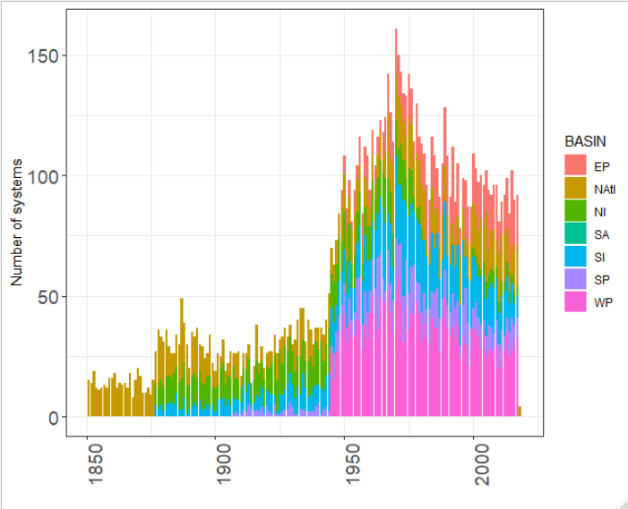

**2.4 – Which comments do you have seeing this graphic ? What is the main reason explaining the strong increase of systems during 1950s-1960s ?**

**For the following parts, we will use only tropical systems formed after 1980.**

To select only these systems, you can use the *filter* function of the *dplyr* library and the « % » operator of the *magrittr* library :

* ***df_filter = df %>% dplyr ::filter(SEASON > 1979 & NATURE == « TS »)*** where df is the dataframe containing all data from IBTrACS database and df_filter is the filtered dataframe.

***3 – TROPICAL SYSTEMS IN MEXICO :***

**3.1 – According to you, from which basins do the hurricanes impacting Mexico come ?**

**3.2 – For the following parts, filter the database on these 2 specific basins.**

**3.3 – From which basin comes the greatest number of tropical systems that have impacted Mexico?**

***3.4 – Which is the minimal pressure (in hPa) measured since 1980? Which is the maximal wind speed (in km/h) measured since 1980?***

Note: You need to analyze USA_WIND and USA_PRES columns because the US agency is in charge to monitor hurricanes in the 2 basins related to Mexico.

***3.5 – Which season was the busiest?***

**4 – FOOTPRINTS OF HISTORICAL HURRICANES :**

You need to load the dataframe available here: « OUTPUTS/df_select_mex.Rdata ». This database contains all tropical systems which had a potential impact on Mexico since 1980.

For loading a dataframe in R, you need to use the *load* function. For example, here, you can use the following command:

* *load(‘’OUTPUTS/df_select_mex.Rdata’’).*

**4.1 – Filter the IBTRACS database for keeping only systems available in the « df_select_mex.Rdata » dataframe.**You could use the « SID » variable.

**4.2 – Then, show on a map all tracks of tropical systems selected. You could use « geom_path » of the ggplot2 library.**

Then, we will focus on 3 hurricanes which had some impacts in Mexico : **Wilma in 2005** (SID = "2005289N18282"), **Odile in 2014** (SID = "2014253N13260") and **Patricia in 2015** ("2015293N13266").

**4.3 – Could you show the tracks on these 3 specific hurricanes ?**

Then, you can read the raster files of these 3 hurricanes. They are stored in the following folder: « OUTPUTS/HISTORICAL_FOOTPRINTS/tiff/ ».

**4.4 – Plot the spatial footprints of these hurricanes on a map.**

**4.5 – Based on the tracks and intensities of these hurricanes, which one do you think cause the highest insurance losses ? Why ?**

*Below, you can find as an example what you should get for hurricane Wilma :*

