Opdracht 1

* 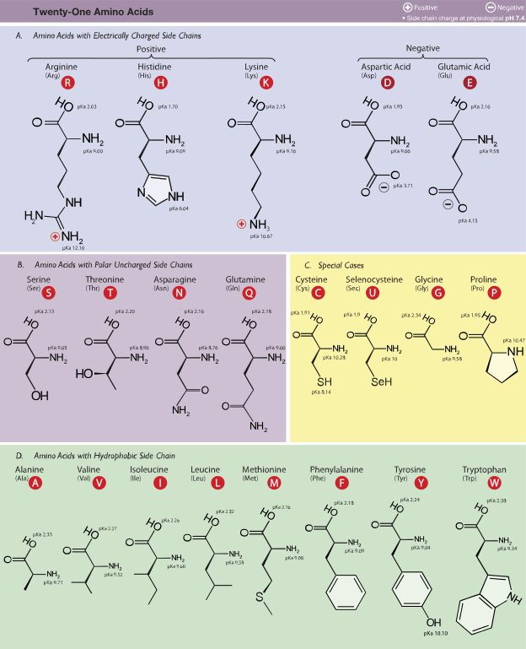

Figuur copy van wikipedia.org amino acids (https://en.wikipedia.org/wiki/Amino\_acid#/media/File:Amino\_Acids.svg)

| **Amino acid** | **3-letter**[[136]](https://en.wikipedia.org/wiki/Amino_acid#cite_note-Hausman-136) | **1-letter**[[136]](https://en.wikipedia.org/wiki/Amino_acid#cite_note-Hausman-136) | **Side chain**  **class** | **Side chain**  **polarity**[[136]](https://en.wikipedia.org/wiki/Amino_acid" \l "cite_note-Hausman-136) | **Side chain**  **charge (pH 7.4)**[[136]](https://en.wikipedia.org/wiki/Amino_acid#cite_note-Hausman-136) | [**Hydropathy index**](https://en.wikipedia.org/wiki/Hydropathy_index)[[137]](https://en.wikipedia.org/wiki/Amino_acid#cite_note-137) | [**Absorbance**](https://en.wikipedia.org/wiki/Absorbance)  **λmax(nm)**[[138]](https://en.wikipedia.org/wiki/Amino_acid#cite_note-Freifelder-138) | [**ε**](https://en.wikipedia.org/wiki/Molar_absorptivity)**at**  **λmax(mM−1cm−1)**[[138]](https://en.wikipedia.org/wiki/Amino_acid#cite_note-Freifelder-138) | [**MW**](https://en.wikipedia.org/wiki/Molecular_mass)  **(weight)** | **Occurrence**  **in proteins (%)**[[139]](https://en.wikipedia.org/wiki/Amino_acid#cite_note-139) | **Coding in the Standard Genetic Code** |
| --- | --- | --- | --- | --- | --- | --- | --- | --- | --- | --- | --- |
| [Alanine](https://en.wikipedia.org/wiki/Alanine) | Ala | A | aliphatic | nonpolar | neutral | 1.8 |  |  | 89.094 | 8.76 | GCN |
| [Arginine](https://en.wikipedia.org/wiki/Arginine) | Arg | R | basic | basic polar | positive | −4.5 |  |  | 174.203 | 5.78 | MGN, CGY |
| [Asparagine](https://en.wikipedia.org/wiki/Asparagine) | Asn | N | amide | polar | neutral | −3.5 |  |  | 132.119 | 3.93 | AAY |
| [Aspartic acid](https://en.wikipedia.org/wiki/Aspartic_acid) | Asp | D | acid | acidic polar | negative | −3.5 |  |  | 133.104 | 5.49 | GAY |
| [Cysteine](https://en.wikipedia.org/wiki/Cysteine) | Cys | C | sulfur-containing | nonpolar | neutral | 2.5 | 250 | 0.3 | 121.154 | 1.38 | UGY |
| [Glutamic acid](https://en.wikipedia.org/wiki/Glutamic_acid) | Glu | E | acid | acidic polar | negative | −3.5 |  |  | 147.131 | 6.32 | GAR |
| [Glutamine](https://en.wikipedia.org/wiki/Glutamine) | Gln | Q | amide | polar | neutral | −3.5 |  |  | 146.146 | 3.9 | CAR |
| [Glycine](https://en.wikipedia.org/wiki/Glycine) | Gly | G | aliphatic | nonpolar | neutral | −0.4 |  |  | 75.067 | 7.03 | GGN |
| [Histidine](https://en.wikipedia.org/wiki/Histidine) | His | H | basic aromatic | basic polar | positive(10%) neutral(90%) | −3.2 | 211 | 5.9 | 155.156 | 2.26 | CAY |
| [Isoleucine](https://en.wikipedia.org/wiki/Isoleucine) | Ile | I | aliphatic | nonpolar | neutral | 4.5 |  |  | 131.175 | 5.49 | AUH |
| [Leucine](https://en.wikipedia.org/wiki/Leucine) | Leu | L | aliphatic | nonpolar | neutral | 3.8 |  |  | 131.175 | 9.68 | YUR, CUY |
| [Lysine](https://en.wikipedia.org/wiki/Lysine) | Lys | K | basic | basic polar | positive | −3.9 |  |  | 146.189 | 5.19 | AAR |
| [Methionine](https://en.wikipedia.org/wiki/Methionine) | Met | M | sulfur-containing | nonpolar | neutral | 1.9 |  |  | 149.208 | 2.32 | AUG |
| [Phenylalanine](https://en.wikipedia.org/wiki/Phenylalanine) | Phe | F | aromatic | nonpolar | neutral | 2.8 | 257, 206, 188 | 0.2, 9.3, 60.0 | 165.192 | 3.87 | UUY |
| [Proline](https://en.wikipedia.org/wiki/Proline) | Pro | P | cyclic | nonpolar | neutral | −1.6 |  |  | 115.132 | 5.02 | CCN |
| [Serine](https://en.wikipedia.org/wiki/Serine) | Ser | S | hydroxyl-containing | polar | neutral | −0.8 |  |  | 105.093 | 7.14 | UCN, AGY |
| [Threonine](https://en.wikipedia.org/wiki/Threonine) | Thr | T | hydroxyl-containing | polar | neutral | −0.7 |  |  | 119.119 | 5.53 | ACN |
| [Tryptophan](https://en.wikipedia.org/wiki/Tryptophan) | Trp | W | aromatic | nonpolar | neutral | −0.9 | 280, 219 | 5.6, 47.0 | 204.228 | 1.25 | UGG |
| [Tyrosine](https://en.wikipedia.org/wiki/Tyrosine) | Tyr | Y | aromatic | polar | neutral | −1.3 | 274, 222, 193 | 1.4, 8.0, 48.0 | 181.191 | 2.91 | UAY |
| [Valine](https://en.wikipedia.org/wiki/Valine) | Val | V | aliphatic | nonpolar | neutral | 4.2 |  |  | 117.148 | 6.73 | GUN |

* Ze zijn beide belangrijk voor het bouwen van het eiwit structuur
* Hydrofobe aminozuren gaan meer naar het midden van het eiwit toe, de hydrofiele aminozuren gaan meer naar de buitenkant toe. Dit komt door de water rijke omgeving

Opdracht 2

* Gp zijn transmembraam, ivg zijn intracellulair
* In afbeelding boven
* Ja, lijkt mij wel handig. Bijv. melatonine
* Script