Would you please survey these suppliers and choose the best one for us?

Yes

Should I choose a supplier only according to their price? Can I check their environmental performance?

TSMC **$50**

FAB A **$60**

FAB C **$40**

Let’s check **Green Guide** for these 3 suppliers.

**Green Guide…**



**TSMC** has the best Environmental Performance!

**Search Results**

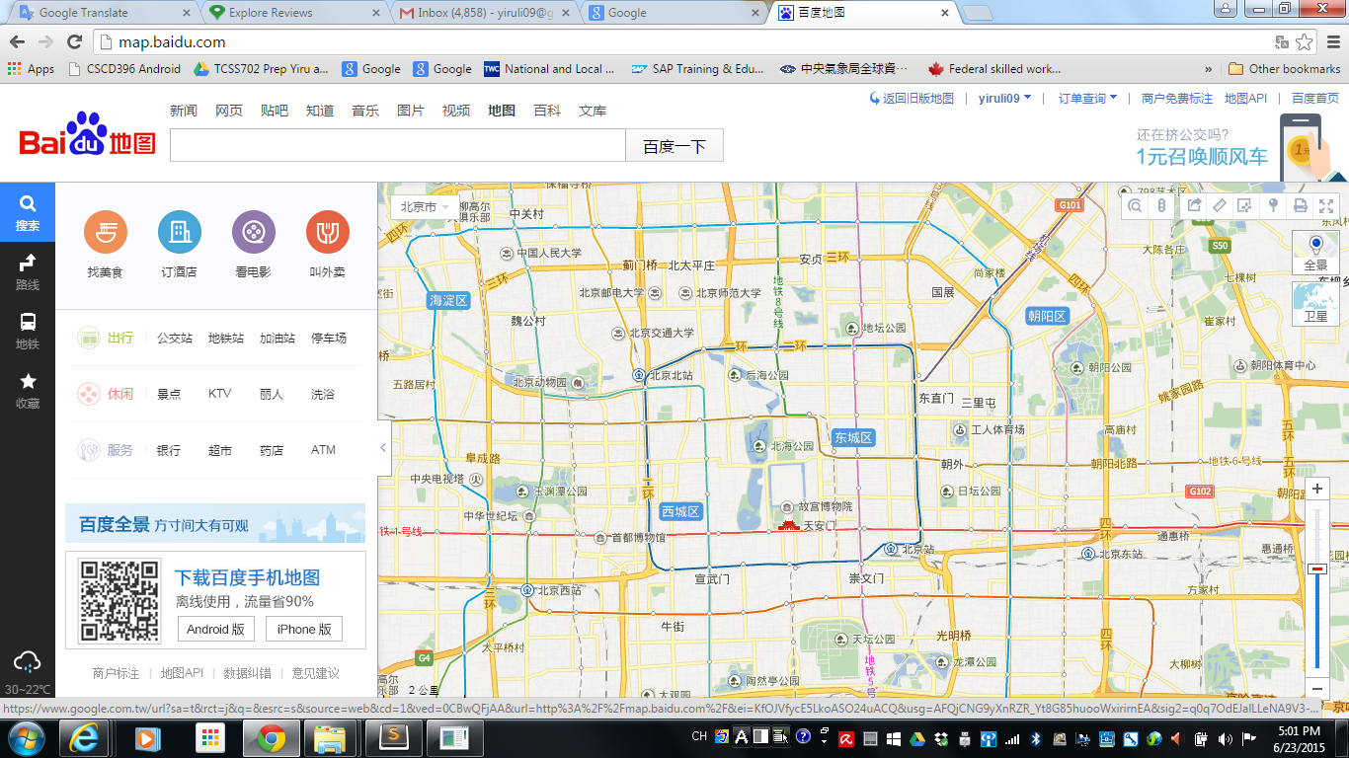

**TSMC**

**+3.0**

**FAB C**

**-3.0**





**FAB A**

**-2.0**

**Green Guide**





**TSMC** has great environmental management & excellent product quality. We love to buy products from this green supplier.

**Green Guide** helps us **compare** companies’ **environmental performance** so **easily** in **low costs**.

***FAB A FAB C***