┌─[root@osboxes]─[/home/osboxes]

└──╼ #whoami

root

┌─[root@osboxes]─[/home/osboxes]

└──╼ #hostname

osboxes

┌─[root@osboxes]─[/home/osboxes/Desktop]

└──╼ #wc Unsaved\ Document\ 1

8 8 137 Unsaved Document 1

┌─[✗]─[root@osboxes]─[/home/osboxes/Desktop]

└──╼ #w

10:44:24 up 1:10, 1 user, load average: 0.00, 0.00, 0.00

USER TTY FROM LOGIN@ IDLE JCPU PCPU WHAT

osboxes tty7 :0 09:53 1:10m 37.44s 0.19s x-session-manag

┌─[root@osboxes]─[/home/osboxes/Desktop]

└──╼ #!6

ls

README.license 'Unsaved Document 1'

┌─[root@osboxes]─[/home/osboxes/Desktop]

└──╼ #uptime

10:48:10 up 1:14, 1 user, load average: 0.05, 0.01, 0.00

┌─[root@osboxes]─[/home/osboxes/Desktop]

└──╼ #TZ="ASIA/DUBIA" date

┌─[root@osboxes]─[/home/osboxes/Desktop]

└──╼ #cal >>date

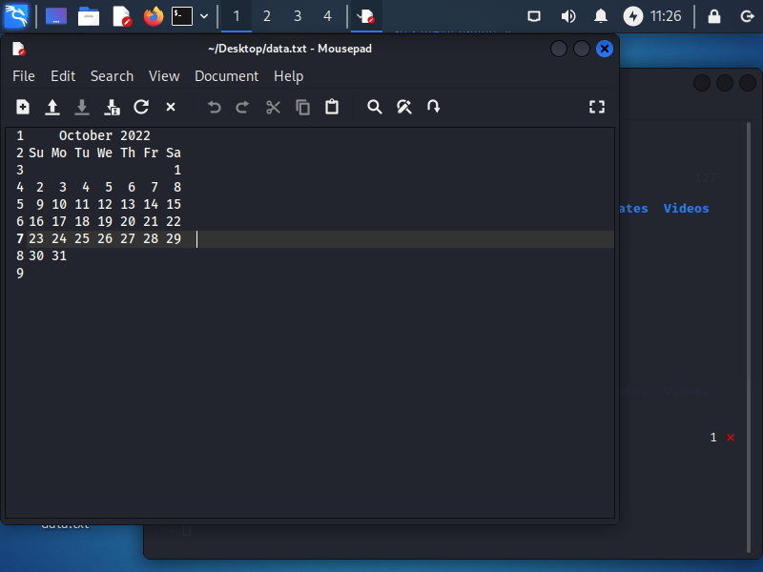

┌─[root@osboxes]─[/home/osboxes/Desktop]

└──╼ #echo "oh this is error">>log.txt

]