* Install httpd

# **yum install httpd**

# **service httpd start**

# **chkconfig httpd on**

# **service httpd configtest**

* Enable and start the apache2 server

# apt-get install apache2

# /etc/init.d/apache2 start

# /etc/init.d/apache2 status

# /etc/init.d/apache2 restart

* Create a new ECS

1. Go to the [Custom Launch](https://ecs-buy.aliyun.com/wizard/#/) tab of the instance buy page.
2. In the **Basic Configurations** step, configure parameters and click **Next**.

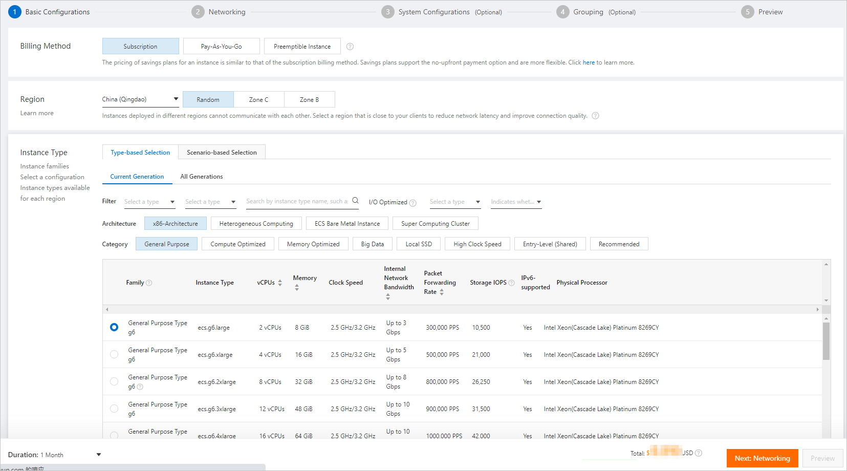

1. In the **Networking** step, configure the public IP address and bandwidth settings, as shown in the following figure. Then, click **Next**.

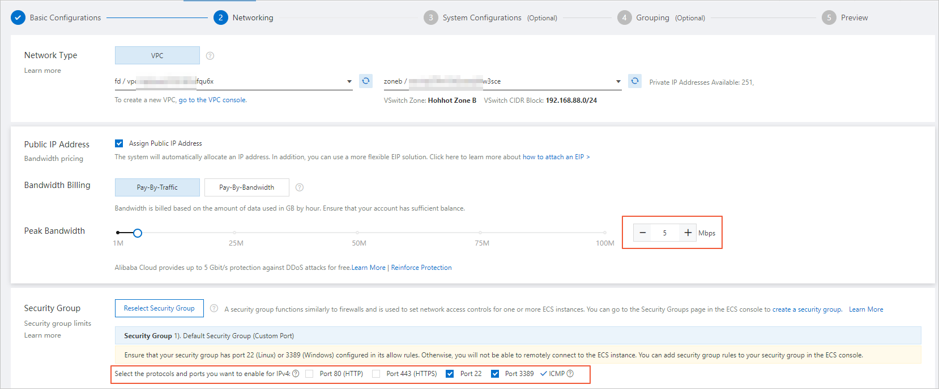

In the Public IP Address section, select Assign Public IPv4 Address and specify a public bandwidth value. For the Network Type and Security Group parameters, you can use the default settings.

| **Parameter** | **Description** |
| --- | --- |
| Network Type | A virtual private cloud (VPC) is created by default. |
| Public IP Address | Specify a public bandwidth value. The default public bandwidth value is 1 Mbit/s. |
| Security Group | A default security group is created. |

1. In the **System Configurations (Optional)** step, set the logon password of the instance and click **Preview**.

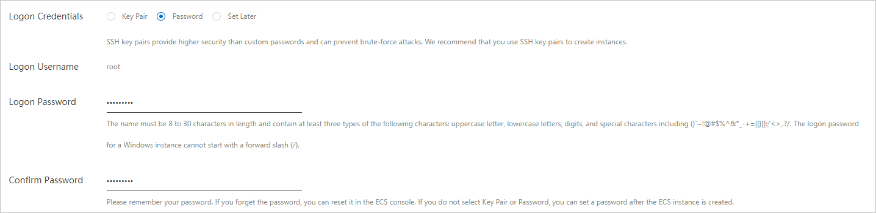

1. In the Preview step, read and select the ECS Terms of Service and Product Terms of Service. Then, click **Create Order**.
2. Confirm and pay for the order.

* Deploy HTML webpage in your ECS