Hi Todd, it´s a very simple application, but very goog to make a demonstration at customer home. The File are in EBCDIC representation, but, you can translate it to ASCII.

If you need more help, please ask me!

Step-by-step

1 – Compile COBOL program with COBOL-IT

2 – Compile BMS map

3 – Create table CLIENTE

4 – Put the tranid into PCT Tuxedo - ORA0 🡺 ORA001

5 – Put the file into FCT Tuxedo - OR02FILE – DSN (OR02FILE.VSAM.KSDS.EBCDIC)

- Key (0 2)

RECZ(27 27)

5.1 – QSAM file generated with IDCAMS REPRO

6 – Run the Tranind ORA0

7 – Type CLIENTE 001 until

TN3270

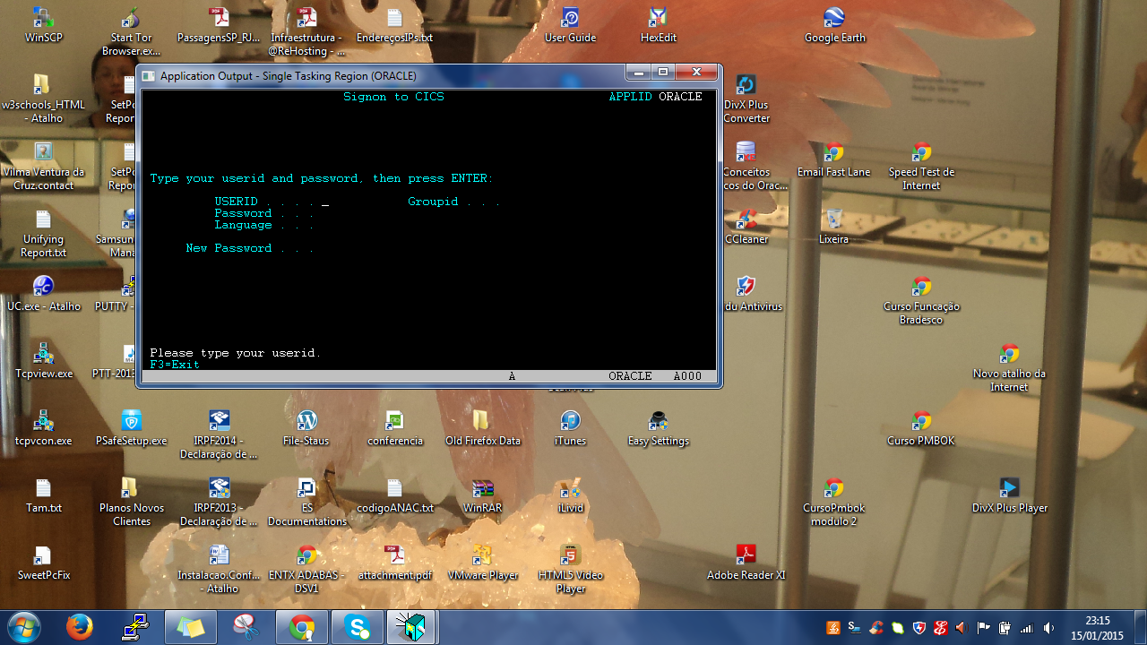

Type the TRANID =🡺 ORA0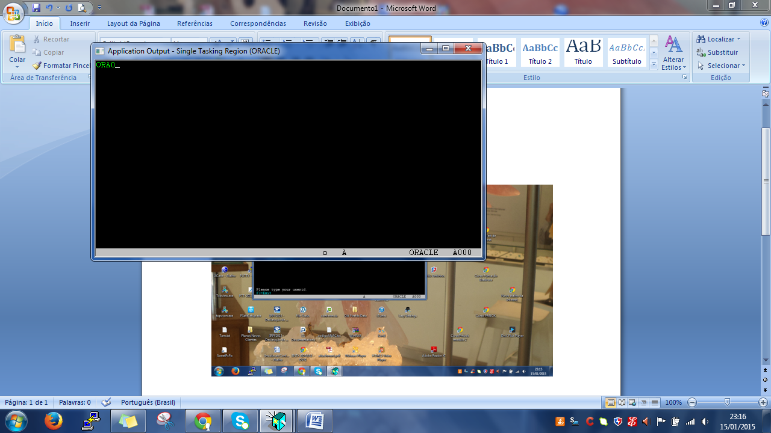

Type 001 to Client number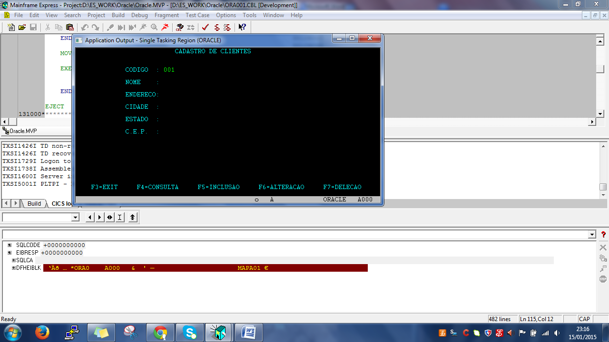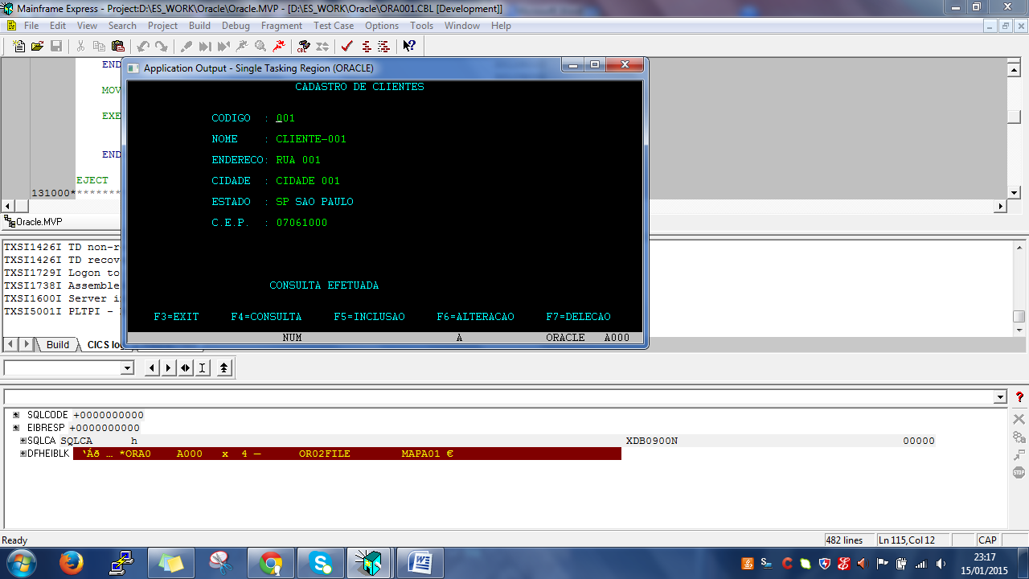

Table Display

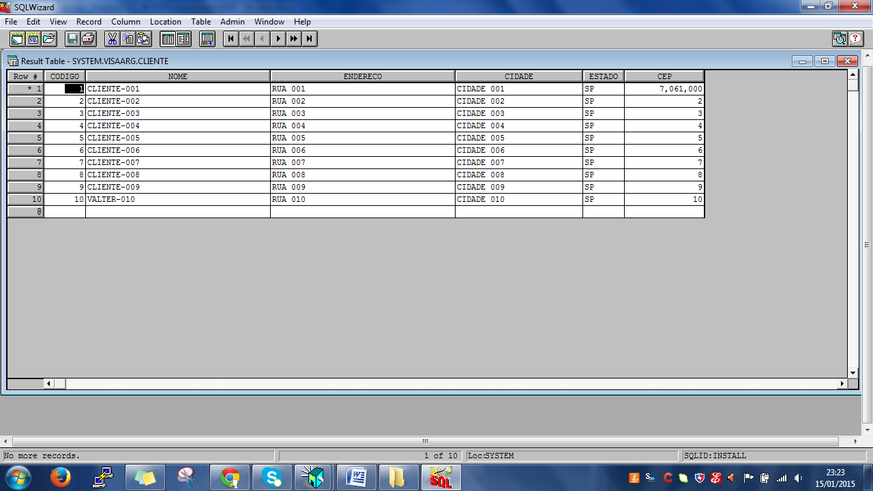

File Display

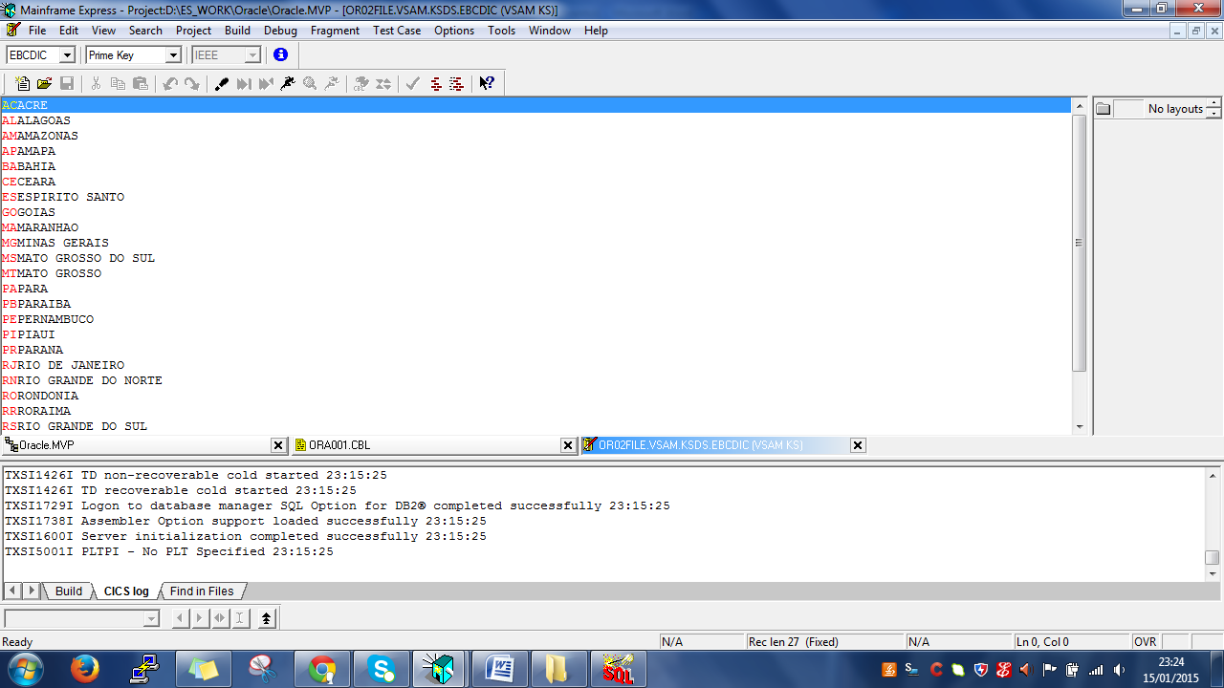

The BMS are in Portugues language, but you can translate to English.