Group Project Documentation
MICROSERVICES WITH SPRING BOOT

Airline booking system

Prepared by Group 4
Ngô Giản Tuy-HE190571
Nguyễn Văn Phú-HE190795
Trần Tiến Đạt-HE182018
Nguyễn Hữu Khải-HE180234
Nguyễn Ngọc Vinh-HE182101

Ha Noi , 2026
Table of Contents

Table of Contents ii
Revision History ii
1. Project Introduction 1
1.1 Product Perspective 1
1.2 User Classes and Characteristics 1
2. Database Design 1
3. System Architecture 1
4. Implementation 2
4.1. Deployment Considerations 2
4.2. Screenshots and explanations 2
5. References 2

Revision History
Name | Date | Reason For Changes | Version
<Van Vo> | <01 May 2025> | <Initial draft> | <1.0 draft 1>
<Van Vo> | <04 May 2025> | <Add project introduction> | <1.0 draft 1>
<Van Vo> | <01 July 2025> | <Final change for submission> | <1.0 >

Project Introduction

Product Perspective
<Provide a short description of the project being specified and its purpose. Describes the system that you will implement (this project perspective is not certain to be too detailed. It's just a paragraph so that the reader can understand the system that will be presented).>

User Classes and Characteristics
<You should mention the important issue; other detailed information can be presented in the form of Business rules.>
Customer
 | Function Name | Function Description
1 | Login (by Google authentication)
2 | Update profile
3 | Search product by name
4

Staff
 | Function Name | Function Description
1 | Login (by Google authentication)
2 | Manage Product (CRUD + Search)
3 | Manage Order
4

<Identify the various user classes that you anticipate will use this project and describe their pertinent characteristics. Some requirements might pertain only to certain user classes.>

Database Design
<A data model is a visual representation of the data objects and collections the project will process and the relationships between them. Include a data model for the business operations being addressed by the system, or a logical representation for the data that the system itself will manipulate.
Data models are most commonly created as an entity-relationship diagram.
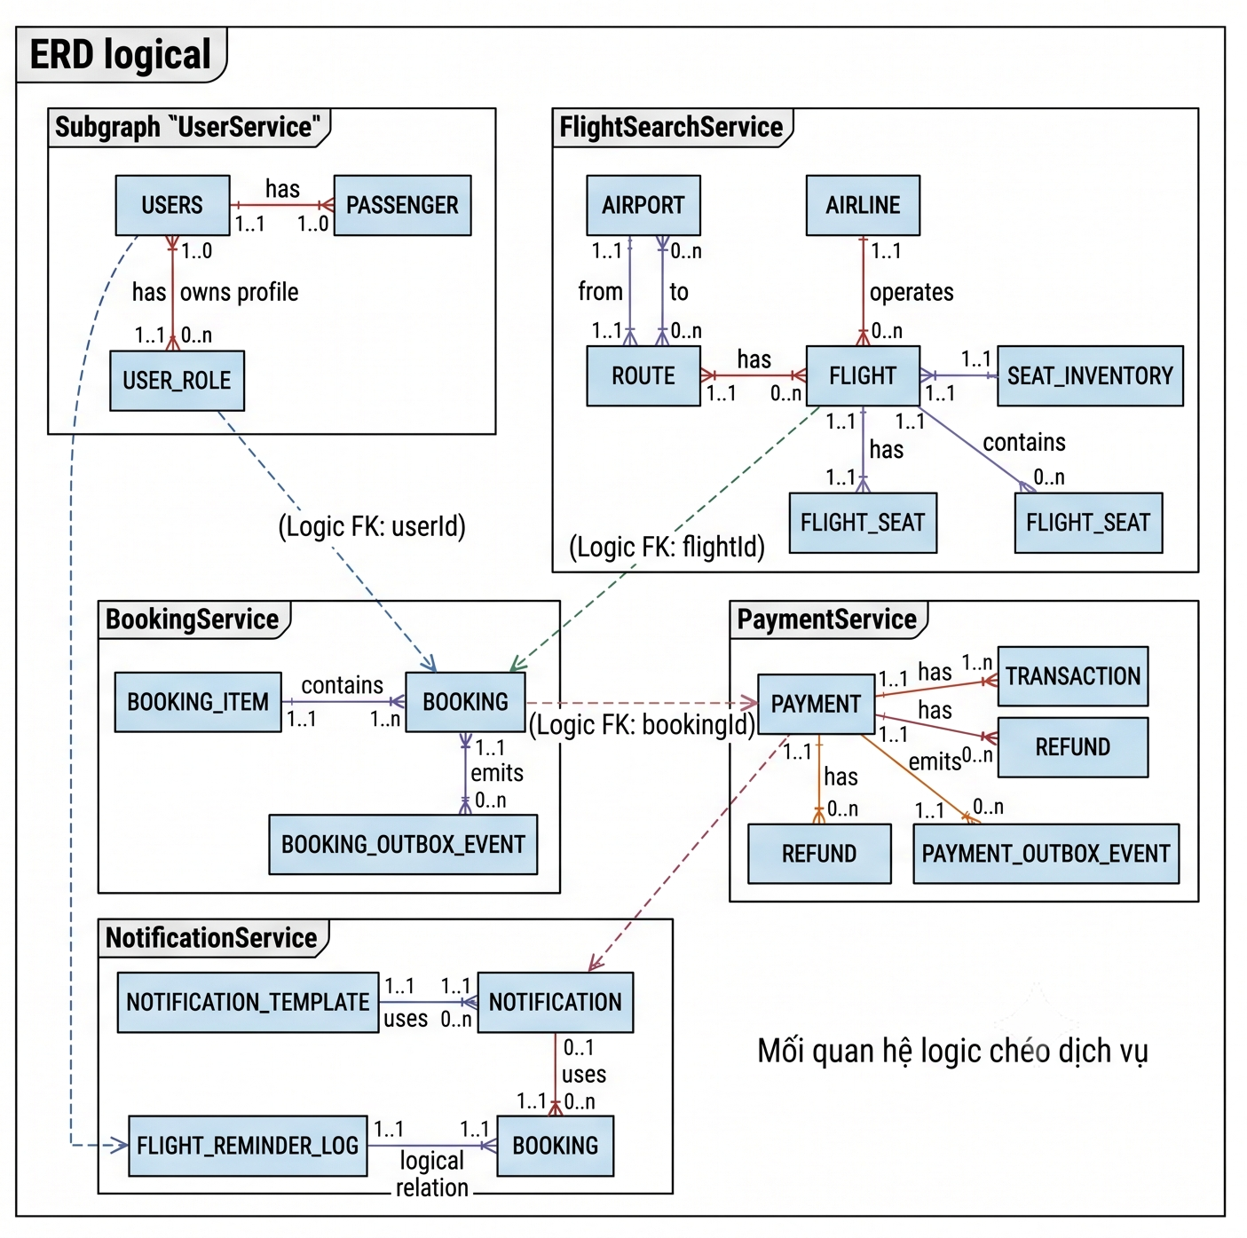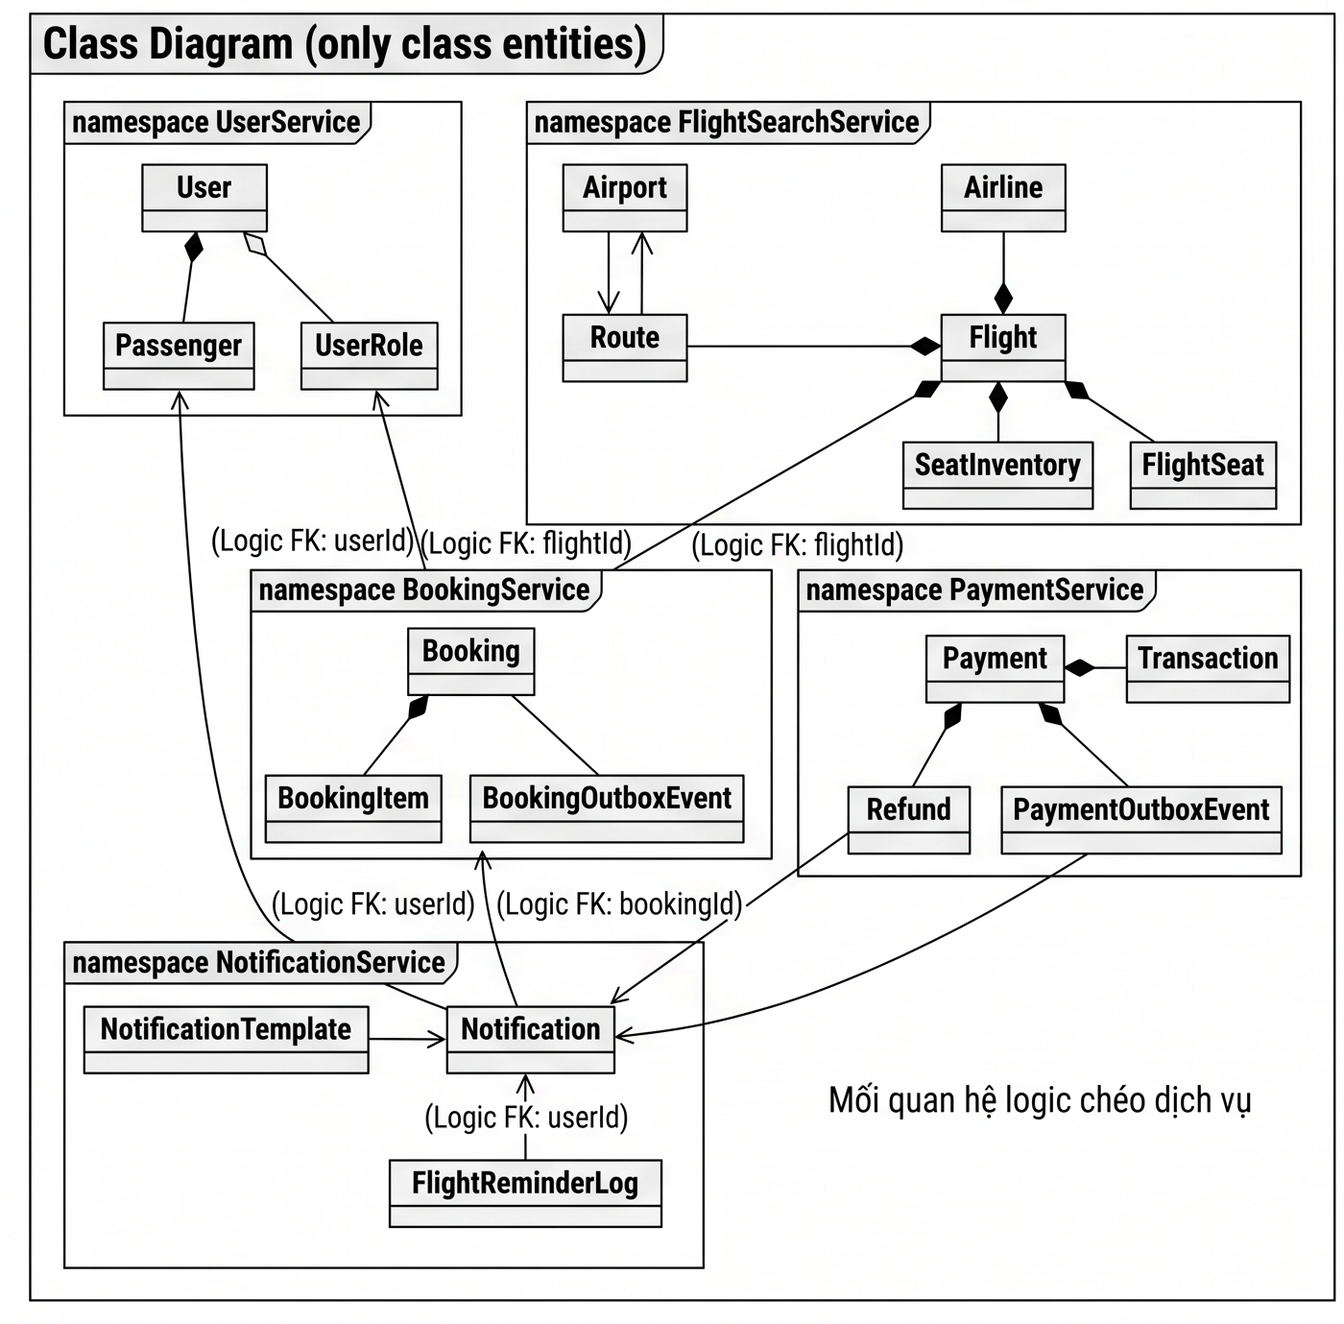

System Architecture (Microservices Architecture)
<Describe the environment in which the project will operate, including the hardware platform; operating systems and versions; geographical locations of users, servers, and databases; and organizations that host the related databases, servers, and websites.>

<A detailed description of how you design the system. You should provide your understanding of your architecture and how your application implemented. The diagrams (eg UML: deployment diagram, class diagrams) should be provided if necessary.>

<A detailed description of any new technologies you find out (not in school) to develop applications.>
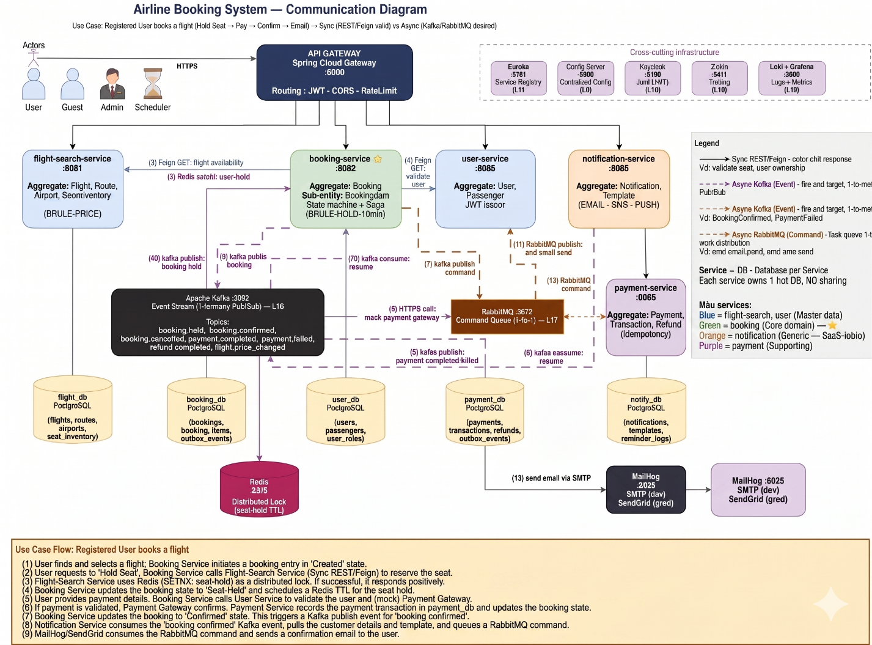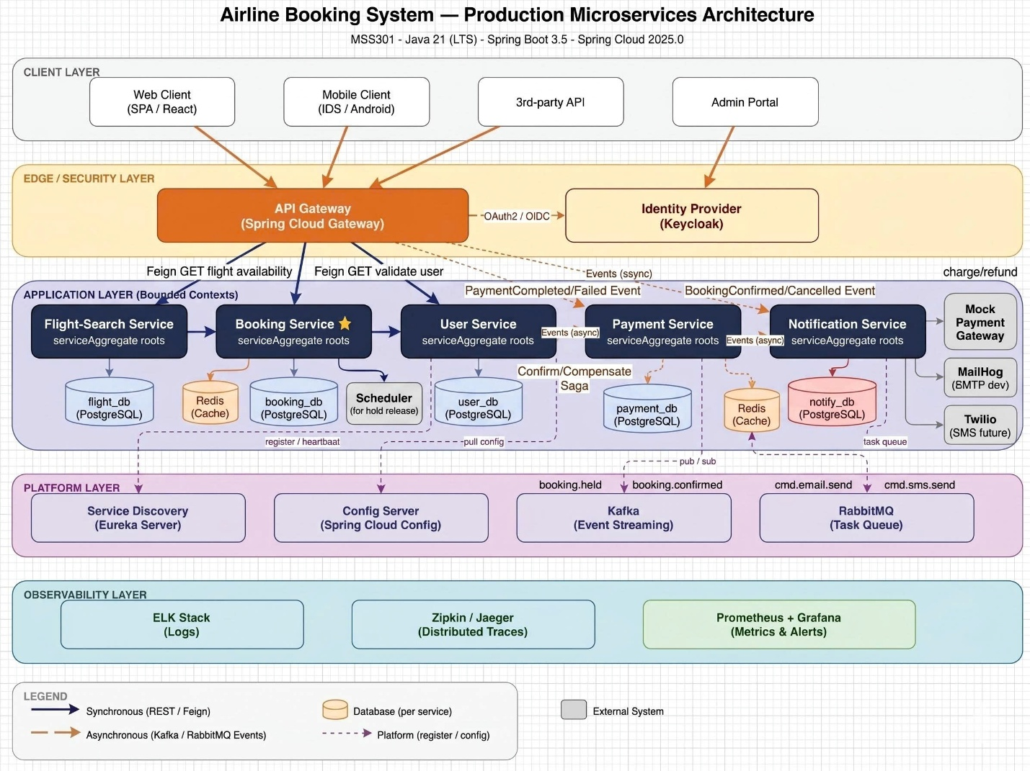

Implementation

Deployment Considerations
<Summarize the information and activities that are needed to ensure an effective deployment of the solution into its operating environment.>

<Describe the access that users will require to be able to use the system, such as whether the users are distributed over multiple time zones or located close to each other. State when the users in various locations need to access the system. If infrastructure changes are needed to support the software’s need for capacity, network access, data storage, or data migration, describe those changes.>

<Record any information that will be needed by people who will be preparing training or modifying business processes in conjunction with deployment of the new solution.>

Screenshots and explanations
<Screen flow | Dialog Map>
<The screenshots and explanations>

References
- Beatty, Joy. Process Impact Intranet Development Standard, Version 1.3, www.processimpact.com/corporate/standards/PI Intranet Development Standard.pdf
- Rath, Andrew. Process Impact Internet Application User Interface Standard, Version 2.0, www.processimpact.com/corporate/standards/PI Internet UI Standard.pdf

In the case your group have no references, please note N/A.

