Example Description

1. This example describes how to configure platform on iNIC mode.
2. iNIC has two interfaces: SDIO/SPI or USB, which can be configured in inc/platform_opts.h, and SDIO is enabled by default.

How to build:

1. Copy src\main.c to project\realtek_ameba1_va0_example\src
2. Switch to INIC-SDIO, then re-build the project

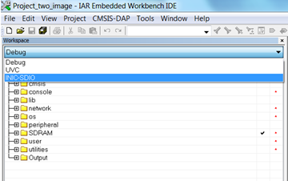

Pin assignment for SDIO device on Ameba EVB:

|  |  |  |
| --- | --- | --- |
| GPIO Pin name | SDIO Pin name | Pin name on Ameba EVB 3V0 |
| GPIOA4 | SD_D0 | D5 |
| GPIOA5 | SD_D1 | D2 |
| GPIOA0 | SD_D2 | D17 |
| GPIOA1 | SD_D3 | D16 |
| GPIOA2 | SD_CMD | D7 |
| GPIOA3 | SD_CLK | D6 |
| GND | GND | GND |