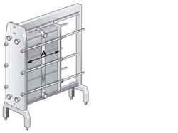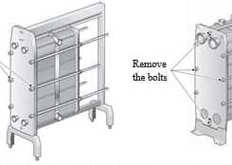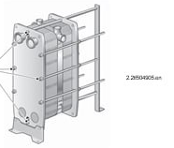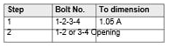
3) Loosen znd remove the bolts s show in the figures aoe
) Use the remaining fou balls t open the het exchanger. On the larger
‘unt exchangers these balls ae equipped wih bezring boxes.
TỞ Pairs a bolts ae openedalterztely and diagonally nt seps, sae
‘gues below,
[Be cael sothatthe frame plate and pressure plat ae aba
‘parall. Skening of the pressure plate during opening mast not exceed
‘10mm Ö tums perbolt) across th wth znd 25 mma Ở tans per ball)
(Cont’d)

