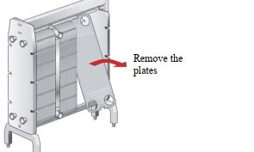
) Open the plate pack by letting the pressure plate glide on the carrying,
bar If plates are to be numbered, do this before removing the plates.
Plates do not need to be removed if cleaning is done using only water,
ie without cleaning agent.
Closing
T the plates have bemn taken owt, tnsst A-and'B plates alteraately, and with
‘the gaskets turned towards the pressure plate or the flame pate depending om
{ype of plate heat exchanger. On opening the PHE, check that all gaskets are
‘lem, in good condition and correctly positionsd in the grooves of plates and commections.
2), Check hatall gaskets are correctly positioned in the grooves and tat the
sealing surfaces ae clean. Even slight produc zemains or feign
Daticles may cause lnkage. If a PHE is opened without previously
Tượng been efficiently clemed by circulation it is necoseny t brush
fhe plates mamally ano rinse them with a waterhase.
) Brus the treads of the bolts clea, sing a ste wire brush rica
fhe treads with a thin layer of grease, Glsitmo 800 ar equivalent
©). Chock that all gaskets are properly attached tthe plates.
Note! {Efe gncetin wrongly positioned it wll show by the fc that it rises out of| fhe gasket groove or tat itis positioned onfside the groove,
(Conta

