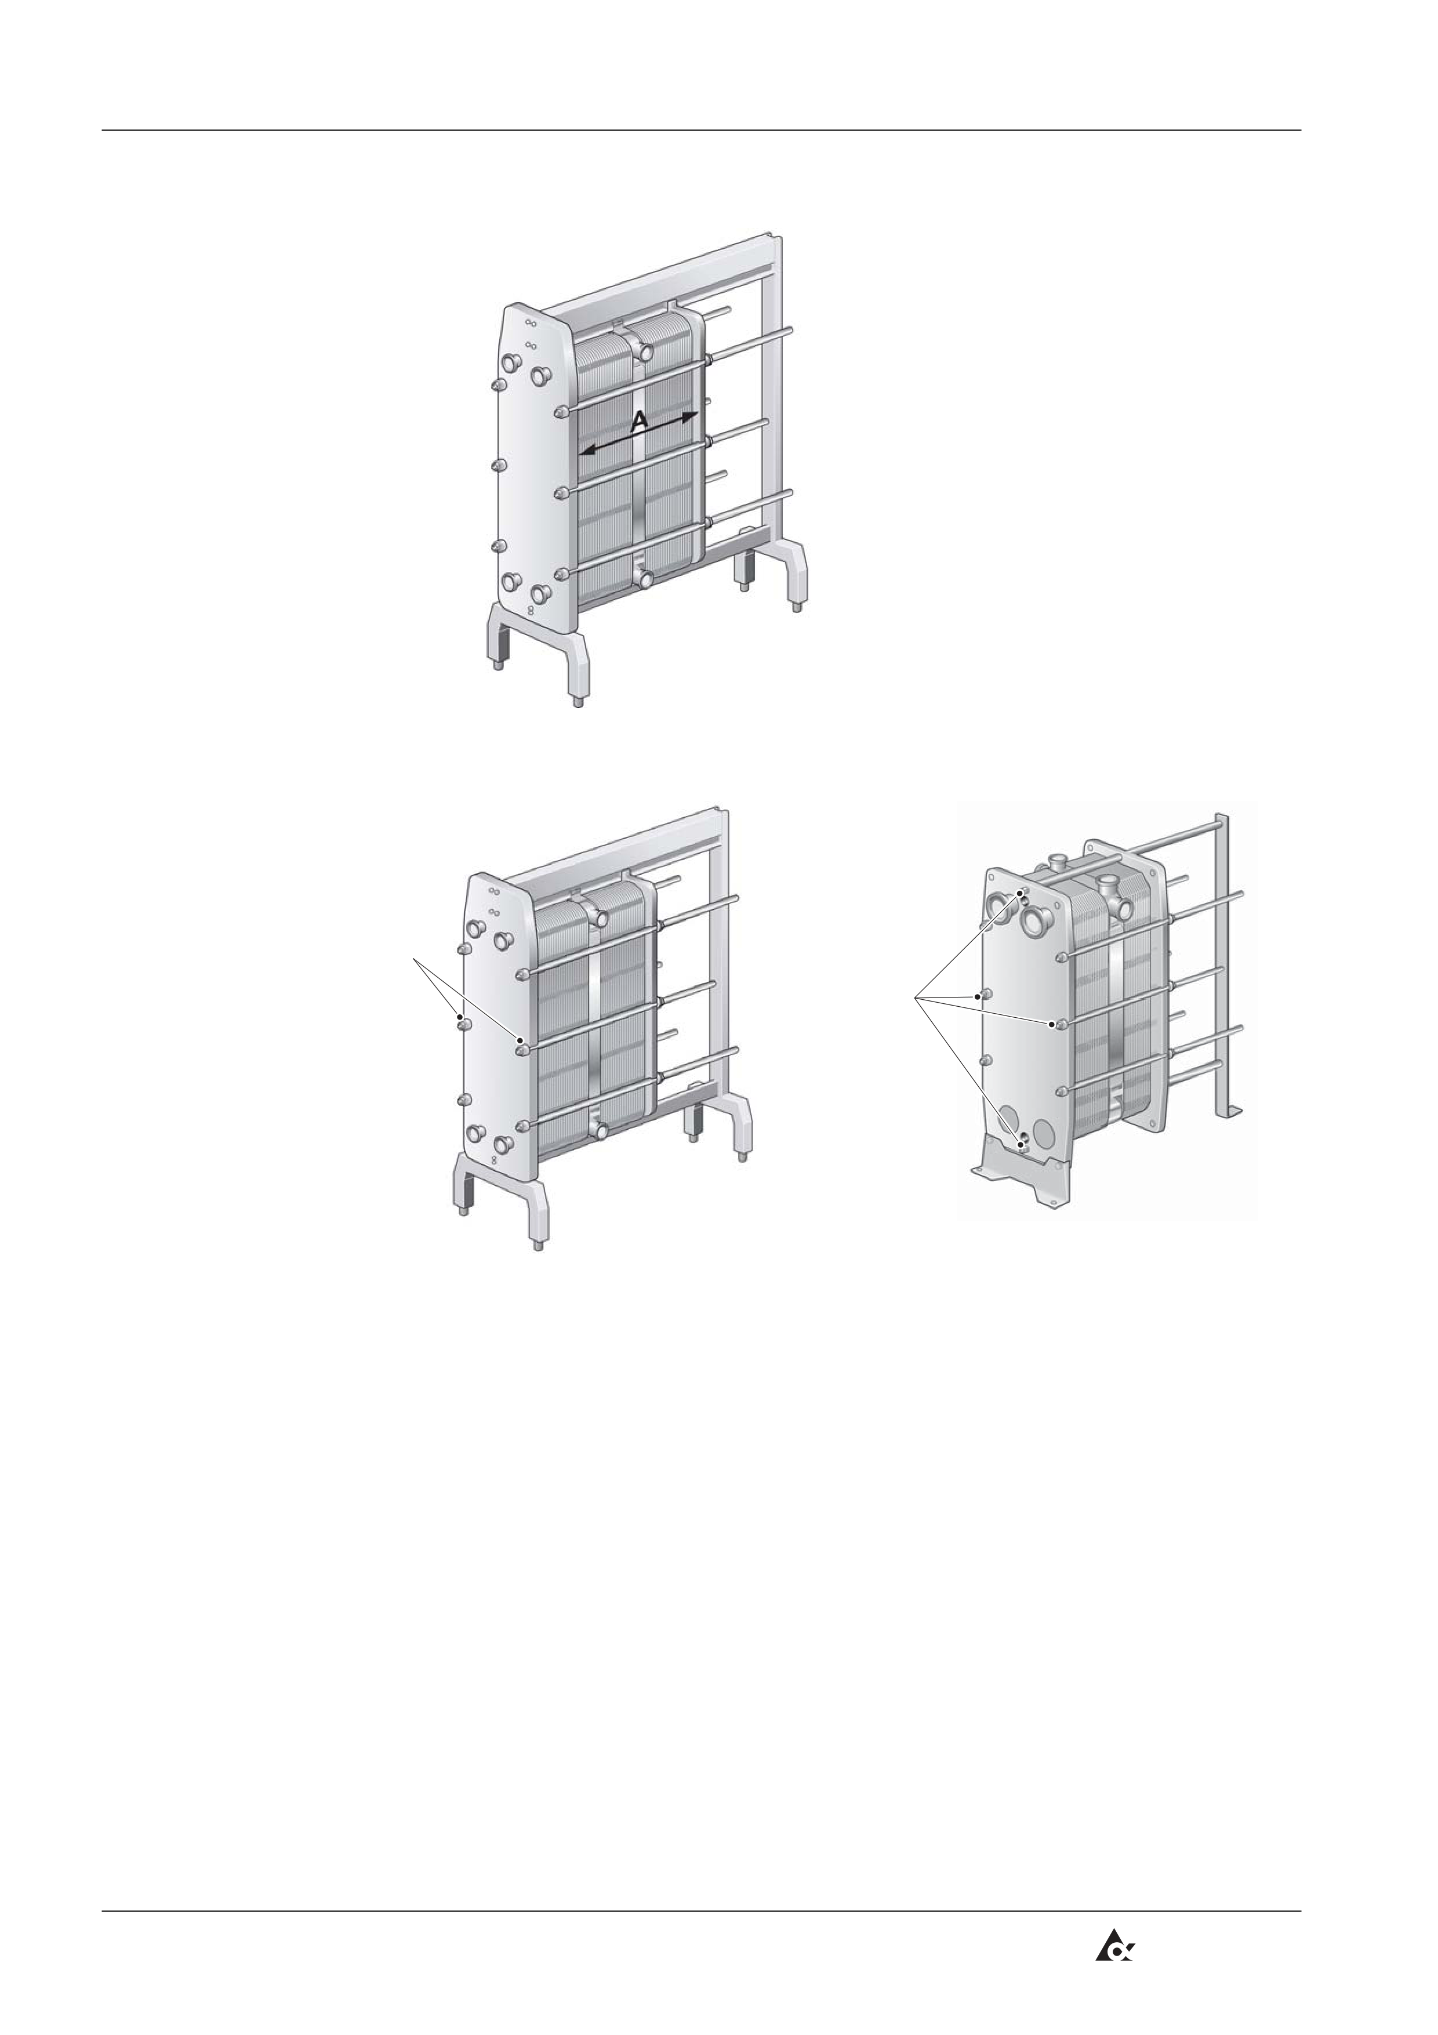
Maintenance
(Cont'd)
h) Measure and note the dimension A.
Remove the
bolts
Remove
the bolts
2.2tf504905.en
i)
j)
Loosen and remove the bolts as shown in the figures above.
Use the remaining four bolts to open the heat exchanger. On the larger
heat exchangers these bolts are equipped with bearing boxes.
k) Pairs of bolts are opened alternately and diagonally in two steps, see
figures below.
Step | Bolt No. | To dimension
1 | 1-2-3-4 | 1.05 A
2 | 1-2 or 3-4 | Opening
Be careful so that the frame plate and pressure plate are always in
parallel. Skewing of the pressure plate during opening must not exceed
10 mm (2 turns per bolt) across the width and 25 mm (5 turns per bolt)
vertically.
(Cont'd)
6
Tetra Pak
Doc No. 1220922-0101

