Email is one of the most common tools in professional and academic communication. The way an email is structured can either strengthen or weaken relationships with its recipients. Below, I will compare two email samples: one exemplary (the Webinar Invitation) and one problematic (the Grading Notification).
Exemplary Email: Webinar Invitation

The webinar invitation email serves as an excellent example of effective communication. The subject line, “Take Control of Your Finances—Join Our Live Webinar!” is clear, engaging, and action-oriented. It immediately conveys both the content and the benefits to the recipient. The greeting (“Dear Dat,”) adds personalization, which builds rapport. The body of the email is well-structured with concise details: event date, time, location, and a direct registration button. Bullet points and bold formatting make it easy to scan quickly. The tone is supportive and professional, encouraging the reader to act without feeling pressured.
Problematic Email: Grading Notification
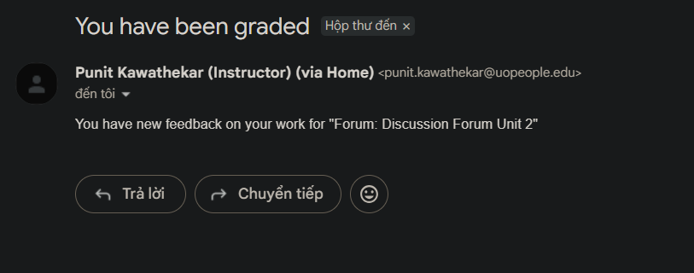
The grading notification email, on the other hand, demonstrates weaknesses in professional communication. The subject line “You have been graded” is clear but too minimal, lacking warmth or context.
The body is extremely brief: “You have new feedback on your work for 'Forum: Discussion Forum Unit 2’.” While concise, it feels mechanical and impersonal, offering no encouragement or direct link to the grade/feedback.
First, the email should include a proper greeting and closing. Currently, it jumps straight into the message, which feels abrupt and impersonal. Adding a greeting such as “Dear Student” and closing with “Best regards, Instructor [Name]” would demonstrate courtesy and professionalism, ensuring the student feels acknowledged rather than treated as just another entry in a system. The subject line of the email should be more descriptive. The current subject, “You have been graded,” is blunt and lacks context. A clearer subject line, such as “Feedback Available – Discussion Forum Unit 2,” would help students immediately understand the purpose of the email and emphasize the importance of reviewing the feedback. Additionally, the email should provide context and encouragement. Right now, the message simply states that feedback is available. Including a supportive sentence, such as “Please review the comments carefully, as they are intended to help you strengthen your future assignments,” would create a more personalized tone, motivate students to engage with the feedback.
The comparison between these two emails highlights the importance of email etiquette. The webinar invitation demonstrates exemplary practices: clear subject, supportive tone, structured details, and professional formatting. The grading notification, in contrast, is problematic because it lacks personalization, warmth, and clarity.

