Excercise 1:
Code HTML
<!DOCTYPE html>
<html>
<head>
<title>Travel Blog</title>
</head>
<body>

<style>
body {
font-family: Arial, sans-serif;
padding: 20px;
background-color: #f9f9f9;
}

h1 {
font-size: 32px;
color: #2c3e50;
}

.buttons {
margin: 20px 0;
}

.circle {
display: inline-block;
width: 50px;
height: 50px;
line-height: 50px;
border-radius: 50%;
text-align: center;
font-size: 20px;
color: white;
margin-right: 10px;
cursor: pointer;
transition: transform 0.3s ease, box-shadow 0.3s ease;
}

.circle:hover {
transform: scale(1.1);
box-shadow: 0 4px 10px rgba(0, 0, 0, 0.25);
opacity: 0.65;
}

.red { background-color: #f44336; }
.blue { background-color: #3f51b5; }
.green { background-color: #4caf50; }
.orange { background-color: #ff9800; }

.destination {
display: none;
margin-top: 30px;
padding: 15px;
background: white;
border-radius: 8px;
box-shadow: 0 2px 6px rgba(0,0,0,0.1);
}

.destination.active {
display: block;
}

.destination ol > li {
color: #2c3e50;
font-weight: bold;
margin-top: 10px;
}

.destination ol > li ul > li {
color: #555;
margin-left: 20px;
list-style-type: circle;
font-weight: normal;
}

</style>
<h1>Travel Blog</h1>

<div class="buttons">
<div class="circle red" onclick="showDestination(1)">1</div>
<div class="circle blue" onclick="showDestination(2)">2</div>
<div class="circle green" onclick="showDestination(3)">3</div>
<div class="circle orange" onclick="showDestination(4)">4</div>
</div>

<div id="destination1" class="destination active">
<h2>Destination 1: Europe</h2>
<ol>
<li>France
<ul>
<li>Paris</li>
<li>Nice</li>
<li>Marseille</li>
</ul>
</li>
<li>Italy
<ul>
<li>Rome</li>
<li>Florence</li>
<li>Venice</li>
</ul>
</li>
<li>Greece
<ul>
<li>Athens</li>
<li>Thessaloniki</li>
<li>Santorini</li>
</ul>
</li>
</ol>
</div>

<div id="destination2" class="destination">
<h2>Destination 2: Asia</h2>
<ol>
<li>Japan
<ul>
<li>Tokyo</li>
<li>Kyoto</li>
<li>Osaka</li>
</ul>
</li>
<li>China
<ul>
<li>Beijing</li>
<li>Shanghai</li>
<li>Xi'an</li>
</ul>
</li>
<li>India
<ul>
<li>New Delhi</li>
<li>Mumbai</li>
<li>Jaipur</li>
</ul>
</li>
</ol>
</div>

<div id="destination3" class="destination" >
<h2>Destination 3: America</h2>
<ol>
<li>USA
<ul>
<li>New York City</li>
<li>Los Angeles</li>
<li>Chicago</li>
</ul>
</li>
<li>Brazil
<ul>
<li>Rio de Janeiro</li>
<li>São Paulo</li>
<li>Salvador</li>
</ul>
</li>
<li>Canada
<ul>
<li>Toronto</li>
<li>Vancouver</li>
<li>Montreal</li>
</ul>
</li>
</ol>
</div>

<div id="destination4" class="destination">
<h2>Destination 4: Africa</h2>
<ol>
<li>South Africa
<ul>
<li>Cape Town</li>
<li>Johannesburg</li>
<li>Durban</li>
</ul>
</li>
<li>Egypt
<ul>
<li>Cairo</li>
<li>Luxor</li>
<li>Sharm El Sheikh</li>
</ul>
</li>
<li>Morocco
<ul>
<li>Marrakech</li>
<li>Casablanca</li>
<li>Fez</li>
</ul>
</li>
</ol>
</div>
<script>
function showDestination(num) {
const destinations = document.querySelectorAll('.destination');
destinations.forEach((dest) => {
dest.classList.remove('active');
});
document.getElementById('destination' + num).classList.add('active');
}

</script>
</body>
</html>
Output:
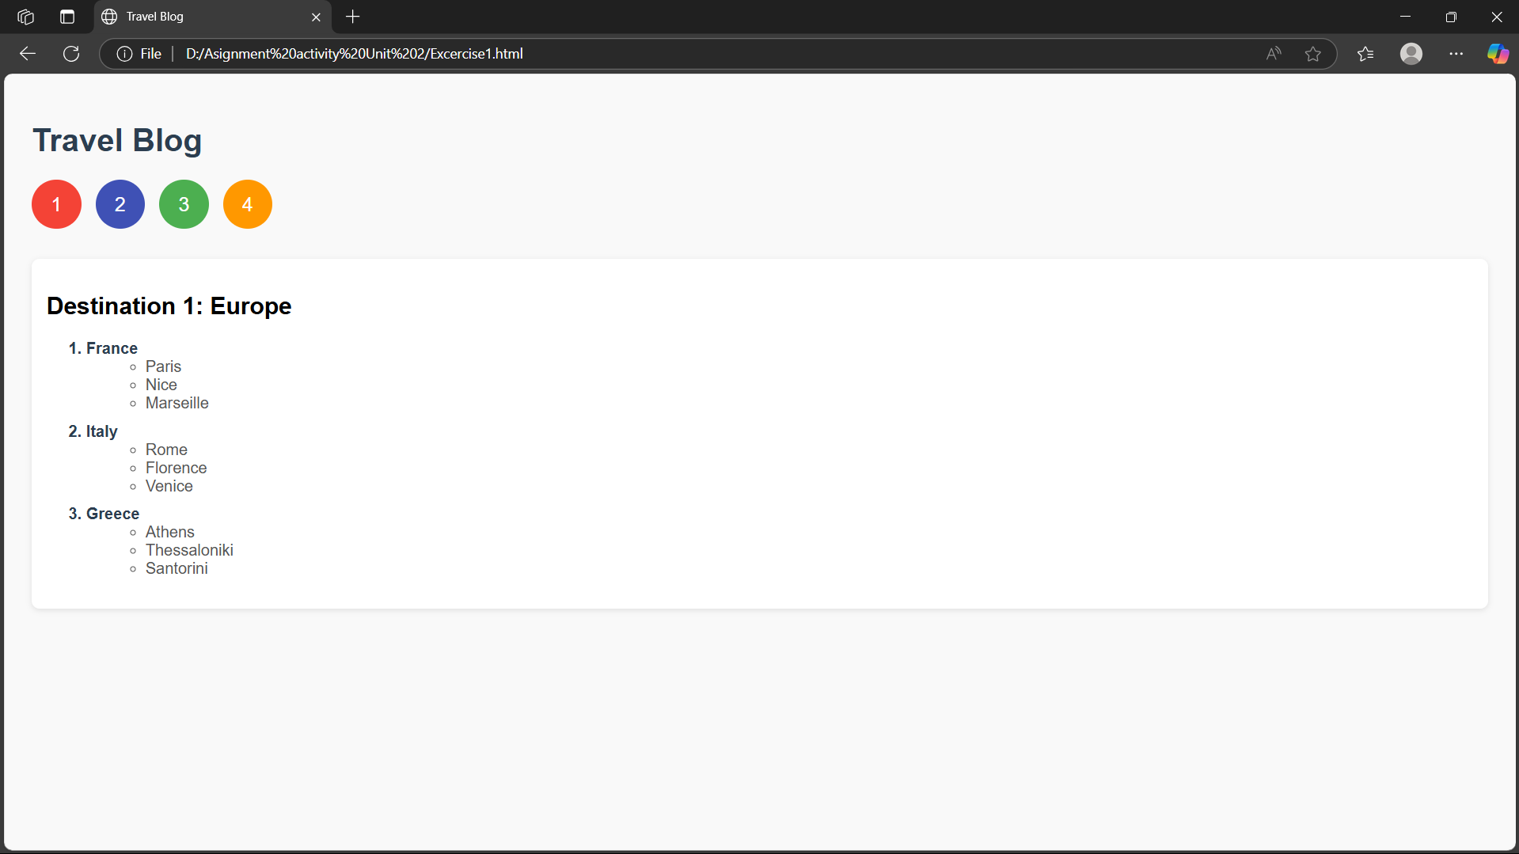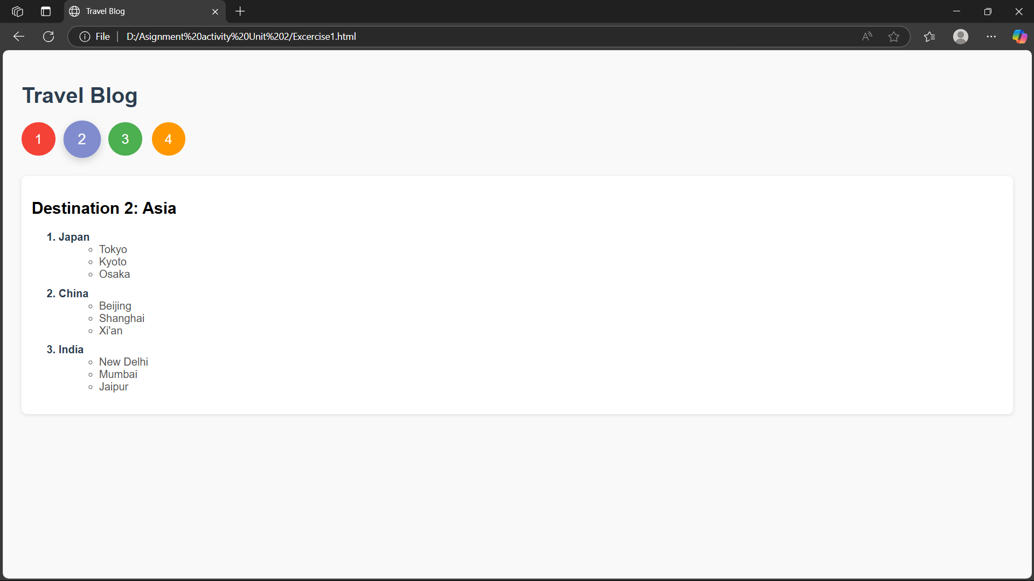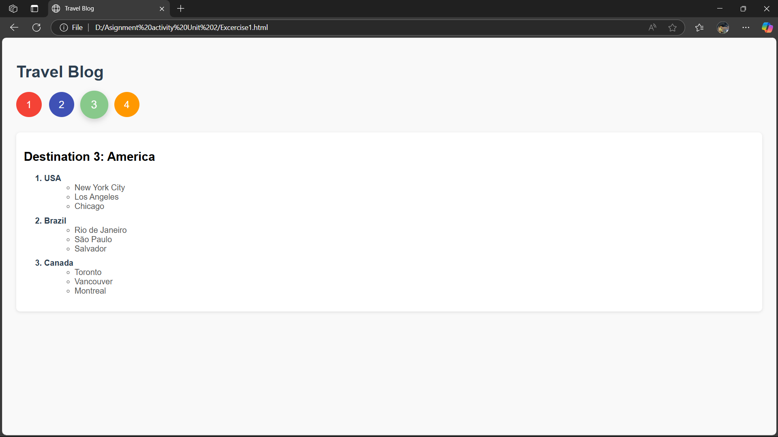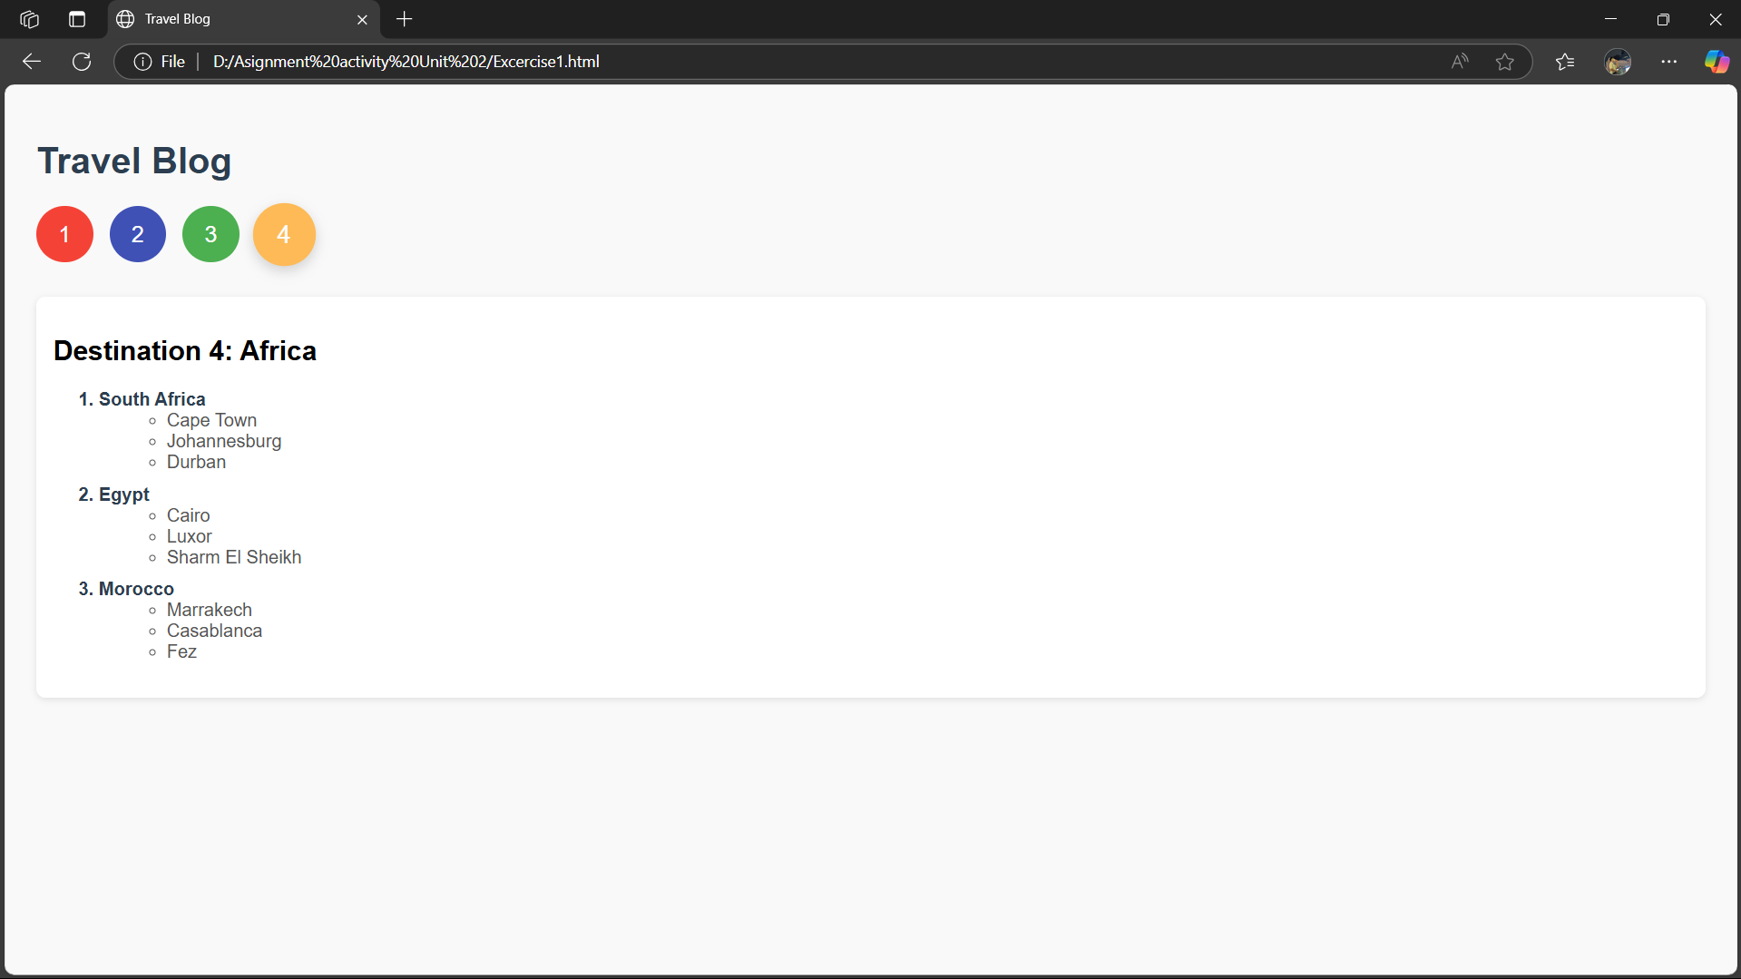
Excercise 2:
Code HTML
<!DOCTYPE html>
<html lang="en">
<head>
<meta charset="UTF-8">
<title>Travel Destinations</title>
</head>
<body>
<style>
body {
font-family: Arial, sans-serif;
padding: 20px;
background-color: #f9f9f9;
}

h1 {
font-size: 32px;
color: #2c3e50;
margin-bottom: 30px;
text-align: center;
}

table {
width: 80%;
border-collapse: collapse;
margin: 0 auto 40px auto;
background-color: white;
box-shadow: 0 4px 12px rgba(0, 0, 0, 0.1);
}

table, th, td {
border: 2px solid #7f8c8d;
}

tr {
background-color: #f5f5f5;
}

th {
background-color: #db5dd7;
color: white;
font-size: 18px;
font-weight: bold;
padding: 15px;
}

td {
padding: 14px;
font-size: 16px;
color: #2c3e50;
text-align: center;
}

button.image-button {
background: none;
border: none;
cursor: pointer;
padding: 0;
transition: transform 0.3s ease;
}

button.image-button:hover img {
transform: scale(1.05);
}

img {
width: 120px;
border-radius: 8px;
transition: transform 0.3s ease, opacity 0.3s ease;
}

img:hover {
opacity: 0.7;
}

.info-section {
width: 80%;
margin: 0 auto;
padding: 20px;
background: #fff;
border-radius: 10px;
box-shadow: 0 0 8px rgba(0,0,0,0.1);
}

.description {
display: none;
animation: fadeIn 0.3s ease;
}

.description.active {
display: block;
}

.description h2 {
color: #2c3e50;
}

.description p {
color: #555;
line-height: 1.6;
}

@keyframes fadeIn {
from {opacity: 0;}
to {opacity: 1;}
}

</style>
<h1>Travel Destinations</h1>
<table>
<tr>
<th>Destination</th>
<th>Attraction</th>
</tr>
<tr>
<td>Paris</td>
<td>
<img src="paris.webp" alt="Eiffel Tower" onclick="showDescription('eiffel')">
</td>
</tr>
<tr>
<td>Rome</td>
<td>
<img src="rome.jpg" alt="Colosseum" onclick="showDescription('colosseum')">
</td>
</tr>
<tr>
<td>New York</td>
<td>
<img src="new-york.jpeg" alt="Statue of Liberty" onclick="showDescription('statue')">
</td>
</tr>
</table>
<div class="info-section">
<div id="eiffel" class="description">
<h2>Eiffel Tower – Paris</h2>
<p>Paris, the capital of France, is world-famous for its romance, fashion, and art. Home to the Eiffel Tower, the Louvre Museum, and charming cafés lining cobblestone streets, Paris blends historic charm with modern elegance. Whether it's a sunset by the Seine or a croissant in Montmartre, Paris captivates all who visit.</p>
</div>

<div id="colosseum" class="description">
<h2>Colosseum – Rome</h2>
<p>Rome is a living museum of the ancient world. With its iconic Colosseum, Roman Forum, and Vatican City, the Italian capital tells stories of emperors, gladiators, and timeless architecture. Its vibrant piazzas, world-class cuisine, and rich heritage make Rome a must-see for every traveler.</p>
</div>

<div id="statue" class="description">
<h2>Statue of Liberty – New York</h2>
<p>New York City is a global powerhouse of culture, finance, and entertainment. From the towering Statue of Liberty to the bright lights of Times Square, NYC is full of energy and diversity. It's a place where dreams are chased, Broadway lights shine, and every neighborhood has its own story.</p>
</div>
</div>
<script>
function showDescription(id) {
const sections = document.querySelectorAll('.description');
sections.forEach(section => {
section.classList.remove('active');
});
document.getElementById(id).classList.add('active');
}
</script>
</body>
</html>
Output:
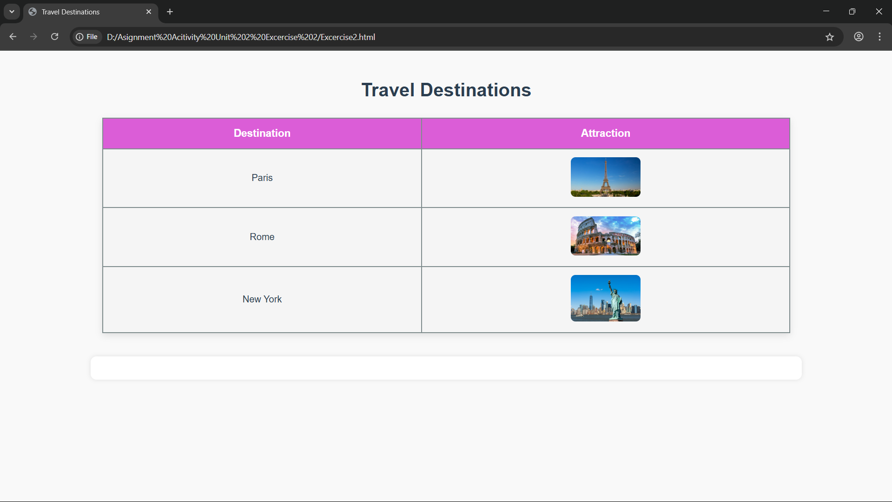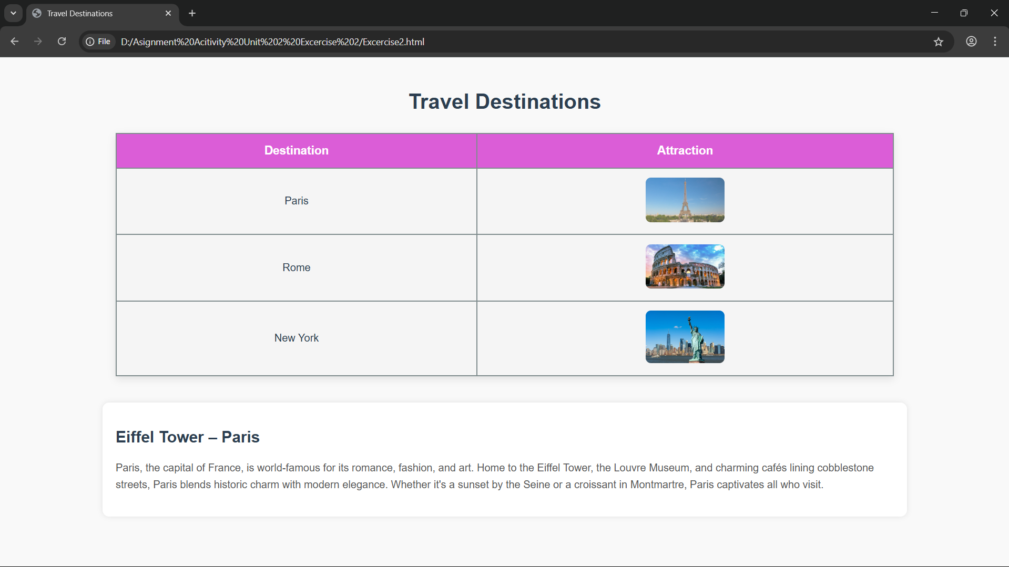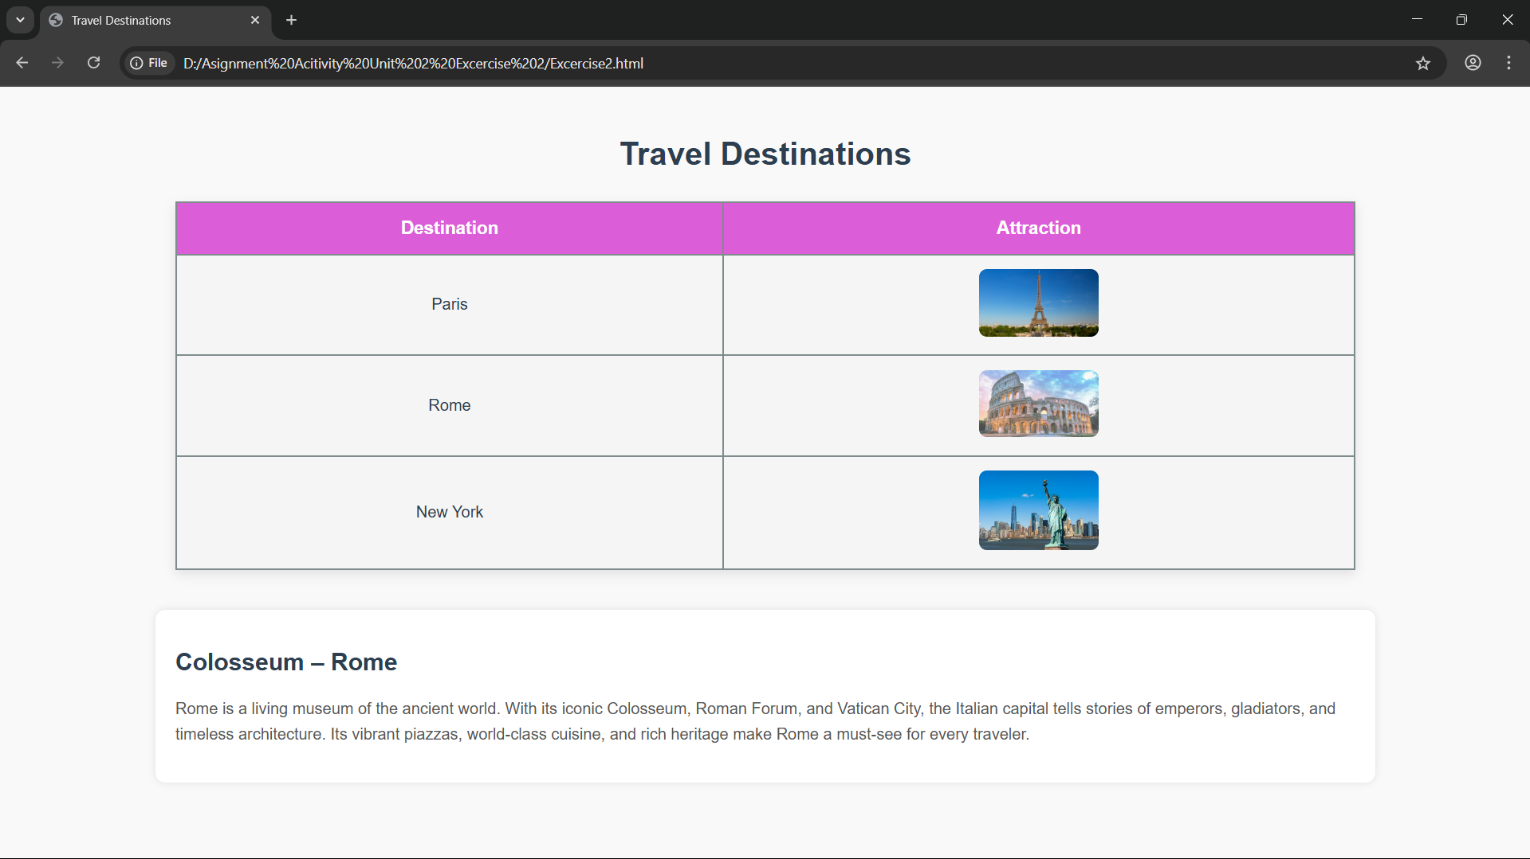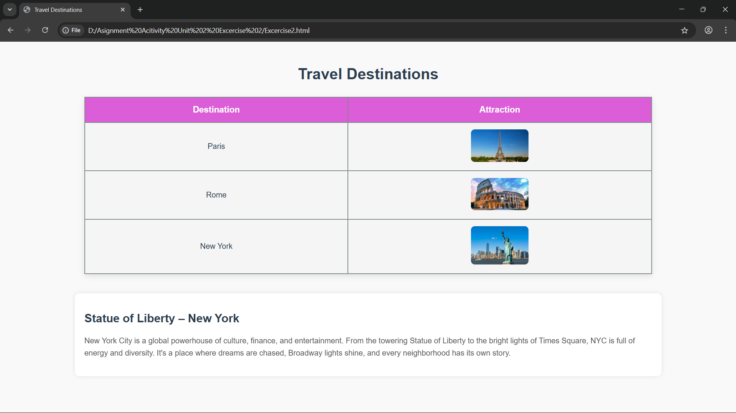
References:
- MDN Web Docs. (2023, September 15). Document and website structure - Learn web development. MDN Web Docs. https://developer.mozilla.org/en-US/docs/Learn/HTML/Introduction_to_HTML/Document_and_website_structure#planning_a_simple_website.
- Coulson, L., Jephson, B., Larsen, R., Park, M., & Zburlea, M. (2019). The html and css workshop : Learn to build your own websites and kickstart your career as a web designer or developer. Packt Publishing, Limited.
- MDN Web Docs. (2024, July 2). Fundamental text and font styling - Learn web development. MDN Web Docs. https://developer.mozilla.org/en-US/docs/Learn/CSS/Styling_text/Fundamentals

