Tanvir Singh 6/01/2023

Exercise: Create an ER diagram data model and implement it in MySQL

Task 3 (SHOW DATABASES)

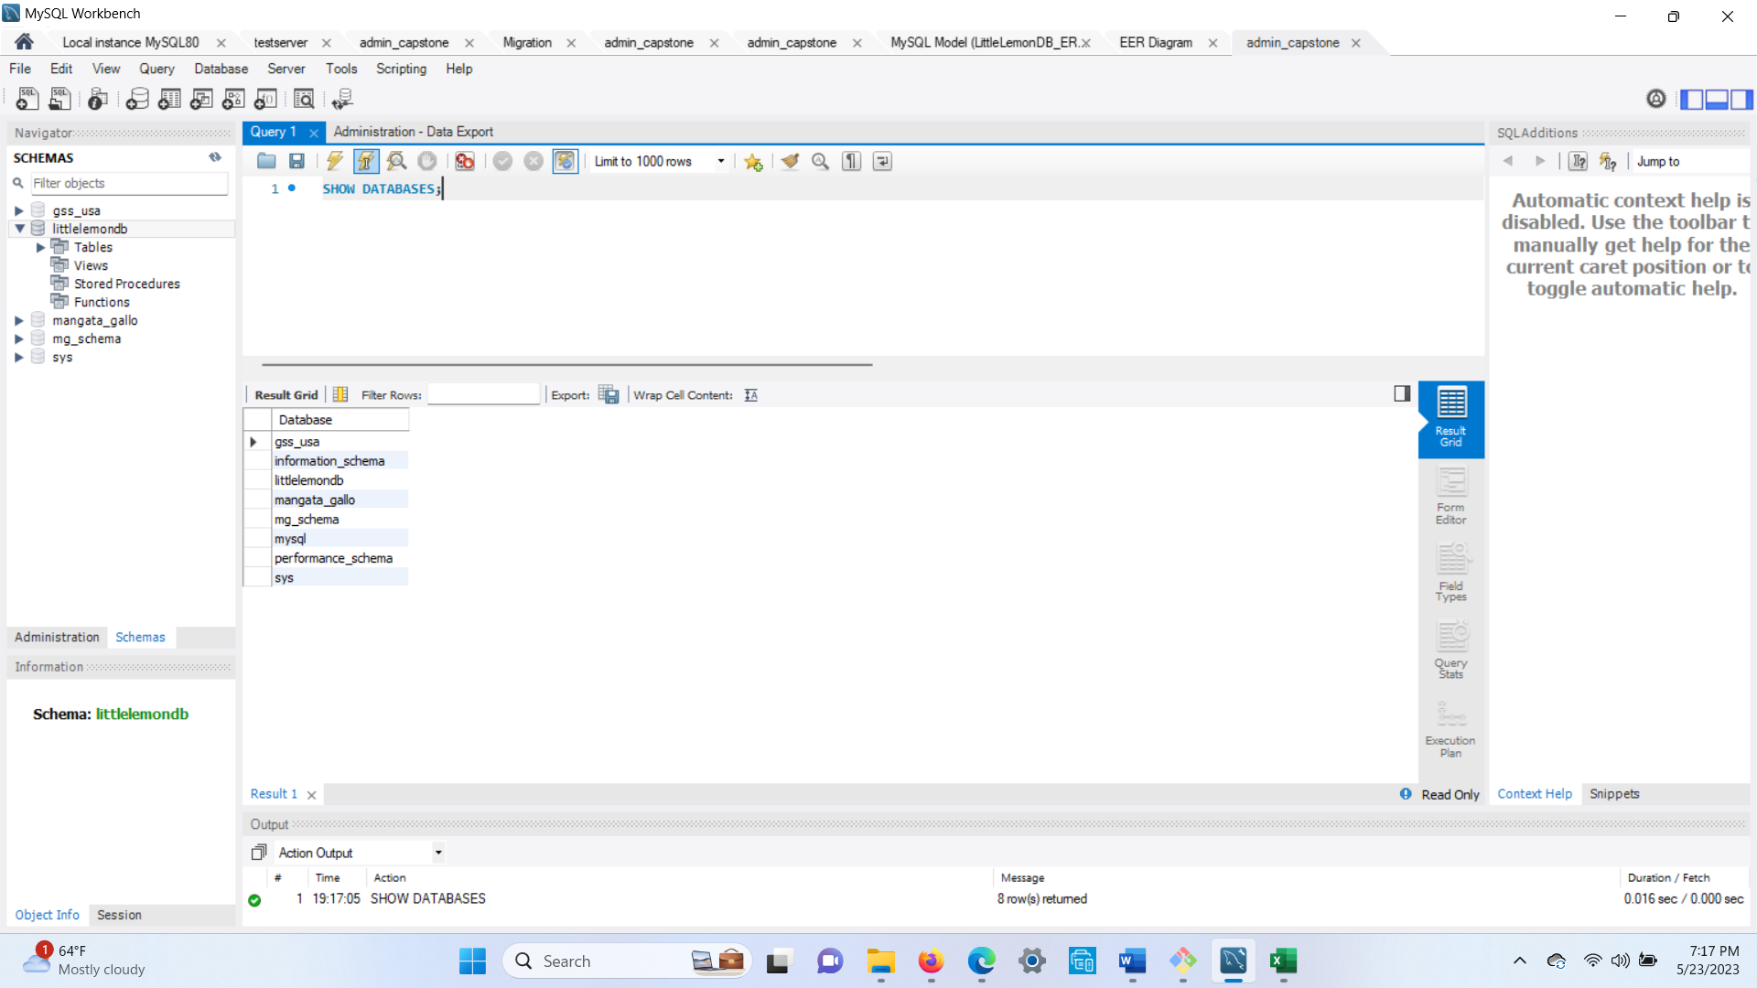

Exercise: Create a virtual table to summarize data: Task 1 (Create View)

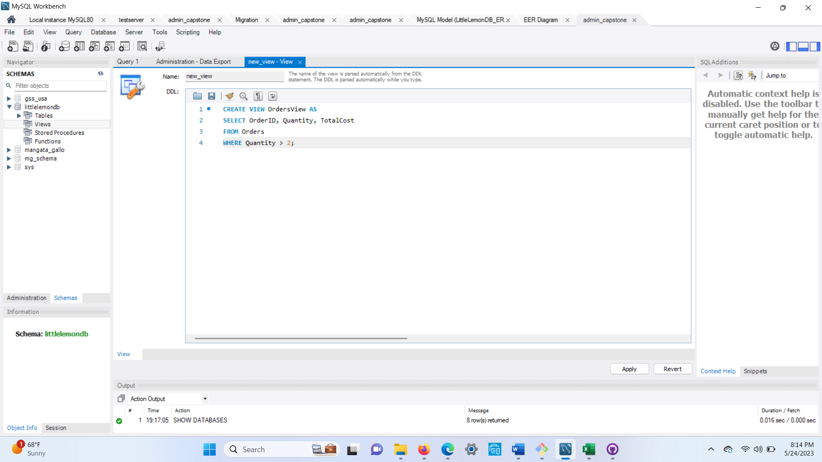

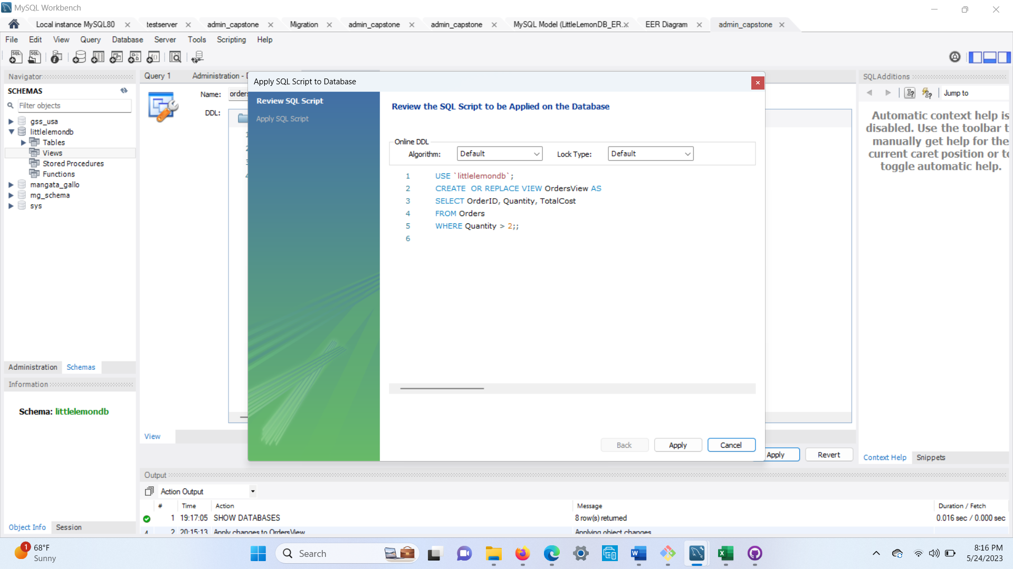

Exercise: Create a virtual table to summarize data: Task 2 (JOIN)

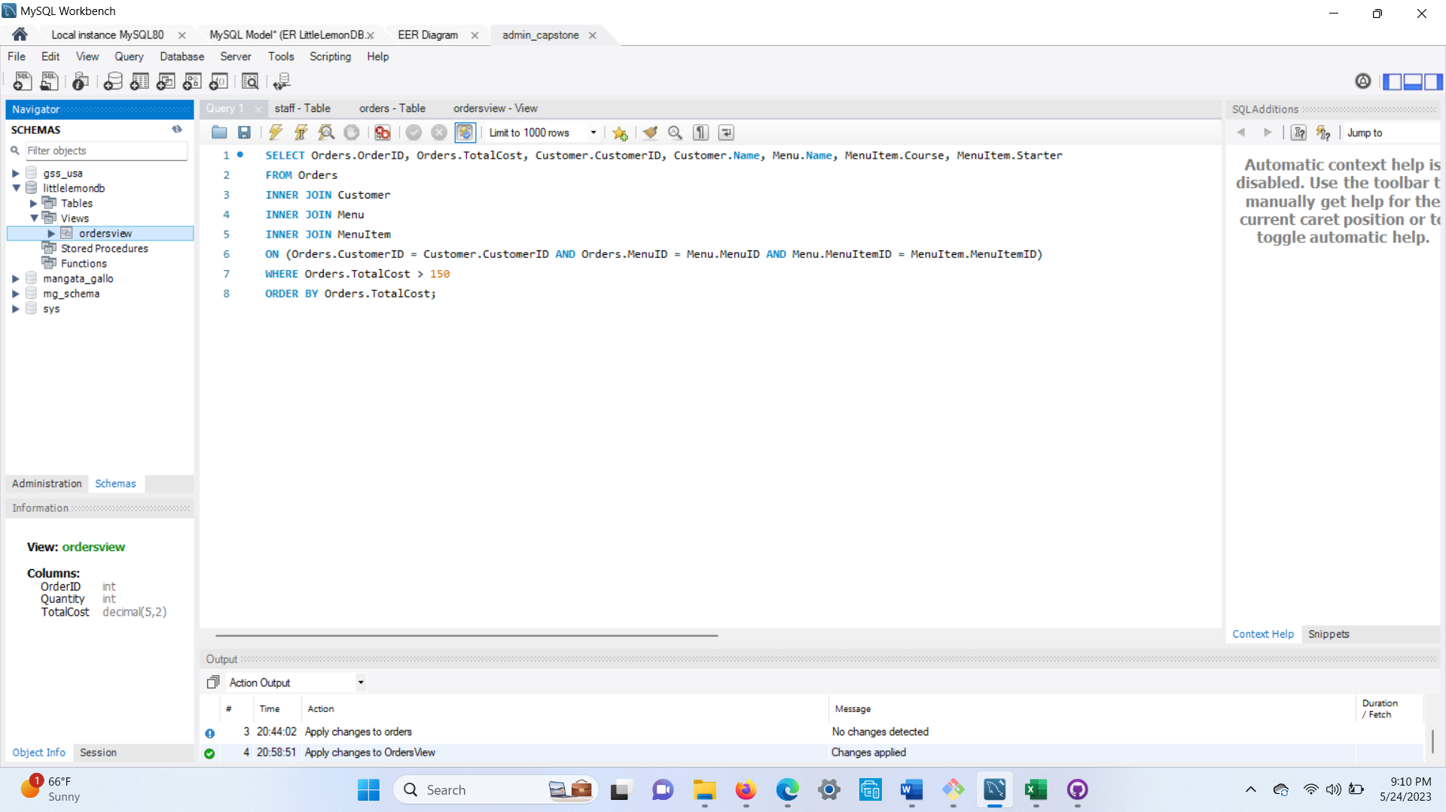

\

Exercise: Create a virtual table to summarize data : Task 3 (subquery)

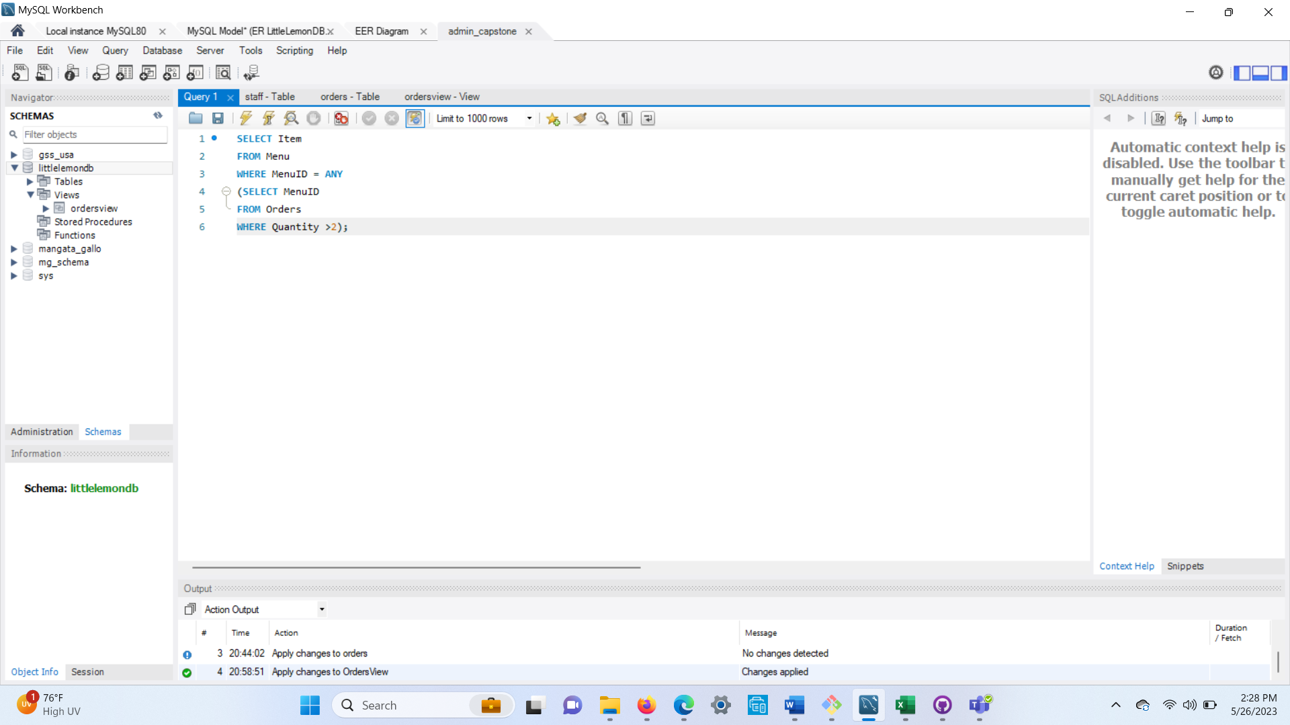

Next Exercise is to create optimized queries to manage and analyze data: Task 1 (procedure)

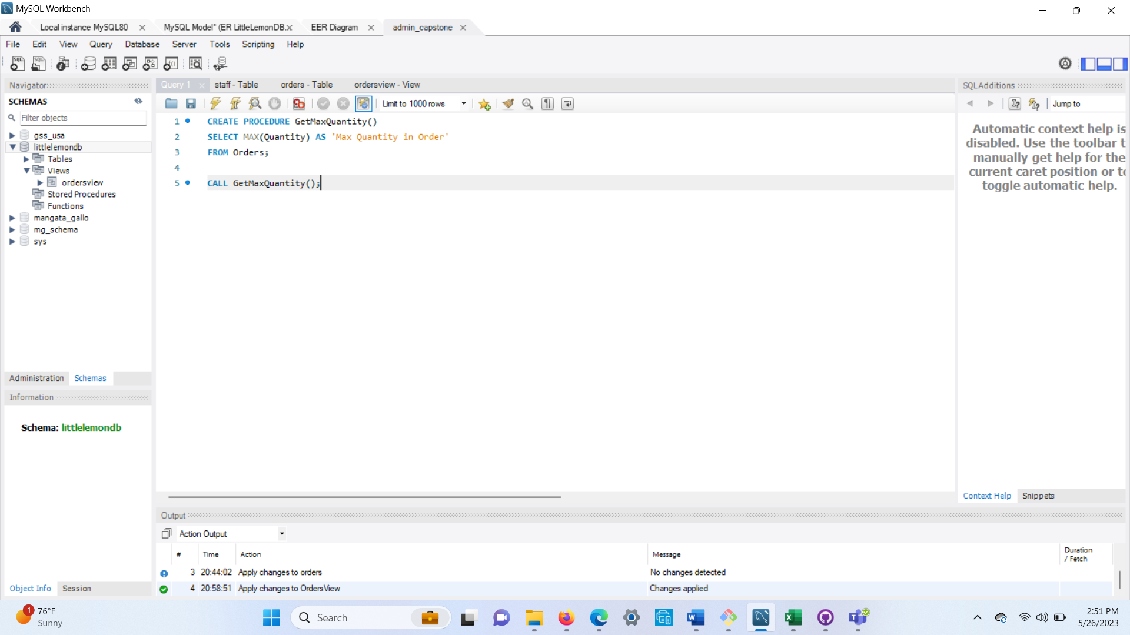

\

Exercise: Create optimized queries to manage and analyze data: Task 2 (prepared statement)

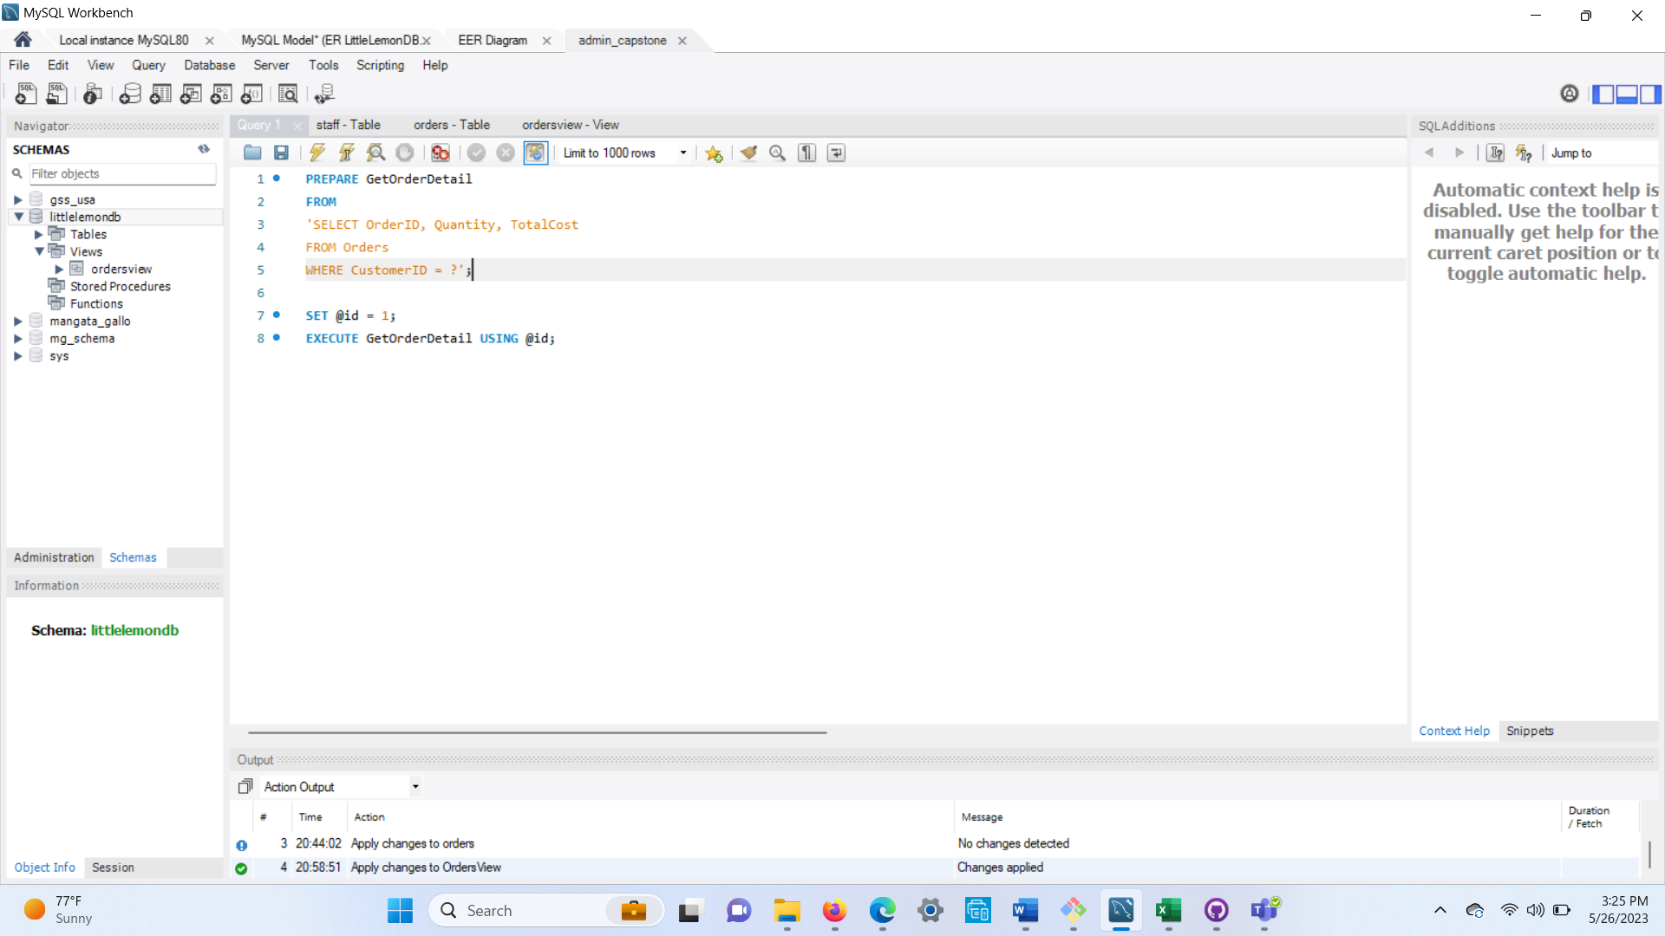

/

Exercise: Create optimized queries to manage and analyze data: Task3 (procedure)

