**Part 1-Array**

1. Write a Java program to test if an array contains a specific value.

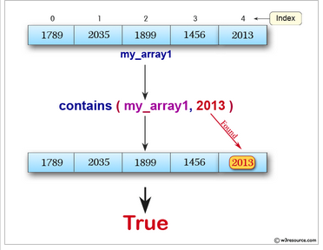

2. Write a Java program to find the maximum and minimum value of an array

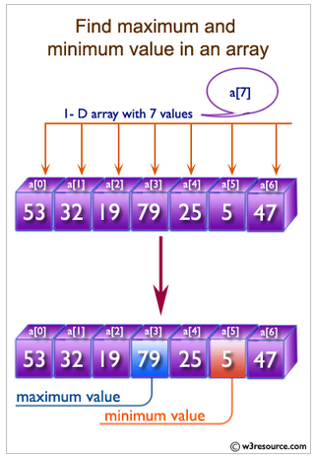

3. Write a Java program to find the common elements between two arrays of integers.

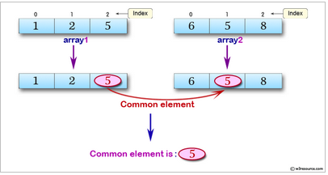

4. Write a Java program to sum values of an array.

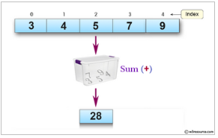

5. Write a Java program to sort a numeric array and a string array

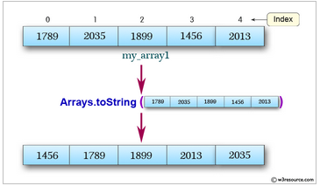

**Part 2. String**

1. Write a java program to get the length of a given string

2. Write a Java program to check whether a given string starts with the contents of another string

3. Write a Java program to get a substring of a given string between two specified positions

4. Write a Java program to convert all the characters in a string to lowercase

5. Write a Java program to convert all the characters in a string to uppercase

6. Write a Java program to replace all the 'd' characters with 'f' characters

7. Write a Java program to trim any leading or trailing whitespace from a given string

8. Write a Java program to check whether a given string starts with the contents of another string.

9. Write a Java program to replace each substring of a given string that matches the given regular expression with the given replacement

Ex: “A Dog has 2 ears” -> replace dog by cat -> “A Cat has 2 ears”

10. Write a java program to print current date and time in the specified format