**MUT Rewards Executive Summary:**

MUT Rewards is an evergreen Loyalty and Rewards program for Madden NFL Ultimate Team players.

**What is Madden Ultimate Team:**

Madden Ultimate Team, known as MUT to players, is a mode within Madden that allows the player to create a team of players who play for different teams within the NFL in order to create their “Ultimate Team”. Madden Ultimate Team players acquire new NFL players for their Ultimate Teams by opening Packs within the game.

Packs can be earned by playing challenges within the game or purchased for real world money in the Madden Ultimate Team store.

**Customer Facing Description of Madden Ultimate Team:**

Madden Ultimate Team, affectionately known as MUT to its players, puts together some of the most fun and addictive features of video gaming and football. If you have ever dreamed of throwing a Hail Mary from Tom Brady to Calvin “Megatron” Johnson, or having NFL Legends like Deion Sanders or Ronnie Lott line up in your secondary, Madden Ultimate Team is the place for you.

Do you like Fantasy Football and the idea of building a winning team from scratch? Do you like opening packs of items to enhance your line up, sell in an auction environment, trade with your friends or even put in sets for more players, packs, or in-game currency? MUT has all of these things and more!

Madden Ultimate Team is packed with sets, solo challenges, and a complete multiplayer head-to-head “Seasons Mode,” which lets players challenge their friends’ Ultimate Team for ultimate bragging rights! Ultimate Team also provides never-ending content and promotions throughout the year. With Madden Ultimate Team, the football season never ends.

**Glossary/Important Terms/Acronyms:**

* **ARPS:** Average Revenue per Spender
* **Coins:** Soft currency within Madden NFL Ultimate Team. Coins cannot be purchased, only earned through playing the game. Coins can be used to purchase packs and other items.
* **Contracts:** Players must apply Contracts to each player on their starting lineup. Each time they play a game or challenge with a given player 1 contract is consumed. Players can earn contracts by opening packs or purchasing them from within the Madden NFL Ultimate Team store.
* **Levels:** Levels are the representation of progress milestones players can achieve throughout the program. The 3 levels are:
  + Rookie: 0-49 Packs Opened
  + Pro: 50-249 Packs Opened
  + All Pro: 250-999 Packs Opened
  + Legendary: 1,000+ Packs Opened
* **Madden HD:** Madden played on Microsoft or Sony consoles
* **Madden NFL Mobile:** Madden played on Apple and Android devices (Phones and Tablets)
* **MUT:** Madden Ultimate Team, described above
* **Nucleus:** The central repository of user data within the EA ecosystem.
* **Packs:** Digital Packs that players open to receive in game content within MUT. These packs can be earned through sweat equity (playing the game) or purchased from the in game store
* **Points:** Points are hard currency that can be purchased from within the Madden Ultimate Team store. Points can be used to purchase packs.

**How MUT Rewards works:**

* Players register for MUT Rewards via the web at [www.mutrewards.com](http://www.mutrewards.com)
  + Players are required to sign in with an EA Account with a validated email address
    - If they have not yet validated their EA Account email address they are prompted to prior to being allowed to register
  + Players can also Opt out of MUT Rewards at anytime via [www.mutrewards.com](http://www.mutrewards.com)
* There are 3 Levels of MUT Rewards visible to the player and 1 that we track but players don’t see, players progress through levels by opening packs in Madden Ultimate Team. The 4Levels of MUT Rewards are:
  + Rookie: 0-49 Packs Opened
  + Pro: 50-249 Packs Opened
  + All Pro: 250-999 Packs Opened
  + Legendary: 1,000+ Packs Opened
* Players are rewarded each month with digital rewards. Ad hoc physical rewards are also distributed throughout the year.
  + Rewards may consist of Non-Madden EA Products such as:
    - Full game titles: NBA Live, for example
    - EA Services: 1 month of EA Access, for example
  + Rewards may consist of free products from other companies such as:
    - Tickets to NFL Games
    - Ticketmaster Cash
    - Custom Paraphernalia: Bobble Heads, Jerseys, etc.
  + Players in the US are eligible to receive physical and digital rewards
  + Players outside the US are eligible to receive digital rewards only
* **NOTE:** There is no concept of accruing or spending points in MUT Rewards. Rewards are rooted in opening packs and rewards are granted to players on a surprise and delight basis, not through conscious choice of reward by the player.

**Technical Workflows:**

**Opting in/out:**

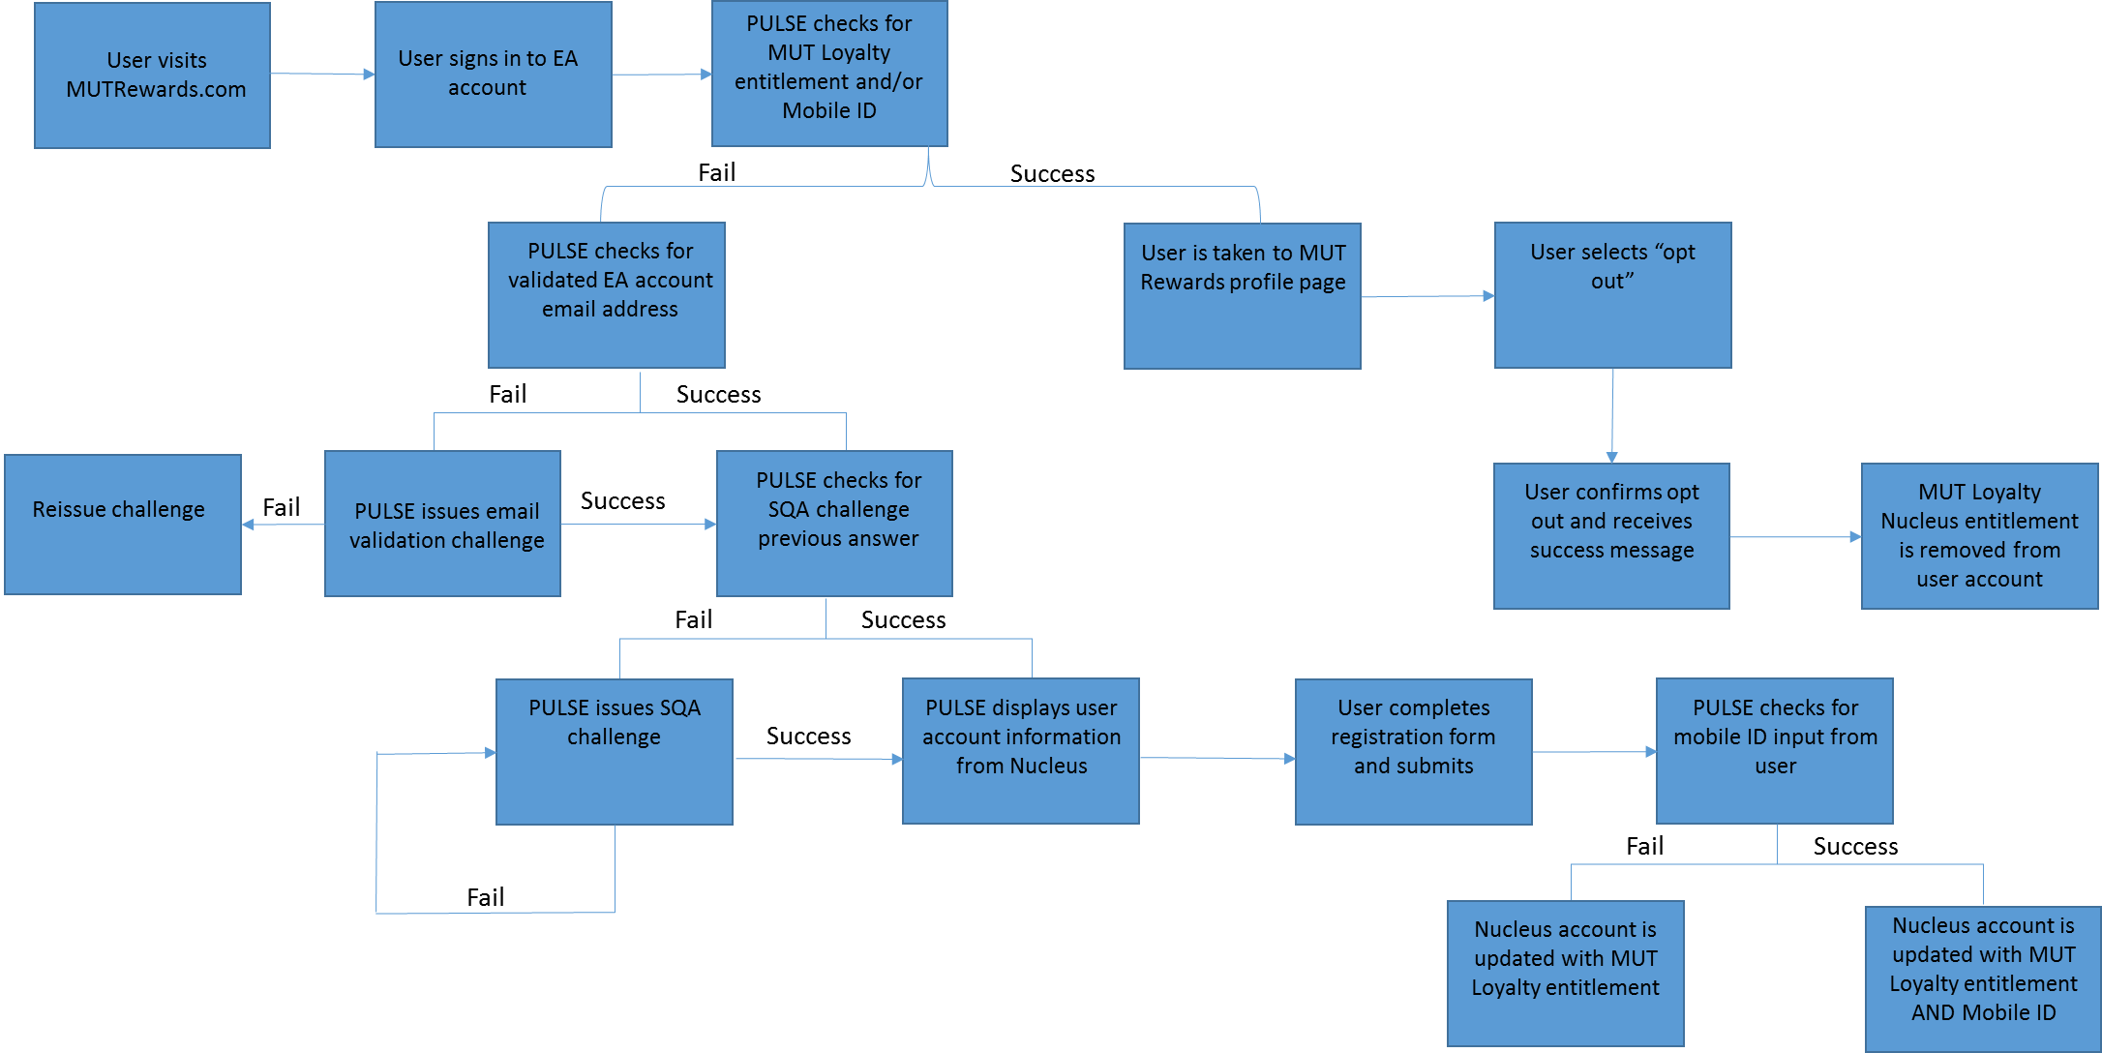

**Users Receiving In-Game Rewards:**

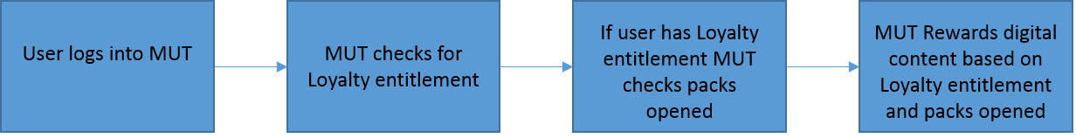

**Messaging:**

Visit [www.mutrewards.com](http://www.mutrewards.com) for the full page:

**MADDEN ULTIMATE TEAM REWARDS:**

Join MUT Rewards today and start earning rewards for opening packs in Madden Ultimate Team. All packs you open will count towards your total.

MUT Rewards members can receive Coins, Packs, and other great surprises throughout the Madden season.

**REWARDS NOW AVAILABLE OUTSIDE THE UNITED STATES**

MUT Rewards is open to players both in the US and in countries outside of the US. Only players living in the US are eligible for physical rewards. Players located outside of the US are only eligible for Digital Rewards.

You’ll receive a Loyalty Badge just for signing up today, redeemable in Madden NFL 16 Ultimate Team for Packs, Player Items, and Contracts.

**WHAT MUT REWARDS HAVE PLAYERS RECEIVED?\***

* All players who signed up for MUT Rewards received a Loyalty Badge. Loyalty Badges could be redeemed in Madden NFL 16 Ultimate Team for Packs, Player Items, and Contracts.
* In September, select MUT Rewards players received early copies of NBA LIVE 16 shipped to them as a special reward.
* Early in August, two copies of Madden NFL 16 were sent to select MUT Rewards Legendary members.
* Later in that same month, a very few select MUT Rewards players received tickets to NFL football games as a reward for their Legendary level of participation.
* In September, MUT Rewards players who had reached Pro Level or higher received awards of 1,000 to 2,000 Contracts for their MUT accounts.

**MUT REWARDS LEVELS**

* There are three levels of MUT Rewards:
* Legendary Level: 1,000 Packs Opened – all packs count
* All-Pro Level: 250 Packs Opened – all packs count
* Pro level: 50 Packs Opened – all packs count

Sign up below and start earning MUT Rewards today for opening packs in Madden Ultimate Team!

*Rewards not guaranteed and are subject to change.

**Screenshots of the signup process:**

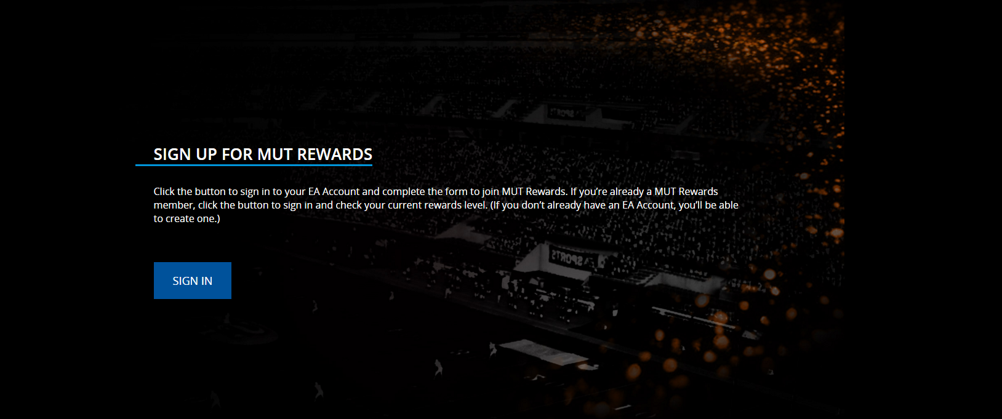



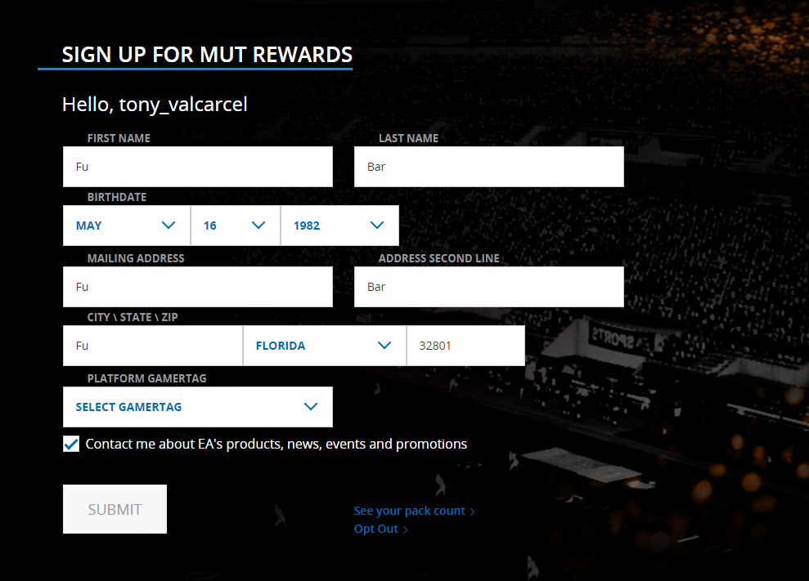

**Profile Screen:**

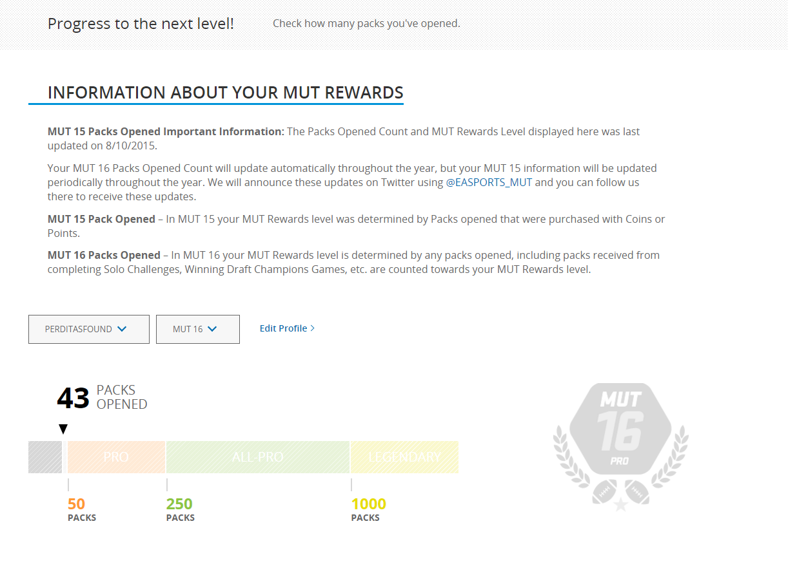

**Strategy/Goals:**

The goals for this program are:

* Increase engagement with Madden Ultimate team as measured by average logins per player
* Increase spender conversion
* Increase YoY retention for our highest spending players

The strategy we have adopted to achieve these goals is to keep the program rooted in opening packs, which the player can earn through sweat equity (playing the game) or purchase from the in game store.

This model supports both the goal of increasing engagement with MUT by providing incremental incentives for players to continue to open packs. Players who want to progress through the program without spending money will engage with the mode more deeply in order to acquire and open more packs.

Additionally, as players progress through the program and work towards opening more packs, they are more likely to convert to spenders in order to expedite the process.

**Program Benefits:**

* **Digital Transformation:** 
  + We now have a web based tool that allows players to register for a program and receive content in game.
  + We now have an in game system that is able to consume a Nucleus entitlement granted via a web utility and provide the player with in game content.
  + We have built analytics tools to monitor the health of this program and provide deeper insight into our most valuable players, how they interact with our game, and their spending behavior.
* **Player First 1:1 Relationships:** Provide a reason for players to provide us with accurate and updated Nucleus account information:
  + **Pre-launch opportunity analysis:**
    - We know that the majority of our players have inaccurate or obsolete information contained in Nucleus. We know this based on 2014 direct mail campaign investigation: when NCAA Football 14 business closed and the Tiburon team attempted to direct mail copies of Madden NFL 25 to NCAA Football 14 owners. We were unable to identify more than 100 players with accurate Nucleus information.
  + **Actual Results as of 10/14/2015:**
    - Thus far we’ve taken over 89K registrations with 96% account accuracy.
* **Engagement:** Because the program is rooted in opening packs, which can be accomplished through sweat equity (playing the game) **OR** through purchase (buying packs from the store) players are motivated to engage more deeply with Madden Ultimate Team in an effort to open more packs.
  + **Results:** Average Logins are up for the MUT Rewards Cohort:
    - **Average Logins:**
      * **Rookie:** 9 ( **+126%** from baseline)
      * **Pro:** 25 ( **+25%** from baseline)
      * **All-Pro:** 38 ( **+13%** from baseline)
      * **Legendary:** 44 ( **+15%** from baseline)

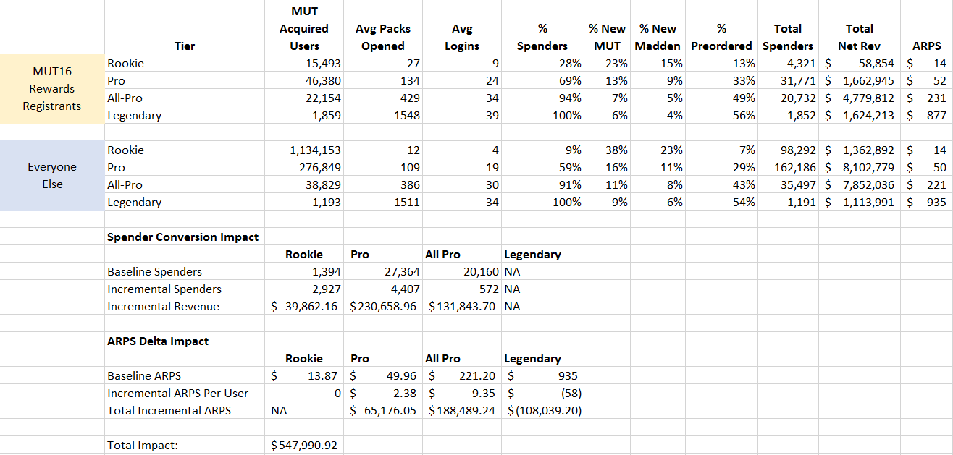

* **Monetization: Spender Conversion**:
  + **Pre-launch opportunity analysis:**
    - 2.9M MUT Players have opened packs but never spent
    - ARPS is $126
    - A 1% increase in conversion from non-spending MUT player to spending MUT player will drive $3.5M incremental revenue (2.9M X .01 X $126)
  + **Actual Results as of 10/14/2015:**



**+$547K** total financial impact of the program calculated as follows:

First, let’s define rewards levels again:

* Rookie: 0-49 Packs Opened
* Pro: 50-249 Packs Opened
* All-Pro: 250-999 Packs Opened
* Legendary: 1,000+ Packs Opened

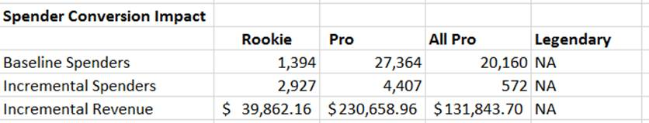

**Baseline Spenders:**

Here I’m multiplying the number of players registered for MUT Rewards at each level and multiplying that number by the baseline conversation rate for that same cohort.

So, as an example, for the Rookie Level:

* 15,493 people are registered and at the Rookie level
* Players NOT registered for MUT Rewards at the Rookie Level convert at 9%
* 15,493 X 9% = 1,394 baseline spenders

**Incremental Spenders:**

Here I’m subtracting actual spenders in the MUT Rewards Cohort, by level, from the baseline spenders calculated in the previous step.

Continuing with the Rookie example:

* 4,321 MUT Rewards Players in the Rookie Cohort converted to spenders
* 1,394 of these players would have converted at the 9% level
* 4,321 – 1,394 = 2,927 incremental spenders

**Incremental Revenue:**

Here I’m multiplying our incremental spender count by ARPS for that spender cohort:

Rookie example:

* 2,927 players converted that otherwise would not have
* The ARPS for this group is $14
* 2,927 * $14 = $39,862 incremental revenue

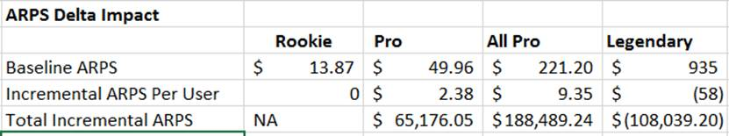

**Baseline ARPS:**

This is just the ARPS for the Cohort of players at each level who are not registered for MUT Rewards.

For example, Pro Players have a $49.96 ARPS

**Incremental ARPS Per User:**

Here I’m subtracting the MUT Rewards Cohort ARPS from the baseline ARPS.

Using Pro as an example again:

* Pro Player Baseline ARPS: $49.96
* MUT Rewards Pro Player ARPS: $52.34

**Total Incremental ARPS:**

Here I’m backing out incremental spenders from total spenders and then multiplying by the previously calculated incremental ARPS Per User.

Continuing with the Pro Example:

* Previously calculated Incremental ARPS Per User: $2.38
* Incremental Spenders previously calculated: 4,407
* Spenders who we saw a benefit from the incremental ARPS lift: 31,771 Total Pro spenders – 4,407 incremental spenders = 27,364
* Total Incremental ARPS: 27,364 users seeing a benefit from the incremental ARPS * $2.38 incremental ARPS per user = $65,176
* **Monetization: Top Spender Retention:**
  + **Pre-launch opportunity analysis:**
    - 8K players have opened 1,000+ packs
    - Players who open 1,000 packs are also our top spenders
    - ARPS for our top spenders is $1,877
  + **Actual Results as of 10/14/2015:**
    - The information below describes the impact of sending 778 players 2 copies of Madden NFL 16 1 week early.
    - **+$66K** incremental financial impact for the program (incremental impact calculation methodology described above):

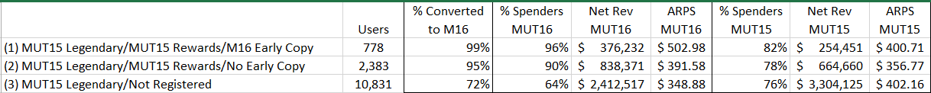



**Where are we at:**

* MUT Rewards launched in the US on 7/28
  + MUT Rewards was expanded to allow players outside the US to register on 10/6.
  + Non-US players only receive digital rewards, not physical
* 89K players have registered
  + 4,500 non-us players have registered since 10/6
* We have distributed the following rewards to players:
  + **08/25**: 778 players received 2 copies of Madden NFL 16 1 week early
  + **09/02:** MUT Coin Grant #1
    - Pro: 7,500 Coins
    - All-Pro: 15,000 Coins
    - Legendary: 25,000 Coins
  + **09/08:** NFL Tickets sent to 20 MUT Rewards members
  + **09/29:** 500 players received 1 copy of NBA Live 16 1 week early
  + **10/01:** MUT Contracts Grant:
    - Pro: 1,000 Contracts
    - All-Pro: 1,500 Contracts
    - Legendary: 2,500 Contracts
* See above for financial impact of the program in aggregate.

**How did we get here:**

* MUT Rewards launched in the US on 7/28
  + MUT Rewards was expanded to allow players outside the US to register on 10/6.
  + Non-US players only receive digital rewards, not physical
* 89K players have registered
  + 4,500 non-us players have registered since 10/6
* The vast majority of the work to launch this program was completed in 6 months by the team at Tiburon.
* See above for financial impact

**Where are we going:**

* + - * **Upcoming Activations:**
        + **(Mid-Nov):** Direct Mailer, 18K recipients, package focused on Draft Champions Ranked Launch, (includes $10 - $15 value to DC Ranked).
        + **Late October/Early November:** 2,000 XBOX One MUT Rewards players will receive up to 3, 1 month subscription codes for Early Access. The message will be “extend your membership by up to 3 months or share the EA Access experience with a friend”, similar to the message we delivered with the 2 early copies of Madden.
        + **Friday, October 23rd:** MUT Rewards players will receive Packs containing Most Feared content. Most Feared content is live in packs on 10/23, but Most Feared Packs do not launch until 10/24 so this is an opportunity for MUT Rewards members to start participating in the program immediately.
        + **TBD Pending EADP:** Taking steps to connect Mobile Rewards with MUT Rewards to connect those 2 "silo-ed platforms" and unlock full ecosystem view of player behavior
        + **TBD Pending EADP:** Exploring the ability to provide error messaging and prompting to the player when they enter an incorrect or invalid shipping address.

**Scope:**

**What games are in scope:**

Madden HD and Madden NFL Mobile

**What Channels are in scope:**

* Web
* On device
* Social Media

**Which customers are in scope:**

Players of Madden HD and Madden NFL Mobile

**Which Platforms are in scope:**

* Xbox 360
* Playstation 3
* XBOX ONE
* Playstation 4
* Iphone/Ipad
* Android Phones/Tablets
* Amazon Tablets/Phone

**Geographies:**

All Geographies where Madden HD and Madden NFL Mobile are sold and distributed.

**What is out of scope:**

Rewards programs for games other than Madden HD or Madden NFL Mobile

**Assumptions:**

* EA has the ability to reward content in game based on activity by the user on the web
* EA has the ability to track in game behavior, including telemetry and transactions for players within Madden HD and Madden NFL Mobile
* EA has the ability to add columns to the tables in the data warehouse that store Nucleus information
* EA has the ability to identify all players who have consumed an entitlement and received a given within the game

**Dependencies:**

We do not have any third party agreements that create dependencies for MUT Rewards.

**Risks:**

* Web to in game rewards: We must ensure that all players who register for MUT Rewards via the web are granted in game rewards appropriately

**User Stories:**

**User Story 1:**

**Summary:**

The purpose of this document is to describe the work required to integrate Madden NFL Mobile into MUT Rewards.

**User Stories:**

As a user, I need to be able to add my Madden NFL Mobile userId, located in the credits within the game, to my Nucleus account via the MUT Rewards profile update screen.

As a user, I need to be provided with information, in close proximity to the input field for Madden NFL Mobile userId, explaining how to navigate to and find my Madden NFL Mobile userId.



As a user I need to be able to associate IDs for multiple mobile games with a single EA (Nucleus) account.



As a marketer I need to be able to query Madden NFL Mobile userids from the MUT Rewards dataset.



As a marketer I need to be able to identify which mobile game a given ID is associated with.

**Requirements:**

* The user must be able to enter their Madden NFL Mobile userId into the profile update section for MUT Rewards
* The user’s Madden NFL Mobile userId must be stored in such a way that allows the marketing team to query MUT Rewards users and include Madden NFL Mobile userId in the output
* The form submitted by the web must append a two letter acronym to the beginning of the string entered by the user. In the future, this acronym will be used to identify which game the ID corresponds to.
  + For example, if the user arrives at [www.mutrewards.com](http://www.mutrewards.com) and enters the User ID 12345, the form will append and transmit MM12345 to the datawarehouse.
* The user must be able to associated multiple IDs with a single Nucleus ID, in the same way that a single user may associate multiple personas with a given Nucleus ID

**Mock Up Examples:**

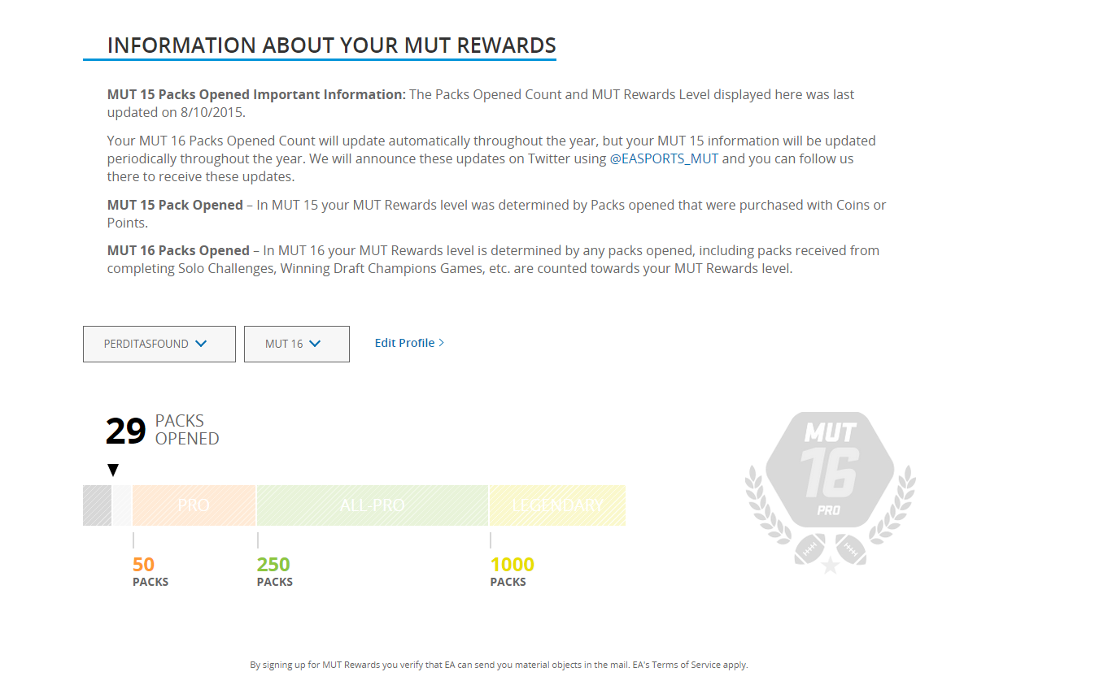

Link Madden NFL Mobile Account >

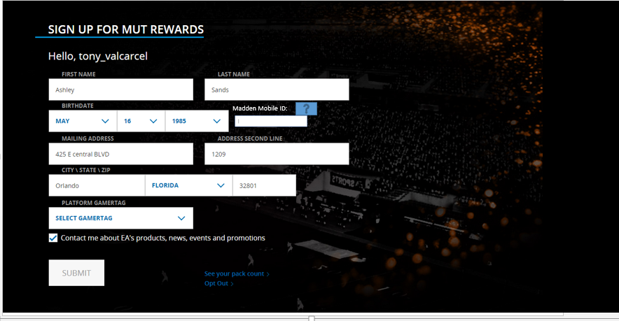

**User Story 2:**

**Summary:**

The purpose of this story is to describe the work required from the Pulse team in order to expand MUT Rewards to allow players to redeem a code form their profile page, triggering an in game reward the next time they log in.

**User Stories:**

As a user, I need to be able to input a code into a field and receive an in game reward the next time I log in.



As a user, I should receive confirmation that my code has been successfully redeemed, and what Gamertag it was redeemed for.



As a marketer I need to be able to understand how many people have inputted this code and successfully redeemed.



As a marketer I need to be able to create a database of Alphanumeric codes specific to individual promotions for redemption by players. For example, if we have two code programs running, one with Doritos and one with McDonald’s the set of codes available for each promotion would be unique, distinct, and trackable for each promotion.

**Requirements:**

* The user must be able to enter an alphanumeric code into an input field and receive an entitlement specific to that code. NOTE: I’m suggesting entitlements as the solution here because it seems like the best solution based on what I know about our systems. Looking for PULSE to advise if there is a better solution.
* Marketers must be able to create sets of codes specific to each promotion.
* Marketers must be able to query user information for players who have successfully redeemed the code

**Mock Up Examples:**

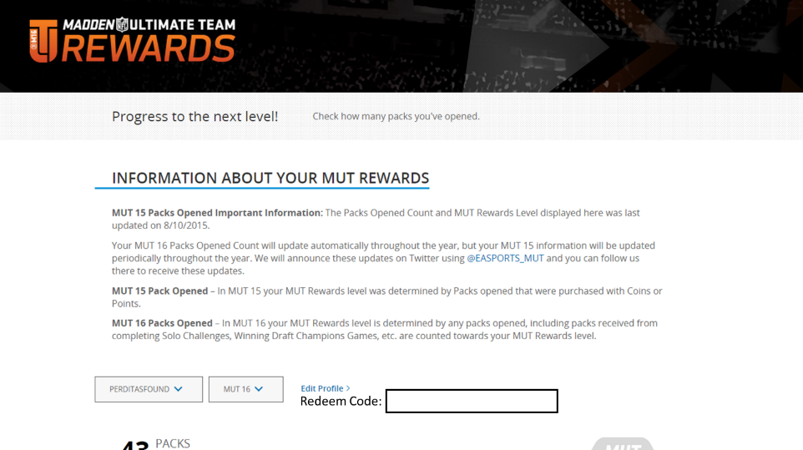

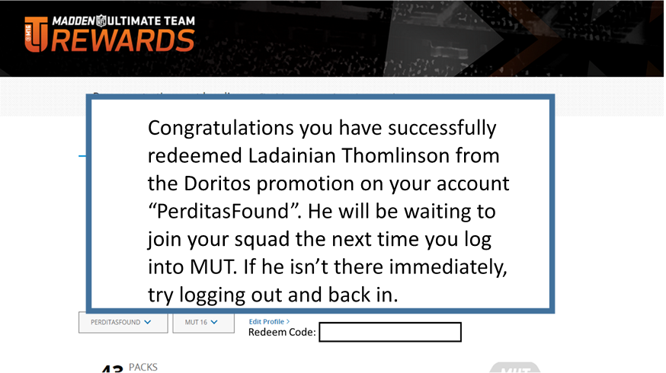

**User Story 3:**

**Summary:**

The purpose of this story is to describe the work required from the back office and EADP teams in order to expand MUT Rewards, and future Sports Franchise rewards programs, to allow Electronic Arts to pre-announce rewards that loyalty members are eligible to receive over the course of a full year, in advance of receiving those rewards.

**User Stories:**

As a user, I want to be able to understand the full offering of rewards across a rolling 6 month time period because I want to understand what rewards I will receive after joining.



As a marketer, I want to be able to clearly describe all scheduled rewards in a 6 month time period because I want players to understand what rewards they will receive when joining the Loyalty program.

**Requirements:**

* The user must have access to a cadence of rewards months in advance, including knowledge of rewards that cross quarters
* EA must properly account for this pre-announcement, eliminating the requirement to defer all quarterly revenue when pre-announcing rewards that cross quarters.

**High Concept:**

Madden NFL Ultimate Team users, on any Gen 3/Gen 4 console platform (Xbox 360, Xbox One, PS3, PS4) will visit a website containing a description of the MUT Rewards Loyalty Program. Users will also be able to log into their Origin account and sign up for MUT Rewards on this website. In doing so they will link their Nucleus and Blaze IDs, and be granted an entitlement allowing our game servers, and Nucleus to identify them as MUT Rewards Members. Upon successful sign up, users will receive an immediate in game reward for joining (more information below). Players will be assigned a “Level” based on the number of packs they have been opened, and rewards will vary based on MUT Rewards Level (more information below). Users will be able to opt out of this program by returning to the MUT Rewards website, logging in, and selecting the option to opt out. Users will be provided with progress information detailing the number of packs they have currently opened, and the number needed to progress to the next level of MUT Rewards, in addition to a ledger detailing past rewards granted. These features will be found in the user panel located on the MUT Rewards Website after the user logs in using their Origin ID.

Users will see this copy, on the website, prior to the sign up form:

**--Start Copy Example--**

**MADDEN ULTIMATE TEAM REWARDS:**

Join MUT Rewards today and start earning rewards for opening packs in Madden Ultimate Team. All packs you open will count towards your total.

MUT Rewards members can receive Coins, Packs, and other great surprises throughout the Madden season.

**REWARDS NOW AVAILABLE OUTSIDE THE UNITED STATES**

MUT Rewards is open to players both in the US and in countries outside of the US. Only players living in the US are eligible for physical rewards. Players located outside of the US are only eligible for Digital Rewards.

You’ll receive a Loyalty Badge just for signing up today, redeemable in Madden NFL 16 Ultimate Team for Packs, Player Items, and Contracts.

**WHAT MUT REWARDS HAVE PLAYERS RECEIVED?\***

* All players who signed up for MUT Rewards received a Loyalty Badge. Loyalty Badges could be redeemed in Madden NFL 16 Ultimate Team for Packs, Player Items, and Contracts.
* In September, select MUT Rewards players received early copies of NBA LIVE 16 shipped to them as a special reward.
* Early in August, two copies of Madden NFL 16 were sent to select MUT Rewards Legendary members.
* Later in that same month, a very few select MUT Rewards players received tickets to NFL football games as a reward for their Legendary level of participation.
* In September, MUT Rewards players who had reached Pro Level or higher received awards of 1,000 to 2,000 Contracts for their MUT accounts.

**MUT REWARDS LEVELS**

* There are three levels of MUT Rewards:
* Legendary Level: 1,000 Packs Opened – all packs count
* All-Pro Level: 250 Packs Opened – all packs count
* Pro level: 50 Packs Opened – all packs count
* Sign up below and start earning MUT Rewards today for opening packs in Madden Ultimate Team!
* *Rewards not guaranteed and are subject to change.

**Rewards Calendar:**

**July:**

All players who join MUT Rewards will receive an M16 Loyalty Badge immediately the next time they log into MUT.

**August:**

* Level 3: 2 early copies of Madden 16, delivered in custom packaging

**September:**

* Level 1: 2 sets of tickets for 2 randomly selected Level 1 MUT Rewards members for opening weekend games
* Level 2: 4 sets of tickets for 2 randomly selected Level 2 MUT Rewards members for opening weekend games
* Level 3: 10 sets of tickets for 2 randomly selected Level 3 MUT Rewards members for opening weekend games

**October:**

* Level 1: 5,000 Coins
* Level 2: 10,000 Coins
* Level 3: 25,000 Coins

**November:**

* Level 1: 250 contracts
* Level 2: 500 contracts
* Level 3: 1,000 contracts

**December:**

* Level 1: +5% Coins rewards for the month
* Level 2: +10% Coins rewards for the month
* Level 3: +15% Coins rewards for the month

*Users will clearly understand:*

* How to Join MUT Rewards
* How to progress through the levels of MUT Rewards
* What rewards they will receive as members of MUT Rewards and when they will receive them, regardless of the time between the user consuming this information and the delivery of the rewards.

**--End Copy Example--**

**Calendar of Rewards:**

Throughout the course of the year, and at any time, users will be able to visit a website, social media page, or other external marketing pages and receive a detailed calendar detailing the content and rewards that members of MUT Rewards will receive throughout the year. Users will consume this information throughout the year, the events on this calendar will span fiscal quarters and years. **See example above.**

**User Story 4:**

**Summary:**

The purpose of this story is to describe the work required from the back office and EADP teams in order to create the ability to take a loyalty program across all our Sports franchises so this includes NHL/UFC/FIFA HD Products on top of Madden/NBA and all our Mobile products

* + NHL wants to do something for NHL 17.  FIFA likely won’t be ready for FIFA 17 but still wants to participate throughout.  UFC would like to participate likely for UFC 3.  For our Mobile products excluding Madden Mobile, I still need to discuss this with Dan Box and his team.
  + The ability to track spend/loyalty status across multiple titles/franchises.  If there are people engaging across a lot of titles, we should be aware of this and track it.

**User Stories:**

As a user I want to be able to understand which Sports Loyalty programs I am a member of in a single view



As a user I want to be able to understand what my status is within individual Sports Loyalty programs in a single view



As a user I want to be able to understand what rewards I have received as a member of Sports Loyalty programs, both in aggregate and at the individual Sports Loyalty program level



As a user I want to be able to opt in or out of individual Sports Loyalty programs from a single location



As a user I want to be able to opt in or out of all Sports Loyalty programs in aggregate



As a marketer I want to be able to track players who are members of Loyalty programs across Sports franchises.



As a marketer I want to be able to understand the status of players across multiple Sports Loyalty programs



As a marketer I want to be able to track the rewards players have received across Loyalty programs



As a marketer I want to be able to track the amount of money players have spent in any games they are members of Loyalty programs for, both in aggregate and at the individual game level

**Requirements:**

* The user must be able to view which Sports Loyalty programs they are opted into from a single view
* The user must be able to view rewards they’ve received, both by Loyalty Program and in aggregate
* The marketer must be able to query users and break them into Cohorts based on:
  + Individual Sports Loyalty program participation
  + Multiple Sports Loyalty program participation
  + Aggregate Sports Loyalty program participation
  + Individual Sports Loyalty rewards
  + Multiple Sports Loyalty rewards
  + Aggregate Sports Loyalty rewards
  + Individual Sports Game spend
  + Aggregate Sports Game spend

**User Story 5:**

**Summary:**

The purpose of this story is to define requirements for incorporating other modes/functionality as part of a Rewards Program.

* + Here are some of the things we may want to track outside of just FUT packs opened: Engagement which could be Days/Hours played, matches played, logging in for successive days, total monetary spend, accomplishments, leaderboards, tournaments entered and even down the road, maybe items related to E-Sports

**User Stories:**

As a marketer I want to be able to be able to track telemetry within all game modes for a given game.

For example, within Madden we will want to be able to track telemetry within MUT, Draft Champions, or Draft Champions Ranked.

For example, within NBA Live we will want to be able to track telemetry within LUT and Pro-Am.

Within FIFA we will want to be able to track telemetry within:

Within NHL we will want to be able to track telemetry within:

Within UFC we will want to be able to track telemetry within:



As a marketer I want to be able to be able to track the following telemetry, at the user level and in aggregate, within a given game mode, within a given game:

* Days/Hours played
* Matches played
* Consecutive days with login sessions
* Money Spent
* Accomplishments/Achievements/Trophies
* Leaderboards
* Tournament participation
  + Registration
  + Competition
  + Viewership

**Requirements:**

* The user must be able to access this information via a web based UI, without executing SQL statements.

**User Story 6:**

**Summary:**

The purpose of this story is to describe the work required from the back office and EADP teams in order to create systemic, web based reporting for a loyalty program at the franchise level. This includes aggregate loyalty program reporting, in addition to individual reward cohort reporting.

An example of the current output being used by MUT Rewards can be found in the file “MUT_Rewards_Report_Example.xlsx”.

An example of an existing we based reporting suite within EA can be found here: <http://easportsbar.ea.com/Madden/UTForecastTrend>

<http://easportsbar.ea.com/Madden/UTEconomyChart>

**User Stories:**

As a marketer, I want to visit a website and generate reports regarding the performance of a franchise specific loyalty program where performance is measured by:

* Engagement with the game or specific mode by users in the Loyalty program vs. those not:
  + Logins
  + Packs Opened in UT
  + New to UT %
  + New to Franchise %
* Spend on/within the game:
  + Pre-order %
  + Spender Conversion %
  + Total Spenders
  + Total Revenue
  + ARPS
* Calculations:
  + Baseline Spenders
    - Calculated by multiplying number of spenders in a Cohort of Loyalty players (example in MUT Rewards the cohorts are broken out by the number of packs opened) by the conversion % of that same Cohort of players not registered for the Loyalty program
  + Incremental Spenders
    - Calculated by subtracting actual total spenders in a given Cohort of loyalty players by the Baseline Spenders identified above
  + Incremental Spender Conversion Revenue
    - Calculated by multiplying incremental spenders in a given Cohort of Loyalty players by the ARPS for that Loyalty Cohort
  + Incremental ARPS/User
    - Calculated by subtracting the ARPS of a given Cohort of Loyalty players by the ARPS of that same Cohort of players not registered for the Loyalty program
  + Incremental ARPS Delta Revenue
    - Calculated by first subtracting total spenders in a given Cohort of Loyalty players from the incremental spenders in a given Cohort of Loyalty players and then multiplying by the previously calculated Incremental ARPS/User.



As a marketer I want to be able to apply time filters to this reporting suite because I want to be able to examine snapshots of Loyalty program performance over time.



As a marketer I want to be able to input a PersonaId or UserId (NucleusId) and retrieve:

* + UserId
  + PersonaId
  + Platform (PS3, PS4, Xbox One, Xbox 360)
  + Packs Opened
  + Last Login Date



As a marketer I want to be able to export the raw data from any report generated within the Loyalty reporting UI as an Excel doc, or CSV.



As a marketer I want to be able to download data export files.



As a marketer I want to be able to email data export files.

**Requirements:**

* The user must be able to access this information via a web based UI, without executing SQL statements.
* The user must be able to input a UserId or PersonaId into a web based UI and retrieve:
  + UserId
  + PersonaId
  + Platform
  + Packs Opened
  + Last Login Date

**Example SQL being used to generate existing standardized reporting (**see MUT_Rewards_Report_Example.xlsx for output but note that this data may be outdated and should only be used as an example**):**

**Creating the tables needed to generate standard reporting:**

*-----------------------------------------------------------------------------------*

*--(1) Create record for new Rewards Grant in our dimension ("dim") table*

*-- Each time we grant any kind of reward, need to add a record to this table*

*-- We can keep a record of each insert if we comment out line once completed*

*-----------------------------------------------------------------------------------*

**INSERT** **INTO** SANDBOX.TV_REWARDS_GRANTS_DIM

(Grant_Id, Grant_Date, Description)

**VALUES**

(

*--1, '2015-08-18','MADDEN 16 Advance Copy'*

*--2, '2015-09-02','MUT 16 Coin Grant'*

*--3, '2015-09-08','NFL Tickets'*

*--4, '2015-09-23','NBA LIVE 16 Advance Copy'*

*--5, '2015-09-30','MUT 16 Contract Grant'*

*--6, '2015-10-23', 'MUT 16 MOST FEARED Grant'*

*--7, '2015-11-13'', 'MUT 16 RTTP Grant'*

*--8, '2015-11-24', 'MUT 16 DC Ranked DM Recips'*

)

*-----------------------------------------------------------------------------------*

*--(2) Clear out staging table to prepare for new upload*

*-----------------------------------------------------------------------------------*

**DELETE** **FROM** SANDBOX.TV_REWARDS_GRANTS_STAGE

*-----------------------------------------------------------------------------------*

*--(3) Prepare data files for upload*

*-- Will need either a Nucleus Id, Blaze Id or both*

*-- Remove any duplicate records*

*-- See examples in ...\Rewards Reporting 2.0\Rewards Grants Files*

*-- I usually create a separate upload file from the original data set*

*-----------------------------------------------------------------------------------*

*-----------------------------------------------------------------------------------------------------*

*--(4) Import data into the staging table.*

*--Make sure import file extension from .csv to .txt.*

*--Check Options->Import->"Ignore the first record in the import file (Skip Header),"*

*-- Or else delete header in export file from Madden servers.*

*--Go to File->Import Data and run query below.*

*-----------------------------------------------------------------------------------------------------*

**INSERT** **INTO** SANDBOX.TV_REWARDS_GRANTS_STAGE

(User_Account_Id, Persona_Id, Grant_Id)

**VALUES**

(

*--?,?,1 --MADDEN 16 Advance Copy. Source file: Rewards Reporting 2.0\Rewards Grants Files\01 - Madden 16 Advance Copy\UploadMadden16AdvanceCopy.txt*

*--0,?,2 --MUT 16 Coin Grant. Only have Persona Ids here. Will get Nucleus in later step. Source file: ..Rewards Reporting 2.0\Rewards Grants Files\02 - MUT 16 Coin Grant\UploadMut16CoinGrant.txt*

*--?,?,3 --NFL Tickers. Source file: ..Rewards Reporting 2.0\Rewards Grants Files\03 - NFL Tickets\UploadNflTickets.txt*

*--?,0,4 --NBA LIVE 16 Advance Copy. Only have Nucleus Ids, but that's all we need for reporting. Source file: ..Rewards Reporting 2.0\Rewards Grants Files\04 - NBA LIVE 16 Advance Copy\UploadNbaLive16AdvanceCohort.txt*

*--?,?,5 --MUT 16 Contract Grant. Source file: ..Rewards Reporting 2.0\Rewards Grants Files\05 - MUT 16 Contract Grant\UploadMut16ContractGrant.txt*

*--?,?,6 --MUT 16 Most Feared Grant. Source file: ..Rewards Reporting 2.0\Rewards Grants Files\06 - MUT 16 Most Feared Grant\10-23MFGrant.txt*

*--?,?,7 --'MUT 16 RTTP Grant' Source file: ..*

?,0,8 *--MUT 16 DC Ranked Direct Mailer Cohort. Source file:*

)

*-----------------------------------------------------------------------------------------------------*

*--(5a) Move data to "Production" table*

*-- When we already have Nucleus (Persona not required), use the query below*

*-----------------------------------------------------------------------------------------------------*

**MERGE** **INTO** SANDBOX.TV_REWARDS_GRANTS dest

**USING**

(

**SELECT**

grnt.User_Account_Id

, grnt.Persona_Id

, grnt.Grant_Id

**FROM** SANDBOX.TV_REWARDS_GRANTS_STAGE grnt

) src

**ON** src.User_Account_Id = dest.User_Account_Id

**AND** src.Persona_Id = dest.Persona_Id

**AND** src.Grant_Id = dest.Grant_Id

**WHEN** **NOT** **MATCHED** **THEN**

**INSERT**

(

User_Account_Id

,Persona_Id

,Grant_Id

)

**VALUES**

(

src.User_Account_Id

,src.Persona_Id

,src.Grant_Id

)

*-----------------------------------------------------------------------------------------------------*

*--(5b) Move data to "Production" table*

*-- When we only have Persona, use the query below*

*-----------------------------------------------------------------------------------------------------*

**MERGE** **INTO** SANDBOX.TV_REWARDS_GRANTS dest

**USING**

(

**SELECT**

pers.User_Account_Id

, grnt.Persona_Id

, grnt.Grant_Id

**FROM** SANDBOX.TV_REWARDS_GRANTS_STAGE grnt

**INNER** **JOIN** SPORTS_PUB.PERSONA pers

**ON** pers.Persona_Id = grnt.Persona_Id

**AND** pers.Persona_Ss_Code = 6 *--This is important for indexing purposes*

) src

**ON** src.User_Account_Id = dest.User_Account_Id

**AND** src.Persona_Id = dest.Persona_Id

**AND** src.Grant_Id = dest.Grant_Id

**WHEN** **NOT** **MATCHED** **THEN**

**INSERT**

(

User_Account_Id

,Persona_Id

,Grant_Id

)

**VALUES**

(

src.User_Account_Id

,src.Persona_Id

,src.Grant_Id

)

*-----------------------------------------------------------------------------------------------------*

*--Appendix I: Create Dimension (Dim) table*

*-----------------------------------------------------------------------------------------------------*

**CREATE** **MULTISET** **TABLE** SANDBOX.TV_REWARDS_GRANTS_DIM

,**NO** **FALLBACK**

,**NO** **BEFORE** **JOURNAL**

,**NO** **AFTER** **JOURNAL**,

**CHECKSUM** = **DEFAULT**

(

Grant_Id INTEGER

,Grant_Date DATE

,Description VARCHAR(500)

)

**UNIQUE** **PRIMARY** **INDEX** (Grant_Id)**;**

*-----------------------------------------------------------------------------------------------------*

*--Appendix II: Create staging table for Grants*

*-----------------------------------------------------------------------------------------------------*

**CREATE** **MULTISET** **TABLE** SANDBOX.TV_REWARDS_GRANTS_STAGE

,**NO** **FALLBACK**

,**NO** **BEFORE** **JOURNAL**

,**NO** **AFTER** **JOURNAL**,

**CHECKSUM** = **DEFAULT**

(

User_Account_Id DECIMAL(38,0)

,Persona_Id DECIMAL(38,0)

,Grant_Id INTEGER

)

*-----------------------------------------------------------------------------------------------------*

*--Appendix III: Create "Production" Grants table*

*-----------------------------------------------------------------------------------------------------*

**CREATE** **MULTISET** **TABLE** SANDBOX.TV_REWARDS_GRANTS

,**NO** **FALLBACK**

,**NO** **BEFORE** **JOURNAL**

,**NO** **AFTER** **JOURNAL**,

**CHECKSUM** = **DEFAULT**

(

User_Account_Id DECIMAL(38,0)

,Persona_Id DECIMAL(38,0)

,Grant_Id INTEGER

)

**UNIQUE** **PRIMARY** **INDEX** (User_Account_Id, Persona_Id, Grant_Id)**;**

**Standard Reporting Queries:**

**Aggregate Report (All MUT Rewards Users):**

**SELECT**

SUBSTR(Tier,3) **AS** Tier

,Rewards_User

*--,Received_Grant*

,SUM(Current_MUT_Acquired) **AS** MUT_Acquired_Users

, AVERAGE(Packs_Opened) **AS** Avg_Packs_Opened

, AVERAGE(MUT_Logins) **AS** Avg_MUT_Logins

, AVERAGE(Current_MUT_Spender) **AS** Perc_Spenders

, 1-AVERAGE(Returning_MUT_Acquired) **AS** Perc_New_MUT

, 1-AVERAGE(Returning_Madden) **AS** Perc_New_Madden

, SUM(Current_MUT_Spender) **AS** Total_Spenders

, SUM(Net_Rev) **AS** Cohort_Net_Rev

, SUM(Net_Rev)/SUM(Current_MUT_Spender) **AS** Cohort_ARPS

*--, AVERAGE(Post_Grant_Login) AS Perc_Post_Grant_Login*

*--, AVERAGE(Post_Grant_Spend) AS Perc_Post_Spend_Login*

**FROM**

(

**SELECT**

users.User_Account_Id

,users.Packs_Opened

,users.Rewards_User

,**CASE** **WHEN** prevOwner.User_Account_Id **IS** **NOT** **NULL** **THEN** 1 **ELSE** 0 **END** **AS** Returning_Madden

,**CASE** **WHEN** curMUT.User_Account_Id **IS** **NOT** **NULL** **THEN** 1 **ELSE** 0 **END** **AS** Current_MUT_Acquired

,**CASE** **WHEN** prevMUT.User_Account_Id **IS** **NOT** **NULL** **THEN** 1 **ELSE** 0 **END** **AS** Returning_MUT_Acquired

,**CASE** **WHEN** curSpender.User_Account_Id **IS** **NOT** **NULL** **THEN** 1 **ELSE** 0 **END** **AS** Current_MUT_Spender

,MUT_Logins

,Last_MUT_Login

*--,CASE WHEN Last_MUT_Login >= grantsDim.Grant_Date THEN 1 ELSE 0 END AS Post_Grant_Login*

*--,CASE WHEN Last_Spend_Date >= grantsDim.Grant_Date THEN 1 ELSE 0 END AS Post_Grant_Spend*

,curSpender.Net_Rev

*-- ,CASE WHEN grants.User_Account_Id IS NOT NULL THEN 1 ELSE 0 END AS Received_Grant*

*-- ,grantsDim.Grant_Date*

,**CASE**

**WHEN** users.Packs_Opened < 50 **THEN** '0_Rookie'

**WHEN** users.Packs_Opened >= 50 **AND** users.Packs_Opened < 250 **THEN** '1_Pro'

**WHEN** users.Packs_Opened >= 250 **AND** users.Packs_Opened < 1000 **THEN** '2_All-Pro'

**WHEN** users.Packs_Opened >= 1000 **THEN** '3_Legendary'

**END** **AS** Tier

**FROM**

(

*--Get Packs Opened*

**SELECT**

packs.User_Account_Id

,packs.User_Account_Ss_Code

,packs.Master_Ttl_Name

,**CASE** **WHEN** rewards.User_Account_Id **IS** **NOT** **NULL** **THEN** 1 **ELSE** 0 **END** **AS** Rewards_User

,SUM(packs.Num_Data) **AS** Packs_Opened

**FROM** SPORTS_PUB.USER_EVENT packs

*--Get MUT Rewards Users*

**LEFT** **OUTER** **JOIN** SPORTS_PUB.REDEEMED_RPTG rewards

**ON** packs.User_Account_Id = rewards.User_Account_Id

**AND** packs.User_Account_Ss_Code = rewards.User_Account_Ss_Code

**AND** packs.Master_Ttl_Name = rewards.Master_Ttl_Name

**AND** rewards.Redeem_Offer_Id = '156'

**AND** **CAST**(rewards.Redeem_Timestamp **AS** DATE) >= '2015-08-15'

*--Filters for Packs Opened table*

**WHERE** packs.Event_Complete_Date >= '2015-08-15'

**AND** packs.Master_Ttl_Name = 'MADDEN 16'

**AND** packs.Category_Id = 7

**AND** packs.Event_Name = 'UT Packs Opened Count'

**GROUP** **BY** packs.User_Account_Id, packs.User_Account_Ss_Code, packs.Master_Ttl_Name, Rewards_User

) users

*--Inner Join to MUT16 acquired users*

*--The Inner Join will filter the report to Acquired users only*

**INNER** **JOIN** SPORTS_PUB.UT_USER_ENGAGEMENT curMUT

**ON** users.User_Account_Id = curMUT.User_Account_Id

**AND** users.User_Account_Ss_Code = curMUT.User_Account_Ss_Code

**AND** users.Master_Ttl_Name = curMUT.Master_Ttl_Name

**AND** curMUT.First_Acquired_Dt >= '2015-08-15'

*--Check if user has owned any previous Madden titles*

**LEFT** **OUTER** **JOIN** SPORTS_PUB.PRODUCT_ASSOC_MASTER_TTL prevOwner

**ON** users.User_Account_Id = prevOwner.User_Account_Id

**AND** users.User_Account_Ss_Code = prevOwner.User_Account_Ss_Code

**AND** prevOwner.Online_Access_Dt >= '2007-10-14'

**AND** prevOwner.Online_Access_Dt < '2015-08-15'

**AND** prevOwner.Master_Ttl_Name **IN** ('MADDEN 2008','MADDEN 2009','MADDEN 2010','MADDEN 2011','MADDEN 2012','MADDEN 2013','MADDEN 14','MADDEN 15')

*--Check if user has ever been Acquired in a previous MUT*

**LEFT** **OUTER** **JOIN** SPORTS_PUB.UT_USER_ENGAGEMENT prevMUT

**ON** users.User_Account_Id = prevMUT.User_Account_Id

**AND** users.User_Account_Ss_Code = prevMUT.User_Account_Ss_Code

**AND** prevMUT.First_Acquired_Dt >= '2010-08-10'

**AND** prevMUT.First_Acquired_Dt < '2015-08-15'

**AND** prevMUT.Master_Ttl_Name **IN** ('MADDEN 2011','MADDEN 2012','MADDEN 2013','MADDEN 14','MADDEN 15')

*--Get Net Rev*

*--Doing a full sub-select due to multiple records per user. A little inefficient, but clean*

**LEFT** **OUTER** **JOIN**

(

**SELECT**

User_Account_Id

, User_Account_Ss_Code

, Master_Ttl_Name

, SUM(Estimated_Price_Net) **AS** Net_Rev

, MAX(Purchase_Date) **AS** Last_Spend_Date

**FROM** SPORTS_PUB.PDLC_PURCHASE_RPTG_DAILY

**WHERE** Purchase_Date >= '2015-08-15'

**AND** Master_Ttl_Name = 'MADDEN 16'

**GROUP** **BY** User_Account_Id, User_Account_Ss_Code, Master_Ttl_Name

) curSpender

**ON** users.User_Account_Id = curSpender.User_Account_Id

**AND** users.User_Account_Ss_Code = curSpender.User_Account_Ss_Code

**AND** users.Master_Ttl_Name = curSpender.Master_Ttl_Name

*--Get UT Logins*

*--Doing a full sub-select to get last login. A little inefficient, but clean*

**LEFT** **OUTER** **JOIN**

(

**SELECT**

User_Account_Id

, User_Account_Ss_Code

, Master_Ttl_Name

, COUNT(**DISTINCT**(Login_Dt)) **AS** MUT_Logins

, MAX(Login_Dt) **AS** Last_MUT_Login

**FROM** SPORTS_PUB.UT_USER_LOGIN

**WHERE** Login_Dt >= '2015-08-15'

**AND** Master_Ttl_Name = 'MADDEN 16'

**GROUP** **BY** User_Account_Id, User_Account_Ss_Code, Master_Ttl_Name

) mutLogins

**ON** users.User_Account_Id = mutLogins.User_Account_Id

**AND** users.User_Account_Ss_Code = mutLogins.User_Account_Ss_Code

**AND** users.Master_Ttl_Name = mutLogins.Master_Ttl_Name

*--Add a filter for Rewards Grants*

*--Set to -1 if we don't want to look at any specific grants*

*--Or comment out block*

*-- INNER JOIN*

*--(*

*-- SELECT Grant_Date, Grant_Id*

*-- FROM SANDBOX.TV_REWARDS_GRANTS_DIM*

*-- WHERE Grant_Id = -1*

*--) grantsDim*

*-- ON 1=1*

*--Now join to see which users received grant*

*-- LEFT OUTER JOIN SANDBOX.TV_REWARDS_GRANTS grants*

*-- ON users.User_Account_Id = grants.User_Account_Id*

*-- AND grants.Grant_Id = grantsDim.Grant_Id*

**GROUP** **BY**

users.User_Account_Id

, users.Packs_Opened

, users.Rewards_User

, Returning_Madden

, Current_MUT_Acquired

, Returning_MUT_Acquired

, Current_MUT_Spender

, curSpender.Net_Rev

*-- , Received_Grant*

*-- , grantsDim.Grant_Date*

, MUT_Logins

, Last_MUT_Login

, Last_Spend_Date

, Tier

) tbl

**GROUP** **BY** Rewards_User, Tier*--, Received_Grant,*

**ORDER** **BY** Rewards_User, Tier*--, Received_Grant,*

**Filtered Report (Specific to the Cohort of users who benefited from a specific reward):**

*-- Change Lines 125,144,177 for each grant*

**SELECT**

SUBSTR(Tier,3) **AS** Tier

,Rewards_User

,Received_Grant

,SUM(Current_MUT_Acquired) **AS** MUT_Acquired_Users

,AVERAGE(Packs_Opened) **AS** Avg_Packs_Opened

,AVERAGE(MUT_Logins) **AS** Avg_MUT_Logins

,AVERAGE(Current_MUT_Spender) **AS** Perc_Spenders

,1-AVERAGE(Returning_MUT_Acquired) **AS** Perc_New_MUT

,1-AVERAGE(Returning_Madden) **AS** Perc_New_Madden

,SUM(Current_MUT_Spender) **AS** Total_Spenders

,SUM(Net_Rev) **AS** Cohort_Net_Rev

,SUM(Pre_Net_Rev) **AS** Cohort_Pre_Net_Rev

,SUM(Post_Net_Rev) **AS** Cohort_Post_Net_Rev

,SUM(Net_Rev)/SUM(Current_MUT_Spender) **AS** Cohort_ARPS

,AVERAGE(Post_Grant_Login) **AS** Perc_Post_Grant_Login

,AVERAGE(Post_Grant_Spend) **AS** Perc_Post_Spend_Login

**FROM**

(

**SELECT**

users.User_Account_Id

,users.Packs_Opened

,users.Rewards_User

,CRPre.Pre_Net_Rev

,CRPost.Post_Net_Rev

,**CASE** **WHEN** prevOwner.User_Account_Id **IS** **NOT** **NULL** **THEN** 1 **ELSE** 0 **END** **AS** Returning_Madden

,**CASE** **WHEN** curMUT.User_Account_Id **IS** **NOT** **NULL** **THEN** 1 **ELSE** 0 **END** **AS** Current_MUT_Acquired

,**CASE** **WHEN** prevMUT.User_Account_Id **IS** **NOT** **NULL** **THEN** 1 **ELSE** 0 **END** **AS** Returning_MUT_Acquired

,**CASE** **WHEN** curSpender.User_Account_Id **IS** **NOT** **NULL** **THEN** 1 **ELSE** 0 **END** **AS** Current_MUT_Spender

,MUT_Logins

,Last_MUT_Login

,**CASE** **WHEN** Last_MUT_Login >= grantsDim.Grant_Date **THEN** 1 **ELSE** 0 **END** **AS** Post_Grant_Login

,**CASE** **WHEN** Last_Spend_Date >= grantsDim.Grant_Date **THEN** 1 **ELSE** 0 **END** **AS** Post_Grant_Spend

,curSpender.Net_Rev

,**CASE** **WHEN** grants.User_Account_Id **IS** **NOT** **NULL** **THEN** 1 **ELSE** 0 **END** **AS** Received_Grant

,grantsDim.Grant_Date

,**CASE**

**WHEN** users.Packs_Opened < 50 **THEN** '0_Rookie'

**WHEN** users.Packs_Opened >= 50 **AND** users.Packs_Opened < 250 **THEN** '1_Pro'

**WHEN** users.Packs_Opened >= 250 **AND** users.Packs_Opened < 1000 **THEN** '2_All-Pro'

**WHEN** users.Packs_Opened >= 1000 **THEN** '3_Legendary'

**END** **AS** Tier

**FROM**

(

*--Get Packs Opened*

**SELECT**

packs.User_Account_Id

,packs.User_Account_Ss_Code

,packs.Master_Ttl_Name

,**CASE** **WHEN** rewards.User_Account_Id **IS** **NOT** **NULL** **THEN** 1 **ELSE** 0 **END** **AS** Rewards_User

,SUM(packs.Num_Data) **AS** Packs_Opened

**FROM** SPORTS_PUB.USER_EVENT packs

*--Get MUT Rewards Users*

**LEFT** **OUTER** **JOIN** SPORTS_PUB.REDEEMED_RPTG rewards

**ON** packs.User_Account_Id = rewards.User_Account_Id

**AND** packs.User_Account_Ss_Code = rewards.User_Account_Ss_Code

**AND** packs.Master_Ttl_Name = rewards.Master_Ttl_Name

**AND** rewards.Redeem_Offer_Id = '156'

**AND** **CAST**(rewards.Redeem_Timestamp **AS** DATE) >= '2015-08-15'

*--Filters for Packs Opened table*

**WHERE** packs.Event_Complete_Date >= '2015-08-15'

**AND** packs.Master_Ttl_Name = 'MADDEN 16'

**AND** packs.Category_Id = 7

**AND** packs.Event_Name = 'UT Packs Opened Count'

**GROUP** **BY** packs.User_Account_Id, packs.User_Account_Ss_Code, packs.Master_Ttl_Name, Rewards_User

) users

*--Inner Join to MUT16 acquired users*

*--The Inner Join will filter the report to Acquired users only*

**INNER** **JOIN** SPORTS_PUB.UT_USER_ENGAGEMENT curMUT

**ON** users.User_Account_Id = curMUT.User_Account_Id

**AND** users.User_Account_Ss_Code = curMUT.User_Account_Ss_Code

**AND** users.Master_Ttl_Name = curMUT.Master_Ttl_Name

**AND** curMUT.First_Acquired_Dt >= '2015-08-15'

*--Check if user has owned any previous Madden titles*

**LEFT** **OUTER** **JOIN** SPORTS_PUB.PRODUCT_ASSOC_MASTER_TTL prevOwner

**ON** users.User_Account_Id = prevOwner.User_Account_Id

**AND** users.User_Account_Ss_Code = prevOwner.User_Account_Ss_Code

**AND** prevOwner.Online_Access_Dt >= '2007-10-14'

**AND** prevOwner.Online_Access_Dt < '2015-08-15'

**AND** prevOwner.Master_Ttl_Name **IN** ('MADDEN 2008','MADDEN 2009','MADDEN 2010','MADDEN 2011','MADDEN 2012','MADDEN 2013','MADDEN 14','MADDEN 15')

*--Check if user has ever been Acquired in a previous MUT*

**LEFT** **OUTER** **JOIN** SPORTS_PUB.UT_USER_ENGAGEMENT prevMUT

**ON** users.User_Account_Id = prevMUT.User_Account_Id

**AND** users.User_Account_Ss_Code = prevMUT.User_Account_Ss_Code

**AND** prevMUT.First_Acquired_Dt >= '2010-08-10'

**AND** prevMUT.First_Acquired_Dt < '2015-08-15'

**AND** prevMUT.Master_Ttl_Name **IN** ('MADDEN 2011','MADDEN 2012','MADDEN 2013','MADDEN 14','MADDEN 15')

*--Get Net Rev*

*--Doing a full sub-select due to multiple records per user. A little inefficient, but clean*

**LEFT** **OUTER** **JOIN**

(

**SELECT**

User_Account_Id

,User_Account_Ss_Code

,Master_Ttl_Name

,SUM(Estimated_Price_Net) **AS** Net_Rev

,MAX(Purchase_Date) **AS** Last_Spend_Date

**FROM** SPORTS_PUB.PDLC_PURCHASE_RPTG_DAILY

**WHERE** Purchase_Date >= '2015-08-15'

**AND** Master_Ttl_Name = 'MADDEN 16'

**GROUP** **BY** User_Account_Id, User_Account_Ss_Code, Master_Ttl_Name

) curSpender

**ON** users.User_Account_Id = curSpender.User_Account_Id

**AND** users.User_Account_Ss_Code = curSpender.User_Account_Ss_Code

**AND** users.Master_Ttl_Name = curSpender.Master_Ttl_Name

*--Get Pre Net Rev*

*--Doing a full sub-select due to multiple records per user. A little inefficient, but clean*

**LEFT** **OUTER** **JOIN**

(

**SELECT**

User_Account_Id

,User_Account_Ss_Code

,Master_Ttl_Name

,SUM(Estimated_Price_Net) **AS** Pre_Net_Rev

,MAX(Purchase_Date) **AS** Pre_Last_Spend_Date

**FROM** SPORTS_PUB.PDLC_PURCHASE_RPTG_DAILY

**WHERE** Purchase_Date <= '2015-09-22' *-- Change this for each grant*

**AND** Master_Ttl_Name = 'MADDEN 16'

**GROUP** **BY** User_Account_Id, User_Account_Ss_Code, Master_Ttl_Name

) CRPre

**ON** users.User_Account_Id = CRPre.User_Account_Id

**AND** users.User_Account_Ss_Code = CRPre.User_Account_Ss_Code

**AND** users.Master_Ttl_Name = CRPre.Master_Ttl_Name

*--Get Post Net Rev*

*--Doing a full sub-select due to multiple records per user. A little inefficient, but clean*

**LEFT** **OUTER** **JOIN**

(

**SELECT**

User_Account_Id

,User_Account_Ss_Code

,Master_Ttl_Name

,SUM(Estimated_Price_Net) **AS** Post_Net_Rev

,MAX(Purchase_Date) **AS** Post_Last_Spend_Date

**FROM** SPORTS_PUB.PDLC_PURCHASE_RPTG_DAILY

**WHERE** Purchase_Date >= '2015-11-25' *-- Change this for each grant*

**AND** Master_Ttl_Name = 'MADDEN 16'

**GROUP** **BY** User_Account_Id, User_Account_Ss_Code, Master_Ttl_Name

) CRPost

**ON** users.User_Account_Id = CRPost.User_Account_Id

**AND** users.User_Account_Ss_Code = CRPost.User_Account_Ss_Code

**AND** users.Master_Ttl_Name = CRPost.Master_Ttl_Name

*--Get UT Logins*

*--Doing a full sub-select to get last login. A little inefficient, but clean*

**LEFT** **OUTER** **JOIN**

(

**SELECT**

User_Account_Id

, User_Account_Ss_Code

, Master_Ttl_Name

, COUNT(**DISTINCT**(Login_Dt)) **AS** MUT_Logins

, MAX(Login_Dt) **AS** Last_MUT_Login

**FROM** SPORTS_PUB.UT_USER_LOGIN

**WHERE** Login_Dt >= '2015-08-15'

**AND** Master_Ttl_Name = 'MADDEN 16'

**GROUP** **BY** User_Account_Id, User_Account_Ss_Code, Master_Ttl_Name

) mutLogins

**ON** users.User_Account_Id = mutLogins.User_Account_Id

**AND** users.User_Account_Ss_Code = mutLogins.User_Account_Ss_Code

**AND** users.Master_Ttl_Name = mutLogins.Master_Ttl_Name

*--Add a filter for Rewards Grants*

*--Set to -1 if we don't want to look at any specific grants*

*--Or comment out block*

**INNER** **JOIN** (

**SELECT** Grant_Date, Grant_Id

**FROM** SANDBOX.TV_REWARDS_GRANTS_DIM

**WHERE** Grant_Id = 4 *-- Change this for each grant*

) grantsDim **ON** 1=1

*--Now join to see which users received grant*

**LEFT** **OUTER** **JOIN** SANDBOX.TV_REWARDS_GRANTS grants

**ON** users.User_Account_Id = grants.User_Account_Id

**AND** grants.Grant_Id = grantsDim.Grant_Id

**GROUP** **BY**

users.User_Account_Id

,users.Packs_Opened

,users.Rewards_User

,Returning_Madden

,Current_MUT_Acquired

,Returning_MUT_Acquired

,Current_MUT_Spender

,curSpender.Net_Rev

,CRPre.Pre_Net_Rev

,CRPost.Post_Net_Rev

,Received_Grant

,grantsDim.Grant_Date

,MUT_Logins

,Last_MUT_Login

,Last_Spend_Date

,Tier

) tbl

**GROUP** **BY** Rewards_User, Tier, Received_Grant

**ORDER** **BY** Rewards_User, Tier, Received_Grant

**BlazeId, Platform Code, Packs Opened, Last Login Query:**

**SELECT**

blazeId,

#1 #PS3

#2 #PS4

#3 #XB1

4 #XB360

**AS** platformCode

,packsOpened

,**CAST**(lastLogin **AS** DATE) **AS** lastLogin

**FROM** ut_userdata

**WHERE** lastLogin >= '2015-08-05 00:00:00'

**AND** blazeID = 1217040527