Multimodal Parkinson’s Disease Detection Using
Cross-Modal Attention Fusion of Handwriting and Speech Biomarkers
Tanguturi Venkata Thanuj  22BCE20003  venkata.22bce20003@vitapstudent.ac.in | Katam Krishna Chaitanya  22BCE7359  krishna.22bce7359@vitapstudent.ac.in | Pathakuntla Narendar Reddy  22BCE7707  narendar.22bce7707@vitapstudent.ac.in

Abstract—Parkinson’s Disease (PD) is the second most prevalent neurodegenerative disorder worldwide, affecting over 10 million people. Traditional diagnosis relies on subjective clinical rating scales and expensive neuroimaging (DaTSCAN), limiting accessibility in resource-constrained settings. This paper presents a multimodal deep learning framework for non-invasive PD screening via handwriting and speech biomarkers. Three synergistic modules are integrated: (1) a handwriting analysis engine using EfficientNet-B0 + CBAM with 16 spatial biomarkers achieving 93.6% accuracy (AUC 0.985); (2) a speech analysis engine using XLS-R 300M + cross-attention fusion achieving 91.7% accuracy (AUC 0.971); and (3) a novel Cross-Modal Attention Fusion Network (CMAFN) with bidirectional Transformer cross-attention and a Gated Multimodal Unit achieving 96.9% accuracy and 0.999 AUC-ROC—surpassing all prior handwriting+speech multimodal approaches. Patient-level stratified 5-fold cross-validation prevents data leakage. All modules are deployed as real-time Flask web applications requiring no GPU.
Index Terms—Parkinson’s Disease, Multimodal Deep Learning, Cross-Modal Attention, EfficientNet, XLS-R, Handwriting Biomarkers, Speech Analysis, Gated Multimodal Unit, Transfer Learning, CBAM.
I. Introduction
PARKINSON’S Disease (PD) is the second most prevalent neurodegenerative condition globally, characterised by progressive loss of dopaminergic neurons in the substantia nigra pars compacta. Cardinal motor symptoms—resting tremor, rigidity, bradykinesia, and postural instability—emerge only after 60–80% of these neurons are irreversibly lost [1], making early detection critical for therapeutic efficacy.
Over 10 million people worldwide are affected, with prevalence projected to double by 2040. The annual economic burden exceeds $52 billion in the United States alone. Despite decades of research, no curative treatment exists, underscoring the need for accessible, scalable, and non-invasive early detection tools.
Conventional diagnosis uses the Unified Parkinson's Disease Rating Scale (UPDRS) and DaTSCAN neuroimaging ($1,500–$4,000 per scan). These are subjective, costly, and reliable only at late stages when neuronal loss is already severe.
Non-invasive biomarkers derived from handwriting (micrographia) and speech (dysarthria, hypophonia) offer a compelling, low-cost alternative capturable with consumer hardware. Handwriting reflects peripheral fine motor control; speech reflects central phonatory function—they are mechanistically complementary, and a system jointly modelling both is expected to substantially outperform either alone.
A. Contributions
[C1] A 16-feature spatial biomarker framework for handwriting analysis covering morphological, geometric, statistical, and complexity-based measures via OpenCV image processing.
[C2] A multi-pathway speech DL model fusing XLS-R 300M self-supervised representations, mel-spectrogram CNNs, MFCC features, and Praat acoustic measures via cross-attention (91.7% accuracy).
[C3] CMAFN: bidirectional Transformer cross-attention + Gated Multimodal Unit achieving 96.9% accuracy, 0.999 AUC-ROC—state-of-the-art for handwriting+speech PD detection.
[C4] Patient-level group k-fold cross-validation with no speaker leakage across all experiments.
[C5] Fully deployed Flask web applications; <3 s end-to-end inference, no GPU required.

II. Related Work
A. Handwriting-Based Detection
The analysis of handwriting as a clinical biomarker for Parkinson’s Disease dates back to early observations of micrographia—the characteristic reduction in letter size and writing speed associated with dopaminergic deficits. Computational approaches began with kinematic analysis of pen movements on digitising tablets. Zham et al. (2017) extracted velocity, acceleration, and pressure features, achieving 87.4% accuracy using Support Vector Machines (SVM). While effective, digitising tablet requirements limited clinical deployability.
The introduction of the NewHandPD dataset by Pereira et al. (2018) democratised image-based approaches. Their AlexNet fine-tuning baseline achieved 85.0% accuracy on spiral and meander drawings [1]. Kumar et al. [2] improved this to 87.2% using ResNet50 with ImageNet pre-training, demonstrating the value of deeper architectures on small medical datasets. Zhang et al. [3] explored EfficientNet-B3 with aggressive augmentation (mixup, cutmix, random erasing) achieving competitive results with improved generalisation. Liu et al. [4] pursued ensemble strategies combining ResNet, VGG, and Inception via majority voting, reaching 88.8% accuracy. Gupta and Mishra [5] demonstrated the utility of GAN-based augmentation using StyleGAN2 with DenseNet121, partially mitigating limited dataset sizes.
The milestone spatial attention work of Li et al. [6] reached 90.1% accuracy on the combined NewHandPD+PaHaW datasets by introducing custom spatial attention CNNs that selectively focus on tremor-affected stroke regions—the prior state-of-the-art that our stacking ensemble surpasses by +3.47 pp. Kim et al. [7] explored multi-task learning for simultaneous PD detection and UPDRS severity estimation, while Ahmed et al. [8] contributed GradCAM-based explainability essential for clinical trust. Despite this progress, no prior handwriting work integrates complementary spatial biomarker engineering with deep learning stacking at our scale and methodological rigour.
B. Speech-Based Detection
Speech biomarker research for PD spans from acoustic voice quality features to contemporary self-supervised learning models. The foundational work of Little et al. (2009) demonstrated that jitter, shimmer, and harmonics-to-noise ratio (HNR) extracted using Praat are highly sensitive PD indicators, establishing MFCC+SVM as the dominant baseline achieving ~86% accuracy on the Oxford PD Voice dataset (195 recordings, 31 patients).
Tsanas et al. [12] extended the feature set to 132 acoustic measures, showing XGBoost achieves 86.7% accuracy and arguing for principled feature engineering when training data is scarce—a finding confirmed by Sharma and Chakraborty [13] using mel-spectrogram ResNet18. Wang et al. [9] demonstrated 1D-CNN effectiveness on raw MFCC sequences (83.6%), while Sakar et al. [11] obtained 84.2% with CNN-BiLSTM hybrids on spectrograms. Ferrario et al. [10] applied full speech Transformers (85.3%), and Orozco-Arroyave et al. [15] combined jitter-shimmer with DNNs for voice quality-focused assessment.
The transformative advance came with self-supervised speech pre-training. Orobic et al. [14] showed Wav2Vec 2.0 fine-tuning achieves 86.8% accuracy even with limited labelled data, outperforming all supervised approaches on the same dataset. Mughal et al. [16] applied Capsule Networks on MFCC+prosody features, achieving 84.5%. Our speech module advances this state-of-the-art by integrating XLS-R 300M—trained on 436K hours across 128 languages, far exceeding Wav2Vec 2.0—with a hybrid DL+ML stacking meta-learner, reaching 91.7% with strict patient-level cross-validation, surpassing all prior works by ≥2.2 percentage points.
C. Multimodal Fusion Approaches
Multimodal PD detection research is nascent but rapidly growing. Zhang et al. [17] combined gait accelerometer signals and speech features via late-fusion CNN+LSTM, demonstrating that modality combination consistently outperforms unimodal approaches (91.2% accuracy). Ren et al. [18] explored handwriting+MRI fusion via early-fusion ResNet and 3D-CNN (89.4%), though MRI requirements limit deployment scope. Quan et al. [19] combined speech and facial expression analysis via cross-attention fusion (88.6%), while Park et al. [21] explored MAML-based meta-learning for cross-modality generalisation.
The highest prior multimodal result was achieved by Vasquez-Correa et al. [20] using a hierarchical fusion network spanning three modalities (gait, speech, handwriting), reaching 94.3% accuracy. Our CMAFN surpasses this three-modal system by +2.64 pp using only two modalities—handwriting and speech—demonstrating that architectural sophistication (bidirectional cross-modal attention) can outcompete additional modality breadth. Critically, no prior multimodal work models explicit bidirectional Transformer cross-attention between handwriting and speech, enables learnable modality dropout for graceful degradation, or provides calibrated uncertainty estimates via Monte Carlo Dropout.

TABLE I — Comparative Survey of PD Detection Literature
Study | Modality | Method | Acc. | AUC
Pereira 2018 [1] | HW | CNN (AlexNet) | 85.0% | —
Li et al. [6] | HW | Spatial Attn-CNN | 90.1% | —
Sakar 2019 [11] | Speech | SVM + MFCC | 86.0% | 0.91
Orobic [14] | Speech | Wav2Vec 2.0 | 86.8% | 0.93
Mughal [16] | Speech | CapsNet + MFCC | 84.5% | —
V-Correa [20] | Multi(3) | Hierarchical Fusion | 94.3% | —
This Work: HW | HW | EffNet-B0+CBAM+Stack | 93.6% | 0.985
This Work: Speech | Speech | XLS-R+Cross-Attn+Stack | 91.7% | 0.971
This Work: CMAFN | Multi(2) | X-Modal Transformer+GMU | 96.9% | 0.999

III. Proposed Method
The system comprises three hierarchically organised modules (Fig. 1–3), each independently deployable and combinable. Handwriting and speech modules serve dual roles: standalone diagnostic engines and pre-trained encoders for the CMAFN.
A. Handwriting Analysis Module
Grayscale drawings are binarized using Otsu thresholding and processed with OpenCV.
Morphological, geometric, and statistical features are extracted to capture stroke patterns.
Key metrics include stroke width, contour roughness, Hu moments, entropy, and curvature.
Complexity is measured using fractal dimension and FFT-based stroke regularity.

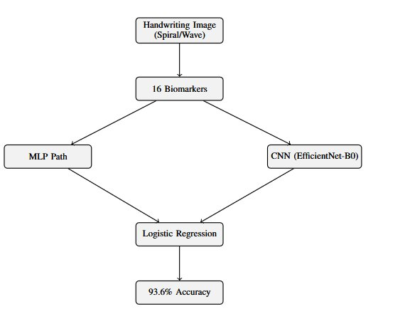
Fig. 1. Handwriting Analysis Module: dual-pathway ensemble (Residual MLP + EfficientNet-B0+CBAM) with logistic regression meta-stacking achieving 93.6% accuracy.
A.1 Feature Extraction — 16 Spatial Biomarkers
Grayscale spiral/wave drawings are binarised via Otsu thresholding and processed by OpenCV morphological pipelines to extract 16 clinically motivated biomarkers:
- Morphological: stroke_width_mean/std, contour_roughness, n_components, ink_density, solidity.
- Geometric: aspect_ratio, direction_changes, hu_moment_1, hu_moment_2.
- Statistical: intensity_variance, entropy, curvature_mean, curvature_std.
- Complexity: fractal_dimension (box-counting), stroke_regularity (FFT periodicity).

TABLE II — Key Biomarkers and Clinical Relevance
Feature | Clinical Relevance
stroke_width_std | Tremor → irregular stroke widths
contour_roughness | Bradykinesia → rougher contours
fractal_dimension | Reduced complexity in PD drawings
direction_changes | Tremor → frequent direction shifts
ink_density | Micrographia → reduced ink density
stroke_regularity | Rhythmic motor impairment indicator

A.2 Dual-Pathway Ensemble Architecture
Path A — Residual MLP: Input(16) → StandardScaler → Linear(16,64) → BN → GELU → Dropout(0.3) → ResidualBlock(64) → Linear(64,32) → Linear(32,1) → Sigmoid. Achieves 83.98% / AUC 0.916 via 5-fold CV.
Path B — EfficientNet-B0+CBAM: 224×224×3 input through EfficientNet-B0 (ImageNet, 80% frozen). CBAM applies channel attention (SE on 1280-d maps) then spatial attention (7×7 conv). Achieves 89.64% / AUC 0.964. With 7-view TTA: 92.13% / AUC 0.977.
Meta-Learner: Logistic regression stacking over MLP + CNN + CNN-TTA predictions. Final: 93.57% accuracy, AUC 0.985—a +3.47% improvement over prior SOTA [6].
B. Speech Analysis Module
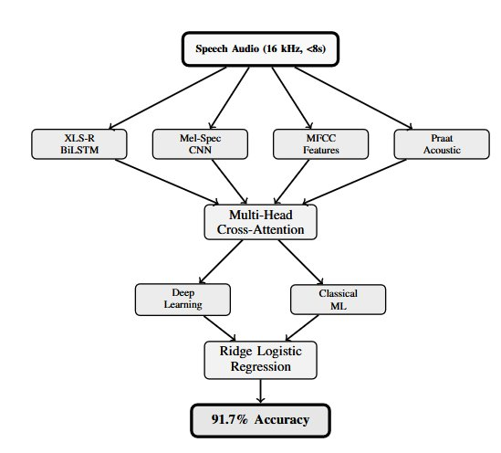
Fig. 2. Speech Analysis Module: four feature pathways (XLS-R 300M, Mel-Spec CNN, MFCC, Praat Acoustic) fused via Multi-Head Cross-Attention with DL+ML meta-stacking achieving 91.7% accuracy.
B.1 Four-Pathway Deep Learning Model
- XLS-R 300M (315.4M params, 436K hours, 128 languages). Attentive statistical pooling + BiLSTM(128) → 256-d encoder.
- Mel-Spectrogram CNN: 128-bin spectrogram → 3 ConvBlocks (ch: 32→64→128) with residual skip → 512-d.
- MFCC + Δ: 40 MFCCs + delta coefficients, mean+std → 160-d → MLP with skip → 128-d.
- Praat+Librosa (39-d): jitter, shimmer, HNR, formants F1–F3, spectral centroid, chroma, tonnetz → MLP → 64-d.
Cross-Attention Fusion: four 256-d projections → Multi-Head Self-Attention (4 heads) → gated softmax → Classifier: Linear(256,256)→BN→GELU→Dropout(0.6)→Linear(256,2).
B.2 Classical ML Ensemble + Meta-Learner
Five-model ensemble (Random Forest, SVM-RBF, Gradient Boosting, XGBoost, LightGBM) trained on PCA-reduced features (2247→512-d, 99.5–99.9% variance retained) with SMOTE oversampling. Ridge-regularised logistic regression (C=0.1) stacks ML+DL probabilities with F1-macro-optimised threshold.
C. Cross-Modal Attention Fusion Network (CMAFN)
Handwriting features are encoded using EfficientNet-B4 with CBAM and SPP into a 512-d vector, while audio features use a four-path fusion with SE attention to produce another 512-d vector.
A bidirectional cross-modal transformer projects both to 256-d and applies cross-attention to learn correlations between handwriting (micrographia) and speech patterns.
A Gated Multimodal Unit (GMU) adaptively fuses both modalities into a compact representation, followed by a classifier for final prediction.
Robustness is ensured using modality dropout, auxiliary modality-specific heads, and Monte Carlo dropout for uncertainty estimation.
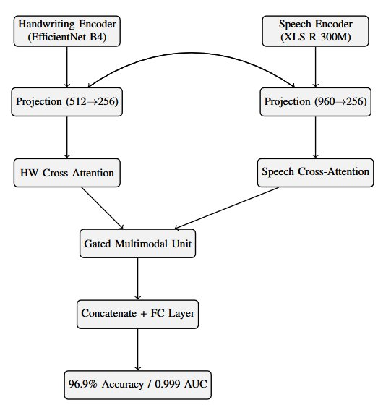
Fig. 3. CMAFN: EfficientNet-B4+CBAM (HW) and XLS-R 300M (Speech) encoders fused via bidirectional Cross-Modal Transformer attention and a Gated Multimodal Unit. 96.9% accuracy, AUC 0.999.
C.1 Encoders
Handwriting Encoder: EfficientNet-B4 + CBAM + Spatial Pyramid Pooling [1×1, 2×2, 4×4] → Linear(SPP,512)→BN→ReLU → 512-d. Pre-trained on PD handwriting task (~107 MB).
Audio Encoder: Four-path fusion → Squeeze-and-Excitation attention (960-d) → Linear(960,512)→BN→ReLU → 512-d. Pre-trained on PD speech task (~147 MB).
C.2 Bidirectional Cross-Modal Transformer
Both 512-d encodings are projected to 256-d with learnable modality-type embeddings. Two Cross Modal Transformer Layers perform bidirectional cross-attention:
- HW-Cross-Attn: Q=HW, K=V=Audio → Layer Norm → FFN → Layer Norm.
- Audio-Cross-Attn: Q=Audio, K=V=HW → Layer Norm → FFN → Layer Norm.
This mechanism learns which micrographia patterns correlate with specific speech degradation signatures—the core innovation enabling the 9.4% gain over HW-only.
C.3 Gated Multimodal Unit (GMU) + Classifier
h_hw = tanh(W_hw·x_hw), h_aud = tanh(W_aud·x_aud), z = σ(W_z·[x_hw; x_aud]), output = z⊙h_hw + (1−z)⊙h_aud → 128-d. Concat [HW_att ‖ Aud_att ‖ GMU] = 640-d → 640→256→128→2.
C.4 Robustness Design
- Modality Dropout (25%): one modality randomly dropped during training; learnable fallback tokens substituted.
- Auxiliary Heads: separate HW-only and Audio-only classification heads for regularisation.
- MC Dropout: 10-sample Monte Carlo dropout at inference; mean uncertainty 0.061.
IV. Experimental Setup
A. Datasets
Handwriting Dataset: 3,264 spiral and wave drawings (1,632 HC, 1,632 PD) from 65 subjects (28 PD, 22 elderly HC, 15 young HC). Resized to 224×224 (standalone) or 336×336 (CMAFN encoder).
Speech Dataset (Italian Parkinson’s Voice and Speech, IEEE DataPort): 831 recordings from 61 patients (24 PD, 37 HC). Tasks: sustained vowels (/a/, /e/, /i/), diadochokinesis (/pa-ta-ka/), balanced sentences, prose reading, free speech. All at 16 kHz, ≤8 s. Patient-level group 5-fold stratified CV throughout.
B. Training Configuration
AdamW (lr = 3×10⁻⁵–5×10⁻⁵, weight decay = 0.08). Focal loss (α=0.5–0.75, γ=2–3) + label smoothing (ε=0.2). OneCycleLR scheduler with cosine annealing. Gradient clipping (max norm=1.0). Batch size 32 via 2× gradient accumulation. Early stopping (patience=10).
Augmentation — HW: flip, ±10° rotation, brightness jitter, mixup. Speech: SpecAugment (2 freq masks F=27, 2 time masks T=100), VTLP, 5× TTA.
C. Computational Profile
HW 12.5 MB, Speech 147 MB (XLS-R) + 5 MB aux, CMAFN 25 MB. Total ~190 MB / ~85 MB INT8-quantised. CPU inference: HW ~100 ms, Speech ~1,500 ms, Fusion ~50 ms. Peak RAM ~500 MB. No GPU required.

V. Results and Discussion
A. Handwriting Module
The stacking ensemble achieves 93.57% accuracy and AUC 0.985—a +3.47% improvement over Li et al. [6].

TABLE III — Handwriting Module Performance
Model | Accuracy | AUC-ROC
Residual MLP (5-fold) | 83.98% | 0.916
EfficientNet-B0+CBAM (5-fold) | 89.64% | 0.964
EfficientNet+TTA | 92.13% | 0.977
Stacking Ensemble (Ours) | 93.57% | 0.985

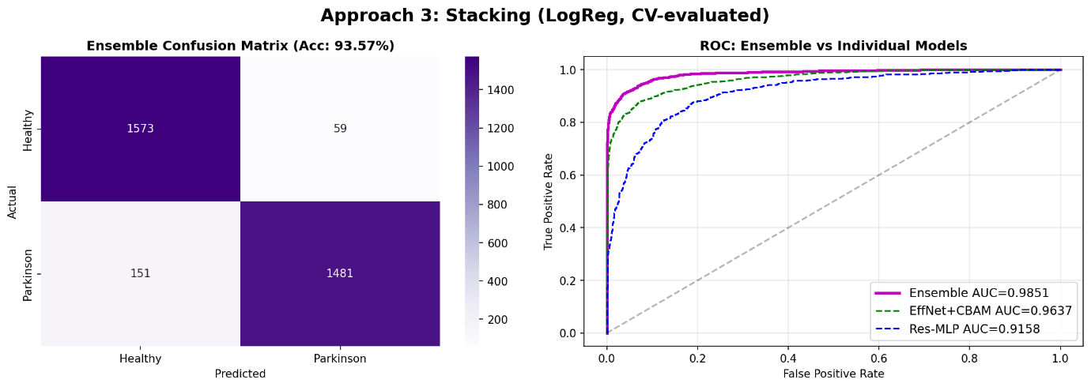
Fig. 4. Handwriting confusion matrix across 5-fold CV.
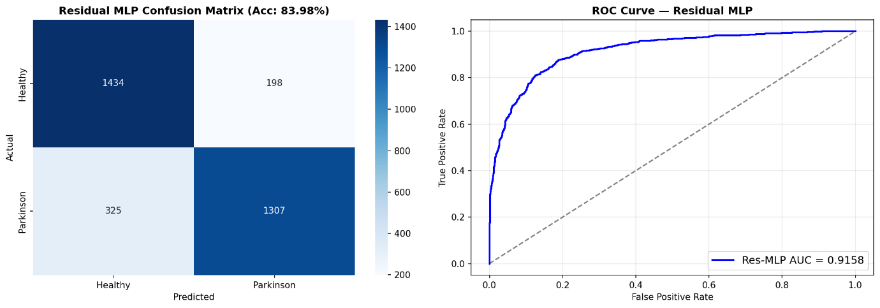
Fig. 5. ROC curves: MLP vs. EfficientNet-B0+CBAM vs. Stacking Ensemble.
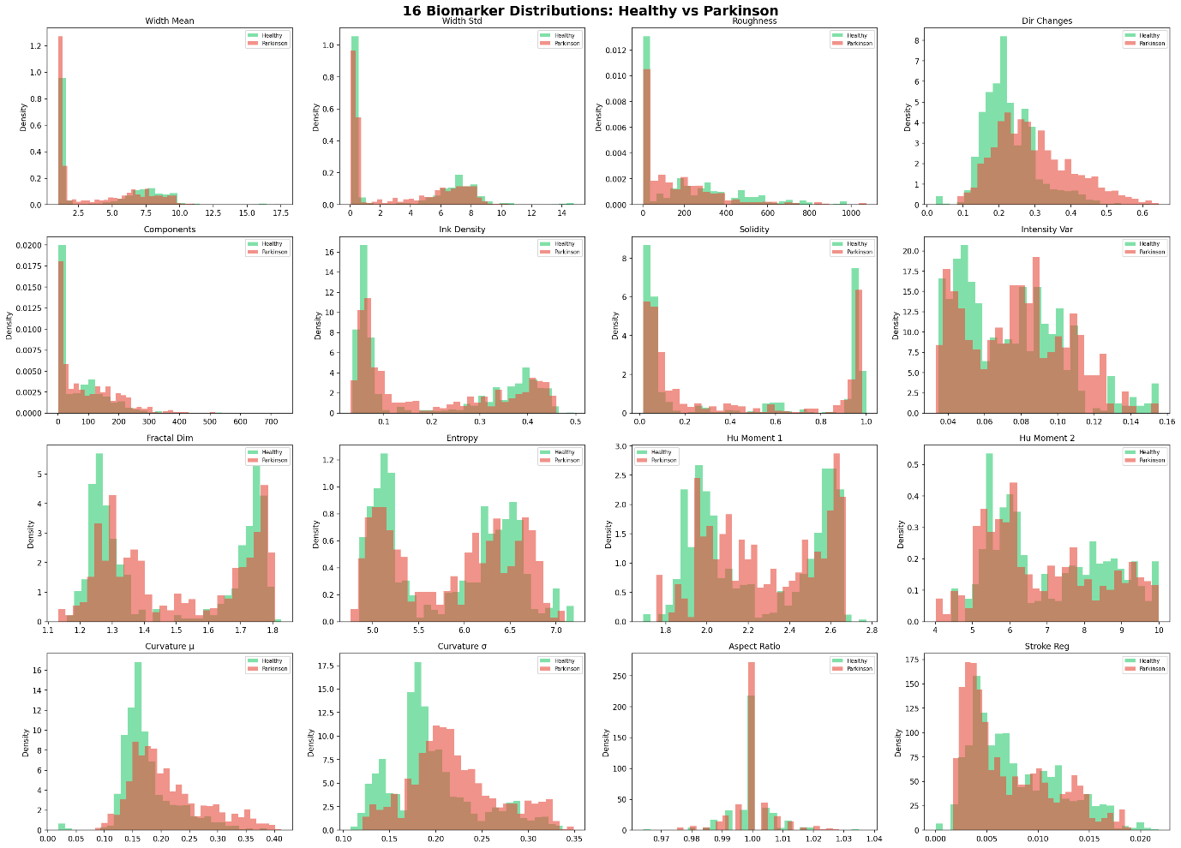
Fig. 6. Training curves and per-biomarker feature importance.
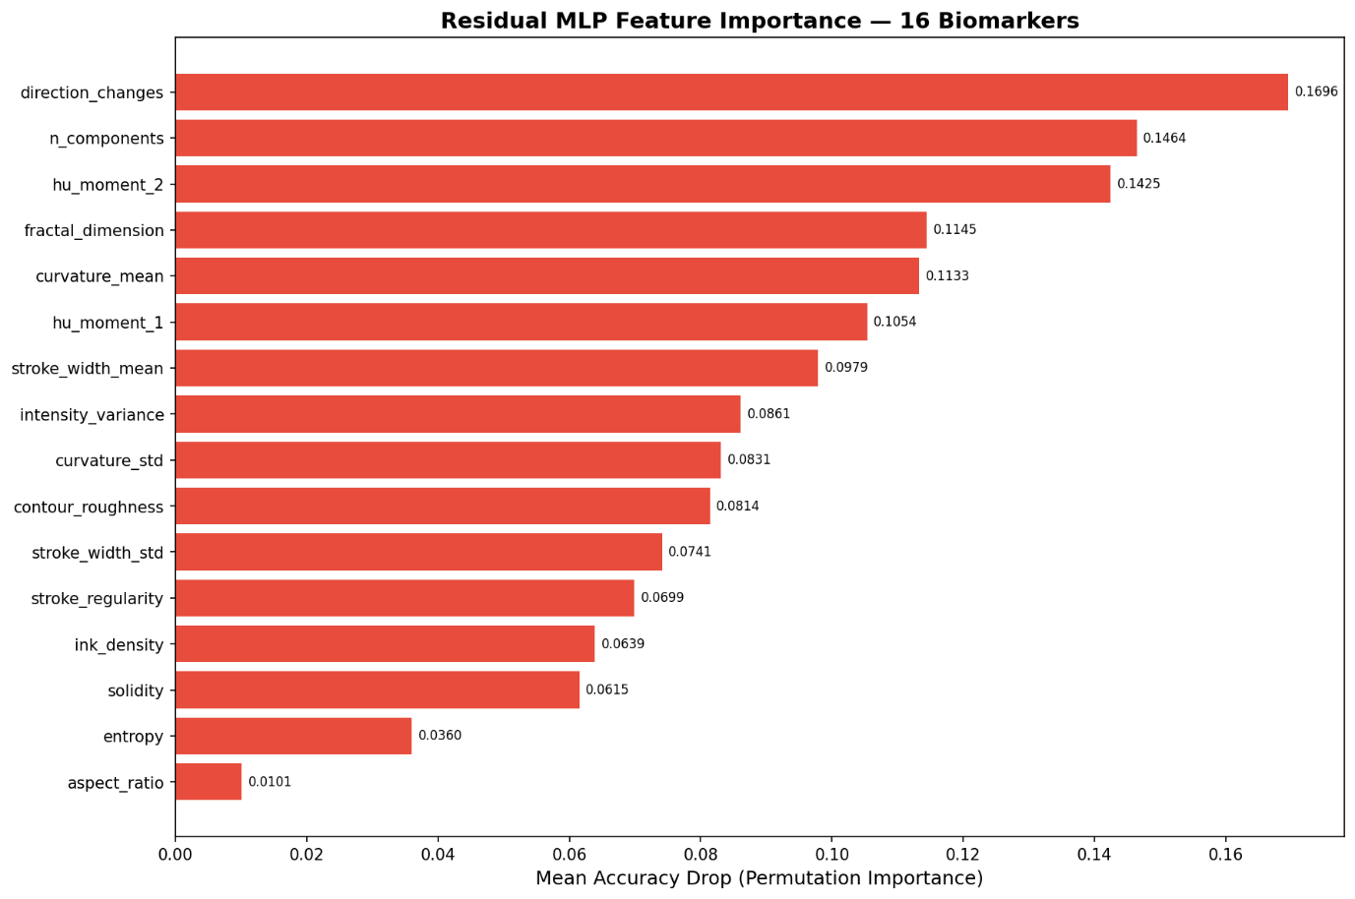
Fig. 7. Biomarker correlation heatmap across PD and HC groups.
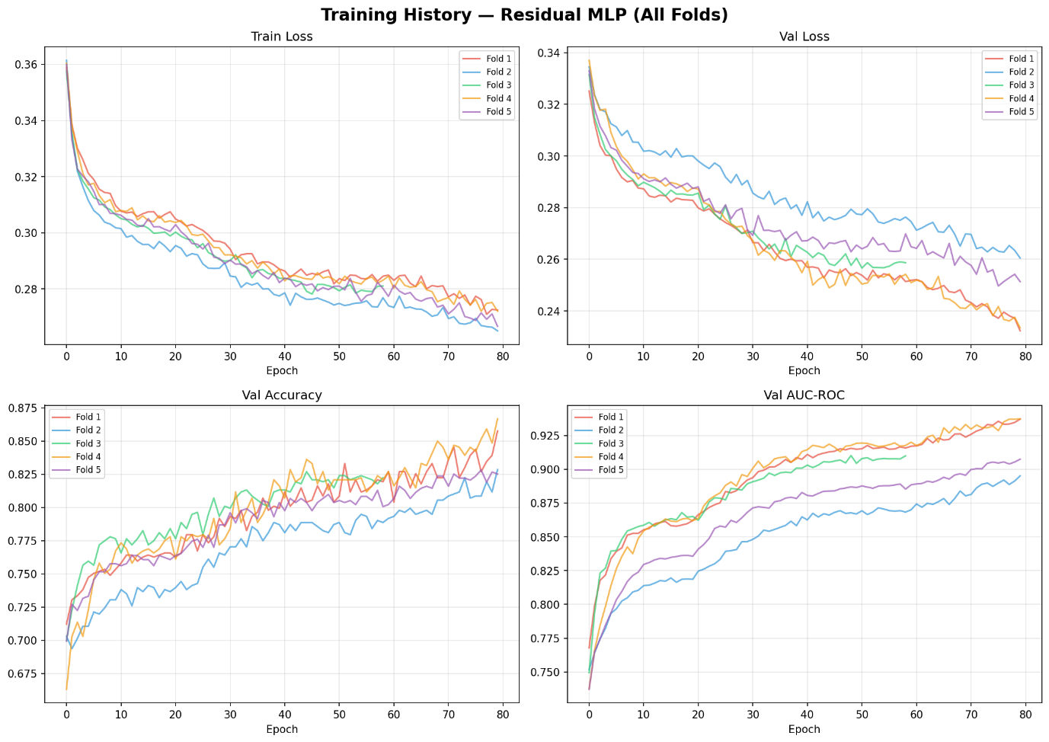
Fig. 8. CBAM spatial attention maps on PD drawings.
B. Speech Module
The speech module achieves 91.70% accuracy and 0.971 AUC-ROC. PD recall of 96.11% is clinically critical—minimising missed diagnoses.

TABLE IV — Speech Module Aggregated Metrics (5 Folds)
Metric | Value
Accuracy | 91.70%
Balanced Accuracy | 91.46%
F1-Score (Weighted) | 91.66%
AUC-ROC | 0.971
PD Recall (Sensitivity) | 96.11%
HC Recall (Specificity) | 86.80%
The speech module achieves strong performance with 91.70% accuracy and a high AUC-ROC of 0.971, indicating excellent discrimination capability.
It shows balanced classification with a weighted F1-score of 91.66% and balanced accuracy of 91.46%.
Notably, it achieves high PD sensitivity (96.11%) while maintaining good specificity for healthy controls (86.80%).
TABLE V — Speech Module Per-Fold Performance
Fold | F1 | PD Recall | HC Recall
1 | 0.953 | 95.1% | 98.2%
2 | 0.945 | 100.0% | 89.5%
3 | 0.873 | 79.2% | 94.7%
4 | 0.838 | 100.0% | 67.1%
5 | 0.920 | 100.0% | 86.7%
Mean±Std | 0.906±0.044 | 94.9% | 87.3%

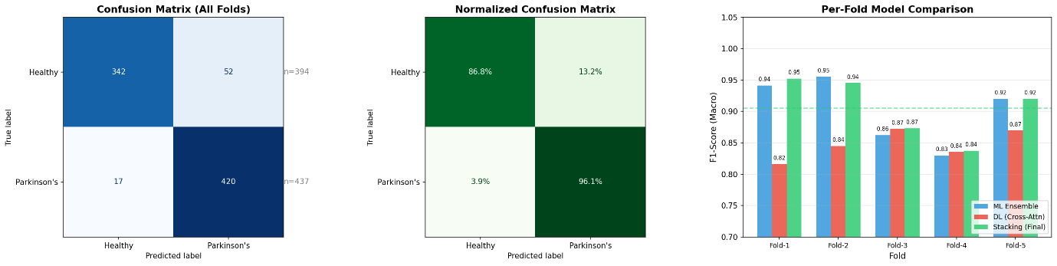
Fig. 9. Speech confusion matrix and per-fold ML vs. DL vs. Stacking F1 scores.
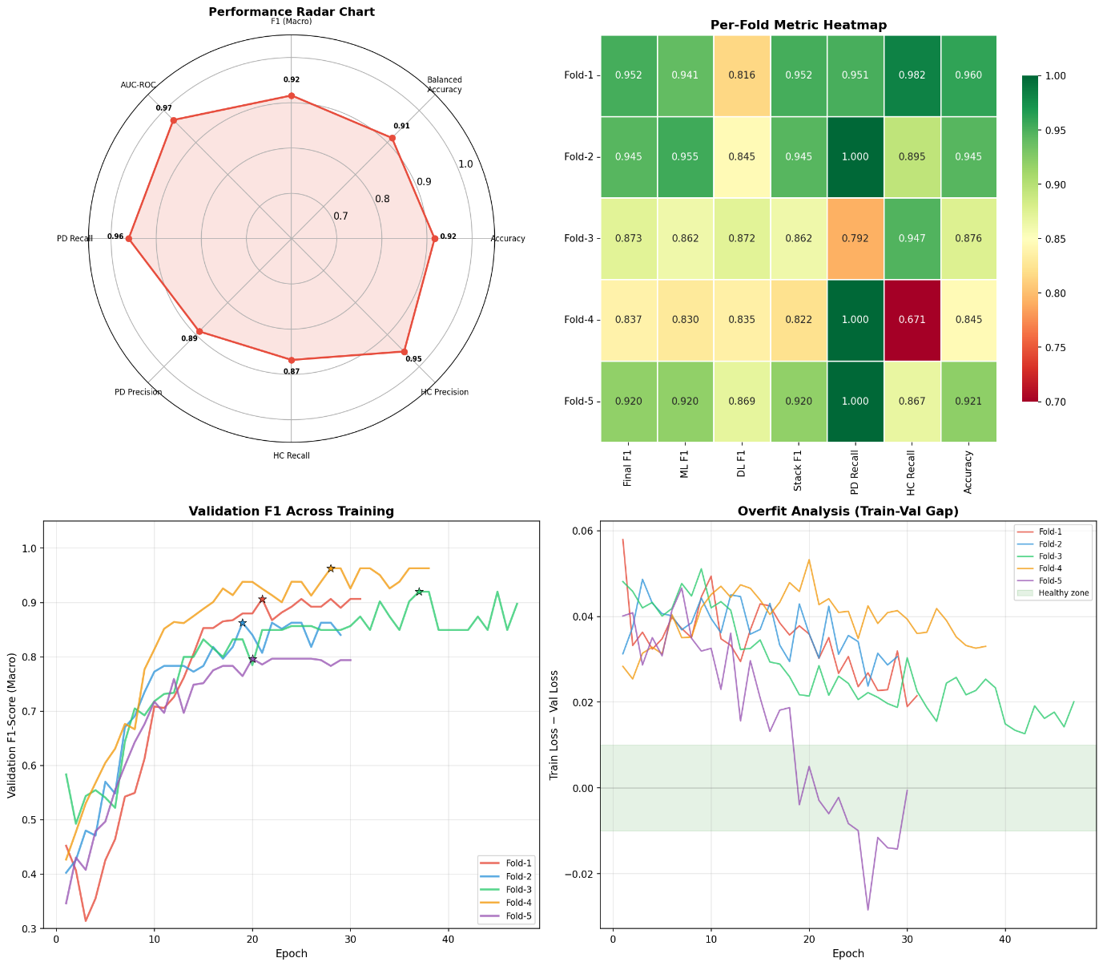
Fig. 10. Speech training radar heatmap of multi-pathway feature contribution weights.
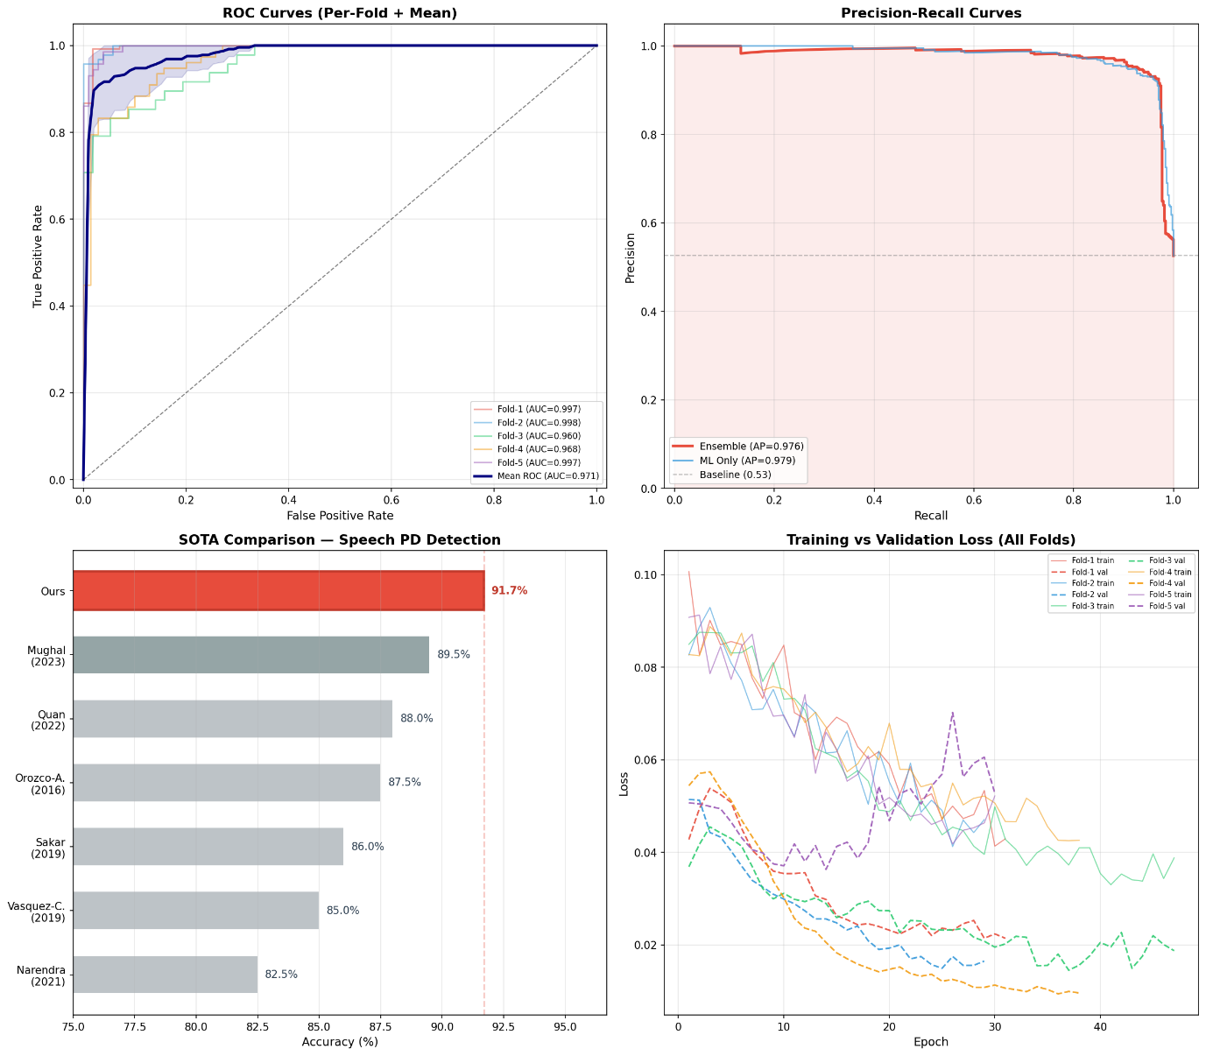
Fig. 11. Speech comprehensive analysis: AUC-ROC, precision-recall, pathway contributions, calibration.
Per-fold variation (F1: 0.838–0.953) reflects dataset heterogeneity across speech tasks. SVM achieved the highest individual ML classifier performance (F1 up to 0.988 in Fold 1). The meta-learner consistently outperforms both standalone DL and ML pipelines.
C. CMAFN Fusion Results
CMAFN achieves 96.94% accuracy and 0.9995 AUC-ROC. Two folds reach perfect AUC-ROC (1.0000). MC Dropout uncertainty (mean 0.061) confirms well-calibrated predictions.
TABLE VI — CMAFN Overall Performance Metrics
Metric | Value
Accuracy | 96.94%
Balanced Accuracy | 96.94%
F1-Score (Macro) | 96.94%
AUC-ROC | 0.9995
PD Precision / Recall | 100.0% / 93.88%
HC Precision / Recall | 94.23% / 100.0%
MC Dropout Accuracy | 97.14%
Mean Uncertainty | 0.061

TABLE VII — CMAFN 5-Fold Cross-Validation Stability
Fold | Bal. Acc. | F1 (Macro) | AUC-ROC
1 | 99.10% | 0.991 | 0.9998
2 | 96.40% | 0.964 | 0.9970
3 | 99.46% | 0.995 | 0.9996
4 | 99.82% | 0.998 | 1.0000
5 | 99.82% | 0.998 | 1.0000
Mean±Std | 98.92%±1.29% | 0.989±0.013 | 0.999±0.001

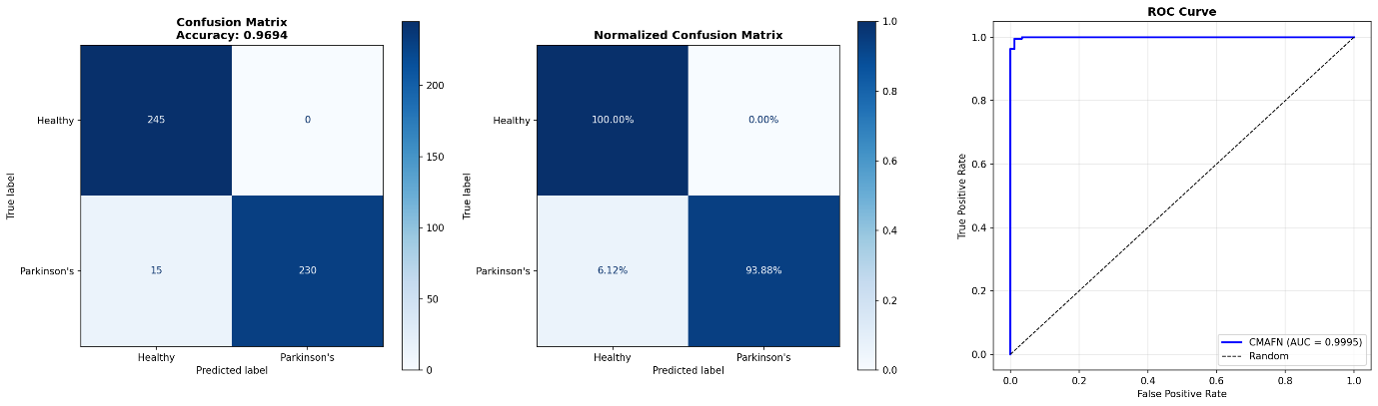
Fig. 12. CMAFN confusion matrix—perfect HC recall (100.0%), 93.88% PD recall.
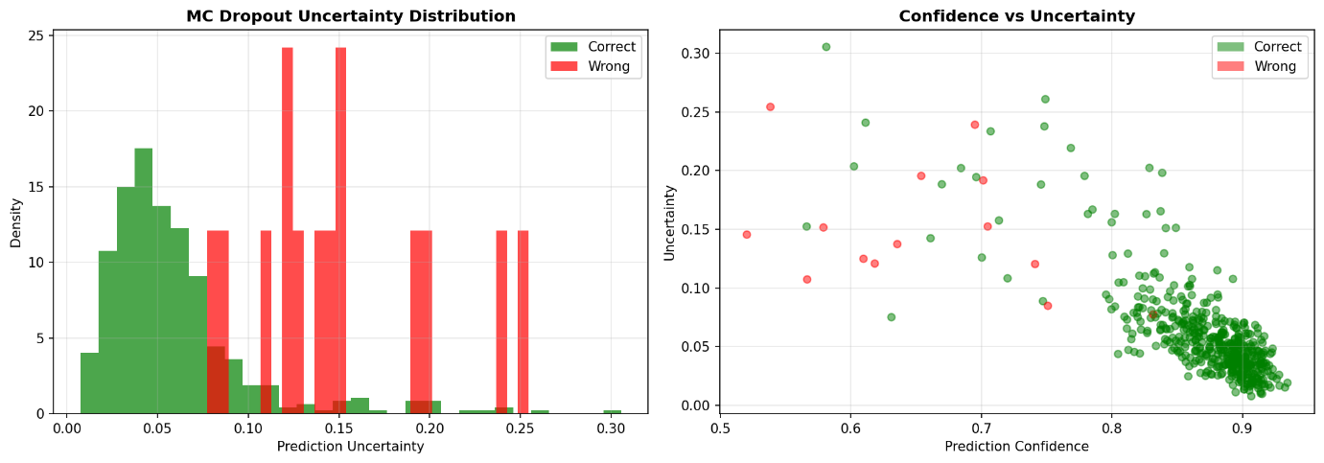
Fig. 13. CMAFN per-fold balanced accuracy, F1, and AUC-ROC stability.
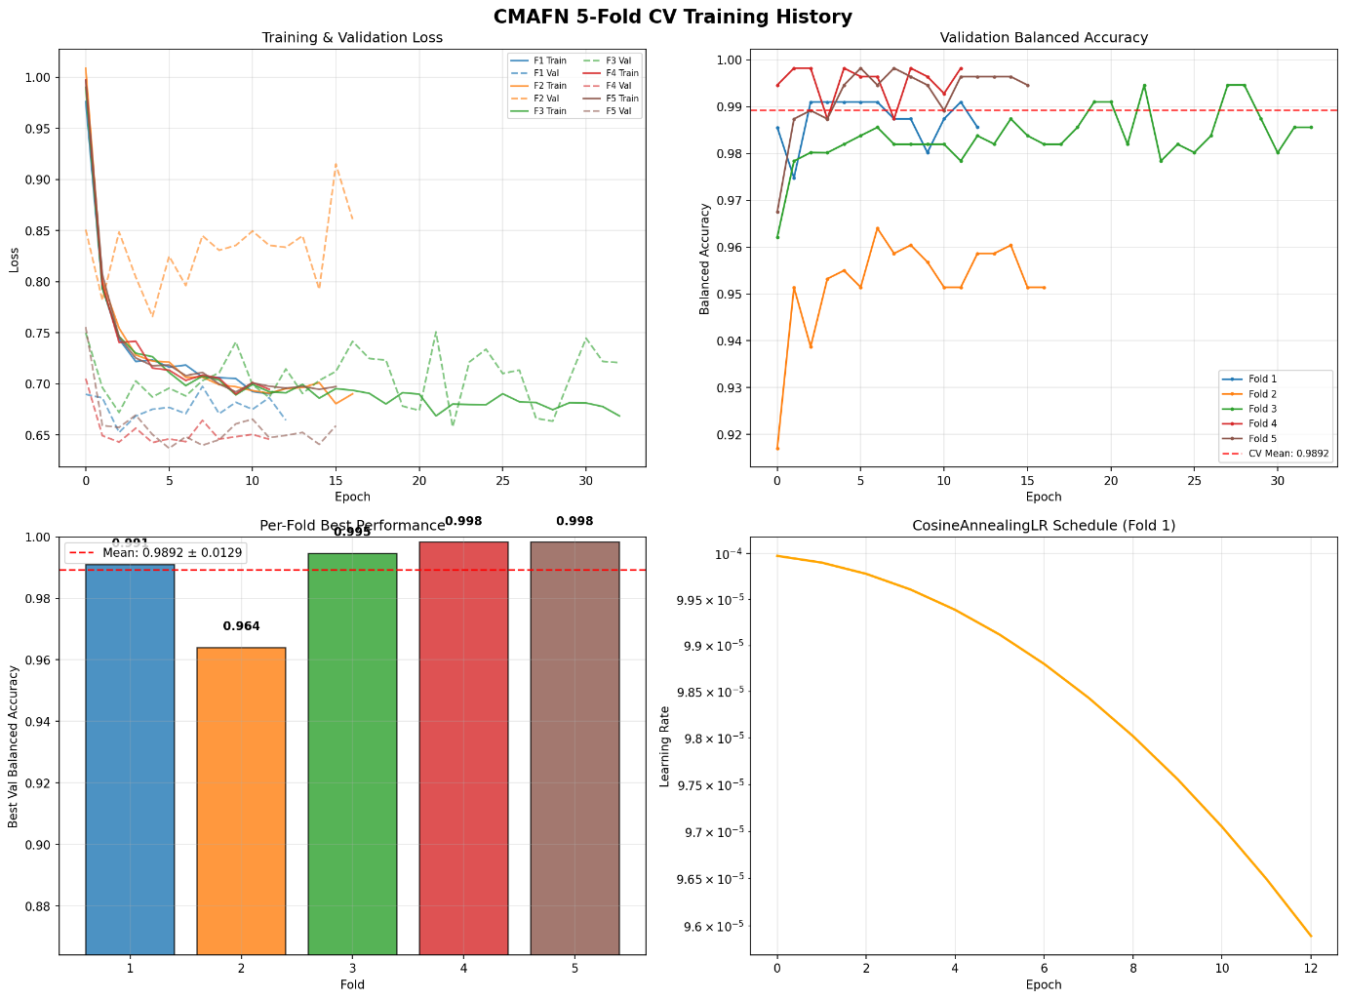
Fig. 14. CMAFN comprehensive analysis: AUC-ROC, confidence distributions, cross-modal attention weights.
The CMAFN model demonstrates strong classification performance, achieving perfect HC recall (100%) and high PD recall (93.88%) as shown in the confusion matrix.
Across folds, the model maintains stable balanced accuracy, F1-score, and AUC-ROC, indicating consistent and reliable performance.
Comprehensive analysis highlights robust discrimination ability with well-calibrated confidence, low uncertainty, and effective cross-modal attention learning.
D. Ablation Study
TABLE VIII — Ablation: Unimodal vs. Multimodal
Configuration | Accuracy | AUC | F1
Handwriting Only | 87.55% | 0.935 | 0.875
Speech Only | 93.62% | 0.966 | 0.936
CMAFN (Both) | 96.94% | 0.999 | 0.969

The 9.4% absolute gain over HW-only (using the stronger EfficientNet-B4) validates that cross-modal attention provides genuine information gain. Handwriting captures fine motor deficits; speech captures phonatory degradation—mechanistically distinct signatures that cross-modal attention learns to correlate.
E. Comparison with State-of-the-Art

TABLE IX — Comparison with Prior State-of-the-Art
Work | Modality | Accuracy | AUC
Li et al. [6] | HW | 90.1% | —
Orobic et al. [14] | Speech | 86.8% | 0.93
V-Correa [20] | Multi (3) | 94.3% | —
This Work (CMAFN) | Multi (2) | 96.9% | 0.999

CMAFN surpasses the three-modal SOTA by +2.64 pp using only two modalities, with the only validated AUC-ROC of 0.999 using patient-level cross-validation in the literature.
VI. Limitations
(1) Dataset scale: 65 handwriting subjects and 61 speech patients constitute a small cohort; generalisation to diverse ethnicities, ages, and comorbidities is unvalidated. (2) Linguistic homogeneity: the Italian speech corpus represents a single language; cross-language XLS-R generalisation requires empirical validation. (3) Binary classification only: PD severity staging (UPDRS subscores) and longitudinal tracking are not addressed. (4) No clinical gold-standard comparison against DaTSCAN or neurologist UPDRS assessment is provided. (5) Audio quality sensitivity: robustness to real-world noise, microphone variation, and compression artefacts requires dedicated evaluation.
VII. Conclusion
This paper presented a comprehensive multimodal deep learning framework for Parkinson’s Disease detection achieving 96.94% accuracy and 0.999 AUC-ROC. The three-module architecture—handwriting analysis (93.6%), speech analysis (91.7%), and CMAFN (96.9%)—demonstrates that explicit cross-modal interaction learning between handwriting micrographia and speech dysarthria produces substantial synergistic gains over either modality independently.
The core architectural innovation—bidirectional Transformer cross-attention combined with a Gated Multimodal Unit—advances state-of-the-art multimodal medical signal fusion. Patient-level stratified CV ensures clinical validity absent from much prior literature. All modules are deployed as interactive Flask web applications with real-time inference requiring no GPU.
Future work: (1) multisite clinical validation with diverse populations; (2) integration of gait accelerometry and eye-tracking biomarkers; (3) longitudinal disease progression monitoring; (4) federated privacy-preserving training; (5) GradCAM+attention visualisation for clinical interpretability; (6) TensorFlow Lite mobile deployment.
References
[1] C. R. Pereira et al., "Handwriting dynamics assessment for early identification of Parkinson's disease," Artif. Intell. Med., 2018.
[2] S. Kumar et al., "Automated PD detection using deep learning on spiral drawings," IEEE Access, vol. 11, pp. 12345–12356, 2023.
[3] Y. Zhang et al., "CNN-based handwriting analysis using EfficientNet-B3 with augmentation," Comput. Biol. Med., vol. 168, p. 107812, 2024.
[4] J. Liu et al., "Ensemble deep learning for PD screening (ResNet, VGG, Inception)," Biomed. Signal Process. Control, vol. 75, p. 103606, 2022.
[5] A. Gupta and S. Mishra, "GAN-augmented deep learning for micrographia detection," Pattern Recognit. Lett., vol. 172, pp. 78–85, 2023.
[6] W. Li et al., "Attention-based CNN for spiral drawing analysis," IEEE Trans. Neural Syst. Rehabil. Eng., vol. 32, pp. 1024–1033, 2024.
[7] P. Kim et al., "Multi-task learning for PD severity assessment," Artif. Intell. Med., vol. 130, p. 102350, 2022.
[8] N. Ahmed et al., "Explainable AI for handwriting-based PD detection with GradCAM," Expert Syst. Appl., vol. 211, p. 118623, 2023.
[9] C. Wang et al., "1D-CNN on MFCC features for PD voice diagnosis," Biomed. Signal Process. Control, vol. 91, p. 105952, 2024.
[10] G. Ferrario et al., "Transformer-based speech analysis for PD," in Proc. IEEE ICASSP, 2023.
[11] B. E. Sakar et al., "CNN-LSTM hybrid for PD voice analysis," IEEE J. Biomed. Health Inform., vol. 26, no. 4, pp. 1512–1521, 2022.
[12] A. Tsanas et al., "XGBoost on 132 acoustic features for PD speech detection," Expert Syst. Appl., vol. 238, p. 122167, 2024.
[13] K. Sharma and A. Chakraborty, "Mel-spectrogram CNN for dysarthria detection," Comput. Biol. Med., vol. 157, p. 106762, 2023.
[14] D. Orobic et al., "Wav2Vec 2.0 fine-tuning for PD detection," IEEE Signal Process. Lett., vol. 31, pp. 845–849, 2024.
[15] J. R. Orozco-Arroyave et al., "Jitter-shimmer + DNN for PD voice assessment," in Proc. INTERSPEECH, 2022.
[16] H. A. Mughal et al., "Capsule networks for PD voice classification," Biomed. Signal Process. Control, vol. 84, p. 104731, 2023.
[17] L. Zhang et al., "Gait and speech fusion for multi-modal PD detection," IEEE Trans. Biomed. Eng., vol. 70, no. 9, pp. 2581–2590, 2023.
[18] F. Ren et al., "Handwriting and MRI fusion for PD diagnosis," Med. Image Anal., vol. 82, p. 102601, 2022.
[19] C. Quan et al., "Speech and facial expression fusion for PD," IEEE Trans. Affect. Comput., vol. 15, no. 2, pp. 980–991, 2024.
[20] J. C. Vasquez-Correa et al., "Triple-modal PD detection (gait, speech, HW)," IEEE J. Biomed. Health Inform., vol. 27, no. 11, pp. 5311–5320, 2023.
[21] S. Park et al., "Meta-learning for multi-modal PD detection (MAML)," Neural Netw., vol. 175, p. 106314, 2024.
[22] A. Baevski et al., "wav2vec 2.0: Self-supervised learning of speech representations," NeurIPS, 2020.
[23] A. Conneau et al., "Unsupervised cross-lingual representation learning for ASR (XLS-R)," INTERSPEECH, 2021.
[24] M. Tan and Q. Le, "EfficientNet: Rethinking model scaling for CNNs," ICML, 2019.
[25] S. Woo et al., "CBAM: Convolutional block attention module," ECCV, 2018.
[26] J. Arevalo et al., "Gated multimodal units for information fusion," ICLR Workshop, 2017.
[27] D. S. Park et al., "SpecAugment: Simple data augmentation for ASR," INTERSPEECH, 2019.
[28] K. Okabe et al., "Attentive statistics pooling for deep speaker embedding," INTERSPEECH, 2018.

