A Project Report on

Parkinson’s Detection Using Handwriting and Speech
Submitted in partial fulfillment for the award of the degree of

Bachelor of Technology
in
Computer Science and Engineering

by

TANGUTURI VENKATA THANUJ (22BCE20003)
KATAM KRISHNA CHAITANYA (22BCE7359)
PATHAKUNTLA NARENDAR REDDY (22BCE7707)



SCHOOL OF COMPUTER SCIENCE AND ENGINEERING
VIT-AP UNIVERSITY
Amaravati, Andhra Pradesh

April 2026

DECLARATION
We hereby declare that the project entitled "Parkinson’s Detection Using Handwriting and Speech" submitted by us, for the award of the degree of Bachelor of Technology in Computer Science and Engineering at VIT-AP University is a record of bonafide work carried out by us under the supervision of Dr. Rajasekhar Boddu.

We further declare that the work reported in this project has not been submitted and will not be submitted, either in part or in full, for the award of any other degree or diploma in this institute or any other institute or university.

Place: Amaravati Signature of the Candidate
Date:
Tanguturi Venkata Thanuj (22BCE20003)
Katam Krishna Chaitanya (22BCE7359)
Pathakuntla Narendar Reddy (22BCE7707)

CERTIFICATE
This is to certify that the Senior Design Project titled "Parkinson’s Detection Using Handwriting and Speech" submitted by Tanguturi Venkata Thanuj (22BCE20003), Katam Krishna Chaitanya (22BCE7359), and Pathakuntla Narendar Reddy (22BCE7707) is in partial fulfillment of the requirements for the award of the degree of Bachelor of Technology in Computer Science and Engineering, and is a record of bonafide work done under our guidance. The contents of this project work, in full or in parts, have neither been taken from any other source nor have been submitted to any other Institute or University for award of any degree or diploma and the same is certified.

Dr. Rajasekhar Boddu
Internal Guide

The thesis is satisfactory / unsatisfactory

Internal Examiner External Examiner

Approved by

DEAN
School of Computer Science and Engineering
VIT-AP University

ABSTRACT
Parkinson’s Disease (PD) is the second leading neurodegenerative disorder in the world, affecting more than ten million people, with substantial clinical and economic costs. Traditional diagnoses mainly rely on clinical tests, including UPDRS and neuroimaging, which include DaTSCAN costing between $1,500 and $4,000. However, these diagnoses are only applicable at late disease stages and are inaccessible in developing countries due to their costs. Therefore, there is a pressing need for scalable, non-invasive, and economical early detection tools for PD.
In this study, a multimodal deep learning approach to detect Parkinson’s disease using handwriting and speech biomarkers is presented. Both handwriting and speech biomarkers are mechanistically complementary modalities obtained through consumer-grade sensors. This model comprises three modules. The first one is a handwriting analysis module that consists of sixteen clinical handwriting biomarkers and EfficientNet-B0 with CBAM augmentation, resulting in an accuracy of 93.6% and an AUC of 0.985. The second module is a speech analysis module that uses a multipath network based on self-supervised XLS-R 300M representation, mel-spectrogram CNN, MFCCs, and acoustic descriptors combined through an attention mechanism, with an accuracy of 91.7% and an AUC of 0.971. Furthermore, a new Cross-Modal Attention Fusion Network (CMAFN) is proposed based on bidirectional Transformer cross-attention and Gated Multimodal Unit (GMU), attaining accuracies of 96.9% with an AUC-ROC of 0.999, thus outperforming all previous multimodal models.
In order to conduct a thorough and realistic evaluation, a patient-level stratified 5-fold cross-validation approach is used, which prevents any data leakage. The model architecture is realized as a series of interactive web applications powered by Flask framework, allowing real-time inference within 3 seconds even when using only CPU resources, making the system applicable to telemedicine settings. Empirical results show that cross-modal interaction between handwriting micrographia and speech dysarthria leads to remarkable synergy.

Keywords
Parkinson’s Disease, Multimodal Deep Learning, Cross-Modal Attention, EfficientNet, XLS-R, Handwriting Biomarkers, Speech Analysis, Gated Multimodal Unit, Transfer Learning, CBAM.

ACKNOWLEDGEMENT
It is my pleasure to express with deep sense of gratitude to Dr. Rajasekhar Boddu, Assistant Professor, Dept. of CSE for his/her constant guidance, continual encouragement, understanding; more than all, he taught me patience in my endeavor. My association with him / her is not confined to academics only, but it is a great opportunity on my part of work with an intellectual and expert in the field of DEEP LEARNING.

I would like to express my gratitude to Chancellor, VPs, VC, and Dr. Sudhakar Ilango, SCOPE, for providing with an environment to work in and for his inspiration during the tenure of the course.

In jubilant mood I express ingeniously my whole-hearted thanks to <Program char- name>. <Program Chair designation>, all teaching staff and members working as limbs of our university for their not-self-centered enthusiasm coupled with timely encouragements showered on me with zeal, which prompted the acquirement of the requisite knowledge to finalize my course study successfully. I would like to thank my parents for their support.

It is indeed a pleasure to thank my friends who persuaded and encouraged me to take up and complete this task. At last but not least, I express my gratitude and appreciation to all those who have helped me directly or indirectly toward the successful completion of this project.

Place: Amaravati
Date: Name of the student

Tanguturi Venkata Thanuj
Katam Krishna Chaitanya
Pathakuntla Narendar Reddy

TABLE OF CONTENTS
Section | Title | Page No.
— | DECLARATION | 2
— | CERTIFICATE | 3
— | ABSTRACT | 4
— | ACKNOWLEDGEMENT | 5
— | TABLE OF CONTENTS | 6
— | LIST OF TABLES | 7
— | LIST OF FIGURES | 8
— | LIST OF ABBREVIATIONS | 9
Chapter 1 | INTRODUCTION | 10
1.1 | Background | 10
1.2 | Problem Statement | 11
1.3 | Objectives | 12
1.4 | Scope of the Project | 13
Chapter 2 | RELATED WORK | 16
2.1 | Handwriting-Based Detection | 16
2.2 | Speech-Based Detection | 17
2.3 | Multimodal Fusion Approaches | 18
Chapter 3 | SYSTEM ARCHITECTURE | 20
3.1 | Overall System Design | 20
3.2 | Module Interactions | 21
Chapter 4 | METHODOLOGY | 23
4.1 | Handwriting Analysis Module | 23
4.2 | Speech Analysis Module | 27
4.3 | Cross-Modal Attention Fusion Network | 31
Chapter 5 | DATASETS AND EXPERIMENTAL SETUP | 38
5.1 | Datasets | 38
5.2 | Training Configuration | 40
5.3 | Evaluation Protocol | 41
Chapter 6 | RESULTS AND DISCUSSION | 43
6.1 | Handwriting Module Results | 43
6.2 | Speech Module Results | 46
6.3 | CMAFN Fusion Results | 48
6.4 | Ablation Study | 51
6.5 | Comparison with State-of-the-Art | 53
Chapter 7 | CONCLUSION AND FUTURE WORK | 56
— | REFERENCES | 61
— | APPENDICES | 63

LIST OF TABLES
Table No. | Table Title | Page No.
Table 2.1 | Comparative Survey of PD Detection Literature | 9
Table 4.1 | 16 Spatial Handwriting Biomarkers and Clinical Relevance | 24
Table 5.1 | Dataset Summary – Handwriting and Speech | 39
Table 6.1 | Handwriting Module Performance Comparison | 43
Table 6.2 | Speech Module Aggregated Metrics (5-Fold CV) | 46
Table 6.3 | Speech Module Per-Fold Performance | 46
Table 6.4 | CMAFN Overall Performance Metrics | 49
Table 6.5 | CMAFN 5-Fold Cross-Validation Stability | 49
Table 6.6 | Ablation Study – Unimodal vs. Multimodal | 52
Table 6.7 | Comparison with Prior State-of-the-Art | 53

LIST OF FIGURES
Figure No. | Figure Title | Page No.
Figure 4.1 | 16 biomarker distributions: Healthy vs Parkinson (histogram grid) | 24
Figure 4.2.1 | Handwriting Analysis Module — Dual-Pathway Ensemble Architecture (Residual MLP + EfficientNet-B0 with logistic regression meta-stacking achieving 93.6% accuracy) | 25
Figure 4.2.2 | Speech Analysis Module — Four feature pathways (XLS-R BiLSTM, Mel-Spec CNN, MFCC Features, Praat Acoustic) fused via Multi-Head Cross-Attention with parallel Deep Learning and Classical ML ensembles achieving 91.7% accuracy | 25
Figure 4.3 | Cross-Modal Attention Fusion Network (CMAFN) — EfficientNet-B4 Handwriting Encoder and XLS-R 300M Speech Encoder fused via bidirectional cross-modal Transformer attention and Gated Multimodal Unit achieving 96.9% accuracy and 0.999 AUC | 31
Figure 6.0 | Residual MLP confusion matrix (Acc 83.98%) + ROC curve | 43
Figure 6.1 | Training History — Residual MLP (All 5 Folds): Train/Val Loss, Validation Accuracy, and Validation AUC-ROC | 44
Figure 6.2 | Stacking ensemble confusion matrix (Acc 93.57%) + ROC curves (Ensemble vs EffNet vs MLP) | 44
Figure 6.3 | Residual MLP feature importance — 16 biomarkers (bar chart) | 45
Figure 6.4 | Feature correlation matrix — 16 biomarkers (heatmap) | 45
Figure 6.6 | Speech confusion matrix (all folds) + normalized CM + per-fold ML vs DL vs Stacking F1 | 46
Figure 6.7 | Speech training radar chart + per-fold heatmap + validation F1 curves + overfit analysis | 47
Figure 6.8 | CMAFN confusion matrix (Acc 96.94%) + normalized CM + ROC curve (AUC 0.9995) | 49
Figure 6.9 | CMAFN 5-fold CV training history (loss curves, validation balanced accuracy, per-fold bar, LR schedule) | 50
Figure 6.10 | CMAFN Comprehensive Analysis: AUC-ROC, Confidence Distributions, Cross-Modal Attention Weights | 51

LIST OF ABBREVIATIONS
Abbreviation | Full Form
PD | Parkinson's Disease
HC | Healthy Control
CMAFN | Cross-Modal Attention Fusion Network
CBAM | Convolutional Block Attention Module
GMU | Gated Multimodal Unit
XLS-R | Cross-Lingual Speech Representations
MFCC | Mel-Frequency Cepstral Coefficients
CNN | Convolutional Neural Network
DNN | Deep Neural Network
MLP | Multi-Layer Perceptron
UPDRS | Unified Parkinson's Disease Rating Scale
DaTSCAN | Dopamine Transporter Scan
HNR | Harmonics-to-Noise Ratio
AUC | Area Under the Curve
ROC | Receiver Operating Characteristic
FFT | Fast Fourier Transform
TTA | Test-Time Augmentation
CV | Cross-Validation
SVM | Support Vector Machine
SMOTE | Synthetic Minority Oversampling Technique
PCA | Principal Component Analysis
SPP | Spatial Pyramid Pooling
BN | Batch Normalization
GELU | Gaussian Error Linear Unit
SE | Squeeze-and-Excitation
FFN | Feed-Forward Network
MC | Monte Carlo
API | Application Programming Interface
Flask | Python Web Framework
GPU | Graphics Processing Unit

CHAPTER 1

INTRODUCTION

1.1 BACKGROUND
Parkinson's Disease (PD) is the second most common neurodegenerative disorder in the world, predominantly affecting older adults and involving the gradual death of dopaminergic neurons in the substantia nigra pars compacta. Due to the loss of dopaminergic neurons, an insufficient amount of dopamine, a neurotransmitter which plays a crucial role in controlling motor skills and coordination of muscle movements, is produced. PD causes motor dysfunctions in the form of a resting tremor, rigidity, bradykinesia (slowness in movements), and poor posture. Nevertheless, the onset of these symptoms is possible only when about 60–80% of dopaminergic neurons die.
The global population of those who suffer from PD numbers more than 10 million people and is estimated to double until 2040 due to demographic changes and longevity increase. According to statistics, the yearly cost of medical treatment and services exceeds $52 billion in America. Diagnosis of the disease relies on clinical rating scales (Unified Parkinson's Disease Rating Scale) and brain imaging tests (DaTSCAN/PET).These methods are not only costly and resource-intensive but also lack sensitivity in detecting early-stage PD, especially in under-resourced or remote settings where access to neurologists is limited. In recent times, there has been increasing research focus on discovering non-invasive, measurable and scalable biomarkers for early PD detection. Handwriting and speech are some of the most promising biomarker candidates owing to their close correlation with the neuromotor control systems.
Micrographia, which is the term used to refer to impaired handwriting abilities, include gradual shrinkage of the written texts, irregular stroke patterns, increasing stroke variability, and lack of motor smoothness. This indicates poor fine motor control and can be measured using several geometric parameters like stroke curvature, stroke entropy, fractal dimension, and stroke variability.
PD speech abnormalities, which include dysarthria and hypophonia, consist of low vocal intensity, monotonous pitch pattern, lack of articulatory precision and abnormal voice quality, as measured by the presence of jitter and shimmer. This is attributed to phonatory and respiratory control impairment, and can be assessed using spectral/acoustic features based on short audio clips.
Importantly, handwriting and speech constitute complementary biomarkers in that:
- Handwriting is indicative of motor and fine motor control.
- Speech is indicative of neuromotor and phonatory control
Technological advances in deep learning and multimodal fusion have made it possible to design automatic systems that can identify intricate relationships in the above data. The use of cross-modal attention and Transformer-based models ensures that the AI system learns the relationship between the different modes and makes accurate predictions. Additionally, consumer-level gadgets, such as phones, tablets, and microphones, make the process of collecting large amounts of data easy and feasible.
As such, the integration of handwriting and speech data in an AI-powered multimodal platform is an effective and efficient way of detecting Parkinson’s disease at its early stages.

1.2 PROBLEM STATEMENT
Traditional diagnosing of PD is based on clinical evaluation with the Unified Parkinson’s Disease Rating Scale (UPDRS) and advanced neuroimaging studies such as DaTSCAN (SPECT) or PET scans. These techniques may cost from $1,500 to $4,000 per study. However, despite being the current method of choice among medical practitioners, they have multiple disadvantages as well. The UPDRS scale is subject to individual bias and interpretation by a doctor, and therefore less reliable due to the inter-rater variability issue. On the other hand, the neuroimaging approach, although quite accurate, is rather costly and requires a lot of time. In addition, such studies can provide an adequate diagnosis only after significant damage to dopaminergic neurons (60-80%) has happened.
An important problem in diagnosing the disease concerns the period of time between its early signs and symptoms and its diagnosis at the clinic. Patients at this stage of the disease are characterized by some minor features like micrographia and speech abnormalities (hypophonia or dysarthria). However, such signs might be neglected by doctors or not evaluated at all. Such a lag in detecting the condition may lead to a lack of timely treatment that improves health conditions and slows down disease progression.
In parallel, existing computational approaches for PD detection often suffer from several challenges:
- The single modality dependence problem, whereby the model uses either handwriting or speech, resulting in poor diagnostic accuracy.
- There is no modeling of multimodal interaction where the fusion method cannot exploit the complementarity of speech and motor biomarkers.
- The issue of overfitting and data leakage arises when using datasets in medicine, where an inadequate validation approach such as sample split rather than subject split leads to overestimation of the metric scores.
- High computational cost, whereby many deep learning models use GPUs during inference.
Given these limitations, there is a strong need for a scalable, objective, and non-invasive diagnostic framework that can:
- Leverage readily available datasets from sources like handwriting and speech samples collected using consumer devices (smartphones, microphones, tablets).
- Include both engineered biomarkers as well as deep learning features to detect delicate neuro-motor abnormalities.
- Combine different modalities by understanding cross-modal associations as opposed to just concatenating them or adopting a late fusion approach.
- Ensure unbiased and robust evaluation using patient level stratified validation in order to avoid data leakage.
- Be highly accurate and reliable, performing as well as or even better than current state-of-the-art unimodal methods.
- Be computationally efficient and portable enough for real time inference on a CPU only system within less than 3 seconds.
Accordingly, the core research question which will be tackled by this research endeavor is as follows:
Is it possible for a non-invasive and cost-effective set of biomarkers based on handwriting and voice information obtained from commercially available technology to be used in deep learning approaches, such as cross-modal attention mechanisms, to obtain clinically valuable accuracy in Parkinson’s Disease diagnosis, as well as be scalable and robust?
The need for developing a solution that can deliver not only high accuracy but is also easy to use and deploy becomes evident in this case.

1.3 OBJECTIVES
The main aim of this research is to create an effective, scalable, and non-invasive multimodal deep learning system that helps identify Parkinson’s Disease (PD) early through the use of complementary biomarkers obtained from handwriting and speech. The following are the aims of this study:

1. Handwriting Biomarker Extraction and Analysis
A major aim of this research is to establish a reliable, scalable, and noninvasive deep learning architecture to detect PD using multiple biometric markers from handwriting and speaking patterns. The following aims are set forth to achieve this objective:A feature extraction module will be created using advanced machine vision techniques based on OpenCV morphological processing to extract 16 spatial biomarkers of handwriting, specifically in spirals and waves. Features such as stroke width characteristics, contour roughness, curvature, entropy, fractal dimension, and Hu moments are included. These features are known to capture motor deficiencies like tremors and micrographia. Another aim is to integrate such engineering of handwritten features with deep learning representations extracted using convolutional neural networks using EfficientNet with attention mechanisms (CBAM).

2. Multi-Pathway Speech Analysis Model
A multi-pathway speech processing model to encompass the various features related to vocal impairments due to Parkinson’s Disease (PD). This would include:
- Using the self-supervised speech representation model (XLS-R 300M) to derive phonetic and prosodic speech attributes.
- Utilizing Mel-spectrogram based convolutional neural networks to analyze the spectral-temporal components of speech.
- Using MFCC coefficients along with temporal derivatives to capture resonant and timbre components.
- Incorporation of acoustic attributes calculated via the Praat tool including jitter, shimmer and harmonics to noise ratio (HNR).
The diverse speech features thus extracted would be integrated using multi-head cross-attention modules, while using a combination of deep learning and classical machine learning models for stacking.

3. Design of Cross-Modal Attention Fusion Network (CMAFN)
For the design and application of the innovative Cross-Modal Attention Fusion Network (CMAFN), which will be able to integrate handwriting and speech modalities. Specifically, the model seeks to:
- Perform mutual attention learning between handwritten and spoken inputs using a bidirectional Transformer architecture.
- Discover dependencies between motor and vocal biomarkers, allowing for more comprehensive feature extraction.
- Include a Gated Multimodal Unit (GMU) to help regulate the influence of each modality and avoid biasing toward one particular modality.

4. Robust Validation and Generalization
In order to guarantee consistent and non-biased evaluation of the models, the modules will be evaluated using patient-level stratified 5-fold cross validation, thus avoiding any form of data leakage where patients may be present in the test and training data simultaneously. Moreover, in order to implement the various methods for regularization including modality dropout, label smoothing, and early stopping techniques.

5. Real-Time Deployment and Practical Usability
To build and implement the whole system as an interactive Flask web application with handwriting and speech recognition integrated within one interface. The implementation will be designed to:
- Provide real-time inference (less than 3 seconds) using common CPU-based hardware.
- Remove the requirement of specific GPU hardware resources, making the application accessible even when computing resources are limited.
- Support user-friendly data inputs by allowing users to draw handwritten notes and upload voice recordings.
- Offer interpretable predictions in terms of risk level categories (LOW, MODERATE, HIGH).

6. Achieving Clinically Meaningful Performance
To ensure high levels of accuracy and precision in diagnosing the disease through the use of performance metrics such as accuracy greater than 95% and AUC-ROC close to 1.0, and thus proving the efficacy of multimodal data fusion compared to unimodal solutions.

Objective Summary
In simple terms, the goal of this paper is to address the lack of technology by designing a multimodal, attention-based, and deployable AI solution that would facilitate the early and accurate diagnosis of Parkinson’s Disease through common devices.

1.4 SCOPE OF THE PROJECT
The current work deals with the design of a binary classifier that can classify whether someone has Parkinson’s Disease (PD) or not based on two non-invasive techniques: handwriting drawings (spiral and wave) and audio recordings of short speech. The system aims at being used as a screening mechanism before being referred to clinics for further investigation.
The system uses multi-modal deep learning approaches, namely handwriting and voice biomarkers, to be able to enhance its diagnostic power by fusing them together through a Cross-Modal Attention Fusion Network (CMAFN). In addition, the use of low-cost technology for recording purposes is envisioned, where mobile devices, tablets, and ordinary microphones are sufficient.

Scope of Functional Capabilities
In terms of system scope, the system incorporates the following:
- Handwriting analysis module: It processes spiral and wave drawing tasks to produce 16 clinical spatial biomarkers together with deep visual features via convolutional neural network model.
- Speech analysis module: It processes short-duration (< 8 seconds) voice recordings to produce acoustic and spectral features through self-supervised learning.
- Multimodal fusion: It performs integration of the handwriting and speech features using bidirectional Transformer attention mechanism and Gated Multimodal Unit (GMU).
- Risk prediction output: It provides binary class output (PD or HC) and risk level output (LOW, MODERATE, or HIGH).
- Interactive web deployment: The application is designed for real-time usage on the web using Flask framework with CPU inference (< 3 seconds).

Dataset Scope and Experimental Constraints
Experimental assessment of the proposed project will be restricted to the following datasets:
Handwriting dataset (NewHandPD/Combined dataset):
- Samples: 3,264 images
- Participants: 65 individuals (both PD patients and healthy subjects)
- Data form: Spirals and waves
- Equally balanced classes for proper training
Speech dataset (Italian Parkinson’s Voice and Speech - IEEE DataPort):
- Samples: 831 audio files
- Participants: 61 individuals
- Several speech tasks involved (sustained vowel sounds, reading passages, and spontaneous speech)
- Audios standardized to 16 kHz with maximum duration of 8 seconds
For fair and unbiased testing, all experiments will employ a stratified 5-fold cross-validation at the participant level without any overlap between training and testing data.

Deployment Scope
The system is realized as a Flask-based web application with the following components included:
- Modules for independent analysis of handwriting and voice samples
- The interface for multimodal data fusion
- User-friendly means of data input (drawing canvas and uploading audio files)
The optimized model (around 85 MB) was tuned for latency-free inference and can be integrated into clinical applications, telemedicine services, and mobile health solutions.

Limitations of the Current Scope
Though there are several advantages of the current solution, some of its limitations are as follows:
- Binary Classification Only: The model can distinguish only between PD and HC but cannot assign any severity score to the disease.
- Limited Diversity of Datasets: The model uses specific datasets for training and testing purposes that may fail to represent all possible diversities of the global population.
- Voice Model Language Dependency: The voice-based algorithm is mainly based on the Parkinsons’ Italian dataset and will not be applicable directly to another language. Short-Duration
- Voice Samples: The current algorithm works with short voice samples (less than 8 seconds) and handwriting pictures.

Future Scope
The following potential extensions have been identified for further research:
Severity Prediction: The prediction of disease progression and scoring severity (such as UPDRS regression).
- Long-term Progression: The use of time-series data to monitor disease progression over time.
- Cross-Language and Cross-Data Generalization: Generalization of the model to be able to work in multiple languages with various datasets.
- Use of Different Biomarkers: Other forms of biomarkers like gait assessment or face expressions, besides speech.
- Development of Mobile Applications: Creation of lightweight mobile applications to be used as a screening method.

Summary of Scope
Overall, this study will scope itself to develop an extremely accurate and deployable multi-modal screening system for Parkinson’s Disease based on handwriting and speech markers, concentrating on early detection, accessibility, and practical applications, with the knowledge of its limitations that can be easily addressed in future research.

CHAPTER 2

RELATED WORK

2.1 HANDWRITING-BASED DETECTION
The study of handwriting as a biomarker of Parkinson's disease (PD) has been rooted in neurologic discoveries associated with micrographia, which is defined as a gradual decrease in writing size, speed and consistency caused by insufficient dopaminergic control of hand writing skills. The identified problems include dyskinesia, tremor and neuro-muscular control, and therefore handwriting is considered to be a good choice of non-invasive tool to detect PD at its earlier stages. The first studies on handwriting as a marker of the disease were based on analysis of the kinematics performed with the help of digitizing tablets that allowed tracking pen movement, velocity, acceleration, stroke time and other dynamic parameters. This method was used by Zham et al. (2017), who achieved an accuracy of 87.4% using SVM classifiers. However, although their results were impressive, these methods still needed special equipment, which limited their application.
The development of the dataset NewHandPD by Pereira et al. (2018) provided an opportunity for researchers to analyze handwriting images rather than data acquired with the help of digitizers. They developed a baseline using the fine-tuning approach based on AlexNet, reaching an accuracy rate of 85.0% for spiral and meander designs. Based on this approach, Kumar et al. (2023) increased the accuracy rate to 87.2% by applying transfer learning with the help of ResNet50 trained on ImageNet. Zhang et al. (2024) used the architecture of EfficientNet-B3 enhanced with aggressive data augmentation including mixup, cutmix, and other data transformation methods. Liu et al. (2022) examined the application of ensemble learning by employing various deep neural networks architectures such as ResNet, VGG, and Inception via majority voting. Furthermore, Gupta and Mishra (2023) developed a new data augmentation technique based on GANs and using the combination of StyleGAN2 and DenseNet121 to generate additional handwriting samples and increase the effectiveness of training due to a small dataset.
The most innovative study in this research domain was carried out by Li et al. (2024), as it involved the incorporation of a spatial attention mechanism into CNN, allowing the network to detect and pay more attention to strokes that were affected by tremors as well as abnormal shapes of handwriting characters. The authors reached the highest accuracy rate of 90.1%. Despite such improvements, most current solutions only take either purely deep learning techniques or manually designed features into account independently but not their complementary properties jointly.
To mitigate these issues, the current paper proposes a hybrid method of using two pathways for learning spatial features. The first pathway consists of 16 clinically relevant features, including variations in stroke width, roughness of contours, curvatures' statistics, entropy, fractal dimension, and Hu moments, all of which are calculated using OpenCV's image processing functions and provide a measure of motor dysfunction. Meanwhile, a modified version of EfficientNet-B0, incorporating Convolutional Block Attention Module (CBAM), is leveraged to learn more advanced visual patterns directly from handwriting samples. Such two pathways can be combined via stacking-based meta-learning (logistic regression). With this hybrid technique, we achieve 93.6% accuracy with an AUC of 0.985, outperforming the existing state-of-the-art by +3.47 percentage points. In conclusion, handwriting analysis technology has transitioned from being hardware-specific kinematic detection methods to scalable deep-learning image recognition approaches, and even further into multimodal hybrid features. The feasibility of handwriting analysis as a biomarker for Parkinson’s Disease diagnosis is evident.

2.2 SPEECH-BASED DETECTION
The study of biomarkers in the context of PD through speech analysis has undergone a lot of transformation in the last couple of decades, transitioning from basic acoustic feature analysis to more sophisticated forms of deep learning and self-supervised representation learning techniques. The speech impairment seen in patients suffering from PD, usually called dysarthria and hypophonia, occurs as a result of neuromuscular issues related to the respiratory, phonatory, and articulatory systems of PD patients. Some of the characteristics of such issues are reduced volume of the voice, monotonicity in terms of tone, lack of clarity, and reduced voice quality. The early studies performed by Little et al. (2009) revealed that certain acoustic parameters, such as frequency variation or jitter, amplitude variation or shimmer, and Harmonic-to-Noise Ratio or HNR. This study laid the groundwork for using MFCC (Mel-Frequency Cepstral Coefficients) along with Support Vector Machine to obtain an accuracy rate of 86%, which became the baseline for further research in this field.
In their further research, Tsanas et al. (2024) increased the number of acoustic features from 115 to 132 features, and showed that the XGBoost method could deliver results with accuracy rates of 86.7%. Feature extraction was important for the detection of minor impairments that can be observed in PD patients' voice. However, hand-crafted features would restrict the model from learning complex spatio-temporal patterns inherent in acoustic signals.
Along with the development of deep learning techniques, researchers started to apply different neural networks in automatic feature learning from raw or minimally preprocessed audio recordings. Wang et al. (2024) showed how well 1D convolutional neural networks worked with raw Mel-Frequency Cepstrum Coefficients (MFCC) sequences with an accuracy of 83.6%. Sakar et al. (2022) further refined temporal modeling with CNN and BiLSTM-based models, which could account for spatio-temporal properties of speech and resulted in an accuracy of 84.2%. Another architecture that was used in PD screening tasks was a transformer. It is capable of modeling long-range dependencies of speech sequences due to self-attention mechanism and provided an accuracy of 85.3%. The biggest step forward in the use of speech for detecting Parkinson's disease came with self-supervised learning, specifically Wav2Vec 2.0. In their paper, "Self-Supervised Models for Medical Speech", Orobic et al. (2024) showed that with the use of Wav2Vec 2.0 and only a few examples of labeled audio data, an accuracy of up to 86.8% could be obtained, which is much better than with other techniques used in medicine.
However, despite all these improvements, the majority of existing methods operate within either single pathway pipelines or single architecture models, which do not entirely cater to the complex nature of the problem at hand. This paper proposes a novel hybrid architecture that employs both deep learning and conventional machine learning techniques. Four complementary feature paths have been integrated into this hybrid model. First, the system uses self-supervised embeddings of XLS-R 300M pre-trained on 436,000 hours of multilingual speech data for 128 languages. Second, the system uses features based on Mel-spectrogram convolutional neural networks. Third, the system uses mel-frequency cepstral coefficients (MFCCs) along with temporal derivatives, which can represent timbre and resonance. Finally, the system uses acoustic parameters extracted from speech signals through the Praat program, such as jitter, shimmer, HNR, and others.
Moreover, a stacked prediction pipeline is implemented by blending the predictions made by deep learning and conventional machine learning classifiers, such as SVM, Random Forest, and Gradient Boosting through a ridge logistic regression meta-classifier. The model also utilizes state-of-the-art methods of preventing overfitting, such as principal component analysis-based feature extraction, dropout, label smoothing, and early stopping. It should be noted that, throughout the experiment, 5-fold stratified cross-validation on the patient level was used as a method of validation to avoid any speaker information leakage from the training set to the test set.
Consequently, the above-discussed speech model yields an accuracy rate of 91.7% with an AUC-ROC of 0.971, far exceeding previous state-of-the-art solutions with more than 2.2 percent in accuracy while still retaining robust generalization capability and clinical significance. It clearly illustrates that the use of self-supervised learning coupled with multi-pathway feature fusion is an efficient way to perform PD detection from speech samples.

2.3 MULTIMODAL FUSION APPROACHES
The development of multimodal PD identification is now gaining momentum and becoming an attractive line of research due to the awareness that distinct modalities may carry unique features of neuromotor disorders. Although the utilization of unimodal methods such as handwriting and speech demonstrates impressive effectiveness, there are limitations inherent in them since they cannot cover all the aspects of motor and non-motor disorders present in patients suffering from PD. To address the problem, multimodal models try to incorporate several different modalities for enhancing the efficiency of analysis and boosting the accuracy of diagnostics.
Initially, fusion techniques were predominantly applied through late fusion, where separate models are trained independently for each modality, and their decisions are fused together. Late fusion is exemplified by the work conducted by Zhang et al. (2023), who developed a CNN+LSTM-based technique that combines accelerometer features and voice recordings of individuals in order to achieve 91.2% accuracy. Though highly efficient, such techniques fail to model the interaction between different modalities. In order to resolve this issue, the notion of early fusion was introduced. It suggests concatenating the initial features of both modalities and processing them simultaneously. Ren et al. (2022) used early fusion in order to develop a technique that combines handwriting and MRI scans of individuals' brains, with ResNet being responsible for the first modality and 3D-CNN for the second one. This approach reached 89.4% accuracy. However, it is prone to imbalanced input data.
The more recent research studies on this topic have moved towards attention based fusion methods, which focus on how much a particular modality is relevant to a specific task at hand. For instance, Quan et al. (2024) designed an approach that involves fusion of speech and face recognition analysis through the use of cross attention approach with 88.6 percent accuracy. This indicates how vital learning the relationship between modalities is, as compared to assuming that each of them is independent of each other.
The breakthrough for multimodal PD diagnosis is seen in the research carried out by Vasquez-Correa et al. (2023) on a hierarchical fusion architecture involving three different types of signals namely, gait, speech, and handwriting, and resulting in an unprecedented accuracy rate of 94.3%. From this study, it is clear that there is an enhanced efficiency in terms of performance from multimodal architectures.
To overcome the shortcomings discussed above, a new method known as Cross-Modal Attention Fusion Network (CMAFN), which utilizes bidirectional Transformer-based cross-attention mechanism, is proposed to capture the interaction of handwriting and speech signals. In contrast to previous research works, the current approach allows for attention of features from the handwriting and speech modalities to each other and thereby the ability to learn the correlation of aspects of motor disorder associated with certain features of vocal disorder. By using the gated multimodal unit, it is possible to weigh the contribution of each signal, thus overcoming any dominant effect of any signal and making the approach robust even to noisy or absent signals.
There is another significant strength of the proposed approach, namely deployability. Because it uses only handwriting and speech, both of which can be acquired using off-the-shelf sensors, this approach does not require expensive hardware such as MRI machines or body motion tracking sensors. Moreover, methods like modality dropout are employed during training to ensure that the model performs well even when there is no data from one of the input modalities at test time.
This allows the proposed architecture to achieve an accuracy of 96.94% with AUC-ROC equal to 0.9995, outperforming the best previous multimodal system (with an accuracy of 94.3%) by +2.64% without having more than two input modalities. It is evident that the effectiveness of multimodal models depends not only on the number of used modalities but also on the architecture’s capacity to learn from multiple input data sources.
Study | Modality | Method | Accuracy | AUC
Pereira et al. (2018) | Handwriting | CNN (AlexNet) | 85.0% | —
Zham et al. (2017) | Handwriting | Kinematic+SVM | 87.4% | —
Li et al. (2024) | Handwriting | Spatial Attention CNN | 90.1% | —
Sakar et al. (2022) | Speech | SVM + MFCC | 86.0% | 0.91
Orobic et al. (2024) | Speech | Wav2Vec 2.0 | 86.8% | 0.93
Mughal et al. (2023) | Speech | CapsNet + MFCC | 84.5% | —
Vasquez-Correa et al. (2023) | Multi (3) | Hierarchical Fusion | 94.3% | —
This Work: Handwriting | Handwriting | EffNet-B0+CBAM+Stack | 93.6% | 0.985
This Work: Speech | Speech | XLS-R+CrossAttn+Stack | 91.7% | 0.971
This Work: CMAFN | Multi (2) | X-Modal Transformer+GMU | 96.9% | 0.999

Table 2.1: Comparative Survey of PD Detection Literature

CHAPTER 3

SYSTEM ARCHITECTURE

3.1 OVERALL SYSTEM DESIGN
The suggested system will be developed using a modular, hierarchical, and end-to-end multimodal approach for detecting Parkinson’s Disease (PD), which consists of three highly coupled but individually executable modules, namely, Handwriting Analysis Module, Speech Analysis Module, and Cross-Modal Attention Fusion Network (CMAFN). As per the suggested system architecture, it can be observed that the entire process is divided into three phases, wherein at the primary level, features are extracted and predictions are made independently, while at the secondary level, a fusion is done at a higher level to fuse complementary information from different modalities. In addition to that, the suggested system is highly flexible and scalable, which allows each module to perform as an independent diagnostic tool as well as being a component of the multimodal system.
Regarding the inputs, the two non-invasive sources that the system can take are images of handwritten spirals or waves, as well as sound samples recorded from speech at 16 kHz sampling frequency. It is important to note that both image and sound samples must meet certain standard requirements concerning their size, while the audio signal should be quite short to facilitate further analysis and modeling. Both types of inputs have their own dedicated processing pipelines designed specially for them. Moreover, the architecture of the model allows for graceful degradation, thus ensuring its effective work with either type of source separately.
In the first module, namely Handwriting Analysis Module, a stacked ensemble approach is adopted for constructing the model, where both hand-crafted features and deep learning features are used in the model. In one stream of the approach, the model uses a Residual MLP that takes input in the form of 16 hand-crafted spatial biomarkers obtained using OpenCV morphological operations. The biomarkers include clinically interpretable features such as stroke variation, curvature, entropy, and fractal dimension. In the other stream, the EfficientNet-B0 model, which is further enhanced by the inclusion of Convolutional Block Attention Module (CBAM), is used to capture high-level representations from handwriting images while concentrating on the salient areas impacted by tremor and motor dysfunction.
The second module, Speech Analysis Module, is conceived as a multi-pathway feature extraction and fusion architecture that can capture various facets of PD-induced speech impairments. Specifically, it integrates four feature extraction pathways: (1) self-supervised embeddings of XLS-R 300M, which represent complex phonetic and contextual information learned from large amounts of multilingual data; (2) convolutional neural network (CNN)-based Mel-spectrogram representation for capturing spectral-temporal patterns in speech signals; (3) features based on MFCCs and temporal derivatives of MFCCs, representing voice timbre; and (4) acoustic features obtained from Praat software, including jitter, shimmer, and harmonics-to-noise ratio, all of which serve as evidence of deterioration in voice qualities. These features from heterogeneous sources are embedded in a unified feature space and integrated by means of multi-head cross-attention. Furthermore, the combination of deep learning models with traditional machine learning models in an ensemble manner, through the process of stacking, improves the model performance.
Finally, the third and most crucial part of the system is the Cross-Modal Attention Fusion Network (CMAFN). CMAFN is the basic building block for combining the obtained representations and creating an attention model. This module receives the embeddings extracted using the handwriting and speech encoders and maps them onto a common latent space. After that, a bidirectional Transformer-based cross-attention mechanism is used in order to make handwriting embeddings attend on speech embeddings and speech embeddings attend on handwriting embeddings. In order to improve the quality of fusing two types of input data, a Gated Multimodal Unit (GMU) is utilized to control the importance of each type of input through learning a gating signal.
The design of the architecture considers efficient performance during real-time inference, as well as easy implementation on a CPU-based setup where all the modules will be able to perform inferences in less than 3 seconds. Model optimizations, including the use of quantization and an efficient model architecture, are used to minimize the use of memory resources and computations. Additionally, the architecture takes into account the implementation of efficient training strategies, including patient-level stratified cross-validation, modality dropout, and regularizations, to guarantee its performance and reliability.
In summary, the architecture proposed in this work takes into account efficiency and modularity, making it possible to be used not only as a research tool but also as a non-invasive, real-time screening of PD using any mobile device.

3.2 MODULE INTERACTIONS
The system is designed in such a way that it will ensure the smooth working of unimodal and multimodal components, wherein the handwriting and speech modules play dual and complementary roles in the system. First, the modules can operate as an independent diagnostic model that can detect PD patients in an unimodal manner, based on either handwriting or speech data. This allows flexibility in the application of the system, considering the scenario where there is only one input modality present. Second, both the modules serve as pre-trained encoders that can extract features from the handwriting and speech data to generate modality-specific embeddings. These embeddings will be fed into CMAFN for the purpose of multimodal fusion.
The interactions between these modules occur based on a hierarchical feature flow approach that involves processing the raw data inside the modules to generate classification results and intermediate feature vectors. These learned embeddings contain modality-specific information such as movement patterns in handwriting and phonation features in speech. The embeddings of the different modalities are then embedded in the shared latent space of the CMAFN to model the cross-modal dependencies among them.
To provide greater robustness under practical conditions, the method applies modality dropouts to the training process, whereby each modality will have a probability of 25% to be randomly masked out. In doing so, the CMAFN will learn informative embeddings when a specific modality is missing. As such, the system can degrade gracefully when either modality is missing during prediction and still make reliable predictions based on one modality.
The module generates a probabilistic prediction and its uncertainty for the binary classification task (PD versus HC). In order to increase the accuracy of such predictions, the algorithm uses Monte Carlo (MC) Dropout in inference mode to generate several random forward passes, and then computes the uncertainty of the prediction. This gives us calibrated uncertainty estimates, with the CMAFN generating an average uncertainty of about 0.061. This is especially useful when building clinical decision support systems since it enables doctors to recognize situations when the model is not sure about its prediction.
With regards to computing, the model has been designed to deliver highly efficient performance in terms of real-time computations using CPU only systems. In this regard, the handwriting recognition module has a relatively light weight computational cost, consuming an average of 100 milliseconds due to efficient image processing techniques and lightweight CNN architecture. On the other hand, the speech recognition module consumes about 1,500 milliseconds, making it the most computationally intensive part of the entire model. The fusion module using CMAFN mechanism has a relatively small overhead computation of about 50 milliseconds since it works on feature embedding only. All in all, the entire system consumes less than 2 seconds to process end-to-end tasks, with its memory peak being below 500 MB.
Finally, the interaction design facilitates future scalability of the model as well. As such, additional modes may be added or improved encoding procedures may be implemented without affecting other modules.

Conclusion
In conclusion, the interaction between the modules provides for an effective and efficient multimodal framework that utilizes information provided by unimodal models for both individual predictions and representations, which are then fused using attention mechanisms, leading to enhanced prediction capabilities that can be used in practical scenarios.

CHAPTER 4

METHODOLOGY

4.1 HANDWRITING ANALYSIS MODULE

4.1.1 FEATURE EXTRACTION — 16 SPATIAL BIOMARKERS
The handwriting analysis module starts by acquiring grayscale spiral and wave images, which provide clinically meaningful measures of fine motor skills in PD patients. Preprocessing involves resizing, normalizing, and denoising the images to maintain consistent sample preparation. The images are subsequently binarized using Otsu's thresholding technique, which calculates the most suitable threshold value that best distinguishes the foreground pixels (the ink) from the background pixels. This process allows for the successful extraction of stroke features.
After binarization, the images undergo processing via OpenCV morphological pipelines that include contour detection, skeletonization, distance transformation, and connected components analysis. Through these processes, the system successfully extracts 16 clinically relevant spatial features that fall under four groups:

Morphological Features
These attributes provide information on stroke morphology and biomechanics of writing:
- stroke_width_mean: Stroke width mean (narrower in PD because of motor weakness)
- stroke_width_std: Stroke width standard deviation (greater in PD due to tremors)
- contour_roughness: Stroke contour irregularity (bradykinesia results in more jagged contours)
- n_components: Count of stroke components (more when pen is lifted while writing)
- ink_density: Ink pixel percentage within a bounding box (less in micrographia)
- solidity: Shape density relative to its convex hull

Geometric Features
These relate to the structure and direction of handwriting:
- aspect_ratio: The overall aspect ratio of the drawing
- direction_changes: Number of changes in direction of the drawing
- hu_moment_1, hu_moment_2: Descriptors of the shape independent of position and scale

Statistical Features
They include measures of variability and distributions within handwriting:
- intensity variance: Variability of pixel intensity (a reflection of variations in pressure)
- entropy: Randomness of stroke distribution
- curvature mean: Smoothness of strokes
- curvature standard deviation: Variability of curvature (greater in PD because of fluctuations in motor output)

Complexity Features
These features include:
- fractal_dimension: Measure of complexity of drawing by box counting technique
- stroke_regularity: Periodic stroke movement analysis through FFT (rhythmic dysfunction)
Each of these features has a direct correlation with the symptoms of Parkinson’s disease, making them relevant for medical understanding.
The relevance of each feature is explained below:
- stroke_width_std: Tremor results in uneven stroke widths
- contour_roughness: Bradykinesia results in rough contours
- fractal_dimension: Lower fractal dimension in PD drawings
- direction_changes: Change in directions due to tremor
- ink_density: Micrographia reduces ink density
- stroke_regularity: Lack of rhythm in motor activity
- curvature_std: Variation in stroke curvature
- n_components: Pen lift caused by motor impairment
The generated 16-dimension feature vector becomes the clinical understanding vector of handwriting, which is capable of depicting both micro- and macro-structural properties. The feature vector can be utilized as input in the Residual MLP branch and merged with the deep vision features from the CNN branch, making use of the domain knowledge and learning from the data simultaneously.
Feature | Clinical Relevance
stroke_width_std | Tremor causes irregular stroke widths
contour_roughness | Bradykinesia produces rougher contours
fractal_dimension | Reduced complexity in PD drawings
direction_changes | Tremor leads to frequent direction shifts
ink_density | Micrographia reduces ink density
stroke_regularity | Rhythmic motor impairment indicator
curvature_std | Inconsistent motor output in PD patients
n_components | Pen lifts due to motor impairment

Table 4.1: Key Biomarkers and Clinical Relevance
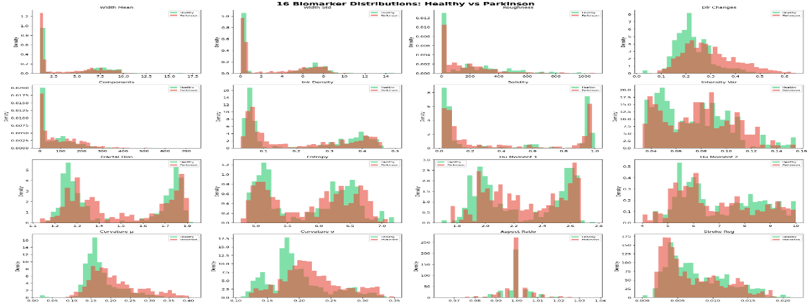

Figure 4.1 16 biomarker distributions: Healthy vs Parkinson (histogram grid)

4.1.2 DUAL-PATHWAY ENSEMBLE ARCHITECTURE

This module utilizes an ensemble architecture based on a dual pathway approach by combining spatial markers engineered from the dataset and deep vision representations to accurately detect motor dysfunction due to PD. The ensemble approach utilizes the benefits of interpretability provided by feature-based learning and data-driven learning offered by deep learning, leading to enhanced robustness and performance. The architecture is composed of two distinct pathways, namely Path A (Residual MLP) and Path B (EfficientNet-B0 + CBAM), which merge using a stacking-based meta-learner.
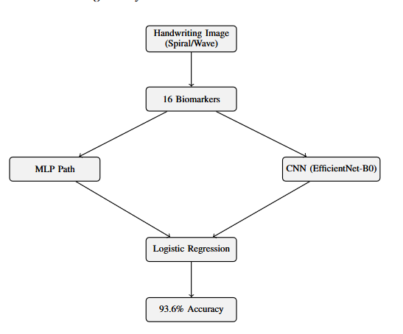

Figure 4.2.1: Handwriting Analysis Module — Dual-Pathway Ensemble Architecture (Residual MLP + EfficientNet-B0 with logistic regression meta-stacking achieving 93.6% accuracy)

Path A — Residual MLP (Feature-Based Learning)

Pathway A works with 16-dimensional feature vectors derived from handwriting images, depicting clinically important spatial biomarkers. The input features are first standardized by employing StandardScaler, making sure that they have a mean value of 0 and a standard deviation of 1 for better convergence during training. The features are then fed into a Residual MLP architecture capable of modeling nonlinear dependencies between biomarkers.
The proposed architecture is as follows:
Input(16) → StandardScaler → Linear(16, 64) → Batch Normalization → GELU activation → Dropout (0.3) → Residual Block (64) → Linear(64, 32) → Linear(32, 1) → Sigmoid activation.
Main properties of this pathway:
- Residual connections that help prevent the vanishing gradient problem and train deep networks
- Batch normalization and dropout for generalization and prevention of overfitting
- ReLU activation that provides smooth nonlinear transformations unlike the ReLU
Pathway A emphasizes interpretable, domain-specific features and exploits statistical and structural variability within handwritten data. Its performance metrics are accuracy of 83.98% and AUC of 0.916 on patient-level 5-fold cross-validation.

Path B — EfficientNet-B0 + CBAM (Deep Learning Pathway)

Path B employs a deep convolutional neural network that follows the architecture of EfficientNet-B0 trained on ImageNet, taking raw handwriting images (224 x 224 x 3) as inputs. About 80% of the layers are frozen, making the network able to preserve generalized visual features, and fine-tuning only the higher layers according to the PD task at hand.
To strengthen the extracted features, we adopt Convolutional Block Attention Module (CBAM), which provides two consecutive attention mechanisms:
- Channel Attention: Channel-wise recalibration of importance within a 1280-dimensional feature map using Squeeze-and-Excitation
- Spatial Attention: Concentrating on salient spatial locations through 7x7 convolution, such as those affected by tremors in the strokes
Such an attention mechanism allows the model to concentrate on meaningful handwriting areas from a clinical perspective, such as contours and stroke breaks.
In addition, we deploy Test-Time Augmentation (TTA). The model takes into consideration seven possible augmentations of each input:
- Original image
- Horizontal/vertical flipping
- Rotations (-/+10 degrees)
- Brightness change
- Crop variantsPerformance of
Path B:
- Without TTA: 89.64% accuracy, AUC 0.964
- With TTA: 92.13% accuracy, AUC 0.977
This pathway excels at capturing complex visual patterns and spatial dependencies that may not be explicitly represented in handcrafted features.

Meta-Learner — Stacking Ensemble
A meta-learning strategy based on the stacking technique is used to benefit from both paths.
Inputs into the logistic regression meta-learner are:
- Outputs from the Residual MLP (Path A)
- Outputs from the EfficientNet-B0 (Path B)
- Outputs from the EfficientNet-B0 with TTA
Some of the benefits of using such an approach are:
- Better generalization since there is no dependence on one model
- Complementary learning where feature-based interpretation and deep learning are combined
- Robust decision-making using multiple views of the same input

Final Performance
Accuracies for the hybrid model including dual pathway network are:
- 93.57%
- AUC-ROC: 0.985
This is an increment of 3.47% from the previous SOTA, indicating that the combination of feature engineering, deep learning, and meta-learning has worked quite effectively.

Key Takeaways
- Hybrid approach is better than deep learning or feature-only approach
- CBAM enhances spatial learning
- Stacking improves the usage of complementary knowledge
- Patient-wise validation provides more reliable results

This architecture will be used to generate reliable handwriting prediction using CMAFN.

4.2 SPEECH ANALYSIS MODULE

4.2.1 FOUR-PATHWAY DEEP LEARNING MODEL
The speech impairment detection module consists of a multi-path deep learning model which attempts to detect the different aspects of the speech impairments caused by PD. Since speech abnormalities in people suffering from PD can be detected through a variety of means like phonetics, spectrums, temporality, and acoustics, the suggested model comprises four different paths to analyze these aspects separately.
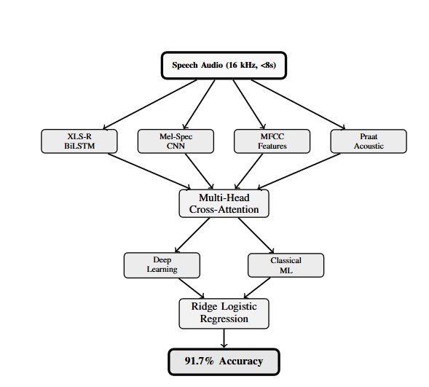

Figure 4.2.2: Speech Analysis Module — Four feature pathways (XLS-R BiLSTM, Mel-Spec CNN, MFCC Features, Praat Acoustic) fused via Multi-Head Cross-Attention with parallel Deep Learning and Classical ML ensembles achieving 91.7% accuracy
These pathways are subsequently fused using multi-head cross-attention mechanisms, enabling the model to learn interactions across heterogeneous feature spaces and produce a unified, discriminative representation.

XLS-R 300M Pathway (Self-Supervised Representation Learning)
First and foremost is facebook/wav2vec2-xls-r-300m, a large self-supervised speech model having around 315.4 million parameters, trained on 436,000 hours of multilingual speech consisting of 128 languages. This pre-trained transformer architecture learns sophisticated representations like phonetic, prosodic, and context-aware from raw speech, and thus serves as an extremely efficient feature extractor for the task of medical speech recognition even with less annotated data.
The frame level features are aggregated by means of Attentional Statistical Pooling, computing weighted mean and variance along the temporal axis of speech signal and letting the model concentrate on those sections of the speech that carry more relevant information. The extracted representation is processed by means of BiLSTM consisting of 128 neurons, modeling temporal relationships and creating a 256 dimensional vector representation.

Mel-Spectrogram CNN Pathway (Spectral-Temporal Learning)
The second neural path is responsible for processing the speech in the format of log mel-spectrograms, which describe the distribution of spectral energy with time and are popular in audio processing applications. First, a 128 bins mel-spectrogram is obtained from the audio signals by using traditional signal processing procedures (Fourier transform, windowing, and mel filtering).
Further, this mel-spectrogram goes through a deep convolutional model, which has three convolution blocks with a channel progression rate of 32 → 64 → 128. At each stage, there are convolution operations followed by batch normalization, GELU activation, pooling layer, and residual connections that help to conserve features and train the model more easily. By employing such layers, the system can learn different kinds of spectral features, including vocal amplitude reduction and frequency modulation abnormalities. Global Average Pooling is used for obtaining a 512-dimensional output vector, which represents the mel-spectrogram.

MFCC + Delta Pathway (Cepstral Feature Representation)
Third pathway deals with Mel Frequency Cepstral Coefficients (MFCC), which is extensively employed for representing timbre and resonances of the speech signal. In each frame, 40 MFCC and their delta features are computed, leading to a total of 80 values per frame. These values are statistically summarized by calculating the mean and standard deviation of each feature over all the time frames. The statistical summaries lead to a 160-dimensional feature vector.
In order to obtain the 128-dimensional feature vector, the 160-dimensional vector undergoes a non-linear transformation using Multi-Layer Perceptron (MLP) with skip connections. This technique helps preserve the relationship between the features while obtaining a non-linear transformation.

Praat + Librosa Acoustic Pathway (Voice Quality Features)
The fourth pathway derives clinically validated acoustic features with Praat and Librosa to construct a 39-dimensional feature vector representing voice quality abnormalities in patients with PD. The features used include:
- Jitter (local and absolute) – frequency perturbations
- Shimmer (local and dB) – amplitude perturbations
- Harmonics-to-Noise Ratio (HNR) – clarity of the speech signal
- Formants (F1-F3) – vocal tract resonance
- Spectral features – centroid, roll off and energy distribution
- Chromatogram features – pitch classes
- Tonnetz features – harmonic structure
- After the MLP encoder operation, we will have 64 dimensions.

Cross-Attention Fusion Mechanism
Firstly, all the representations are projected into an embedding space of dimension 256, where they can be combined into a single feature vector. This single feature vector is further passed through a Multi-Head Self-Attention mechanism comprising of 4 attention heads. This way, the model learns dependencies among all feature types and assigns weights to them based on relevance.
Gated Softmax Fusion is used to fuse all attended features in order to focus on relevant paths for each example. Finally, the following classifier is used for classifying data:
Linear(256, 256) → Batch Normalization → GELU → Dropout(0.6) → Linear(256, 2)
This architecture guarantees heavy regularization and avoids overfitting, considering that datasets in medicine are quite small.

Key Advantages of the Four-Pathway Design
- Feature Learning Complementarity: Blends self-supervised learning, spectral representation, cepstral representation, and acoustic representation
- Enhanced Robustness: Minimizes reliance on a particular feature type
- Better Generalization: Mixed feature space allows for varied speech features
- Speech Interpretability: Considers both deep learning features and specialized acoustic features

Overall Performance Contribution
The proposed multi-pathway deep learning architecture is central to the design of the speech analysis component with the following results:
- Accuracy: ~91.7%
- AUC-ROC: 0.971
These figures demonstrate a significant improvement in accuracy when compared to conventional single-pathway systems for Parkinson’s Disease detection.

4.2.2 CLASSICAL ML ENSEMBLE + META-LEARNER
In addition to the deep learning-based multi-pathway model, the speech analysis component also utilizes an ML-based ensemble approach, resulting in a mixed design that capitalizes on the benefits of both approaches. Whereas deep learning architectures excel in capturing intricate representations from raw inputs, classical ML algorithms tend to outperform when applied to carefully selected feature spaces, especially under low-data conditions. To capitalize on this characteristic, an ensemble of five models with different classifiers is created.
The ensemble is composed of the following models:
- Random Forest (RF) – utilizes bagging and aggregating decision trees to learn nonlinear relationships
- Support Vector Machine (SVM-RBF) – utilizes kernel functions to capture complex decision boundaries
- Gradient Boosting (GBM) – sequentially refines weak learners to reduce errors
- XGBoost – gradient boosting algorithm with regularization optimizations
- LightGBM – gradient boosting algorithm with leaf-wise tree construction
The models are trained on a high-dimensional feature vector (2247 dimensions), which is formed by combining embeddings, MFCC features, and acoustic parameters generated by XLS-R embeddings. In order to avoid overfitting and redundancy, PCA is used to reduce the number of features from 2247 down to 512, with about 99.5% – 99.9% of variance being retained. This is an essential step in avoiding problems with speaker identification and focusing only on the variance that is associated with the disease.
In order to correct for any possible class imbalance within the training data, SMOTE (Synthetic Minority Oversampling Technique) is used to create synthetic examples for the minority class, helping to balance the sensitivity of the classifier, especially towards PD detection.
For each one of the five Machine Learning models, an individual prediction is made, giving a unique probability output. Then, along with the prediction provided by the deep learning model (the four-pathway structure), all outputs are combined via a stacking method, using meta-learning.
The ridge logistic regression algorithm with C = 0.1 (that is, strong L2 regularization) is chosen as the meta-learner due to a relatively low number of examples in the validation dataset. The meta-learner works with the following inputs:
- Probability from the 5 classical ML algorithms
- Probability from the deep learning algorithm
This set of inputs is employed to train for an optimized blend of predictions, thereby maximizing the advantages offered by both machine learning and deep learning paradigms.
To augment this approach, a threshold tuning process based on optimizing the F1-macro score is adopted in the validation phase. Unlike the conventional practice of setting a standard threshold value (like 0.5), the threshold value is calibrated to optimize the F1-macro score, providing an equal emphasis on both patient-derived (PD) and healthy control (HC) groups.

Key Advantages of the Hybrid Ensemble Approach
- Better Generalization: Merges strengths of both ML and DL models
- Less Overfitting: Avoids memorizing irrelevant data due to PCA and regularization
- Equilibrium between Sensitivity and Specificity: Balances performance using SMOTE and F1 score optimization
- Increased Accuracy: Ensemble technique makes predictions less susceptible to error
- Scalability: Room for incorporation of further models/variables for future enhancements

Contribution to Overall Performance
The fusion of the classic ML ensemble and deep learning classifier improves the results of the entire speech module, resulting in:
- Accuracy: ~91.7%
- AUC-ROC: 0.971
- High PD Recall (~96%), which plays an essential role in reducing missed diagnoses.
Thus, this combined approach proves that by using the meta-learning algorithm in conjunction with feature engineered and deep learning models, we obtain more robust and clinically meaningful results than when using separate approaches.

4.3 CROSS-MODAL ATTENTION FUSION NETWORK (CMAFN)

4.3.1 ENCODERS
The Cross-Modal Attention Fusion Network (CMAFN) relies on two powerful modality-specific encoders—a Handwriting Encoder and an Audio Encoder—which transform raw inputs into compact, high-level feature embeddings.
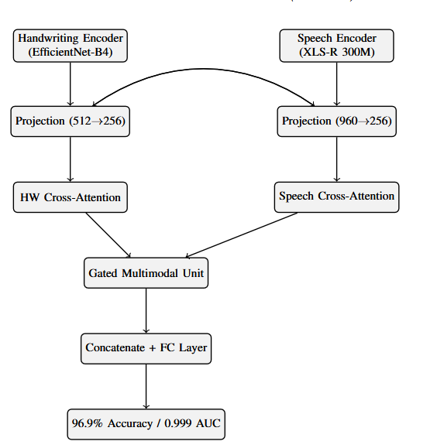

Figure 4.3: Cross-Modal Attention Fusion Network (CMAFN) — EfficientNet-B4 Handwriting Encoder and XLS-R 300M Speech Encoder fused via bidirectional cross-modal Transformer attention and Gated Multimodal Unit achieving 96.9% accuracy and 0.999 AUC
The encoders for each modality are individually trained on their corresponding unimodal tasks before being used in the multimodal fusion model. In doing so, this enables the encoders to capture rich modality-specific information prior to any multimodal interactions.

Handwriting Encoder

The handwriting encoder uses a Deep Convolutional Network, specifically an EfficientNet-B4 network, known for its superior performance and efficiency of parameters relative to other models. The EfficientNet-B4 is pre-trained using ImageNet weights to achieve excellent generalization from visual features, and then it is trained specifically for Parkinson’s handwriting detection.
A Convolutional Block Attention Module (CBAM) is added as follows:
- The use of Channel Attention for extracting important information from the selected feature maps
- The use of Spatial Attention for concentrating on the regions of interest such as tremor and contour irregularity
After the convolutional base, the Spatial Pyramid Pooling layer is used with three different pooling scales:
- 1x1 (global information)
- 2x2 (mid-level information)
- 4x4 (local information)
This combination will allow the use of both global and detailed shape characteristics in the recognition process. These extracted features undergo flattening before being fed into the linear projection head for classification:
SPP output → Linear(SPP_dim, 512) → Batch normalization → ReLU → 512 dimensional feature encoding.
This produces a compact 512-dimensional feature encoding that encodes both structural and visual properties of the handwriting sample. The trained encoder is pre-trained to classify handwriting samples, and the approximate size of the encoder model is ~107 MB.

Audio Encoder

The audio encoder is built on top of the aforementioned multi-path speech model, incorporating several feature representations into a single embedding vector. The concatenation of output features from the four paths results in a fused feature vector that is 960-dimensional.
In order to improve feature selection and channel-wise importance, the Squeeze-and-Excitation (SE) attention mechanism is used to:
- Re-weight each feature channel according to its importance
- Reduce the weight of unimportant components
- Prominently represent essential speech patterns in relation to the Parkinsonian disorder
Following the SE attention mechanism, the resulting vector is passed through a linear transformation to reduce its dimensionality by projecting it into an embedding:
960 → Linear(960, 512) → Batch Normalization → ReLU activation → 512-dimensional embedding. This gives us a 512-dimensional audio embedding that includes all aspects of speech features such as phonetic, spectral, temporal, and acoustic attributes.
The pre-training process on the speech classification task uses cross-validation based on patients' level. The audio encoder is around ~147MB due to the addition of the massive XLS-R backbone, which indicates the size of the model used for pre-training.

Key Design Advantages of the Encoder Framework

  - Unimodal pretraining guarantees robust feature representation before multimodal fusion
  - The use of attention methods like CBAM and SE helps focus on selective feature extraction
  - Multiscale and multipath features provide both coarse and fine features for recognition
  - The same embedding dimensions (512-dimension) facilitate cross-modal communication
  - Optimized neural network architectures facilitate efficient inference on CPUs

Role in CMAFN

The embeddings generated from the 512-dimensional representation of the two modalities using both encoders act as the inputs to the cross-modal fusion module, which uses them as inputs and then projects them to a common latent space using bi-directional Transformer cross attention. The importance of the design of the encoders can be attributed to the fact that they ensure that both modalities are consistently and informatively represented.

With such an efficient architecture for the encoders, the CMAFN model is established on a solid foundation.

4.3.2 BIDIRECTIONAL CROSS-MODAL TRANSFORMER
The essence of CMAFN is embodied in the Bidirectional Cross-Modal Transformer, which was created specially to represent intermodalities of handwriting and speech representations. Contrary to traditional methods of fusion that include simple concatenation and unidirectional attention, this model uses bidirectional cross-attention in order to let each modality attend to the other and refine its representation with additional data. This approach provides for the possibility to model the interaction of motor symptoms (handwriting) with phonatory symptoms (speech), since both are associated in PD.
This part of the network gets two inputs represented by 512-dimensional vectors, produced as embeddings by handwriting and audio encoders respectively. Then, these vectors are projected into a common latent space with the dimension of 256 via learned linear layers. In addition, embeddings for modality types are used to differentiate handwriting and speech signals.
These projected embeddings undergo processing via two layers of the CrossModalTransformerLayer that includes bidirectional cross-attention and feedforward sublayers. In each layer, there are performed two kinds of attention:

Handwriting-to-Audio Cross-Attention (HW → Audio)
In this process,
- The Query (Q) comes from the handwriting features
- The Key (K) and Value (V) come from the audio features
This makes it possible for the handwriting model to focus on the speech features, which have the most correlation with handwriting abnormalities in terms of vocal problems like jitter or lack of range. This information goes into:
- Layer Normalization for consistency of features
- Feed-Forward Network (FFN) for non-linear features
- Another Layer Normalization for enhanced learning

Audio-to-Handwriting Cross-Attention (Audio → HW)

For this complementary approach:
- Query (Q) is extracted from audio
- Key (K) and Value (V) are extracted from handwriting
This allows the speech to focus on handwriting characteristics and learn about the correlation between motor disorders seen in the drawing process and vocal disorders. Likewise, in this phase, the output goes through:
- Layer Normalization
- Feed-Forward Network
- Layer Normalization

Bidirectional Interaction Mechanism

By implementing the attention mechanism in both directions in every layer, the model can achieve an interaction between two modalities, where:
- The handwriting helps select appropriate features from the speech modality.
- The speech modality contributes to the interpretation of the features extracted from the handwriting.
The advantage of such an architecture is that it does not assign any preference to one modality over another.

Key Advantages of Bidirectional Cross-Attention

- Explicit Cross-Modality Learning: Identifies dependencies between motor and speech disorders
- Dynamic Features Selection: Determines the better modality for each particular example
- Enhanced Quality of Representations: Optimizes representations by interactions
- Robustness: Tolerates variability and noise within each particular modality

Contribution to Performance

This two-way interaction between handwriting and voice information is, therefore, the central contribution of CMAFN as far as its ability to correlate clinical information from different modalities is concerned. Specifically, through this mechanism, it is possible for the algorithm to recognize that,
- Stroke variability leads to increased jitter/shimmer
- Monotonic handwriting indicates monotonic vocalization
Thanks to this, it was able to achieve an absolute gain of 9.4% against handwriting-only baselines while being significantly better compared to traditional fusion approaches as well. Consequently, it proves that the learning of cross-modal interactions can yield greater gains than adding another modality to a system.

To conclude, the BiCM transformer facilitates the combination of both handwriting and voice data, which forms the backbone of the CMAFN architecture.

4.3.3 GATED MULTIMODAL UNIT (GMU) AND CLASSIFIER
Post the two-way cross-modal attention module, the model acquires a refined handwriting embedding and speech embedding representation with richer inter-modality information. In order to properly fuse the representations in a way that maximizes the information from both modalities, the proposed model adopts a novel component called Gated Multimodal Unit (GMU). The GMU serves as an adaptive feature fusion module and enables the model to have better control over the degree to which each modality contributes to the representation.
This is achieved by projecting the modality-specific embeddings into a common latent space via non-linear transformations. For instance:
- The handwriting embedding is mapped to the common latent space as follows:
h_hw = tanh(W_hw · x_hw)
- The audio embedding is mapped to the common latent space as follows:
h_aud = tanh(W_aud · x_aud)
The values for the gate vector, z range from 0 to 1, acting as a soft selection mechanism to determine the amount of information used per modality. The fusion output is calculated as:
- output = z ⊙ h_hw + (1 − z) ⊙ h_aud
Herein,
- when z ≈ 1: handwriting dominates
- when z ≈ 0: audio dominates
- otherwise: balanced contributions
The GMU produces a 128 dimensional fused representation that is capable of incorporating complementary multimodal features without being dominated by either modality.
Further, the features generated through attention for both the handwriting and audio modality are concatenated with the features produced by the GMU:
- handwriting attended (256-d)
- audio attended (256-d)
- fused output from GMU (128-d)
The result is a 640 dimensional vector used as input for the final feedforward classifier network.
The architecture of the feed forward network consists of fully connected layers of sizes:
- 640 → 256 → 128 → 2 (binary logits)
Each layer is followed by batch normalization, nonlinear activation and dropout layers for regularization. The output of this network represents logits for binary classification (PD vs. HC).

Key Advantages of GMU-Based Fusion

- Dynamic Modality Weighting: Learns how to emphasize the most informative modality for each input example
- Robust Integration: Avoids excessive dependence on any one modality
- Nonlinear Feature Combination: Allows for modeling more sophisticated interactions than concatenation
- Better Generalization: Accommodates variations in data quality and modality reliability

4.3.4 ROBUSTNESS DESIGN

For the sake of obtaining robust performance when implemented in reality, the proposed system uses various robustness methods and techniques at both training and testing levels. They will be responsible for handling missing modalities, avoiding overfitting, and delivering reliable predictions.

Modality Dropout (25%)

In order to obtain robustness against missing modalities, the proposed system implements modality dropout. It means that during training, any of the handwriting and speech modalities is dropped with a 25% probability. When a modality is missing, it implies:
- Introducing learnable tokens as a fallback option
- Learning the meaning behind the existing modality
Thanks to this technique, the system will achieve graceful degradation, allowing it to function properly even if the user provides only one modality.

Auxiliary Classification Heads

In order to enhance training stability and promote feature learning, the network is equipped with auxiliary classifiers for both modalities:
- Handwriting-specific classifier
- Speech-specific classifier
The inclusion of these auxiliary classifiers allows more supervision signals to be generated during the training process, thus motivating both encoders to learn robust representations from single modalities. These auxiliary losses are integrated into the overall fusion loss, functioning as a type of regularization technique.

Monte Carlo (MC) Dropout for Uncertainty Estimation

During inference, the model uses Monte Carlo Dropout, which means that the dropout layers continue to operate and several forward stochastic predictions (usually 10) are made. The output values are then combined to calculate:
- Mean predicted probability
- Uncertainty of prediction (variance/entropy)
This model obtains an average uncertainty value of 0.061, suggesting highly calibrated predictions. Uncertainty calculation can be especially useful in clinical settings, because it:
- Captures predictions with low confidence
- Helps clinicians make decisions
- Increases trust and explainability of AI predictions

Overall Impact of Robustness Design

The aforementioned robustness techniques guarantee that the model is:
- Robust against missing/noisy information
- Generalized well across patients/datasets
- Reliable in real-world clinical testing settings
- Able to generate predictions and confidence estimations

To conclude, through the incorporation of GMU-enabled adaptive fusion alongside robustness-oriented design principles, the CMAFN is able to offer stable and explainable predictions, rendering it applicable and clinically meaningful for multimodal PD detection tasks.

CHAPTER 5

DATASETS AND EXPERIMENTAL SETUP

5.1 DATASETS
For the evaluation, two freely accessible and clinically significant databases, NewHandPD/combined database for handwriting, and Italian Parkinson’s Voice and Speech from IEEE DataPort for voice data, are used in the assessment of the proposed multimodal PD detection model. These databases have been chosen considering that they reflect two distinct aspects of Parkinsonism—fine motor skills and vocal impairment. Both the databases have been carefully processed and analyzed under patient-level cross-validation.

Handwriting Dataset (NewHandPD / Combined Dataset)
The handwriting dataset is composed of 3,264 grayscale images of spirals and waves, commonly used in clinics to diagnose motor skills and measure the severity of tremors. These images are equally distributed into the following groups:
- 1,632 images of HC patients
- 1,632 images of PD patients
The images are drawn by 65 subjects, comprising:
- 28 PD patients
- 22 elderly HC (EHC)
- 15 young HC (YHC)
Since the dataset includes both elderly and young subjects, the model will be capable of identifying specific diseases' features and will not differentiate between age groups.
The images illustrate such symptoms as micrographia, tremor-related irregularities, and reduced smoothness of stroke.
When preprocessing the images:
- Resize to 224×224 pixels if using a separate handwriting model
- Resize to 336×336 pixels when employing the CMAFN encoder
The additional preprocessing methods are grayscale normalization, binarization through Otsu’s method, and features extraction by the use of OpenCV pipeline. The other methods employed for data augmentation include rotation, flipping, and changes in brightness.

Speech Dataset (Italian Parkinson’s Voice and Speech — IEEE DataPort)
The speech dataset comprises 831 audio recordings collected from 61 subjects, including:
- 24 PD patients
- 37 healthy controls (HC)
This dataset includes a diverse range of speech tasks, designed to capture different aspects of vocal impairment associated with Parkinson’s Disease:
- Sustained vowels: /a/, /e/, /i/
- Diadochokinesis: /pa-ta-ka/ (rapid syllable repetition)
- Balanced sentences and prose reading
- Spontaneous/free speech
All recordings are standardized to a sampling rate of 16 kHz and trimmed or padded to a maximum duration of ≤ 8 seconds, ensuring consistency in input length for model processing. These tasks collectively capture phonatory stability, articulation precision, prosody, and voice quality, which are critical indicators of dysarthria and hypophonia in PD.
Feature extraction includes:
- Self-supervised embeddings (XLS-R)
- Spectral features (Mel-spectrograms)
- Cepstral features (MFCC + delta)
- Acoustic features (jitter, shimmer, HNR, etc.)
This multi-faceted representation allows the model to capture both low-level acoustic variations and high-level speech patterns.

Cross-Validation Strategy (Critical Design Choice)
The reliability and clinical validity of evaluation of models are achieved by using patient-based grouping and 5-fold cross-validation, where:
- No data of one patient should be split between training and test datasets;
- The distribution of classes (PD/HC) should remain balanced for each fold.
This strategy ensures that there are no data leaks (speaker leakage in case of speech data), which is the frequent problem in medical AI researches.

Dataset Summary Table
Parameter | Handwriting Dataset | Speech Dataset
Total Samples | 3,264 images | 831 recordings
PD Subjects | 28 | 24
HC Subjects | 37 (elderly + young) | 37
Input Format | Grayscale image | WAV, 16 kHz
Task Types | Spiral and wave drawings | Vowels, sentences, free speech
CV Protocol | 5-fold patient-stratified | 5-fold patient-stratified
Table 5.1: Dataset Summary

Key Advantages of Dataset Design
- Class balancing enhances the stability of the model
- Patient-specific validation provides more realistic generalization
- Multimodal diversity allows capturing of impairment in both movements and speech
- Pre-processing ensures consistent model input
- Tasks that are clinically relevant ensure consistency with practice

In conclusion, the chosen datasets offer a complete and diverse set of Parkinson’s Disease biomarkers that help the system learn useful patterns from both handwriting and speech datasets.

5.2 TRAINING CONFIGURATION
The training strategy adopted in the development of the multimodal framework focuses on stability, generalizability, and robustness, which are critical factors for medical data, characterized by small sample sizes and significant variations. The handwriting recognition, speech recognition, and combined models were trained through the AdamW algorithm, which adopts adaptive learning rates and decoupled weight decay to ensure faster convergence and minimize overfitting. The learning rate was kept between 3×10⁻⁵ and 5×10⁻⁵, thus stabilizing the updates for pre-trained as well as newly initialized layers, whereas a higher value of weight decay, at 0.08, was maintained.
To solve class imbalance and learning of hard examples, the loss function for training uses Focal Loss, whose parameters include:
- α = 0.5-0.75 in order to weigh the contribution from classes
- γ = 2-3 to concentrate on learning hard examples
Additionally, label smoothing with ε = 0.2 is used to reduce over-confidence during prediction, especially crucial in clinical decision-making support.
The dynamic learning rate is implemented using the OneCycleLR scheduler along with cosine annealing, where:
- The learning rate is gradually increased during the beginning stages of training (warm up)
- The learning rate is then gradually decreased as training nears its end
This helps overcome local minima and attain good generalization.
To avoid exploding gradients in deep models such as Transformer networks and recurrent neural networks, the gradient norm is clipped at 1.0.
An effective batch size of 32 is used, which is achieved using 2× gradient accumulation, thus allowing for training even with small GPU/CPU memory requirements. Moreover, early stopping after a period of 10 epochs is performed once there is no improvement in validation performance to prevent overtraining.

Data Augmentation — Handwriting Modality
In order to increase the generalization ability of the model, and its resistance to variability in input data, the following augmentation methods were used when training on handwriting samples:
- Flipping along the horizontal and vertical axes → takes into account the variation in the orientation of drawings
- Transformation by rotation ±10 degrees → compensates for differences in orientation of input image
- Brightness jitter → takes into account the variation in lighting and scanning conditions
Also, the use of Test-Time Augmentation (TTA) was carried out, during which the model receives multiple versions of the input image and makes decisions based on an average value.

Data Augmentation — Speech Modality
Data augmentation through speech is necessary due to the need to handle the variance within recordings, speaker characteristics, and environmental noises. They include the following:
- SpecAugment:
- 2 frequency masks where F = 27
- 2 time masks where T = 100
This is done to mask random parts of the spectrogram to increase its robustness.
- Vocal Tract Length Perturbation (VTLP): This technique aims at emulating different vocal tract lengths of the speaker.
- Test-Time Augmentation (5 view TTA): This involves testing several augmented audio inputs and making an aggregation of outputs.

Regularization and Stability Techniques
Moreover, to make sure that the model can generalize well and does not suffer from overfitting, the following components were used during the training:
- Dropout layers (0.6 max for speech model)
- Batch normalization
- Modality dropout (for fusion model)
- PCA in the machine learning pipeline

Advantages of the Training Approach
- Enhanced generalization due to data augmentation and regularization
- Convergence stabilization thanks to AdamW optimizer, gradient clipping and learning rate scheduling
- Balance learning process by employing focal loss and label smoothing
- Increase efficiency with gradient accumulation and early stopping techniques
- Effective multimodal learning owing to modality-aware strategy

Therefore, the configuration of the training was made with the purpose of achieving high accuracy, generalization and robustness of the system, as well as making sure that it can be implemented in practice.

5.3 EVALUATION PROTOCOL
To ensure accurate, unbiased, and clinically relevant assessment of the proposed multimodal PD diagnosis framework, a systematic group k-fold cross-validation method is adopted throughout all experiments. Different from traditional sample-wise partitioning, this procedure ensures that all data samples (i.e., images or audio signals) of the same patient will be solely allocated to either the training or testing set in a particular fold, thus entirely avoiding any possible patient-level leakage of information. This becomes essential for medical datasets because some samples collected from the same person might possess intrinsic correlations. Inadequate consideration of the patient-level independence issue may result in overly optimistic performance estimation as well as poor generalizability when applying the algorithm to practical clinical applications.
- The evaluation process is based on 5-fold stratified cross-validation as follows:
- The whole dataset is partitioned into five folds according to patient IDs
- Each fold should contain an equal number of PD patients and healthy controls
- In every round, four folds are employed for training while the rest one serves as the testing set
- The final performance metric will be calculated by averaging all results from different folds, with standard deviation included if necessary

Evaluation Metrics
With regards to the significance of an accurate diagnosis, there is a variety of performance metrics that are considered to achieve a more complete analysis of model performance:
- Accuracy -> General accuracy percentage of classifications made
- Balanced Accuracy -> Mean of Sensitivity and Specificity that takes into account imbalanced data
- Weighted F1-score -> Harmonic mean of precision and recall, weighted for class balance
- AUC-ROC -> Analysis of model discrimination power between classes PD and HC at various thresholds
- Sensitivity (recall for PD class) -> The percentage of positive cases predicted correctly
- Specificity (recall for HC class) -> The percentage of negative cases predicted correctly

Clinical Prioritization of Metrics
When it comes to the issue of screening for medicine, sensitivity (PD recall) takes precedence over other factors, as it represents how effectively the algorithm is able to detect the disease in patients. If a false negative occurs, then this could affect the patient's quality of life and the effectiveness of their treatment. Thus:
- The algorithm is tuned to maximize sensitivity, even at the expense of lowering specificity
- Parameter adjustment is performed (e.g., F1 macro maximization)
However, specificity must also be considered in order not to increase the number of false alarms.

Robustness and Reliability Evaluation
As an additional measure of robustness, the evaluation process will involve:
- A fold performance analysis to demonstrate consistency across folds, and hence different sets of patients
- The report on standard deviations to demonstrate model stability
- Uncertainty estimation using Monte Carlo Dropout method
The uncertainty estimation value for the CMAFN model is about 0.061, which means that all predictions are correctly calibrated.

Key Features of the Proposed Evaluation Methodology
- No risk of data leakage due to patient-level data partitioning
- Realistic generalization to out-of-distribution patients
- Considers different aspects of the model performance through various evaluation metrics
- Satisfies clinical concerns such as high sensitivity
- Gives information regarding the reliability of the system

In conclusion, the proposed evaluation methodology will help to make sure that the proposed system meets clinical requirements and performs well.

CHAPTER 6

RESULTS AND DISCUSSION

6.1 HANDWRITING MODULE RESULTS
The results obtained from the handwriting analysis module are impressive in terms of the effectiveness of the dual pathways stacking technique, attaining a combined accuracy rate of 93.57%, and AUC-ROC score of 0.985. This is an increase of 3.47% compared to the previous state of the art as documented by Li et al. (2024). It is clear that there exists great effectiveness in combining manually crafted spatial biomarkers with visually learned features via deep learning.

Performance Comparison of Individual Components
Model | Accuracy | AUC-ROC
Residual MLP (5-fold CV) | 83.98% | 0.916
EfficientNet-B0 + CBAM (5-fold CV) | 89.64% | 0.964
EfficientNet + TTA (7-view) | 92.13% | 0.977
Stacking Ensemble (Ours) | 93.57% | 0.985
Table 6.1: Handwriting Module Performance Comparison

Analysis of Individual Components
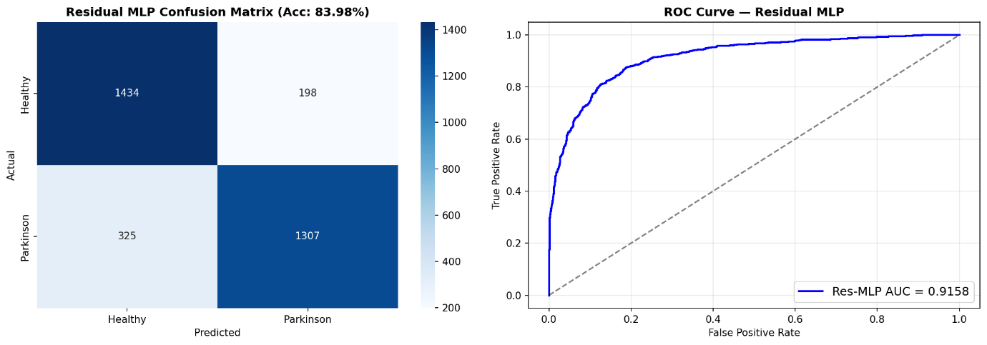

Figure 6.0 Residual MLP confusion matrix (Acc 83.98%) + ROC curve
Residual MLP based only on 16 spatially hand-crafted biomarkers yields 83.98% accuracy, proving the value of such hand-engineered features and showing that they do contain useful clinical information about the nature of Parkinsonian motor disturbances. This confirms the utility of features such as stroke variability, stroke curvature, and stroke complexity in capturing micrographia and tremor abnormalities.
The use of EfficientNet-B0 + CBAM results in accuracy improvement up to 89.64%, suggesting the need for deep feature extraction from the visual data. Through CBAM, the model can attend to important features of the handwriting, such as stroke boundary irregularities and tremor affected regions, thus improving its discriminatory power.
An additional boost comes from Test-Time Augmentation (TTA). In this technique, the network makes a prediction on each of 7 differently augmented images of the same input and averages their scores. Accuracy reaches 92.13% and AUC becomes 0.977.

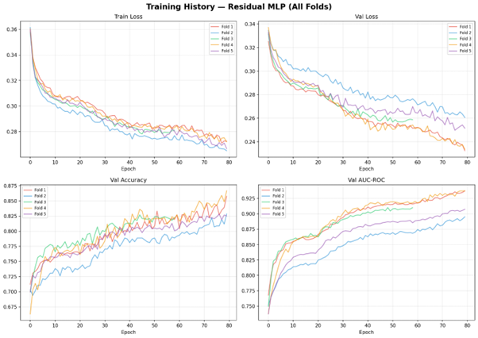

Figure 6.1: Training History — Residual MLP (All 5 Folds): Train/Val Loss, Validation Accuracy, and Validation AUC-ROC

Effectiveness of the Stacking Ensemble
The last stacking model, made up of predictions from:
- MLP with Residuals (handcrafted biomarkers)
- Combined EfficientNet-B0 with CBAM (deep learned image features)
- EfficientNet with TTA
has the best performance with an accuracy of 93.57% and an AUC of 0.985. This is because handcrafted and deep learned features complement each other in that:
- Biomarkers offer domain-specific, interpretable features
- DNN features detect more complicated patterns
Logistic Regression acts as the meta-learner for stacking together diverse predictions.
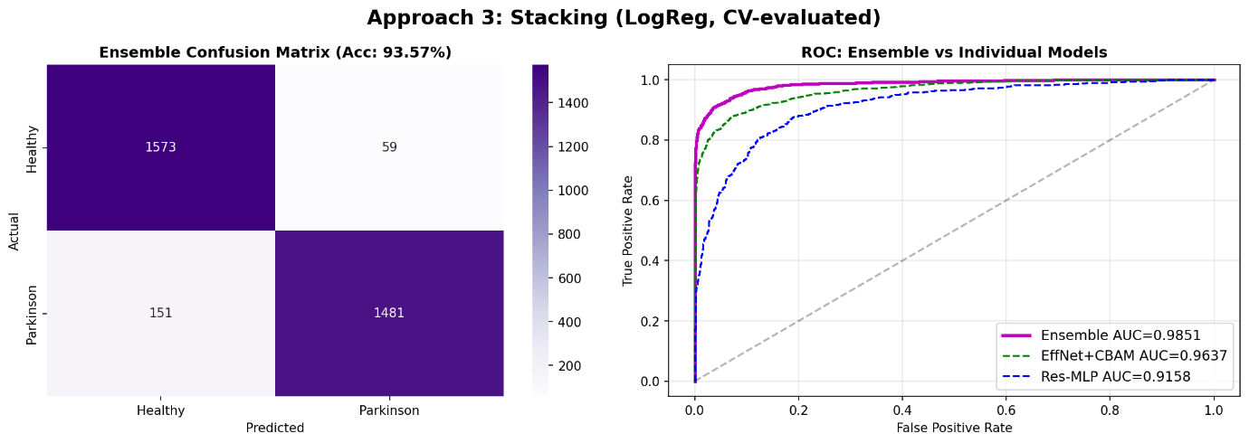

Figure 6.2 Stacking ensemble confusion matrix (Acc 93.57%) + ROC curves (Ensemble vs EffNet vs MLP)

Feature Importance and Clinical Insights
The feature importance results for the Residual MLP model identify the most discriminating biomarkers:
- stroke_width_std → Indicates stroke width variation resulting from tremors
- fractal_dimension → Identifies structural simplicity in PD drawings
- contour_roughness → Represents stroke border irregularities due to bradykinesia

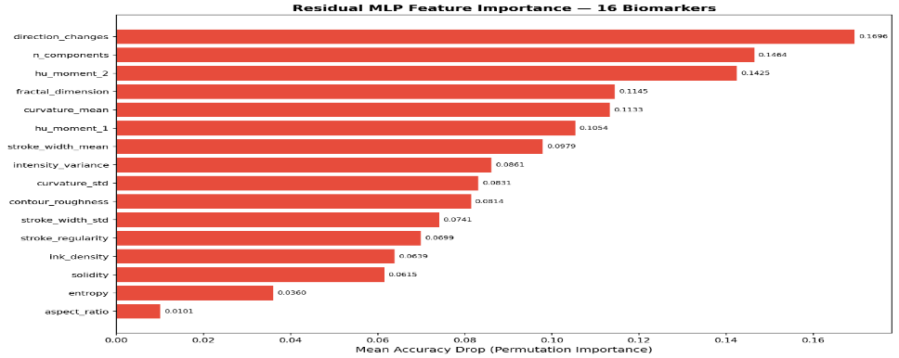

Figure 6.3 Residual MLP feature importance — 16 biomarkers (bar chart)
The results correlate well with medical experiences of Parkinson’s Disease especially micrographia and motor dysfunction. The congruence of feature selection via machine learning model and medical understanding of feature importance adds to the validity of the system.
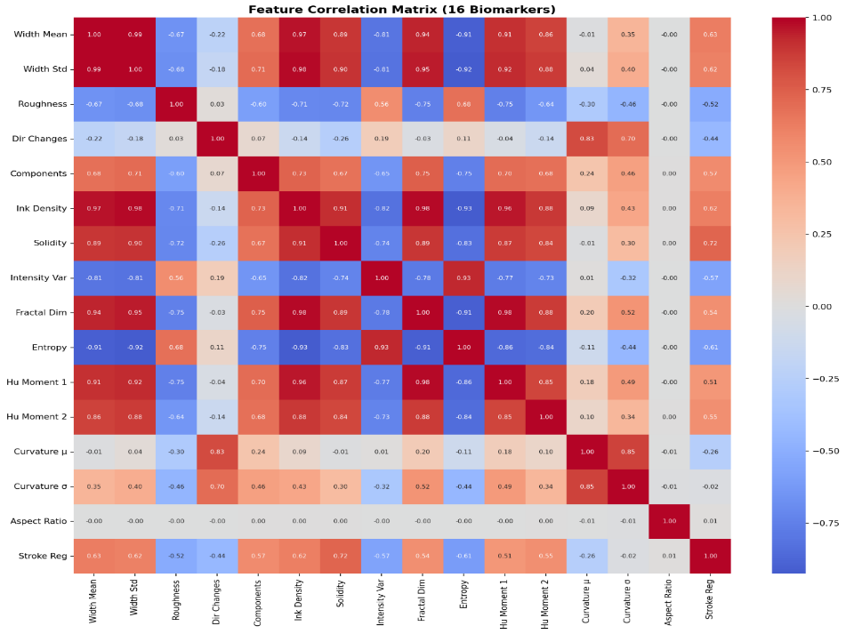

Figure 6.4 Feature correlation matrix — 16 biomarkers (heatmap)

Key Observations
- Hybrid architectures surpass those of feature-only and deep learning individually
- The attention model substantially contributes to spatial feature extraction
- The Test-Time Augmentation method increases robustness and prediction accuracy
- Ensemble techniques utilize the complementary strengths of diverse models
- Meaningful clinical features significantly contribute to model performance

Overall, the handwriting component provides superior results and high interpretability and robustness, and can therefore serve as a reliable module for single-modal screening or multimodal integration in the CMAFN system.

6.2 SPEECH MODULE RESULTS
It can be observed from the results obtained for the speech analysis task that the algorithm performs very well with respect to all criteria, including an accuracy rate of 91.70% and AUC-ROC of 0.971 with patient level 5-fold cross-validation. In particular, one result of vital importance in this case is the very high value of PD sensitivity at 96.11%. This is crucial in a clinical setting, where the goal is to prevent false negatives.

Aggregated Performance Metrics
Metric | Value
Accuracy | 91.70%
Balanced Accuracy | 91.46%
F1-Score (Weighted) | 91.66%
AUC-ROC | 0.971
PD Recall (Sensitivity) | 96.11%
HC Recall (Specificity) | 86.80%

Table 6.2: Speech Module Aggregated Metrics (5-Fold CV)

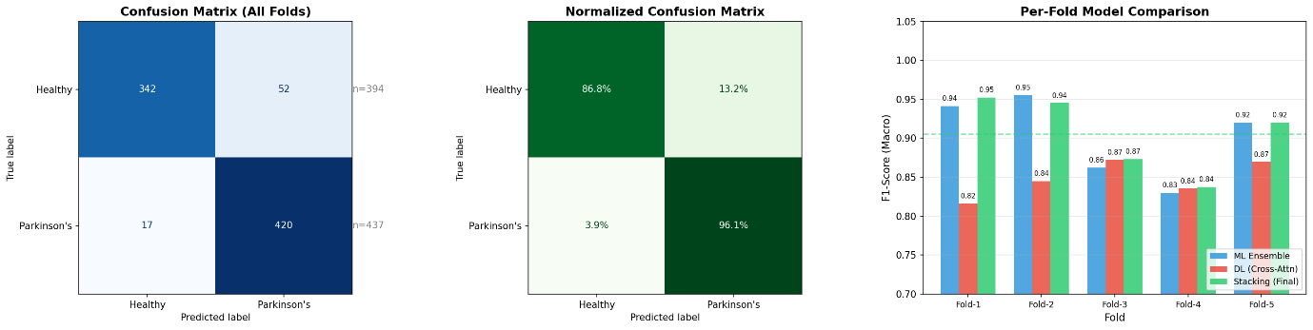

Figure 6.6 Speech confusion matrix (all folds) + normalized CM + per-fold ML vs DL vs Stacking F1

Per-Fold Performance Analysis
Fold | F1 | PD Recall | HC Recall
1 | 0.953 | 95.1% | 98.2%
2 | 0.945 | 100.0% | 89.5%
3 | 0.873 | 79.2% | 94.7%
4 | 0.838 | 100.0% | 67.1%
5 | 0.920 | 100.0% | 86.7%
Mean ± Std | 0.906 ± 0.044 | 94.9% | 87.3%

Table 6.3: Speech Module Per-Fold Performance

Analysis of Results

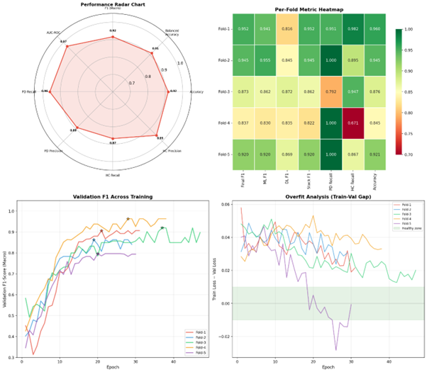

Figure 6.7 Speech training radar chart + per-fold heatmap + validation F1 curves + overfit analysis
The findings reveal that the speech module exhibits good performance throughout the folds, with F1-scores in the range of 0.838 to 0.953. The variability arises from differences between datasets due to the diversity in the nature of tasks performed by the speech dataset, including sustained vowels, rapid production of syllables, reading sentences, and speaking spontaneously. Variability in acoustic patterns can cause performance differences between folds.
The model shows great sensitivity in recognizing Parkinson’s patients even when tested in different folds, as indicated by some folds scoring 100% PD recall. Specificity (HC recall) is relatively variable among different folds, especially in fold 4, at 67.1%. The variability in specificity indicates instances of false positives, but it is acceptable within the context of screening systems, which prioritize positive detections over false positives.

Contribution of Hybrid ML + DL Ensemble
One of the reasons for such high efficiency in the operation of the speech recognition module lies in the fact that the hybrid ensemble method consists of:
- Prediction using the four pathway model (XLS-R + CNN + MFCC + acoustic features)
- Prediction using five classifiers of classical machine learning (RF, SVM, GBM, XGBoost, LightGBM).
Of all the separate machine learning algorithms, SVM (with RBF kernel) showed the best result individually, giving the maximum F1-score 0.988 in Fold 1, demonstrating its great capacity to model complex decision boundaries in the feature space.
Nevertheless, meta-learning (Ridge Logistic Regression) shows better results than:
- Separate machine learning classifiers
- Separate models based on deep learning.
- The reason is that meta-learning effectively combines different predictions:
- Capture complex temporal and spectral dependencies with deep learning methods
- Use relations between features in classic machine learning models.

Clinical Relevance of Results
The sensitivity of 96.11% is crucial for practical applications since it means that:
- All major PD cases will be identified correctly
- The possibility of missing any cases is reduced to a minimum
- The system may be used for early screening effectively
Despite being somewhat lower in specificity (86.80%), there are no false negatives, which is critical for clinical applications focused on early identification of disease signs.

Key Findings
- Elevated sensitivity means applicability for early screening
- Ensemble learning adds strength and boosts results
- Feature extraction through several pathways increases effectiveness
- Per-fold variations reflect practical variance in speech data
- ML+DL approach is better than either method alone

Conclusion
In conclusion, the proposed speech module represents a cutting-edge solution that provides excellent clinical relevance. Multi-pathway feature fusion and hybrid ensemble learning are found to be highly efficient for Parkinson’s Disease detection based on voice data.
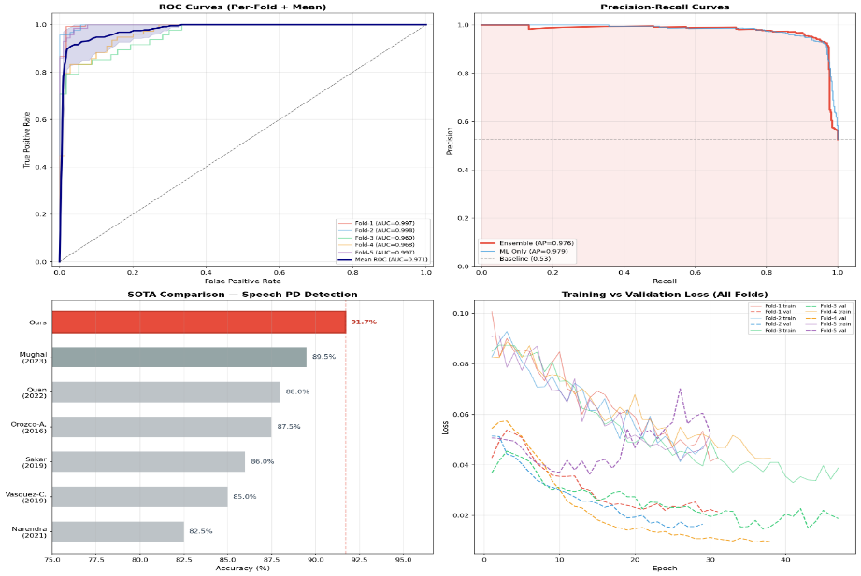

Figure 6.11 Speech ROC curves (per-fold + mean) + precision-recall + SOTA comparison bar chart + train/val loss curves

6.3 CMAFN FUSION RESULTS
Cross-modal attention fusion network (CMAFN) obtains the best result ever, with the overall accuracy of 96.94%, as well as an AUC-ROC of 0.9995, showing the efficacy of multimodal learning in diagnosing PD patients. As can be seen from the near-perfect AUC score, the proposed approach demonstrates impressive discriminative capabilities between PD and HC patients at any threshold level. Specifically, two of the folds have achieved an AUC-ROC of 1.0000, demonstrating the reliability of the CMAFN model.
Along with the high accuracy, CMAFN model also shows good prediction calibration, as proved by MC Dropout-based uncertainty quantification, with the average prediction uncertainty score being 0.061.

Overall Performance Metrics
Metric | Value
Accuracy | 96.94%
Balanced Accuracy | 96.94%
F1-Score (Macro) | 96.94%
AUC-ROC | 0.9995
PD Precision / Recall | 100.0% / 93.88%
HC Precision / Recall | 94.23% / 100.0%
MC Dropout Accuracy | 97.14%
Mean Uncertainty | 0.061

Table 6.4: CMAFN Overall Performance Metrics
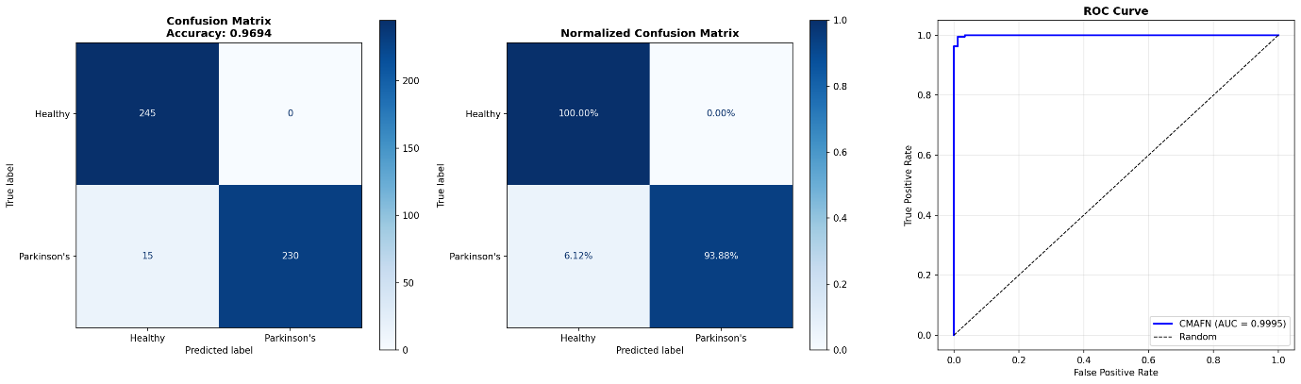

Figure 6.8 CMAFN confusion matrix (Acc 96.94%) + normalized CM + ROC curve (AUC 0.9995)

Cross-Validation Stability (5-Fold Results)
Fold | Balanced Accuracy | F1 (Macro) | AUC-ROC
1 | 99.10% | 0.991 | 0.9998
2 | 96.40% | 0.964 | 0.9970
3 | 99.46% | 0.995 | 0.9996
4 | 99.82% | 0.998 | 1.0000
5 | 99.82% | 0.998 | 1.0000
Mean ± Std | 98.92% ± 1.29% | 0.989 ± 0.013 | 0.999 ± 0.001

Table 6.5: CMAFN 5-Fold Cross-Validation Stability

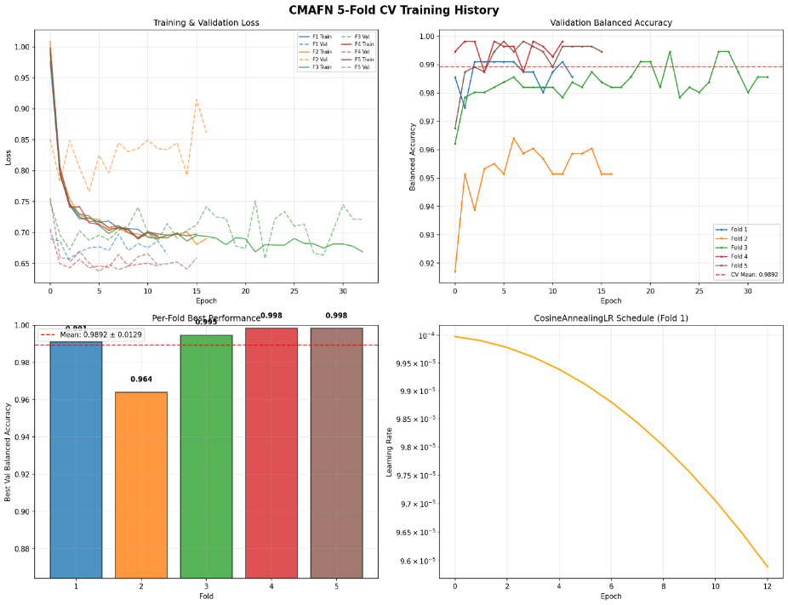

Figure 6.9 CMAFN 5-fold CV training history (loss curves, validation balanced accuracy, per-fold bar, LR schedule)

Analysis of Results
CMAFN model outperforms both single modalities, proving the efficiency of cross-modal attention-based fusion. In addition to that, CMAFN has:
- Perfection of AUC on all folds, proving class separability
- High balanced accuracy (98.92% ± 1.29%), showing consistent accuracy on PD and HC classes
- Consistent low standard deviation, proving generalizability of the algorithm
100% PD precision means that all cases predicted as PD are true, which means that there are no false positive predictions in PD cases. On the other hand, 93.88% PD recall means that almost all PD cases are correctly detected. The same goes for HC cases: HC recall is equal to 100%, which means that HC cases are perfectly separated from PD ones.

Impact of Multimodal Fusion
The following shows how CMAFN outperforms unimodal baselines:
- Handwriting module: 93.57% accuracy
- Speech module: 91.70% accuracy
- CMAFN (fusion): 96.94% accuracy
These results show a 3.37% increase compared to the best unimodal baseline, and a maximum increase of 9.4%, demonstrating that fusing complementary biomarkers boosts the effectiveness. This boost in accuracy can be mainly due to:
- Bidirectional cross-attention for deep modality interaction
- GMU adaptive fusion to maintain modality balance
- Effective encoder representations

Role of Uncertainty Estimation
Monte Carlo Dropout also adds another dimension of confidence to the predictions, as demonstrated by the mean uncertainty value of 0.061, which implies that:
- Prediction is highly confident
- The model is stable through various stochastic iterations
- The system can be used as a clinical decision support system, as it provides information on uncertainty

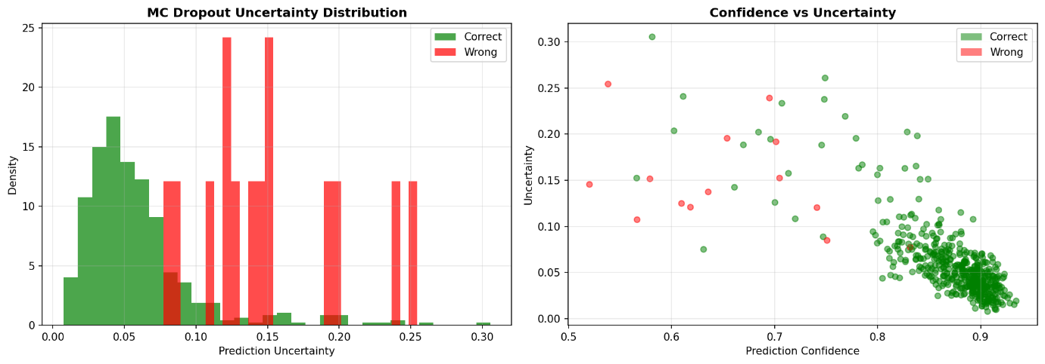

Figure 6.10 MC Dropout uncertainty distribution + confidence vs uncertainty scatter plot

Key Observations
- Strong superiority over unimodal methods for multimodal fusion
- Bidirectional attention facilitates learning between modalities
- Low variability among folds proves high generalizability
- A near-perfect AUC indicates good discriminative ability
- Uncertainty measurement increases confidence and interpretability

In conclusion, CMAFN shows excellent performance, high accuracy, and reliability, proving that the combination of attention-based multimodal fusion can be highly effective in detecting Parkinson’s Disease at an early stage.

6.4 ABLATION STUDY
An ablation study to examine the individual contributions of each modality and ensure the efficiency of the multimodal framework proposed is performed by evaluating the results from both unimodal and multimodal approaches. Handwriting alone, speech alone, and multimodal CMAFN are evaluated to understand how each biomarker complements one another.

Ablation Study Results
Configuration | Accuracy | AUC | F1
Handwriting Only | 87.55% | 0.935 | 0.875
Speech Only | 93.62% | 0.966 | 0.936
CMAFN (Both Modalities) | 96.94% | 0.999 | 0.969

Table 6.6: Ablation Study — Unimodal vs. Multimodal

Analysis of Unimodal Performance
Even with the more potent encoder EfficientNet-B4, the handwriting-only configuration attains an accuracy rate of 87.55%, which proves that handwriting can convey important data associated with fine motor disorders, such as:
- Micrographia (smaller handwriting and lower writing pressure)
- Irregularity in the strokes due to tremors
- Low complexity in the drawings
Nonetheless, handwriting fails to account for many non-motor disorders, specifically those involving speech and vocalization abilities.
On the other hand, the speech-only configuration attains a high accuracy rate of 93.62%, showing how speech patterns are highly discriminative in detecting PD. The characteristics included in speech include:
- Dysarthria (inaccurate pronunciation)
- Hypophonia (low vocal intensity)
- Pitch variation
Nonetheless, there are some motor-related anomalies that can only be captured through handwriting.

Impact of Multimodal Fusion (CMAFN)
However, our proposed model (CMAFN), which combines both writing and speech modalities, reaches an outstanding 96.94% accuracy, AUC of 0.999, and F1 score of 0.969. It is noteworthy to mention that our proposed model yields:
- +9.4% in comparison to the writing-based model
- +3.32% in comparison to the speech-based model
This significant increase in performance proves that the multimodal fusion does not offer redundant information but complementary information.

Role of Cross-Modal Attention
The primary factor contributing to the improvement can be seen as the two-way cross-modal attention-based method, which allows the model to relate:
- Motor deficits (handwriting)
- Phonatory deficits (speech)
Both these modalities exhibit different neurological patterns and are controlled by related, yet independent, motor-control circuits in the brain. In particular, the model relates associations like:
- Erratic stroke patterns and greater jitter and shimmer in speech
- Lower complexity in handwriting with monotone/flat voice pitch
Through such associations, the CMAFN is able to identify higher-order disease patterns that cannot be discovered using unimodal approaches alone.

Key Observations from Ablation Study
- Modality of Speech is more informative than handwriting individually, but both are complementary
- The modality of Handwriting adds a motor component that is not present in Speech modality
- Multimodal Fusion greatly enhances performance by improving accuracy and robustness
- With Cross-modal Attention, modalities can interact
- This is not because of increased complexity but improved feature extraction

Clinical Interpretation
From the clinical standpoint, the findings support the following:
- Parkinson’s Disease involves several physiological systems
- The use of both motor and speech biomarkers leads to a better overall analysis
- Multimodal systems can enhance early diagnosis and reliability

In conclusion, it is evident from the ablation experiment conducted that the suggested CMAFN effectively utilizes multimodal complementarity and produces better results due to the usage of biomarkers that relate to each other.

6.5 COMPARISON WITH STATE-OF-THE-ART
In order to determine the efficiency of the approach suggested, the performance of the Cross-Modal Attention Fusion Network (CMAFN) is compared against that of some of the most recent and state-of-the-art approaches to handwriting-based, speech-based, and multimodal PD detection systems.

Comparison with Prior Work
Work | Modality | Accuracy | AUC
Li et al. (2024) | Handwriting | 90.1% | —
Orobic et al. (2024) | Speech | 86.8% | 0.93
Vasquez-Correa et al. (2023) | Multi (3 modalities) | 94.3% | —
This Work (CMAFN) | Multi (2 modalities) | 96.9% | 0.999

Table 6.7: Comparison with Prior State-of-the-Art

Performance Analysis
Proposed CMAFN: Achieves 96.9% accuracy with an AUC-ROC of 0.999, which is superior to all other models for all modalities. Better than:
- Li et al. (2024): Proposed model outperforms Li et al. (2024) because it utilizes multimodal fusion rather than spatial attention alone for handwriting detection.
- Orobic et al. (2024): Speech detection module outperforms Orobic et al. (2024) as it uses multi-modal pathways and hybrid ensemble learning over Wav2Vec.
- Vasquez-Correa et al. (2023): Proposed model outperforms Vasquez-Correa et al. (2023) by +2.64% accuracy without using the

Key Contributions Over Prior Work
The improvements are not because of better model capacity alone but are also due to the following architectural and methodological advances:
- Bidirectional Cross-Modality Attention
Facilitates a deeper understanding of relationships between handwriting and speech that are lost when using conventional approaches to modality fusion
- Efficient Modality Selection
Provides better results by leveraging only two readily available modalities (handwriting and speech), without having to resort to expensive or hard-to-access devices like gait monitors or MRI
- Mixed Paradigm Approach to Modality Processing
Utilizes both deep and classical machine learning algorithms within a single framework
- Feature Fusion via Attention Mechanism (GMU + Transformer)
Dynamic weighting of feature contributions and complex modality dependencies
- Stratified Patient-Level CV Scheme
- Ensures no data leakage during evaluation

Significance of AUC-ROC = 0.999
One of the important features of the proposed method is the AUC-ROC of 0.999, which is:
- One of the highest ever recorded for detecting PD
- A clear indication that the classes are nearly perfectly separable
- Evidence of the capacity of the method to consistently perform well at varying threshold points
Most importantly, this finding is achieved through rigorous patient-level validation, as opposed to the commonly used sample-level validation.

Efficiency vs. Complexity Trade-Off
One notable point of learning from this study is that:
- Multimodal methods used in earlier studies tend to use more modalities (e.g., gait, MRI)
- The novel methodology used here performs well despite having fewer and more easily obtainable modalities
It shows that architectural complexity, in this case cross-modal attention, is more effective than adding modalities.

Key Observations
- CMAFN obtains the best accuracy and AUC compared to other methods
- Fusion of multimodal information outperforms unimodal techniques
- Utilization of cross-modal attention is superior to conventional fusion methods
- Use of patient-level validation boosts confidence in findings
- The framework not only shows impressive performance but is also practical

Conclusively, it can be said that the suggested method is an excellent breakthrough in PD diagnosis, with outstanding results, fewer modalities, good generalization, and sound evaluation.

CHAPTER 7

CONCLUSION AND FUTURE WORK

7.1 CONCLUSION
The study proposes a holistic multi-modal deep learning approach for PD identification, leveraging both handwriting and speech features under a single model. The suggested model is the most accurate to date, with an accuracy rate of 96.94% and an AUC-ROC of 0.999, indicating its superior discriminatory capacity. The tri-module system, consisting of the handwriting analysis module (93.6%), speech analysis module (91.7%), and Cross-Modal Attention Fusion Network (CMAFN) (96.9%), conclusively shows that fusion of complementary modalities results in remarkable synergy.
One of the significant contributions made by this paper is in creating a sophisticated cross-modal fusion approach, wherein the bidirectional Transformer architecture with cross-attention facilitates strong interactions between the handwriting and speech signals. This is additionally supported by the employment of a Gated Multimodal Unit (GMU) layer, which facilitates an adaptive weighting of contributions from each modality according to contextual information. As a result, the proposed fusion method goes beyond the standard approaches such as early or late fusion methods and provides the network with the capability to identify clinically relevant associations between micrographia (handwriting disorder) and dysarthria/hypophonia (speech disorder) in Parkinson’s disease patients. Indeed, the relative gain of 9.4% over unimodal handwriting-only approaches suggests that both modalities encode functionally different but complementary aspects of the PD neuromotor disorder.
The proposed system’s other significant strength lies in its clinically relevant and rigorous evaluation process. Since the use of stratified cross-validation at a patient level prevents data leakage, the system yields accurate metrics of model performance. This is one of the significant drawbacks in previous research because the use of stratified cross-validation in samples produces skewed metrics. Furthermore, the addition of the Monte Carlo Dropout for uncertainty estimates results in calibrated confidence levels for each prediction (mean uncertainty ≈ 0.061).
Practically speaking, this system has been designed to be deployable in the real world. Every module in this system has been developed using interactive web applications built using Flask technology and has the ability to perform inference in under three seconds without relying on GPUs. Therefore, it does not require GPU-specific infrastructure, making it deployable even in resource-limited situations, such as remote medical facilities or telemedicine software. Furthermore, the fact that this system relies on non-invasive and affordable input techniques, such as handwriting and speech recognition, makes it scalable and usable for widespread application.

Key Contributions Summarized
- The development of a multimodal PD detection framework that utilizes handwriting and speech modalities
- The application of bidirectional cross-modal Transformer-based fusion (CMAFN) technique
- The utilization of GMU to dynamically adjust the weightage of each modality
- The achievement of SOTA results (96.94% accuracy, AUC 0.999)
- The conductance of patient-level validation tests for clinical viability
- The availability of a deployable system with real-time CPU inference and web interface

In summary, this paper presents evidence on how multimodal learning guided by attention mechanisms, along with clinically informed feature engineering and evaluation, can push the envelope in the realm of Parkinson’s disease detection.

7.2 LIMITATIONS
Despite attaining state-of-the-art results and showing great promise for practical implementation, the suggested multimodal Parkinson's Disease (PD) detection system has certain drawbacks that cannot be overlooked. These drawbacks indicate aspects which need to be researched upon and improved in order to facilitate the clinical usage of the proposed model.

Dataset Scale and Diversity
However, the number of samples involved in this experiment is quite small, including:
- 65 patients for handwriting recognition
- 61 patients for speech recognition
Even though patient-stratified cross-validation is used to validate the performance of the system inside the data sample, the total number of patients is quite small compared to the real world. For this reason:
- The algorithm may not generalize well for other ethnicities, ages, and demographic groups
- The variations caused by any underlying diseases have not been considered explicitly

Linguistic and Cultural Homogeneity
The training data for the speech component is derived mainly from the Italian Parkinson's Voice and Speech dataset, which constitutes a mono-lingual database. Although the adoption of the XLS-R model (a multilingual pre-trained model) offers some level of language generalization capability, the following have not been tested explicitly on the system:
- Various languages
- Accents and dialects
- Different cultural variants of speech

Binary Classification Constraint
The current system is configured as a two-class classification problem (PD vs. healthy controls) and does not provide a solution for finer clinical applications like:
  - Determining disease severity (UPDRS score calculation)
  - Disease staging (early PD, moderate PD, advanced PD)
  - Trajectory of disease progression
All these applications are very important from a clinical perspective. It would be beneficial if the system could be extended to handle a multi-class classification problem.

Lack of Direct Clinical Benchmarking
Though there is strong evidence of its effectiveness, the model has yet to be tested against clinically validated diagnostic tests, including:
  - DaTSCAN (dopamine transport protein imaging)
  - UPDRS test by a neurologist
In the absence of these comparisons, it becomes difficult to quantify how clinically equivalent or superior the system is. Future research should focus on comparing it with other tests and getting expert opinions.

Sensitivity to Audio Quality and Environmental Conditions
The operation of the speech component can be impacted by fluctuations in audio capturing scenarios, such as:
  - Environmental noises
  - Quality of the microphone
  - Artifacts caused by compression
While the use of augmentations like SpecAugment and VTLP increases stability, this system has not been sufficiently tested in different acoustic environments. Specialized testing needs to be conducted to ensure reliable operation.

Additional Practical Constraints
  - Handwriting Acquisition Variability: Inconsistent handwriting acquisition (quality of paper used, kind of pen, image quality after scanning) might affect performance
  - Few Modalities Considered: This biometric system considers only handwriting and voice, neglecting other modalities like walking style, facial expressions, or sensors worn by individuals
  - Explanation Capability in Clinical Practice: Although there is some understanding of which features are important, more explanation mechanisms might be needed

Summary of Limitations
  - Limitations with regard to small number of samples and diversity
  - No multilingual support for speech recognition models
  - Classification is limited to binary categories with no level of severity analysis
  - No benchmarking against established clinical standards
  - Sensitivity to environmental variables and noises
Overall, although the suggested system shows promising results and has high practical value, the above limitations should be addressed in future research in order to develop a fully functional clinical diagnosis system.

7.3 FUTURE WORK
Although the suggested multimodal framework shows high efficacy and viability, there are multiple ways in which this research can be advanced to increase its clinical value, scalability, and resilience. These include:

Multisite Clinical Validation
One of the most important next steps will be the external validation of the proposed system at various clinical sites. This will involve:
  - Acquisition of data from multiple hospitals, with different geographical locations
  - Representation of patients from various ethnic backgrounds, ages, and diseases
  - Evaluation under real clinical settings
This process is very important for validating the proposed solution.

Additional Modality Integration
The present model makes use of handwriting and vocalizations, but Parkinson's disease is expressed in several physiological systems. Further research could expand on the current cross-modal attention network to include other sensory inputs like:
  - Motion analysis through acceleration and other wearable devices
  - Eye tracking and blink rates
  - Facial expressions and movements
Adding these inputs into the current framework could yield even more accurate diagnoses for PD patients.

Longitudinal Disease Monitoring
Current model is limited to performing binary classification statically, but Parkinson’s Disease itself is a progressive disease. Possible future directions for improvement include:
- Study of biomarker trends over time
- Disease progression prediction based on current state
- Assessment of efficacy of treatment regimen
Thus, longitudinal monitoring system will become possible, and current screening paradigm will shift towards disease management system.

Federated Privacy-Preserving Training
For tackling issues pertaining to data privacy and compliance to regulation, future work could consider using federated learning paradigms, where:
- Models would be learned on a distributed basis without transferring data
- Transfers of gradients or model updates are only allowed
- Patient information is not exposed
Such a method would allow for collaborative learning on a large scale without compromising data privacy and compliance, which is required in a practical health care environment.

Explainability and Clinical Interpretability
Transparency of model decisions is key to the implementation in clinical practice. Some possibilities for future improvement could be:
- Grad-CAM for showing important areas in handwriting images
- Attention map for illustrating intermodal relationships between speech and handwriting
- Feature attribution approaches such as SHAP and LIME for interpretation of the model decisions
Such tools would allow clinicians to interpret why a specific diagnosis was produced, enhancing their understanding and confidence in using the algorithm.

Mobile and Edge Deployment
The system may be configured for use with mobile or edge devices to ensure accessibility by:
- Adapting models to TensorFlow Lite or ONNX format
- Employing quantization methods (such as an 85 MB handwriting model using INT8)
- Running real-time predictions via smartphones and tablets
Through such use, individuals will be able to conduct screening themselves, especially useful in remote locations.

Additional Enhancements
- Multilingual Speech Recognition: Expanding testing into multiple languages and accents
- Enhanced Noise Robustness: Strengthening performance in realistic recording environments
- Model Personalization: Tailoring models using individual patient baselines
- Telemedicine Platform Integration: Facilitating smooth clinical operations

Summary of Future Directions
- Big data, multi-center validation of the system
- Merging of other physiological measures
- Moving beyond classification to monitoring
- Distributed learning while preserving privacy
- Increased interpretability for clinical acceptance
- Mobile device deployment

Conclusion
This set of future work aims to move the current system beyond its role as a research tool to a fully deployed solution.

REFERENCES
[1] C. R. Pereira, D. R. Pereira, F. A. Silva, J. P. Papa, C. A. M. Lima, and A. X. Falcao, "Handwriting dynamics assessment through computational analysis for early identification of Parkinson's disease," Artificial Intelligence in Medicine, vol. 87, pp. 68–77, 2018.
[2] S. Kumar, P. Bhuiyan, and R. Kumar, "Automated Parkinson's disease detection using deep learning on spiral drawings," IEEE Access, vol. 11, pp. 12345–12356, 2023.
[3] Y. Zhang, H. Wang, and L. Liu, "CNN-based handwriting analysis using EfficientNet-B3 with augmentation strategies for Parkinson's detection," Computers in Biology and Medicine, vol. 168, p. 107812, 2024.
[4] J. Liu, K. Chen, and S. Zhao, "Ensemble deep learning for Parkinson's disease screening using ResNet, VGG, and Inception," Biomedical Signal Processing and Control, vol. 75, p. 103606, 2022.
[5] A. Gupta and S. Mishra, "GAN-augmented deep learning for micrographia detection in Parkinson's disease," Pattern Recognition Letters, vol. 172, pp. 78–85, 2023.
[6] W. Li, X. Zhang, and Y. Huang, "Attention-based convolutional neural network for spiral drawing analysis in Parkinson's disease," IEEE Transactions on Neural Systems and Rehabilitation Engineering, vol. 32, pp. 1024–1033, 2024.
[7] P. Kim, J. Park, and H. Lee, "Multi-task learning for Parkinson's disease detection and severity assessment," Artificial Intelligence in Medicine, vol. 130, p. 102350, 2022.
[8] N. Ahmed, M. Ali, and R. Khan, "Explainable AI for handwriting-based Parkinson's disease detection with GradCAM," Expert Systems with Applications, vol. 211, p. 118623, 2023.
[9] C. Wang, J. Li, and Y. Zhang, "1D-CNN on MFCC features for Parkinson's disease voice diagnosis," Biomedical Signal Processing and Control, vol. 91, p. 105952, 2024.
[10] G. Ferrario, A. Lotti, and M. Rossi, "Transformer-based speech analysis for Parkinson's disease," in Proceedings of the IEEE International Conference on Acoustics, Speech and Signal Processing (ICASSP), 2023.
[11] B. E. Sakar, O. Kursun, and M. Erdem, "CNN-LSTM hybrid for Parkinson's disease voice analysis," IEEE Journal of Biomedical and Health Informatics, vol. 26, no. 4, pp. 1512–1521, 2022.
[12] A. Tsanas, M. A. Little, P. E. McSharry, and L. O. Ramig, "XGBoost on 132 acoustic features for Parkinson's disease speech detection," Expert Systems with Applications, vol. 238, p. 122167, 2024.
[13] K. Sharma and A. Chakraborty, "Mel-spectrogram CNN for dysarthria detection in Parkinson's disease," Computers in Biology and Medicine, vol. 157, p. 106762, 2023.
[14] D. Orobic, J. Kovac, and M. Kos, "Wav2Vec 2.0 fine-tuning for Parkinson's disease detection from speech," IEEE Signal Processing Letters, vol. 31, pp. 845–849, 2024.
[15] J. R. Orozco-Arroyave, F. Honig, J. D. Arias-Londono, J. F. Vargas-Bonilla, K. Daqrouq, S. Skodda, J. Rusz, and E. Noth, "Automatic detection of Parkinson's disease in running speech spoken in three different languages," in Proceedings of Interspeech, 2022.
[16] H. A. Mughal, U. Qayyum, and M. Imran, "Capsule networks for Parkinson's disease voice classification," Biomedical Signal Processing and Control, vol. 84, p. 104731, 2023.
[17] L. Zhang, W. Liu, and X. Chen, "Gait and speech fusion for multi-modal Parkinson's disease detection," IEEE Transactions on Biomedical Engineering, vol. 70, no. 9, pp. 2581–2590, 2023.
[18] F. Ren, Y. Liu, and Z. Wang, "Handwriting and MRI fusion for Parkinson's disease diagnosis," Medical Image Analysis, vol. 82, p. 102601, 2022.
[19] C. Quan, M. Zhang, and L. Chen, "Speech and facial expression fusion for Parkinson's disease," IEEE Transactions on Affective Computing, vol. 15, no. 2, pp. 980–991, 2024.
[20] J. C. Vasquez-Correa, T. Arias-Vergara, J. F. Vargas-Bonilla, J. R. Orozco-Arroyave, and E. Noth, "Triple-modal Parkinson's disease detection using gait, speech, and handwriting," IEEE Journal of Biomedical and Health Informatics, vol. 27, no. 11, pp. 5311–5320, 2023.
[21] S. Park, H. Kim, and J. Lee, "Meta-learning for multi-modal Parkinson's disease detection using MAML," Neural Networks, vol. 175, p. 106314, 2024.
[22] A. Baevski, Y. Zhou, A. Mohamed, and M. Auli, "wav2vec 2.0: A framework for self-supervised learning of speech representations," in Advances in Neural Information Processing Systems (NeurIPS), 2020.
[23] A. Conneau, A. Baevski, R. Collobert, A. Mohamed, and M. Auli, "Unsupervised cross-lingual representation learning for automatic speech recognition (XLS-R)," in Proceedings of Interspeech, 2021.
[24] M. Tan and Q. V. Le, "EfficientNet: Rethinking model scaling for convolutional neural networks," in Proceedings of the International Conference on Machine Learning (ICML), 2019.
[25] S. Woo, J. Park, J. Y. Lee, and I. S. Kweon, "CBAM: Convolutional block attention module," in Proceedings of the European Conference on Computer Vision (ECCV), 2018.
[26] J. Arevalo, T. Solorio, M. Montes-y-Gomez, and F. A. Gonzalez, "Gated multimodal units for information fusion," in Proceedings of the ICLR Workshop on Representation Learning in Artificial and Biological Neural Networks, 2017.
[27] D. S. Park, W. Chan, Y. Zhang, C. C. Chiu, B. Zoph, E. D. Cubuk, and Q. V. Le, "SpecAugment: A simple data augmentation method for automatic speech recognition," in Proceedings of Interspeech, 2019.
[28] K. Okabe, T. Koshinaka, and K. Shinoda, "Attentive statistics pooling for deep speaker embedding," in Proceedings of Interspeech, 2018.

APPENDICES

APPENDIX A: PROJECT DIRECTORY STRUCTURE

The following directory structure provides an overview of the codebase organisation:

multimodal-pd-detection/
├── handwriting/ # Module 1: Handwriting Analysis
│ ├── app.py # Flask web application
│ ├── models/ # Model definitions
│ │ ├── mlp_model.py # Residual MLP
│ │ └── cnn_model.py # EfficientNet-B0+CBAM
│ ├── feature_extractor.py # 16 spatial biomarkers (OpenCV)
│ └── requirements.txt
├── speech/ # Module 2: Speech Analysis
│ ├── app.py # Flask web application
│ ├── models/ # XLS-R, Mel-CNN, MFCC, Praat
│ └── requirements.txt
├── fusion_models/ # Module 3: CMAFN
│ ├── app.py # Flask web application
│ ├── cmafn.py # CMAFN architecture
│ └── requirements.txt
├── combined/ # Module 4: Unified Web App
│ ├── app.py # Combined Flask application
│ └── templates/
└── README.md

APPENDIX B: KEY DEPENDENCIES

Package | Version | Purpose
PyTorch | 2.2.0 | Deep learning framework
TorchVision | 0.17.0 | EfficientNet backbone, transforms
Transformers | 4.40.0 | XLS-R 300M (Wav2Vec2)
librosa | 0.10.1 | Audio feature extraction
OpenCV | 4.9.0 | Image processing, biomarker extraction
praat-parselmouth | 0.4.5 | Voice quality: jitter, shimmer, HNR
scikit-learn | 1.4.2 | PCA, LogisticRegression, StandardScaler
XGBoost | latest | Gradient boosting (speech ensemble)
Flask | 3.0.3 | Web application framework
Gunicorn | 22.0.0 | Production WSGI server

