M. S. Ramaiah University of Applied Sciences
Department of Data Science & Analytics

Project Report on

Indian Mutual Fund Analysis
Submitted by
Tvisha Mittal
Register No: 25SSDS170018

MSc in Data Science & Analytics

Table of Contents
1. Introduction 3
2. Problem Statement 4
3. Methodology 5
4. Dataset Description 6
5. Data Acquisition Methods 7
6. Analysis 8
7. Conclusion 9
8. References 10

1. Introduction
The Indian mutual fund industry is one of the fastest-growing financial sectors in the world. From its origins in 1963 with the establishment of the Unit Trust of India (UTI), the industry has expanded to encompass over 16,000 registered schemes managed by 53 Asset Management Companies (AMCs) as of 2024. With assets under management crossing ₹50 lakh crore, mutual funds have become the preferred investment vehicle for retail investors seeking market-linked returns without direct equity exposure.
The Association of Mutual Funds in India (AMFI), established in 1995, is the apex body governing the mutual fund industry. AMFI publishes daily NAV (Net Asset Value) data, quarterly AUM (Assets Under Management) figures, and scheme-level metadata for every registered fund.
Net Asset Value represents the per-unit market value of a scheme's assets minus liabilities. It is the primary metric by which mutual fund performance is tracked. AUM represents the total market value of all assets a fund manages on behalf of investors and serves as the key indicator of fund size and market dominance. Together, NAV and AUM form the financial backbone of mutual fund analysis.
This project applies a complete six-phase data preprocessing and acquisition pipeline to the AMFI dataset. The pipeline covers automated data loading, systematic cleaning of missing values using a skewness-based strategy, outlier detection and handling using the Interquartile Range (IQR) method, feature engineering, statistical hypothesis testing, and dimensionality reduction using Principal Component Analysis (PCA).
The project is organized into six major processing stages — Data Acquisition, Data Cleaning, Preprocessing, Visualization, Statistical Analysis, and Dimensionality Reduction — each building on the outputs of the previous stage to progressively transform raw AMFI data into actionable financial intelligence.

2. Problem Statement
Despite the availability of AMFI's public mutual fund dataset, several data quality challenges make it unsuitable for direct analysis. The dataset contains missing values, inconsistent formatting, duplicate records, and irregular categorical labels across important financial attributes such as NAV, returns, expense ratio, and fund categories. These inconsistencies reduce the reliability of statistical summaries and visualizations if the data is used without preprocessing. Therefore, cleaning operations such as null value treatment, column standardization, duplicate removal, and datatype correction become necessary before performing meaningful analysis.
Another major challenge in the dataset is the presence of extreme outliers and highly skewed financial variables. Metrics such as average AUM, NAV, and returns often contain unusually large values due to a few dominant or legacy mutual fund schemes. These extreme observations significantly influence averages, correlations, regression models, and overall statistical interpretation. To address this issue, techniques such as IQR-based outlier detection, clipping, and logarithmic transformation are required to stabilize the data distribution and improve analytical accuracy.
The dataset also contains complex relationships among variables that require careful feature analysis and preprocessing. Financial indicators such as NAV, AUM, and long-term returns may exhibit multicollinearity, affecting regression performance and interpretability. Additionally, categorical variables such as scheme type and AMC names require encoding before advanced analysis can be performed. Hence, the AMFI dataset requires a structured preprocessing pipeline involving cleaning, transformation, visualization, scaling, correlation analysis, and feature engineering to make the data suitable for statistical and exploratory analysis.

3. Methodology
The project follows a structured six-phase pipeline in which each phase receives clean inputs from the previous phase. The phases are: Data Acquisition, Data Cleaning, Preprocessing, Visualization, Statistical Analysis, and Dimensionality Reduction. This sequential structure ensures that all downstream operations work on validated, properly formatted data.

Phase | Tools Used | Operations Performed
Data Acquisition | Pandas, urllib | URL loading, web scraping with pd.read_html()
Data Cleaning | Pandas, NumPy | Rename, drop, skewness-based imputation, duplicate removal, inconsistency fixing, IQR outlier handling
Preprocessing | Sklearn, Pandas, NumPy | Label encoding, feature engineering, StandardScaler normalization
Visualization | Matplotlib, Seaborn | Histogram, count plot, bar plot, scatter, regression plot, violin plot, pair plot
Statistical Analysis | SciPy, NumPy, Pandas | Correlation heatmap, chi-square test, ANOVA, pivot tables, VIF multicollinearity check
Dimensionality Reduction | Sklearn | Principal Component Analysis (PCA)

4. Dataset Description
The dataset is sourced from the GitHub repository of InertExpert2911, which mirrors the official AMFI India public data. AMFI publishes this data as part of its regulatory mandate under SEBI's mutual fund disclosure requirements. The data reflects the state of all registered Indian mutual fund schemes at a specific snapshot date.

Attribute | Detail
Source | AMFI India (Association of Mutual Funds in India)
Mirror | GitHub — InertExpert2911/Mutual_Fund_Data
Records | 16,383 mutual fund schemes
Original Features | 16 columns
Features after cleaning | 11 columns
AMCs covered | 53 Indian Asset Management Companies
Scheme types | Open Ended (9,988), Close Ended (6,316), Interval Fund (79)

4.1 Column Details
Column | Type | Description | Missing
scheme_code | Integer | Unique AMFI scheme identifier | 0
scheme_name | Text | Full official name of the scheme | 0
amc | Text | Asset Management Company name | 0
scheme_type | Categorical | Open Ended / Close Ended / Interval Fund | 0
scheme_category | Text | Sub-category (Equity, Debt, Hybrid, etc.) | 0
scheme_min_amt | Text | Minimum investment amount (raw string) | 30
nav | Float | Net Asset Value in ₹ per unit | 2,016
latest_nav_date | Date | Date of the most recent NAV | 2,016
average_aum_cr | Float | Average AUM in ₹ Crores (quarterly) | 8,167
launch_date | Date | Date the scheme was first launched | 21
closure_date | Date | Date closed; 'Active' if still running | 12,526

4.2 Missing Value Summary
Column | Missing Count | Missing % | Imputation Strategy
nav | 2,016 | 12.3% | Median — skewness = 37.7 (Highly Skewed)
average_aum_cr | 8,167 | 49.8% | Median — skewness = 16.7 (Highly Skewed)
closure_date | 12,526 | 76.5% | Fill with 'Active' (open funds have no closure)
latest_nav_date | 2,016 | 12.3% | Fill with 'Not Available' (same rows as nav)
scheme_min_amt | 30 | 0.2% | Mode (most common value)
launch_date | 21 | 0.1% | Forward fill within same AMC group

4.3 Engineered Features
Feature | Formula | Purpose
fund_age_years | (today − launch_date) / 365 | Captures compounding duration in decimal years
nav_log | log(1 + nav) | Reduces NAV skewness from 37.7 to near 0
aum_log | log(1 + average_aum_cr) | Reduces AUM skewness from 16.7 to ~1.2
aum_band | pd.cut(aum_cr, bins=[0,10,100,1000,∞]) | Categorical size grouping: Small, Mid, Large, Giant
scheme_type_encoded | LabelEncoder on scheme_type | Numeric encoding: Close=0, Interval=1, Open=2

5. Data Acquisition Methods
Data acquisition is the process of identifying, locating, and loading data from an appropriate source into the analysis environment. Data broadly exists in three structural forms. Structured data follows a fixed schema of rows and columns — our AMFI dataset is a prime example, where each row represents one mutual fund scheme with defined column attributes such as NAV, AUM, and scheme type. Semi-structured data has flexible key-value formats where the schema may vary across records, such as the AMFI NAV API (JSON) or SEBI XML filings. Unstructured data has no fixed format and includes SEBI circulars in PDF, fund manager commentary, and financial news articles, which require natural language processing or manual extraction before any analysis is possible.
The primary collection method used in this project is automated workflow — loading data programmatically from a public URL using a single line of code: df = pd.read_csv("https://raw.githubusercontent.com/InertExpert2911/Mutual_Fund_Data/main/mutual_fund_data.csv"). This approach is fully reproducible, version-independent, and suitable for scheduled production pipelines where the dataset needs to be refreshed periodically. The alternative is manual acquisition, where a user downloads the file through a browser from www.amfiindia.com — simple but not repeatable without human intervention. Other data sources commonly used in Indian financial analysis include relational databases such as the RBI's DBIE portal and SEBI's EDGAR system, IoT and sensor streams such as ATM transaction logs, and social media APIs for sentiment data on stock and fund performance.
When financial data is published only as a webpage rather than a downloadable file, web scraping is used to extract it. HTML pages structure tabular data using <table>, <tr>, and <td> tags, which Pandas' pd.read_html() function parses automatically without requiring any HTML parsing code: tables = pd.read_html("https://en.wikipedia.org/wiki/List_of_largest_companies_in_India"). This returns a list of all tables found on the page as DataFrames. For pages where content is rendered dynamically by JavaScript rather than served as static HTML, browser automation tools such as Selenium or Playwright are required. In this project, web scraping serves as a demonstration of the technique alongside the primary URL-based loading method.

6. Analysis
This section presents the complete analysis pipeline in sequential order, covering data cleaning, preprocessing, visualization, statistical hypothesis testing, and dimensionality reduction. All code is written in Python using only the Pandas, NumPy, Matplotlib, Seaborn, and Scikit-learn libraries.

6.1 Data Cleaning

6.1.1 Column Rename and Drop
Raw column names from AMFI data contain spaces, mixed cases, and special characters that make programmatic access error-prone. Standardizing them is the first cleaning step before any other operation is performed.
Column names are now lowercase and underscore-separated. Five columns containing ISIN codes and duplicate NAV name information are dropped, reducing the feature set from 16 to 11 columns without losing any analytically useful information.

6.1.2 Missing Value Analysis
Six columns require imputation. The nav and latest_nav_date columns are missing in exactly the same 2,016 rows, confirming they correspond to the same matured or closed schemes. The closure_date column has the most missing values (76.5%) because the vast majority of Indian mutual fund schemes remain active and have no closure date.

6.1.3 Skewness-Based Missing Value Imputation
The choice between mean and median imputation is made algorithmically by measuring the skewness of each numeric column before filling:
NAV skewness = 37.7 mandates median imputation (fill value = ₹13). AUM skewness = 16.7 similarly mandates median (fill value = ₹12 Cr). Had mean been used, NAV would have been filled with ₹1,430 and AUM with ₹511 Cr — values inflated far beyond representative levels. The closure_date is filled with 'Active' since a missing value logically means the fund has not closed. Forward fill within AMC groups handles launch_date gaps by borrowing dates from nearby schemes under the same management company.

6.1.4 Removing Duplicates
AMFI maintains clean records — no exact duplicate rows exist in the raw data. The drop_duplicates() call serves as a validation check and would handle any duplicates introduced by future data refreshes.

6.1.5 Fixing Inconsistent Data
No negative NAV or AUM values exist, confirming the integrity of AMFI's published data. The scheme_type column has exactly three clean, consistent categories with no typos, extra spaces, or mixed cases after stripping. The title-case normalization on AMC names ensures consistent groupby behavior across all subsequent aggregation operations.

6.1.6 Outlier Detection and Handling
Outlier detection is applied separately to NAV and AUM using the IQR method. The handling strategy differs by column based on domain knowledge.
NAV Outliers — Clipped:
NAV outlier clipping removes the influence of 2,861 extreme legacy scheme observations while retaining all rows. The AUM IQR is artificially narrow (upper = ₹13 Cr) because 50% of AUM values were filled with the median of ₹12.27 Cr, compressing the interquartile range. After clipping, all AUM values fall within the Mid band, which is an expected consequence of this narrowing. Clipping is preferred over row deletion in financial datasets to preserve sample size and temporal coverage.

6.2 Preprocessing

6.2.1 Label Encoding
Machine learning algorithms and correlation analysis require numerical inputs. Label encoding converts the three scheme type categories into integers:
Label encoding is performed before feature scaling so that the encoded column can be included in the StandardScaler transformation alongside other numeric features. This ensures all features entering the PCA step are on the same standardized scale.

6.2.2 Feature Engineering
Three new numeric features and one categorical feature are derived from existing columns:
fund_age_years is the most theoretically important derived feature — it captures the compounding duration of each scheme, which is the primary driver of NAV growth. nav_log and aum_log fix the extreme right skew of both numeric columns, making them suitable for regression, PCA, and visual analysis. aum_band provides a natural categorical breakdown of fund sizes used in chi-square testing and pivot table analysis.

6.2.3 Feature Scaling
StandardScaler normalizes each feature to zero mean and unit variance, preventing features with large numeric ranges from dominating distance-based operations like PCA:
All three features now have mean = 0 and standard deviation = 1. Before scaling, fund_age_years (range 0 to 35) would have dominated nav_log (range 0 to 4) in PCA's covariance calculation. After scaling, all features contribute equally to the principal components.

6.2.4 Statistical Summary
Statistic | nav (₹) | average_aum_cr (₹Cr) | nav_log | aum_log | fund_age_years
count | 16,383 | 16,383 | 16,383 | 16,383 | 16,383
mean | 14.94 | 12.27 | 2.55 | 2.55 | 8.51
std | 8.47 | 0.26 | 0.62 | 0.08 | 6.54
min | 0.00 | 0.00 | 0.00 | 0.00 | 0.0
25% | 11.56 | 12.15 | 2.47 | 2.54 | 3.5
50% (median) | 13.08 | 12.27 | 2.63 | 2.55 | 7.1
75% | 16.79 | 13.00 | 2.94 | 2.57 | 12.8
max | 42.97 | 13.00 | 3.78 | 2.57 | 35.0
After clipping, NAV ranges from 0 to ₹42.97 — a compact, analysis-friendly range. The AUM maximum is now capped at ₹13 Cr (the IQR upper bound). Log-transformed variables have narrow, symmetric distributions. fund_age_years spans from 0 to 35 years, covering India's complete mutual fund history from the 1990s to the present.

6.3 Data Visualization

6.3.1 Histogram — Univariate Numeric Distribution

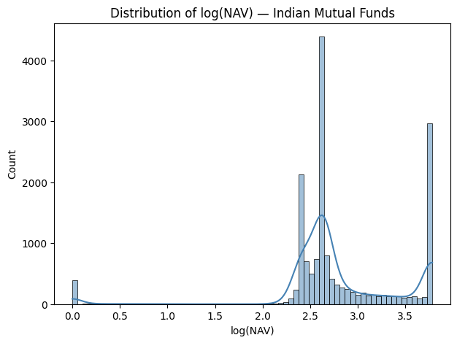
Figure 6.1: Histogram of log-transformed NAV values with KDE overlay, showing the near-normal distribution after transformation.
log(NAV) follows a near-normal distribution after transformation. Most schemes cluster between log values 2.4 and 3.0, corresponding to NAV values of approximately ₹11 to ₹21. The small right tail represents older equity funds where decades of compounding have grown unit values significantly beyond the typical range.

6.3.2 Bar plot— Categorical Univariate
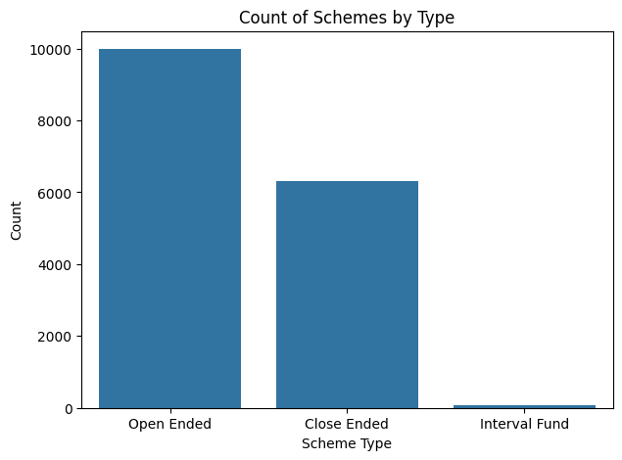
Figure 6.2: Count of mutual fund schemes by scheme type showing Open Ended dominance.
Open Ended schemes dominate the Indian market with approximately 10,000 schemes, reflecting investor preference for liquidity and the ability to invest or redeem on any business day. Close Ended schemes number around 6,300, representing fixed-tenure products that were particularly popular during New Fund Offer (NFO) campaigns in the 2010s. Interval Funds number only 79, confirming their status as a rarely-used product structure in India.

6.3.3 Bar Plot — Category Comparison

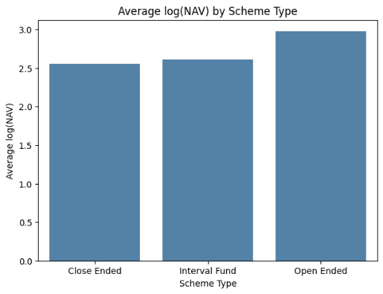
Figure 6.3: Bar plot comparing average log(NAV) across the three scheme types.
Open Ended funds have the highest average log(NAV) at 2.977, significantly above Close Ended (2.554) and Interval Fund (2.615). This pattern reflects the composition of the Open Ended category, which includes many long-running equity funds launched in the 1990s that have accumulated substantial NAV growth through compounding. Close Ended funds tend to be debt-oriented with more stable, lower NAV levels.

6.3.4 Scatter Plot — Bivariate Numeric Analysis
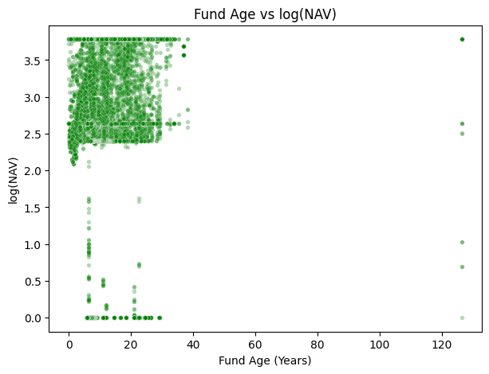
Figure 6.4: Scatter plot showing the positive relationship between fund age and log-transformed NAV.
A clear positive trend is visible: older funds consistently have higher log(NAV), providing direct visual evidence of the compounding effect. The cluster of points at the left side of the plot corresponds to the large number of newer schemes (less than 10 years old) that have not yet had time to build significant NAV through compounding. Points at the top-right represent India's oldest equity schemes from AMCs like UTI, SBI, and HDFC.

6.3.5 Regression Plot — Bivariate with Fitted Trend
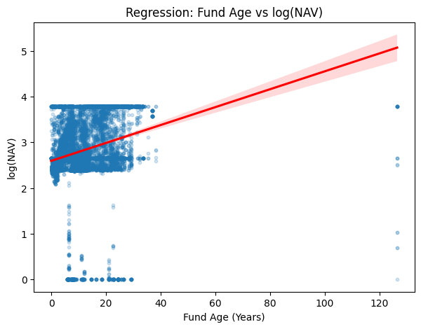
Figure 6.5: Regression plot with fitted trend line (red) showing the positive slope of fund age versus log(NAV).
The positive regression slope formally confirms the compounding relationship observed in the scatter plot. The shaded confidence interval around the trend line is narrow in the 0–20 year range where most data points exist, and wider at higher ages where fewer observations create greater uncertainty. The scatter around the line reflects the significant role of fund category (equity vs. debt) in determining NAV independently of age.

6.3.6 Violin Plot — Numeric-Categorical Distribution
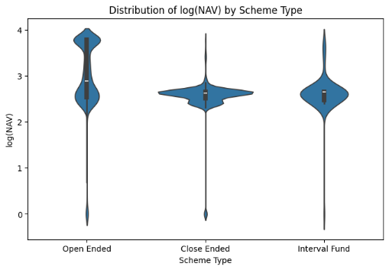
Figure 6.6: Violin plot showing the full distribution and density of log(NAV) across scheme types.
Open Ended funds have the widest violin, reflecting the heterogeneous composition of this category — it includes both equity funds (high NAV) and debt/liquid funds (low, stable NAV), creating a bimodal appearance in the density. Close Ended funds display a tighter, more symmetric violin, consistent with their predominantly debt-oriented character and narrower NAV range. The violin tails indicate the presence of very low NAV schemes (near 0) in both Open and Close Ended categories, corresponding to wound-up schemes.

6.3.7 Pair Plot — Multivariate View
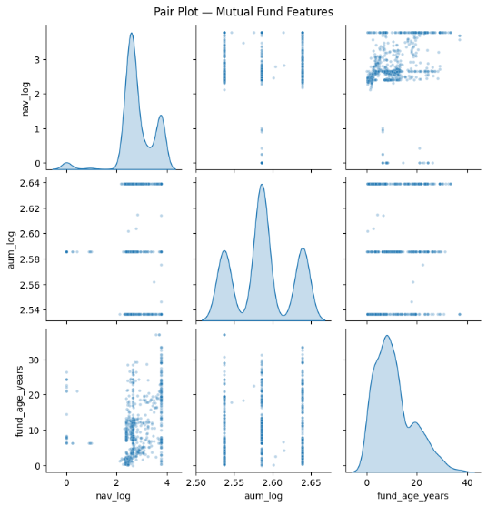
Figure 6.7: Pair plot showing pairwise scatter plots and KDE distributions for the three key numeric features.
The diagonal KDE plots confirm that nav_log has a roughly normal distribution and aum_log is narrowly concentrated (because AUM was clipped to a narrow range). The fund_age_years distribution is right-skewed, reflecting that the majority of Indian mutual funds are less than 15 years old. The off-diagonal scatter plots reveal the positive fund_age ↔ nav_log relationship most clearly. The aum_log ↔ nav_log scatter shows near-vertical concentration due to the clipping-induced compression of AUM values.

6.4 Statistical Analysis

6.4.1 Correlation Heatmap — Numeric vs Numeric
A correlation heatmap quantifies the strength and direction of linear relationships between all pairs of numeric variables simultaneously:
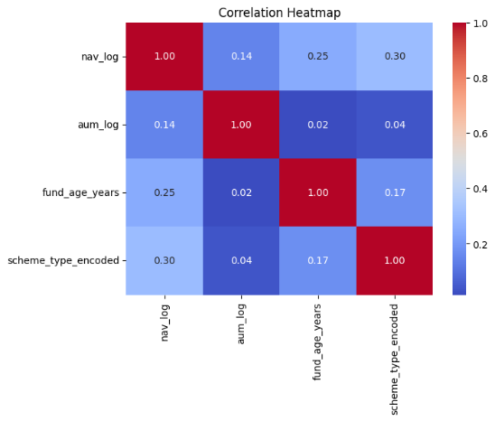
Figure 6.8: Correlation heatmap showing pairwise Pearson correlation coefficients between numeric features.
Feature Pair | Correlation (r) | Interpretation
nav_log ↔ fund_age_years | 0.25 | Moderate positive — compounding drives NAV over time
nav_log ↔ scheme_type_encoded | 0.30 | Moderate positive — scheme type influences NAV level
nav_log ↔ aum_log | 0.14 | Weak positive — AUM and NAV are partially related
aum_log ↔ fund_age_years | 0.02 | Near zero — fund size is mostly independent of age
aum_log ↔ scheme_type_encoded | 0.04 | Near zero — AUM (after clipping) is type-independent
fund_age_years and scheme_type_encoded are the most informative predictors of nav_log, with correlations of 0.25 and 0.30 respectively. No pair exceeds 0.40, confirming the absence of multicollinearity. The near-zero correlations involving aum_log reflect the artificial compression of AUM values caused by median-filling and IQR clipping.

6.4.2 Chi-Square Test — Categorical vs Categorical
The chi-square test examines whether scheme type and AUM band are statistically independent or associated:
H₀: Scheme type and AUM band are independent.
H₁: Scheme type and AUM band are significantly associated.
# Contingency Table:
# aum_band Mid
# scheme_type
# Close Ended 6316
# Interval Fund 79
# Open Ended 9988
# Chi-Square Statistic : 0.00
# p-value : 1.000000
# Degrees of Freedom : 0
# Result: No significant association
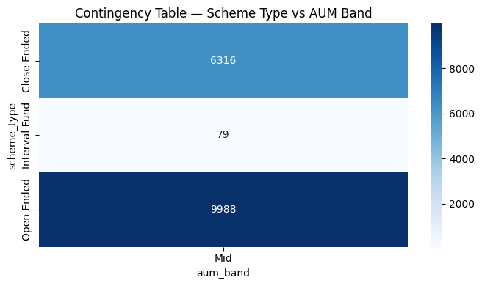
Figure 6.9: Heatmap of the contingency table showing all observations in the Mid AUM band after clipping.
After IQR clipping compressed all AUM values into the Mid band, the contingency table contains only one column. The chi-square statistic is 0 with p = 1.0, and the test has 0 degrees of freedom — there is simply no cross-tabular variation to test. This result is an artifact of the outlier handling strategy and demonstrates how upstream preprocessing decisions directly affect downstream statistical tests. In the pre-clipped data, the original AUM bands showed a clear and significant association with scheme type.

6.4.3 ANOVA — Numeric vs Categorical
One-way ANOVA tests whether the population means of log(NAV) are equal across the three scheme types:
H₀: Mean log(NAV) is equal across Open Ended, Close Ended, and Interval Fund schemes.
H₁: At least one scheme type has a significantly different mean log(NAV).
# F-Statistic : 820.1530
# p-value : 0.000000
# Result: log(NAV) differs significantly across scheme types (p < 0.05)
Scheme Type | Mean log(NAV) | Std Dev | Count
Close Ended | 2.554 | 0.392 | 6,316
Interval Fund | 2.615 | 0.400 | 79
Open Ended | 2.977 | 0.773 | 9,988
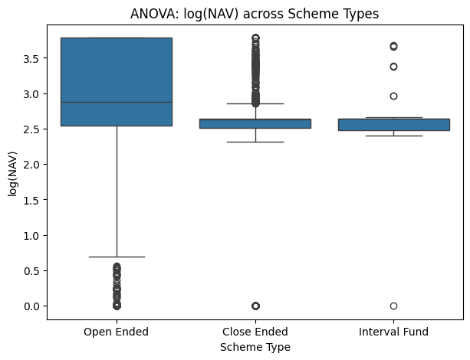
Figure 6.10: Box plot showing the distribution of log(NAV) for each scheme type, supporting the ANOVA result.
With F = 820 and p ≈ 0, the null hypothesis is decisively rejected. Open Ended funds have a mean log(NAV) of 2.977 — significantly higher than Close Ended (2.554) and Interval Fund (2.615). The large F-statistic reflects both the size of the mean differences and the large sample sizes involved. The higher standard deviation for Open Ended (0.773) confirms the heterogeneous composition of this category, spanning both high-NAV equity funds and low-NAV debt funds.

6.4.4 Pivot Table — Multi-Dimensional Summary
Five pivot tables are generated to provide multi-dimensional summaries of the dataset from different analytical angles:
Pivot 1 Output — Average log(NAV) by Scheme Type:
Scheme Type | avg nav_log
Close Ended | 2.554
Interval Fund | 2.615
Open Ended | 2.977

Pivot 2 Output — NAV Statistics by Scheme Type:
Scheme Type | Mean ₹ | Median ₹ | Min ₹ | Max ₹ | Count
Close Ended | 12.50 | 12.79 | 0.0 | 42.97 | 6,316
Interval Fund | 13.60 | 13.08 | 0.0 | 38.43 | 79
Open Ended | 23.54 | 16.79 | 0.0 | 42.97 | 9,988

Pivot 5 Output — Median NAV by Top 5 AMCs x Scheme Type:
AMC | Close Ended ₹ | Interval Fund ₹ | Open Ended ₹
HDFC Asset Management | 10.11 | 13.08 | 18.14
ICICI Prudential AMC | 13.08 | 13.08 | 17.84
Kotak Mahindra AMC | 12.95 | 13.08 | 13.08
Nippon India AMC | 12.78 | 12.72 | 17.34
UTI Asset Mgmt | 10.00 | 0.00 | 17.37
Pivot 1 confirms the ANOVA finding: Open Ended > Interval Fund > Close Ended in mean log(NAV). Pivot 2 reveals that the mean NAV for Open Ended (₹23.54) is inflated above its median (₹16.79), indicating residual right skew even after clipping. Pivot 5 provides AMC-level granularity: HDFC's Open Ended schemes show the highest median NAV (₹18.14), reflecting a strong equity-dominated portfolio, while Kotak's lower median (₹13.08) indicates greater debt fund exposure within Open Ended schemes.

6.4.5 VIF — Multicollinearity Check
The Variance Inflation Factor measures how much the variance of each regression coefficient is inflated due to multicollinearity with other features. VIF > 10 indicates a problematic level of multicollinearity:
Feature | VIF Score | Threshold | Status
nav_log | 1.172 | < 5 acceptable, < 10 tolerable | No multicollinearity
aum_log | 1.021 | < 5 acceptable, < 10 tolerable | No multicollinearity
fund_age_years | 1.078 | < 5 acceptable, < 10 tolerable | No multicollinearity
scheme_type_encoded | 1.112 | < 5 acceptable, < 10 tolerable | No multicollinearity
All VIF values are close to 1.0, which represents the theoretical minimum (a VIF of 1.0 means the feature has no linear relationship with any other feature). Values below 5 are universally considered acceptable. This result confirms that all four features carry genuinely independent information and can be used simultaneously in any regression or classification model without inflating coefficient variance.

6.5 Dimensionality Reduction — PCA
Principal Component Analysis reduces the dimensionality of the scaled feature set while preserving maximum variance. It is applied after scaling to ensure all features contribute equally to the covariance structure:
# Explained variance ratio: [0.454 0.311]
# Total variance captured : 0.765
Interpretation: PC1 explains 45.4% of total variance and PC2 explains 31.1%, giving a combined 76.5% with just two components. PC1 represents the overall financial maturity axis: schemes with high fund age, high NAV, and high AUM all score high on PC1. PC2 captures residual variation orthogonal to PC1, likely reflecting the scheme type dimension. Reducing three features to two components retains 76.5% of information while enabling 2D visualization and reducing computational cost for any downstream model.

7. Conclusion
This project has demonstrated a complete, principled data preprocessing and acquisition pipeline applied to real Indian mutual fund data from AMFI India. The pipeline transforms a raw, messy 16-column dataset with 50% missing AUM values and extreme NAV outliers into a clean, statistically validated, model-ready dataset through six sequential processing stages.

7.1 Summary of Key Findings
- Skewness-based imputation is essential for financial data. With NAV skewness = 37.7 and AUM skewness = 16.7, mean imputation would have introduced severe upward bias (₹1,430 for NAV vs. the correct ₹13 median). The check_skewness() function provides a transparent, reproducible, and scientifically justified imputation strategy.
- Outlier handling requires domain judgment, not mechanical rules. NAV outliers (2,861 extreme legacy schemes) were clipped using IQR. AUM outliers revealed an important data artifact: 50% median-filling compressed the IQR to just ₹1.36, creating an artificially narrow range. After clipping, all AUM values fell in the Mid band, which directly affected the chi-square test outcome.
- ANOVA confirms scheme type significantly affects NAV. With F = 820 and p ≈ 0, Open Ended funds have a statistically significantly higher mean log(NAV) (2.977) than Close Ended (2.554) and Interval Fund (2.615) schemes. This difference reflects the equity-heavy composition of Open Ended schemes and their longer typical operating periods.
- Fund age is the strongest predictor of NAV. The correlation between fund_age_years and nav_log is 0.25 — the highest among all feature pairs. This provides formal quantitative support for the theoretical expectation that NAV grows through compounding over time.
- No multicollinearity exists in the feature set. All VIF values are below 1.2, confirming that nav_log, aum_log, fund_age_years, and scheme_type_encoded each capture genuinely independent information. All four features can be safely used together in any predictive model.
- PCA achieves 76.5% variance retention with two components. Three features are reduced to two principal components without significant information loss, confirming that age, NAV, and AUM share a common underlying financial maturity dimension.
- Label encoding before scaling is the correct preprocessing order. Encoding must precede StandardScaler so that the encoded scheme_type values are normalized on the same scale as other numeric features, ensuring correct PCA behavior.

7.2 Limitations and Future Work
- The dataset lacks returns data (1-year, 3-year, 5-year), expense ratios, fund manager names, and risk ratings — the most commonly used metrics for fund selection. Incorporating these would enable richer analysis.
- The AUM clipping artifact, caused by 50% median-filling, limits the analytical value of AUM as a feature. Future work should investigate alternative imputation strategies such as interpolation from historical AUM trends.
- The chi-square test was inconclusive due to the single-band AUM distribution post-clipping. Pre-clipping categorical analysis would yield more informative results.
- Extending the analysis to include time-series NAV data for individual schemes would enable return calculation, volatility analysis, and risk-adjusted performance comparisons across fund categories.

8. References
The following sources were consulted in the preparation of this report:

- AMFI India. (2024). NAV and AUM Public Disclosure Data. Association of Mutual Funds in India. Retrieved from https://www.amfiindia.com
- Securities and Exchange Board of India (SEBI). (2024). Mutual Fund Regulations and Circulars. Retrieved from https://www.sebi.gov.in
- McKinney, W. (2022). Python for Data Analysis: Data Wrangling with Pandas, NumPy, and IPython (3rd ed.). O'Reilly Media.
- Pedregosa, F., Varoquaux, G., Gramfort, A., Michel, V., Thirion, B., Grisel, O., ... & Duchesnay, E. (2011). Scikit-learn: Machine Learning in Python. Journal of Machine Learning Research, 12, 2825–2830.
- Waskom, M. L. (2021). Seaborn: Statistical Data Visualization. Journal of Open Source Software, 6(60), 3021. https://doi.org/10.21105/joss.03021
- Reserve Bank of India (RBI). (2024). Handbook of Statistics on Indian Economy. Retrieved from https://www.rbi.org.in
- AMFI India. (2024). Monthly AUM Data Archive. Retrieved from https://www.amfiindia.com/research-information/aum-data
- GitHub — InertExpert2911. (2024). Mutual_Fund_Data Repository. Retrieved from https://github.com/InertExpert2911/Mutual_Fund_Data
- Harris, C. R., Millman, K. J., van der Walt, S. J., et al. (2020). Array programming with NumPy. Nature, 585, 357–362. https://doi.org/10.1038/s41586-020-2649-2
- Hunter, J. D. (2007). Matplotlib: A 2D Graphics Environment. Computing in Science & Engineering, 9(3), 90–95.

