**Name: *Tejal Nijai***

**Email id:** [***nijai.tejal20@gmail.com***](mailto:nijai.tejal20@gmail.com)

**GitHub Directory: *https://github.com/Tvn2005/Asymmetric_key_gen_app_in_Docker***

**Problem Statement:**

Given the hypothetical scenario as discussed above, How can we use Python programming and Docker Container constructs to develop an simple app that can be deployed at scale. Assuming a simple Asymmetric-Key-Gen app can handle 10 concurrent requests per second, how can we run multiple asymmetric-keygen apps to scale the requests to 500 concurrent requests per second.

**Problem statement in brief:**

As per my understanding, an asymmetric key generation application should be developed and deployed in docker to handle the user requests in a large-scale scenario. Basically, in real-time life when an application or service is accessible by multiple users at the same time, the system might get crashed. To handle such a situation, docker comes into the picture to provide an efficient solution.

**Proposed Solution:**

There can be two solutions as per my research and understanding.

1.Creating multiple containers for subsequent number of requests and balancer them using load balancer.

2.Using the new master slave architecture i.e Kubernetes for scaling the application.

As per the functional requirement, I developed a website which displays a button to generate the public and private keys. By clicking the button, it returns both (private and public) keysas JSON format.

**Block Diagram:**

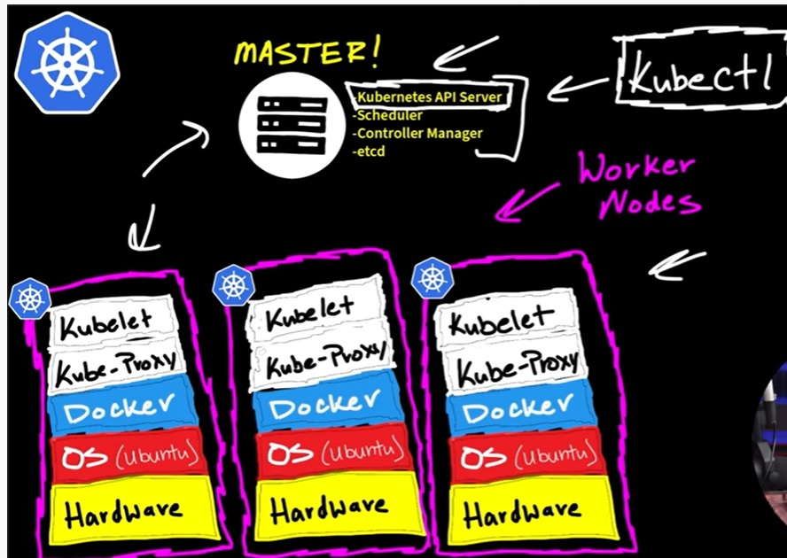

**Sample test Results:** 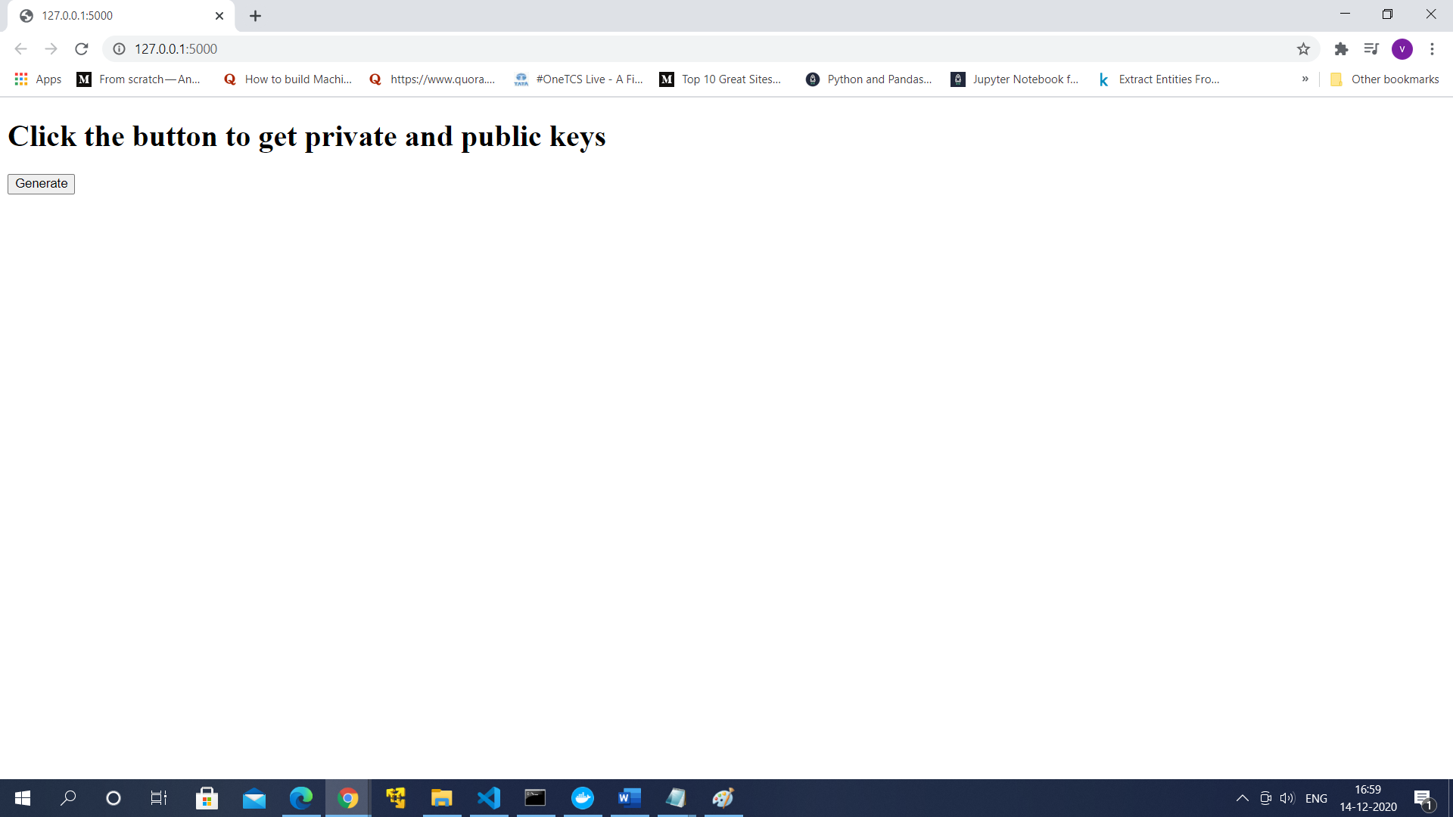

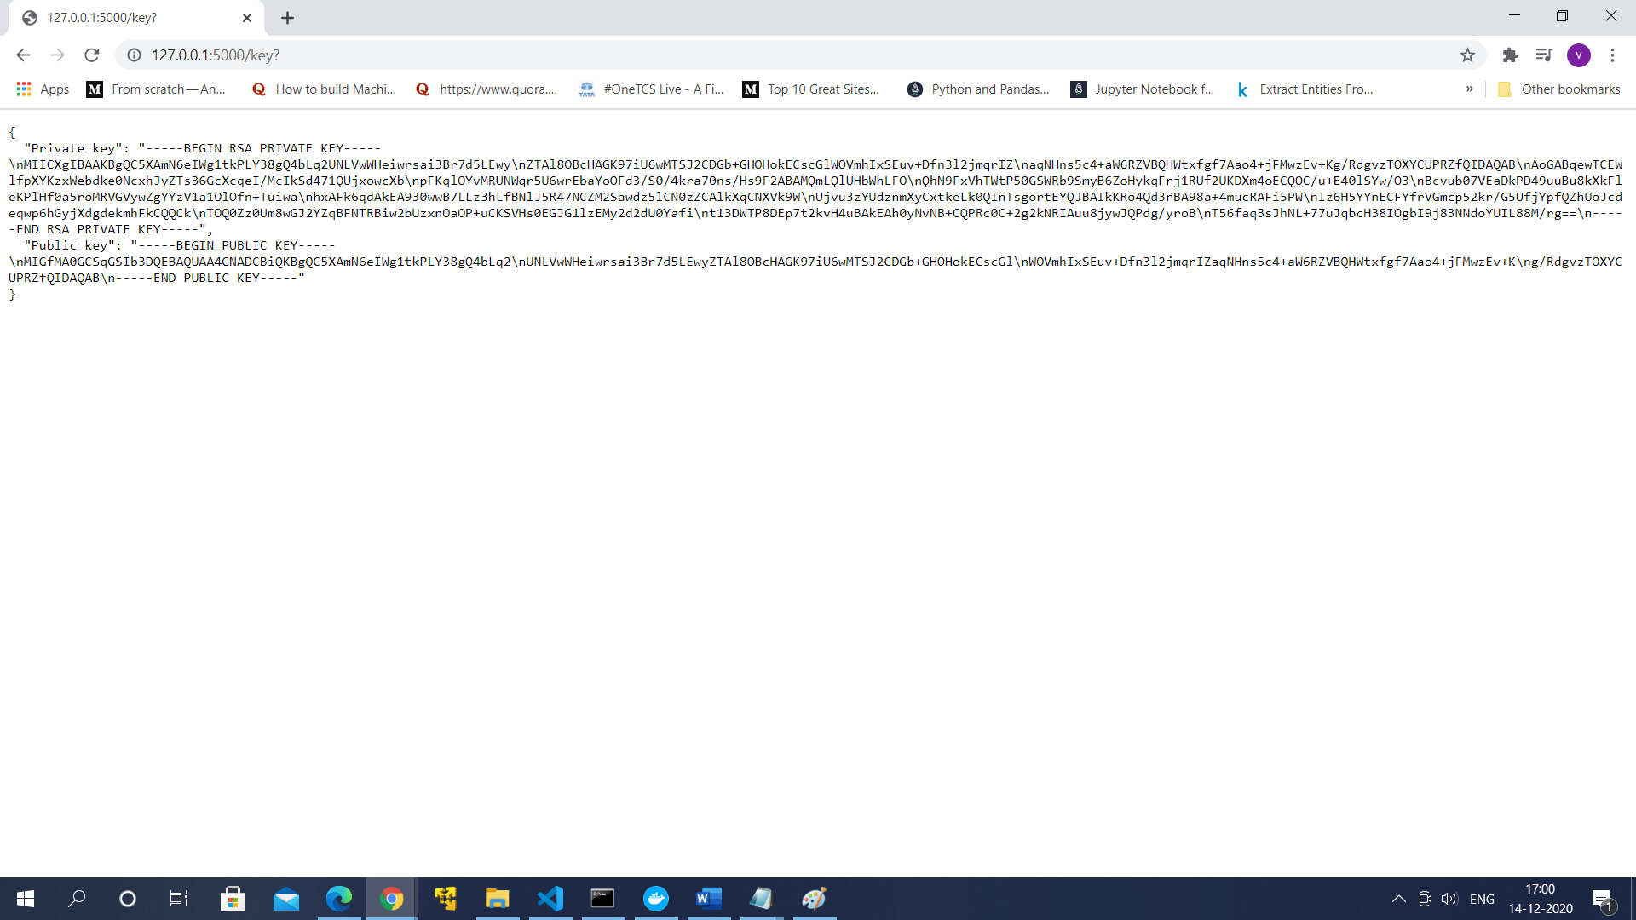

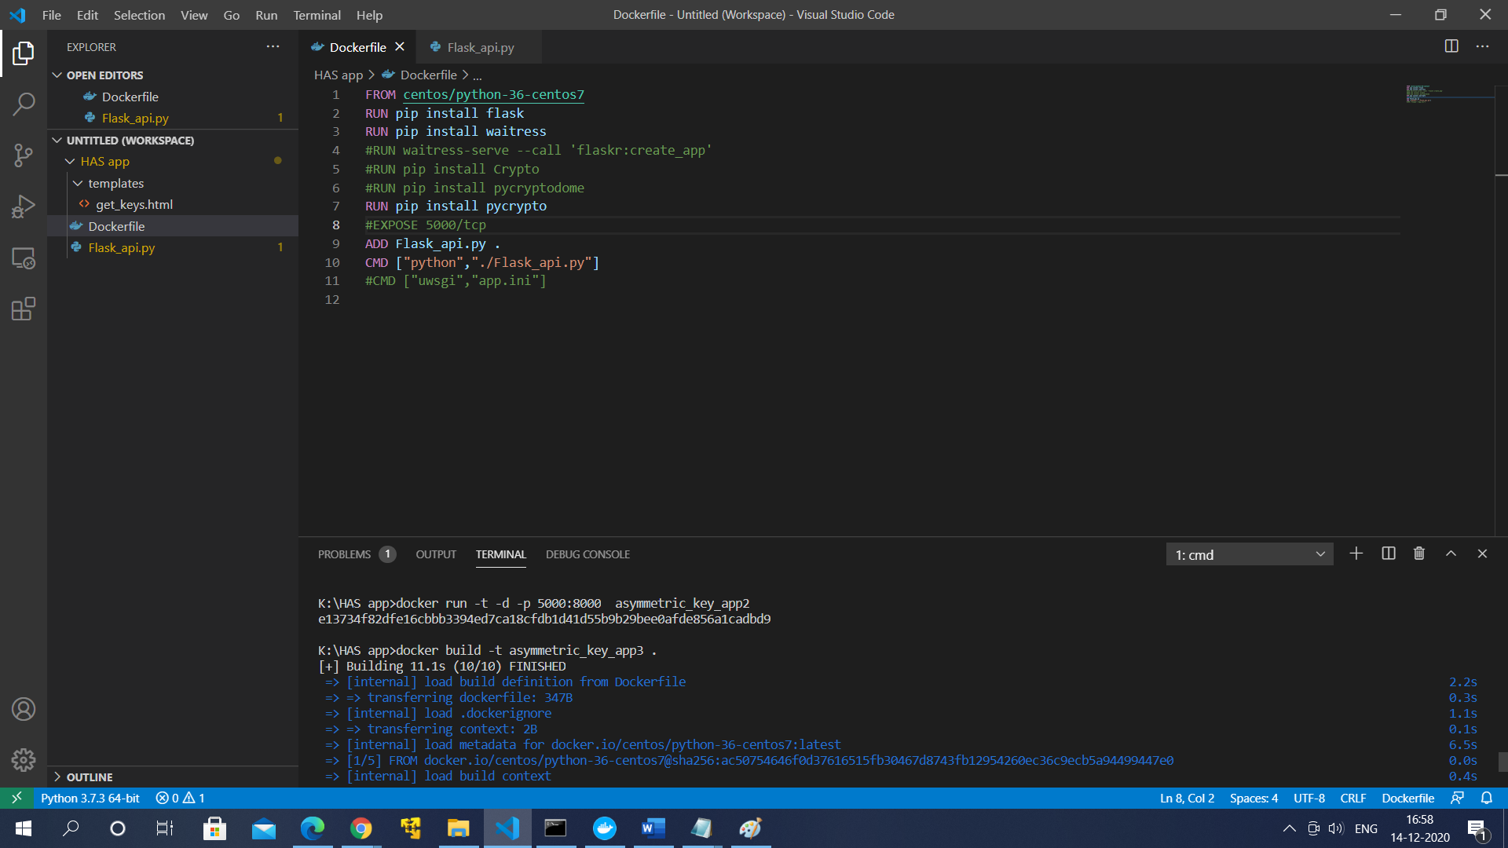

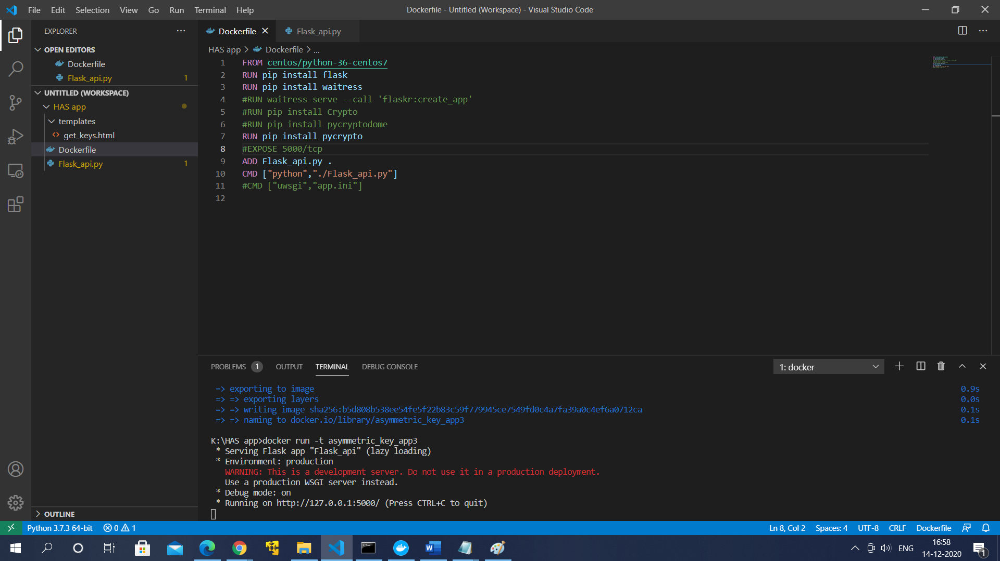

**Future Scope:**

Whole project can be executed and deployed in a cloud platform.

**Note:** I tried to launch the website in the container and also in Kubernetes but could not do it. This is the partial implementation. It would be helpful to have your feedback and guidance because I will be working on it to finish it.