Test Title: Verify Kirchoff’s Voltage Law and Voltage Division

R4 Requirement
Purpose: The purpose of this test is to verify that Kirchoff’s Voltage Law and Voltage Division apply and work for all circuits.

Variables:
Independent Variables

Input Voltage

Control Variables

Resistance

Dependent Variables

Output Voltage

Uncontrollable Variables
Resistance Variance
Voltage Spiking
Measurement Error

Experimental Setup:

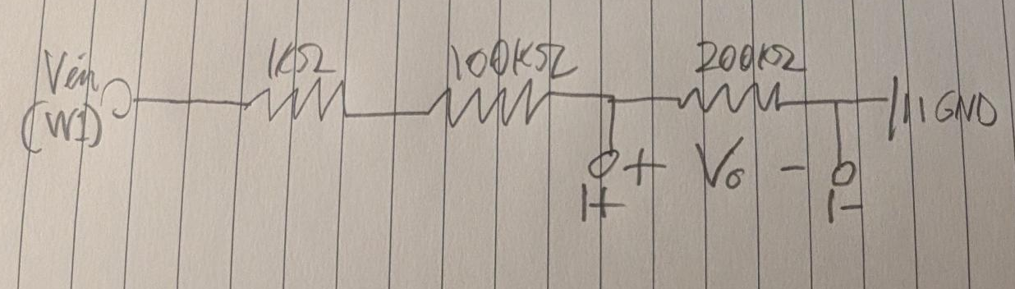
Figure 1: Experimental Setup

Procedure:
- Build a circuit with 3 resistors with the following nominal values:
  - 200k
  - 100k
  - 1k
- Wire the resistors in series such that the first resistor is 1k, the second resistor is 100k, and the third resistor is 200k.
- Wire W1 input to the start of the first resistor. Wire GND to the end of the third resistor.
- Wire 1+ and 1- to both ends of the third resistor to measure it’s voltage drop. Make sure 1- is wired to the same node as GND.
- Set an arbitrary test voltage in for W1 in Waveforms. Record the output voltage.
- Repeat two more times.

Sample Calculations:
$$V1 = (\frac{200k}{200k+100k+1k})1V=0.664V$$
$$V2 = (\frac{200k}{200k+100k+1k})3V=3.322V$$
$$V3 = (\frac{200k}{200k+100k+1k})=1.993V$$

R5 Requirement
Equipment:
- 3 Resistors
  - 200k
  - 100k
  - 1k
- Analog Discovery 3 board
- Male-to-male dupont connectors

Quantitative Results:

 | Vin | V1 Calculated | V1 Measured (Tr 1) | V1 Measured (Tr 2)
Input 1 | 1V | 0.644V | 636 mV | 632 mV
Input 2 | 3V | 3.322V | 1.8851 V | 1.8756 V
Input 3 | 5V | 1.993V | 3.1332 V | 3.1429 V

Pictures:

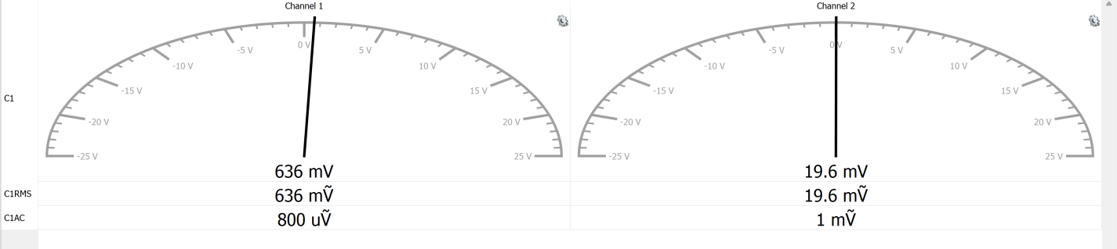
Figure 2: 1 Volt Input Results

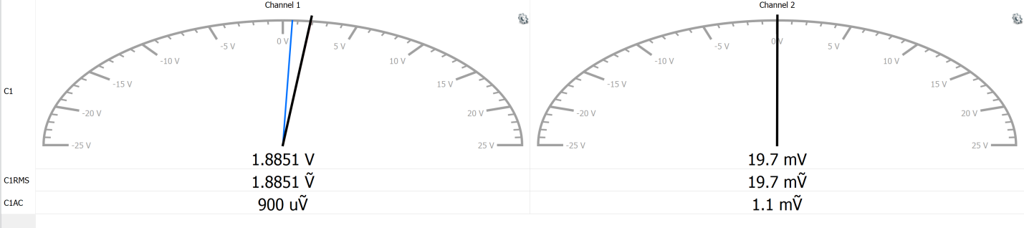
Figure 3: 3 Volt Input Results

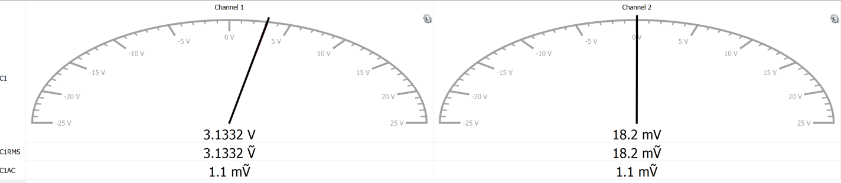
Figure 4: 5 Volt Input Results

R6 Requirement
      - Observations and Conclusions:
- Observations:
  - The measured voltages across the 200 kΩ resistor did not match calculations but were close, within a few hundred mV.
  - At lower input voltages (1 V), the measured and calculated values were very close (less than 2% difference).
  - At higher input voltages (3V and 5V), larger gaps were displayed between calculated and measured values. The 3V test showed the largest gap, while the 5V test was near the middle.
- Discussion of Results:
  - The experiment supports Kirchhoff’s Voltage Law and Voltage Division, since the resistor voltages add up consistently to the applied input voltage.
  - The larger gaps between calculated and measured output voltages at higher input voltages could mean either measurement limitations, resistor tolerances, or noise.
- Possible Sources of Error:
  - Resistor tolerances: The resistors may not have been exact, leading to deviations from calculated values.
  - Measurements: The Analog Discovery 3 may have some small errors in measurement, especially at higher voltage, since it is a low voltage device with only a 5V power supply
- Conclusions:
  - The tests validates that KVL is true.
  - Voltage Division was observed, though real-world error prevented exact matching with the calculations.
- Potential Improvements:
  - Use resistors with tighter tolerances (like 0.1% instead of 1–5%).
  - Double-check the calculated voltage values before comparing to the measured data from the Discovery 3.
  - Use additional measuring equipment (a lab multimeter with a dedicated power supply) to verify results.

Conducted by: Corbin Hibler

Date test conducted: 2025-09-04

