Scott Bingham, Donald Zhang

Introduction
Our final project in ECE576 was implementing a ray tracer capable of rendering, rotating, and moving spheres, as well we rendering planes.

Our initial goal was to realistically render and shade spheres with reflections while being able to navigate through the scene and allow the spheres to bounce and roll around. Once we met this goal, we added anti-aliasing and the ability to render planes as well. Because spheres are particularly hard to draw accurately with non-ray tracing 3-D accelerators and spheres can be used as bounding objects for polygon tracing, we chose to implement spheres first. Planes were added because they can be used as polygons to render more complicated objects with sufficient bounding. We used a NIOSII processor to update the sphere table in hardware so that we could rotate spheres about any axis and have them move without adding significant complexity to the hardware. Rotations and motion were done in floating point on the CPU, making the calculations more accurate than the 24bit 12.12 fixed point representation used in the hardware. All input switches and keys were used to allow motion of the light source, motion of the origin, rotation of the scene, selection of the resolution, selection of the scene if the CPU was not used, the level of reflections, the level of anti-aliasing, reset, the option to render planes, and finally telescoping/widening the camera view.

High Level Design
The idea for our project came from Prof. Land’s lectures on ray tracing. Ray tracing is very well suited for FPGA’s where many calculations can proceed in parallel. Spheres allow quite interesting scenes to be drawn, especially when reflections are added. We found that once we had implemented sphere rendering, adding planes was easier because fewer calculations were needed and we had existing experience and states in place to do the required calculations, reflections, and shadowing.

Ray Tracing
The basic idea of ray tracing is to trace the path of a photon through a scene to the eye. Because we are only concerned with the photons that actually hit the eye, we actually shoot rays out from the eye through the screen into the scene and seeing what objects it hits. The ray picks up color based on the reflectivity as it collides with objects in the scene. Eventually the ray is stopped because it misses objects in the scene or picks up negligible color in subsequent reflections. Shadows are determined by shooting rays from intersection points back towards the light source(s) in the scene and seeing if there is an object in the way to block the light. Shading is also done by weighting light that hits a surface perpendicularly greater than light that merely glances off.

Figure 1 shows an example of a ray tracing through a scene. The initial ray leaves the eye in a direction such that it passes through one of the pixels in the screen. It then collides with the red sphere. A shadow ray is shot towards the light source; since that shadow ray reaches the light source, the intersection point on the red sphere would be lit, and is not shadowed. A reflection ray is then shot towards blue sphere, getting its direction from a specular reflection. Next, a shadow ray is shot to the light source, which again makes it without obstruction and so the blue sphere is lit at the intersection point. Then another reflection ray is shot from the blue sphere intersection point towards the green plane, which it hits. The shadow ray from this point, however, is blocked by the red sphere and so that point on the green plane is in shadow. The reflection ray from the green plane then leaves the scene without hitting another object so the tracing for that pixel is completed. Its color is the sum of the lit red sphere color, the product the red sphere reflectivity and the lit blue sphere color, and the product of red and blue sphere reflectivity’s and the shadowed green plane color.

The tracer would then repeat the process for the next pixel in the scene (or another ray for that pixel if anti-aliasing is used). Since each ray must check for intersections with every object in the scene, the processing time increases significantly with a large number of objects. However, since pixel is independent of each other, they can be processed in parallel if the hardware is available.
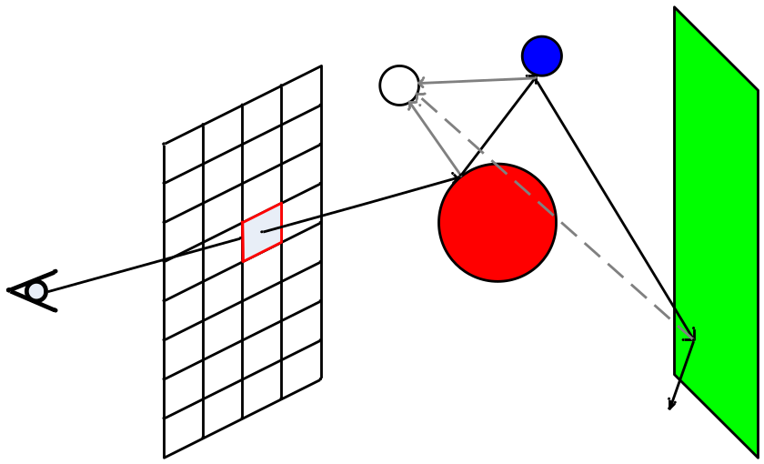
Figure 1

Figure 2 shows the affects of varying the distance from the eye to the screen on the viewing frustum. While you can see a wider angle and more of the scene with the screen close, the pixel density goes down, which can cause pixels to miss objects they would had previously hit. Also, when the screen is too close to the eye, objects become skewed, where spheres get stretched into ovals as they are farther from the center of the screen. The tradeoff is how much of the scene you see with how much detail you see.

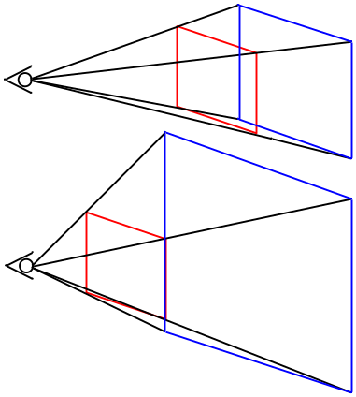
Figure 2

Our coordinate system and sample scene setup are shown in figure 3. Depth is in the Z direction. Because we use 12.12 two’s complement fixed point numbers, each coordinate is limited to between -2048 and +2047 (considering the 12 integer bits only). For scenes with planes, we use the configuration shown so that we can get reflections all around the spheres while still being able to see the scene.

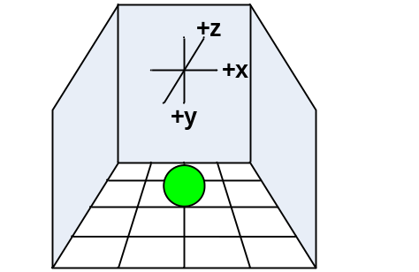
Figure 3

Our ray decision tree is shown in figure 4. Each ray that intersects with an object shoots a shadow ray and possibly a reflection ray depending on the switches and weight given to the reflection ray to be launched. If less than 1% of the light is going to be reflected, we don’t launch a reflection ray. We also impose the restriction of a maximum of three reflection rays to limit the time spent per pixel.
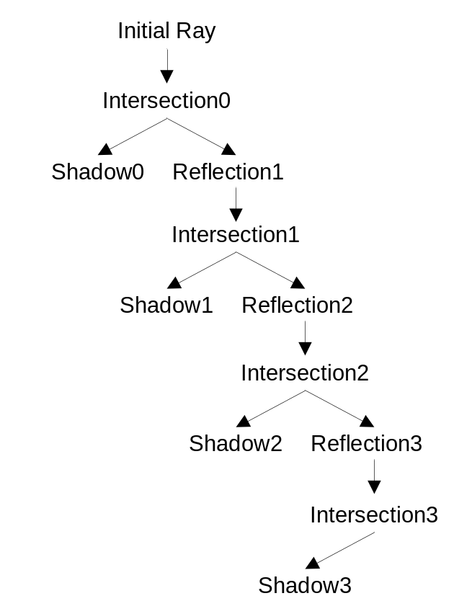
Figure 4

A high level state diagram for the ray tracer is shown in figure 4. At reset, the tracer is initialized. It then proceeds to load the sphere list from the CPU. The transfer is controlled by the CPU once the hardware signals that a frame has completed. A ray then checks for the closest intersection, if any, with the spheres in the scene. If it hits one, Lambertian lighting is applied to give it a color based on the amount of shadow. If the intersection is completely in shadow, no shadow ray would be needed as it will be blocked by the sphere the ray intersected with. If the ray did not hit a sphere, the planes in the scene are checked for the closest intersection. We chose to give spheres priority and not check planes in the event of a sphere intersection because of performance considerations and that we added planes as a last minute extra once we satisfied our initial project specifications. This imposed the restriction that spheres must be on top of planes and not behind them, which is a reasonable restriction for the scenes we wanted to render.

A shadow ray was launched towards the light source. Again, the shadow ray checked the sphere list for an intersection, but only spheres closer than the light source were counted as actual intersections. Because spheres must be in front of planes, the plane list was not checked to see if a plane cast a shadow on a sphere.

At this point, the pixel has an initial color, it is either black because it missed all objects, the color of the intersected object, or the color of the intersected object with a shadow. For shadows, we halved the color of the intersection object to allow for some ambient lighting affects. For the Lambertian/cosine shading, the dot product of the normalized normal with the normalized vector from the intersection point to the light source was multiplied by the object’s color. Because both vectors were normalized, the dot product produces a scaling factor between 1 and 0. We offset the resulting color by the completely shadowed color and made sure the resulting color did not overflow when the offset was added to the color with a saturating addition.

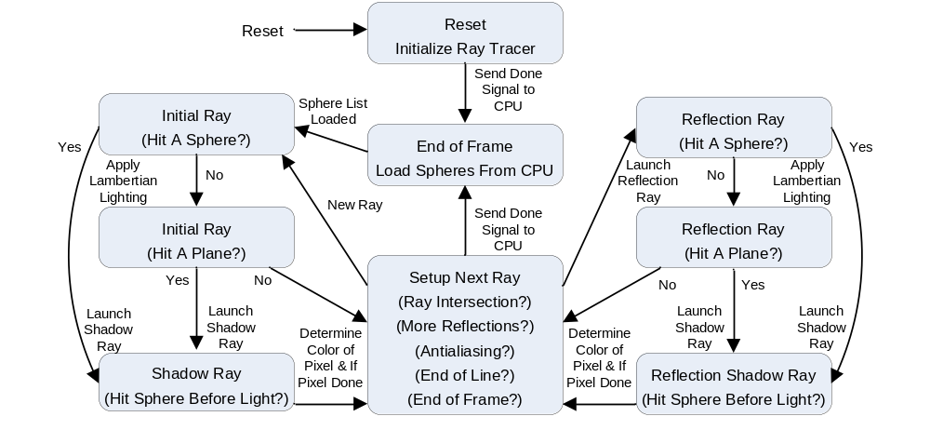
Figure 5

The next ray could be a reflection ray, in which case the color from that ray would be scaled by a reflection weight and added to the original color. If anti-aliasing is used, all the rays for each pixel are combined with different weights as will be discussed later. Finally, if a pixel is done, the tracer moves on to the next pixel. When the last pixel of the frame is drawn, the sphere list is again loaded from the CPU to allow for sphere motion and rotation. The steps involved in each state are discussed in more detail later.

Sphere Background Math ^{[1]}

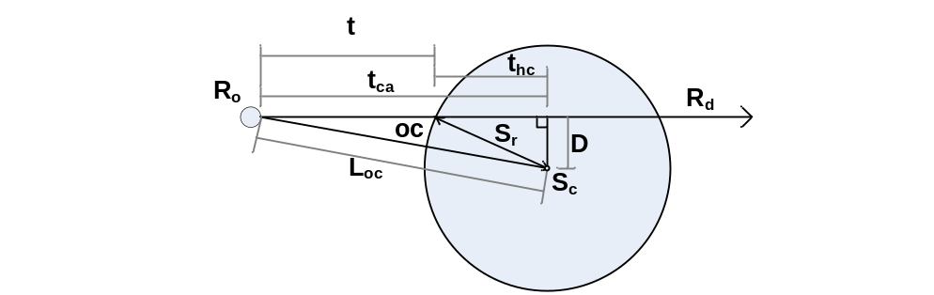
Figure 6
R_{origin} = R_{o} = [ X_{o} Y_{o} Z_{o} ]
R_{direction} = R_{d} = [ X_{d} Y_{d} Z_{d} ]
R(t) = R_{o} + R_{d} * t
R_{intersection} = R_{i} = [ X_{i} Y_{i} Z_{i} ] = [ X_{o} + X_{d} * t Y_{o} + Y_{d} * t Z_{o} + Z_{d} * t ]
R_{normal} = R_{n} = [ X_{n} Y_{n} Z_{n} ] = [ (X_{i} – X_{c})/S_{r} (Y_{i} – Y_{c})/S_{r} (Z_{i} – Z_{c})/S_{r} ]
t = intersection distance
D² = L²_{oc} – t_{ca}²
t²_{hc} = S_{r}² – D² = S_{r}² - L²_{oc} + t_{ca}²
OC = S_{c} - R_{o}
L²_{oc} = OC · OC
t_{ca} = OC · R_{d}
S_{center} = S_{c} = [ X_{c} Y_{c} Z_{c} ]
S_{radius} = S_{r}
S_{surface} = S_{s} = [ X_{s} Y_{s} Z_{s} ]
S_{r}² = (X_{s} – X_{c})² + (Y_{s} – Y_{c})² + (Z_{s} – Z_{c})²

This final equation gives us the implicit equation for a sphere. We can test points to see if they in fact lie on the sphere’s surface. The algebraic solution is as follows. By substituting X(t), Y(t), and Z(t) in the form of R(t) into the implicit equation, we get that,
S_{r}² = (X_{o} + X_{d} * t – X_{c})² + (Y_{o} + Y_{d} * t – Y_{c})² + (Z_{o} + Z_{d} * t – Z_{c})².
In terms of t,
A * t² + B * t + C = 0.
A = X_{d}² + Y_{d}² + Z_{d}² = 1
B = 2 * (X_{d} * (X_{o} – X_{c}) + Y_{d} * (Y_{o} – Y_{c}) + Z_{d} * (Z_{o} – Z_{c}))
C = (X_{o} – X_{c})² - (Y_{o} – Y_{c})² - (Z_{o} – Z_{c})² - S_{r}²
You can then solve the quadratic equation for t and find the closet intersection point, if any.

However, we chose to use a faster geometric solution to the intersection problem which delays the square root of the quadratic equation and offers checks to bail out of the calculations sooner if an intersection is impossible.

First we check if the ray originates inside the sphere by calculating a vector from the ray origin to the center of the sphere and its magnitude:
OC = S_{c} - R_{o}
L²_{oc} = OC · OC
If L²_{oc} is less than S_{r}², then we know the ray originated inside the sphere. If the ray originates inside any sphere, we chose to color the pixel black and move on because no light penetrates our spheres. (Note this is not true of shadow rays because they may originate (R_{i}) under the surface due to the limited precision of our calculations and we ignore the result of this comparison for shadow rays.)

Next we calculate the distance from the origin to the point along the ray that is closest to the sphere’s center.
t_{ca} = OC · R_{d}
If t_{ca} is negative, then the sphere is not in front of the ray origin (as defined by the ray direction) and so we know that the ray does not intersect this sphere and can move on to the next one.

Following that comparison, we next calculate the half cord distance squared, where the half chord distance is the distance from the point found by t_{ca} and the surface of the sphere.
t²_{hc} = S_{r}² – D² = S_{r}² - L²_{oc} + t_{ca}²
D² = L²_{oc} + t_{ca}²
If t²_{hc} is negative, the ray misses the sphere. We then calculate the intersection distance.
t = t_{ca} - √(t²_{hc} )
Once we have the intersection distance, we can calculate the intersection point and the normal.
R_{i} = [ X_{o} + X_{d} * t Y_{o} + Y_{d} * t Z_{o} + Z_{d} * t ]
R_{n} = [ (X_{i} – X_{c})/S_{r} (Y_{i} – Y_{c})/S_{r} (Z_{i} – Z_{c})/S_{r} ]
We check all spheres in the sphere list in order to find the closest intersection if there is more than one.

All direction vectors are normalized in our calculations to simplify and reduce the number of calculations required. This also helps prevent overflowing when we determine the magnitude of vectors by limiting the size of the result. The inverse radius and radius squared are precomputed and stored in the sphere list to save calculation time at the expense of memory/register usage.

Plane Background Math ^{[1]}
R_{origin} = R_{o} = [ X_{o} Y_{o} Z_{o} ]
R_{direction} = R_{d} = [ X_{d} Y_{d} Z_{d} ]
R(t) = R_{o} + R_{d} * t
R_{intersection} = R_{i} = [ X_{i} Y_{i} Z_{i} ] = [ X_{o} + X_{d} * t Y_{o} + Y_{d} * t Z_{o} + Z_{d} * t ]
R_{normal} = R_{n} = [ X_{n} Y_{n} Z_{n} ] = [ (X_{i} – X_{c})/S_{r} (Y_{i} – Y_{c})/S_{r} (Z_{i} – Z_{c})/S_{r} ]
P = A * x + B * y + C * z + D = 0
A² + B² + C² = 1
D = - P_{n} · point, distance from [0 0 0]
P_{normal} = P_{n} = [A B C]

Planes, in comparison, require fewer calculations to determine if there is a ray intersection. We start with the implicit equation for a plane.
P = A * x + B * y + C * z + D = 0
Which can be written as,
A * (X_{o} + X_{d} * t) + B * (Y_{o} + Y_{d} * t) + C * (Z_{o} + Z_{d} * t) + D = 0
We can solve this for t, the intersection distance, and get
t = - (A * X_{o} + B * Y_{o} + C * Z_{o} + D) / (A * X_{d} + B * Y_{d} + C * Z_{d})
t = - (P_{n} · R_{o} + D) / P_{n} · R_{d}
t = v_{o} / v_{d} , where v_{o} = - (P_{n} · R_{o} + D) and v_{d} = P_{n} · R_{d}
We calculate the denominator first. If v_{d} equals zero, the ray is parallel to the plane and we can disregard it. Likewise if v_{d} is positive, the normal is pointing away from the plane, and we disregard it in our rendering. This is done so that planes cannot block spheres. If we move the origin behind a plane, it is simply not drawn. This gives the affect of it being a one way mirror. When behind it, it appears to be not there but when in front, it acts as a normal surface (mirrored if the reflection is not zero).

Next, we calculate the numerator v_{o} and then t.
t = v_{o} / v_{d}
If t is negative, then the intersection is behind the origin and therefore not a hit. Again the intersection point is calculated.
R_{i} = [ X_{o} + X_{d} * t Y_{o} + Y_{d} * t Z_{o} + Z_{d} * t ]
We do not have to calculate the normal as with spheres because we already have it in the plane table in P_{n} = [A B C] which was used in the previous calculations. Also, the normal is the same for any point on the plane (opposite sign on the other side), which is not true of spheres. This also makes planes much quicker to render than spheres.

Reflections ^{[1]}

Figure 7
θ_{incident} = θ_{i} = θ_{reflected} = θ_{r}
R = αI + βN

Physics tells us that the above two statements are true; the angle of incidence equals the angle of reflection, and the reflection vector is a linear combination of the incident and normal vectors. This can be transformed into a useable equation by the following:
cos(θ_{i}) = cos(θ_{r})
- I · N = N · R
- I · N = α(N · I) + β
If we set α = 1, β = - 2*(N · I). Substituting into our physical law, we get that,
R = I – 2*(N · I)*N
The resulting reflection vector R is also normalized when the incident vector I and the normal vector N are also normalized.

Software/Hardware Tradeoff
Many of the functions in the ray tracer can be performed by either the hardware or the software. We tried to take advantage of the hardware parallism as much as possibile by calculating most of the arthtimics using hardware modules. The software on the other hand can compute more complex calculations that are not crucial to ray tracing itself. Calculations such as sphere movement and rotation are performed by the software while the hardware is drawing the frames. This maximizes the efficiencies of both parts as hardware statemachine can run as fast as possibile while the software will not be sitting there idel waiting for the hardware. By using a real floating point unit the software also has the advantage of having higher precision than the hardware, which uses fixed point.

Hardware/Software Design

Ray Tracer Hardware
The ray tracing hardware consisted of a large state machine responsible for calculating the color of all the pixels. It wrote these results to a write buffer which coordinated with the VGA controller to access SRAM. The VGA controller read the screen values from SRAM and sent them to the VGA DAC along with the necessary clock and synch signals. The ray tracing hardware interfaced with the NIOSII CPU through the sphere table and one state in the state machine in which it read values from the CPU. All input switches and pushbuttons were used up to configure the hardware and move the origin/light source/screen position.

State Machine
The detailed state machine is shown below in figure 8. The main idea of the state machine is to implement the ray tracing math previously discussed. We start with initializing many state variables and the vector direction at reset. Also at reset, the option to render or not to render planes is made. The initial ray is normalized over several cycles, which requires a magnitude calculation, a square root, and a division. Then for each sphere, it is checked whether the ray origin is inside a sphere. If it is, then the pixel is drawn black and we can move on to the next one. Otherwise, we check that a sphere is in front of the ray and whether or not it intersects.

If an initial ray does not intersect with any sphere, it would then be checked with the plane list. The same is true for a reflection ray. Shadow rays, however, do not consider planes for reasons stated earlier. Also, if a shadow ray intersects with any sphere closer than the light source, a shadow is cast on the origin of the shadow ray. Because we are concerned with the closest intersection, we still must check every sphere after an intersection is detected, so the closest distance and its intersection point are stored until all spheres have been checked. The alternative to checking every sphere is to sort the sphere list, thereby making the closest intersection the first one. However, this doesn’t work for reflection rays which go through the same states as initial rays and so we check all spheres. Shadow ray’s can stop once a single intersection has been found and so typically take less time. Also we impose the limitation that the light source itself does not cast shadows. Although the light source is a single point in space, we draw it as a small, “pure” white sphere to make it more convincing. The light source also does not reflect any light although it appears in the reflections on other spheres and planes.

To create a reflection vector we must know the normal to the intersection point on the sphere. For planes, this is trivial as it is already stored in the plane table. The direction of the sphere normal is easy to get, however it takes many cycles to again normalize it. Once we have the normal and the direction of a shadow vector, we take the dot product and scale the color of the intersection accordingly. This creates realistic shadows that are brighter when the light vector coincides with the normal. We store the inverse of the radius in the sphere table to make normalization slightly faster by doing a multiply instead of divide. Once we have the normal, we have part of the reflection vector calculations done. At this point we need to check whether or not we want to launch a reflection, based on the number of reflections so far and the weight of the reflection. The weight of each object intersected with thus far is multiplied together so that less light reaches the eye from further intersections. If there is to be a reflection vector, the color produced from the previous ray is stored and any reflection color is added on top of that when the reflection ray completes. We check for saturation on any given color and so adding more of that color to the pixel does not help. This gives the realistic effect that you see reflections better on dark, shiny objects. Anti-alias sub-pixel rays are stored in a special buffer until all the rays for that pixel have been calculated, and then they are combined.

Planes are checked in a similar way to spheres but with more restrictions as discussed previously. These are for performance reasons and the fact that we will only use planes as bounding mirrored surfaces in our scenes. The closest plane intersection is calculated when intersecting with planes as with spheres, but there are typically much fewer planes than spheres in the scenes. Normalizing the normal is not necessary as it has already been done (similar to the way radius parameters are precalculated and stored in the sphere table). We can apply a checkerboard pattern to planes by simply checking the intersection coordinates in two axes and looking the value of a certain bit, depending on how wide you want the checkers. We can also impose boundaries on how far planes extend by disregarding hits that intersect outside of the bounds.

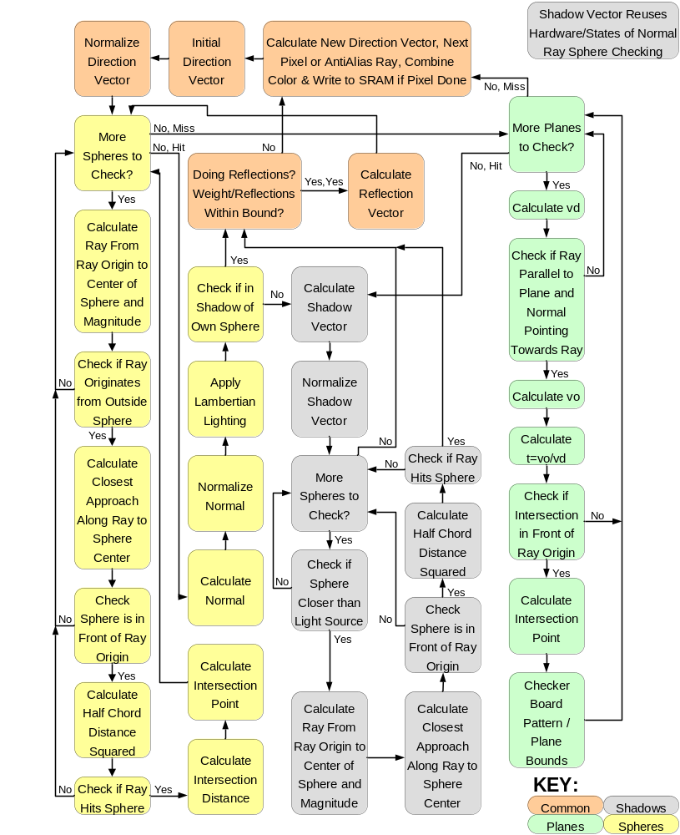
Figure 8

Anti-Aliasing
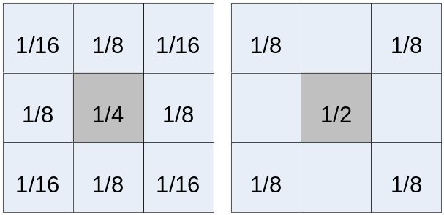
Figure 9-A Figure 9-B

Jaggies appear in images rendered on a computer screen due to the finite pixilation/quantization used. No matter how much we increase the resolution, the jaggies will never disappear, only get smaller. The solution is to super-sample the image and average the color among adjacent rays. Our anti-aliasing implementation has the option to do either 8x or 4x anti-aliasing. For 8x anti-aliasing, nine rays are shot per pixel and the resulting color from each is summed using the weightings in figure 9-A. 4x anti-aliasing uses the weightings in figure 9-B. The colors of each sub-pixel were stored in an alias buffer until all sub-pixel colors had been determined. We used these weightings for several reasons: equal weightings blurred the image too much, Prof. Land suggested these weights and that they were more realistic, each is a fraction that can be resolved by shifts, and the sum of all the weights equals one. Each sub-pixel was +1/2, 0, or -1/2 from the center pixel in the X and Y directions. The effects of anti-aliasing are clear in figure 10. The top image has no anti-aliasing or reflections. The next image has 4x anti-aliasing, followed by 8x anti-aliasing, followed by 1, 2, and 3 levels of reflections without anti-aliasing, followed by 3 levels of reflections and 8x anti-aliasing, and finally 3 levels of reflections, 8x anti-aliasing, and planes being rendered.
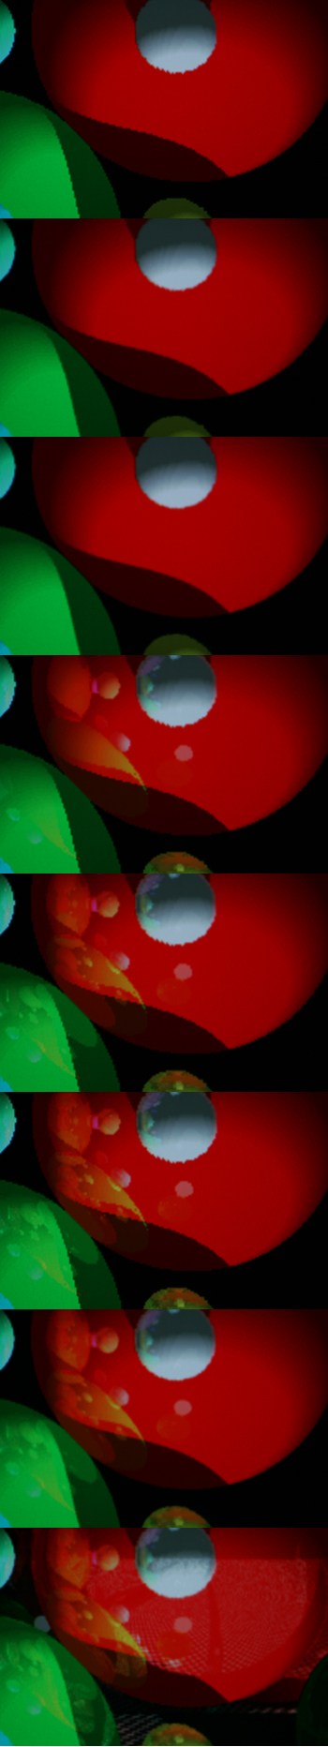
Figure 10

Write Buffer
In previous labs that used VGA output, the execution of our state machine was tied to the blanking signal from the VGA controller; that is, the state machine only ran while the VGA controller was synching. This was to avoid trying to write to SRAM while the VGA controller was reading from it. However, this was overly restrictive. Only writing to memory had to wait on the VGA controller. To decouple the execution of the ray tracer from writing to memory, we implemented a 64-entry circular FIFO buffer to store information to be written to the SRAM. This enabled the ray tracer to always run full speed. We experimentally determined 64-entries to be the optimal size. Thirty-two entries were too few and using a power of two allows the head and tail pointers to naturally loop around to the beginning of the circular buffer when they overflow. The buffer stored both the 18-bit SRAM address and the 16-bit data to be written and was indexed by 6-bit head and tail pointers. The tail pointer advanced whenever it did not point to the same entry as the head pointer and wrote the entry it was pointing to back to memory. The speedup provided by using this method was significant.

Square Root ^{[2]}
Because we were initially unsure how the MegaFunction square root module would work, we implemented one we found on the internet for fixed point numbers and modified it to work with our 12.12 representation. In retrospect, this was probably not the ideal solution as it takes approximately four cycles to complete. However, it was too difficult to verify another square root implementation once we had devoted resources to interfacing with the one we implemented.
The C code we transformed into Verilog and modularized to do multiple iterations per cycle is included in the Verilog file for the square root module. The square root module we implemented used an edge triggered start signal to begin calculations. When the correct number of iterations for the number of sub-modules had completed, the result was placed on the outputs and a done signal was raised. The hardware spun on the done signal from the square root module and then reset it once it had read the results.

[2] http://www.worldserver.com/turk/computergraphics/FixedSqrt.pdf

VGA/SRAM
The VGA controller was responsible for fetching pixels to draw on the screen from SRAM, producing synchronization signals, and creating the front and back porches required for VGA displays. We implemented both 320x240 and 512x480 (really 640x480 with part of the screen black) resolutions. The VGA controller has two counters, one for horizontal pixels and one for vertical lines. A line is drawn according to the timings in the table above. First a synch signal (active low) is produced, after the counter reaches a certain value, the synch returns high and the back porch begins. Once the back porch is completed, the VGA controller uses the horizontal and vertical counters to produce coordinates for the current pixel being drawn. These coordinates are used as an address for memory. Once the visible resolution is completed, the front porch begins. Following the front porch, the process repeats with a synch signal. The color output is grounded from the start of the front porch until the end of the back porch. Similar actions are taken by the vertical line counter, except the clock is the end of a line rather than a pixel. Output is grounded during porches and synching. While the VGA controller was synching, the write buffer was free to write to SRAM at a pixel per cycle.

The coordinates produced by the VGA controller were used to access memory at the word level; we used the lower 9 bits from each the X and Y coordinates to index SRAM. This limited our resolution to 512 pixels wide but made indexing easy. We simply blacked the right part of the screen when the X count exceeded 511 (0-511 visible) and disregarded whatever data was being read from SRAM. If we didn’t do this, the left part of the screen was duplicated on the right side when the coordinates rapped around (x > 511). Because SRAM holds 16 bit words, we used 1 bit to indicate a pixel was the light source, and 5 to represent each the red, blue, and green content of a pixel. When read back from SRAM, these RGB values were used as the upper 5 bits of the 10bit RGB lines going to the DAC. If the pixel being drawn was part of the light source, the lower bits were set high to allow us to produce “pure” white; otherwise, they were left as 0 because they are mostly insignificant in the overall color and not worth using another word in SRAM for which would require prefetching values. Representing each color in 5 bits, however, lead to some quantization of color, which is most clearly visible in the Lambertian shading where there are small concentric rings of a shade of the sphere color before jumping to the next slightly different shade, rather than being a smooth gradient.

Inputs
Input | Function | Input | Function
SW[17] | Light Source +X | SW[03] | Reflection Select[1]
SW[16] | Light Source –X | SW[02] | Reflection Select[0]
SW[15] | Light Source +Y | SW[01] | Anti-alias x8
SW[14] | Light Source –Y | SW[00] | Anti-alias x4
SW[13] | Light Source +Z | KEY[3] | Reset
SW[12] | Light Source –Z | KEY[2] | Render Planes
SW[11] | Origin +X | KEY[1] | Telescope View
SW[10] | Origin –X | KEY[0] | Widen View
SW[09] | Origin +Y | SW[17]&SW[16] | Rotate CCW around z
SW[08] | Origin –Y | SW[15]&SW[14] | Rotate CW around z
SW[07] | Origin +Z | SW[13]&SW[12] | Rotate CCW around x
SW[06] | Origin –Z | SW[11]&SW[10] | Rotate CW around x
SW[05] | Resolution Selection | SW[09]&SW[08] | Rotate CCW around y
SW[04] | Scene Select-No CPU | SW[07]&SW[06] | Rotate CW around y

Communication between NIOS II and FPGA
The following wires are used to interface between the C code running on the NIOS II processor and the hardware in FPGA.
- Sphere[7:0](output) used to control the total number of spheres being drawn and the sphere number that is currently being drawn. The upper 4 bits are set by the software at initialization, which equals the number of spheres plus one light source. The lower 4 bits are set every time a new sphere is being sent to the FPGA. The state machine in the hardware uses the value of the lower 4 bits to set the index to the Spheres register.
- Color[15:0] (output) specifies the color of a sphere. The lower 15 bits are allocated 5 bits each to color red, green and blue, while bit 16 represents whether if the sphere is a light source. This configuration gives a good balance between range of color and amount of memory needed to store the color information.
- X1[23:0] (output) the x location of the current sphere. All locations are represented in fixed point format, with 12 bits each for integer and decimal portions. On the software side the location needs to be multiplied by 4096 (2^12) so that the hardware will get the correct value.
- Y1[23:0] (output) the y location of the current sphere.
- Z1[23:0] (output) the z location of the current sphere.
- Reflect[11:0] (output) reflectivity of a sphere in a 12 bits integer.
- Radius[11:0] (output) radius of a sphere in a 12 bits integer. This was originally designed to be 24 bits fixed point, which would make the radius squared value to be 48 bits, however the maxim width of PIO bus is only 32 bits. To simplify the interaction between NIOS II and the FPGA, only the integer portion of the radius is stored. The radius squared and inverse followed the same convention.
- R2[23:0] (output) radius squared of a sphere in a 24 bit integer. By having the software calculate the radius square, it saves the hardware from doing it. If the radius stay constant, this value only needs to be calculated once in the init block in the software.
- R_inv[11:0] (output) inverse of the radius of a sphere in 12 bit decimal point. This is also calculated in software for the same reason. It needs to be multiplied by 4096 (2^12) before sending to hardware for the correct value.
- Valid (output) Every time all the wires are set for a particular sphere, the software will turn on the valid signal telling the hardware the data on the buses is valid to read. The valid bit will remain high until the next sphere on the list is ready to be sent. At that point the software will turn off valid bit and set the data.
- Rotz[7:0] (input) sets the different mode for rotating all the spheres around the x, y, and z axis. This allows the hardware (DE2 board) to control how the scene is rotated around the origin, which gives the effect of rotating the camera view to show different scenes.
- Done (input) done is asserted by the hardware at the beginning of state 1. State 1 is only entered either at reset or at the end of each frame. Only when done is high will the software sends out the sphere information one by one. As soon as the hardware gets all the updated sphere information it will move on to draw the frame. In the mean time the software will call motion and rotation functions to calculate the new locations of the spheres. This is the fastest way software can provide the sphere data to the hardware, allowing the state machine to spend the minimum amount of time in state 1.
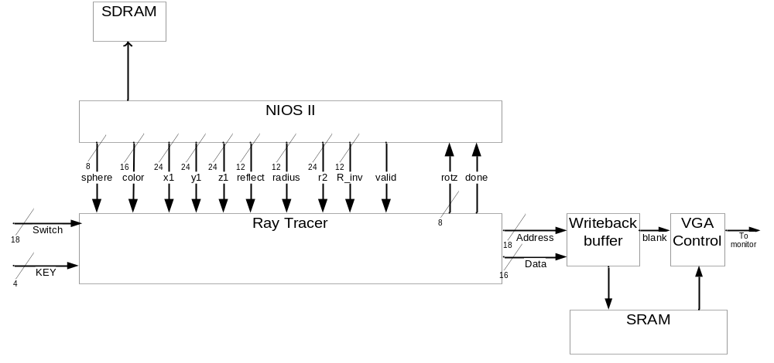
Figure 11

Software Overview
The software running on the NIOS II has three main functions. It stores the list of spheres to the drawn on the screen. Each sphere in the list contains information such as its location, color, velocity, radius, and reflectivity. The original idea of implementing the NIOS II processor is simply to be able to store large number of spheres and polygons on the DRAM without writing a separate memory controller. Putting the scene object list on the DRAM frees up the SRAM for the VGA memory. However as we soon discovered that at the current speed and number of logic elements available on the DE2 board, implementing a large number of spheres is simply not realistic. The frame rate decreases drastically with sphere numbers passing 10. Instead of being used as a sophiscated DRAM controller the NIOS II processor is used to implement motion and camera rotation in the scene, which are the two other main functions of the software.

The motion function updates the current location for each sphere by its current velocity. It also performs boundary and collision detection with other spheres. The boundary detection is fairly straight forward. Once a sphere’s new location (x, y, or z) is found to be outside of the predefined bounding box, the sphere’s velocity that is normal to the plane of the bounding box will be sign reversed. This new velocity is used to calculate the next location for that sphere. To avoid capture of a wall, the sphere that has breached a boundary is always first reset to the boundary before the velocity is sign reversed.

The second feature of the motion function is collision detection with other spheres. A collision between two spheres happens when the distance between their centers is less that the sum of their radius. The direction of motion of the bounced sphere is going to be decided by the vector that is normal to both sphere’s surfaces and pass through the point of contact. This normal is the line that connects the two spheres centers. A 2-D sphere collision algorithm is used to expand to work on a 3-D scale. The sphere collision detection becomes very computationally intensive as the number of spheres increases, since every sphere in the list has to check against every other spheres for a potnetial bounce.

Sometimes instead of bouncing off each other two spheres would capture each other. This happens when two spheres don’t have enough velocity to escape each other after their initial collision, during this time it would mistakenly register a second collision, thus reversing the velocity vector so the two spheres would be going toward each other again. The solution for this is to keep an individual counter for each sphere. Every time a collision occurs the counter is reset to its maxim value, and it is decremented once every time the motion function is called. Until the counter reaches zero again there will be no further collision detection for that sphere. The reset value for the counter is depended on the magnitude of the current velocity; the higher the velocity the smaller the counter reset value.

The rotation function rotates all the spheres in the list about x, y, or z axis by a fixed radians every frame. The rotation is always revolving around the center (0, 0, 0) in space. The direction of rotation is controlled by switches 17 to 6 on the DE2 board, with each pair of two neighboring switches controlling one of the six possible rotation directions (x, y, z with clockwise and counter clockwise directions). Each rotation is simply a 3-D coordinates transformation with a fixed angle.

All the location calculations in software are done in floating point, and whenever the data is ready to be send to the hardware, the result is converted to integers by multiplying the correct two’s power.

SOPC builder specs
We used the highest level NIOS II/f CPU available to us to be able to send the sphere list as fast as possible. The CPU runs at 50Mhz, and has a 1KB instruction cache and 8KB data cache with a line size of 16 Bytes. The data cache is big enough to hold all our sphere data so the CPU doesn’t have to go to DRAM all the time. The CPU also has a floating point unit for the floating point calculations in the software. Logic elements were used for hardware multiply. The performance of this processor is up to 51 DMIPS.

Results

Design Difficulties
Our biggest design challenge turned out to be signed arithmetic. We found that we had to explicitly manage the signs of operands in multiplications by making both operands positive, multiplying, and then fixing the resultant’s sign if necessary. Also, we found that the arithmetic shift operator ‘>>>’ didn’t always work as expected. Compile times at the end of the project were approaching half an hour which made debugging very difficult. Meeting the clock cycle timing requirements while trying to pack as many calculations as possible into a given state was also tricky at times. Debugging on a per pixel basis was also impossible once a large number of spheres, shadows, and reflections were added so we had to rely on mostly the VGA output to see if our changes were correct. Also, occasionally toggling one of the input switches, the state machine would jump to a state that it was never designed to reach. To solve this, we simply made any unused state return to the initial state for the ray.

On the software side one of the biggest problems is timing and handshaking between the hardware and software. Problems include assigning the spheres data to the wrong sphere registers, or cutting off the first or the last sphere due to timing problem. These problems are all fixed when we handed over the control of the interface to the software. The software would tell the hardware when the data is valid and which sphere register it should be storing the data to.

Statstical Analysis of Ray Tracer
This section presents some of the performance stats of our ray tracer. A total of 17 scenes were drawn to show the speed of the ray tracers in term of rays per second and frames per second. These 17 scenes include four configurations for four different scenes which all have resolution 512x480, and a best case performance (a low resolution scene 320X240 with no features turned on). Also note that the following time does not include the time the hardware waits for the software to sends the sphere list.
 |  | Rays per frame | cycles (25MHz)/frame | rays/sec | frames/sec
Image 1 | simple | 277,814 | 12,662,119 | 548,514 | 1.974
8 Spheres | full reflection | 310,175 | 14,003,794 | 553,734 | 1.785
no plane | full anti aliasing | 2,500,295 | 113,981,083 | 548,401 | 0.219
 | full AA + reflection | 2,792,565 | 126,094,828 | 553,664 | 0.198
Image 1 | simple | 490,699 | 22,300,008 | 550,111 | 1.121
8 Spheres | full reflection | 1,802,813 | 78,305,473 | 575,571 | 0.319
4 planes | full anti aliasing | 4,413,303 | 200,596,329 | 550,023 | 0.125
 | full AA + reflection | 16,213,574 | 704,338,405 | 575,489 | 0.035
Image 2 | simple | 353,528 | 22,544,244 | 392,038 | 1.109
8 Spheres | full reflection | 547,627 | 33,850,568 | 404,444 | 0.739
no planes | full anti aliasing | 3,182,440 | 203,017,700 | 391,892 | 0.123
 | full AA + reflection | 4,929,447 | 304,791,218 | 404,330 | 0.082
Image 2 | simple | 492,358 | 28,868,738 | 426,376 | 0.866
8 Spheres | full reflection | 1,804,498 | 102,301,169 | 440,977 | 0.244
4 planes | full anti aliasing | 4,428,189 | 259,797,987 | 426,118 | 0.096
 | full AA + reflection | 16,225,005 | 920,108,168 | 440,845 | 0.027
best case |  | 108,422 | 4,678,168 | 579,404 | 5.344

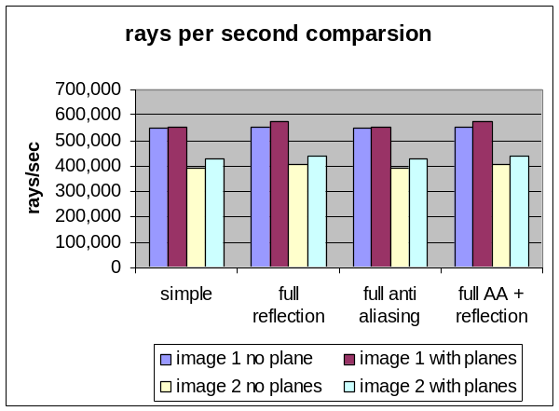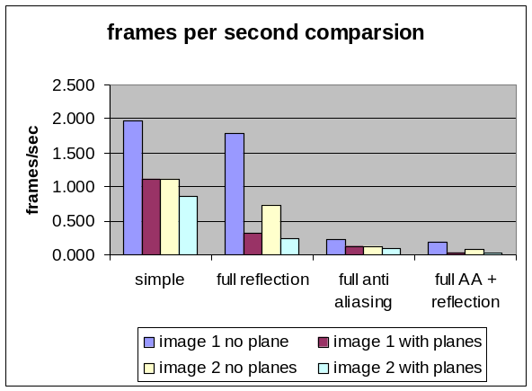
Figure 12

The number of rays per second varied between 440,000 to 540,000 depending on the specific scene. As expected the number of spheres and planes both have a big impact on the performance of the ray tracer. Certain relationship can be observed from the above graphs. The number of rays per second is more effected by the number of spheres and planes, and less by what features are turned on. On the other hand the frames per second is mostly effected by what features are turned on. For the same scene when both 8 times anti-aliasing and 3 levels of reflection are turned on, the frame rate can have as much as 30 times decrease from the standard case.

Hardware Usage
In the end we had to limit our design due to limited number of logic elements available to us on the DE2 board. The NIOS II CPU uses about 1400-1800 LEs, which leaves us with 33216 LEs for the ray tracer hardware. We had to shrink the size of the number of spheres that can be drawn down to 4 so our design can fit on the FPGA. Below is some stats from the compliation report of our final design.
Family | Cyclone II
Device | EP2C35F672C6
Total Logic Elements | 32529/33216 (98%)
Totla registers | 6348
Total memory bits | 94688 (20%)
Total PLL | 2/4 (50%)

Conclusion
Overall, our ray tracer performed much better than expected. We believe our renderings look very impressive. By using spheres and planes, we can create very impressive scenes, especially with high levels of reflections and anti-aliasing. Because we used nearly every logic element on the FPGA, we were unable to instantiate multiple tracers or pipeline our giant state machine. This severely limited our frame rate; however, drawing a few bouncing spheres on the 320x240 resolution with 4x anti-aliasing and full reflections still ran at a reasonable rate. We felt that adding anti-aliasing, reflections, and planes were a better use of the hardware resources than pipelining our design, and the realistic renderings we were able to produce support this. While the tracer draws slowly on the complicated scenes with many objects, there are no visible artifacts on the screen.

Another feature we tried to add but wasn’t successful was to have the DE2 board interface with a PS/2 mouse, and use the mouse to control the rotation of the camera view instead of using switches. This should have been a very simple design to implement. However the DE2 board and the manual gave conflicting information on whether if it can actually interface with a mouse. When we tried to connect a mouse to the DE2 board it showed no sign of detecting any hardware, while when a keyboard is pluged in it worked fine.

In this lab we learnt a great deal about ray tracing and programing FPGA as well as NIOS II in general. Another important aspect of this project is doing fixed point arthmetic in FPGA. We also pushed the FPGA to its limit as far as number of logic elements go in our final design. There is defintely room to optimiz both for speed and size in our design for future work.

Future Work:
-Add triangular polygon detection to the plane hardware
-Use multiple FPGA’s to increase frame rate
-Pipeline the design on a larger FPGA to increase frame rate

Appendix
Work-breakdown:
Scott: Ray Tracing Hardware (Spheres/Shadows/Reflections/Planes/Anti-aliasing), Sphere/Plane Tables, Square Root Hardware, Write Buffer Hardware, Relevant Report Sections
Donald: NIOSII/SOPC Design, Hardware/Software Interface, Software to Bounce/Move/Rotate Spheres, Hardware Performance Analysis, Software to Write Spheres to Hardware, Relevant Report Sections, Webpage Version of Report

Source Code
Verilog Code
DET2_TOP.v
Div24.v
VGA_Controller.v
Sqrt_fixedpoint.v
VGA_Audio_PLL.v

Header Files
RayTrace.h
VGA_Param.h

NIOSII C Files
Memory.c

Pictures

Reference
[1] Glassner, Andrew “An Introduction to Ray Tracing,” Academic Press, Harcourt Brace Jovanovich Publishers.

[2] Turkowski, Ken “Fixed Point Square Root” Apple Technical Report No. 96, Oct 1994. http://www.worldserver.com/turk/computergraphics/FixedSqrt.pdf

[3] Land, Bruce, “Ball Bouncing Physics” ECE 476 Lab 4.

