ECE 576: Lab 1
1D Cellular Automaton
Dave Drew (djd36), Idan Beck (ib54)

Introduction
The purpose of this lab was to drive the VGA display with the contents of SRAM to display a 1 dimensional cellular automaton (CA) progression over time. Time was represented by the Y axis of the display and the current state of the 1 dimensional CA was displayed along the X axis. The diagram below explains the axis orientations:
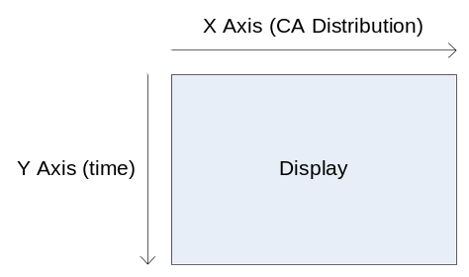
The way this was done was through a design of a State Machine which would initialize SRAM as well as read it to decide what the next generation should look like and then write this generation to SRAM as well. This was done during the sync pulses of the VGA display (both horizontal and vertical). At all other times the SRAM was used to drive the VGA controller and in turn the display. The following block diagram depicts the overall scheme in simplicity.
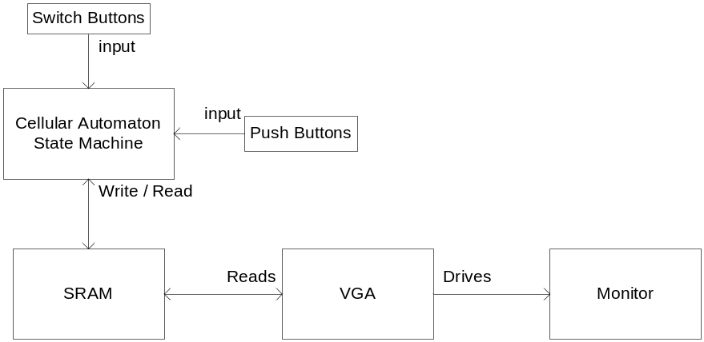

Design
Hardware
The hardware design of this lab consisted of three main components. This was the VGA controller, the SRAM controller, and the State Machine that generated the Cellular Automaton. The random number generation is included in the State Machine section below since it is not used in any other part of the design.
A VGA monitor was hooked up into the FPGA using a standard VGA cable connected to the VGA port on the DE2 development board.
VGA Controller
The VGA controller code was mostly provided to us by Bruce Land and the DE2 default design example. However the use of these modules was a little convoluted in use so we developed a module that wrapped up everything into an easier to use module. This was placed into the VGACNT module which uses a few macros to simplify the DE2 interfaces:
VGA_CLOCKS_DE2 – This wires in the CLOCK_50 and CLOCK_27 for use in the internal modules
VGA_INTERFACE_DE2 – This is the VGA interface for the DE2.
VGA_TD_RESET_DE2 – This is the Television decoder reset which is used to bypress the 27 MHz clock. It’s a little redundant but looks nicer.
For more explaination of how to use the module the VGACNT.v file is heavily documented, including a usage template.
SRAM Controller
The SRAM was implemented through a module named SRAM which was used to bundle together the SRAM interface to let it behave like a more cohesive memory rather than random wires. Some advanced functionality was begun to be implemented with the SRAM_SCREEN_BUFFER which is the file included in the top level file but this is because the SRAM.v file is included in SRAM_SCREEN_BUFFER.v. There is a macro used for simplifying the SRAM interface called SRAM_INTERFACE_DE2 which stays with the VGA macro convention. This convention will continue to be used in future labs as well.
The SRAM_SCREEN_BUFFER module was under development for use with a 640x480 display. However, this was never successfully demonstrated.
Like the VGACNT module the SRAM module’s code contains a usage template that could easily be cut and pasted into a design for rapid development use.

Cellular Automaton State Machine
The state machine consisted of 11 states. Many of these states were used for various side cases such as producing the scroll functionality, and initializing a random vector for the initial CA seed. The below state diagram shows the overall functionality of the machine.
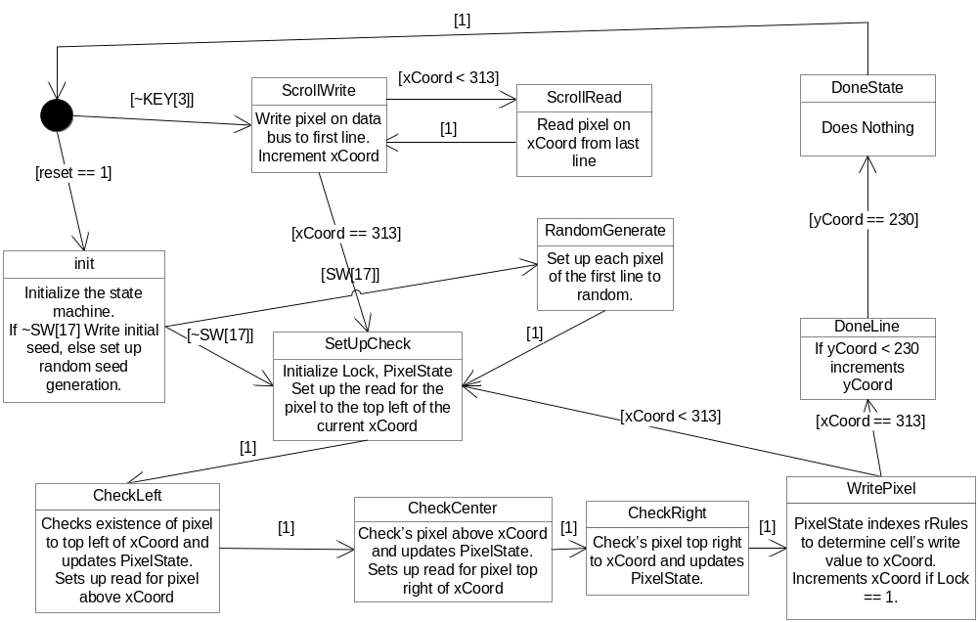
Init – This state initializes the state machine and chooses which state to move into. This is based on the status of SW[17] which determines whether the first line will be a single seed in the middle of the screen or a random vector that is generated by a random number generator.
RandomGenerate – This state generates a series of random numbers to be placed as seed vector at the top of the screen. The random numbers are generated using a 31 bit wide register called RandomGen which is initially set to 0x55555555. Each time a number is used RandomGen is shifted over 1 bit and the missing bit replaced with the evaluation of the expression RandomGen[27] ^ RandomGen[30] (from before the shift). This provides a rather good pseudo random number when only random bit fields are used. For each color we use 4 bits spread through RandomGen.
Notice, however, that RandomGen[30] decides to write a pixel or not, and that the resulting bit written to data_reg[15] is 1 so that we neither write a continuous spectrum of colors (this creates a discrete live or die scheme) and so that when we check the pixels later only data_reg[15] decides if the cell is alive or not. This allows colors to be used but not to affect the functionality of the CA. We also kept the color for appearing too black by forcing the MSB of each color to be 1.
ScrollWrite / ScrollRead – These two states essentially look at the value of the pixel on the bottom line of the display and copy it to the top line. This allows us then to continue the propogation of the CA from the state that it ended on previously to hitting the bottom of the screen. This state is entered at any time by hitting KEY[3] or evaluating ~KEY[3].
SetUpCheck, CheckLeft, CheckCenter, CheckRight – These states set up the appropriate read location of the next check and then check the value of that pixel and update PixelState. SetUpCheck does not update PixelState, but it will initialize it as well as initializing Lock. Lock is an important flag which will tell if the VGA controller hit a sync pulse. If it has during the WritePixel state it will need to throw away the calculations since they may be corrupt and start again from that point.
WritePixel – This is where all of the writing to SRAM occurs. This state will use PixelState as an index for the rRules variable which is set by SW[7..0]. There are 256 rules but there are only 8 switches where each switch refers to a different rule. Since each CA cell can only belong to one rule the PixelState becomes exactly the number of that rule. If the value of rRules[PixelState] == 1 then that rule has been set and we write a pixel to that location using the random number scheme explained above (the number generator is updated every time it is used). The xCoord is then checked to see if we are at the end of a line, if so the state changes to DoneLine otherwise it goes back to SetUpCheck.
DoneLine – This state checks the value of yCoord. If this is equal to the width of the screen it will move on to DoneState if not it will increment yCoord and return to SetUpCheck. This state signifies the completion of a CA time step.
DoneState – This state does nothing, it simply is a place holder and could be eliminated. Once this state is reached the machine is no longer generating the CA. It turns off write to SRAM and stats there. On the state diagram the do nothing state is shown as the black spot. This means once this state is entered any of the valid state transitions can occur from it. It must be understood, however, that once in this state the machine stays in DoneState until it is forced out of it.
Software
This lab consisted of no software design. All functionality was implemented in hardware.

Testing
Hardware
Testing was rather intuitive during this lab because the results were visual and the pixels were rather large since we were using a 320x240 display. This made debugging very easy since we could see glitches and then find where they occurred in the Verilog. We used no external tools other than the DE2 board and a standard VGA color monitor.
Software
This lab consisted of no software design. All functionality was implemented in hardware.

Results and Analysis
Results
Our program successfully computed and displayed a binary, one dimensional, nearest neighbor cellular automata using the DE2 switches to define the rules. The CA was displayed with no flickering or distortion. Both random and non-random initial states worked, as well as KEY3 to display another screen of the CA scrolled down from the final line of the CA. In addition, we implemented a random number generator which was used for random coloring of the CA as well as used to generate a random initial seed vector for the CA to “grow” off of.
Below a few screen captures of the CA is shown
Rule 1:
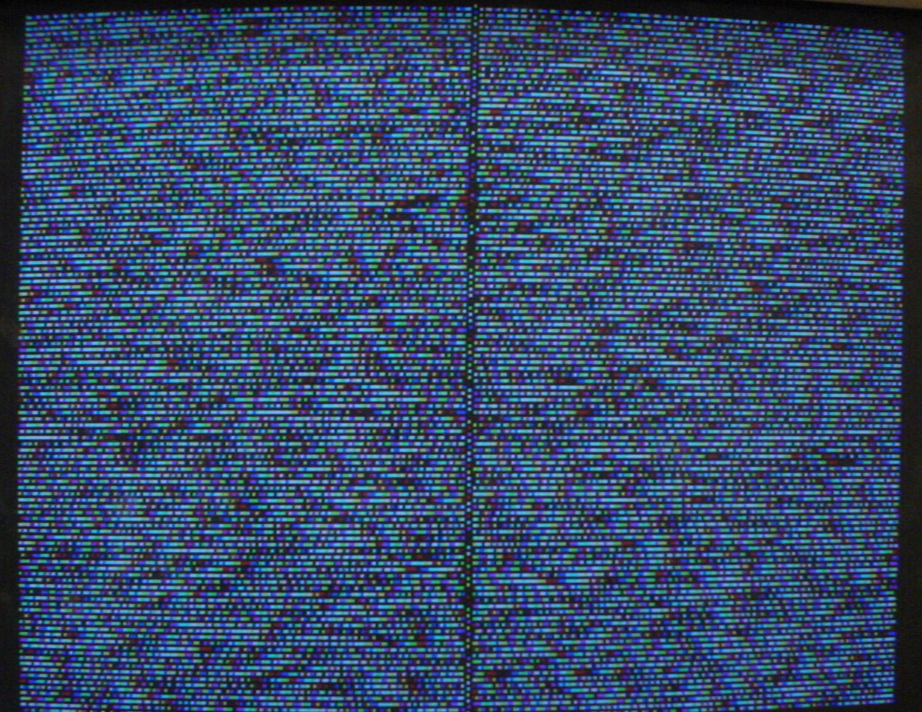

Rule 28:
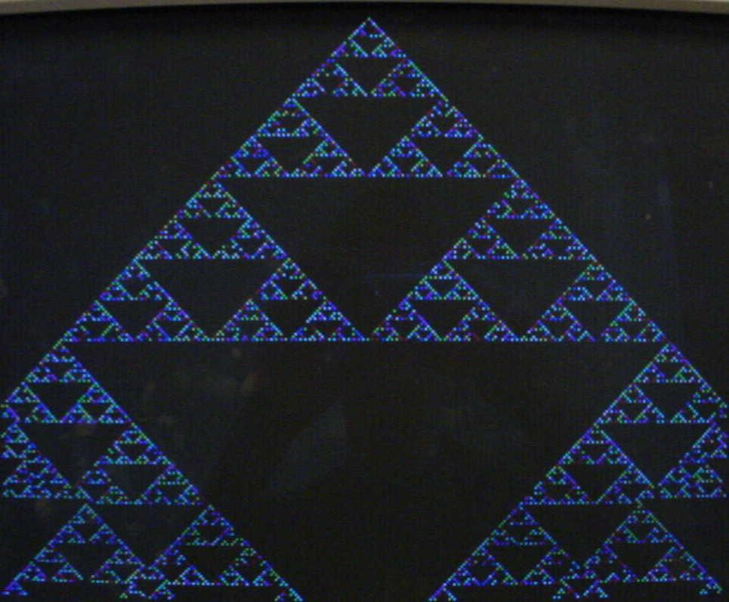
Analysis
Apart from actually ensuring the correct visual functionality there was no other real way to ensure the correct results. A few issues were encountered, however, regarding a few rules. For example, rule 14 should display a triangular-ized line that extends down and to the left forever. Since the monitor is finite it should simply cut off on the left but what happens instead is that the line clips at the left edge and goes straight down. After doing some investigation the reason behind this is due to the cut off where the pixels were not being registered beyond that boundary so the edge case was affecting the CA rules. This was replicated for the complimentary rule that displayed the equivalent CA but that went down and right rather than left.

Conclusion
We were able to complete the lab successfully and learned much about how to use the VGA and SRAM. We saw that by implementing the design with modules, we simplified the code and allowed the modules to be reused in later designs. Our addition of random colors further enhanced the images.
Finally, we learned about cellular automata, and the fascinating they can create. We attempted to push the design towards a higher resolution; although this was not successful for the current lab it paved most of the way for use of this module in future labs. Overall this was a very good lab involving the VGA controller, SRAM and state machines implemented on the FPGA.

