Customer Shopping Behavior Analysis

Abstract
This project analyzes customer shopping behavior to identify patterns based on age, gender, product categories, payment methods, and purchasing trends.
Python, SQL, and Power BI were used to transform raw data into actionable business insights.

Problem Statement
Retail businesses require insights into customer behavior to improve sales performance, customer targeting, and inventory management. This project aims to analyze customer shopping data to support data-driven decision-making.

Dataset Description
The dataset customer_shopping_behavior.csv contains transactional data with customer demographics and purchase details.
Key Columns:
- Customer ID
- Age
- Gender
- Category
- Item Purchased
- Purchase Amount
- Payment Method
- Location
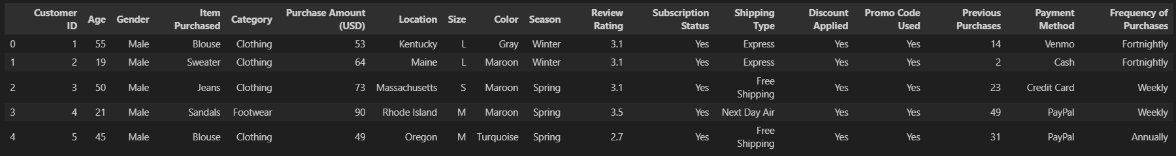

Tools & Technologies Used
- Python (Pandas, NumPy, Matplotlib, Seaborn)
- SQL
- Power BI
- Jupyter Notebook

Data Preprocessing
- Remove Null values
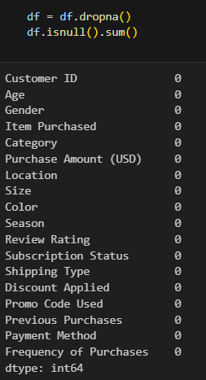
- Standardizing column names
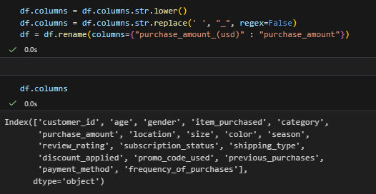

Exploratory Data Analysis (EDA)
EDA was performed to understand customer purchase patterns and trends.
Initial Exploration – Used df.info() to check structure and .describe() for summary statistics.
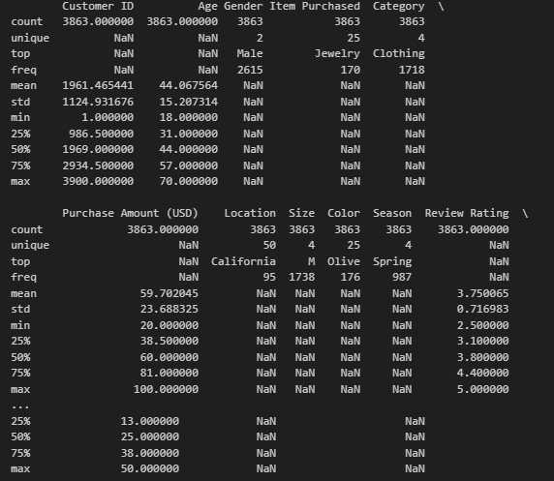

Feature Engineering –
- Created age_group columns by bringing customer ages.
- Created purchase_frequency_days column from purchase data.

Data Consistency Check – Verified if discount_applied and promo_code_used were redundant; dropped promo_code_used .
Database Integrations – Connected Python Scripts to PosterSQL and loaded the cleaned dataframe into the database for SQL analysis.

SQL Analysis
SQL queries were used to derive structured insights from the dataset.
1. Revenue by Gender – Compared total revenue by Male VS Female Customers.
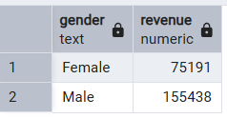
2. High-Spending Discount Users – Identified Customers who used discount but still spent above the purchase amount.
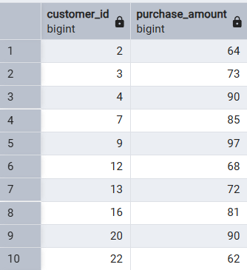
3. Tops 5 Products by Rating-
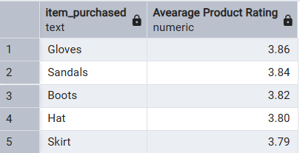

4. Compare the avarage purchase amounts between Standard and Express Shipping
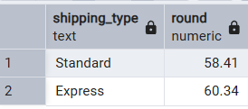
5. subscribers VS non subscribrs - Compare average speed and total revenue between subscribers and non subscribers.
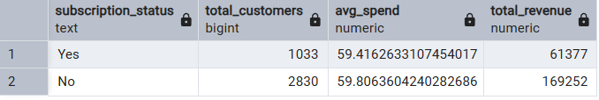

6. Discount-Dependent Products – Identified 5 Products with the highest percentage of Discount purchases.
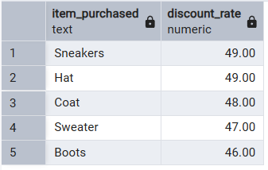

7. Customer Segmentation – Classified Customers into new, returning and loayl based on their purchase history.
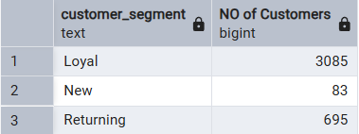

8. Top 3 Products per category - Listed the most purchased products within each category.
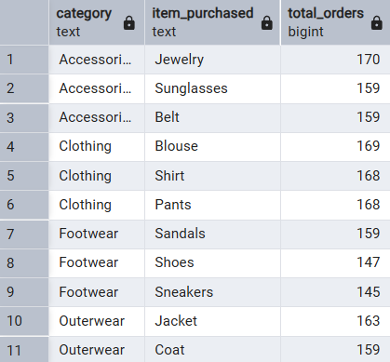

9. Repeat Buyers and Subsribers – Checked whether customers with >5 purchases are more likely to Subsribe.
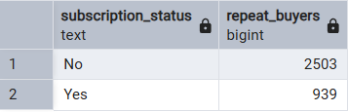

10. Revenue by Age Group - Calculated total revenue contribution of each age group.
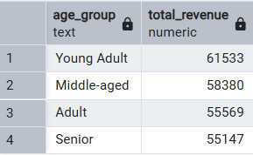

Power BI Dashboard
An interactive Power BI dashboard was created to visualize insights.
Dashboard Includes:
- Revenue by Age Group
- Category-wise Sales
- Gender Distribution
- Payment Method Usage
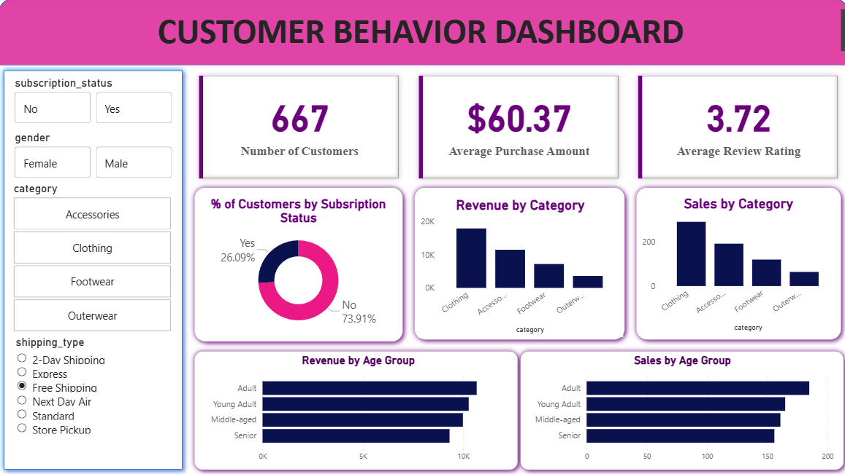
Key Insights
- Middle-aged customers contribute the highest revenue
- Clothing and accessories are top-performing categories
- Digital payment methods are most preferred
- Purchase behavior varies by gender

Business Impact
- Improved customer segmentation
- Better inventory planning
- Enhanced marketing strategies
- Data-driven decision support

Challenges Faced
- Handling categorical variables
- Choosing appropriate visualizations
- Maintaining consistency across tools

Conclusion
This project demonstrates an end-to-end data analytics workflow using Python, SQL, and Power BI to generate meaningful business insights.

Future Scope
- Predictive modeling for customer spending
- Customer segmentation using clustering
- Advanced KPIs and real-time dashboards

