Clustering Analysis

Objective:
The objective of this project is to introduce to various clustering algorithms, including K-Means, hierarchical, and DBSCAN, and provide hands-on experience in applying these techniques to a real-world dataset.
Data Preprocessing:
- Preprocess the dataset to handle missing values, remove outliers, and scale the features if necessary.
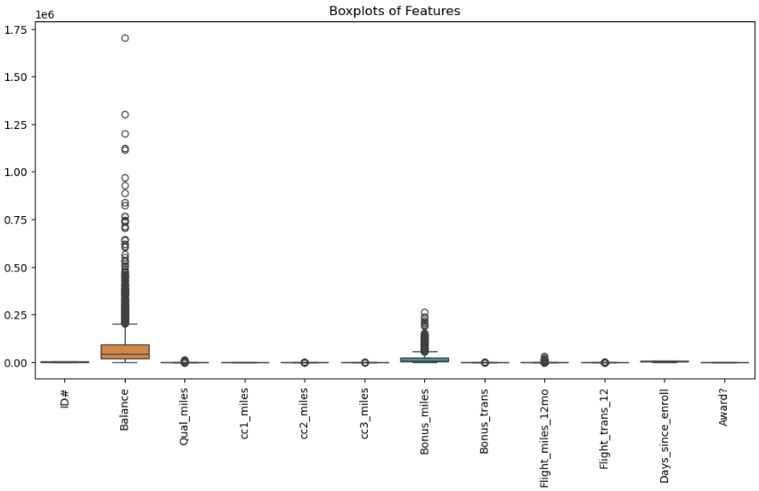

2.Use multiple visualizations to understand the hidden patterns in the dataset
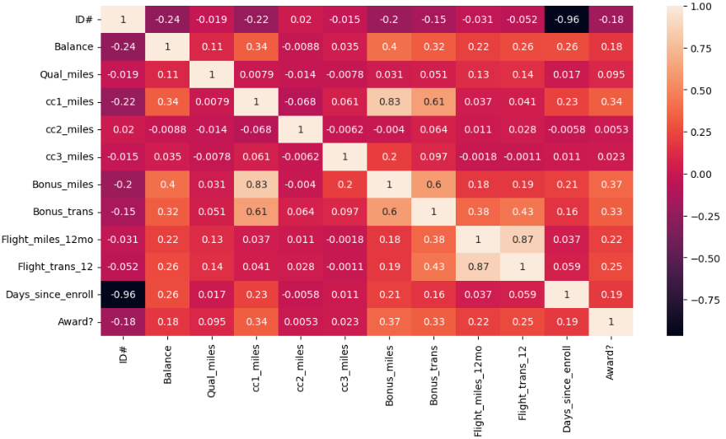
Scatter plot

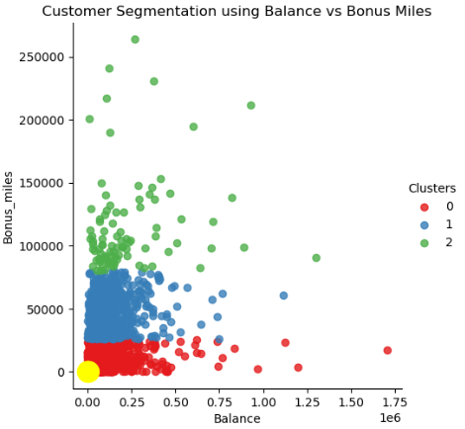

#hierarchical clustering
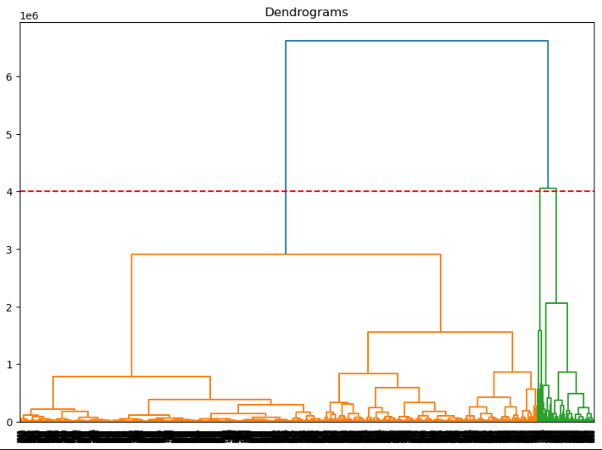

#DBSCAN
