Multiple Linear Regression
In this project we perform multiple linear regression analysis to predict the price of Toyota corolla based on the given attributes.
Dataset Description: The dataset consists of the following variables:
Age: Age in years
KM: Accumulated Kilometers on odometer
FuelType: Fuel Type (Petrol, Diesel, CNG)
HP: Horse Power
Automatic: Automatic ( (Yes=1, No=0)
CC: Cylinder Volume in cubic centimeters
Doors: Number of doors
Weight: Weight in Kilograms
Quarterly_Tax:
Price: Offer Price in EUROs
Taskes: Perform exploratory data analysis (EDA) to gain insights into the dataset. Provide visualizations and summary statistics of the variables. Pre process the data to apply the MLR.
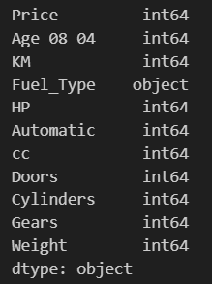
Checking Outliers
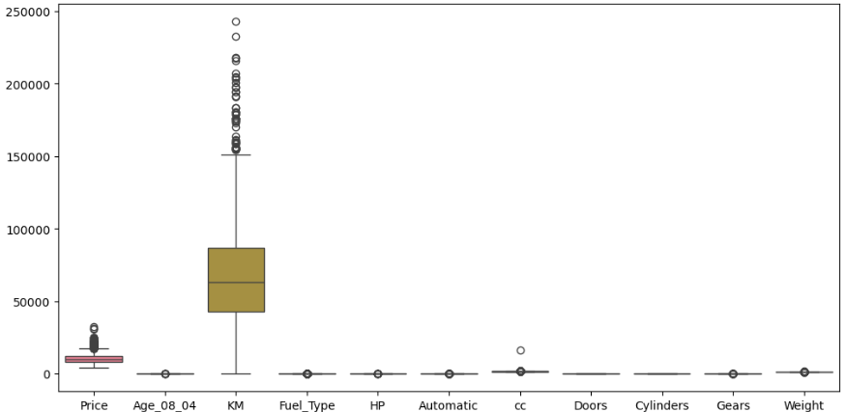

After Removing Outliers
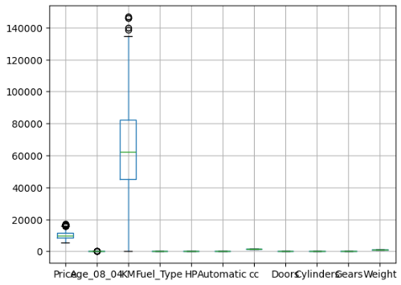

histogram for numerical column to understand the Data
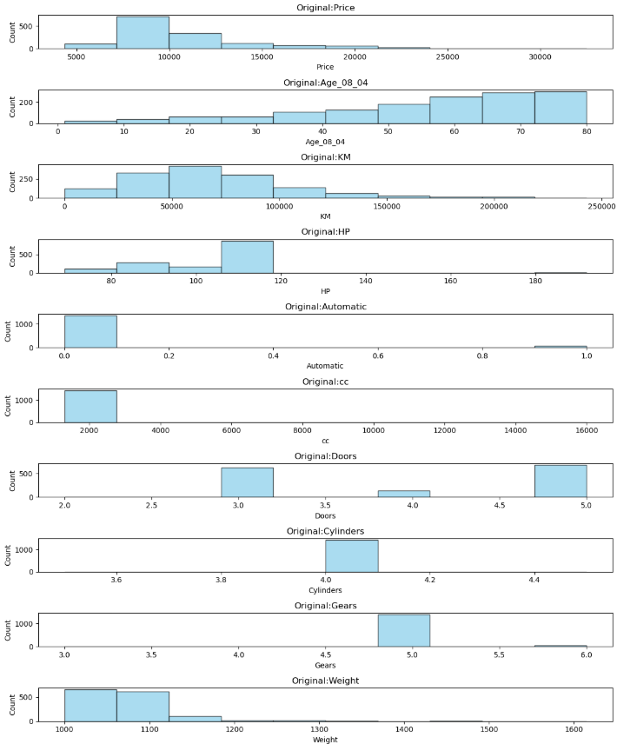

Count plot for Categorical column to understand the Data
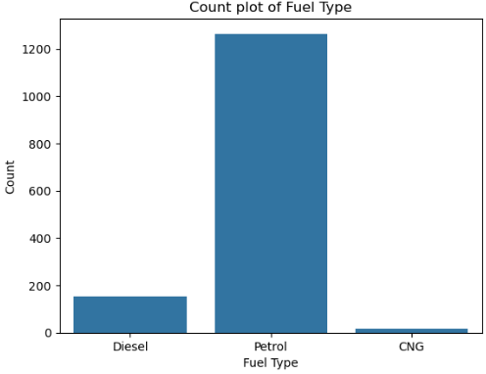
Evaluate the performance of the 3 model using appropriate evaluation metrics on the testing dataset.
