[Insert Karnavati University logo here]
KARNAVATI UNIVERSITY
UNITEDWORLD INSTITUTE OF TECHNOLOGY (UIT)
MINI PROJECT REPORT
ON
“STUDENT LEARNING AGENT: AN AI-ASSISTED PYTHON LEARNING AND ASSESSMENT SYSTEM”
Submitted as a part of the course
AGENTIC AI
Submitted By
Student Name | Enrollment No.
[Your Full Name] | [Your Enrollment Number]
Program: B.Tech CSE / B.Tech CSE-AIML
Semester: [Enter Your Actual Semester]
Section: [Enter Your Section]
Under the Guidance of
[Faculty Guide’s Name]
[Faculty Guide’s Designation]
Department of Computer Science & Information Technology
UnitedWorld Institute of Technology
Karnavati University, Gandhinagar, Gujarat
Academic Year: 2026–27

CERTIFICATE
This is to certify that the mini project entitled “Student Learning Agent: An AI-Assisted Python Learning and Assessment System” has been completed by the following student(s) of B.Tech [CSE/CSE-AIML], Karnavati University, as a part of the course Agentic AI during the academic year 2026–27.
Sr. No. | Student Name | Enrollment No.
1 | [Your Full Name] | [Your Enrollment Number]

The project has been carried out under the guidance and supervision of the faculty member. The work presented in this report describes the implementation developed for the mini project.
Faculty Guide
Name: [Faculty Guide’s Name]
Signature: ____________________
Date: _________________________

DECLARATION
I hereby declare that the mini project entitled “Student Learning Agent: An AI-Assisted Python Learning and Assessment System”, submitted as part of the course Agentic AI, is my original work carried out under the guidance of the faculty member.
I further declare that this work has not been submitted previously to any other institution or university for the award of any degree, diploma, or academic certification. The external resources, documentation, APIs, frameworks, and libraries used during the development of this project have been acknowledged in the references.
Sr. No. | Student Name | Enrollment No.
1 | [Your Full Name] | [Your Enrollment Number]
Date: ____________________
Place: Gandhinagar

ACKNOWLEDGEMENT
I would like to express my sincere gratitude to my faculty guide, [Faculty Guide’s Name], for the guidance and support provided during the development of this mini project. Their suggestions helped me understand the practical application of Artificial Intelligence and Agentic AI concepts.
I am thankful to the Department of Computer Science and Information Technology, UnitedWorld Institute of Technology, Karnavati University, for providing the opportunity to work on this project as part of the Agentic AI course.
I also acknowledge the developers and documentation teams of Python, Streamlit, and Google Gemini for providing the technologies and resources used to develop the application.
This project helped me understand how a generative AI model can be integrated into a web-based learning application and combined with rule-based assessment logic. I also gained practical experience in designing a user interface, managing conversation context, processing quiz responses, calculating scores, handling API errors, and presenting learning recommendations.
Finally, I am grateful to everyone who supported and encouraged me during the completion of this project.

ABSTRACT
Learning programming requires students to understand concepts, practise examples, evaluate their knowledge, and identify topics that need revision. Traditional learning resources provide explanations and exercises, but students may need additional assistance when they have questions or want immediate feedback on their understanding.
The Student Learning Agent: An AI-Assisted Python Learning and Assessment System is a web-based application developed using Python and Streamlit. It integrates the Google Gemini API to provide a conversational assistant for learning Python concepts. The assistant is instructed to explain concepts in simple English and, where appropriate, provide definitions, short code examples, expected outputs, and explanations. The application maintains recent conversation context using Streamlit session state so that follow-up questions can refer to earlier messages.
The system also contains a Python knowledge quiz with five predefined multiple-choice questions covering functions, data types, loops, syntax, and conditions. Users can attempt the complete quiz or select an individual topic. After submission, the application calculates the score and percentage, displays feedback for each answer, recommends a difficulty level based on score thresholds, and identifies a topic for revision from incorrect answers.
The application uses Python, Streamlit, the google-genai library, and python-dotenv. Its assessment and recommendation logic is rule-based, while the conversational explanations are generated by the Gemini model. The project demonstrates a practical combination of generative AI, session-based conversational context, and deterministic assessment logic. It is a learning-assistance prototype rather than a fully autonomous multi-agent system.
Keywords: Agentic AI, Generative AI, Python Learning, Gemini API, Streamlit, Conversational Memory, Quiz Assessment.
TABLE OF CONTENTS

LIST OF FIGURES
Figure 1: Overall System Architecture
Figure 2: Student Learning Agent Workflow
Figure 3: Project Structure
Figure 4: Application Home Page
Figure 5: AI Learning Assistant
Figure 6: Python Knowledge Quiz
Figure 7: Quiz Results and Recommendations
Figure 8: AI Learning Assistant Output
Figure 9: Quiz Assessment Results
Figure 10: Recommended Difficulty
Figure 11: Revision Topic Recommendation

LIST OF TABLES
Table 1: Comparison of a Basic Learning Approach and the Proposed Application
Table 2: Hardware Requirements
Table 3: Software Requirements
Table 4: Component Responsibilities
Table 5: Predefined Quiz Questions
Table 6: Score-Based Difficulty Recommendations
Table 7: Test Cases
Table 8: Performance Evaluation
Table 9: Additional Screenshots
Table 10: Sample Prompts
Table 11: Quiz Answer Key

CHAPTER 1 – INTRODUCTION

1.1 Introduction
Artificial Intelligence (AI) refers to techniques that enable computer systems to perform tasks such as understanding language, recognizing patterns, solving problems, and generating responses. Generative AI is a branch of AI that can generate content such as text, code, images, and other outputs based on user input.
Agentic AI refers to systems that use AI capabilities to work toward objectives through actions, decisions, and interactions with their environment. The level of autonomy differs between systems. Some systems independently plan and execute multiple steps, while others combine an AI model with predefined functions and decision rules.
The Student Learning Agent is a web-based Python learning and assessment application. It combines a Gemini-powered conversational tutor with a predefined quiz and rule-based recommendations. Students can ask questions about Python, review explanations, test their knowledge, and identify topics that require further practice.
The project uses generative AI for explanations and conventional Python logic for quiz evaluation. It demonstrates an AI-assisted educational workflow without claiming the capabilities of a fully autonomous agent.

1.2 Background
Python is widely used in programming education because its syntax is comparatively readable and it supports a broad range of applications. Beginners commonly study variables, data types, conditions, loops, functions, and other fundamental concepts.
While studying these topics, learners may need explanations in simpler language, short examples, and clarification of earlier answers. They may also need a way to assess their understanding and decide what to revise next.
The Student Learning Agent addresses these needs through two connected features:
- An AI Learning Assistant that generates explanations using the Gemini API.
- A Python Knowledge Quiz that checks answers and provides score-based feedback and revision recommendations.
The application presents these features in a single Streamlit interface.

1.3 Problem Statement
Students learning Python may find it difficult to obtain immediate explanations suited to their questions and to identify their weak topics after practising programming concepts. A separate learning resource and assessment process may require students to switch between different tools.
Therefore, there is a need for a simple application that combines conversational Python assistance, basic knowledge assessment, immediate feedback, and rule-based revision recommendations in one interface.

1.4 Motivation
The project was selected to explore the practical use of generative AI in programming education. It also provides an opportunity to integrate an external AI API with a Python web application. The main motivations are:
- To make Python explanations accessible through a conversational interface.
- To provide code examples and expected outputs where appropriate.
- To support follow-up questions through recent conversation context.
- To allow students to practise Python fundamentals through a quiz.
- To give immediate feedback on quiz answers.
- To recommend a revision topic and a difficulty level based on quiz performance.
The intended users are students who are learning Python fundamentals and want a simple tool for explanations and self-assessment.

1.5 Objectives
The objectives of the project are:
- To develop a web-based Python learning application using Streamlit.
- To integrate the Google Gemini API for generating Python explanations.
- To maintain recent conversational context during a session.
- To implement a topic-filtered, multiple-choice Python quiz.
- To calculate quiz scores and display answer-wise feedback.
- To recommend difficulty levels and revision topics using predefined rules.
- To handle missing configuration, unsuccessful API requests, and empty AI responses.
- To evaluate the application using test cases and actual outputs.

1.6 Scope of the Project
The current project includes:
- A Streamlit interface with custom styling.
- A conversational Python tutor powered by the Gemini API.
- Instructions for simple explanations, code examples, and expected outputs.
- Session-based conversation history and a clear-conversation option.
- Five predefined quiz questions covering functions, data types, loops, syntax, and conditions.
- A topic filter for the quiz.
- Score calculation, percentage display, and answer feedback.
- Rule-based Easy, Medium, and Hard difficulty recommendations.
- Revision recommendations based on incorrect answers.
- Basic error handling for API initialization and response failures.
The scope is limited to the implemented prototype. The system does not use a vector database, retrieval-augmented generation (RAG), a trained machine-learning model for difficulty prediction, a permanent learning-history database, or multiple collaborating agents. These are not part of the current implementation.

CHAPTER 2 – LITERATURE REVIEW

2.1 Existing Technologies and Related Systems
The project uses existing technologies to provide AI-assisted explanations and a browser-based user interface. This section reviews the technologies relevant to the implementation.

2.1.1 Generative AI and Large Language Models
Generative AI systems can produce natural-language responses based on prompts. Large language models can explain concepts, generate examples, and respond to follow-up questions. Their responses depend on the model, prompt, and available context; they may sometimes contain inaccurate information.
In this project, the Gemini model is used to generate Python learning explanations. A prompt specifies the expected teaching style and requests definitions, short code examples, expected output, and explanations where appropriate.

2.1.2 Google Gemini API
The Google Gemini API allows applications to send content to a supported generative model and receive generated responses. The project uses the google-genai Python library to initialize a client and request generated content from the model named gemini-flash-latest.
The application sends the student’s question together with recent conversation context. The returned text is displayed in the Streamlit interface. Successful operation depends on valid API configuration, network access, and model availability.

2.1.3 Streamlit
Streamlit is a Python framework for building interactive data and AI applications. It provides components for text input, forms, buttons, messages, selection controls, metrics, and layout.
The project uses Streamlit to build the complete user interface. It displays the learning assistant, maintains session state, accepts quiz answers, and presents assessment results without requiring a separate frontend framework.

2.1.4 Python Libraries and Configuration
Python provides the application logic for processing quiz answers, calculating percentages, counting incorrect topics, and selecting recommendation categories.
The python-dotenv library loads configuration values from a .env file. The google-genai library provides access to the Gemini API. These components support the application’s AI and configuration requirements.

2.2 Comparative Analysis
Table 1 compares a basic learning approach with the proposed application.
Table 1: Comparison of a Basic Learning Approach and the Proposed Application
Feature | Basic Learning Resources | Proposed Student Learning Agent
Access to explanations | Depends on the resource | Conversational AI explanations
Follow-up questions | May require manual searching | Recent session context is included in prompts
Code examples | Depends on the learning material | Requested through the tutor prompt
Knowledge assessment | May use separate exercises | Built-in five-question quiz
Answer feedback | Depends on the resource | Correct/incorrect feedback is displayed
Difficulty recommendation | May be decided manually | Selected through score thresholds
Weak-topic recommendation | May require self-review | Derived from incorrect quiz answers
Permanent learning history | Depends on the resource | Not implemented in the current version
RAG and vector search | Depends on the resource | Not implemented
Multi-agent collaboration | Depends on the system | Not implemented

The proposed application combines several basic learning functions in one interface. Its advantage is the integration of AI explanations with deterministic quiz feedback. However, it is a limited prototype and does not replace a complete learning management system or a comprehensive Python curriculum.

2.3 Research Gap
A basic learning resource may explain programming concepts without considering the student’s immediate question. A quiz may assess knowledge without providing a conversational explanation in the same interface.
The project addresses this practical gap by combining a conversational Python tutor and a small quiz-based assessment feature. The application also recommends a difficulty category and a revision topic after the quiz.
The implementation does not attempt to solve every limitation of existing educational systems. In particular, it does not maintain permanent student profiles, analyse long-term learning progress, retrieve answers from a curated knowledge base, or autonomously generate and execute a personalized learning plan.
The project should therefore be understood as a lightweight AI-assisted learning and assessment prototype.

CHAPTER 3 – PROPOSED SYSTEM

3.1 Proposed Solution
The proposed system is a Streamlit web application named Student Learning Agent. It combines an AI Learning Assistant and a Python Knowledge Quiz.
The AI assistant accepts a student’s Python question and sends it to the Gemini model along with recent conversation context. The model generates a response according to the instructions in the prompt. The application displays the response and stores the question and answer in session state.
The quiz contains five predefined multiple-choice questions. Students can choose all topics or select a specific topic. After submission, the application compares the selected answers with the predefined correct answers, calculates the score and percentage, and displays feedback.
A rule-based decision process then recommends a difficulty level:
- Easy: percentage below 40%.
- Medium: percentage from 40% to below 80%.
- Hard: percentage of 80% or above.
The system also counts the topics associated with incorrect answers and recommends a topic for revision. If all questions are answered correctly, it suggests attempting a more advanced quiz.
The overall workflow is a combination of generative AI and deterministic Python logic. It does not involve an independent planning module or autonomous multi-step tool execution.

3.2 System Requirements

3.2.1 Hardware Requirements
Table 2 lists the hardware requirements.
Table 2: Hardware Requirements
Component | Requirement
Processor | A computer capable of running Python and a web browser
RAM | Sufficient memory to run the operating system, Python, and Streamlit
Storage | Space for Python, project files, and required packages
GPU | Not specifically required by the application; generation is performed through the external Gemini API
Internet Connection | Required for Gemini API requests

Exact minimum hardware specifications were not benchmarked for this project.

3.2.2 Software Requirements
Table 3 lists the software and technologies used.
Table 3: Software Requirements
Software / Technology | Purpose
Python | Application logic
Streamlit | Web interface and session state
google-genai | Gemini API client
python-dotenv | Loading the API key from .env
Google Gemini API | Generating AI tutor responses
Web browser | Accessing the Streamlit application
Code editor or IDE | Editing and running the Python source code

Installed versions: Python [version], Streamlit [version], google-genai [version], python-dotenv [version].

3.3 Functional Requirements
The system must be able to:
- Display the Student Learning Agent interface.
- Accept a Python question from the user.
- Send the question and recent context to the Gemini API.
- Display a generated response when a valid response is returned.
- Maintain recent conversation messages during the session.
- Clear the stored conversation when the user selects the clear option.
- Display the predefined Python quiz.
- Allow selection of all quiz topics or one topic.
- Evaluate submitted answers and calculate the score and percentage.
- Display correct and incorrect answer feedback.
- Recommend a difficulty level using the configured score thresholds.
- Recommend a topic for revision based on incorrect answers.
- Display an appropriate message when AI configuration or response generation fails.

3.4 Non-Functional Requirements

Usability
The interface should present the learning assistant and quiz in a clear format. Input controls, feedback messages, score metrics, and recommendations should be easy to identify.

Reliability
The application includes checks for missing user questions, unavailable Gemini client initialization, API exceptions, and empty generated responses.

Performance
The application depends on the response time of the external Gemini service and the local execution of Python logic. No formal performance benchmark has been completed in this report.

Security
The API key is read from an environment variable named GEMINI_API_KEY, loaded from a .env file. The key should not be written directly into source code, screenshots, or the submitted report.

Maintainability
The current implementation is contained in app.py. The quiz questions, prompt, styling, and assessment rules can be reviewed and modified in the source code. For a larger system, separating these components into modules would improve maintainability.

CHAPTER 4 – SYSTEM ARCHITECTURE

4.1 Overall System Architecture
The system uses a single Streamlit application to coordinate user interaction, AI responses, conversation context, quiz assessment, and recommendations. Figure 1 shows the architecture.
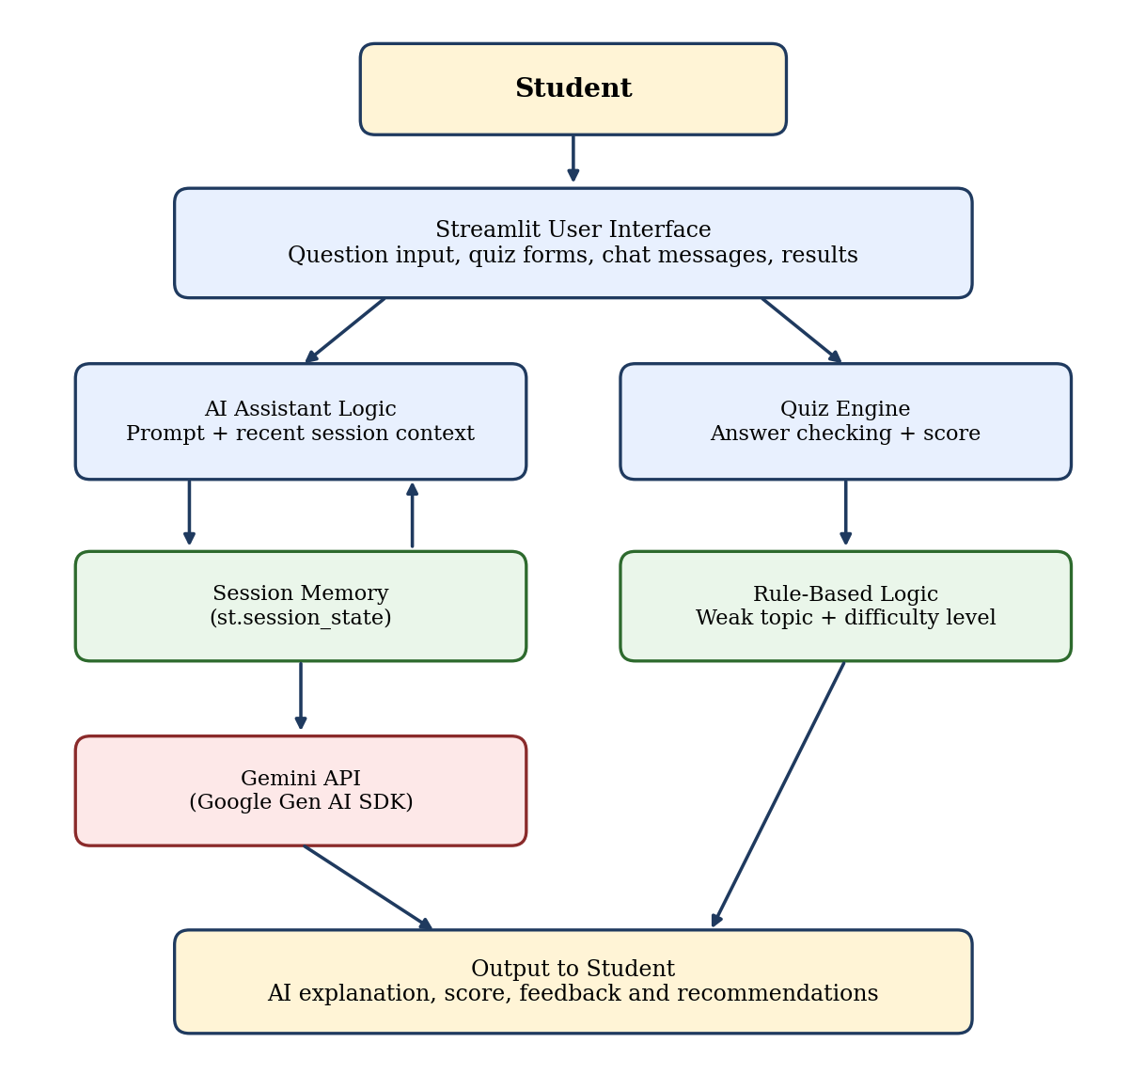
Figure 1: Overall System Architecture
The architecture has two primary functional paths. The first path uses the Gemini API to generate conversational explanations. The second path evaluates predefined quiz answers using Python rules. Both paths present their outputs through Streamlit.
The diagram does not include a vector database, RAG pipeline, autonomous planner, or additional agents, because these components are not present in the current source code.

4.2 Architecture Components

4.2.1 User Interface
Streamlit provides the page layout, headings, input form, buttons, chat messages, topic selector, quiz form, result metrics, and feedback messages. Custom CSS styles the background, buttons, headings, input controls, and result sections.

4.2.2 Gemini Client
The application loads the API key using python-dotenv. If the key is available, it attempts to initialize a Gemini client. The client sends the learning prompt to the configured model and receives the generated response.

4.2.3 Prompt Builder
The prompt contains instructions for the AI tutor and the student’s latest question. It also includes recent conversation messages, formatted as student and tutor messages, to provide context for follow-up questions.

4.2.4 Session-Based Conversation Memory
The application stores successful user questions and assistant responses in st.session_state.chat_history. When processing a new question, it includes the latest six stored messages in the prompt. A clear-conversation button resets this list.
This memory is limited to the active Streamlit session and is not a permanent database.

4.2.5 Quiz Evaluator
The quiz evaluator compares each submitted answer with the correct answer defined in the corresponding question record. It increments the score for correct answers and records the topics associated with incorrect answers.

4.2.6 Recommendation Logic
The recommendation logic calculates the percentage and selects a difficulty category using predefined thresholds. It counts incorrect answers by topic and recommends the most frequently occurring topic. If all answers are correct, the system suggests a more advanced quiz.

4.3 Component Roles and Responsibilities
Table 4 summarises the responsibility of each component.
Table 4: Component Responsibilities
Component | Responsibility
Streamlit UI | Accepts input and displays output
Gemini client | Sends prompts to the external model
Prompt builder | Combines tutor instructions, recent context, and the current question
Session state | Stores recent conversation messages
Quiz data | Defines questions, options, answers, and topics
Quiz evaluator | Checks answers and calculates results
Difficulty logic | Maps score percentage to Easy, Medium, or Hard
Topic recommendation logic | Counts topics linked to incorrect answers
Error handling | Displays messages for configuration, API, or empty-response problems

The project uses one application with several functional components. These components should not be described as independent AI agents, because the implementation does not create or coordinate multiple agents.

4.4 System Workflow
Figure 2 shows the workflow of the two features. The sequence of operations is as follows:
- The student opens the Streamlit application.
- The student chooses to use the AI Learning Assistant or the Python Knowledge Quiz.
- For the assistant, the student enters a Python question.
- The application checks that the question is not empty and that the Gemini client is available.
- The application adds recent conversation messages to the prompt.
- The Gemini API generates a response.
- The application displays the response and saves the successful exchange in session state.
- For the quiz, the student selects a topic, chooses answers, and submits the form.
- The application compares the answers with the correct answers.
- The application displays the score, percentage, and answer feedback.
- The application applies the score thresholds and recommends a difficulty level.
- The application identifies a topic for revision or suggests a more advanced quiz if every answer is correct.
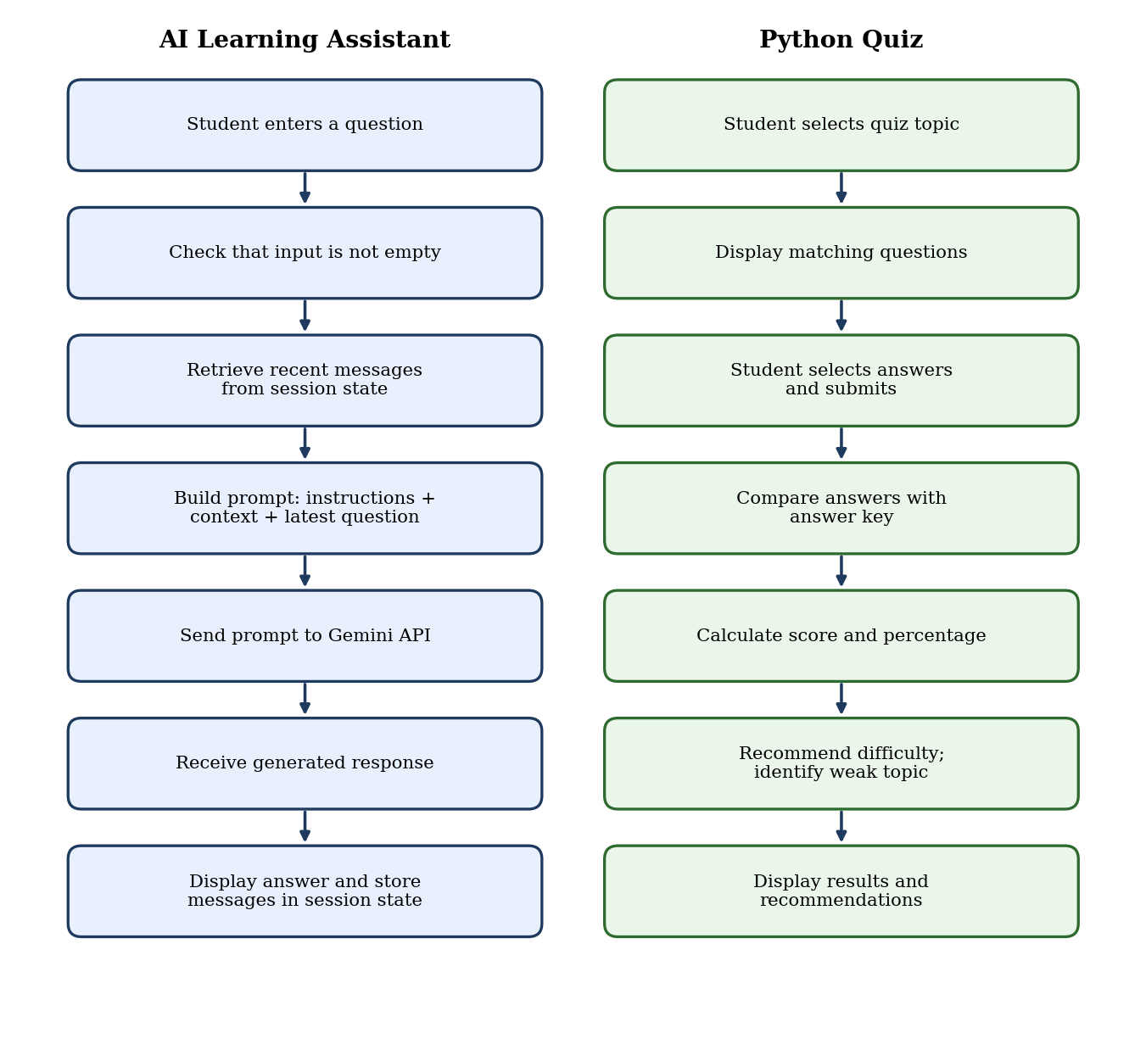
Figure 2: Student Learning Agent Workflow
The two features share the same interface but use different processing mechanisms: API-based generation for tutoring and rule-based evaluation for the quiz.

CHAPTER 5 – AGENTIC AI CONCEPTS USED

5.1 Generative AI and AI-Assisted Interaction
Generative AI is used in the AI Learning Assistant to create natural-language explanations. Instead of relying only on fixed answers, the application sends the user’s question to the Gemini model.
The prompt instructs the model to use simple English, provide definitions, include short Python code examples and expected outputs where appropriate, explain the examples, and use previous conversation details when answering follow-up questions.
The model generates the explanation, while the Streamlit application manages the input, prompt, API request, and display of the response.

5.2 Session-Based Conversational Memory
Conversational memory allows an application to provide previous messages as context for a new request. In this project, the memory is implemented through Streamlit’s session state.
The chat_history list stores successful user and assistant messages. When the student asks a new question, the application selects the most recent six stored messages and includes them in the next prompt. This can help the model interpret follow-up questions.
The clear-conversation button empties the list. The implementation does not save conversation history permanently or retrieve old conversations from a database.

5.3 Rule-Based Decision Making
The assessment and recommendation components use predefined Python rules rather than a trained prediction model.
The difficulty recommendation is based on the quiz percentage. The weak-topic recommendation counts the topics associated with incorrect answers and selects the topic with the highest count.
These rules make the recommendation process straightforward to explain and reproduce. However, they provide only a basic assessment and do not measure a student’s long-term progress or complete understanding of a topic.

5.4 User Interaction and Feedback
The student remains in control of the interaction. The user chooses a question to ask, selects a quiz topic, chooses answers, and submits the quiz.
The application responds with AI-generated explanations or deterministic quiz feedback. It also allows the student to clear the current conversation.
This is a user-driven workflow. The application does not independently decide to launch additional tasks, execute an autonomous study plan, or continue working without user input.

5.5 Concepts Not Implemented
The following concepts are not implemented in the current version and are not presented as completed features:
- ReAct loop: No explicit Reason–Act–Observe agent loop is implemented.
- Autonomous planning: The application does not generate and execute a multi-step plan.
- Tool calling by the AI model: The model is asked to generate explanations; it is not configured to select and invoke external tools.
- Retrieval-Augmented Generation (RAG): There is no document retrieval, embedding generation, or vector database.
- Multi-agent system: No separate planner, researcher, reviewer, or other collaborating AI agents are implemented.
- Long-term memory: Conversation history is not stored in a permanent database.
- Machine-learning-based adaptation: Difficulty selection uses fixed score thresholds, not a trained adaptive-learning model.
- Human approval workflow: There is no separate approval-and-execution process for autonomous actions.
The project demonstrates AI-assisted learning, limited conversational context, and rule-based recommendations. Its agentic scope is accurately described as a lightweight learning-assistance prototype rather than a fully autonomous agent.

CHAPTER 6 – METHODOLOGY

6.1 User Input Processing
The application begins by displaying the main page and its two learning features. The AI assistant accepts a question through a text input form. The quiz provides a topic selector and multiple-choice options.
For the AI assistant, the application checks whether the question is empty. If the input is blank, a warning asks the student to enter a question. If the Gemini client is unavailable, the application displays an error message instead of attempting to generate a response.

6.2 AI Question Processing
When a valid question is submitted and the Gemini client is available, the application builds a prompt containing:
- Instructions for the Python tutor.
- Recent conversation messages.
- The student’s latest question.
The prompt asks for simple explanations and suitable examples. The application sends the prompt to the gemini-flash-latest model using the generate_content method.
If the model returns non-empty text, the response is displayed in the chat interface. If the response is empty, a warning is shown. If the API request fails, an error message asks the student to check connectivity, API access, and model availability.

6.3 Conversation Context Management
The conversation history is initialized in Streamlit session state if it does not already exist. After a successful AI response, the application adds both the student’s question and the assistant’s response to the history.
For the next request, the application includes the most recent six stored messages in the prompt. This is a limited context mechanism intended to support follow-up questions.
When the student clicks the Clear Conversation button, the history list is emptied and the application reruns. This resets the conversation context stored by this feature for the current session.

6.4 Quiz Assessment
The quiz consists of five predefined questions, summarised in Table 5.
Table 5: Predefined Quiz Questions
Topic | Example Question Focus | Correct Answer
Functions | Keyword used to define a function | def
Data Types | Data type that stores key-value pairs | Dictionary
Loops | Loop commonly used to iterate over a list | for
Syntax | Symbol used to start a single-line comment | #
Conditions | Keyword used for another condition after if | elif

The student can choose all topics or one specific topic. The application filters the question list according to the selection.
After the quiz is submitted, each selected answer is compared with the correct answer. Correct answers increase the score, while incorrect answers generate feedback that includes the correct answer. The total number of questions is used to calculate the percentage. The calculation is:
Percentage = (Correct Answers / Total Questions) × 100
The application displays the number of correct answers, incorrect answers, percentage, progress bar, and final score.

6.5 Difficulty and Topic Recommendations
The application maps the score percentage to a difficulty category, as shown in Table 6.
Table 6: Score-Based Difficulty Recommendations
Score Percentage | Recommended Difficulty | Feedback
Below 40% | Easy | Revise the basics and practise easier questions
40% to below 80% | Medium | Strengthen understanding with medium-level practice
80% or above | Hard | Attempt more challenging Python questions

The system also collects the topics associated with incorrect answers. It counts the occurrences of each topic and recommends the topic with the highest count. If all questions are answered correctly, the application displays a message suggesting a more advanced Python quiz.
These recommendations are based on the current quiz attempt. They are not generated from a permanent student profile or a trained model.

6.6 Error Handling
The application includes several checks to make common failures easier to understand:
- A blank AI question produces a warning.
- An unavailable Gemini client produces an error message.
- A client-initialization failure is handled and reported.
- An empty AI response produces a warning.
- An exception during response generation produces an error message and technical details.
- A successful response is added to conversation history only when non-empty text is returned.
These checks improve feedback to the user, although they do not guarantee that every external API or model failure can be resolved automatically.

CHAPTER 7 – IMPLEMENTATION

7.1 Project Structure
The main application is implemented in app.py. The application code contains the interface styling, Gemini client configuration, AI assistant, session-based conversation history, quiz questions, assessment logic, recommendations, and footer.
Student_Learning_Agent/
│
├── app.py
├── .env
└── [Other project files, if present]
Figure 3: Project Structure
The .env file stores the API key locally. It is not uploaded to a public repository or included in screenshots.

7.2 Technologies Used
The project uses the following technologies:
- Python: Implements the application logic, quiz evaluation, and recommendations.
- Streamlit: Builds the interactive web interface and provides session state.
- Google Gemini API: Generates AI tutor responses.
- `google-genai`: Provides the Python client used to communicate with Gemini.
- `python-dotenv`: Loads the API key from environment configuration.
- Custom CSS: Provides styling for the page background, headings, buttons, inputs, metrics, and chat messages.

7.3 AI Learning Assistant Implementation
The application initializes the Gemini client using the API key loaded from the .env file. It uses a tutor prompt to guide the style and content of generated explanations.
The central request sends the constructed prompt to the configured Gemini model. The model response is then checked to ensure that it contains non-empty text before being displayed.
An important part of the prompt is the instruction to explain Python concepts in simple English and, where appropriate, provide a definition, a short code example, expected output, and an explanation.
Code excerpt from the implementation:
response = client.models.generate_content(
model="gemini-flash-latest",
contents=prompt,
config={
"max_output_tokens": 700,
"temperature": 0.3
}
)
This code sends the constructed prompt to the Gemini model. The output-token limit and temperature are configured in the request. The generated response is processed by the surrounding code before being displayed.

7.4 Conversation Memory Implementation
The application initializes conversation history in Streamlit session state:
if "chat_history" not in st.session_state:
st.session_state.chat_history = []
Before making a new request, the application selects recent messages:
previous_messages = st.session_state.chat_history[-6:]
These messages are formatted as student and tutor exchanges and added to the prompt. After a successful non-empty response, the current question and answer are appended to the history.
This approach provides limited conversational continuity during the session. It does not implement permanent storage or a separate memory retrieval service.

7.5 Quiz and Assessment Implementation
The quiz questions are stored as Python dictionaries. Each dictionary includes a question, answer options, correct answer, and topic.
The selected topic determines which questions are displayed. When the user submits the quiz, the application loops through the selected questions and compares the submitted answers with the stored correct answers.
The score percentage is calculated from the number of correct answers and the total number of displayed questions. The result is presented through Streamlit metrics and a progress bar.
The application then uses conditional statements to select a difficulty category. For revision recommendations, it counts the topics associated with incorrect answers and selects the most frequent topic. If no incorrect answers are recorded, it displays a message suggesting a more advanced quiz.
These functions use deterministic rules and do not require a machine-learning training process.

7.6 User Interface
The user interface is built with Streamlit components and custom CSS. The main interface includes:
- A page title and short introduction.
- The AI Learning Assistant section.
- A text input form and Ask AI button.
- Previous chat messages and a Clear Conversation button when history exists.
- The Python Knowledge Quiz section.
- A topic selection control and quiz form.
- Answer feedback, score metrics, and percentage.
- Difficulty and topic recommendations.
- A footer identifying the application.
[Insert an actual screenshot of the running application showing the title and main interface.]
Figure 4: Application Home Page
[Insert an actual screenshot showing a Python question and the generated response.]
Figure 5: AI Learning Assistant
[Insert an actual screenshot showing the topic selector and quiz questions.]
Figure 6: Python Knowledge Quiz
[Insert an actual screenshot showing the score, percentage, recommended difficulty, and revision topic.]
Figure 7: Quiz Results and Recommendations

7.7 Configuration and Execution
The application requires the necessary Python packages and a valid Gemini API key. The API key is loaded from a .env file using the environment variable GEMINI_API_KEY. The actual key must remain private.
After installing the required dependencies and configuring the environment, the application can be started from the project directory using:
python -m streamlit run app.py
The command starts the Streamlit application, which can then be accessed through the local address displayed in the terminal.

CHAPTER 8 – RESULTS, EVALUATION, LIMITATIONS AND CONCLUSION

8.1 Test Cases
Testing verifies that the application accepts inputs, displays expected outputs, evaluates quiz answers, and handles common errors. The test cases in Table 7 are derived from the implemented functionality.
Table 7: Test Cases
Test Case ID | Input / Action | Expected Output | Actual Output | Status
TC01 | Ask the AI assistant, “What is a Python function?” | A generated explanation is displayed if the Gemini service is available | [Fill after testing] | [Pass/Fail]
TC02 | Ask a follow-up question referring to the previous answer | The recent conversation context is included in the new prompt, and a relevant response is attempted | [Fill after testing] | [Pass/Fail]
TC03 | Submit the quiz with known correct and incorrect answers | Correct/incorrect feedback, score, and percentage are displayed | [Fill after testing] | [Pass/Fail]
TC04 | Select one quiz topic instead of all topics | Only the question associated with the selected topic is displayed | [Fill after testing] | [Pass/Fail]
TC05 | Submit a quiz with a score below 40% | Easy difficulty is recommended | [Fill after testing] | [Pass/Fail]
TC06 | Submit a quiz with a score from 40% to below 80% | Medium difficulty is recommended | [Fill after testing] | [Pass/Fail]
TC07 | Submit a quiz with a score of 80% or above | Hard difficulty is recommended | [Fill after testing] | [Pass/Fail]
TC08 | Submit a quiz with all answers correct | A message suggesting a more advanced quiz is displayed | [Fill after testing] | [Pass/Fail]
TC09 | Submit an empty AI question | A warning asks the user to enter a question | [Fill after testing] | [Pass/Fail]
TC10 | Run the application without a usable Gemini configuration | The assistant reports that Gemini is unavailable | [Fill after testing] | [Pass/Fail]

8.2 Sample Outputs

8.2.1 AI Learning Assistant Output
Input: “What is a Python function?”
Expected behavior: The application sends the question to the Gemini API with the tutor instructions. If a valid response is returned, it displays an explanation of Python functions and may include a code example, expected output, and explanation.
Actual output: [Paste a short excerpt from your actual generated response.]
[Insert screenshot of the actual response.]
Figure 8: AI Learning Assistant Output

8.2.2 Quiz Assessment Output
Input: Submit the five-question quiz with a mixture of correct and incorrect answers.
Expected behavior: The application displays feedback for each answer, the number of correct and incorrect answers, the percentage, and the final score.
Actual output: [Record the actual score and feedback displayed during the test.]
[Insert screenshot of the actual quiz result.]
Figure 9: Quiz Assessment Results

8.2.3 Difficulty Recommendation Output
Input: Submit a quiz attempt whose percentage falls within one of the configured difficulty ranges.
Expected behavior: The application recommends Easy, Medium, or Hard according to the score thresholds.
Actual output: [Record the actual percentage and recommendation.]
[Insert screenshot of the actual difficulty recommendation.]
Figure 10: Recommended Difficulty

8.2.4 Weak-Topic Recommendation Output
Input: Submit a quiz with one or more incorrect answers.
Expected behavior: The application counts the topics associated with incorrect answers and recommends the topic with the highest count. If all answers are correct, it suggests attempting a more advanced quiz.
Actual output: [Record the topic recommended during your test, or the all-correct message if applicable.]
[Insert screenshot of the actual recommendation.]
Figure 11: Revision Topic Recommendation

8.3 Performance Evaluation
The application’s functional features are evaluated through observed behavior. Execution time, success rate, and test completion results are recorded from actual runs of the application, as summarised in Table 8.
Table 8: Performance Evaluation
Metric | Evaluation Method | Result
Test Case Success Rate | Passed test cases ÷ total executed test cases × 100 | [Calculate after testing]
AI Response Success | Successful non-empty responses ÷ AI requests tested × 100 | [Measure after testing]
Quiz Evaluation | Compare the displayed score against manually calculated answers | [Record actual result]
Difficulty Selection | Verify recommendations against the configured score thresholds | [Record actual result]
Topic Recommendation | Compare the recommended topic with the topics of incorrect answers | [Record actual result]
Average Response Time | Measure the time taken for multiple AI requests and calculate the average | [Measure if required]

The test case success rate is calculated using:
Test Case Success Rate = (Passed Test Cases / Total Executed Test Cases) × 100
For average response time, the time from submitting a question until the answer is displayed is measured for several requests, and the total measured time is divided by the number of requests.
The result depends partly on the external Gemini service, network conditions, and the selected model. Any reported value should include the testing method and actual observations.

8.4 Challenges and Limitations

8.4.1 External API Dependency
The AI Learning Assistant depends on access to the Gemini API. Missing or invalid configuration, network issues, API access problems, or model availability can prevent a response from being generated. The application includes error messages for several of these conditions.

8.4.2 Generated Response Reliability
The tutor’s explanations are generated by a language model and may not always be fully correct. Students should verify important programming concepts and test code examples rather than assuming every response is accurate.

8.4.3 Limited Conversation Memory
The application includes the latest six stored messages in a new prompt. This provides recent context but does not create a permanent student profile. Older conversation details may not be available to the model when they are excluded from the prompt.

8.4.4 Limited Quiz Coverage
The current quiz contains five predefined questions. It covers only functions, data types, loops, syntax, and conditions. It is not sufficient to measure overall Python proficiency.

8.4.5 Rule-Based Recommendations
Difficulty selection uses fixed percentage thresholds. The topic recommendation is based on the frequency of topics associated with incorrect answers. These rules do not analyse long-term progress, question complexity, or a student’s complete learning history.

8.4.6 No Knowledge Retrieval System
The application does not retrieve explanations from a curated textbook, document collection, or vector database. The AI tutor generates responses from the prompt and the model’s capabilities.

8.4.7 No Autonomous Planning or Multiple Agents
The application does not independently prepare a study plan, coordinate multiple agents, or perform a ReAct cycle. The user initiates questions and quiz attempts, while the application follows its defined processing steps.

8.5 Future Scope
The project can be extended in the following ways:
- Expanded quiz bank: Add more questions covering additional Python concepts and different difficulty levels.
- More detailed assessment: Provide explanations for incorrect answers and link them to learning material.
- Personalized learning history: Add secure database storage for quiz attempts and progress tracking, with suitable privacy controls.
- Improved adaptation: Use more detailed assessment information to recommend practice activities instead of relying only on fixed thresholds.
- Curated learning resources: Add a verified knowledge base and retrieval mechanism if reliable source-grounded explanations are required.
- Study-plan generation: Allow students to define learning goals and create a suggested study schedule.
- Improved error monitoring: Record useful diagnostic information without exposing API keys or other sensitive information.
- Deployment: Deploy the application for broader access with appropriate configuration, security, and usage controls.
These are possible future enhancements and are not implemented in the current version.

8.6 Conclusion
The Student Learning Agent: An AI-Assisted Python Learning and Assessment System was developed as a web-based application to combine conversational Python assistance with basic knowledge assessment. The application uses Python and Streamlit for its interface and processing logic, the Google Gemini API for AI-generated explanations, and python-dotenv for loading the API key from environment configuration.
The AI Learning Assistant accepts Python questions and constructs a prompt containing tutor instructions, the latest question, and recent conversation context. Successful exchanges are stored in Streamlit session state, allowing recent messages to be included in subsequent prompts. The conversation can also be cleared by the user.
The Python Knowledge Quiz contains five predefined multiple-choice questions. It supports topic filtering, evaluates submitted answers, calculates scores and percentages, and displays answer-wise feedback. It also recommends an Easy, Medium, or Hard difficulty category according to predefined score thresholds. The application identifies a topic for revision from incorrect answers or suggests a more advanced quiz when all answers are correct.
The project demonstrates the practical integration of a generative AI API, a Python web interface, session-based conversational context, and rule-based decision logic. It provides a foundation for exploring AI-assisted programming education. At the same time, its limitations must be recognized: the quiz is small, conversation history is not stored permanently, and recommendations are based on simple rules. The application does not implement RAG, autonomous planning, multiple collaborating agents, or a trained adaptive-learning model.
Overall, the project provides a working prototype for conversational Python learning and basic self-assessment. Testing the application with actual inputs, documenting screenshots, and recording measured results are necessary to evaluate its behavior and reliability more completely.

REFERENCES
[1] Streamlit, “Streamlit Documentation.” Available: https://docs.streamlit.io/
[2] Google, “Gemini API Documentation.” Available: https://ai.google.dev/gemini-api/docs
[3] Google, “Google Gen AI Python SDK.” Available: https://github.com/googleapis/python-genai
[4] Python Software Foundation, “Python Documentation.” Available: https://docs.python.org/3/
[5] Theskumar, “python-dotenv Documentation.” Available: https://github.com/theskumar/python-dotenv

APPENDIX A – SOURCE CODE AND REPOSITORY DETAILS
Main source file: app.py
GitHub Repository: [Insert the repository link if one exists]
Deployed Application: [Insert the deployed link if one exists]
The main source code contains the Streamlit interface, Gemini API initialization, AI tutor prompt, session-based conversation history, quiz question data, answer evaluation, difficulty selection, topic recommendation, and error handling.
The complete source code is submitted separately or included according to the faculty’s instructions. Only important excerpts appear in the main chapters.
API key security: The actual .env file and API key are not included in the report, screenshots, or a public repository.

APPENDIX B – ADDITIONAL SCREENSHOTS
This appendix contains additional screenshots that support the description of the implemented system.
Table 9: Additional Screenshots
Screenshot No. | Description | Screenshot
B1 | Application landing page | [Insert actual screenshot]
B2 | Follow-up question using recent context | [Insert actual screenshot]
B3 | Clear Conversation button or cleared state | [Insert actual screenshot]
B4 | Topic-filtered quiz | [Insert actual screenshot]
B5 | Correct and incorrect answer feedback | [Insert actual screenshot]
B6 | API configuration or error-handling message | [Insert actual screenshot]

APPENDIX C – SAMPLE PROMPTS
The following are representative examples of how the application can be used.
Table 10: Sample Prompts
Sr. No. | Sample Prompt | Purpose
1 | What is a Python function? | Test the AI tutor’s explanation of a basic Python concept
2 | Give a short Python code example with its expected output. | Test the tutor’s code-example instructions
3 | Explain the previous example in simpler words. | Test follow-up interaction using recent conversation context

APPENDIX D – TEST DATA
The answer key in Table 11 is used to verify the five predefined quiz questions.
Table 11: Quiz Answer Key
Question Topic | Correct Answer
Functions | def
Data Types | Dictionary
Loops | for
Syntax | #
Conditions | elif

Actual test inputs, selected answers, displayed score, recommended difficulty, recommended topic, and pass/fail status are recorded in Chapter 8 after executing the application.

