**Theology 2**

**Assignment #1**

1. Briefly describe the world into which Jesus was born:
2. The land and its people

*Jerusalem loses its place as the administrative capital to Caesarea Palaestina. John the Baptist is born in Ein Kerem*

1. Politics and economy

*It was the end of the Herodian governorate, Senator Quirinius appointed Legate of the Roman province of Syria, and the spark of the failed revolt of Judas the Galilean and the founding of the Zealot movement, according to Josephus*

*Crassus loots the temple, confiscating all its gold, after failing to receive the required tribute*

1. Religion

Judaism was prominent over Jerusalem.

1. Explain the origin and meaning of the following titles of Jesus to the first Christians
2. Christ/Messiah - *is a saviour or liberator of a group of people in Abrahamic religion.*
3. Lord - *is an appellation for a person or deity who has authority, control, or power over others acting like a master, a chief, or a ruler.*
4. Son of God - *is sometimes used in the Old and New Testaments of the Christian Bible to refer to those with special relationships with God. In the Old Testament, angels, just and pious men, and the kings of Israel are all called "sons of God."*
5. Son of man - *is an expression in the sayings of Jesus in Christian writings, including the Gospels, the Acts of the Apostles and the Book of Revelation. The meaning of the expression is controversial. Interpretation of the use of "the Son of man" in the New Testament has remained challenging and after 150 years of debate no consensus on the issue has emerged among scholars.*
6. Son of David - *Nathan (Hebrew: נתן, Modern: Natan, Tiberian: Nāṯān) was the third of four sons born to King David and Bathsheba in Jerusalem. He was a younger brother of Shammuah (sometimes referred to as Shammua or Shimea), Shobab, and Solomon. Although Nathan is the third son raised by David and Bathsheba, he is the fourth born to Bathsheba.*
7. Word of God - *In Christology, the Logos (Greek: Λόγος, lit. ''Word", "Discourse", or "Reason'') is a name or title of Jesus Christ, derived from the prologue to the Gospel of John (c 100) "In the beginning was the Word, and the Word was with God, and the Word was God", as well as in the Book of Revelation (c 85), "And he was clothed with a vesture dipped in blood: and his name is called The Word of God."*
8. Lamb of God - *Lamb of God (Greek: Ἀμνὸς τοῦ Θεοῦ, romanized: Amnòs toû Theoû; Latin: Agnus Deī [ˈaɲus ˈde.i]) is a title for Jesus that appears in the Gospel of John. It appears at John 1:29, where John the Baptist sees Jesus and exclaims, "Behold the Lamb of God who takes away the sin of the world." It appears again in John 1:36.*
9. Suffering Servant - *The Servant songs (also called the Servant poems or the Songs of the Suffering Servant) are four songs in the Book of Isaiah in the Hebrew Bible, which include Isaiah 42:1-4; Isaiah 49:1-6; Isaiah 50:4-7; and Isaiah 52:13-53:12. They were first identified by Bernhard Duhm in his 1892 commentary on Isaiah.*

**Assignment #2**

1. **The Four Canonical Gospels**

<https://en.m.wikipedia.org/wiki/Synoptic_Gospels>

* 1. Describe each Gospel according to:
     1. The Evangelist
     2. Intended Audience
     3. Date and Place of Composition
     4. Content

1. **What is meant by Synoptic Gospels?**
   1. **Why are the Gospels of Mark, Matthew, and Luke called “Synoptic Gospels”?**

The [gospels](https://en.m.wikipedia.org/wiki/Gospel) of [Matthew](https://en.m.wikipedia.org/wiki/Gospel_of_Matthew), [Mark](https://en.m.wikipedia.org/wiki/Gospel_of_Mark), and [Luke](https://en.m.wikipedia.org/wiki/Gospel_of_Luke) are referred to as the **synoptic Gospels** because they include many of the same stories, often in a similar sequence and in similar or sometimes identical wording.

The term synoptic comes from the Greek syn, meaning "together", and optic, meaning "seen". According to the majority viewpoint, Mark was the first gospel written. Matthew and Luke then used Mark as a source

* 1. **Explain how John’s account differs from the Gospels of Mark, Matthew, and Luke?**

The Gospels of Mark, Matthew, and Luke stand in contrast to [John](https://en.m.wikipedia.org/wiki/Gospel_of_John), whose content is largely distinct.  That fact has been recognized since the early church itself. Already by the year 200, John's gospel was called the spiritual gospel precisely because it told the story of Jesus in symbolic ways that differ sharply at times from the other three.John's approach is so unique that 90 percent of the information he provides regarding the life and ministry of Jesus is absent from the Synoptic Gospels.

**Major Differences:**

1. **OMISSION BY JOHN OF MATERIAL FOUND IN THE SYNOPTICS.**

John’s Gospel omits a large amount of material found in the synoptic Gospels, including some surprisingly important episodes: the temptation of Jesus, Jesus’ transfiguration, and the institution of the Lord’s supper are not mentioned by John. John mentions no examples of Jesus casting out demons. The sermon on the mount and the Lord’s prayer are not found in the Fourth Gospel. There are no narrative parables in John’s Gospel (most scholars do not regard John 15:1-8 [“the Vine and the Branches”] as a parable in the strict sense).

1. **INCLUSION BY JOHN OF MATERIAL NOT FOUND IN THE SYNOPTICS.**

John also includes a considerable amount of material not found in the synoptics. All the material in John 2—4, Jesus’ early Galilean ministry, is not found in the synoptics. Prior visits of Jesus to Jerusalem before the passion week are mentioned in John but not found in the synoptics. The seventh sign-miracle, the resurrection of Lazarus (John 11) is not mentioned in the synoptics. The extended Farewell Discourse (John 13—17) is not found in the synoptic Gospels.

1. **DIFFERENT LENGTH OF JESUS' PUBLIC MINISTRY.**

According to John, Jesus’ public ministry extended over a period of at least three and possibly four years. During this time Jesus goes several times from Galilee to Jerusalem. The synoptics appear to describe only one journey of Jesus to Jerusalem (the final one), with most of Jesus’ ministry taking place within one year.

1. **'HIGH' CHRISTOLOGY AS OPPOSED TO THE SYNOPTICS.**

The Prologue to John’s Gospel (1:1-18) presents Jesus as the Lovgo" become flesh (1:14). John begins his Gospel with an affirmation of Jesus’ preexistence and full deity, which climaxes in John 20:28 with Thomas’ confession “My Lord and my God!” The non-predicated ejgweijmi sayings in the Fourth Gospel as allusions to Exod 3:14 also point to Jesus’ deity (John 8:24, 28, 58). Compare Mark who begins his Gospel with Jesus’ baptism and Matthew and Luke who begin theirs with Jesus’ birth. John begins with eternity past (“In the beginning the Word already was…”).

1. **LITERARY POINT OF VIEW: JOHN VERSUS THE SYNOPTICS.**

The synoptics are written from a third person point of view, describing the events as if the authors had personally observed all of them and were reporting what they saw at the time. Thus they are basically descriptive in their approach. John’s Gospel, on the other hand, although also written from a third person point of view, is more reflective, clearly later than the events he describes. The author of the Fourth Gospel very carefully separates himself from the events he describes (cf. the role of the Beloved Disciple in the Fourth Gospel). However clear it is that he was an eyewitness of the life of Jesus, it is no less clear that he looks back upon it from a temporal distance. While we see the events through his eyes, we are carefully guided to see the events of Jesus’ life not as John saw them when they happened but as he now sees them. We understand more of the significance of the events described from the position the writer now holds than an eyewitness could have understood at the time the events took place. In this sense John’s Gospel is much more reflective.

**Assignment #3**

**THE PARABLES OF JESUS**

1. **What is a Parable?**

* It is a simple story used to illustrate a moral or spiritual lesson, as told by Jesus in the Gospels. A parable envisions the whole narrative to generate the spiritual message.
* A parable is a story about a familiar subject to teach an important moral lesson. The root meaning of the word parable means a placing side by side for the sake of comparison. The Gospel writer generally identifies a narrative with a spiritual meaning by specifically calling the lesson a παραβολή or parable.
* A parable is a type of [analogy](https://en.wikipedia.org/wiki/Analogy).

1. **List down at least Seven Parables of Jesus.**

Listed in the table below are the parables told by Jesus:

|  |  |  |  |
| --- | --- | --- | --- |
| 1 | The Lamp | 18 | Pearl of Great Price |
| 2 | The Speck and the Log | 19 | The Net |
| 3 | New Cloth on Old Garment | 20 | The Invited Guests |
| 4 | The Divided Kingdom | 21 | The Heart of Man |
| 5 | The Sower | 22 | The Lost Sheep |
| 6 | The Growing Seed | 23 | The Lost Coin |
| 7 | The Good Samaritan | 24 | The Prodigal Son |
| 8 | The Friend at Midnight | 25 | The Rich Man and Lazarus |
| 9 | The Rich Fool | 26 | The Persistent Widow |
| 10 | The Barren Fig Tree | 27 | The Pharisee and the Tax Collector |
| 11 | The Weeds Among the Wheat | 28 | The Unforgiving Servant |
| 12 | The Mustard Seed | 29 | Laborers in the Vineyard |
| 13 | The Leaven | 30 | The Two Sons |
| 14 | Hidden Treasure | 31 | The Tenant Farmers |
| 15 | Marriage Feast or Great Banquet | 31 | The Budding Fig Tree |
| 16 | The Two Debtors | 33 | The Faithful and Wicked Servants |
| 17 | The Ten Virgins | 34 | Ten Talents or Gold Coins |

1. Choose one Parable and reflect on it.
   1. Write down the whole content of your chosen parable including from what Gospel and its chapter and verses.
   2. Write a personal reflection about your chosen parable.

**Assignment #4**

**THE MIRACLES OF JESUS DURING HIS PUBLIC MINISTRY**

1. What is a theological meaning of a Miracle?

* a miracle is an extraordinary event, perceptible to the senses, produced by God in a religious context as a sign of the supernatural.
* A miracle is a divine operation that transcends what is normally perceived as natural law; it cannot be explained upon any natural basis.

1. List down at least five Miracles performed by Jesus during His public ministry.

<https://www.jesuschristsavior.net/Miracles.html>

1. Choose one Miracle and reflect on it.
   1. Write down the whole content of your chosen miracle including from what Gospel and its chapter and verses
   2. Write a personal reflection about your chosen miracle.

**Assignment #5**

What is meant by the passion narrative? Explain the main events below which constitute these narratives: <https://www.catholic.org/prayers/station.php><http://lordcalls.com/dailyprayer/the-way-of-the-cross-the-stations-of-the-cross>

1. The agony in the garden
2. Jesus’ arrest
3. Jesus trial before the Sanhedrin
4. The Roman Trial
5. Crucifixion and death
6. The burial

**Assignment #6**

1. **STATIONS OF THE CROSS** <https://www.britannica.com/topic/Stations-of-the-Cross><https://listverse.com/2008/03/21/14-stations-of-the-cross/><http://www.provpresri.org/docs/GoodFri2013StationsCross%20(1).pdf>

|  |  |
| --- | --- |
| 1**First Station:  Jesus is condemned to death**  Station01 |  |
| **2Second Station:**  **Jesus carries His cross**  Station02 |  |
| **3Third Station**  **Jesus falls the first time**  Station03 |  |
| **4Fourth Station**  **Jesus meets his mother**  Station04 |  |
|  |  |
|  |  |
|  |  |

5

Fifth Station

Simon of Cyrene helps Jesus to carry his cross

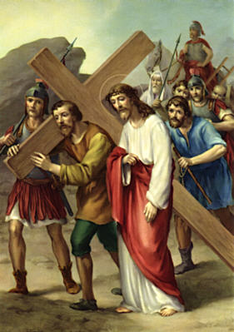

6

Sixth Station

Veronica wipes the face of Jesus

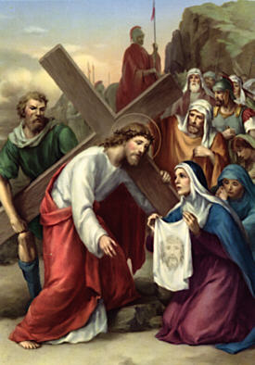

7

Seventh Station

Jesus falls the second time

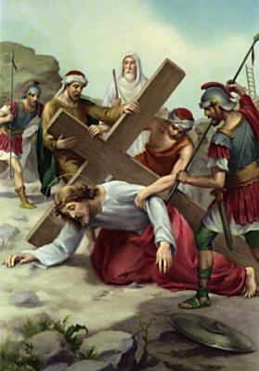

8

Eight Station

Jesus meets the women of Jerusalem

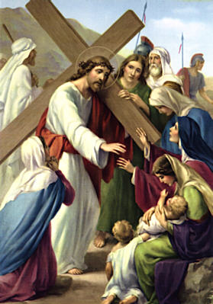

9

Ninth Station

Jesus falls a third time

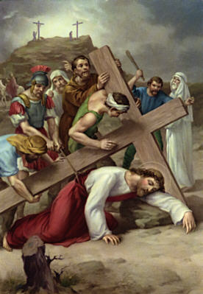

10

Tenth Station

Jesus’ clothes are taken away

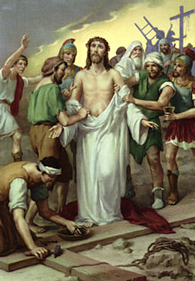

11

Eleventh Station

Jesus is nailed to the cross

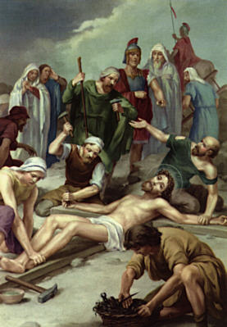

12

Twelfth Station

Jesus dies on the cross

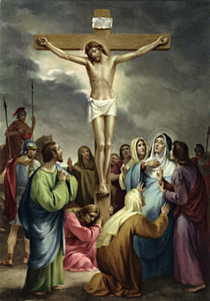

13

Thirteenth Station

The body of Jesus is taken down from the cross

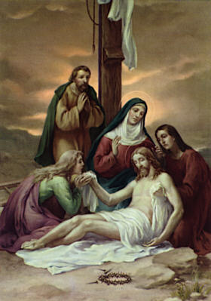

14

Fourteenth Station

Jesus is laid in the tomb

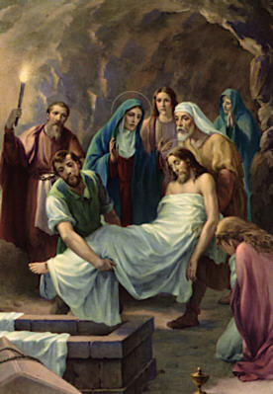

1. List down the 14 Stations of the Cross and write a short personal reflection each station.
2. **SEVEN LAST WORDS**
3. List down the seven last words of Jesus and write a short personal reflection each Last Word of Jesus

<https://stjosemaria.org/the-seven-last-words/>

<https://www.blueletterbible.org/faq/don_stewart/don_stewart_809.cfm>

**THEOLOGY 4**

**Explain the following statements:**

1. “Freedom is doing what I want to do, no matter what.”
2. “As long as my intention in doing a thing is good, I will continue doing it.”
3. “Ignorance of the law excuses no one.”
4. “I am responsible for every act I do, whether good or bad.”

**CHAPTER 17  
LOVE ONE ANOTHER**

1. **Assess your understanding**
2. What does loving God “with all your heart, with all your soul, with all your mind and with all your strength” mean?
3. What does “loving your neighbor as yourself” entail?
4. Explain why love of God and love of neighbor must always go together?
5. How do people misrepresent the link between love of God and love of neighbor?
6. How must we understand our laws and norms today in the context of Christ’s Commandment of love? Below is a list of common laws we observe in the community. Explain how each law or ordinance becomes a way of showing our love for others.
7. No jaywalking
8. Tapatmo, linismo
9. Avoid smoke belching
10. No loading or unloading
11. Speed limit: 60 kph

**CHAPTER 18  
RESPECT GOD’S GIFT: LIFE**

Asses your Understanding

1. How do the Fourth and Fifth Commandments protect the value of life?
2. Why do you think Jesus included “getting angry”, “act of insulting”, and “act of humiliating” one’s brother in the acts that constitute violation of the right to life?
3. Why do we have to protect the value of life?

**CHAPTER 19  
CHRIST’S INVITATION TO APPRECIATE HUMAN SEXUALITY**

Assess your Understanding

1. In what way does the passage from Gen. 1:27 speak of the equality of the sexes?
2. Why is it not good for man to be alone?
3. How do you look yourself? Are you happy with being male/female?

**REFERENCE**

**Catechism for Filipino Catholics**

Before we venture into the nature and reality of sin and its relationship to Christian living, let us do the following exercise. It is designed to make you think about some basic attitudes toward sin and morality. State briefly your own opinion or view on the ideas expressed.

1. Sin has to do with breaking the rules and regulations of the Church.
2. What’s wrong is what I think is wrong.
3. Some actions are wrong even I don’t think they are wrong. They may be wrong in themselves and for others but not necessarily for me.
4. I don’t like going to church. It bores me. I would rather take a walk in the woods and worship God in my own way.
5. I perceive sin primarily in terms of relationship. Every time I do something to harm my relationship with God or a neighbor, I commit a sun. this includes attitudes I have towards them

After you have responded to the above statements, discuss with a partner your attitudes towards sin and morality. Then, write briefly your basic attitude towards sin.

This activity shows the importance of observing laws in your day-to-day living and in your relationship or encounter with other people.

1. Is it true that sin has to do with the breaking of rules and regulations formulated and imposed by the church? Why?
2. Why is it important to have laws? Can you live without them?
3. Enumerate some house rules and school policies and regulations. What is your attitude towards these laws?
4. Can you break laws, rules, and regulations without any harmful consequences? Why?
5. As a Christian, what laws of God do you obey or try to live by? Have you been successful in doing so? Why?

**Theo 5**

**Activity #1**

**MARRIAGE LAWS**

To test your knowledge of the marriage laws of the Church, here are some true and false statements. See how much you know by trying your hand at these.

____ 1. A catholic may not marry a non-Catholic.

____ 2. A Catholic must marry before a priest and two witnesses.

____ 3. The Church encourages a couple to live together before getting married.

____ 4. The Catholic Church recognizes homosexual marriages.

____ 5. Catholic Church teaching holds that marriage is always permanent.

____ 6. The Church will bless a marriage where the couple has decided beforehand not to have any children.

____ 7. The Church hopes each married couple will have as many children as possible.

____ 8. A Catholic is obliged to obey Church laws on marriage.

____ 9. There are no restrictions – besides state laws – for two Catholics who wish to marry.

____ 10. The Catholic Church is strongly against family planning.

**Activity #2**

Fill up the blanks below. In column A, write as many reasons as to why marriages fail. In column B write the “ideals” so that marriage should be successful exactly at each of the opposite items in column A.

|  |  |
| --- | --- |
| **COLUMN A** | **COLUMN B** |
| **Why Do Marriages Fail?** | **How can Marriage be Successful?** |
|  |  |
|  |  |
|  |  |
|  |  |
|  |  |
|  |  |
|  |  |
|  |  |

**Activity #3**

1. What traditional family practices in the past would you want to retain? Explain why.
2. What modern-day practices do you like best? Explain why.
3. What practices would you like to observe in the future in your family life? Explain why.

**Activity #4**

1. Do you think that our value system as Filipinos is helpful to the young in preparing them for choosing their lifetime partners? Explain.
2. Are there differences between society’s expectation in one’s partner and the qualities that really count? YES
3. How would you like to be courted (if a girl)? How would you court a girl (if a boy)?
4. Do you agree that a broken engagement is better than a broken marriage? Explain.
5. Do you believe that engaging in pre-marital sex is justified because you are getting married very soon?

**Activity #5**

1. How do Catholics understand the term “Family Planning” as differentiated from the popular understanding of the term?
2. How is “Pro-choice” differentiated from “Pro-life”: Which is our Catholic stand and what reasons do we give for this choice?

**Activity #6**

Research and submit a paper on this subject (one and a half pages): Why abortion is considered gravely wrong.

S.A.Q.

1. How is responsible parenthood exercised by Catholics?
2. React to this comment: “Catholics do not accept family planning.”

**Activity #7**

1. Which is a more difficult situation for a Catholic spouse: a mixed marriage or one with disparity of cult? Why?
2. Would you encourage a Catholic to marry outside of his or her religion? Why?
3. Would you change your religion to marry your non-Catholic girlfriend or boyfriend? Or would you give up your faith and join his or her religion? Why?

**FINAL EXAM THEOLOGY 5**

**MARITAL ADJUSTMENT**

1. Explain the difference between love and marriage.
   * Love is pure emotion. It is also a feeling at the same time. When you are in love, you are not obligated to undergo marriage, for it is a choice and not a requirement.
   * Marriage is more of a civil status. It is the event in which a couple officially becomes married.
   * Love is a feeling or an emotion, whereas marriage is more of a ceremonial event to formalize a change in one’s civil status from being single to being married.
   * Marriage is more equated to commitments, whereas love doesn’t necessarily have any, unless it is the romantic type of love.
2. What is the primary essence of marriage?
   * Finding a person who completes you, confirming that you and that person have some common goal (having a family, not having a family, traveling, or some other passion), and deciding to make your union legal.
3. What is the difference between adulthood and maturity?
   * adulthood is the time of life when one is expected to take responsibility for one's own actions and well-being while maturity is the state of being mature, ready or ripe.
4. Can a couple escape living with in-laws? How?
5. How can infidelity be avoided?
   * Avoiding being secluded alone with a person you are attracted in a physical, sexual, or even emotional way aside from your partner.
   * Avoid drinking alcoholic beverages with someone else that you are attracted to other than your partner.
   * Strengthening your relationship with your partner and focus on him or her.
   * Reflect on what will be the effects of your infidelity and don’t delude yourself with excuses.

**RESPONSIBLE PLANNED PARENTHOOD**

1. Define Family Planning.
   * the practice of controlling the number of children in a family and the intervals between their births, particularly by means of artificial contraception or voluntary sterilization.
2. What is meant by responsible parenthood?
   * It is the will and ability of parents to respond to the needs and aspirations of the family and children.
3. What is birth control? How different is it from family planning?
   * It is any method that is used to prevent pregnancy
   * Birth control is a method without planning, whilst family planning is managing resources to have the ability to respond to the needs of one’s family and children.
4. Why is it necessary to limit the size of the family?
   * The limit has to be limited to match one’s ability to sustain their family.
5. Why is abortion considered illegal in the Philippines

**THEOLOGY 6**