

专业技能训练报告

学 院： 计算机科学与软件学院
课程名称：专业技能训练—面向对象程序设计(C++)
专业班级： 2016级计算机科学与技术三班
学生姓名： 张远亮 学号： 201624131338
指导教师： 刘俊杰
评 分：

完成时间：2018年6月27日

目 录
1、需求与功能分析 1
2、系统总体框 1
3、模块设计与分析 2
4、类的设计与分析 2
5、功能测试 3
6、程序源代码 6
8、参考文献 21

1、需求与功能分析
  - 储蓄卡开户管理；
储蓄卡开户管理模块：卡号、姓名、开户金额、身份证号、地址、电话、密码、确认密码和保存组成。（开户金额必须是数字，密码和确认密码必须一样是六位数字）
  - 存取款管理；
  - 用户注销，注销模块：一旦注销该卡号就不存在且余额提醒你取出。
  - 管理员功能，管理员能够修改每个用户基本信息，实现用户的增删改查等功能。

2、系统总体框

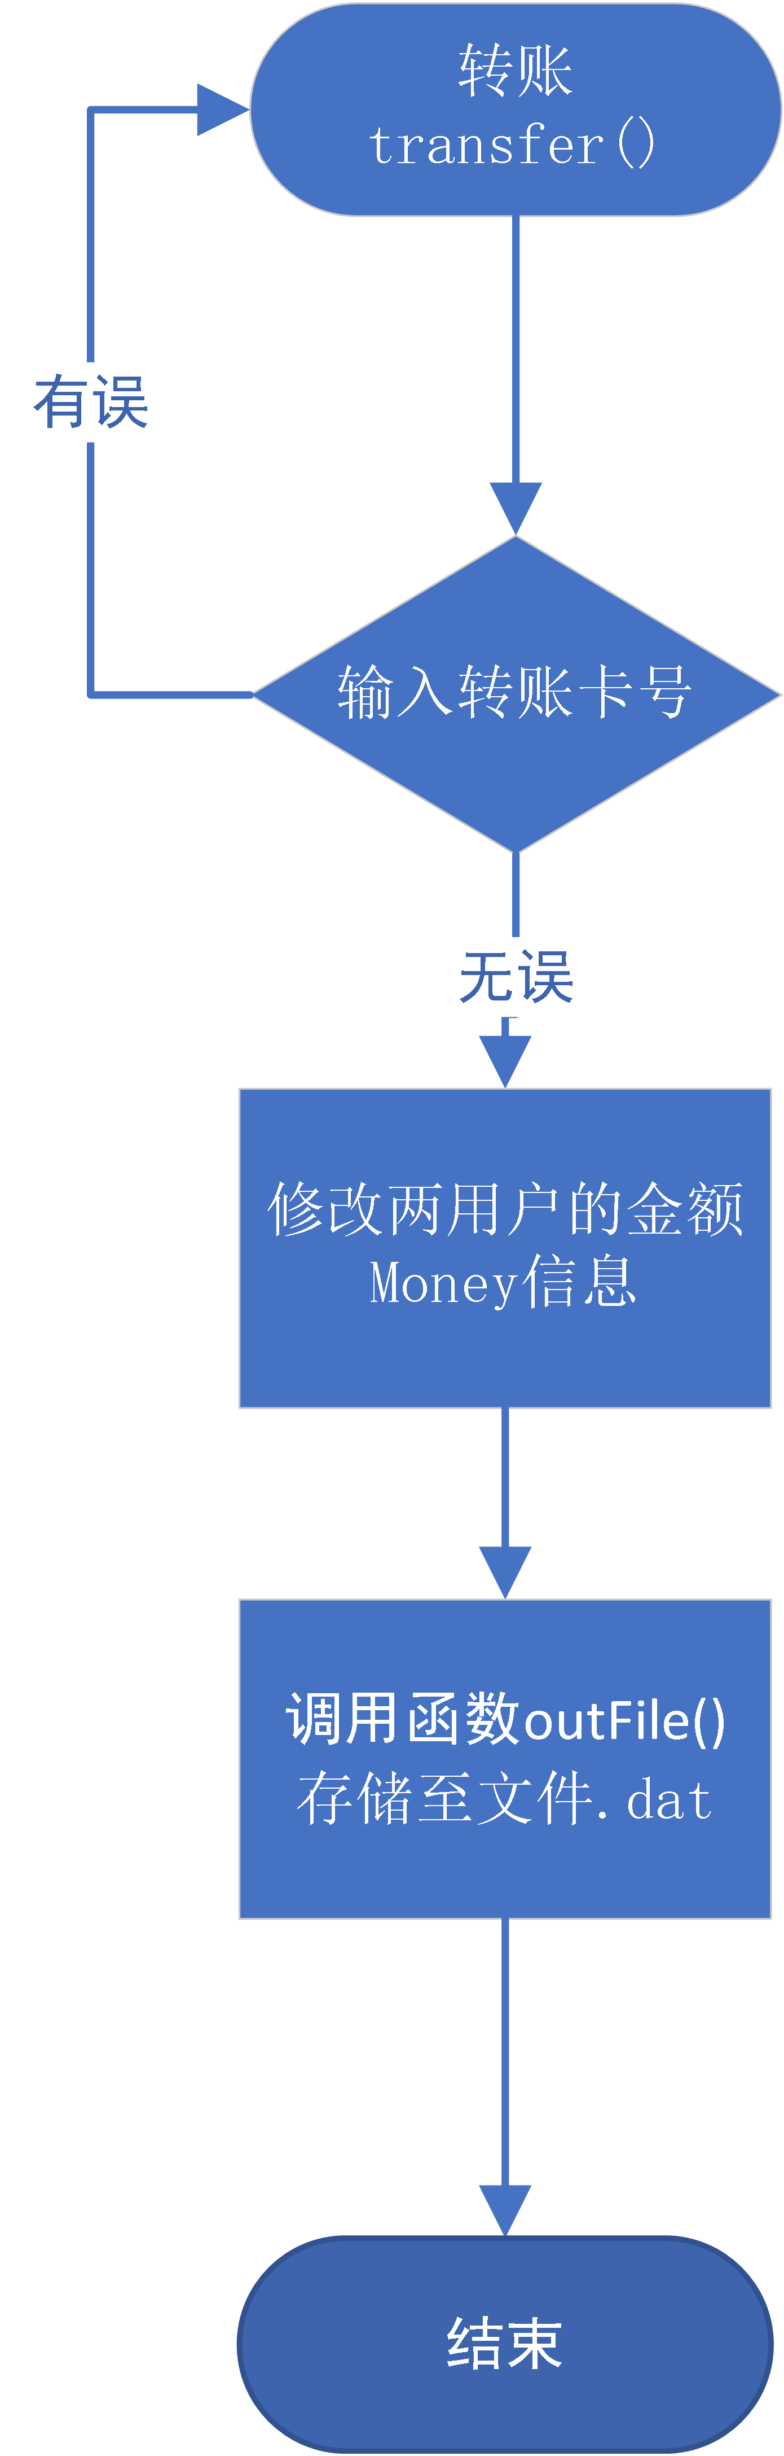
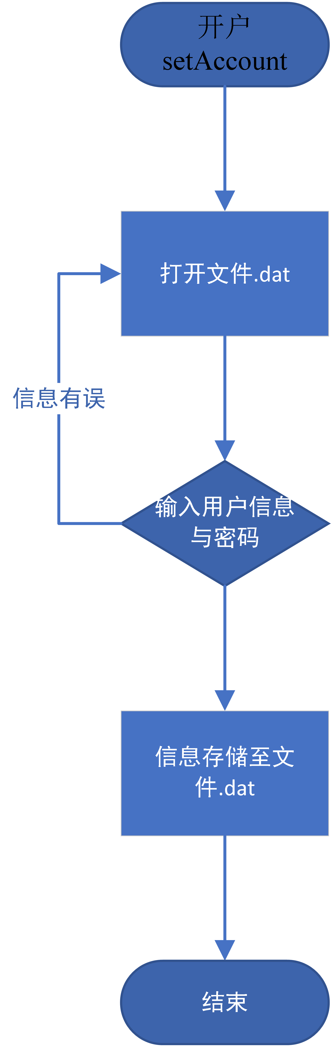
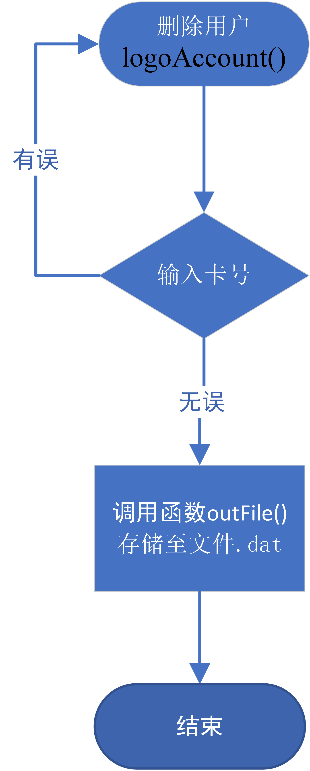
3、模块设计与分析
余下的delAccount()注销用户、withdraw()取款、altAccount()修改用户信息等等函数功能均与上述设计雷同,此处不再赘述。

4、类的设计与分析
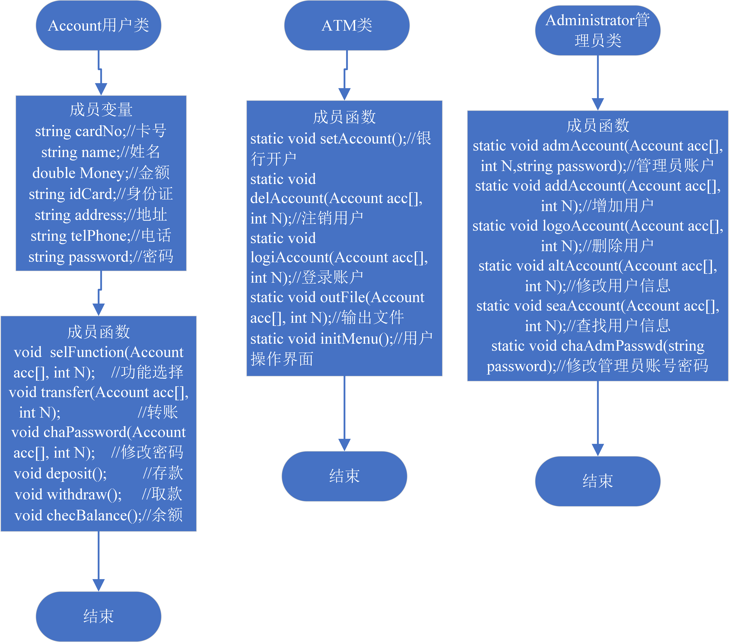

5、功能测试
- 开户
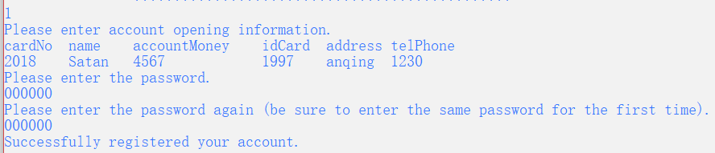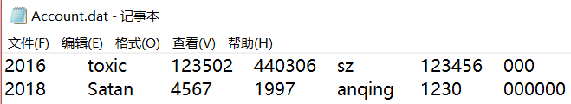

- 用户登录
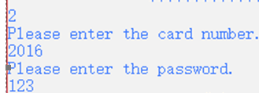

- 存款
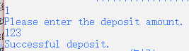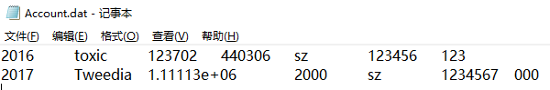

- 取款
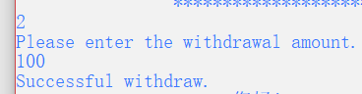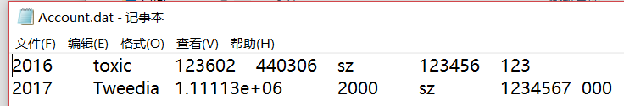

- 转账
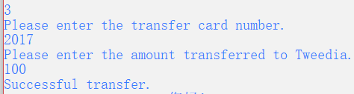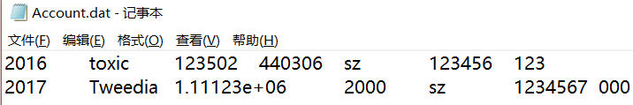

- 修改密码
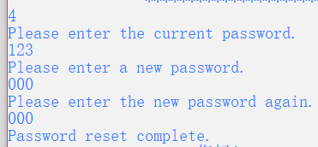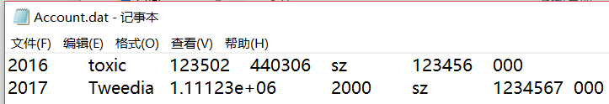

- 查看余额
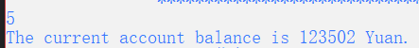

- 删除用户
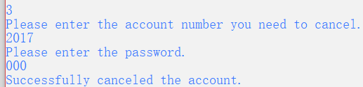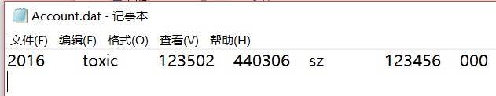

- 登录管理员模式
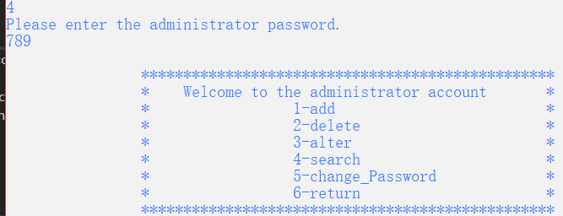

- 增加用户(管理员)
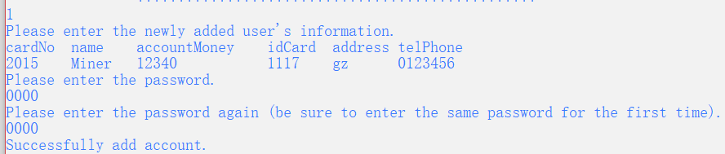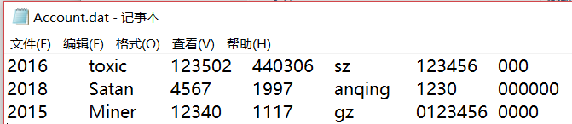

- 删除用户(管理员)
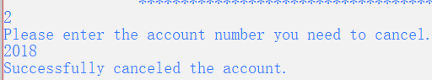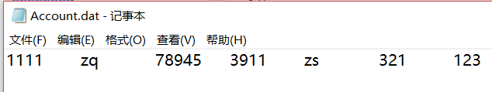

- 修改用户信息(管理员)
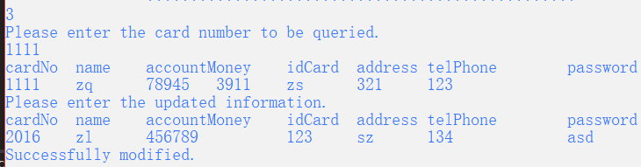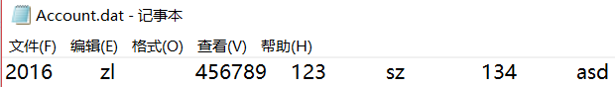

- 查找用户信息(管理员)
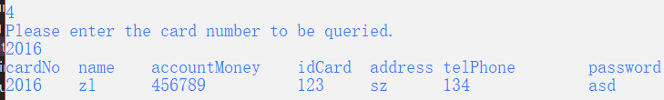

- 修改管理员的账户密码(管理员)
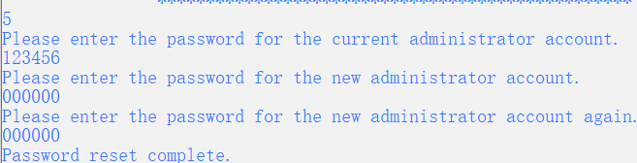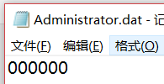

6、程序源代码
// 银行账户管理系统.cpp: 定义控制台应用程序的入口点。
//

#include "stdafx.h"
#include <iostream>
#include <fstream>
#include <string>
#include <iomanip>
using namespace std;

class Account//用户类，公有继承ATM类
{
public:
string cardNo;//卡号
string name;//姓名
double Money;//金额
string idCard;//身份证
string address;//地址
string telPhone;//电话
string password;//密码

void selFunction(Account acc[], int N);//功能选择
void transfer(Account acc[], int N);//转账
void chaPassword(Account acc[], int N);//修改密码
void deposit();//存款
void withdraw();//取款
void checBalance();//查看余额
};

class ATM //ATM类
{
public:
static void setAccount();//银行开户
static void delAccount(Account acc[], int N);//注销用户
static void logiAccount(Account acc[], int N);//登录账户
static void outFile(Account acc[], int N);//输出文件
static void initMenu();//用户操作界面
};

class Administrator :public Account//管理员类，公有继承Account类
{
public:
static void admAccount(string password);//管理员账户
static void addAccount(Account acc[], int N);//增加用户
static void logoAccount(Account acc[], int N);//删除用户
static void altAccount(Account acc[], int N);//修改用户信息
static void seaAccount(Account acc[], int N);//查找用户信息
static void chaAdmPasswd(string password);//修改管理员账号密码
};

void ATM::setAccount()//银行开户功能
{
string a, b, c, d, e, passwd, rePasswd;
double m;
ofstream outfile("Account.dat", ios::app);//以输出方式打开文件Account.dat,输出至文件末尾
cout << "Please enter account opening information." << endl;
cout << "cardNo\tname\taccountMoney\tidCard\taddress\ttelPhone" << endl;
do {
cin >> a >> b >> m >> c >> d >> e;
if (m > 0)//判断输入金额是否正确
break;
else
cout << "Please re-enter the correct information." << endl;
} while (true);
cout << "Please enter the password." << endl;
do {
cin >> passwd;//输入密码
cout << "Please enter the password again (be sure to enter the same password for the first time)." << endl;
cin >> rePasswd;//确认密码
if (passwd == rePasswd)
{
cout << "Successfully registered your account." << endl;
break;
}
else
{
cout << "Two passwords are different. Please re-enter." << endl;
}
} while (true);
outfile << a << "\t" << b << "\t" << m << "\t" << c << "\t" << d << "\t" << e << "\t" << passwd << endl;//将开户的数据存放至文件Account.dat末尾
outfile.close();//关闭文件Account.dat
}

void ATM::delAccount(Account acc[], int N)//银行注销用户功能
{
string No;
string passwd;
int i, flag = 0;
cout << "Please enter the account number you need to cancel." << endl;
cin >> No;
for (i = 0; i < N; i++)
{
if (acc[i].cardNo == No)
{
cout << "Please enter the password." << endl;
while (true)
{
cin >> passwd;
if (passwd == acc[i].password)
{
N--;//注销成功,用户个数 N 减一
flag = 1;
for (; i < N; i++)
{
acc[i] = acc[i + 1];//将用户对象数组在i之后的用户,往前移一位
}
break;
}
else
{
cout << "The password is incorrect. Please re-enter it." << endl;
}
}
}
if (flag) break;
}
if (flag)
{
ATM::outFile(acc, N);//调用静态台函数 ATM::outFile(acc, N); 实现数据的更新
cout << "Successfully canceled the account." << endl;
}
else
{
cout << "The entered account number is incorrect and will return to the main menu." << endl;
}
}

void ATM::logiAccount(Account acc[], int N)//账户登录功能
{
int i, flag = 0;
string No, passwd;
cout << "Please enter the card number." << endl;
cin >> No;//输入卡号
for (i = 0; i < N; i++)
{
if (acc[i].cardNo == No)//判断是否存在此卡号
{
flag = 1;
break;
}
}
if (flag)
{
cout << "Please enter the password." << endl;
while (true)
{
cin >> passwd;//输入密码
if (acc[i].password == passwd)//核对密码是否正确
{
acc[i].selFunction(acc,N);//登陆成功.调用对象的成员函数 selFunction(acc, N); 进入功能选择界面
break;
}
else
{
cout << "Wrong password and re-enter." << endl;
}
}
}
else
{
cout << "The card number is wrong and will return to the main menu." << endl;
}
}

void ATM::outFile(Account acc[], int N)//输出文件功能,用于更新数据
{
ofstream outfile("Account.dat", ios::out);
for (int i = 0; i < N; i++)
{
outfile << acc[i].cardNo << "\t";
outfile << acc[i].name << "\t";
outfile << acc[i].Money << "\t";
outfile << acc[i].idCard << "\t";
outfile << acc[i].address << "\t";
outfile << acc[i].telPhone << "\t";
outfile << acc[i].password << endl;
}
outfile.close();
}

void Administrator::admAccount(string password)//进入管理员界面
{
string admPasswd;
int N;
Account acc[100];
cout << "Please enter the administrator password." << endl;
cin >> admPasswd;//输入管理员密码
if (admPasswd == password)//判断密码是否正确
{
//N++;
int flag = 1;
char Satan;//Switch标志变量
do {
ifstream infile1("Administrator.dat", ios::in);//以输入方式打开文件Administrator.dat
infile1 >> admPasswd;
infile1.close();
N = 0;
ifstream infile("Account.dat", ios::in);//以输入方式打开文件Account.dat
while (infile)//文件内容赋值于对象数组acc
{
infile >> acc[N].cardNo;
infile >> acc[N].name;
infile >> acc[N].Money;
infile >> acc[N].idCard;
infile >> acc[N].address;
infile >> acc[N].telPhone;
infile >> acc[N++].password;
}
infile.close();
N--;
//进入管理员界面
cout << endl;
cout << "\t\t*************************************************" << endl;
cout << "\t\t* Welcome to the administrator account *" << endl;
cout << "\t\t* 1-add *" << endl;
cout << "\t\t* 2-delete *" << endl;
cout << "\t\t* 3-alter *" << endl;
cout << "\t\t* 4-search *" << endl;
cout << "\t\t* 5-change_Password *" << endl;
cout << "\t\t* 6-return *" << endl;
cout << "\t\t*************************************************" << endl;
cin >> Satan;
switch (Satan)
{
case '1':
{
Administrator::addAccount(acc, N);//管理员账户:增加功能
break;
}
case '2':
{
Administrator::logoAccount(acc, N);//管理员账户:删除功能
break;
}
case '3':
{
Administrator::altAccount(acc, N);//管理员账户:修改功能
break;
}
case '4':
{
Administrator::seaAccount(acc, N);//管理员账户:查询功能
break;
}
case '5':
{
Administrator::chaAdmPasswd(admPasswd);//管理员账户:修改管理员密码
break;
}
case '6'://返回初始界面
{
flag = 0;
break;
}
default:
{
cout << "Incorrect input. Please re-enter." << endl;
break;
}
}
} while (flag);
}
else
{
cout << "The password is incorrect and returns to the menu." << endl;
}
}

void Administrator::addAccount(Account acc[], int N)//增加用户(管理员)
{
string a, b, c, d, e, passwd, rePasswd;
double m;
ofstream outfile("Account.dat", ios::app);
cout << "Please enter the newly added user's information." << endl;
cout << "cardNo\tname\taccountMoney\tidCard\taddress\ttelPhone" << endl;
do {
cin >> a >> b >> m >> c >> d >> e;
if (m > 0)
break;
else
cout << "Please re-enter the correct information." << endl;
} while (true);
do {
cout << "Please enter the password." << endl;
cin >> passwd;
cout << "Please enter the password again (be sure to enter the same password for the first time)." << endl;
cin >> rePasswd;
if (passwd == rePasswd)
{
cout << "Successfully add account." << endl;
break;
}
else
{
cout << "Two passwords are different. Please re-enter." << endl;
}
} while (true);
outfile << a << "\t" << b << "\t" << m << "\t" << c << "\t" << d << "\t" << e << "\t" << passwd << endl;
outfile.close();
}

void Administrator::logoAccount(Account acc[], int N)//删除用户(管理员)
{
string No;
int i, flag = 0;
cout << "Please enter the account number you need to cancel." << endl;
cin >> No;
for (i = 0; i < N; i++)
{
if (acc[i].cardNo == No)
{
N--;
flag = 1;
for (; i < N; i++)
{
acc[i] = acc[i + 1];
}
break;
}
}
if (flag)
{
ATM::outFile(acc, N);
cout << "Successfully canceled the account." << endl;
}
else
{
cout << "The entered account number is incorrect and will return to the main menu." << endl;
}
}

void Administrator::altAccount(Account acc[], int N)//修改信息(管理员)
{
string No;
int i, flag = 0;
cout << "Please enter the card number to be queried." << endl;
cin >> No;
for (i = 0; i < N; i++)
{
if (acc[i].cardNo == No)
{
flag = 1;
cout << "cardNo\tname\taccountMoney\tidCard\taddress\ttelPhone\tpassword" << endl;
cout << acc[i].cardNo << "\t";
cout << acc[i].name << "\t";///////////////////////////////////////
cout << acc[i].Money << "\t\t";////////输出当前用户的具体信息////////
cout << acc[i].idCard << "\t";/////////////////////////////////////
cout << acc[i].address << "\t";
cout << acc[i].telPhone << "\t\t";
cout << acc[i].password << endl;
cout << "Please enter the updated information." << endl;
cout << "cardNo\tname\taccountMoney\tidCard\taddress\ttelPhone\tpassword" << endl;
cin >> acc[i].cardNo >> acc[i].name >> acc[i].Money >> acc[i].idCard >> acc[i].address >> acc[i].telPhone >> acc[i].password;
cout << "Successfully modified." << endl;
ATM::outFile(acc, N);
break;
}
}
if (!flag)
{
cout << "The card number is incorrect and will return to the menu." << endl;
}
}

void Administrator::seaAccount(Account acc[], int N)//查询用户信息(管理员)
{
string No;
int i;
cout << "Please enter the card number to be queried." << endl;
cin >> No;
for (i = 0; i < N; i++)
{
if (acc[i].cardNo == No)
{
cout << "cardNo\tname\taccountMoney\tidCard\taddress\ttelPhone\tpassword" << endl;
cout << acc[i].cardNo << "\t";
cout << acc[i].name << "\t";
cout << acc[i].Money << "\t\t";
cout << acc[i].idCard << "\t";
cout << acc[i].address << "\t";
cout << acc[i].telPhone << "\t\t";
cout << acc[i].password << endl;
break;
}
}
if (i == N)
{
cout << "The card number is incorrect and will return to the menu." << endl;
}
}

void Administrator::chaAdmPasswd(string password)//修改管理员账户密码(管理员)
{
int flag = 1;
string newPasswd1, newPasswd2, oldPasswd;
cout << "Please enter the password for the current administrator account." << endl;
do {
cin >> oldPasswd;//输入当前未更新的密码
if (oldPasswd == password)
{
do {
cout << "Please enter the password for the new administrator account." << endl;
cin >> newPasswd1;//输出更新后的密码
cout << "Please enter the password for the new administrator account again." << endl;
cin >> newPasswd2;//确认更新后的密码
if (newPasswd1 == newPasswd2)
{
flag = 0;
ofstream outfile("Administrator.dat", ios::out);
cout << "Password reset complete." << endl;
outfile << newPasswd1;//更新后的密码存放至文件Administrator.dat
outfile.close();
break;
}
else
{
cout << "Two passwords are different. Please re-enter." << endl;
}
} while (true);
}
else
{
cout << "The password is wrong. Please re-enter the password for the current administrator account." << endl;
}
} while (flag);
}

void ATM::initMenu()//银行初始界面
{
Account acc[100];//对象数组acc
char Toxic, ch = NULL;
int N, flag = 1;
string admPasswd;
ifstream infile1("Administrator.dat", ios::in);//以输入方式打开文件Administrator.dat
infile1.get(ch);
if (ch == NULL)//如果文件Administrator.dat内容为空,则设置管理员账户密码
{
infile1.close();
cout << "Please set the password for the administrator account." << endl;
cin >> admPasswd;
ofstream outfile1("Administrator.dat", ios::trunc);
outfile1 << admPasswd;
outfile1.close();
}
else//否则获取文件内容至admPasswd
{
infile1 >> admPasswd;
admPasswd = ch + admPasswd;
infile1.close();
}
do {
N = 0;
ifstream infile("Account.dat", ios::in);//以输入方式打开文件Account.dat
while (infile)//文件内容赋值于对象数组acc
{
infile >> acc[N].cardNo;
infile >> acc[N].name;
infile >> acc[N].Money;
infile >> acc[N].idCard;
infile >> acc[N].address;
infile >> acc[N].telPhone;
infile >> acc[N++].password;
}
N--;
infile.close();
cout << endl;//进入银行初始界面
cout << "\t\t***********************************************" << endl;
cout << "\t\t* Welcome to the banking housing. *" << endl;
cout << "\t\t* 1-set_Account *" << endl;
cout << "\t\t* 2-login_Account *" << endl;
cout << "\t\t* 3-delete_Account *" << endl;
cout << "\t\t* 4-administrator_Account *" << endl;
cout << "\t\t* 5-exit *" << endl;
cout << "\t\t***********************************************" << endl;
cin >> Toxic;
switch (Toxic)
{
case '1':
{
ATM::setAccount();//开户
break;
}
case '2':
{
ATM::logiAccount(acc, N);//登录
break;
}
case '3':
{
ATM::delAccount(acc, N);//注销
break;
}
case '4':
{
Administrator::admAccount(admPasswd);//进入管理员系统
break;
}
case '5':
{
flag = 0;
break;
}
default:
{
cout << "Incorrect input. Please re-enter." << endl;
break;
}
}
} while (flag);
}

void Account::selFunction(Account acc[],int N)//用户登录界面
{
int flag = 1;
char Tweedia;
do {
N = 0;
ifstream infile("Account.dat", ios::in);//以输入方式打开文件Account.dat
while (infile)//文件内容赋值于对象数组acc
{
infile >> acc[N].cardNo;
infile >> acc[N].name;
infile >> acc[N].Money;
infile >> acc[N].idCard;
infile >> acc[N].address;
infile >> acc[N].telPhone;
infile >> acc[N++].password;
}
N--;
infile.close();
cout << "\t\t" << this->name << ",您好！" << endl;
cout << endl;
cout << "\t\t***********************************************" << endl;
cout << "\t\t* Please select function. *" << endl;
cout << "\t\t* 1-deposit *" << endl;
cout << "\t\t* 2-withdraw *" << endl;
cout << "\t\t* 3-transfer *" << endl;
cout << "\t\t* 4-change_Password *" << endl;
cout << "\t\t* 5-check_Balance *" << endl;
cout << "\t\t* 6-return *" << endl;
cout << "\t\t***********************************************" << endl;
cin >> Tweedia;
switch (Tweedia)
{
case '1':
{
this->deposit();//存款
ATM::outFile(acc, N);//更新数据
break;
}
case '2':
{
this->withdraw();//取款
ATM::outFile(acc, N);
break;
}
case '3':
{
this->transfer(acc, N);//转账
ATM::outFile(acc, N);
break;
}
case '4':
{
this->chaPassword(acc, N);//修改用户密码
ATM::outFile(acc, N);
break;
}
case '5':
{
this->checBalance();//查询余额
break;
}
case '6':
{
flag = 0;
break;
}
default:
{
cout << "Incorrect input and re-enter." << endl;
break;
}
}
} while (flag);
}

void Account::deposit()//存款
{
double m;
cout << "Please enter the deposit amount." << endl;
do {
cin >> m;//输入存款金额
if (m > 0)
break;
else
cout << "Enter the wrong amount and re-enter the amount." << endl;
} while (true);
this->Money += m;//增加用户金额
cout << "Successful deposit." << endl;
}

void Account::withdraw()//取款
{
double m;
cout << "Please enter the withdrawal amount." << endl;
do {
cin >> m;//输入取款金额
if (m > 0 && m < this->Money)
break;
else
cout << "The amount entered was incorrect and reentered." << endl;
} while (true);
this->Money -= m;//减少用户金额
cout << "Successful withdraw." << endl;
}

void Account::transfer(Account acc[], int N)//转账
{
int i, flag = 1;
double m;
string No;
cout << "Please enter the transfer card number." << endl;
do {
cin >> No;//输入转账用户
for (i = 0; i < N; i++)
{
if (No == acc[i].cardNo)
{
flag = 0;
cout << "Please enter the amount transferred to " << acc[i].name << "." << endl;
cin >> m;//输入转账金额
this->Money -= m;//减少用户金额
acc[i].Money += m;//增加转账用户金额
cout << "Successful transfer." << endl;
break;
}
}
if (flag)
{
cout << "Bad card number. Please re-enter the transfer card number." << endl;
}
else
break;
} while (true);
}

void Account::chaPassword(Account acc[], int N)//修改用户密码
{
int flag = 1;
string newPasswd1, newPasswd2, oldPasswd;
cout << "Please enter the current password." << endl;
do {
cin >> oldPasswd;
if (oldPasswd == this->password)
{
do {
cout << "Please enter a new password." << endl;
cin >> newPasswd1;
cout << "Please enter the new password again." << endl;
cin >> newPasswd2;
if (newPasswd1 == newPasswd2)
{
flag = 0;
cout << "Password reset complete." << endl;
this->password = newPasswd1;
break;
}
else
{
cout << "Two passwords are different. Please re-enter." << endl;
}
} while (true);
}
else
{
cout << "The password is wrong. Please re-enter the current password." << endl;
}
} while (flag);
}

void Account::checBalance()//查询用户余额
{
cout << "The current account balance is " << this->Money << " Yuan." << endl;
}

int main()
{
ATM::initMenu();//进入初始界面
return 0;
}

8、参考文献
[1] 谭浩强. C++面向对象程序设计(第2版)[M]. 北京:清华大学出版社, 2017.

