# 条件反应函数：四个条件（Good/Bad x Self/Other）选择 Self 的概率随 RT 变化
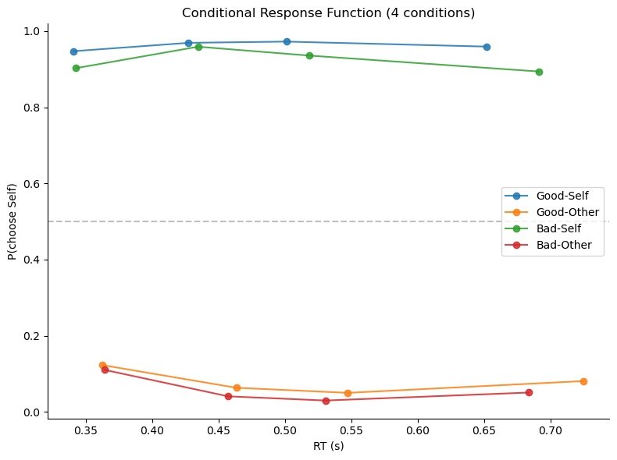
#hddm_acc_coding
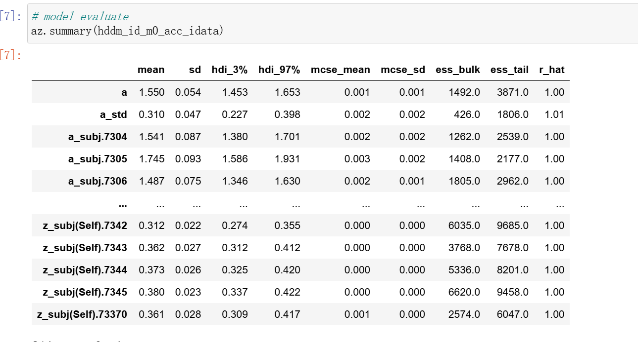
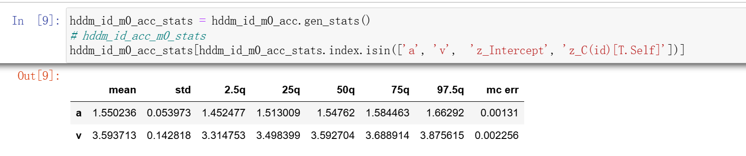
#hddm_choice_m1
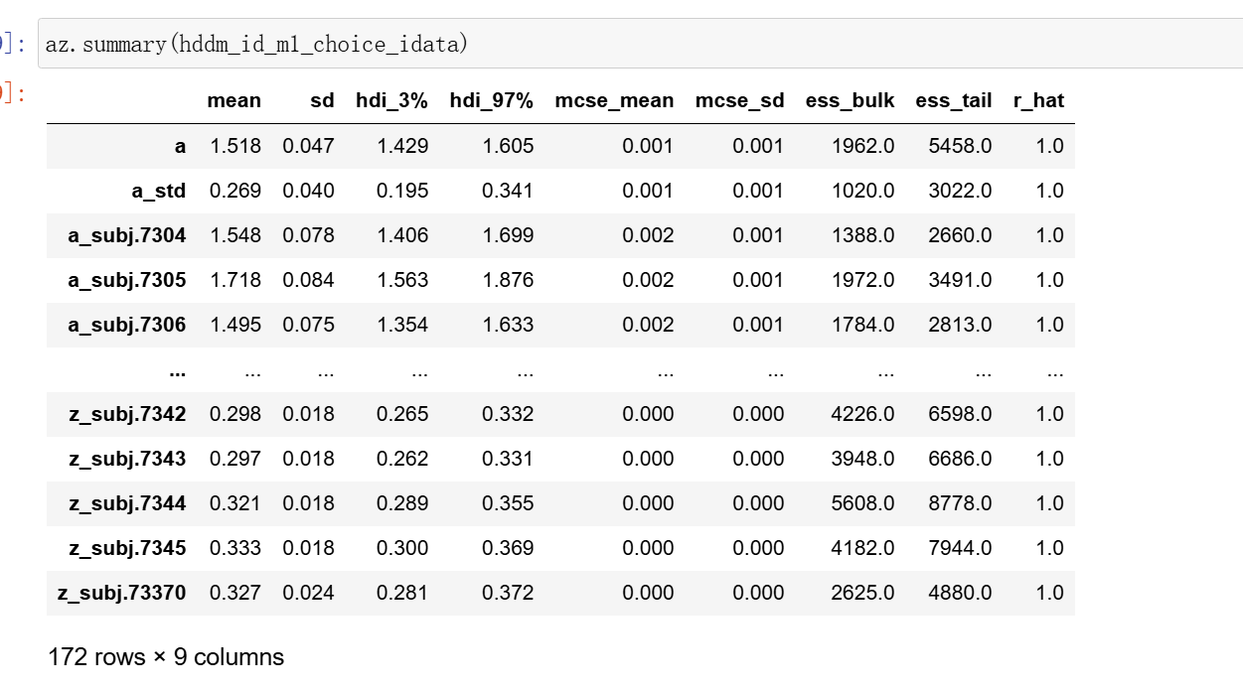
#HDDMStimCoding
#hddmstim_z_flip
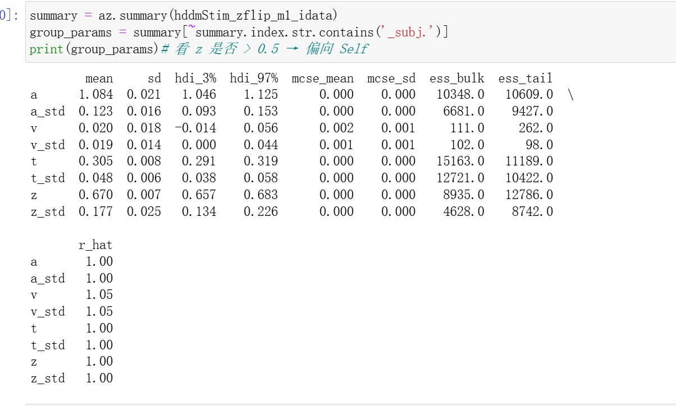
#hddmstim_v_flip
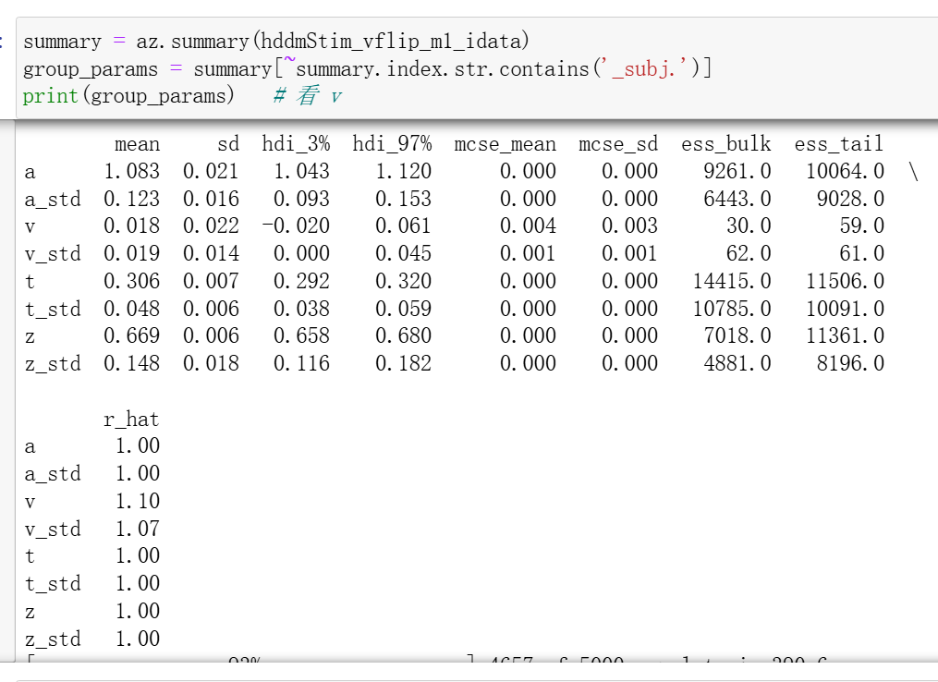
#HDDMRegression
#accuracy coding
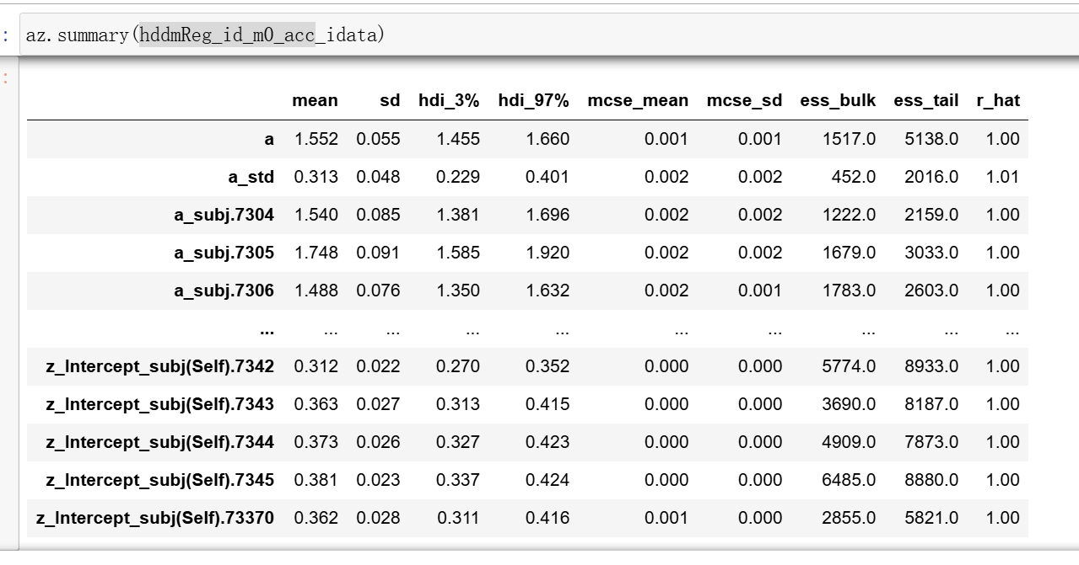
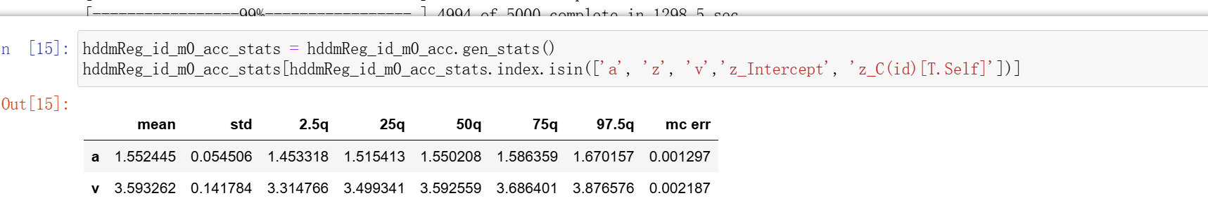
#choice coding
这里本来用z~1+C(id)，但是跑出来不收敛
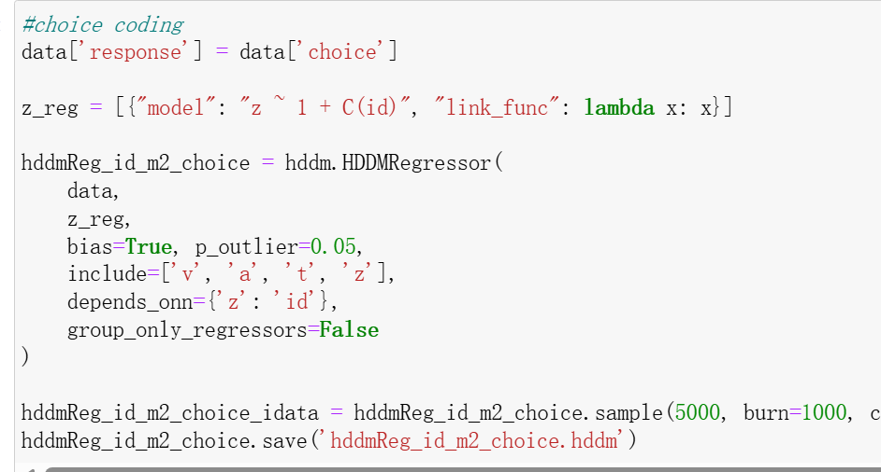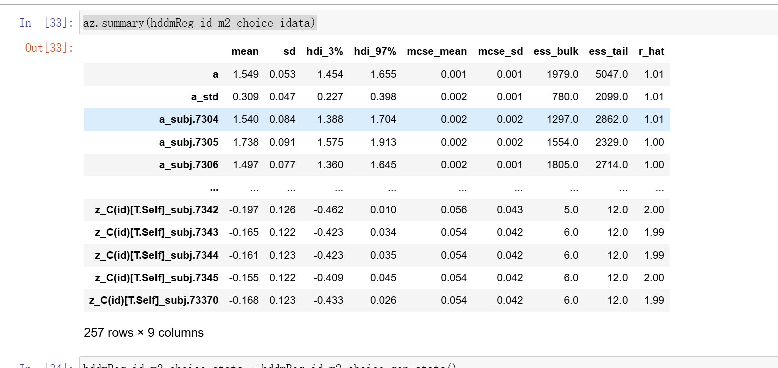
又换成了z~1更改后
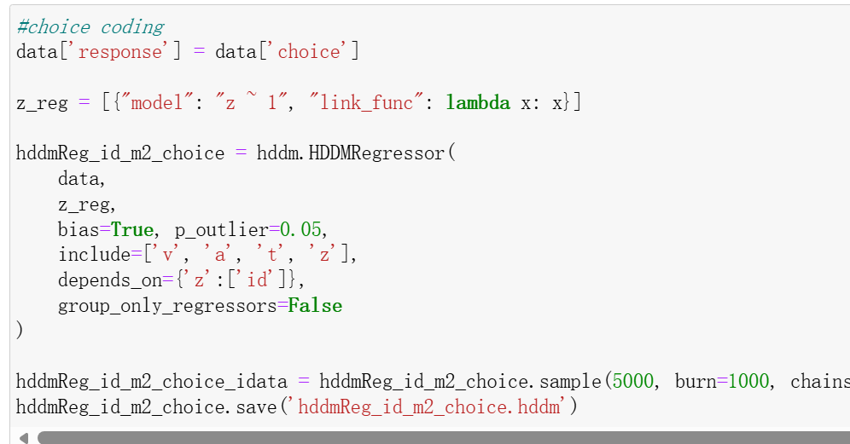
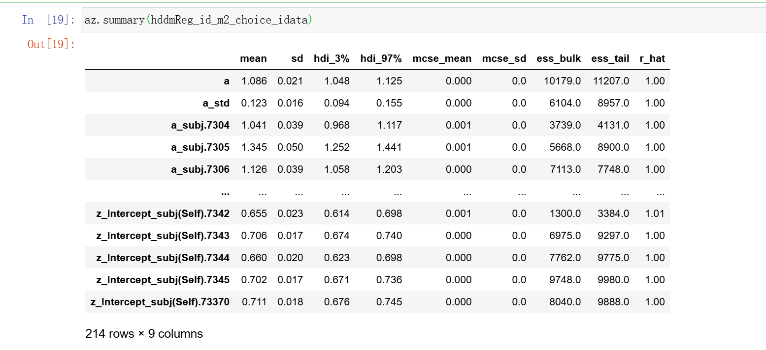
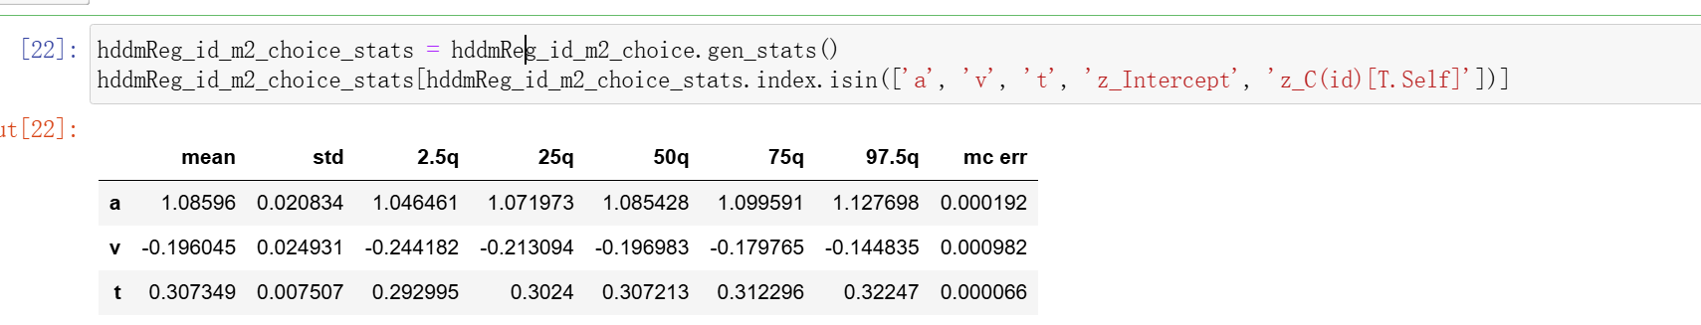
#hddmreg_stim_v_flip
#type1 reg
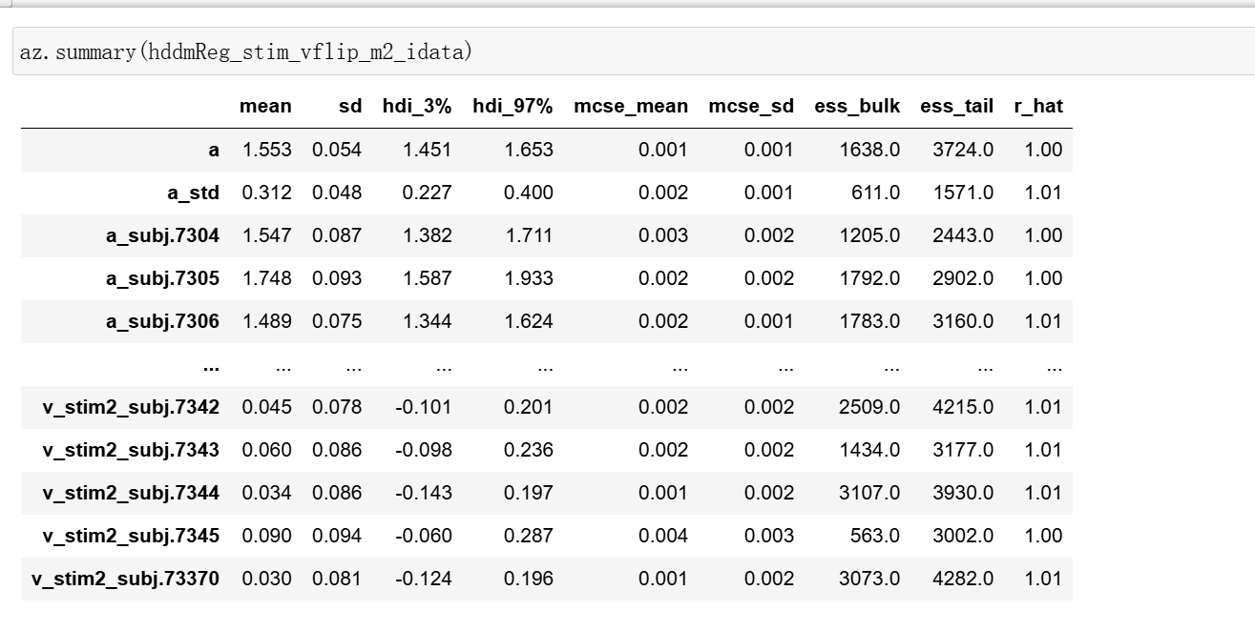
#type2: link function
# using stim coding with HDDMRegressor
# type1: choice coding + v flip
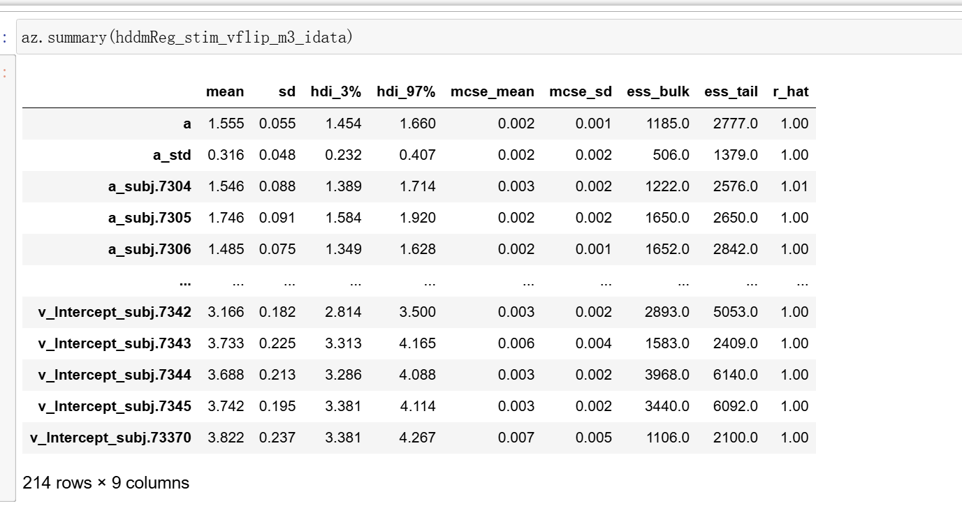
#hddmreg_stim_z_flip
# using stim coding with HDDMRegressor
# type2: acc coding + z flip
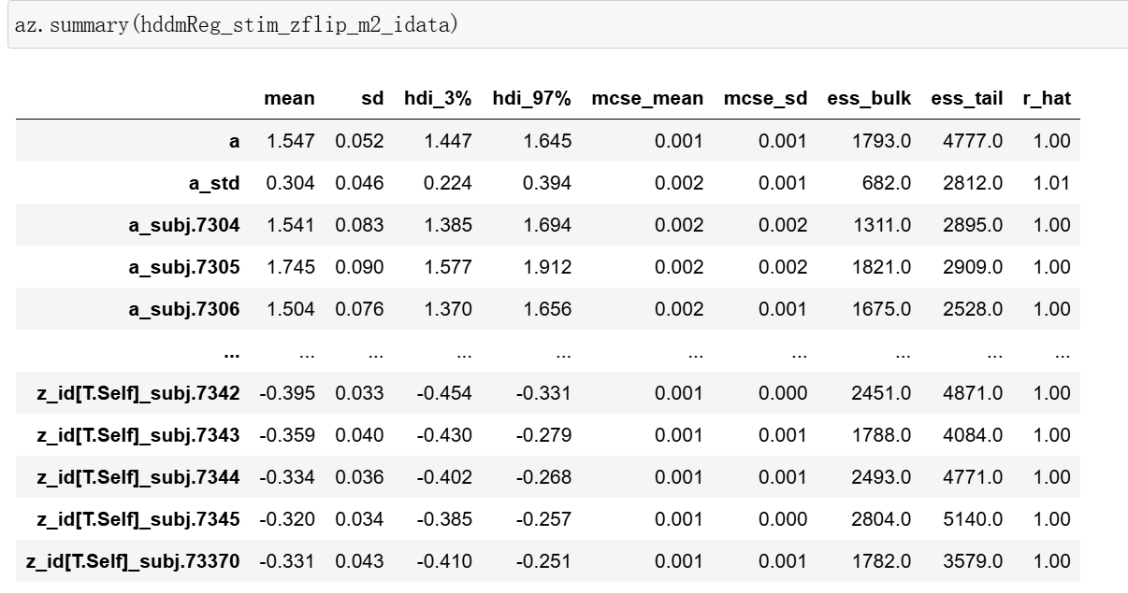
#model comparison
hddm_id_m0_acc = hddm.load('hddm_id_m0_acc.hddm')
hddm_id_m1_choice = hddm.load('hddm_id_m1_choice.hddm')
hddmStim_zflip_m1 = hddm.load('hddmStim_zflip_m1.hddm')
hddmStim_vflip_m1 = hddm.load('hddmStim_vflip_m1.hddm')
hddmReg_id_m0_acc = hddm.load('hddmReg_id_m0_acc.hddm')
hddmReg_id_m2_choice = hddm.load('hddmReg_id_m2_choice.hddm')
hddmReg_stim_vflip_m2 = hddm.load('hddmReg_stim_vflip_m2.hddm')
hddmReg_stim_vflip_m3 = hddm.load('hddmReg_stim_vflip_m3.hddm')
hddmReg_stim_zflip_m2 = hddm.load('hddmReg_stim_zflip_m2.hddm')
DIC_dict = {
"m1": hddm_id_m0_acc.dic,
"m2": hddm_id_m1_choice.dic,
"m3": hddmStim_zflip_m1.dic,
"m4": hddmStim_vflip_m1.dic,
"m5": hddmReg_id_m0_acc.dic,
"m6": hddmReg_id_m2_choice.dic,
"m7": hddmReg_stim_vflip_m2.dic,
"m8": hddmReg_stim_vflip_m3.dic,
"m9": hddmReg_stim_zflip_m2.dic,
}

DIC_table = pd.DataFrame.from_dict(DIC_dict, orient="index", columns=["DIC"])
DIC_table["model"] = DIC_table.index
DIC_table = DIC_table[["model", "DIC"]]
DIC_table.sort_values(by=["DIC"], ascending=False)
