#hddm acc
#hddm
#hddm_acc
# HDDM accuracy coding
# v varies across different stim and id
data['response'] =data['acc']
hddm_id_m0_acc_diff = hddm.HDDM(data, include=['a', 'v', 't','z'], depends_on={'v': ['id','stim']})
hddm_id_m0_acc_diff_idata = hddm_id_m0_acc_diff.sample(2000, burn=500, chains=4, return_infdata=True, dbname = 'hddm_id_m0_acc_diff.db', db = 'pickle')
hddm_id_m0_acc_diff.save('hddm_id_m0_acc_diff.hddm')
# hddm.load('hddm_id_m0_acc.hddm')
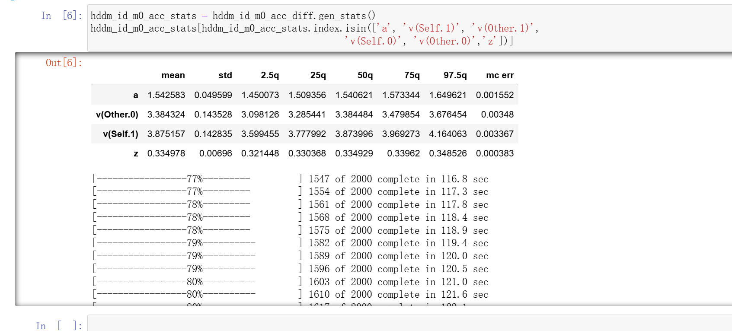
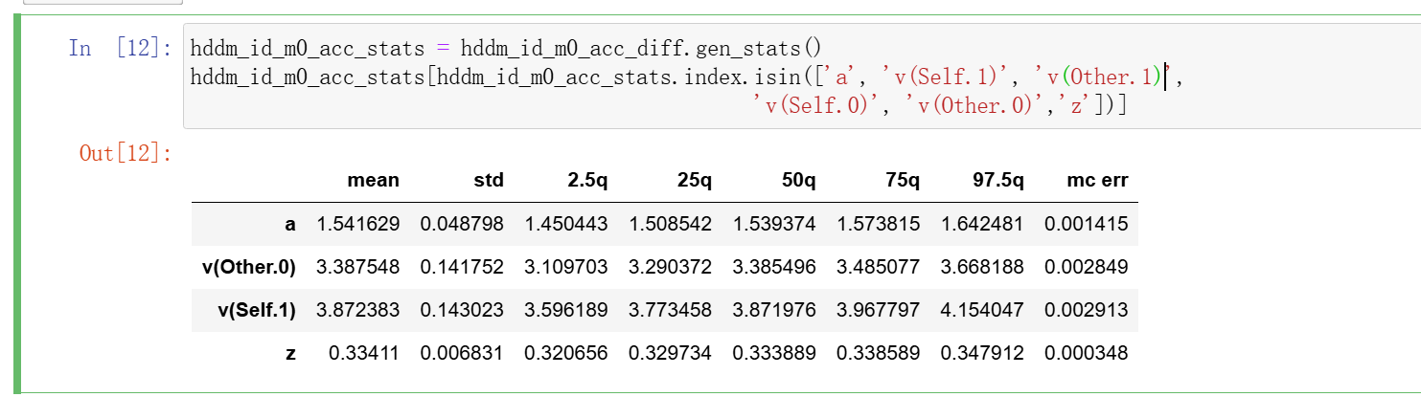
#choice hddm
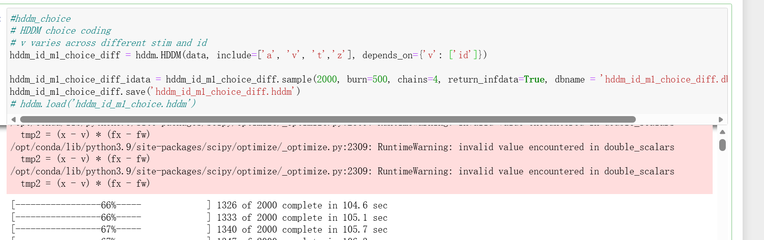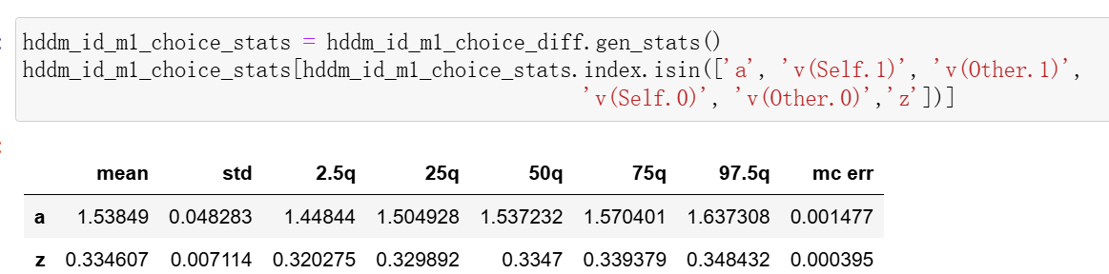
更改后
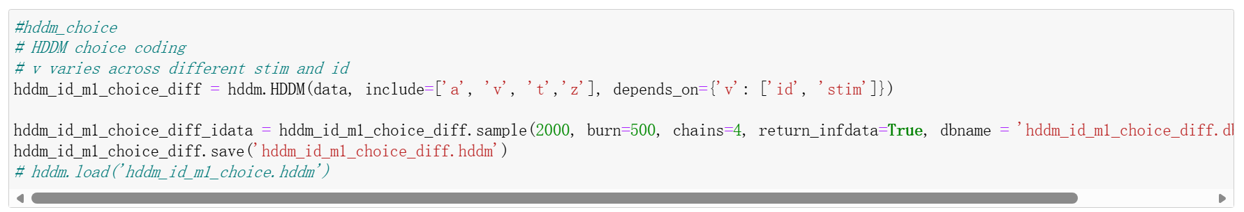
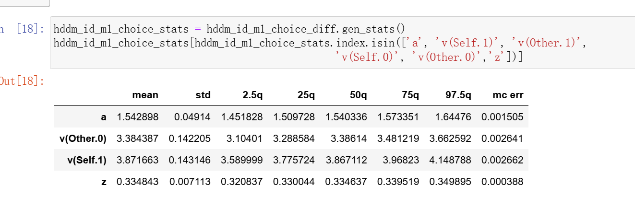
# stimCoding v flip + dc
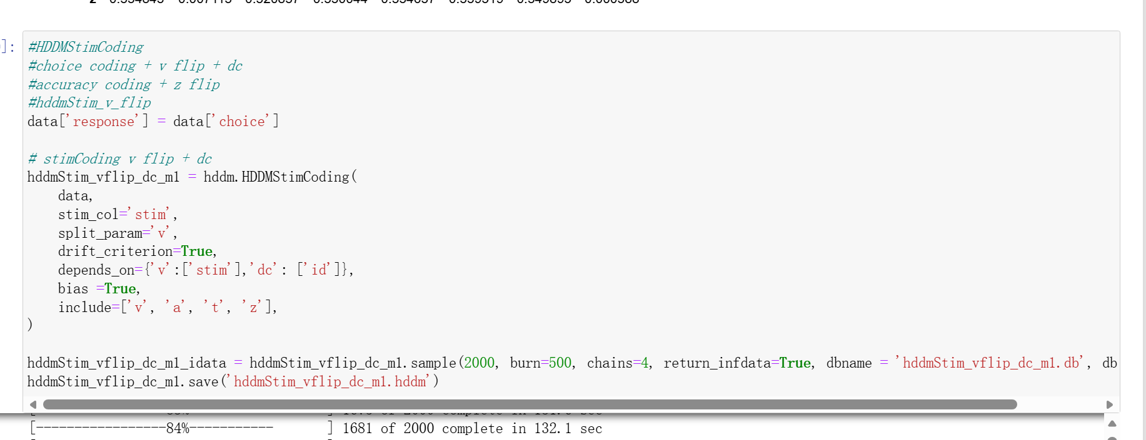
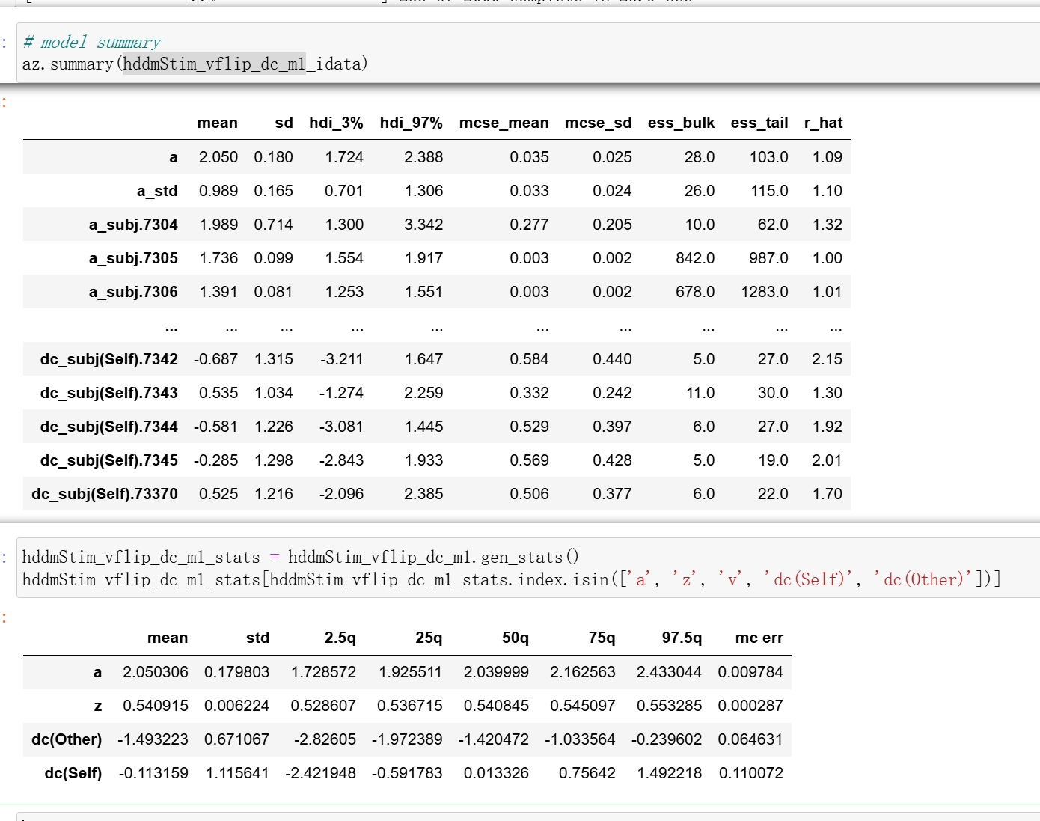
#hddm_zflip
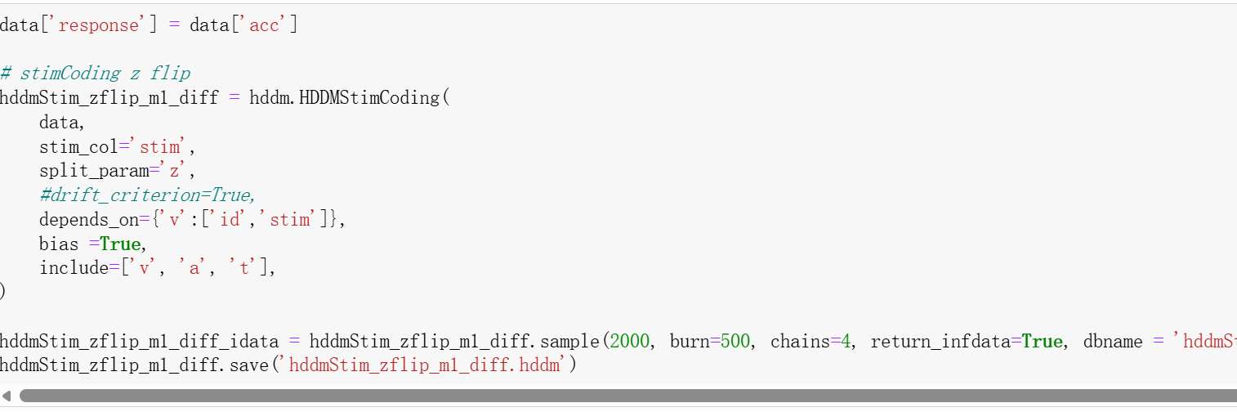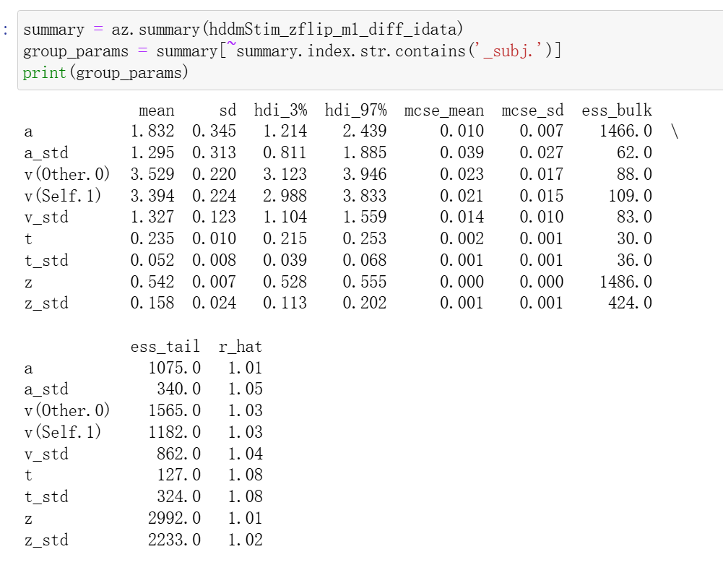
HDDMRegression
- accuracy coding
- choice coding
- stim coding: accuracy coding + v flip + dc
- stim coding: choice coding + z flp
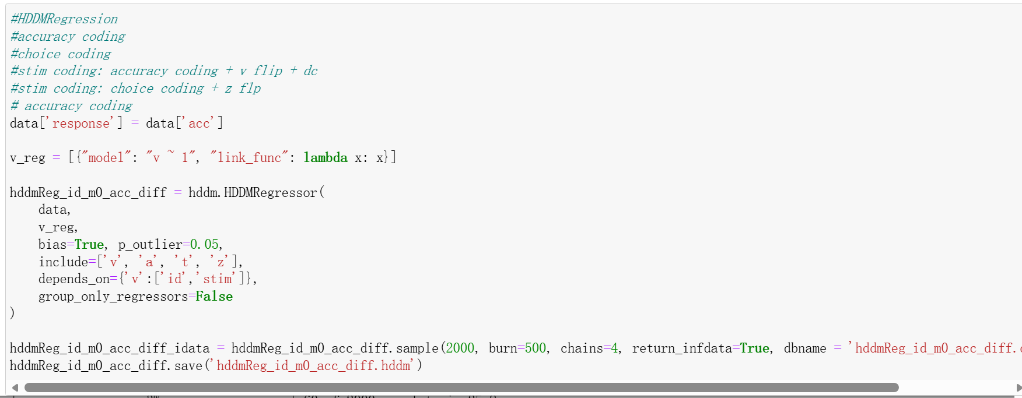
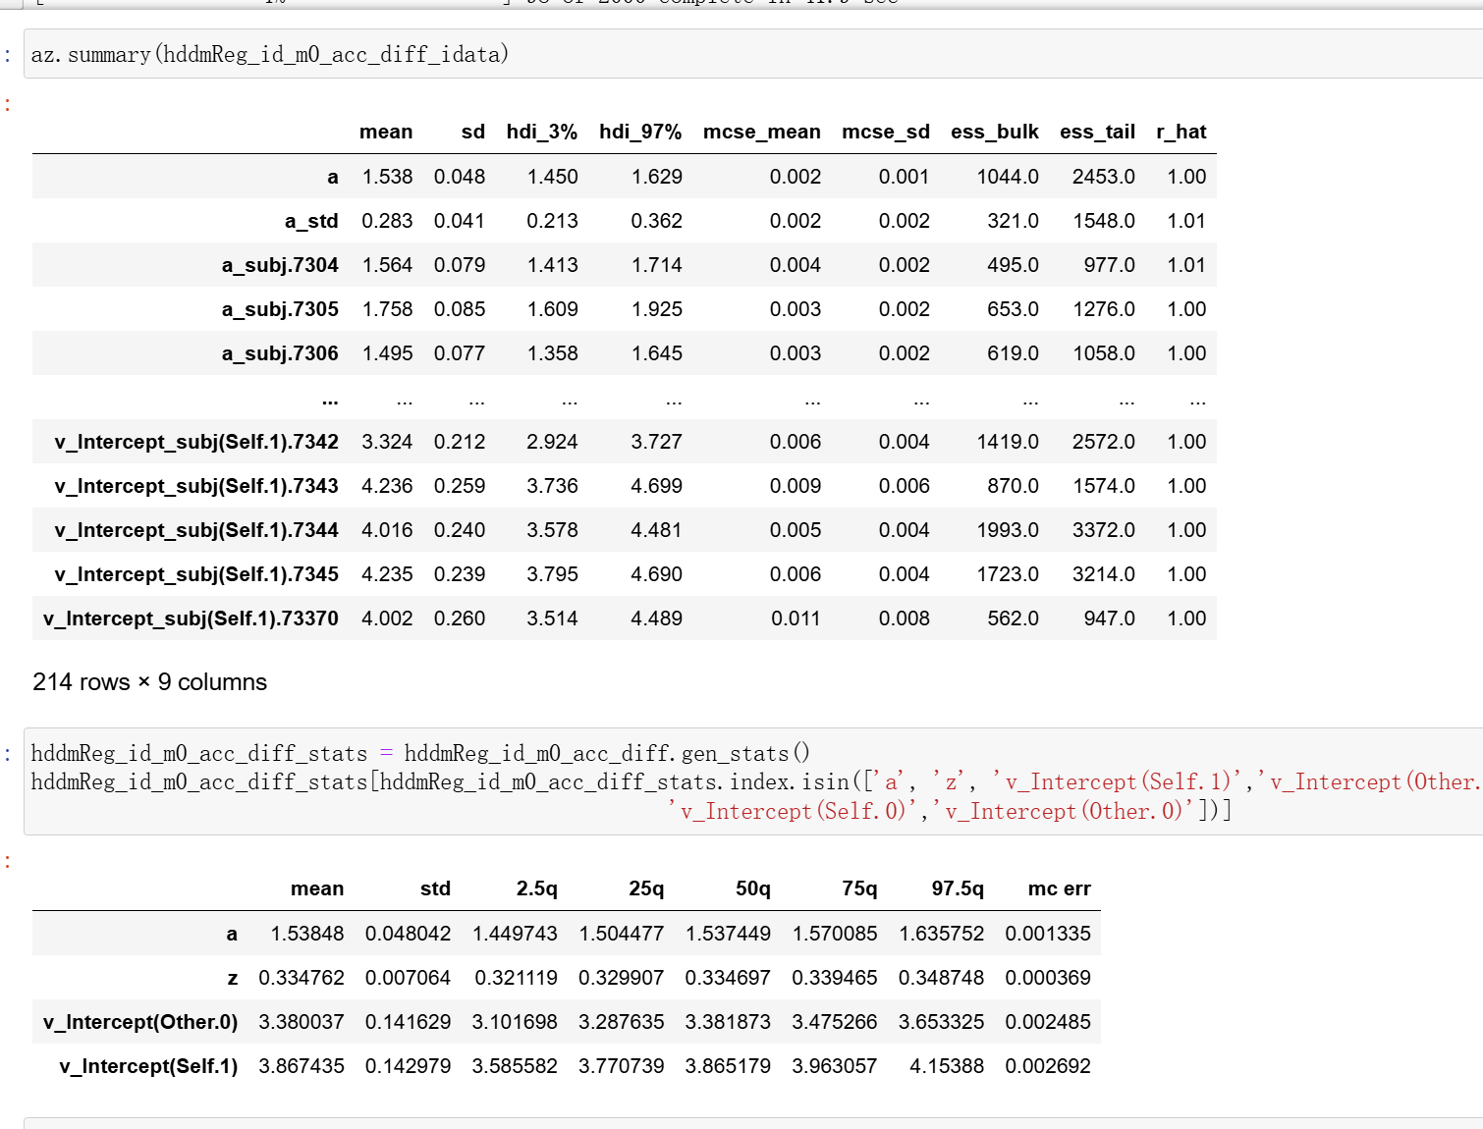
#chouce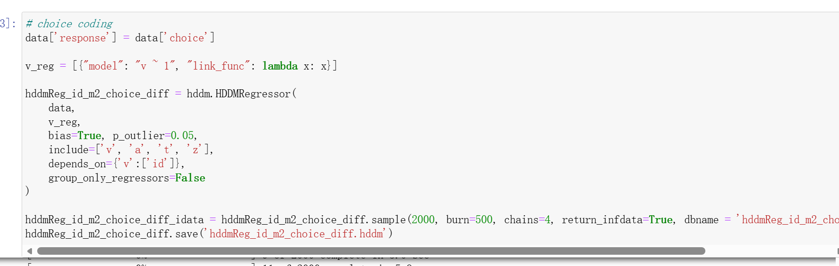
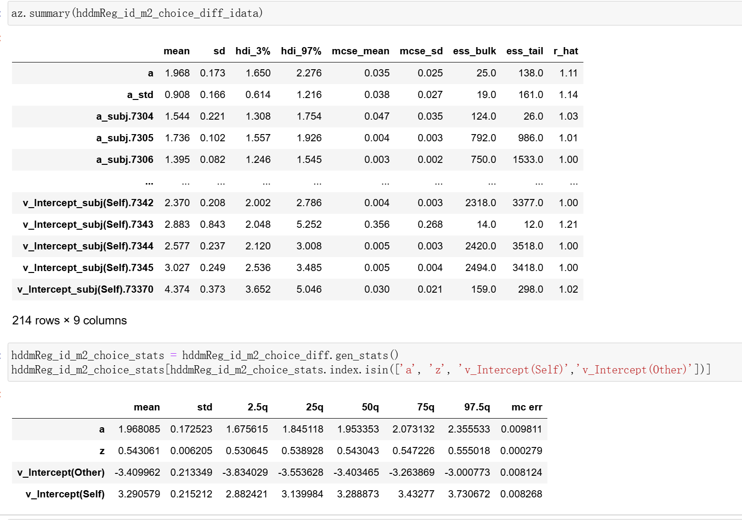
#hddmReg_stim_v_flip_acc
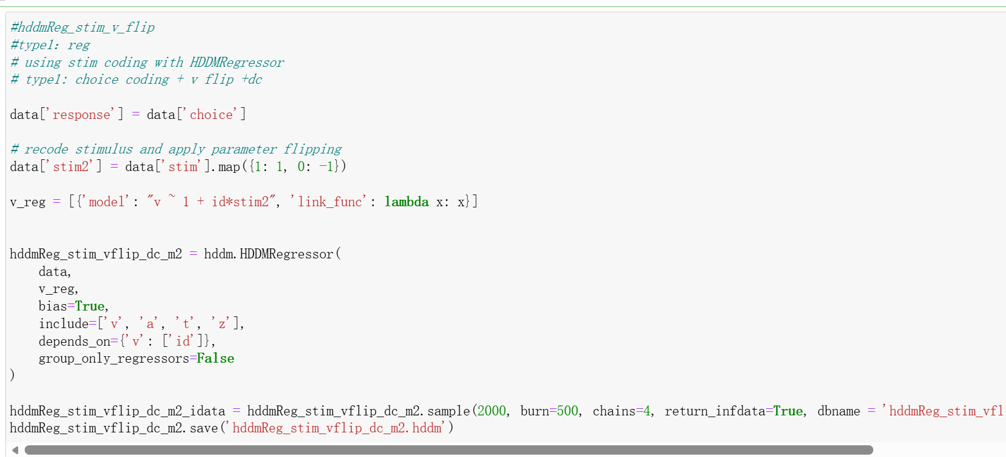
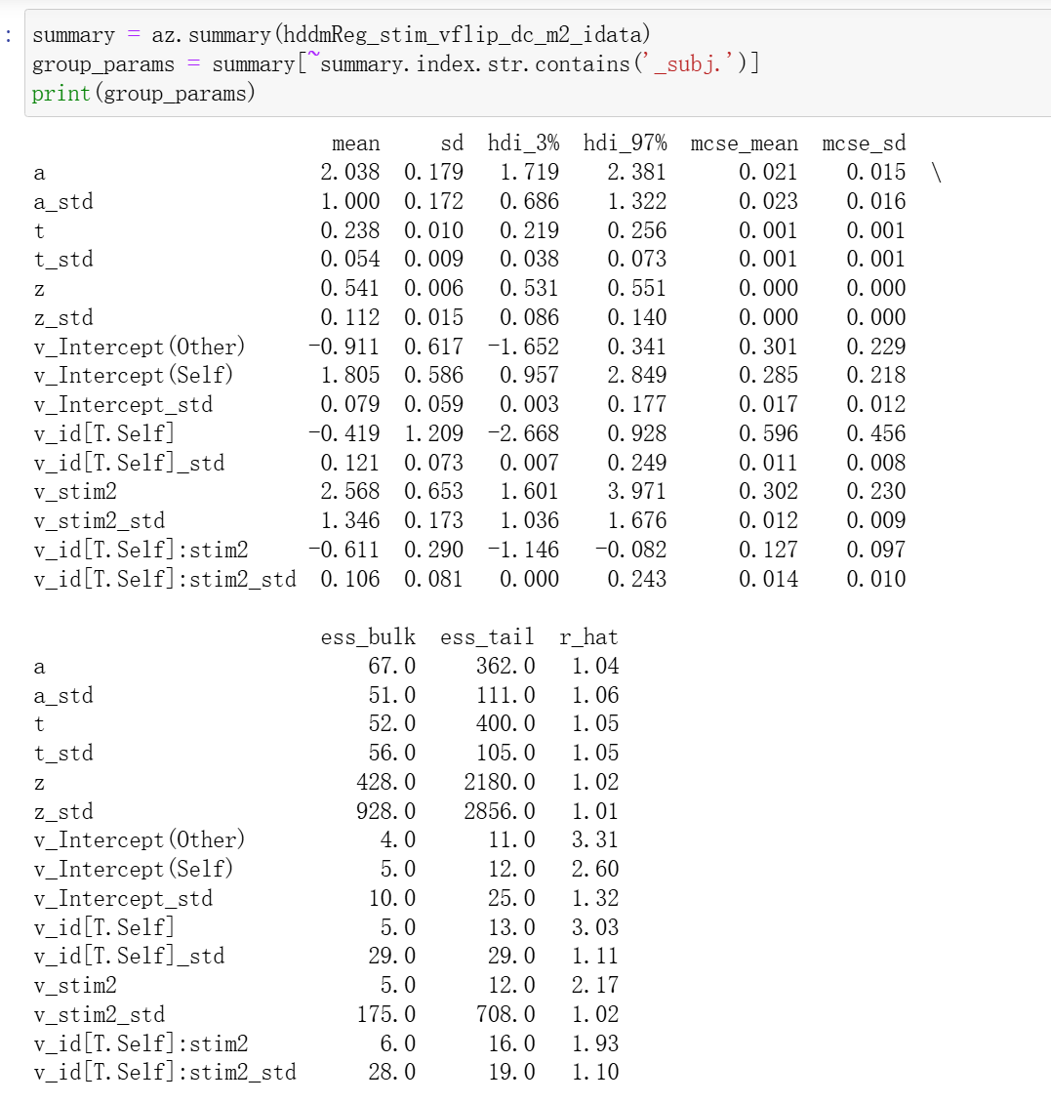
#hddmreg_stim_vflip_choice
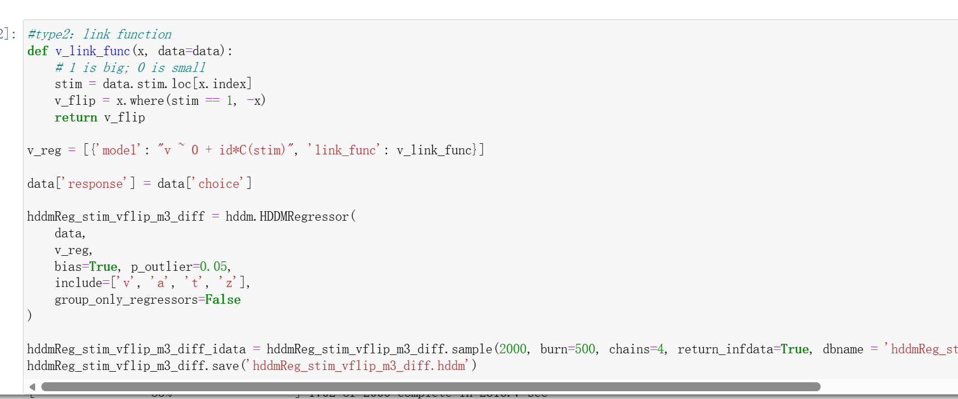
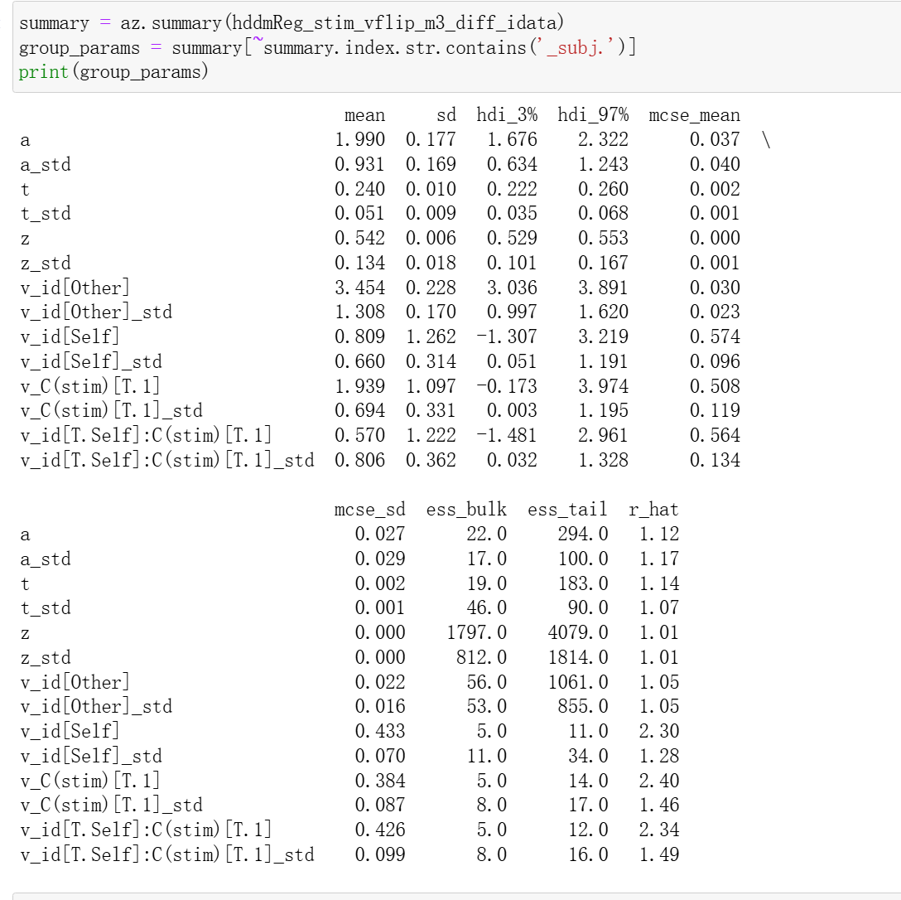
#hddmreg_stim_zflip
