PRODUCT REQUIREMENTS DOCUMENT

Identity Drift Detection in Autonomous AI Agents
Pre-execution security gateway with explainable probabilistic risk scoring
Field | Value
Version | 0.1 — prototype PRD
Date | 25 October 2026
Status | Proposed; not yet validated
Design synthesis | D1: per-dimension drift scoring; D2: taint/provenance and slow drift; D3: gateway and action history
Users | AI platform engineers, security engineers, application owners, security analysts

Executive Summary
This product is a runtime security and behavioural-monitoring layer for autonomous AI agents. It intercepts tool/API actions before execution, enforces deterministic authorization rules, evaluates permitted actions using a shared probabilistic risk engine, and applies a graduated response. It records evidence for audit and supports cautious asynchronous learning from trusted historical behaviour.
It does not replace the LLM or require access to hidden chain-of-thought. It evaluates the available request, tool arguments, declared task, agent identity, permissions, provenance, and action history.

1. Problem Statement
AI agents increasingly call tools, APIs, databases, file systems, browsers, code runners, and other agents. Their actions may be legitimate individually but dangerous in context. Prompt injection, excessive permissions, unsafe integrations, and unexpected model behaviour can cause out-of-role data access, sensitive-data transfer, unwanted modification, or cascading actions.
Static rules are essential but may miss unusual sequences or gradual behavioural change. Pure anomaly scoring is also insufficient: rare does not mean malicious, and an ML score must never override a mandatory authorization rule.

2. Problem Size, Frequency, and Cost
There is not yet a reliable public global estimate for the exact number or annual financial loss of incidents specifically caused by autonomous-agent identity drift. The figures below are adjacent indicators for AI security and data-breach exposure, not a direct market-size estimate or proof of product savings.
Question | Evidence | Interpretation / caveat
How big? | IBM's 2025 report: 13% of surveyed organizations reported breaches of AI models/applications; 8% did not know whether they had been compromised. [1] | AI-related incidents are reported, but this is not specific to agent drift.
How severe? | IBM: 60% of reported AI-related security incidents led to compromised data; 31% led to operational disruption. [1] | Outcomes among incidents in the study, not rate per agent/action.
How much money? | IBM: average global breach cost US$4.44M; US average US$10.22M in 2025. [1] | All-industry breach averages, not expected cost of an agent incident.
Related governance cost | IBM: one in five organizations reported a breach due to shadow AI; high shadow-AI use was associated with US$670,000 higher average breach costs than low/no shadow AI. [1] | Related exposure, not identical to autonomous-agent compromise.
Recognized risk classes | OWASP 2025 LLM risks include prompt injection, sensitive-information disclosure, improper output handling, and excessive agency. [2] | Recognized categories, not incident-frequency statistics.
Unintended agent actions | Salt Security's 2H 2026 report says 49.8% of surveyed organizations confirmed or suspected an agent took an unintended, unexpected, or unauthorized action in the prior year. [3] | Vendor survey/telemetry; treat as directional, not a universal global rate.

Product claim to use: 'The product aims to reduce the likelihood and impact of unauthorized or suspicious agent actions by enforcing policy at the tool boundary and detecting anomalous behaviour.' Do not claim a specific dollar saving until pilot measurements exist.

3. Product Goals
- Prevent unauthorized tool calls before they reach downstream systems.
- Detect suspicious behaviour missed by static rules alone.
- Explain contributing signals for each risk decision.
- Preserve legitimate work through proportionate responses.
- Track short action sequences and long-term behavioural drift per agent/role.
- Create an auditable record of requests, decisions, enforcement, and outcomes.
- Keep request-path checks fast; run retraining and analytics asynchronously.

4. Non-goals
- Replacing or training a foundation LLM.
- Reading hidden internal reasoning that the model/provider does not expose.
- Guaranteeing detection of every hallucination or prompt injection.
- Treating rarity as proof of malicious intent.
- Automatically learning from all actions without trust controls.
- Replacing downstream authorization, least privilege, sandboxing, or audit controls.

5. Users and Use Cases
Persona | Need / workflow
AI platform engineer | Register agents, integrate tool adapters, inspect latency and enforcement failures.
Security engineer | Define role/resource/destination policies; test decisions and escalation rules.
Security analyst | Inspect evidence, annotate false positives, approve or deny step-up requests.
Application owner | Review agent health, policy changes, blocked actions, and audit history.

6. Architecture
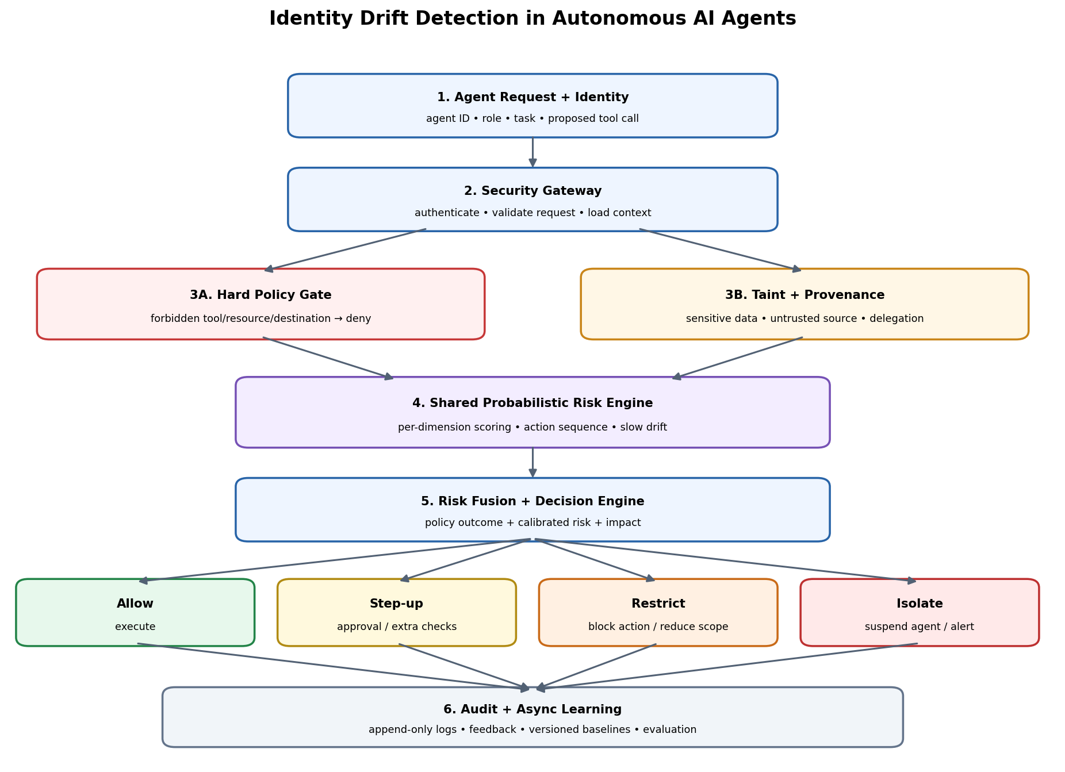
Every supported tool call must pass through the gateway. Hard policy violations are denied regardless of ML score. Probabilistic scoring handles ambiguous or permitted actions. Downstream services must still enforce their own authorization. The system cannot inspect hidden chain-of-thought; it evaluates available structured plans/requests, identity, task context, and observed behaviour.

6.1 Pre-execution Decision Flow
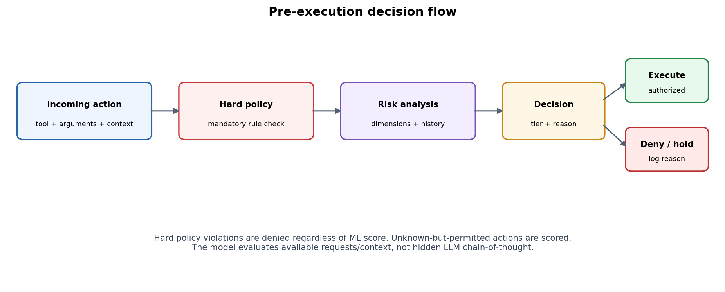

6.2 Component Responsibilities
Component | Responsibility | Fail-safe
Agent registry | Identity, role, task, declared tools, delegation chain. | Unknown identity → deny.
Security gateway | Intercept tool calls; authenticate; validate schema; load context. | No valid decision → no execution.
Hard policy engine | Permissions, forbidden resources, scopes, destinations. | Policy violation → deny regardless of ML.
Taint/provenance | Track untrusted sources, sensitive resources, known data lineage. | Missing provenance increases uncertainty for sensitive actions.
Action history | Recent events, timestamps, transitions, outcomes. | Use conservative role baseline if history unavailable.
Probabilistic engine | Dimension likelihoods, sequence anomaly, drift features. | Return score, reasons, model version, uncertainty.
Decision engine | Combine policy, risk, impact, uncertainty into a tier. | Versioned thresholds; high-impact actions stricter.
Execution adapter | Invoke tools after authorization with constrained permissions/timeouts. | Expired/missing authorization → no execution.
Async control plane | Audit, feedback, baseline updates, metrics. | Versioned and reversible learning updates.

7. Functional Requirements
ID | Requirement | Priority / acceptance
FR-01 | Register agent identity, role, task, tools, resources, destinations, status. | P0: unknown/disabled agents cannot execute.
FR-02 | Intercept every supported tool/API call before execution. | P0: integration tests prove complete mediation.
FR-03 | Authenticate agent/delegation context and validate request schema. | P0: malformed/expired requests rejected and audited.
FR-04 | Enforce deterministic authorization independent of ML score. | P0: hard-denied action remains denied at any score.
FR-05 | Record timestamp, tool, resource, destination, task, size, decision, outcome. | P0: queryable, bounded history.
FR-06 | Score tool, resource, destination, volume, sequence, time/frequency, role fit, provenance. | P1: dimension-level reasons and model version returned.
FR-07 | Return anomaly indicator and tier; distinguish calibrated probability from arbitrary 0–100 score. | P1: API uses explicit fields.
FR-08 | Support allow, step-up approval, restrict/block, isolate. | P1: configurable and auditable.
FR-09 | Support recent-sequence and long-window drift analysis. | P1: synthetic sequence and gradual-drift tests pass.
FR-10 | Capture analyst feedback and labels. | P1: reviewed feedback available for offline evaluation.
FR-11 | Update baselines asynchronously against a frozen role reference. | P2: versioned and reversible.
FR-12 | Expose health, latency, decisions, false-positive and policy metrics. | P1: metrics queryable/exportable.
FR-13 | Support dry-run/shadow mode before enforcement. | P1: log decisions without blocking.
FR-14 | Track multi-agent delegation context and propagate scrutiny. | P2: chain is traceable in audit events.

8. Risk Scoring and Decision Logic
First evaluate mandatory policy. If a hard rule is violated, deny. Otherwise calculate dimension features and anomaly score, combine with task impact and uncertainty, and map the result to a response tier.
Prototype candidate: A = Σ wᵢ × −log(pᵢ), where pᵢ is the estimated likelihood of an observed dimension and wᵢ is a documented weight. This is an anomaly score, not automatically a 0–100 risk probability. Normalize and calibrate against held-out labelled scenarios before calling it a calibrated probability.
- Do not assume dimensions are independent when signals are correlated.
- Separate unusualness from impact: a rare harmless action is not equivalent to likely exfiltration.
- Use smoothing for rare/unseen actions and role/task context for cold start.
- Keep a frozen role reference and cautiously updated behaviour baseline to reduce baseline poisoning.
- High-impact operations may require explicit authorization even when model uncertainty is high.
- Persist score components, policy/model/threshold versions, and decision rationale.

8.1 Initial Response Tiers
Tier | Meaning | Response
L0 — Allow | Policy passes; low risk and adequate context. | Execute with normal logging.
L1 — Observe | Low/moderate uncertainty or low-impact anomaly. | Enhanced logging where policy allows.
L2 — Step-up | Ambiguous/medium-risk action. | Extra checks or human approval.
L3 — Restrict / Block | High risk or suspicious sequence/data flow. | Block action; optionally restrict relevant scope.
L4 — Isolate | Critical signal or repeated high-risk behaviour. | Stop actions, suspend/revoke credentials where supported, alert analyst.

Thresholds are initial concepts and must be tuned experimentally; no numerical cut-offs are claimed as validated.

9. Data Model
Entity | Key fields
Agent | id, name, role, status, declared_task, policy_id, created_at
Credential | id, agent_id, scopes, expires_at, revoked_at; secret stored in secret manager
Policy | id, version, role, allowed_tools/resources/destinations, hard_denies, thresholds
ActionEvent | id, agent_id, session_id, timestamp, tool, resource, destination, parameters_summary, size, provenance_tags
RiskAssessment | id, event_id, dimension_scores, anomaly_score, calibrated_probability nullable, tier, reasons, model_version
Decision | id, event_id, result, reason_codes, approval_id, decided_at, expires_at
Approval | id, decision_id, reviewer_id, status, comment, decided_at
AgentBaseline | id, agent_id nullable, role, window, feature_stats, reference_version, updated_at
AnalystFeedback | id, assessment_id, label, notes, reviewer_id, created_at
AuditEvent | id, event_type, actor, entity_id, timestamp, prev_hash, event_hash

10. Non-functional Requirements
Area | Requirement
Latency | Measure p50/p95/p99 separately for hard checks and full scoring. Prototype target: in-memory hard checks 1–5 ms under local test conditions; full-score latency must be measured.
Availability | No tool executes without a valid authorization decision; define degraded-mode policy.
Security | Least privilege, TLS, secret management, tenant isolation, rate limits, sandboxed adapters.
Audit/privacy | Append-only events, configurable retention, redaction, avoid logging raw secrets or unnecessary payloads.
Scalability | Start with a single service/database; load-test before claiming 100+ agent support.
Explainability | Every nontrivial decision has reason codes; do not expose sensitive detection details to untrusted agents.
Model governance | Version model, baseline, feature schema, thresholds, and evaluation dataset.

11. Threat Model and Controls
Threat | Control
Prompt injection causes tool misuse | Gateway authorization, task context, taint tracking, destination controls, sequence analysis.
Stolen agent credential | Short-lived credentials, revocation, scope checks, rate limits, anomaly detection.
Sensitive read then exfiltration | Sensitivity/provenance, destination risk, sequence scoring, egress enforcement.
Gradual behaviour change | Frozen role baseline, long-window drift, cautious updates.
Baseline poisoning | Do not learn from suspicious/unverified outcomes; reviewed labels and versioned updates.
False positives | Shadow mode, step-up approval, calibration, task-specific policy exceptions.
Gateway bypass | Enforced adapters/network path and downstream authorization.
ML unavailable/uncertain | Hard rules remain active; conservative policy for high-impact actions.
Multi-agent cascade | Delegation-chain logging, per-agent policy, downstream checks, propagated context.

12. MVP Roadmap
Phase | Scope | Exit criteria
MVP-1 | Registry, gateway, hard rules, action log, synthetic tools. | All supported calls intercepted; hard-denies blocked; audit searchable.
MVP-2 | Smoothed per-dimension scoring, per-agent history, sequence features. | Explainable scores; compare rules-only vs rules + scoring.
MVP-3 | Decision tiers, approval queue, dry-run mode, basic dashboard/API. | Reproducible decisions and logged approvals.
MVP-4 | Frozen baseline, slow-drift detector, taint/provenance, reviewed feedback. | Synthetic gradual-drift and taint scenarios evaluated.
Later | Multi-agent propagation, enterprise integrations, advanced ML. | Only after measured utility and safety review.

13. Evaluation and Success Metrics
- Create labelled synthetic scenarios: normal workflows, forbidden access, unusual-but-legitimate actions, sensitive-read → outbound-transfer, prompt injection, gradual drift.
- Compare: hard rules only; rules + per-dimension scoring; full sequence/drift system.
- Measure true-positive rate, false-positive rate, precision/recall, decision latency, approval rate, blocked legitimate-action rate, and policy bypass attempts.
- Measure token/API savings only if the system demonstrably avoids LLM calls; ML does not automatically reduce tokens.
- Prove that hard denies cannot be overridden by the model.
- Report sample size and test limitations; synthetic results are not real-world effectiveness claims.

14. Assumptions and Open Questions
- Protection only covers actions routed through instrumented adapters or enforced downstream controls.
- A score is not proof of malicious intent.
- Public data does not establish global annual losses specifically caused by autonomous-agent identity drift.
- Which integrations are first: custom Python tools, MCP, REST APIs, browser automation, or code execution?
- Which actions always require approval: payments, deletion, external email, production deployment?
- Will historical labelled logs be available, or will the MVP use role templates and synthetic scenarios?
- What are data retention, privacy, tenant isolation, and regulatory requirements?
- Which baseline model wins in evaluation: smoothed frequencies, logistic regression, isolation forest, or sequence model?

15. References
[1] IBM, “IBM Report: 13% Of Organizations Reported Breaches Of AI Models Or Applications, 97% Of Which Reported Lacking Proper AI Access Controls,” 30 July 2025. https://newsroom.ibm.com/2025-07-30-ibm-report-13-of-organizations-reported-breaches-of-ai-models-or-applications%2C-97-of-which-reported-lacking-proper-ai-access-controls
[2] OWASP Gen AI Security Project, “OWASP Top 10 for LLM Applications 2025” and “LLM06:2025 Excessive Agency.” https://genai.owasp.org/llm-top-10/ and https://genai.owasp.org/llmrisk/llm062025-excessive-agency/
[3] Salt Security, “State of AI & API 2H 2026 Report” (vendor survey/telemetry; directional evidence). https://content.salt.security/StateofAIAPI2H2026_LP.html
[4] Verizon, “2025 Data Breach Investigations Report,” broader breach context, not agent-specific frequency. https://www.verizon.com/business/resources/Te0f/reports/2025-dbir-data-breach-investigations-report.pdf

Appendix A — Terminology
Term | Definition
Agent | LLM-driven/autonomous process that can request tools or actions.
Harness | Runtime/orchestration environment that exposes tools and executes actions.
Security gateway | Enforced interception and authorization layer before tool execution.
Hard policy | Deterministic rule that probabilistic scoring cannot override.
Anomaly score | Measure of unusual behaviour under a defined baseline.
Calibrated probability | Estimate validated against labelled outcomes, distinct from arbitrary 0–100 score.
Taint/provenance | Metadata about data origin, trust, sensitivity, and lineage.
Behavioural drift | Sustained change relative to a reference baseline.

