Reset a password in Admin Portal
Offline sample guide showing capture, annotations, rich text, and exports.
4 steps — generated 2026-06-11
1. Open Admin Portal users
Open the users list and select the target account.
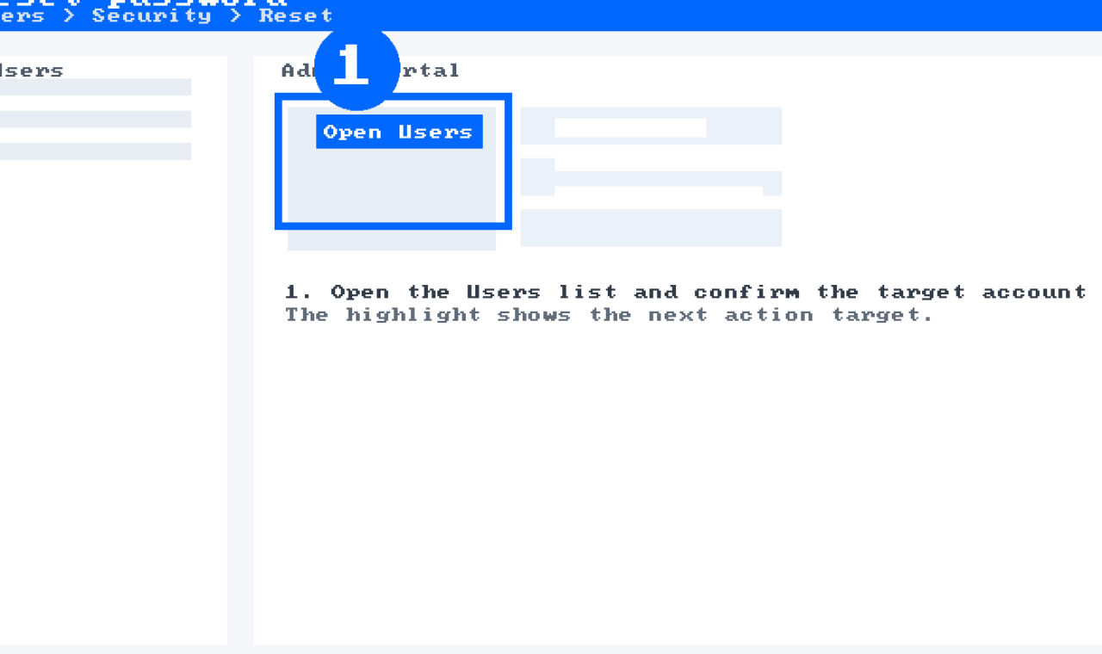
Note: Tip
Use the search box to avoid scrolling.
2. Enable the reset policy
Make sure the policy is active before continuing.
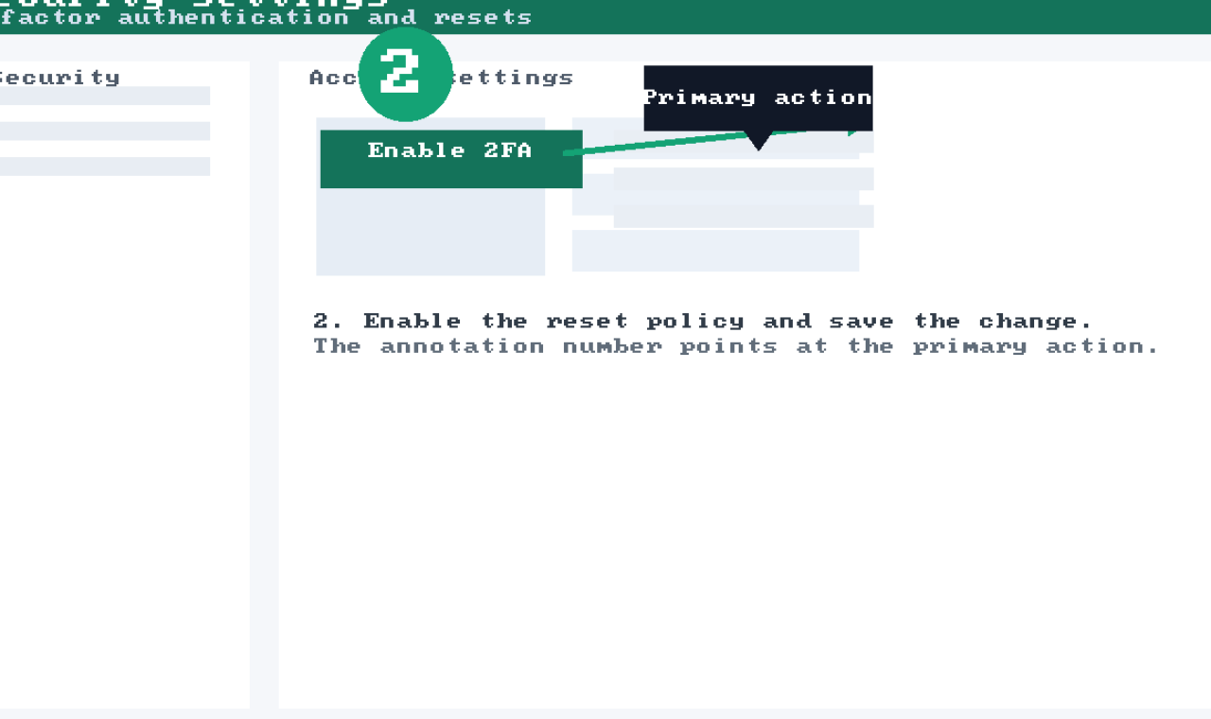
stepforge --capture --window --delay 300
2.1. Confirm permission prompt
Only administrators can complete this step.
Warning: Access
Admin rights required.
3. Review the confirmation
Confirm the summary and close the modal.
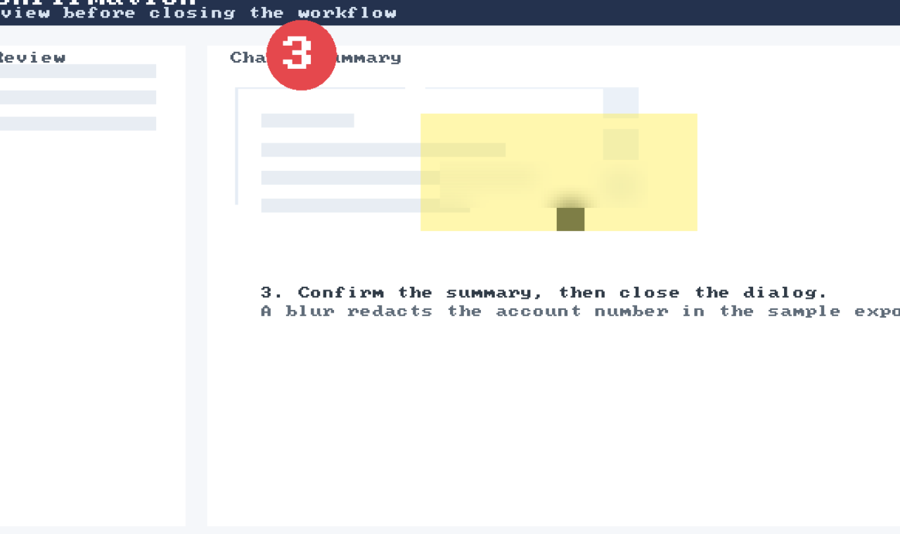
Field | Value
Title | Admin Portal
Owner | Support

