Implementing a mobile payment system mainly requires implementing of certain algorithms. In general, the algorithm has the following properties:

* discreteness. this property is that the algorithm must represent the process of solving a problem as a sequential execution simple steps. to perform each step of the algorithm, the final time interval, that is, the transformation of the original data into the result is discrete in time;
* definition. each algorithm rule must be clear, single-valued;
* efficiency. the algorithm should lead to a solution for finite number of steps;
* the mass. the algorithm for solving the problem is developed in general form, that is, it must be applicable to a certain class of problems, differing only in the initial data;
* correctness. the algorithm is correct if its execution gives correct results of solving the task.

There are different means to make algorithms. The choice of the tool is determined by the type of the algorithm to be executed. The following are ways of recording algorithms:

* Verbal: when the algorithm is described in human language.
* Symbolic, when the algorithm is described by a set of symbols.
* Graphical, when the algorithm is described using a set of graphic images. Common methods of recording are graphical recording using flowcharts.
* Versatility. The algorithm can be used for an entire class tasks, to different sets of initial data.

For this system, the key algorithm of mobile payment is the payment process between user and merchant where there is a confirmation from the merchant side. The data structure to implement this is below.

pay: a semaphore whose count is 1

confirmation: a semaphore whose count is 1

finish: a semaphore whose count is 1.

In figure 2.2 below is a flowchart describing such algorithm

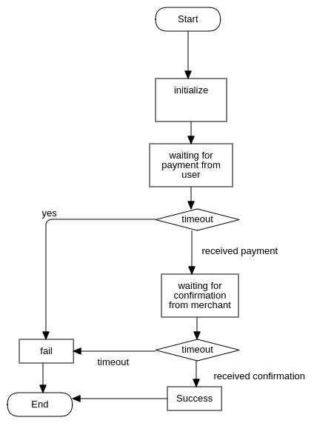

Figure 2.2 – System flowchart: user payment with confirmation

The payment process begins with initialization and then await until the some user made a payment. If the waiting process costs more than specified time, then the payment fails. Otherwise, when there is payment made, the algorithm waits for merchant confirmation, which can be sent from merchant business server. If there is a confirmation request during the scope of waiting time, the algorithm will do the final stage of the payment,which includes the persistence of certain data, make notification... etc.

Ministry of Education of the Republic of Belarus

Institution of Education

Belarusian State University

of Informatics and Radioelectronics

Faculty of Information Technologies and Control

Information Technologies in Automated Systems Department

|  |
| --- |
| *Diploma project submission permitted* |
| The Head of the Information Technologies in Automated Systems Department |
| ____________А.А. Naurotsky |

EXPLANATORY NOTE

Diploma Project

Automated Mobile Payment System

BSUIR 1-53 01 02 01 009 DP

|  |  |  |
| --- | --- | --- |
| Student |  | Tu Xinyuan |
| Supervisor |  | A.F.Trofimovich |
| Advisors: |  |  |
| * *from the Information Technologies in Automated Systems Department* |  | A.F.Trofimovich |
| * *for the Economic feasibility study* |  | I. V. Smirnov |
| Standards Compliance Inspector |  | N. V. Batin |
| Reviewer |  |  |

Minsk 2022