**Create a Simple Pipeline (S3 Bucket)**

## Step 1: Create an S3 Bucket for Your Application

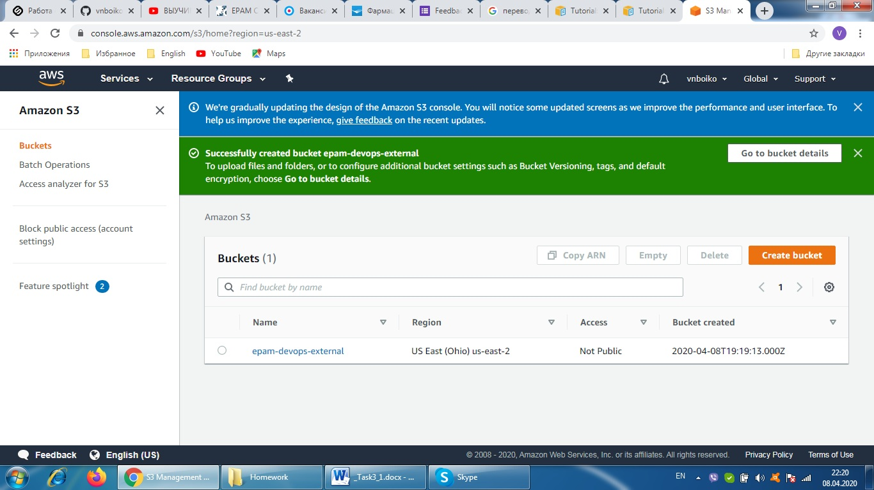

## Step 2: Create Amazon EC2 Windows Instances and Install the CodeDeploy Agent

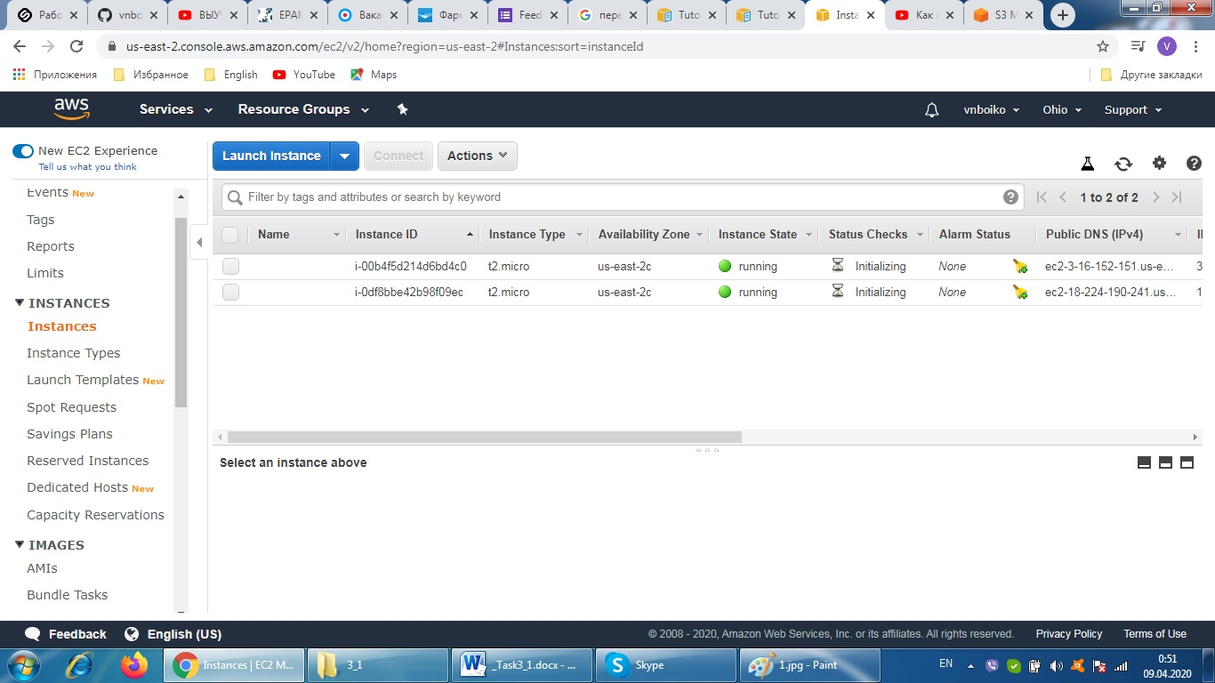

## Step 3: Create an Application in CodeDeploy

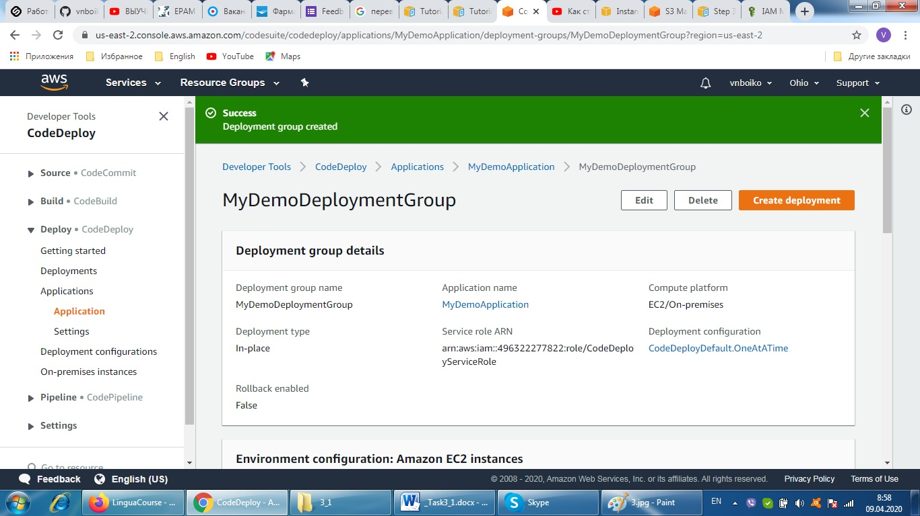

## Step 4: Create Your First Pipeline in CodePipeline

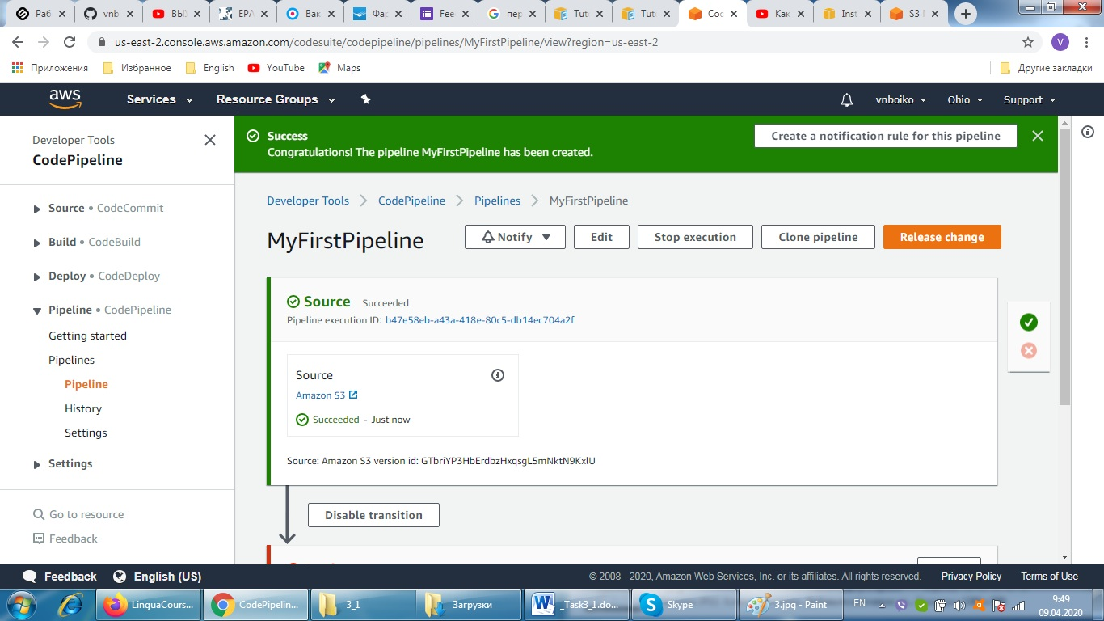

## Step 5: Add Another Stage to Your Pipeline

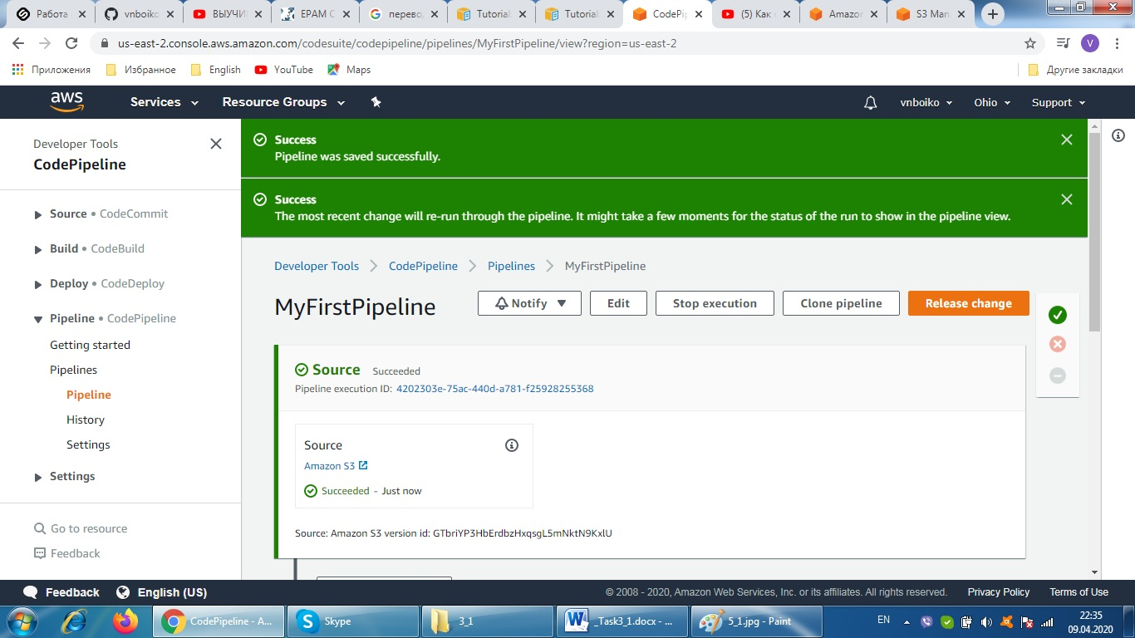

## Step 6: Disable and Enable Transitions Between Stages in CodePipeline

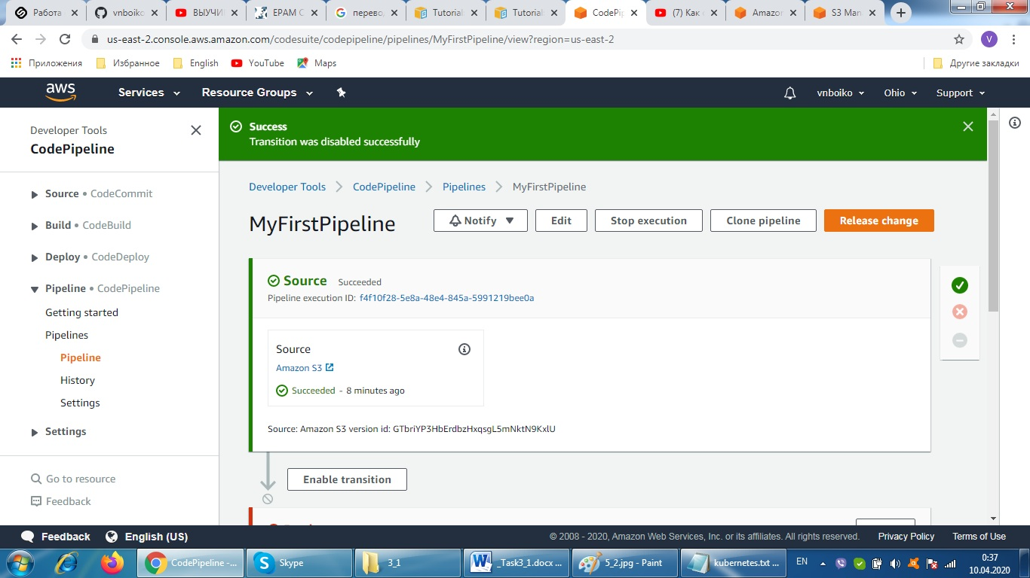

## Step 7: Clean Up Resources

