Module 4 Linux Essentials   
TASK 4.3

After you have logged into the system, do the following.   
1.Invoke pwd to see your current working directory (there should be your home directory).   
2. Collect output of these commands   
ls -l /   
lsls ~   
ls -l   
ls -a   
ls -la   
ls -lda ~   
Note differences between produced outputs. Describe (in few words) purposes of these commands.

**Pwd** print working directory

**Ls** - is a command to list computer files.

**-l** long format, permissions, number of hard links, owner, group, size, last-modified date and filename.

**-d** shows information about a symbolic link or directory, rather than about the link's target or listing the contents of a directory.

**-a** lists all files in the given directory.

**/** The root directory

**~** home directory

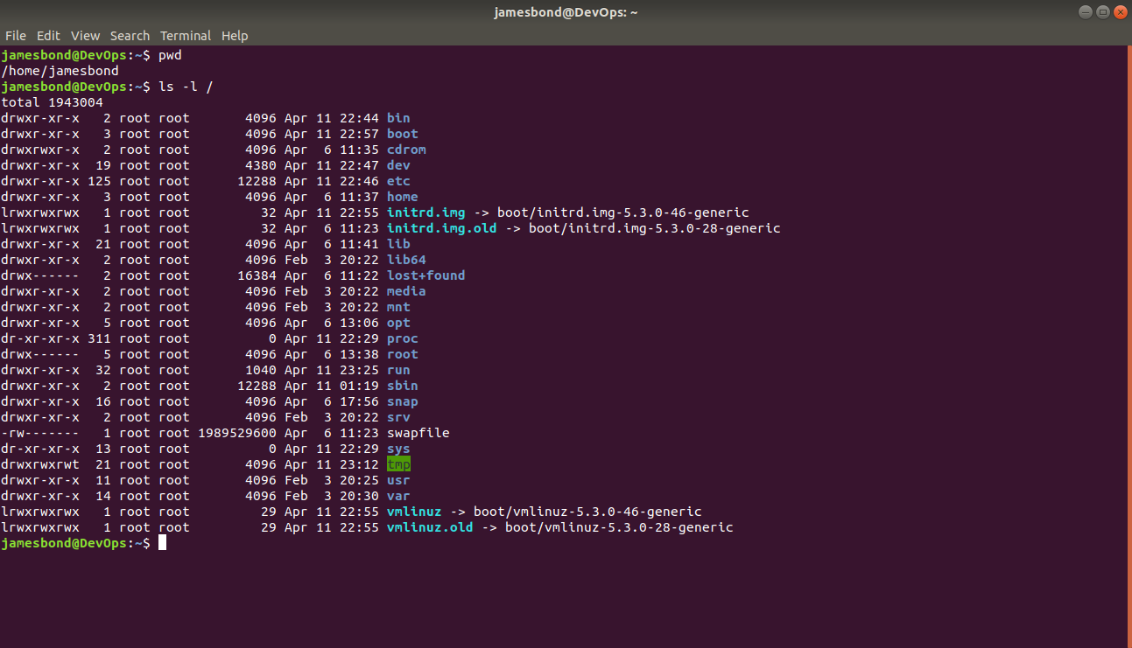

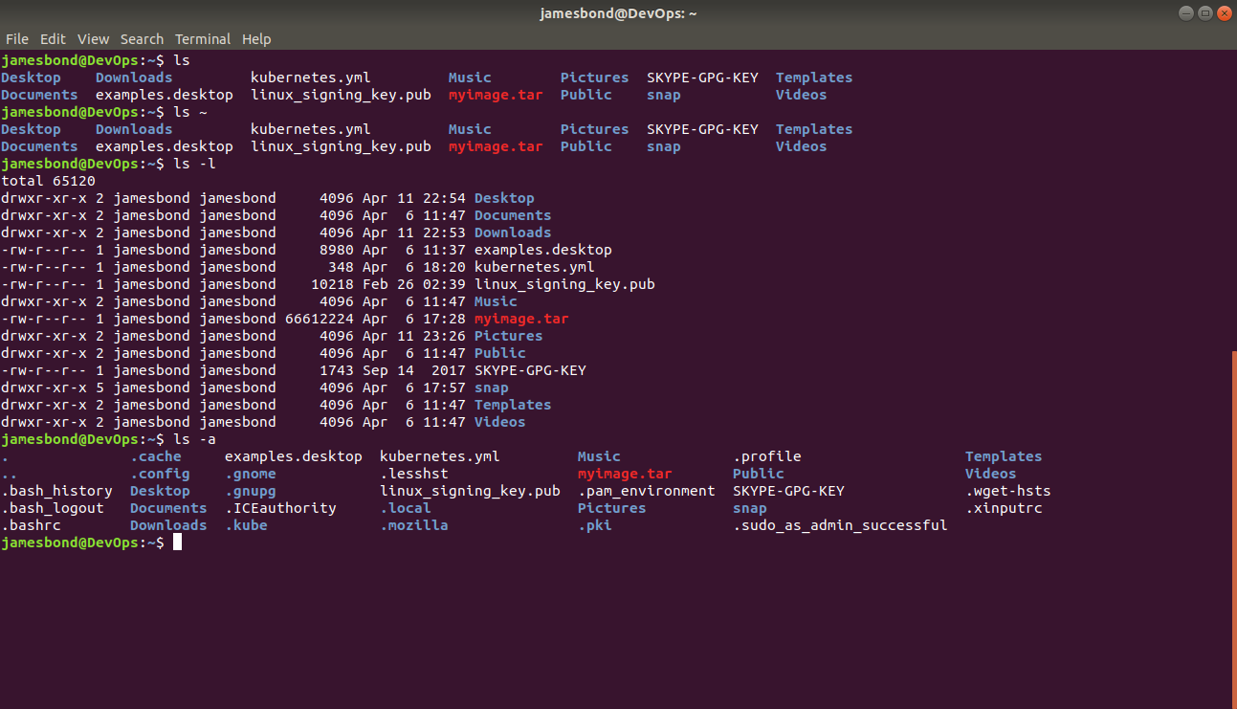

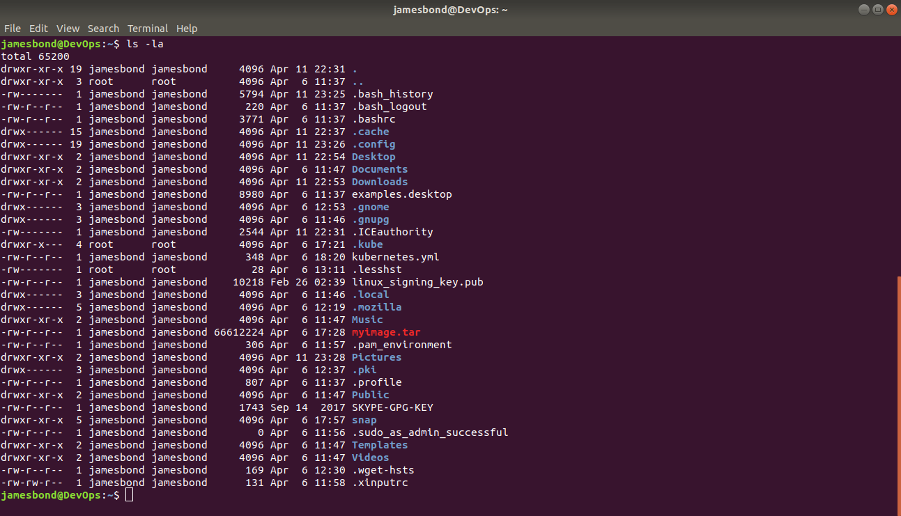

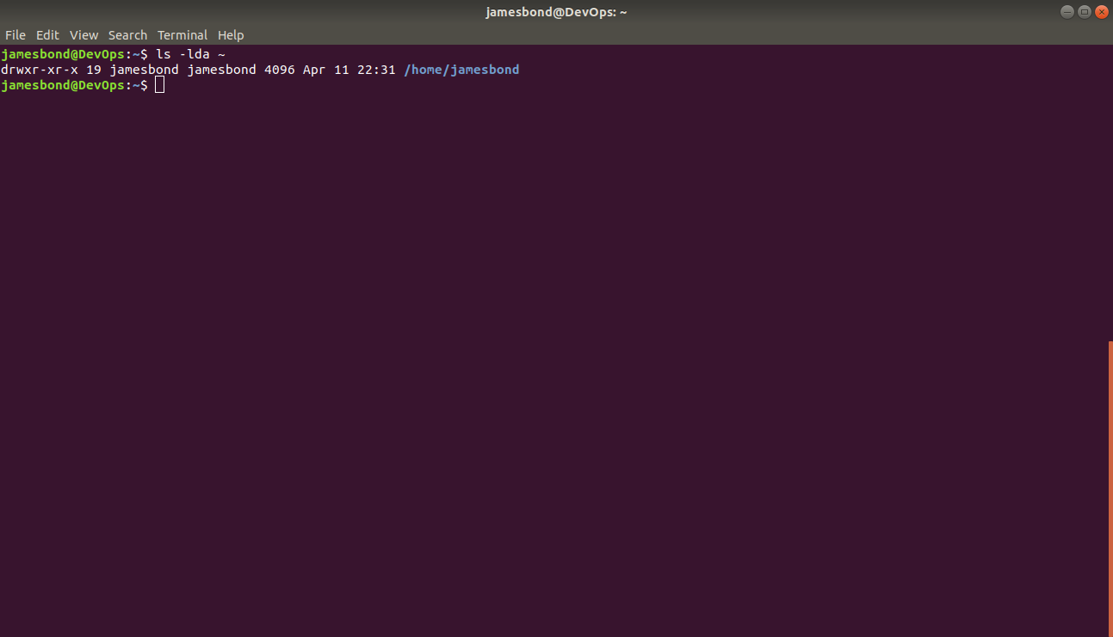

3. Execute and describe the following commands (store the output, if any):   
mkdir test   
cd test   
pwd touch test.txt   
ls -l test.txt   
mkdir test2   
mv test.txt test2   
cd test2   
ls mv test.txt test2.txt   
ls cp test2.txt ..   
cd ..   
ls rm test2.txt   
rmdir test2

**cp** copying files and directories

**mkdir** create directories

**cd**  change directory

**pwd** print working directory

**touch** Creating a new file

**mv** command for moving and renaming files

**rm**  remove objects such as files, directories, symbolic links

**rmdir** remove empty directories from the filesystem

**ls** list information about files and directories

**-r** option remove directories and their contents recursively including all files.

**-f**  option to rm command ignore nonexistent files and arguments.

**-l** option to detailed information on the directory listing

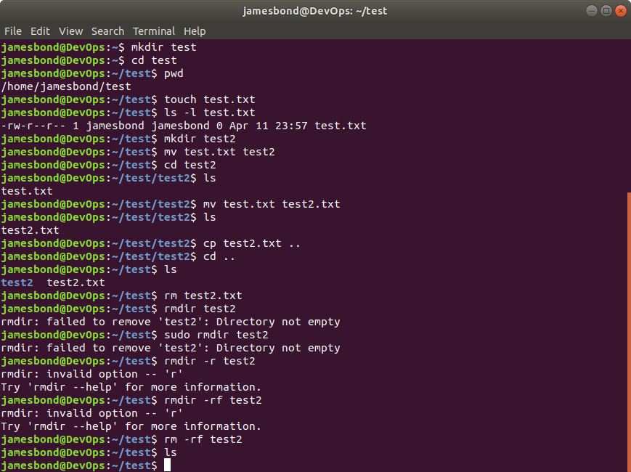

4. Execute and describe the difference   
cat /etc/fstab   
less /etc/fstab   
more /etc/fstab

Cat is a standard Unix utility that reads files sequentially, writing them to standard output.

Less used to view (but not change) the contents of a [text file](https://en.wikipedia.org/wiki/Text_file) one screen at a time.

More is a [command](https://en.wikipedia.org/wiki/Command_(computing)) to view (but not modify) the contents of a [text file](https://en.wikipedia.org/wiki/Text_file) one screen at a time.

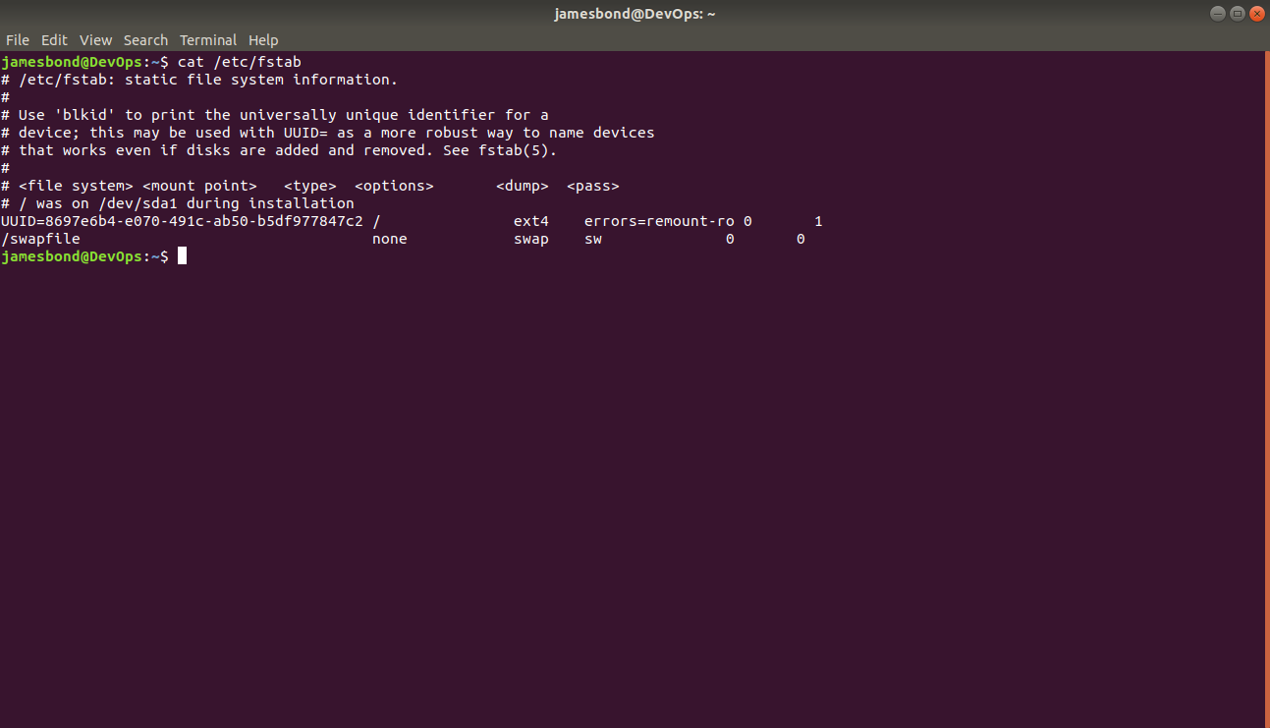

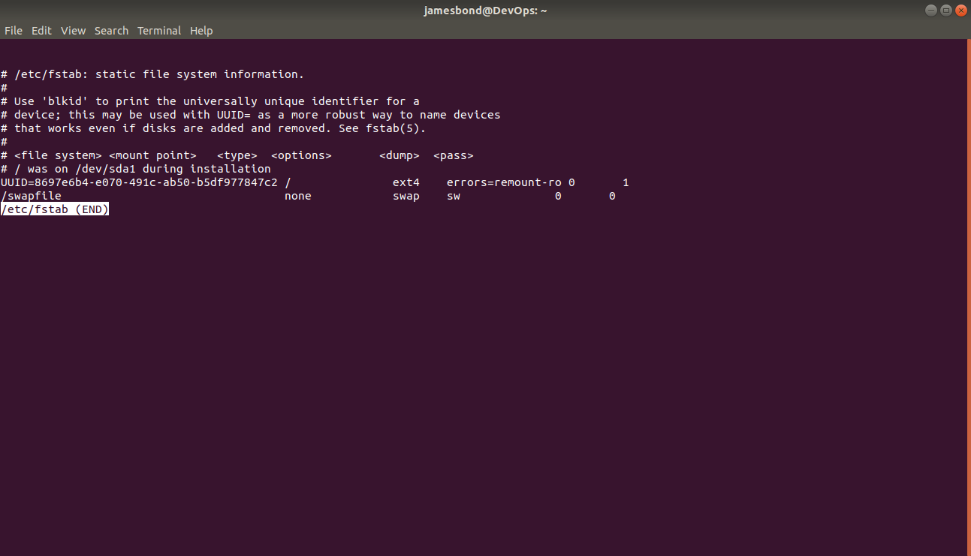

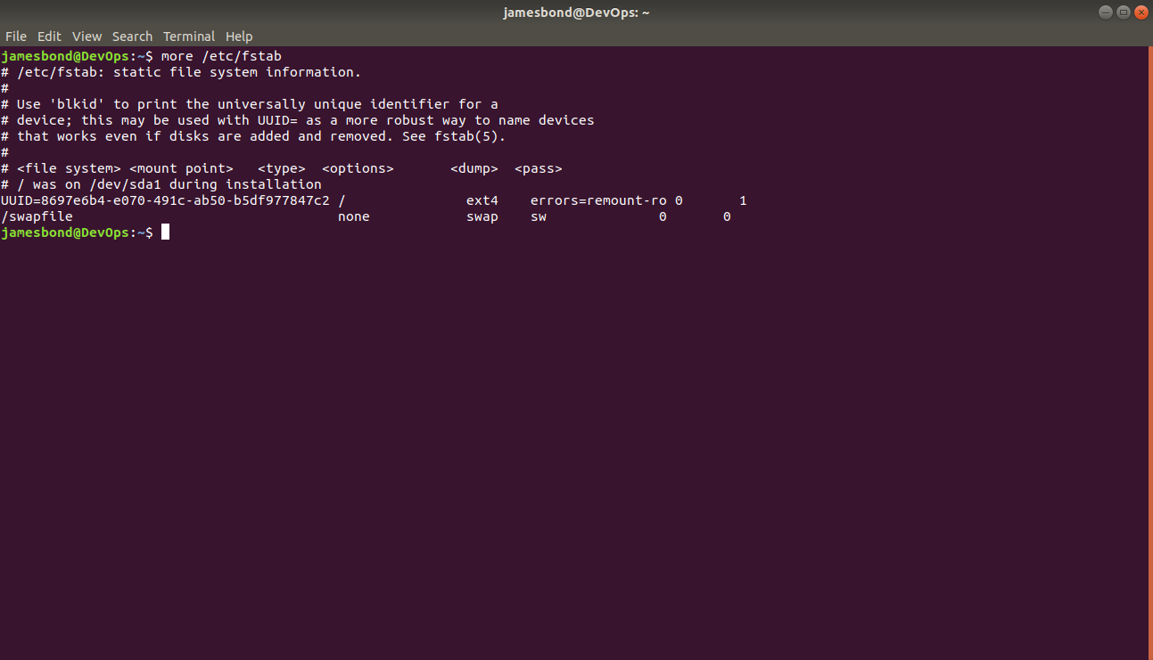

5. Add to archive all ‘test’ directories.

a. to the pure ‘tar’;

b. to the zipped ‘tar’ with only tar command;

c. to the zipped ‘tar’ with gzip command;

extract from archives all above.

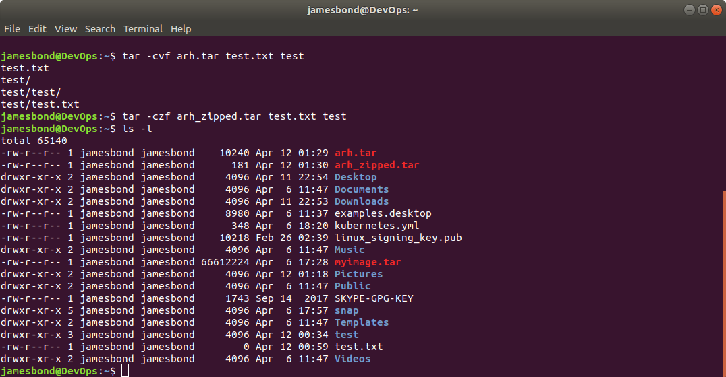

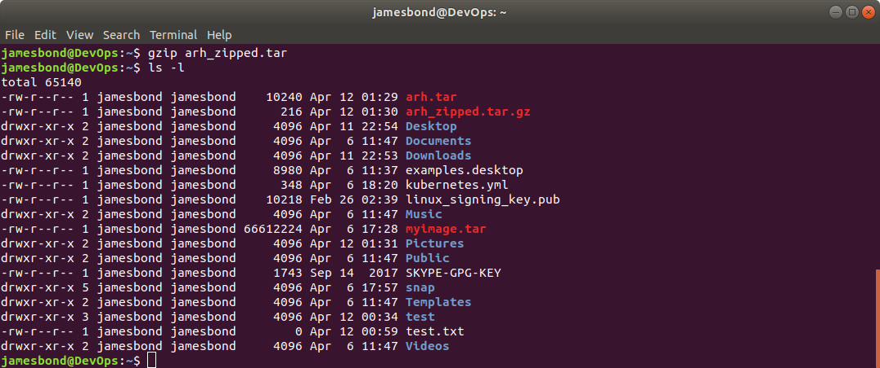

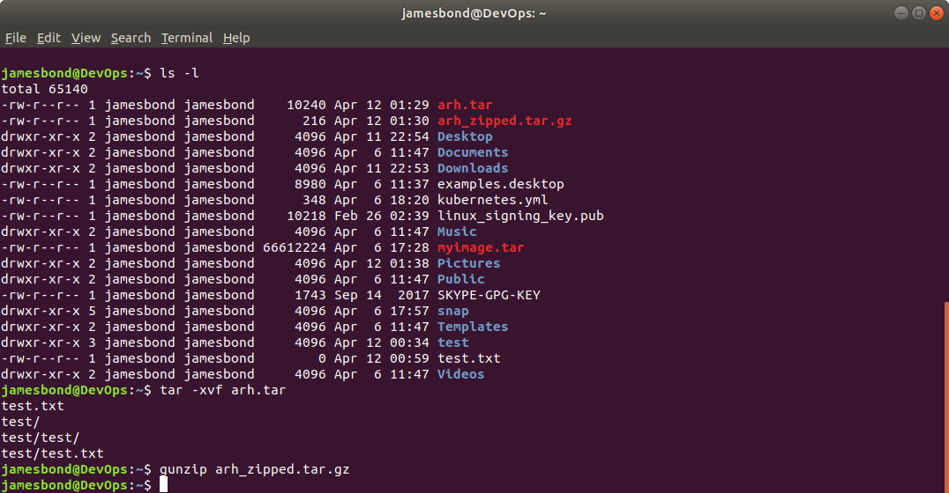

5. Look through man pages of the listed above commands.

