# Work with VirtualBox

VirtualBox is a x86 and AMD64/Intel64 virtualization product for enterprise as well as home use. Not only is VirtualBox an extremely feature rich, high performance product for enterprise customers, it is also the only professional solution that is freely available as Open Source Software under the terms of the GNU General Public License (GPL) version 2. Presently, VirtualBox runs on Windows, Linux, Macintosh, and Solaris hosts and supports many guest operating systems.

## Running Your Virtual Machine

To start a virtual machine, you have several options:

* Double-click on the VM's entry in the list in the VirtualBox Manager window.
* Select the VM's entry in the list in the VirtualBox Manager window and click Start at the top of the window.
* Go to the VirtualBox VMs folder in your system user's home directory. Find the subdirectory of the machine you want to start and double-click on the machine settings file. This file has a .vbox file extension.

Starting a virtual machine displays a new window, and the virtual machine which you selected will boot up. Everything which would normally be seen on the virtual system's monitor is shown in the window.

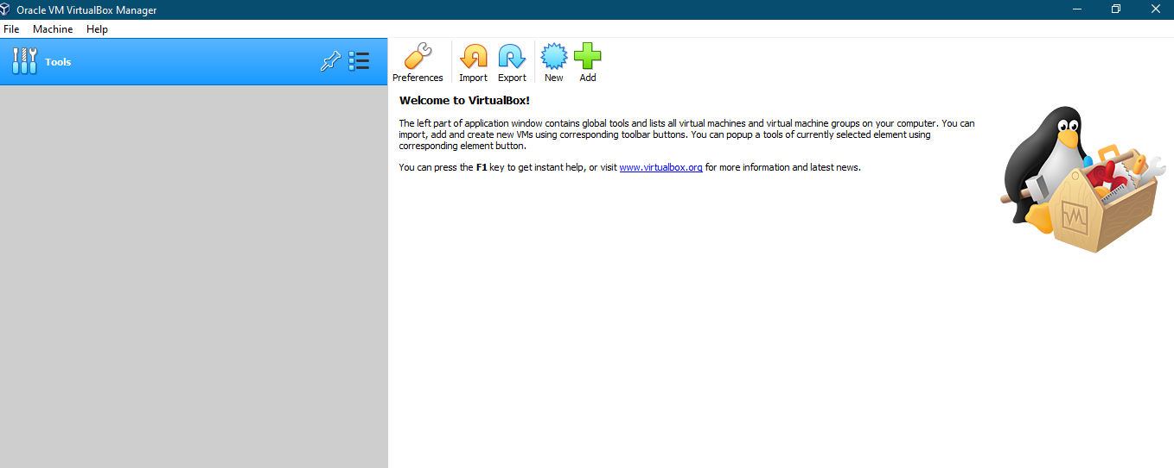

### Starting a New VM for the First Time

When a VM is started for the first time, the First Start Wizard, is displayed. This wizard helps you to select an installation medium. Since the VM is created empty, it would otherwise behave just like a real computer with no OS installed. It will do nothing and display an error message that no bootable OS was found.

For this reason, the wizard helps you to select a medium to install an OS from.

* If you have physical CD or DVD media from which you want to install your guest OS, such as a Windows installation CD or DVD, put the media into your host's CD or DVD drive.

In the wizard's drop-down list of installation media, select Host Drive with the correct drive letter. In the case of a Linux host, choose a device file. This will allow your VM to access the media in your host drive, and you can proceed to install from there.

* If you have downloaded installation media from the Internet in the form of an ISO image file such as with a Linux distribution, you would normally burn this file to an empty CD or DVD and proceed as described above. With Oracle VM VirtualBox however, you can skip this step and mount the ISO file directly. Oracle VM VirtualBox will then present this file as a CD or DVD-ROM drive to the virtual machine, much like it does with virtual hard disk images.

In this case, the wizard's drop-down list contains a list of installation media that were previously used with Oracle VM VirtualBox.

If your medium is not in the list, especially if you are using Oracle VM VirtualBox for the first time, click the small folder icon next to the drop-down list to display a standard file dialog. Here you can pick an image file on your host disks.

After completing the choices in the wizard, you will be able to install your OS.

### Choose name and OS

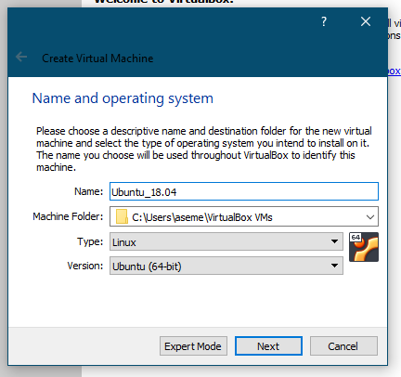

### Select the amount of memory

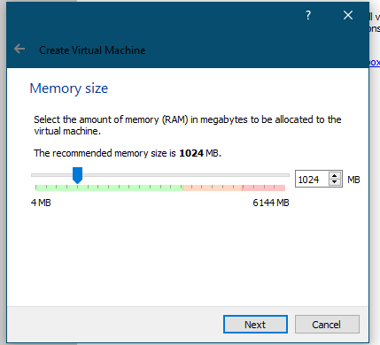

### Create new hard disk

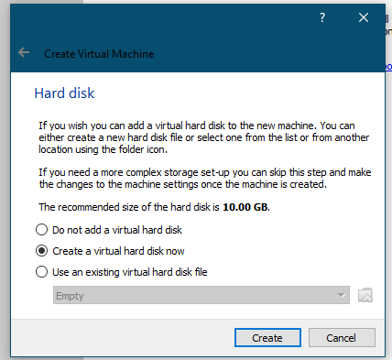

### Choose the type of file

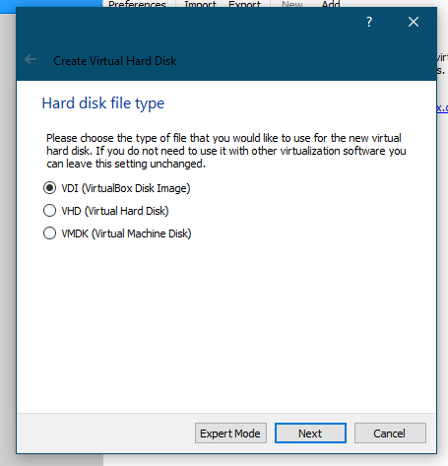

### Choose whether the new virtual hard disk should grow as it is used or if it should be created at its fixed size

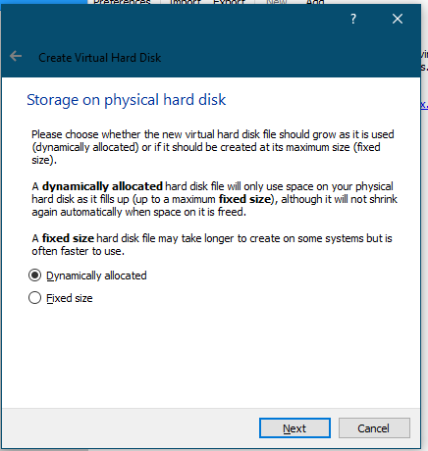

### Select the size of the virtual hard disk and type the name of the new virtual machine

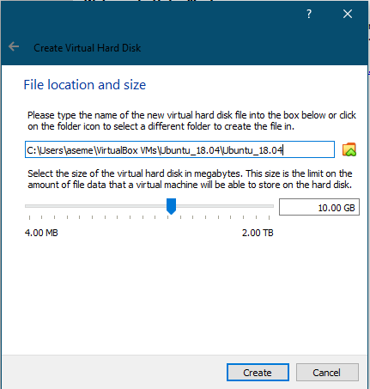

### Virtual machine created

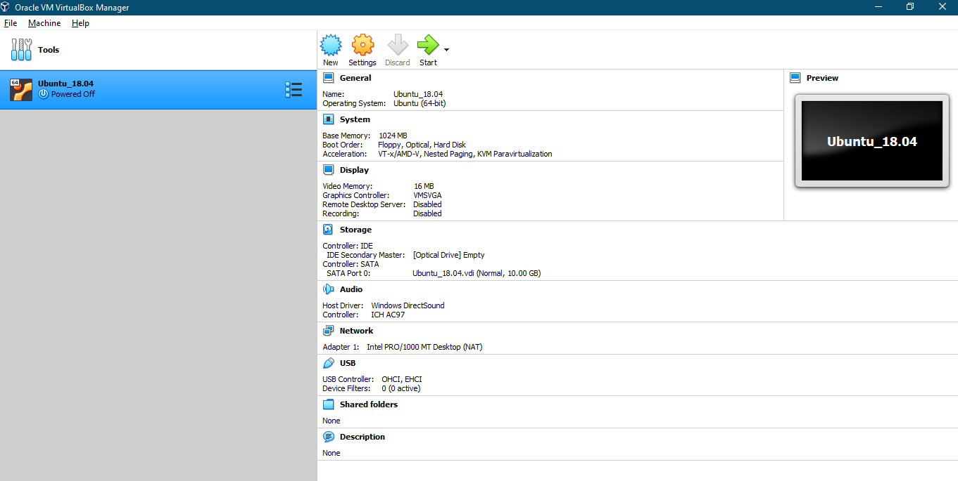

## Saving the State of the Machine

When you click on the Close button of your virtual machine window, at the top right of the window, just like you would close any other window on your system, Oracle VM VirtualBox asks you whether you want to save or power off the VM. As a shortcut, you can also press Host key + Q.

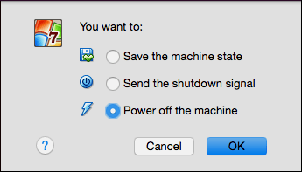

The difference between the three options is crucial. They mean the following:

* Save the machine state: With this option, Oracle VM VirtualBox freezes the virtual machine by completely saving its state to your local disk.
* Send the shutdown signal. This will send an ACPI shutdown signal to the virtual machine, which has the same effect as if you had pressed the power button on a real computer. This should trigger a proper shutdown mechanism from within the VM.
* Power off the machine: With this option, Oracle VM VirtualBox also stops running the virtual machine, but without saving its state.

## Using VM Groups

VM groups enable the user to create ad hoc groups of VMs, and to manage and perform functions on them collectively, as well as individually.

The following figure shows VM groups displayed in VirtualBox Manager.

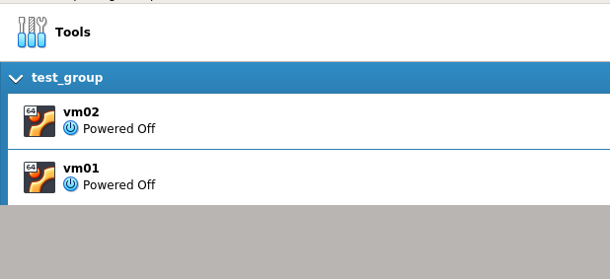

The following features are available for groups:

* Create a group using the VirtualBox Manager. Do one of the following:
  + Drag one VM on top of another VM.
  + Select multiple VMs and select Group from the right-click menu.
* Create and manage a group using the command line. Do one of the following:
  + Create a group and assign a VM. For example:

VBoxManage modifyvm "vm01" --groups "/TestGroup"

* + Detach a VM from the group and delete the group if empty. For example:

VBoxManage modifyvm "vm01" --groups ""

* Create multiple groups. For example:

VBoxManage modifyvm "vm01" --groups "/TestGroup,/TestGroup2"

* Create nested groups, having a group hierarchy. For example:

VBoxManage modifyvm "vm01" --groups "/TestGroup/TestGroup2"

* The following is a summary of group commands: Start, Pause, Reset, Close (save state, send shutdown signal, poweroff), Discard Saved State, Show in File System, Sort.

## Snapshots

With snapshots, you can save a state of a virtual machine for later use. At any later time, you can revert to that state, even though you may have changed the VM considerably since then. A snapshot of a virtual machine is thus like a machine in Saved state, but there can be many of them, and these saved states are preserved.

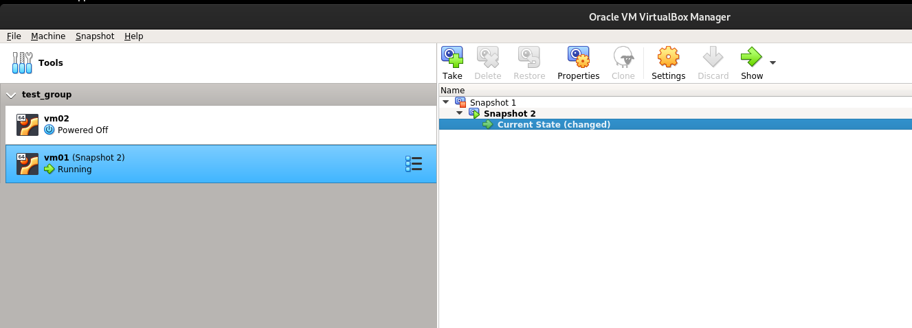To see the snapshots of a virtual machine, click on the machine name in VirtualBox Manager. Then click the List icon next to the machine name and select Snapshots. Until you take a snapshot of the machine, the list of snapshots will be empty except for the Current State item, which represents the "now" point in the lifetime of the virtual machine.

### Taking, Restoring, and Deleting Snapshots

There are three operations related to snapshots, as follows:

1. **Take a snapshot**. This makes a copy of the machine's current state, to which you can go back at any given time later.
2. **Restore a snapshot**. In the list of snapshots, right-click on any snapshot you have taken and select **Restore**. By restoring a snapshot, you go back or forward in time. The current state of the machine is lost, and the machine is restored to the exact state it was in when the snapshot was taken.
3. **Delete a snapshot**. This does not affect the state of the virtual machine, but only releases the files on disk that Oracle VM VirtualBox used to store the snapshot data, thus freeing disk space. To delete a snapshot, right-click on the snapshot name in the snapshots tree and select **Delete**. Snapshots can be deleted even while a machine is running.

## Virtual Machine Configuration

When you select a virtual machine from the list in the VirtualBox Manager window, you will see a summary of that machine's settings on the right.

Clicking on Settings displays a window, where you can configure many of the properties of the selected VM. But be careful when changing VM settings. It is possible to change all VM settings after installing a guest OS, but certain changes might prevent a guest OS from functioning correctly if done after installation.

### General Settings

In the Settings window, under General, you can configure the most fundamental aspects of the virtual machine such as memory and essential hardware. The following tabs are available.

#### Basic Tab

In the Basic tab of the General settings category, you can find these settings:

* **Name**: The name of the VM, as shown in the list of VMs in the main VirtualBox Manager window.
* **Type**: The type of the guest OS for the VM. This is the same setting that is specified in the New Virtual Machine wizard.
* **Version**: The version of the guest OS for the VM. This is the same setting that is specified in the New Virtual Machine wizard.

#### Advanced Tab

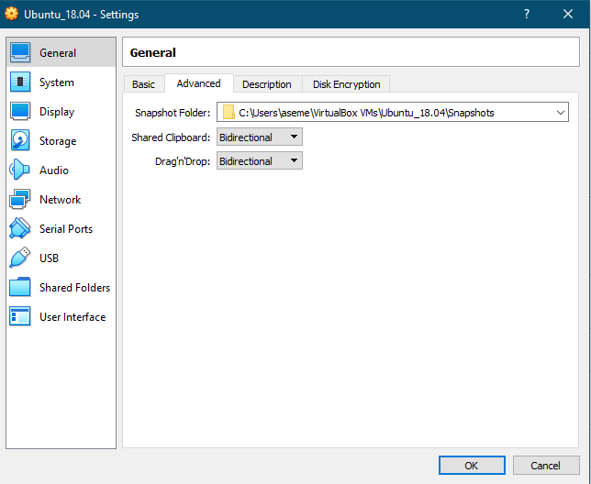

The following settings are available in the Advanced tab:

* **Snapshot Folder**: By default, Oracle VM VirtualBox saves snapshot data together with your other Oracle VM VirtualBox configuration data.
* **Shared Clipboard**: You can select here whether the clipboard of the guest OS should be shared with that of your host. If you select Bidirectional, then Oracle VM VirtualBox will always make sure that both clipboards contain the same data. If you select Host to Guest or Guest to Host, then Oracle VM VirtualBox will only ever copy clipboard data in one direction.
* **Drag and Drop**: This setting enables support for drag and drop. Select an object, such as a file, from the host or guest and directly copy or open it on the guest or host. Multiple drag and drop modes for a VM enable restricting of access in either direction.

#### Description Tab

On the Description tab you can enter a description for your virtual machine.

#### Disk Encryption Tab

The Disk Encryption tab enables you to encrypt disks that are attached to the virtual machine.

To enable disk encryption, select the Enable Disk Encryption check box.

Settings are available to configure the cipher used for encryption and the encryption password.

### System Settings

The System category groups various settings that are related to the basic hardware that is presented to the virtual machine.

#### Motherboard Tab

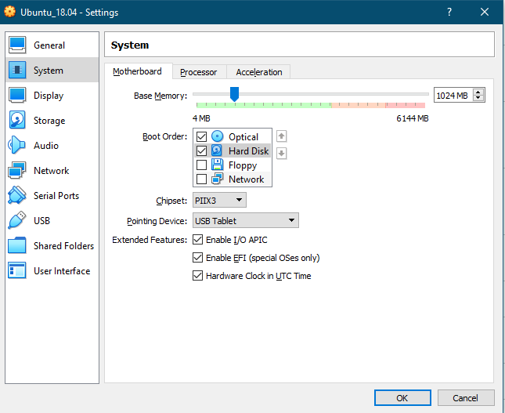

On the Motherboard tab, you can configure virtual hardware that would normally be on the motherboard of a real computer.

* **Base Memory**: Sets the amount of RAM that is allocated and given to the VM when it is running.
* **Boot Order**: Determines the order in which the guest OS will attempt to boot from the various virtual boot devices.
* **Chipset**: You can select which chipset will be presented to the virtual machine.
* **Pointing Device**: The default virtual pointing device for some guest OSes is the traditional PS/2 mouse.
* **Enable I/O APIC**: Advanced Programmable Interrupt Controllers (APICs) are an x86 hardware feature that have replaced Programmable Interrupt Controllers (PICs). With an I/O APIC, OSes can use more than 16 interrupt requests (IRQs) and therefore avoid IRQ sharing for improved reliability.
* **Enable EFI**: Enables Extensible Firmware Interface (EFI), which replaces the legacy BIOS and may be useful for certain advanced use cases.
* **Hardware Clock in UTC Time**: If selected, Oracle VM VirtualBox will report the system time in UTC format to the guest instead of the local (host) time.

#### Processor Tab

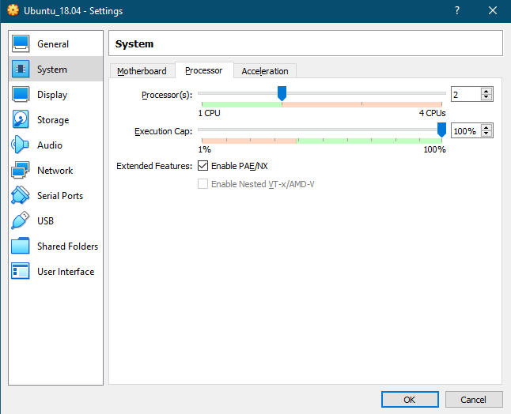

On the Processor tab, you can configure settings for the CPU used by the virtual machine.

* **Processor(s)**: Sets the number of virtual CPU cores the guest OSes can see.
* **Execution Cap**: Configures the CPU execution cap.
* **Enable PAE/NX**: Determines whether the PAE and NX capabilities of the host CPU will be exposed to the virtual machine.
* **Enable Nested VT-x/AMD-V**: Enables nested virtualization, with passthrough of hardware virtualization functions to the guest VM.

#### Acceleration Tab

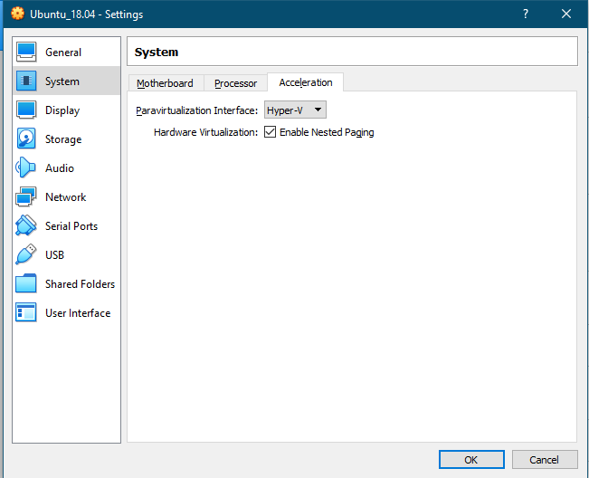

On this tab, you can configure Oracle VM VirtualBox to use hardware virtualization extensions that your host CPU supports.

* **Paravirtualization Interface**: Oracle VM VirtualBox provides paravirtualization interfaces to improve time-keeping accuracy and performance of guest OSes.
* **Hardware Virtualization**: You can configure hardware virtualization features for each virtual machine.
  + **Enable Nested Paging:** If the host CPU supports the nested paging (AMD-V) or EPT (Intel VT-x) features, then you can expect a significant performance increase by enabling nested paging in addition to hardware virtualization.

### Display Settings

The following tabs are available for configuring the display for a virtual machine.

#### Screen Tab

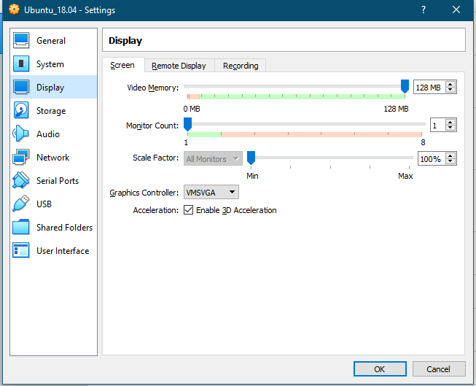

* **Video Memory**: Sets the size of the memory provided by the virtual graphics card available to the guest, in MB.
* **Monitor Count**: With this setting, Oracle VM VirtualBox can provide more than one virtual monitor to a virtual machine.
* **Scale Factor**: Enables scaling of the display size.
* **Graphics Controller**: Specifies the graphics adapter type used by the guest VM. Note that you must install the Guest Additions on the guest VM to specify the VBoxSVGA or VMSVGA graphics controller. The following options are available:
  + **VBoxSVGA**: The default graphics controller for new VMs that use Windows 7 or later.
  + **VBoxVGA**: Use this graphics controller for legacy guest OSes. This is the default graphics controller for Windows versions before Windows 7 and for Oracle Solaris.
  + **VMSVGA**: Use this graphics controller to emulate a VMware SVGA graphics device. This is the default graphics controller for Linux guests.
  + **None**: Does not emulate a graphics adapter type.
* **Enable 3D Acceleration**: If a virtual machine has Guest Additions installed, you can select here whether the guest should support accelerated 3D graphics.
* **Enable 2D Video Acceleration**: If a virtual machine with Microsoft Windows has Guest Additions installed, you can select here whether the guest should support accelerated 2D video graphics.

#### Remote Display Tab

On the Remote Display tab, if the VirtualBox Remote Display Extension (VRDE) is installed, you can enable the VRDP server that is built into Oracle VM VirtualBox. This enables you to connect to the console of the virtual machine remotely with any standard RDP viewer, such as mstsc.exe that comes with Microsoft Windows. On Linux and Oracle Solaris systems you can use the standard open source rdesktop program.

#### Recording Tab

On the Recording tab you can enable video and audio recording for a virtual machine and change related settings. Note that these features can be enabled and disabled while a VM is running.

### Storage Settings

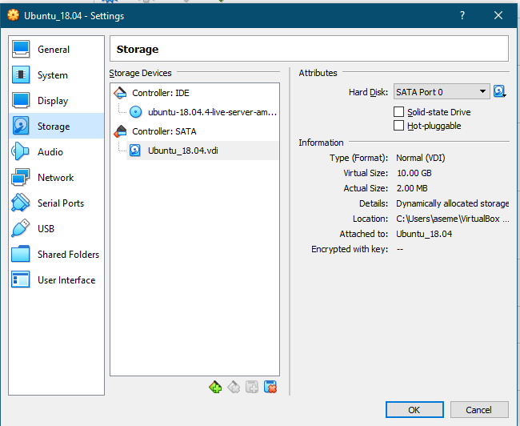

The Storage category in the VM settings enables you to connect virtual hard disk, CD/DVD, and floppy images and drives to your virtual machine.

### Audio Settings

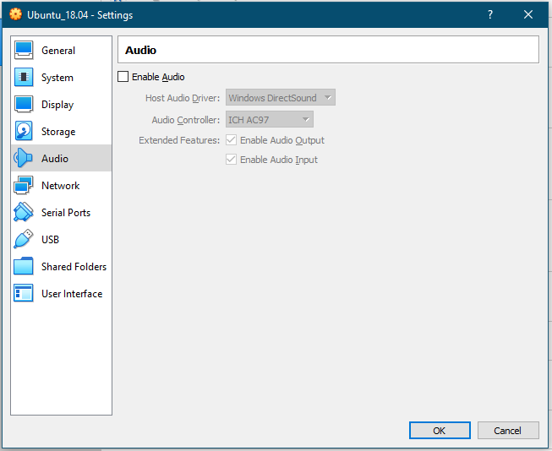

The Audio section in a virtual machine's Settings window determines whether the VM will detect a connected sound card, and if the audio output should be played on the host system.

### Network Settings

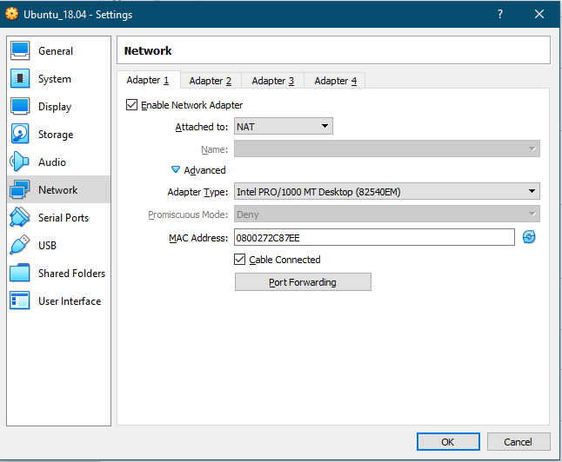

The Network section in a virtual machine's Settings window enables you to configure how Oracle VM VirtualBox presents virtual network cards to your VM, and how they operate.

### Serial Ports

Oracle VM VirtualBox supports the use of virtual serial ports in a virtual machine.

### USB Support

The USB section in a virtual machine's Settings window enables you to configure Oracle VM VirtualBox's sophisticated USB support.

### Shared Folders

Shared folders enable you to easily exchange data between a virtual machine and your host. This feature requires that the Oracle VM VirtualBox Guest Additions be installed in a virtual machine.

### User Interface

The User Interface section enables you to change certain aspects of the user interface of this VM.

### Start Virtual machine

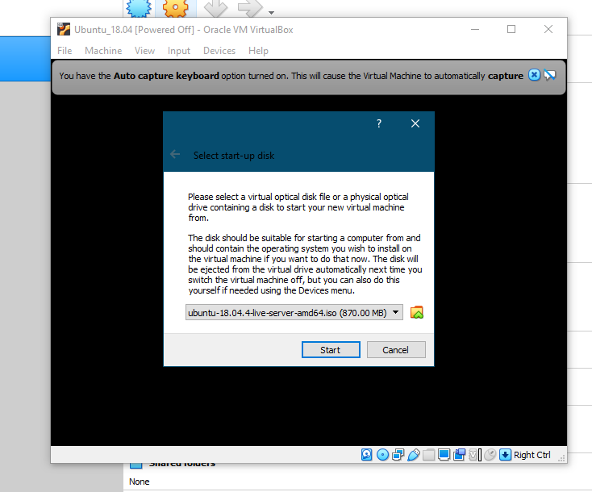

#### Installation OS in VM

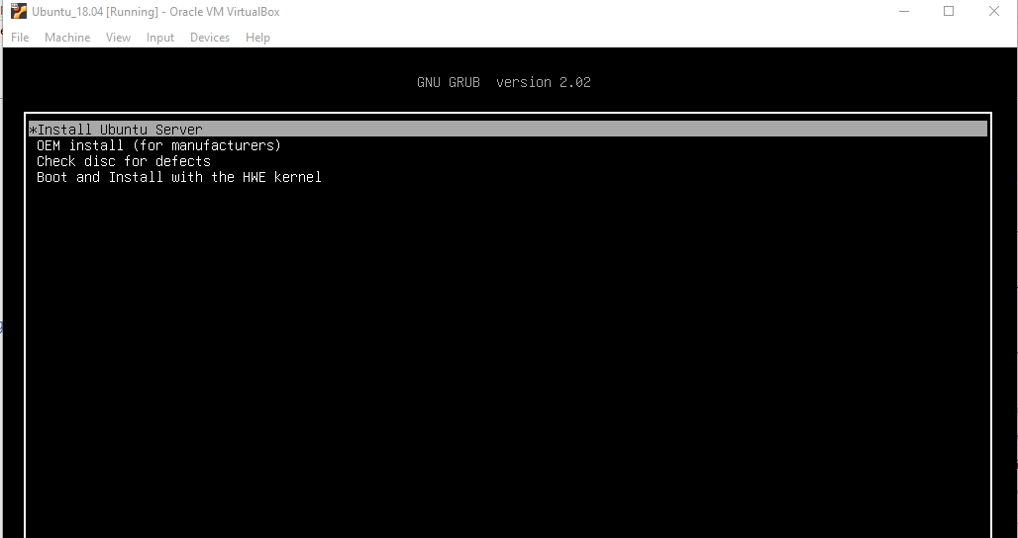

#### Choose language OS

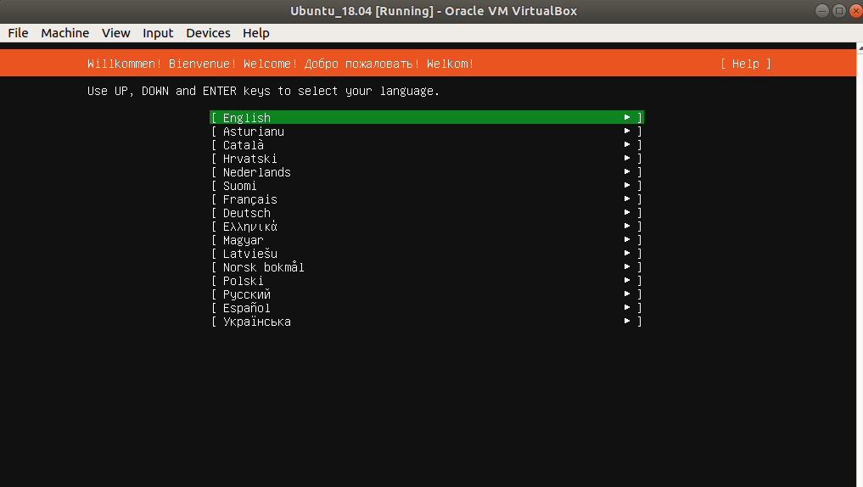

#### Choose keyboard input

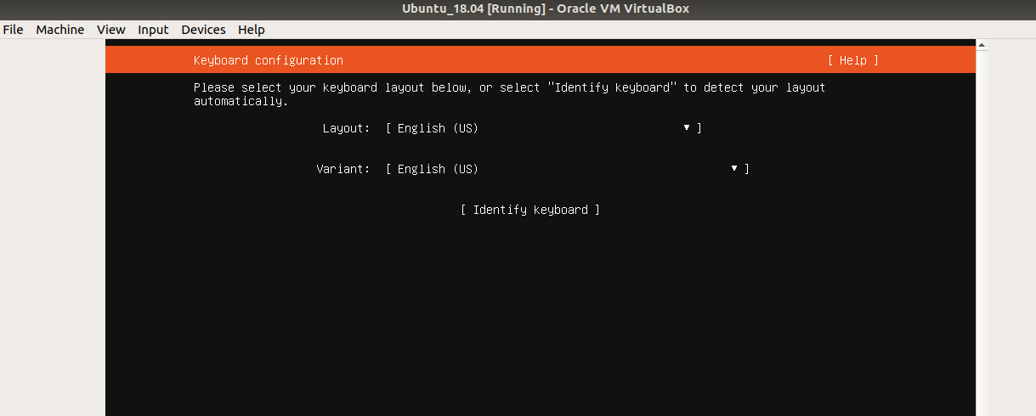

#### Configure network settings

#### Configure archive mirror

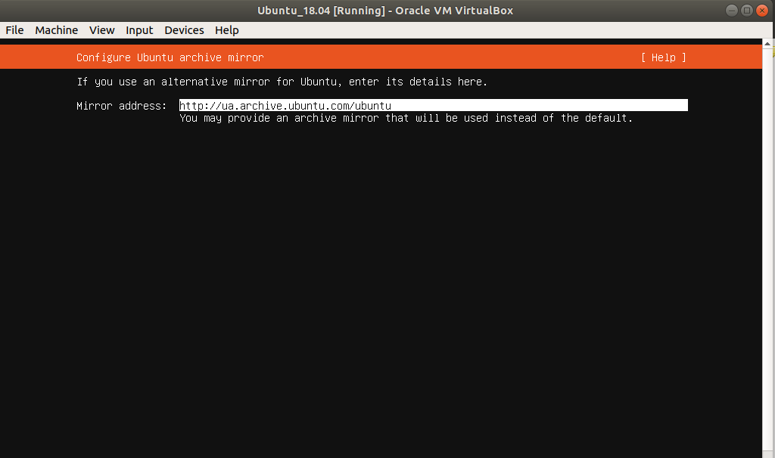

#### Configure proxy setting

#### Configure storage

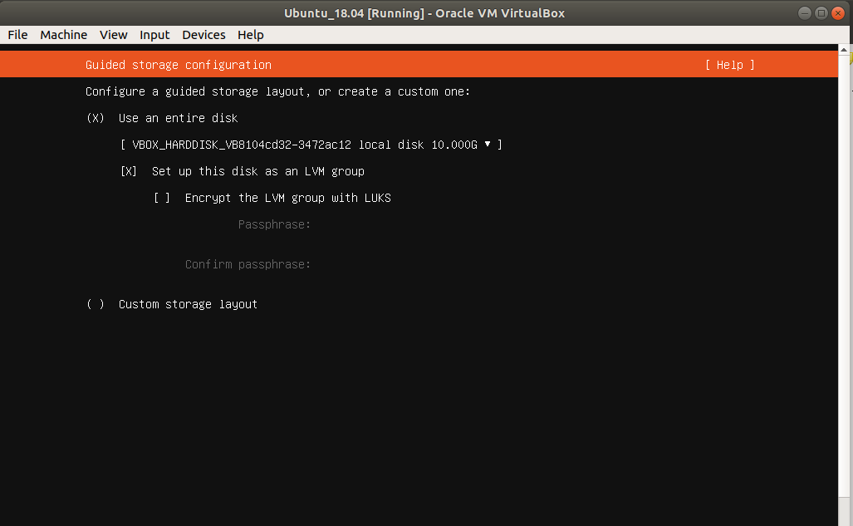

#### 

#### Create system user and name server

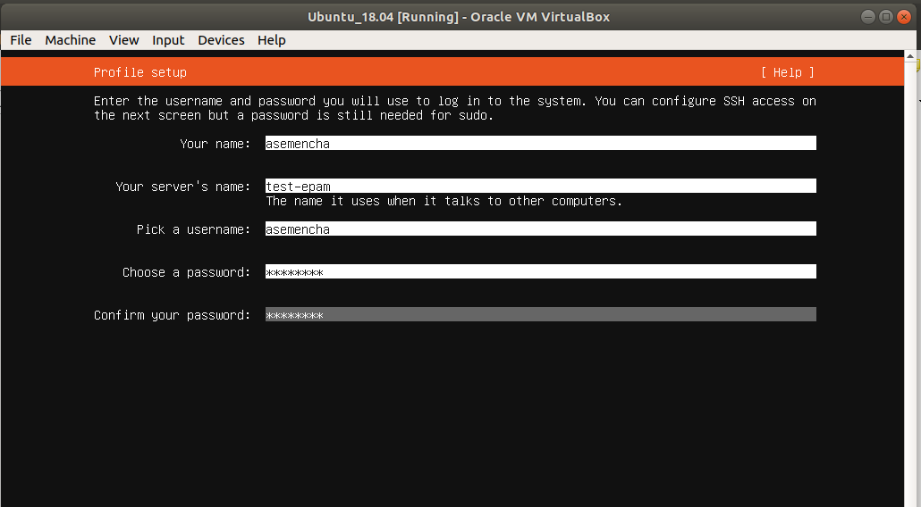

#### Install and configured SSH server

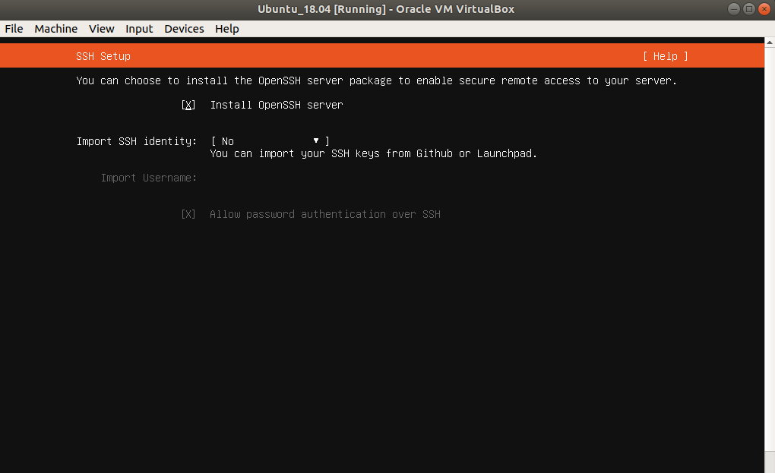

#### Choose feature

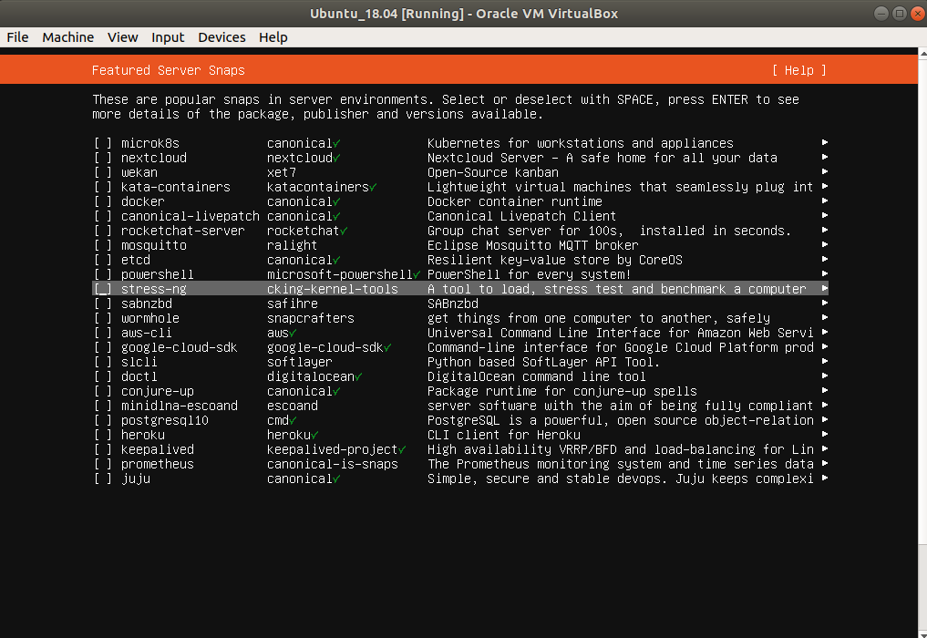

#### Progress installation

#### Firs launch in OS

## Cloning Virtual Machines

You can create a full copy or a linked copy of an existing VM. This copy is called a clone. You might use a cloned VM to experiment with a VM configuration, to test different guest OS levels, or to back up a VM.

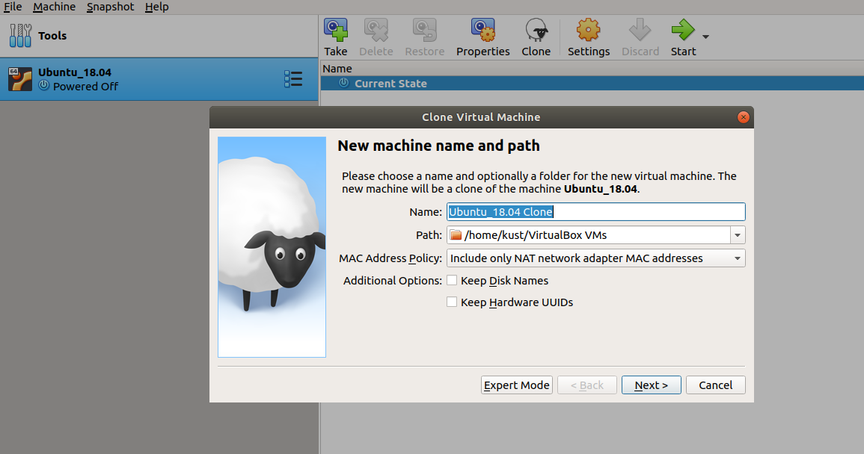The Clone Virtual Machine wizard guides you through the cloning process.

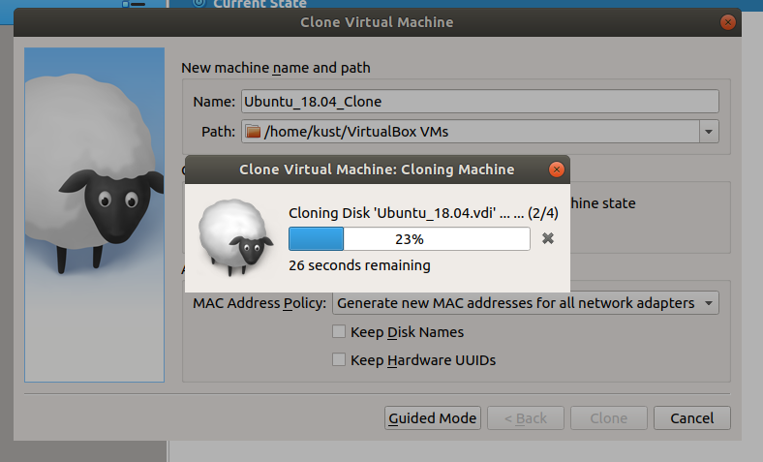

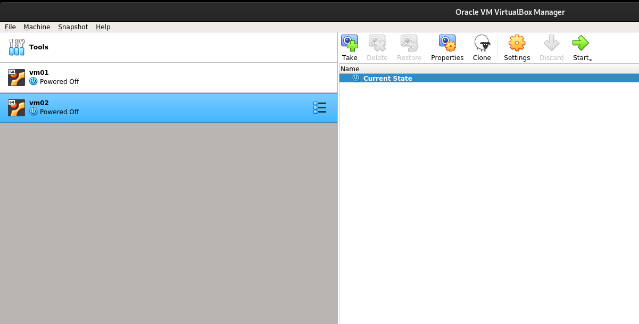

Start the wizard by clicking Clone in the right-click menu of the VirtualBox Manager's machine list or in the Snapshots view of the selected VM.

Specify a new Name for the clone. You can choose a Path for the cloned virtual machine, otherwise Oracle VM VirtualBox uses the default machines folder.

The Clone Type option specifies whether to create a clone linked to the source VM or to create a fully independent clone:

* Full Clone: Copies all dependent disk images to the new VM folder. A full clone can operate fully without the source VM.
* Linked Clone: Creates new differencing disk images based on the source VM disk images. If you select the current state of the source VM as the clone point, Oracle VM VirtualBox creates a new snapshot.

The Snapshots option specifies whether to create a clone of the current machine state only or of everything.

* Everything: Clones the current machine state and all its snapshots.
* Current Machine State and All Children: Clones a VM snapshot and all its child snapshots.

The following clone options are available:

* MAC Address Policy: Specifies how to retain network card MAC addresses when cloning the VM.
* Keep Disk Names: Retains the disk image names when cloning the VM.
* Keep Hardware UUIDs: Retains the hardware universally unique identifiers (UUIDs) when cloning the VM.

The duration of the clone operation depends on the size and number of attached disk images. In addition, the clone operation saves all the differencing disk images of a snapshot.

Note that the Clone menu item is disabled while a machine is running.

## Importing and Exporting Virtual Machines

Oracle VM VirtualBox can import and export virtual machines in the following formats:

* Open Virtualization Format (OVF). This is the industry-standard format.
* Cloud service formats. Export to and import from cloud services such as Oracle Cloud Infrastructure is supported.

### The OVF Format

OVF is a cross-platform standard supported by many virtualization products which enables the creation of ready-made virtual machines that can then be imported into a hypervisor such as Oracle VM VirtualBox. Oracle VM VirtualBox makes OVF import and export easy to do, using the VirtualBox Manager window or the command-line interface.

Using OVF enables packaging of virtual appliances. These are disk images, together with configuration settings that can be distributed easily. This way one can offer complete ready-to-use software packages, including OSes with applications, that need no configuration or installation except for importing into Oracle VM VirtualBox.

### Importing an Appliance in OVF Format

The following steps show how to import an appliance in OVF format.

1. Double-click on the OVF or OVA file.

Oracle VM VirtualBox creates file type associations automatically for any OVF and OVA files on your host OS.

1. Select File, Import Appliance from the VirtualBox Manager window.

From the file dialog, go to the file with either the .ovf or the .ova file extension.

Click Import to open the Appliance Settings screen.

By default, membership of VM groups is preserved on import for VMs that were initially exported from Oracle VM VirtualBox. You can change this behavior by using the Primary Group setting for the VM.

The following global settings apply to all the VMs that you import:

* Base Folder: Specifies the directory on the host in which to store the imported VMs.

If an appliance has multiple VMs, you can specify a different directory for each VM by editing the Base Folder setting for the VM.

* MAC Address Policy: Reinitializes the MAC addresses of network cards in your VMs prior to import, by default. You can override the default behavior and preserve the MAC addresses on import.
* Import Hard Drives as VDI: Imports hard drives in the VDI format rather than in the default VMDK format.

1. Click Import to import the appliance.

Oracle VM VirtualBox copies the disk images and creates local VMs with the settings described on the Appliance Settings screen. The imported VMs are shown in the list of VMs in VirtualBox Manager.

Because disk images are large, the VMDK images that are included with virtual appliances are shipped in a compressed format that cannot be used directly by VMs. So, the images are first unpacked and copied, which might take several minutes.

### Exporting an Appliance in OVF Format

The following steps show how to export an appliance in OVF format.

1. Select File, Export Appliance to open the Export Virtual Appliance wizard.

From the initial window, you can combine several VMs into an OVF appliance.

Select one or more VMs to export and click Next.

1. The Appliance Settings screen enables you to select the following settings:

* Format: Selects the Open Virtualization Format value for the output files.
* File: Selects the location in which to store the exported files.
* MAC Address Policy: Specifies whether to retain or reassign network card MAC addresses on export.
* Write Manifest File: Enables you to include a manifest file in the exported archive file.
* Include ISO Image Files: Enables you to include ISO image files in the exported archive file.

1. Click Next to show the Virtual System Settings screen.

You can edit settings for the virtual appliance. For example, you can change the name of the virtual appliance or add product information, such as vendor details or license text.

Double-click the appropriate field to change its value.

1. Click Export to begin the export process. Note that this operation might take several minutes.

## Testing VM

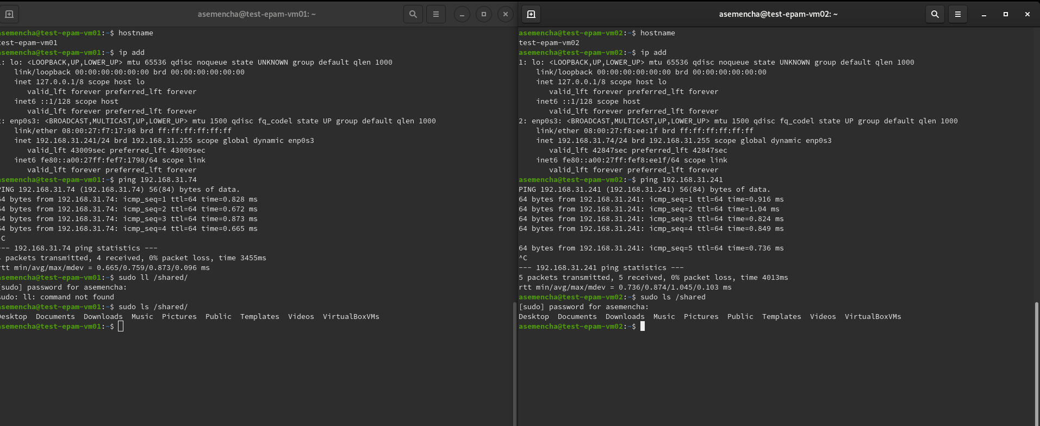

# Working with CLI via VboxManage

### List all registered vm

### Show information about VM

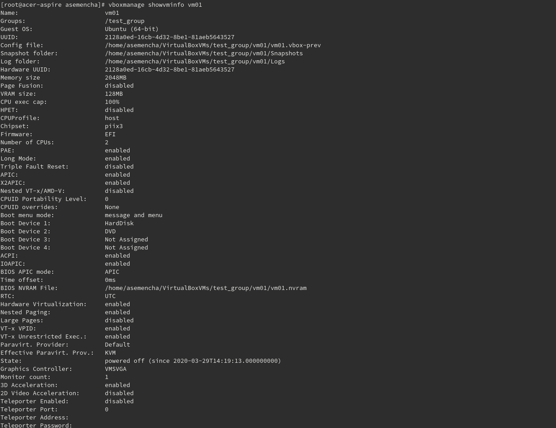

### Manage VM with CLI

### Change characteristic VM with CLI

### Clone VM with CLI

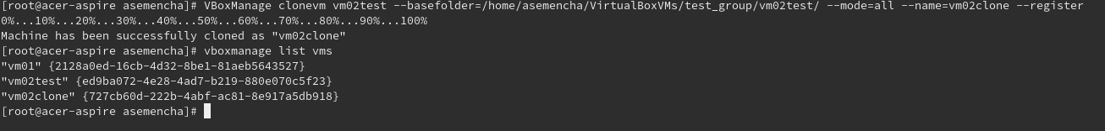Create snapshot with CLI

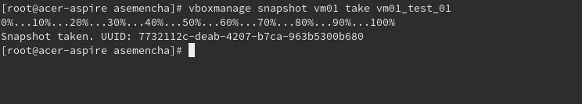

### Create VM with CLI

