# Docker

A container is a standard unit of software that packages up code and all its dependencies, so the application runs quickly and reliably from one computing environment to another. A Docker container image is a lightweight, standalone, executable package of software that includes everything needed to run an application: code, runtime, system tools, system libraries and settings.

Container images become containers at runtime and in the case of Docker containers - images become containers when they run on Docker Engine. Available for both Linux and Windows-based applications, containerized software will always run the same, regardless of the infrastructure. Containers isolate software from its environment and ensure that it works uniformly despite differences for instance between development and staging.

Docker containers that run on Docker Engine:

* **Standard**: Docker created the industry standard for containers, so they could be portable anywhere
* **Lightweight**: Containers share the machine’s OS system kernel and therefore do not require an OS per application, driving higher server efficiencies and reducing server and licensing costs
* **Secure**: Applications are safer in containers and Docker provides the strongest default isolation capabilities in the industry

## Docker Desktop for Windows

Docker Desktop for Windows is the Community version of Docker for Microsoft Windows.

### What’s included in the installer

The Docker Desktop installation includes Docker Engine, Docker CLI client, Docker Compose, Notary, Kubernetes, and Credential Helper.

Containers and images created with Docker Desktop are shared between all user accounts on machines where it is installed. This is because all Windows accounts use the same VM to build and run containers.

Nested virtualization scenarios, such as running Docker Desktop on a VMWare or Parallels instance might work, but there are no guarantees.

## Install Docker Desktop on Windows

1. Double-click Docker Desktop Installer.exe to run the installer.
2. Follow the instructions on the installation wizard to accept the license, authorize the installer, and proceed with the install.
3. Click Finish on the setup complete dialog and launch the Docker Desktop application.

## Start Docker Desktop

Docker Desktop does not start automatically after installation. To start Docker Desktop, search for Docker, and select Docker Desktop in the search results.

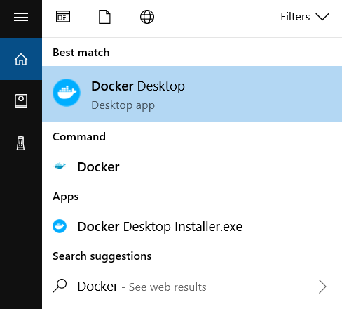

When the whale icon in the status bar stays steady, Docker Desktop is up-and-running, and is accessible from any terminal window.



If the whale icon is hidden in the Notifications area, click the up arrow on the taskbar to show it. To learn more, see Docker Settings.

After installing the Docker Desktop app, you also get a pop-up success message with suggested next steps, and a link to this documentation.

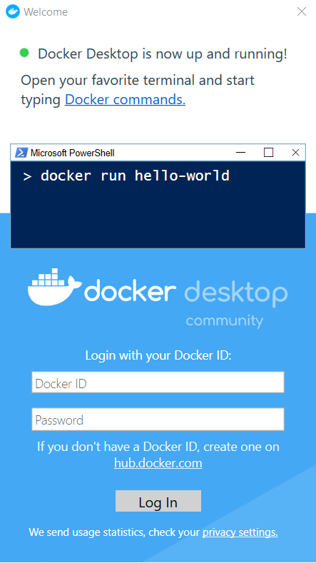

When initialization is complete, click the whale icon in the Notifications area and select About Docker Desktop to verify that you have the latest version.

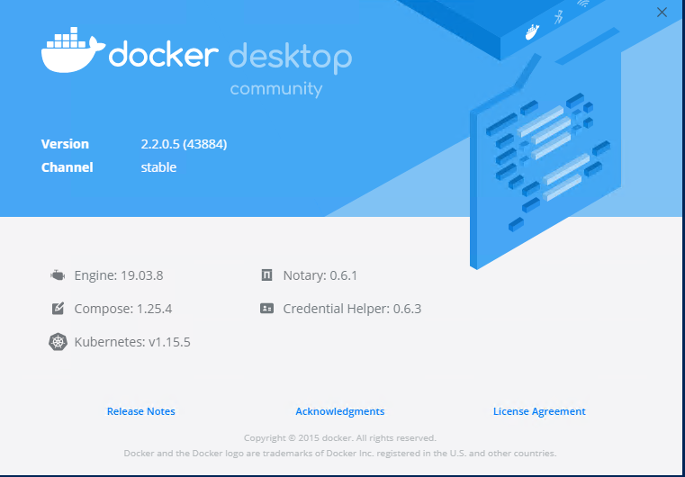

## Docker: basic set of commands

### docker create

This Docker command allows you to create a new container. Command syntax:

***docker create [options] IMAGE [commands] [arguments]***

### docker ps

The command docker ps allows you to see all containers running on the host.

***docker ps***

Displaying only those containers that are running now. If you want to see all containers created on this host in general, regardless of their current status, you need to add the -a option to the command.

***docker ps -a***

### docker start

This command starts any stopped container. Command syntax:

***docker start [options] CONTAINER ID/NAME [CONTAINER ID/NAME…]***

### docker stop

This command is like the previous one. When the container stops, it can also be accessed either by name or by the first few unique characters from the ID. Command syntax:

***docker stop [options] CONTAINER ID/NAME [CONTAINER ID/NAME…]***

### docker restart

This command restarts any container. Command syntax:

***docker restart [options] CONTAINER ID/NAME [CONTAINER ID/NAME…]***

### docker run

This command first creates a container and then launches it. This is a combination of the *docker create* and *docker start* commands. Command syntax:

***docker run [options] IMAGE [commands] [arguments]***

### docker rm

This command is used to delete a container. Command syntax:

***docker rm [options] CONTAINER ID/NAME [CONTAINER ID/NAME…]***

### docker images

This command will list all the Docker images present on the host.

***docker images***

### docker rmi

This command allows you to delete images from the Docker Host. Command syntax:

***docker rmi [options] IMAGE NAME/ID [IMAGE NAME/ID…]***

Check docker version

docker --version



Search docker images for ubuntu

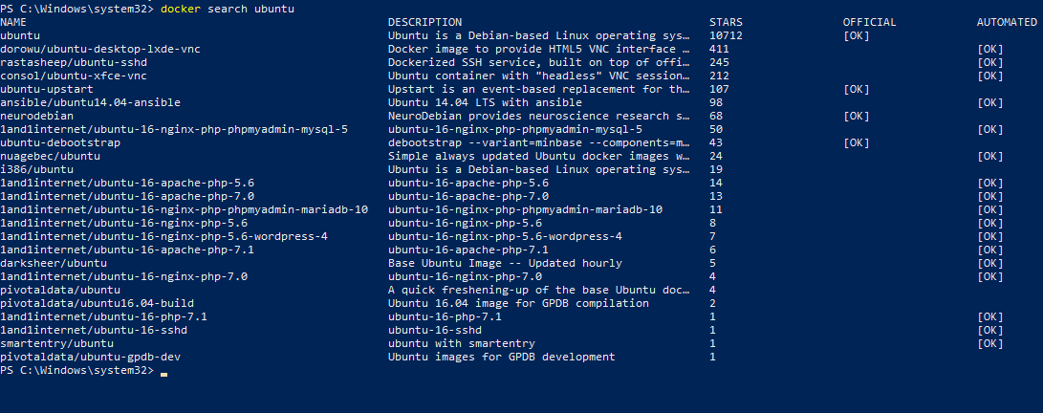

Download docker image

docker pull ubuntu

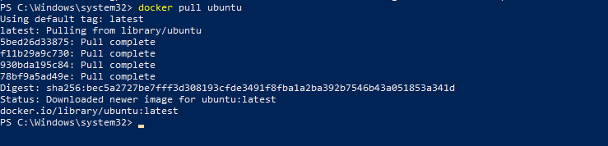

List all downloaded images

docker images –all

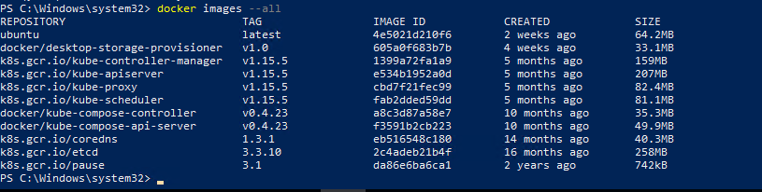

Check run images

docker ps -a



Connect to running container

docker run -it ubuntu

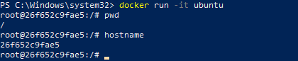

Check system update in container

apt update

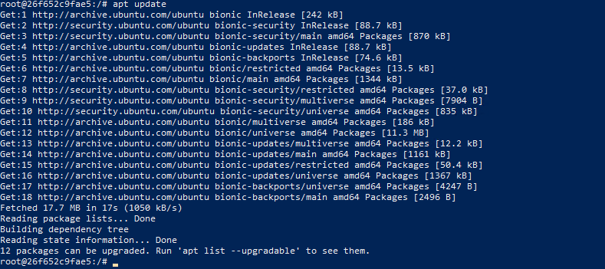

Install program htop in container

apt install htop

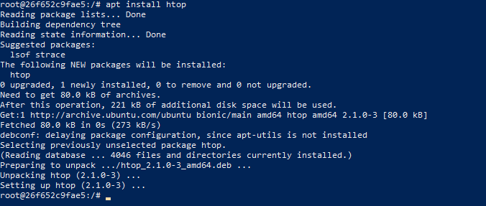

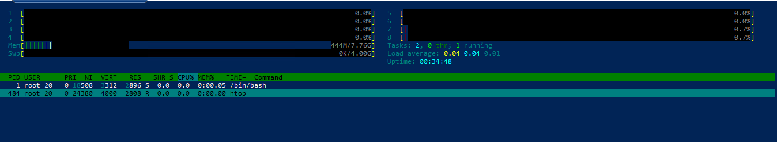

Copy file from host to container:

docker cp test-file.txt 36f402c1bed2:/root/

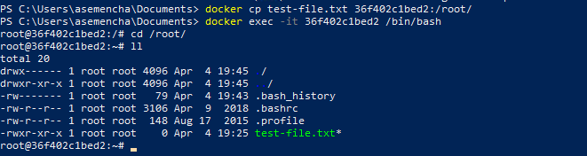

Copy the file from the Docker container to the host:

