# Using the AWS Free Tier

You can try some AWS services free of charge within certain usage limits. AWS calls this the AWS Free Tier. The Free Tier is designed to give you hands-on experience with a range of AWS services at no charge.

When you create an AWS account, you're automatically signed up for the Free Tier for 12 months. Your Free Tier eligibility expires at the end of the 12-month period. When your Free Tier expires, AWS starts charging the regular rates for any AWS services and resources that you're using.

# Launch a Linux Virtual Machine

To create and run the first virtual machine in the AWS cloud, you must complete the following steps.

1. Create an Amazon Lightsail Account
2. Create an Amazon Linux instance in Lightsail
   1. Choose Create instance in the Instances tab of the Lightsail home page.

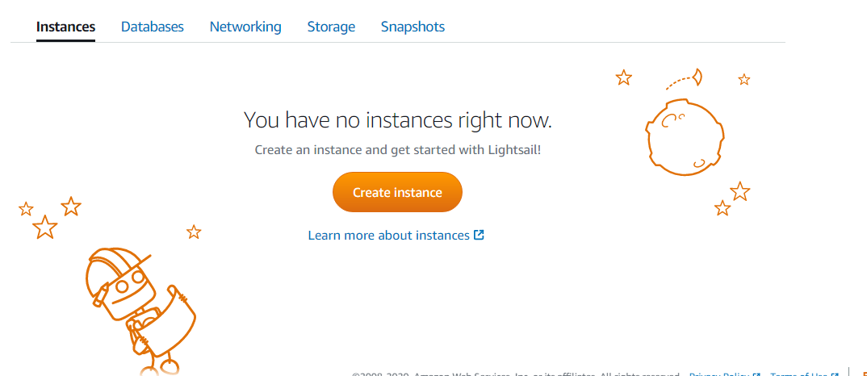

1. Configure your Amazon Lightsail instance
   1. An AWS Region and Availability Zone is selected for you. Choose Change Region and Availability Zone to create your instance in another location.

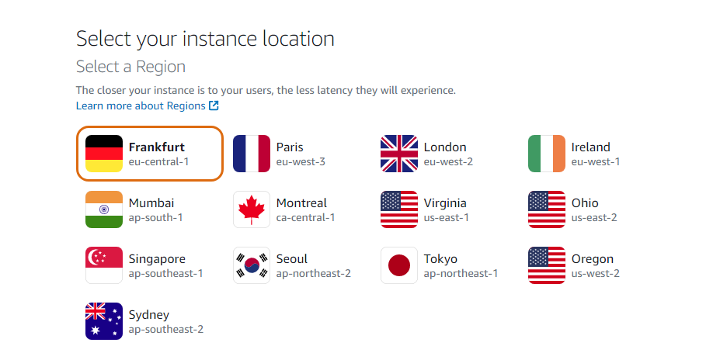

* 1. Choose the Linux/Unix platform option, and choose OS only to view the operating system-only instance images available in Lightsail.

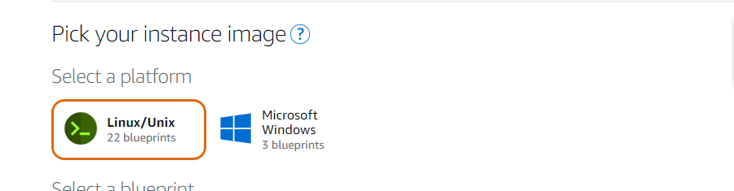

* 1. Choose the CentOS blueprint option.

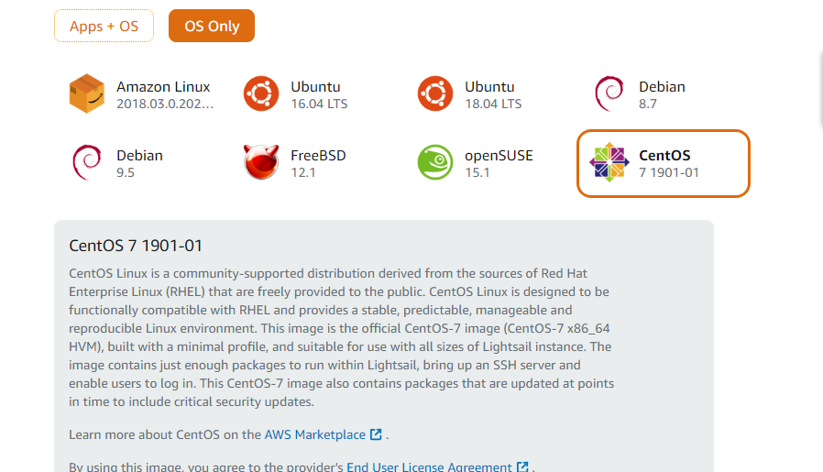

* 1. Choose Add launch script to add a shell script that will run on your instance when it launches. 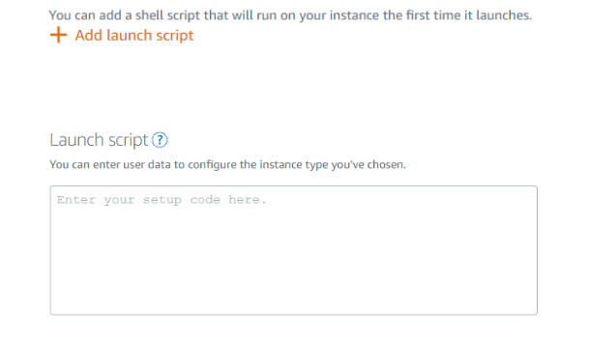
  2. Choose Change SSH key pair to select, create, or upload the key pair you would like to use to SSH into your instance. 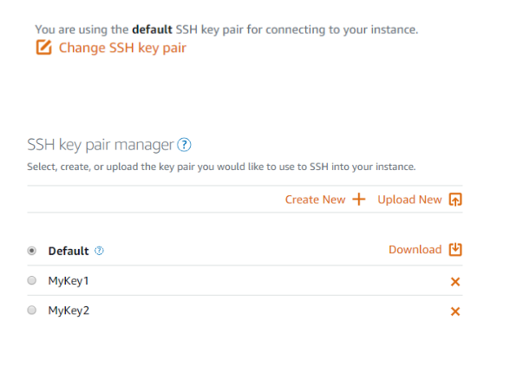
  3. Choose Enable Automatic Snapshots to automatically create a backup image of your instance and attached disks on a daily schedule. 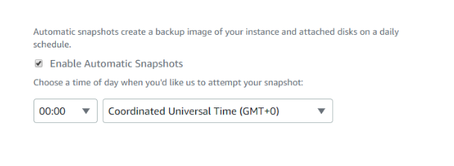
  4. Choose your instance plan. You can try the $3.50 USD Lightsail plan free for one month (up to 750 hours).

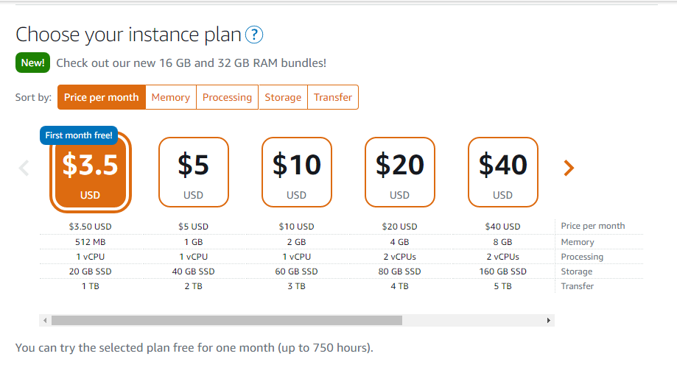

* 1. Enter a name for your instance.

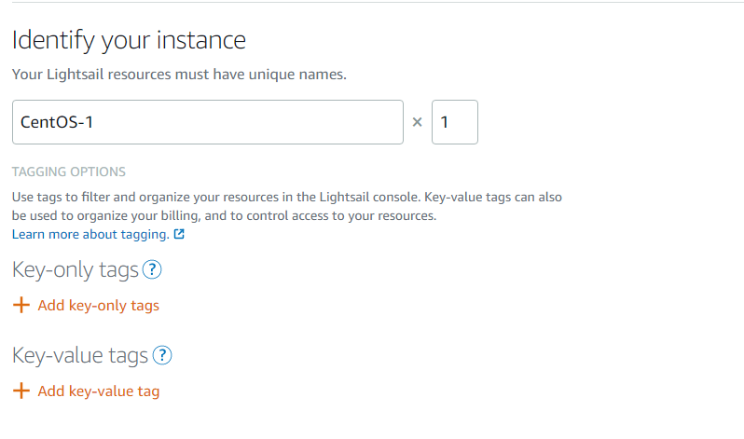

* 1. Choose one of the following options to add tags to your instance:
* Add key-only tags— Enter your new tag into the tag key text box, and press Enter. Choose Save when you’re done entering your tags to add them or choose Cancel to not add them.
* Create a key-value tag— Enter a key into the Key text box, and a value into the Value text box. Choose Save when you’re done entering your tags or choose Cancel to not add them. 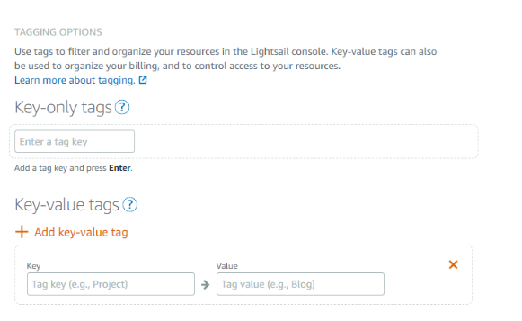
  1. Create instance

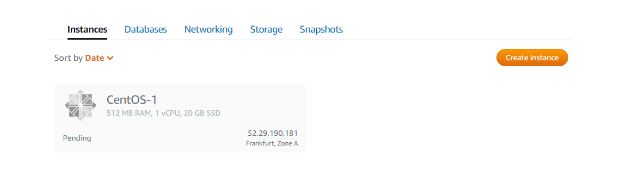

1. Connect your instance

Connect to your instance using the browser-based SSH terminal in Lightsail

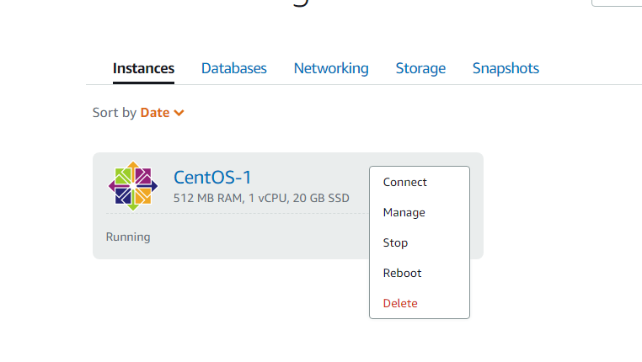

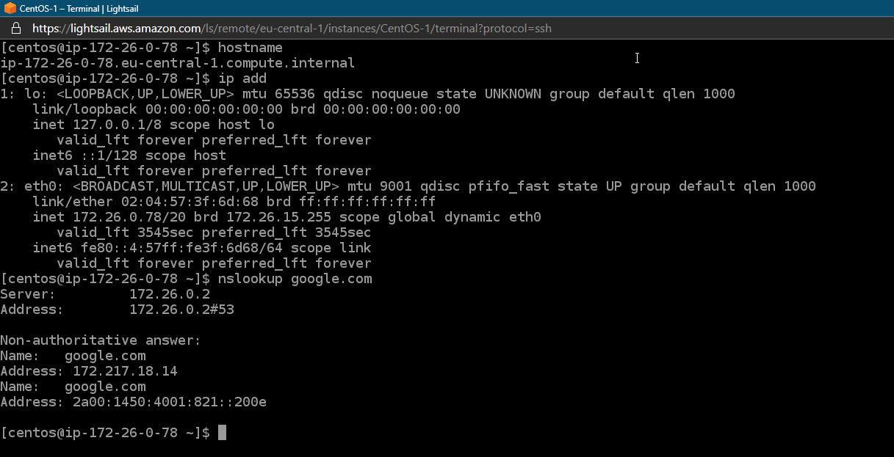

# Store and Retrieve a File

Amazon S3 is a service that enables you to store your data (referred to as objects) in at massive scale.

1. Enter the Amazon S3 Console

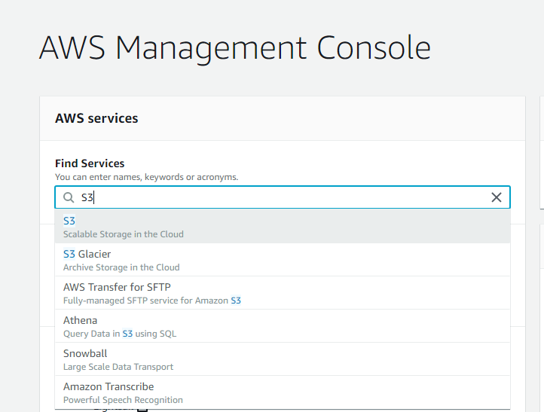

1. Create an S3 Bucket
   1. In the S3 dashboard, click Create Bucket. 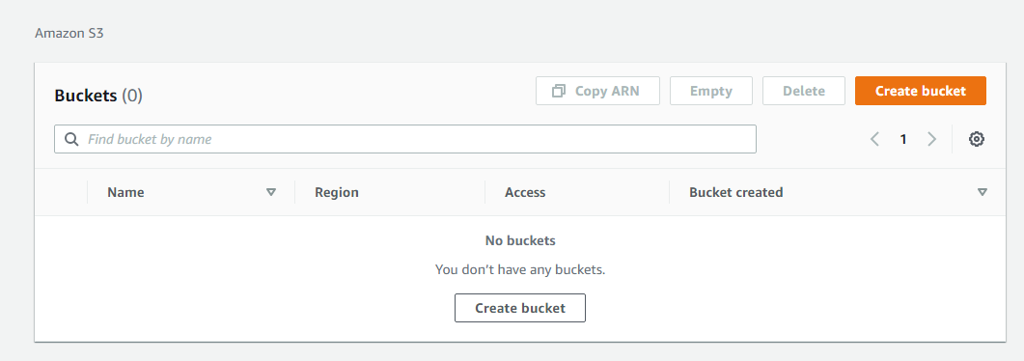
   2. Enter a bucket name. Bucket names must be unique across all existing bucket names in Amazon S3. There are a few other restrictions on S3 bucket names as well. Then select a region to create your bucket in. 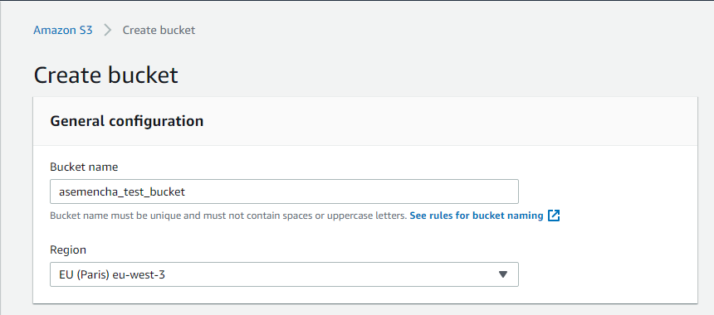
   3. Created Basket

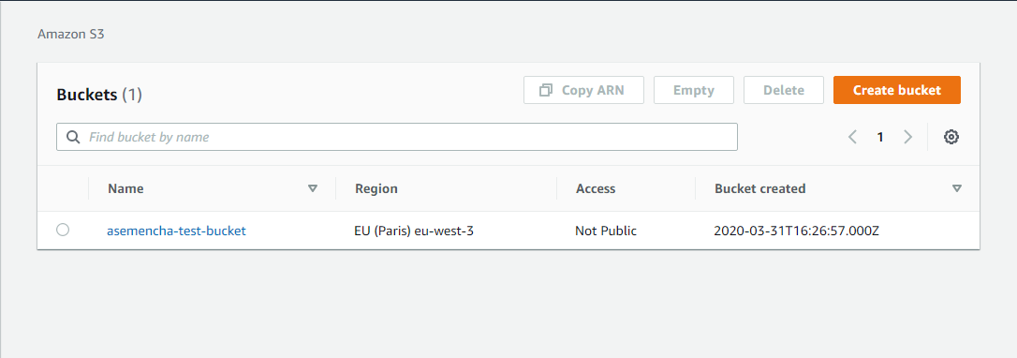

1. Upload a File

You will upload a file to your new Amazon S3 bucket.

* 1. You will see your new bucket in the S3 console. Click on your bucket’s name to navigate to the bucket.



* 1. You are in your bucket’s home page. Select Upload. 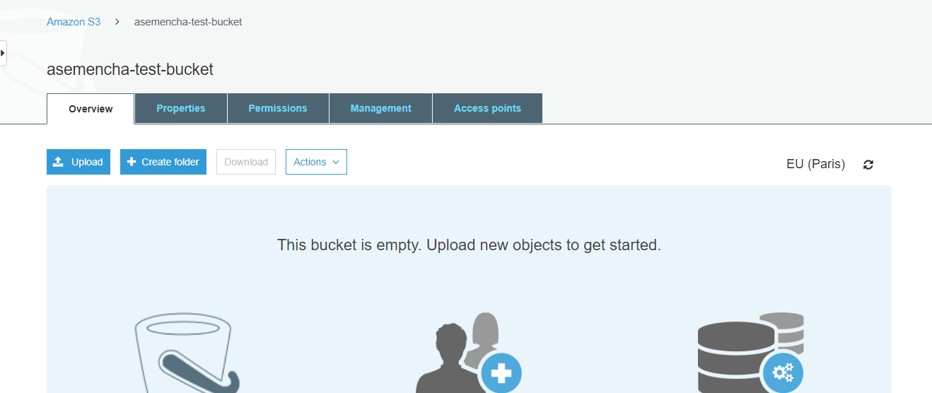
  2. To select a file to upload, either click Add files and select a sample file that you would like to store OR Drag and Drop a file on the upload box. Select Next after you have selected a file to upload. 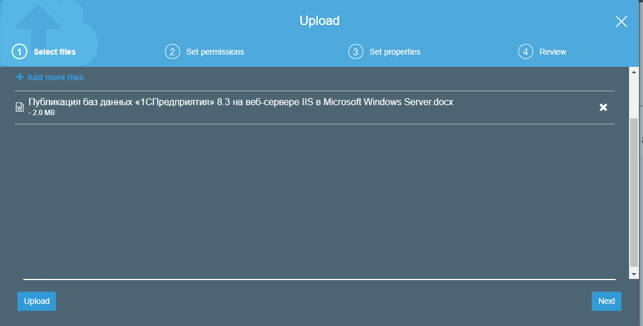
  3. You can set permission settings on your object. For this tutorial, leave the default values and select Next. 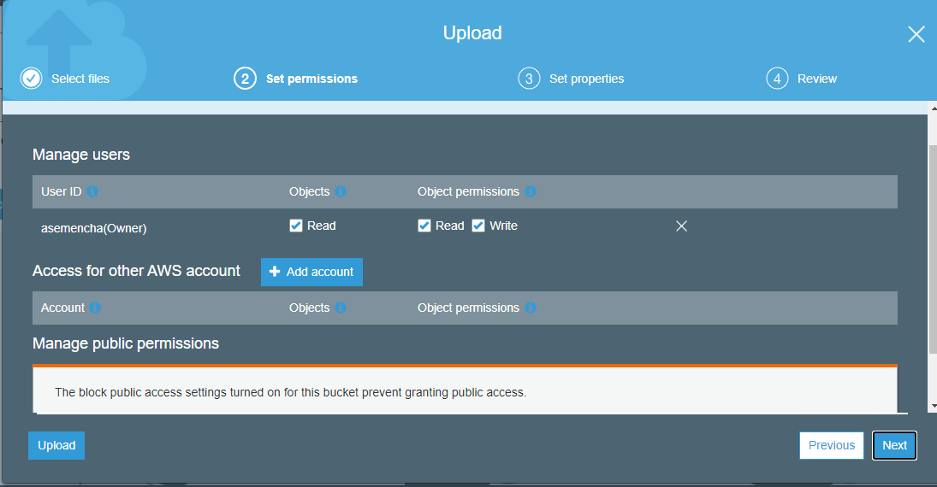
  4. You can set property settings like storage class, encryption, and metadata with your object. Leave the default values and select Next. 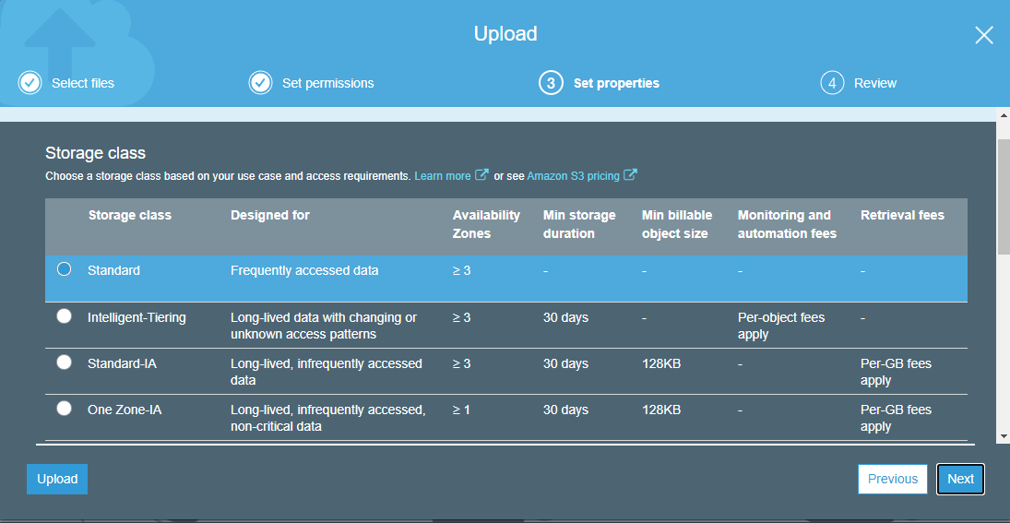
  5. Review your configurations and select Upload. You will see your object in your bucket’s home screen. 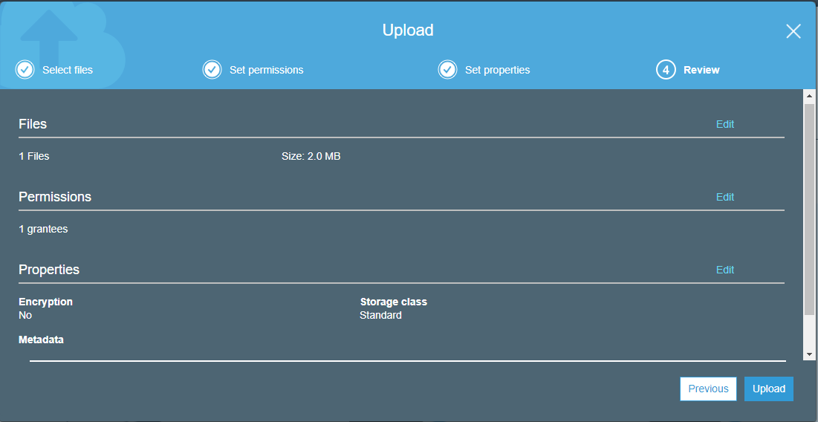

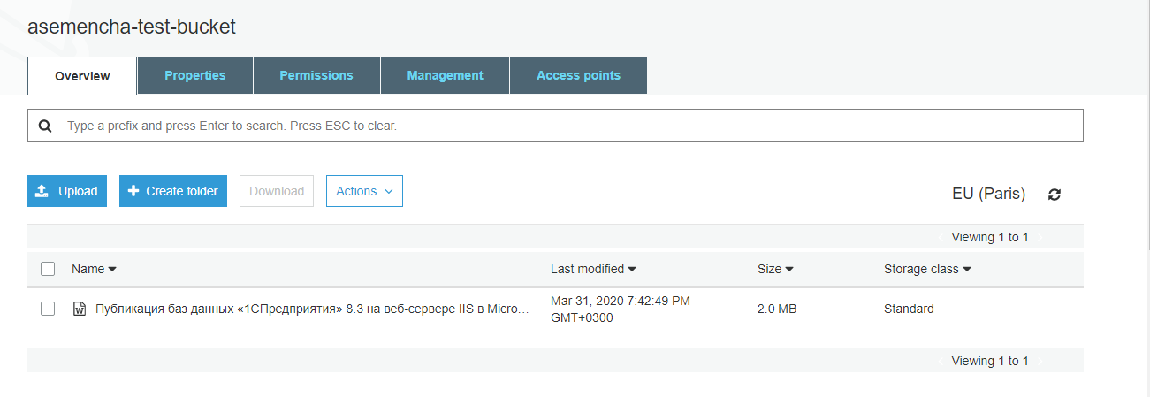

1. Retrieve the Object

Select the checkbox next to the file you would like to download, then select Download. 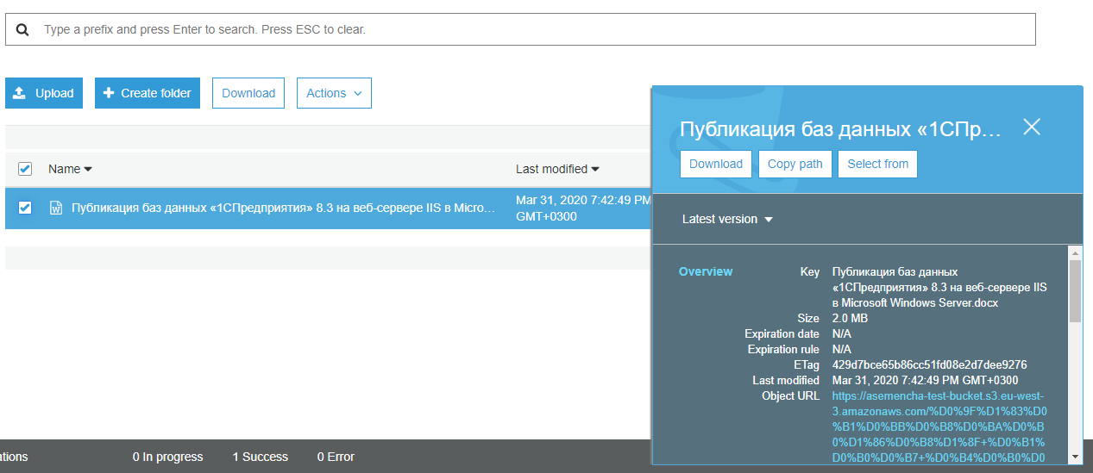

1. Delete the Object and Bucket

You can easily delete your object and bucket from the Amazon S3 console.

* 1. You will first delete your object. Select the checkbox next to the file you want to delete and select More > Delete.

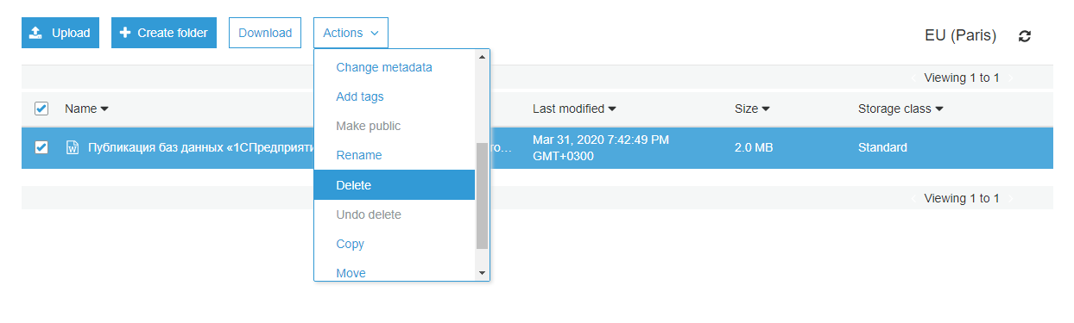

* 1. Review and confirm the object you want to delete. Select Delete. 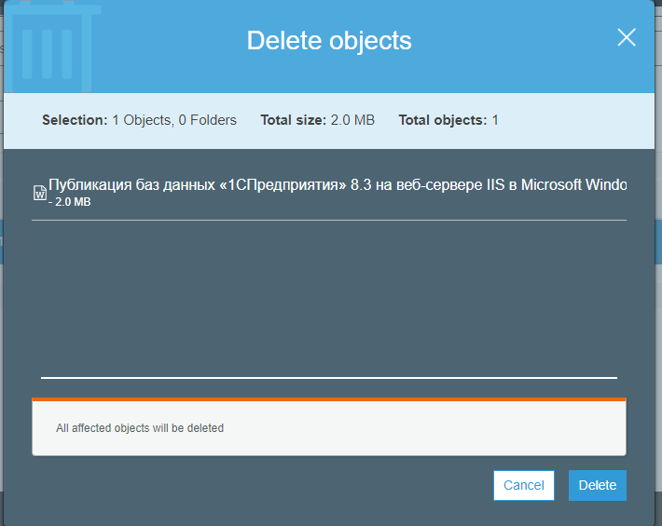
  2. Click to the right of the bucket name of the bucket you created to selected it, then click Delete. Type in the name of your bucket and click Confirm. 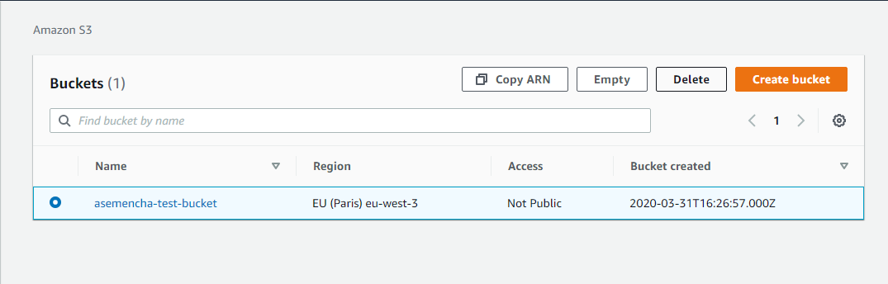 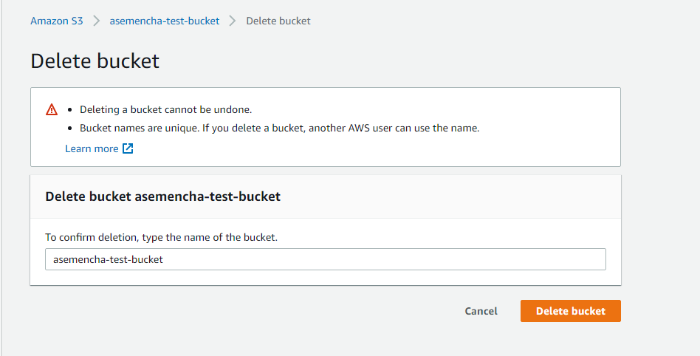

# Launch and configure a WordPress instance

1. Create an Amazon Lightsail Account
2. Create a WordPress instance in Lightsail
   1. On the Instances tab of the Lightsail home page, choose Create instance 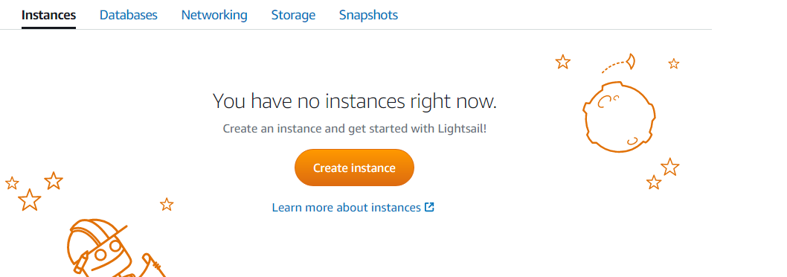
   2. Choose the AWS Region and Availability Zone for your instance. 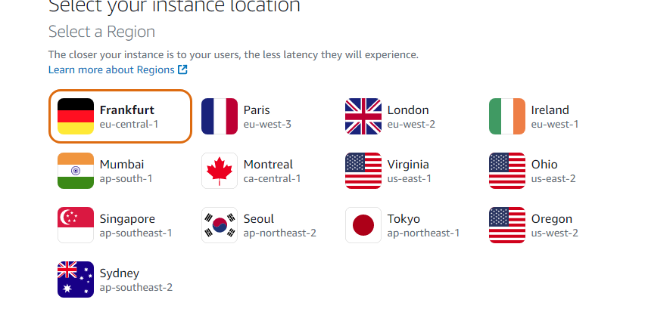
   3. Choose your instance image.

* Choose Linux/Unix as the platform.
* Choose WordPress as the blueprint.

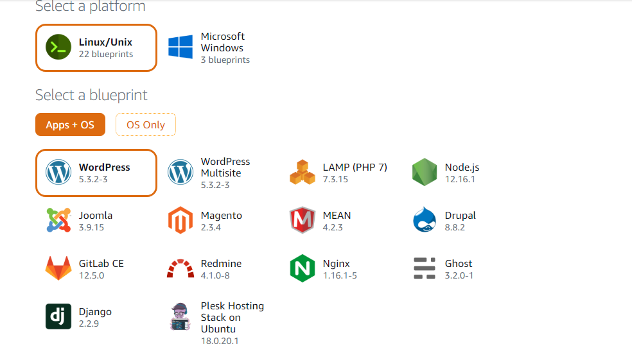

* 1. Choose an instance plan. 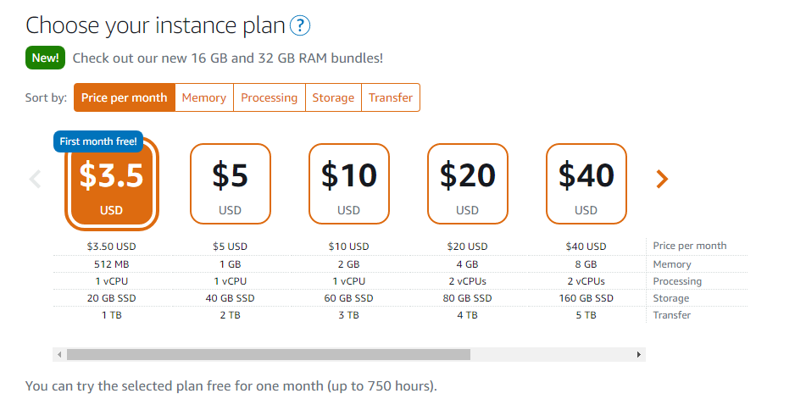
  2. Enter a name for your instance. 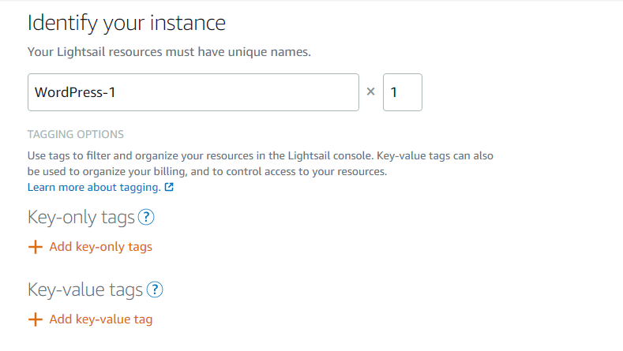
  3. Choose Create instance. 

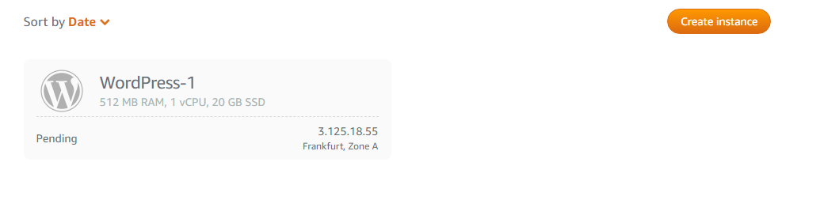

1. Connect to your instance via SSH and get the password for your WordPress website
   1. On the Instances tab of the Lightsail homepage, choose the SSH quick-connect icon for your WordPress instance. 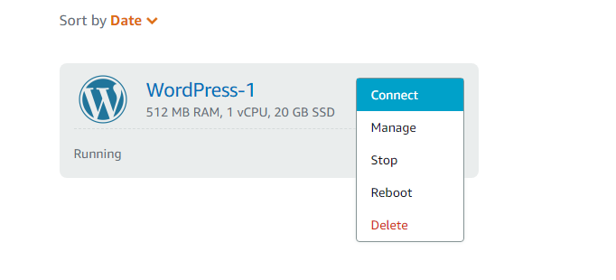
   2. After the browser-based SSH client window opens, enter the following command to retrieve the default application password: $HOME/bitnami_application_password 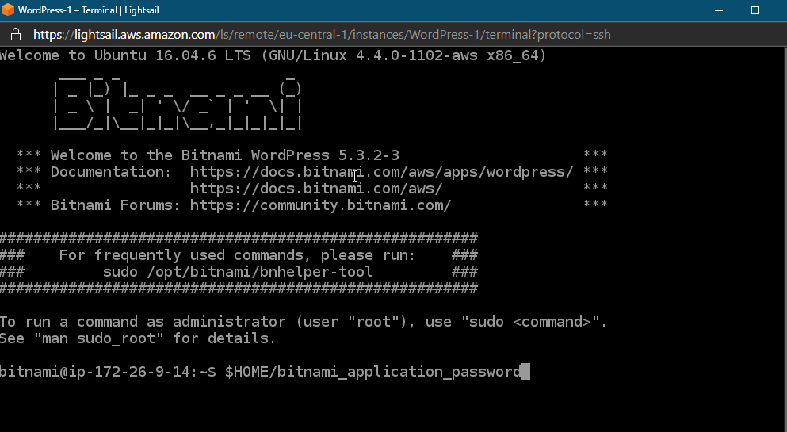
   3. Make note of the password displayed on the screen. You use it later to sign in to the administration dashboard of your WordPress website. 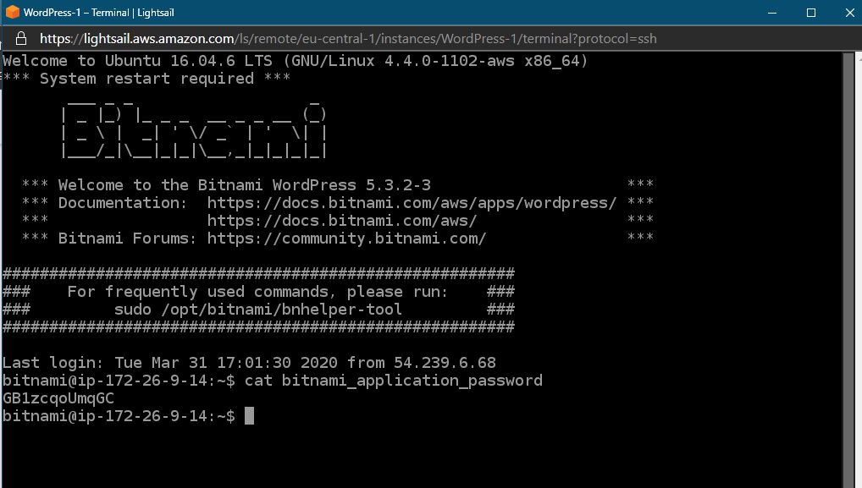
2. Sign into the administration dashboard of your WordPress website

Now that you have the password for the administration dashboard of your WordPress website, you can sign in. In the administration dashboard, you can change your user password, install plugins, change the theme of your website, and more.

* 1. In a browser, go to <http://3.125.18.55/wp-login.php> 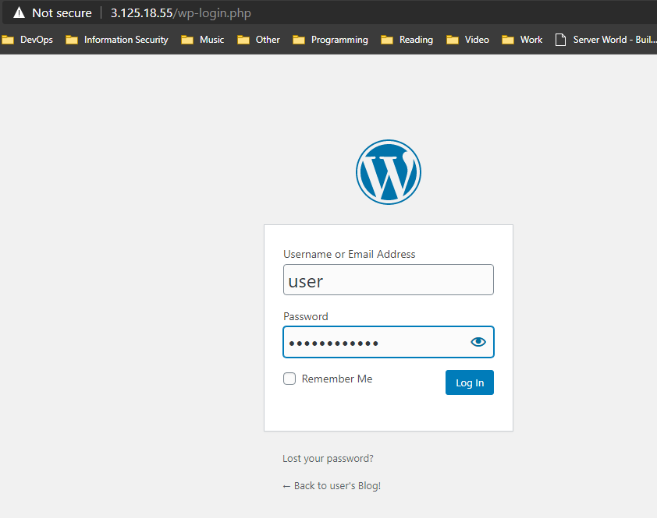
  2. Log into your instance. 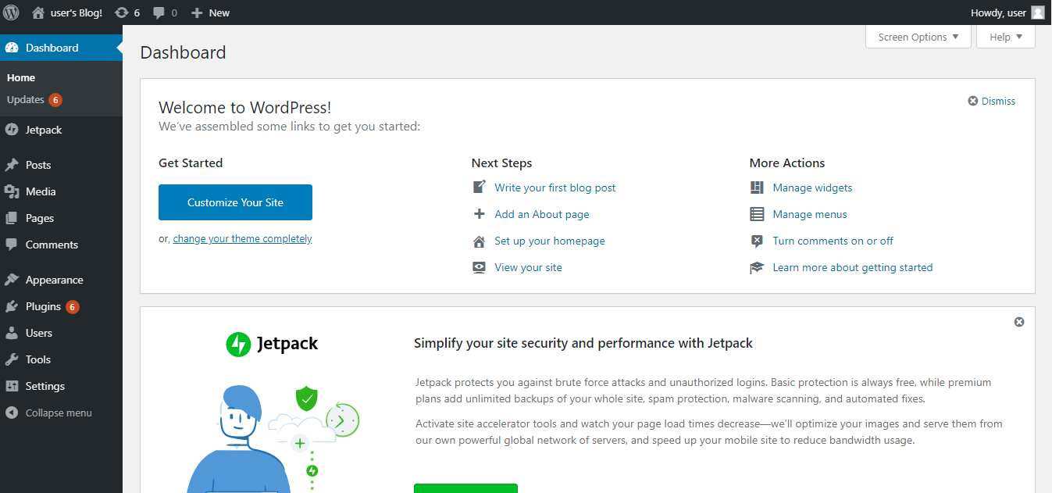

1. Create a Lightsail static IP address and attach it to your WordPress instance

The default public IP for your WordPress instance changes if you stop and start your instance. A static IP address, attached to an instance, stays the same even if you stop and start your instance.

* 1. On the Instances tab of the Lightsail home page, choose your running WordPress instance. 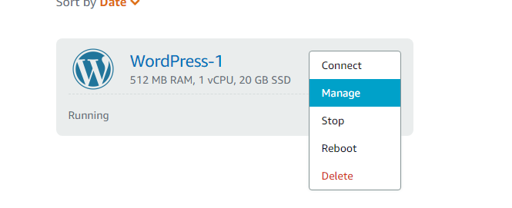
  2. Choose the Networking tab, then choose Create static IP. 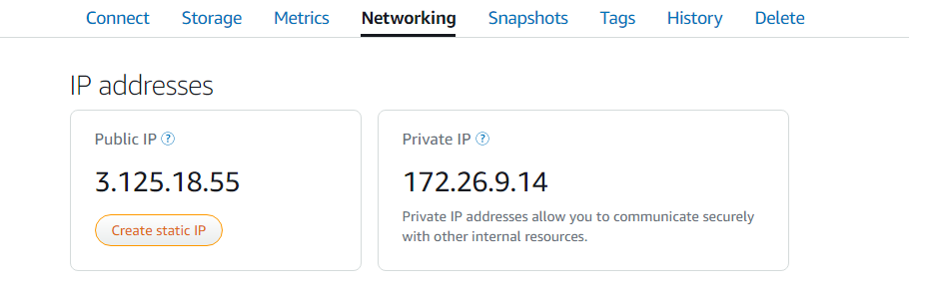
  3. The static IP location, and attached instance are pre-selected based on the instance that you chose earlier in this tutorial. 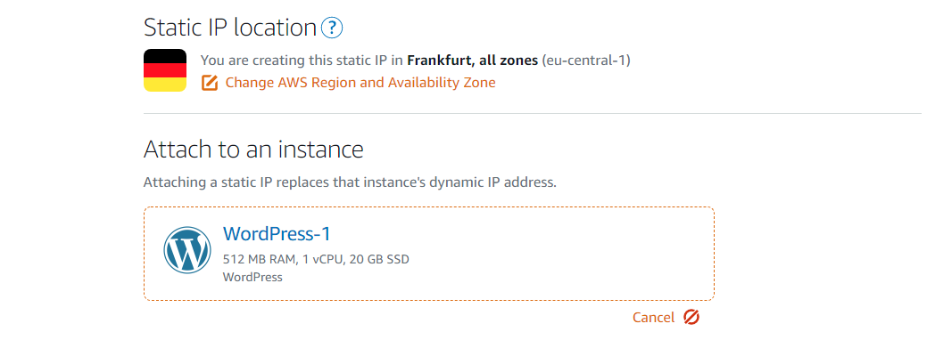
  4. Name your static IP, then choose Create. 