# LXD

LXD is the lightervisor, or lightweight container hypervisor. It also nicely distinguishes LXD from LXC.

LXC is a program which creates and administers "containers" on a local system. It also provides an API to allow higher level managers, such as LXD, to administer containers.

The LXC API deals with a 'container'. The LXD API deals with 'remotes', which serve images and containers. This extends the LXC functionality over the network and allows concise management of tasks like container migration and container image publishing.

LXD uses LXC under the covers for some container management tasks. However, it keeps its own container configuration information and has its own conventions, so that it is best not to use classic LXC commands by hand with LXD containers.

## Installation

LXD is pre-installed on Ubuntu Server cloud images. On other systems, the lxd package can be installed using:

apt install lxd

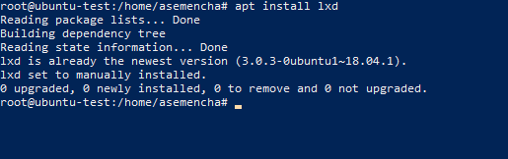

## Creating first container

Creating your first container is as simple as:

lxc launch ubuntu:18.04 epam

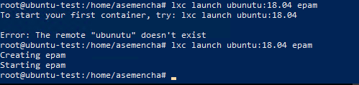

That will create and start a new Ubuntu 18.04 container as can be confirmed with:

lxc list

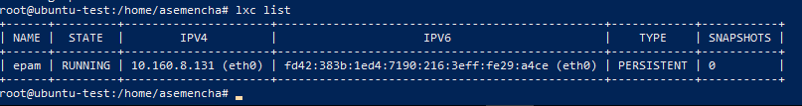

Now that your container is running, you can get a shell inside it with:

lxc exec epam -- /bin/bash

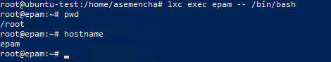

Run install system update:

apt update

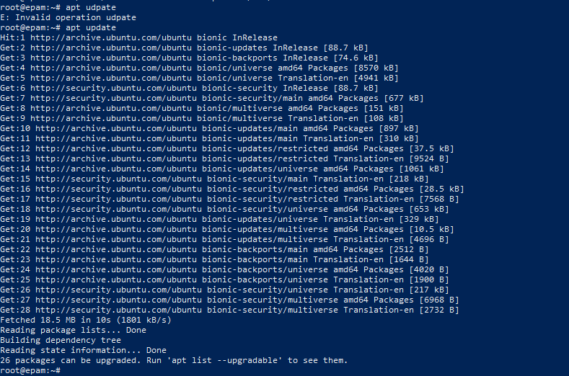

To pull a file from the container, use:

lxc file pull epam/etc/hosts .

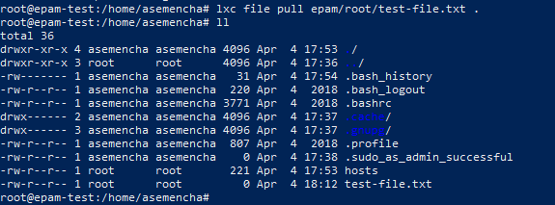

To push one, use:

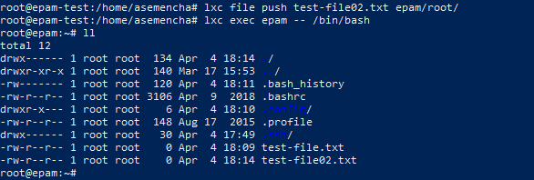

To stop the container, simply do:

lxc stop epm

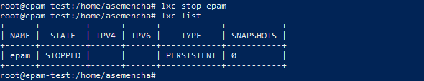

And to remove it entirely:

lxc delete epam

