1. Go to the folder in the home directory ~/tmp/dir1. 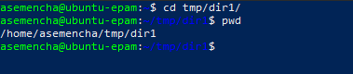
2. Create a file with any name. Redirect to it a long listing of the current directory. View file contents.

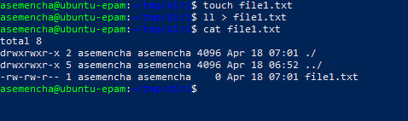

1. Create a second file. It also redirects an extended listing of the current directory. Compare these files in two ways. 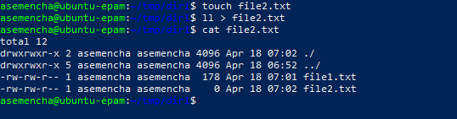

cmp - compare two files byte by byte



comm - compare two sorted files line by line 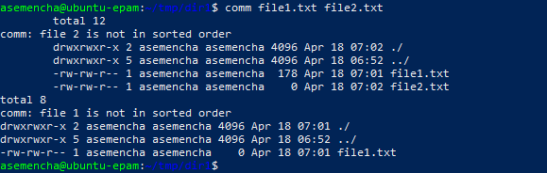

diff - compare files line by line 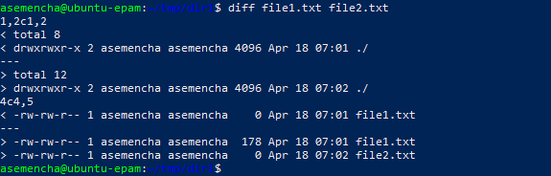

1. Open the first file in vi. Add the last line labeled End of File. Replace the line indicating the total number of files from the form total n to n files, where n is a digit. Save the changes to the file and exit the editor. 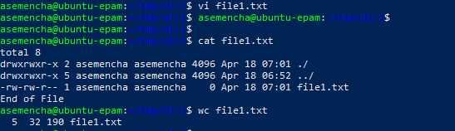

I don't understand how to complete this point.

1. Do the same with the second file in the nano editor. 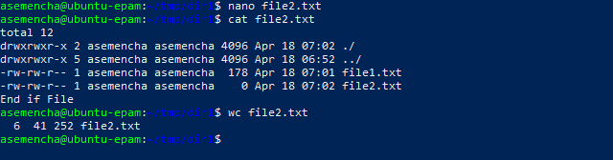

I don't understand how to complete this point too.

1. Create a variable containing the current directory ~/tmp/dir1/

Go to the home directory using a special variable or metacharacter. Go back using a variable. 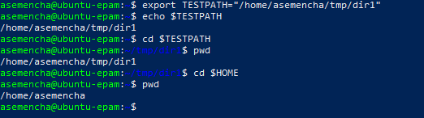

1. Create a command sequence that sequentially redirects the listing to a file from the home directory and, if successful, from the ~/tmp/dir1 directory. Browse the contents of the file and make sure that there are both lists of directory files. 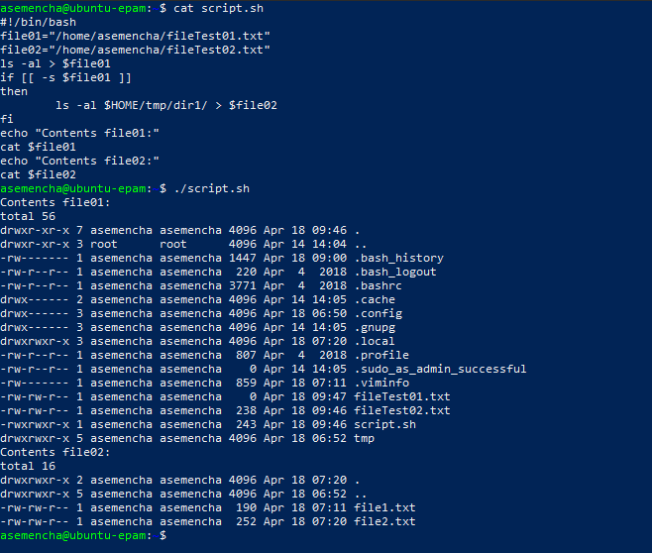
2. Create one variable that will store your Last Name First Name. Create a complex command, which displays the text "username Last Name" and the number of characters name and surname separately.

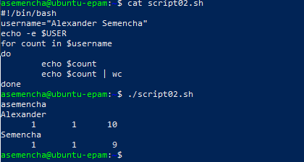

1. Print Last Name First name through a tab character using unprintable characters. 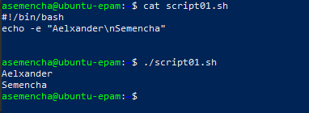
2. Create a variable and assign it an arbitrary value. Display the phrase in the format "The value of the variable NAME is VALUE". 