1. To discover files with active sticky bits, use the following version of the find command:

sudo find / -perm /6000 -type f -exec ls -ld {} \; > setuid.txt 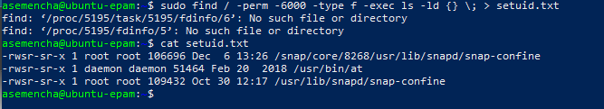

Put into your report a fragment of setuid.txt file. Explain meaning of parameters of the above find command.

find - search for files in a directory hierarchy

**/** - search path

**-perm /6000** - Any of the permission bits mode are set for the file. Symbolic modes are accepted in this form. You must specify `u', `g' or `o' if you use a symbolic mode. See the EXAMPLES section for some illustrative examples. If no permission bits in mode are set, this test matches any file (the idea here is to be consistent with the behavior of -perm -000).

**-type f -** File is of type regular file

**-exec** **command -** Execute command; true if 0 status is returned. All following arguments to find are taken to be arguments to the command until an argument consisting of `;' is encountered. The string `{}' is replaced by the current file name being processed everywhere it occurs in the arguments to the command, not just in arguments where it is alone, as in some versions of find. Both constructions might need to be escaped (with a `\') or quoted to protect them from expansion by the shell. See the EXAMPLES section for examples of the use of the -exec option. The specified command is run once for each matched file. The command is executed in the starting directory. There are unavoidable security problems surrounding use of the -exec action; you should use the -execdir option instead.

1. Discovering soft and hard links.

ln - make links between files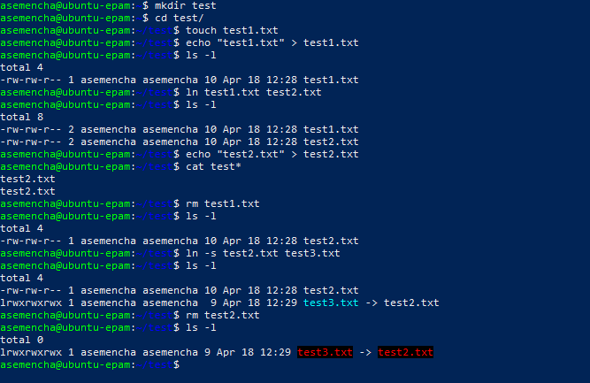

1. I/O redirect.

mount - mount a filesystem

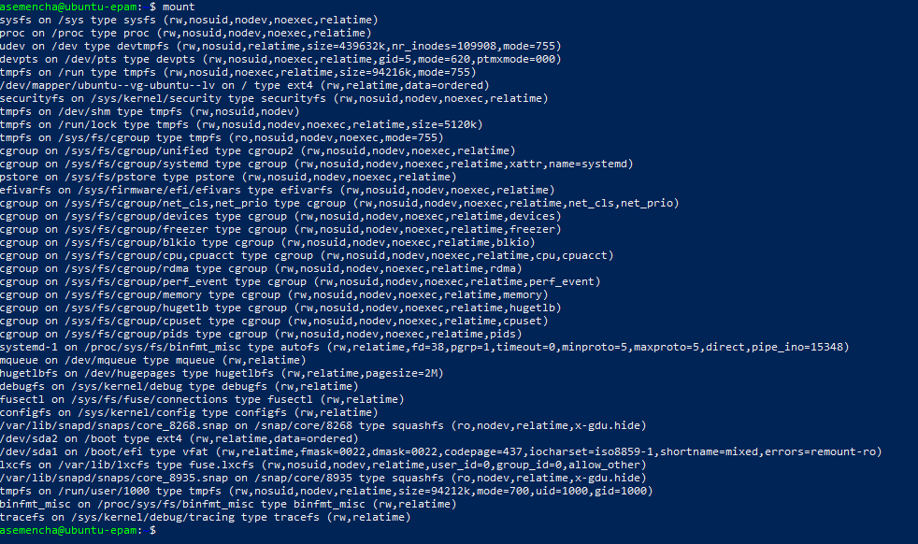

blkid - locate/print block device attributes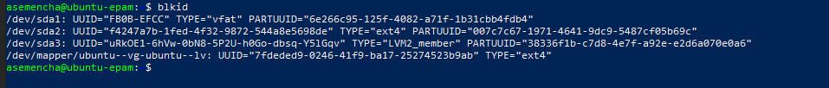

mount | grep sda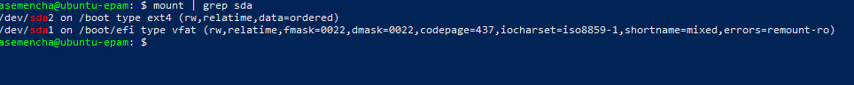

dmesg - print or control the kernel ring buffer

dmesg | grep sda 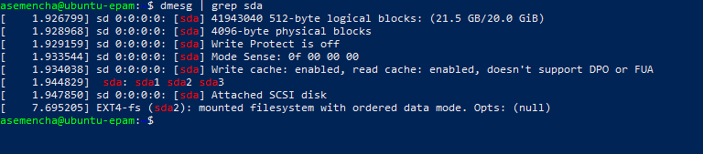

sudo grep -R -e "root" /etc/ > root_entries.txt 