# Quota allocation mechanism.

Employing commands from presentation 4.6, create a new user, say, utest.

Based on the quota mechanism, limit the available disk space for this user to soft:100M and hard:150M. Then, using Midnight Commander (since MC shows warnings about exceedingly the limits of available to a user disk space), copy content of /usr directory to utest’s home directory (actually, /usr isn't mandatory, you are free to copy any other data, the only condition is enough total size of the files to copy).

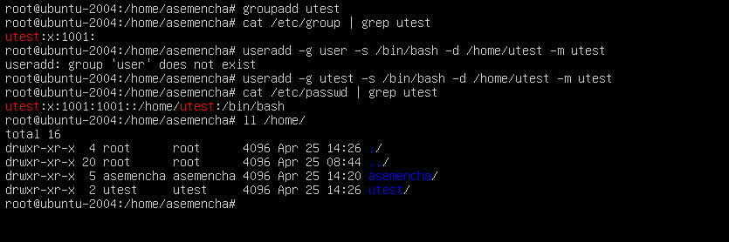

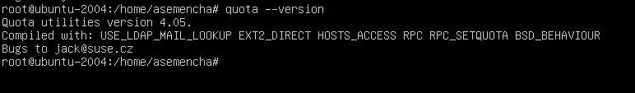

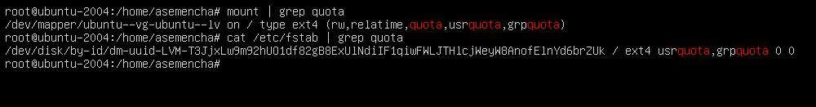

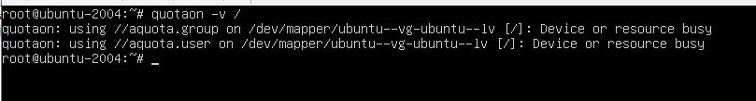

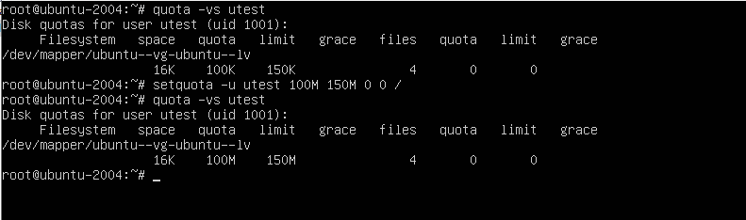

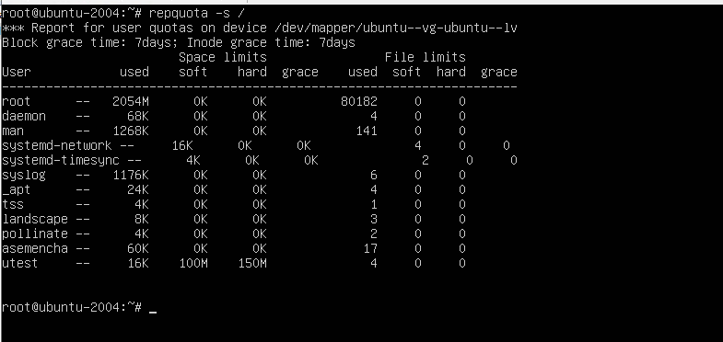

# Access Control Lists, ACLs

In what follows, we assume that there are two users: guest (included into the list of sudoers) and utest. None of the users is the superuser (i.e. UIDs of the users differ from 0).

The most task: to allow user utest visit guest’s home directory.

The average task: to acquaint yourself with the basics of ACL and verify the fact that ACL privileges override the chmod ones.

1. Based on given in presentation 4.7 instructions, turn on and set up the ACL. Prior to any action, it is advised to check if the “acl” flag is on, using tune2fs -l /dev/sda* invoke it twice:
   1. on behalf of guest (i.e. without the superuser privileges);
   2. with sudo (i.e. with the superuser privileges).

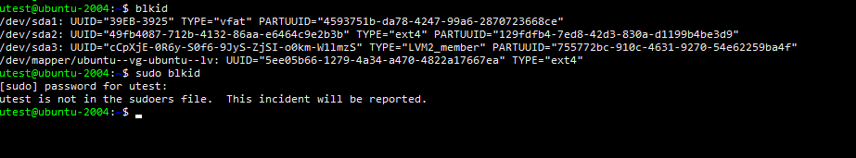

1. Log in as guest. Create in /tmp a directory called acl_test. By means of chmod, allow user utest to perform all possible operations (rwx) with respect to acl_test. Verify that user utest is indeed capable of implementing granted him (her) privileges. For example, acer logging in as utest, create a file in /tmp/acl_test, say, utest.txt with the aid of touch.

ls -ld /tmp/acl_test

ls -l /tmp/acl_test

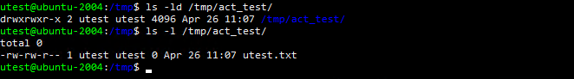

To check ACL permissions, do:

getfacl /tmp/acl_test

getfacl /tmp/acl_test/utest.txt

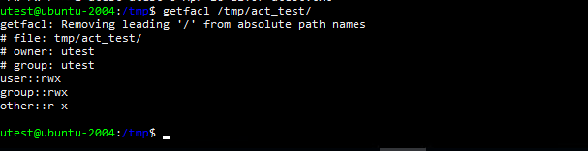

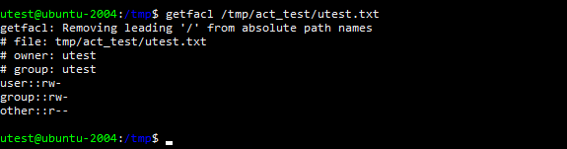

1. Employ ACL to block any activity except for reading, for user utest with respect to directory /tmp/acl_test. Test if the actions are effectively prohibited

touch /tmp/acl_test/prohibited.txt

Is it possible to invoke this command?

echo “new content” > /tmp/acl_test/utest.txt

Test if user utest can be prevented from modifying content of the file utest.txt by means of ACL.

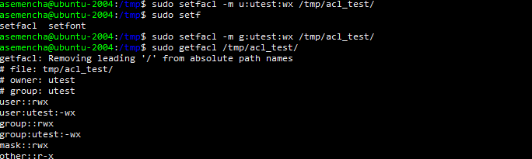

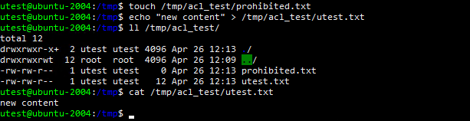

1. Consider a situation when at the ACL level user test is allowed to have all possible privileges with respect to /tmp/acl_test, while no action is allowed with chmod (conventional mechanism)

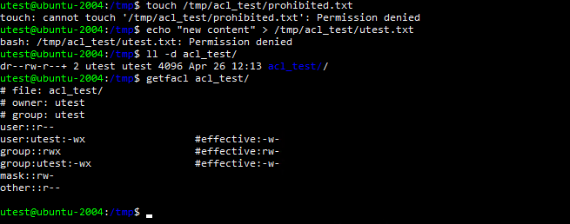

1. For user utest, set default ACLs to the directory /tmp/acl_test which allow read-only access. Being logged in as utest, invoke touch to create the file utest2.txt in the /tmp/acl_test directory. Query permissions on this file using getfacl.

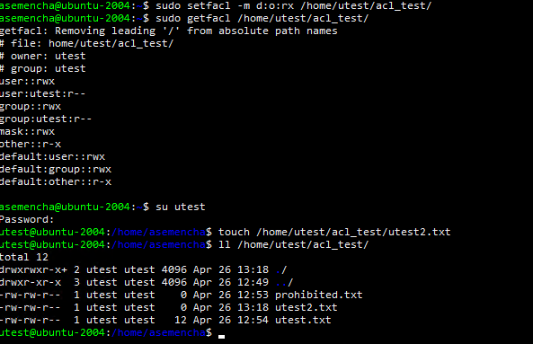

1. Set the maximum permissions mask on the /tmp/acl_test/utest.txt file in such a way as to allow read-only access. Check permissions with getfacl.
2. Delete all ACL entries relative to the /tmp/acl_test directory.